Supplementary Figures & Tables:

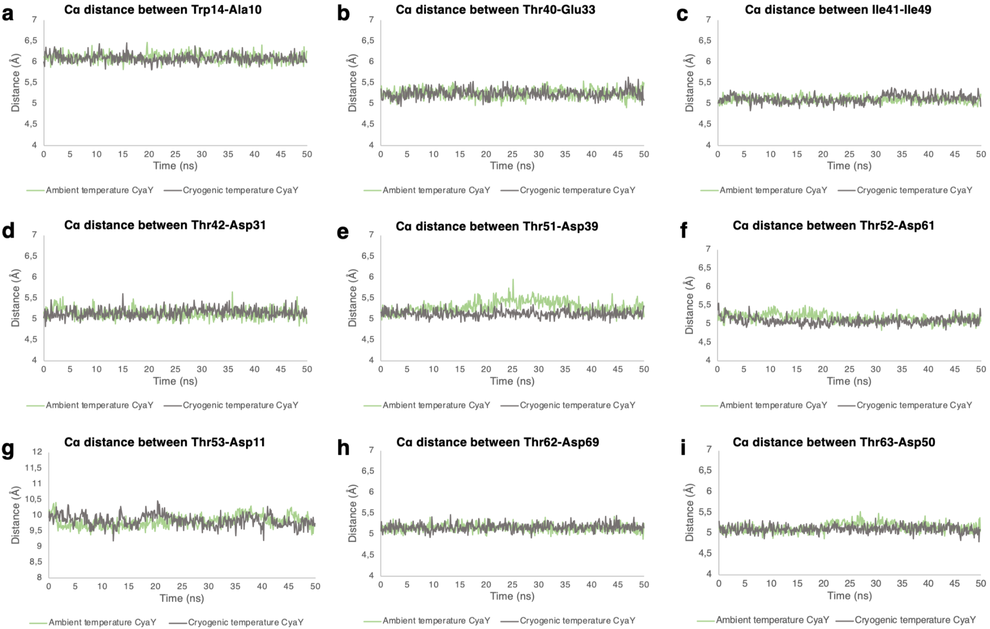

Supplementary Fig. 1: Residues distances during 50 ns MD simulation. Cα distances were calculated for previously detected active site residues based on hydrogen bond analysis. For the final result, the values of each production run averaged and colored green and gray for CyaY^{AT1} and CyaY^{CT1} structures, respectively.

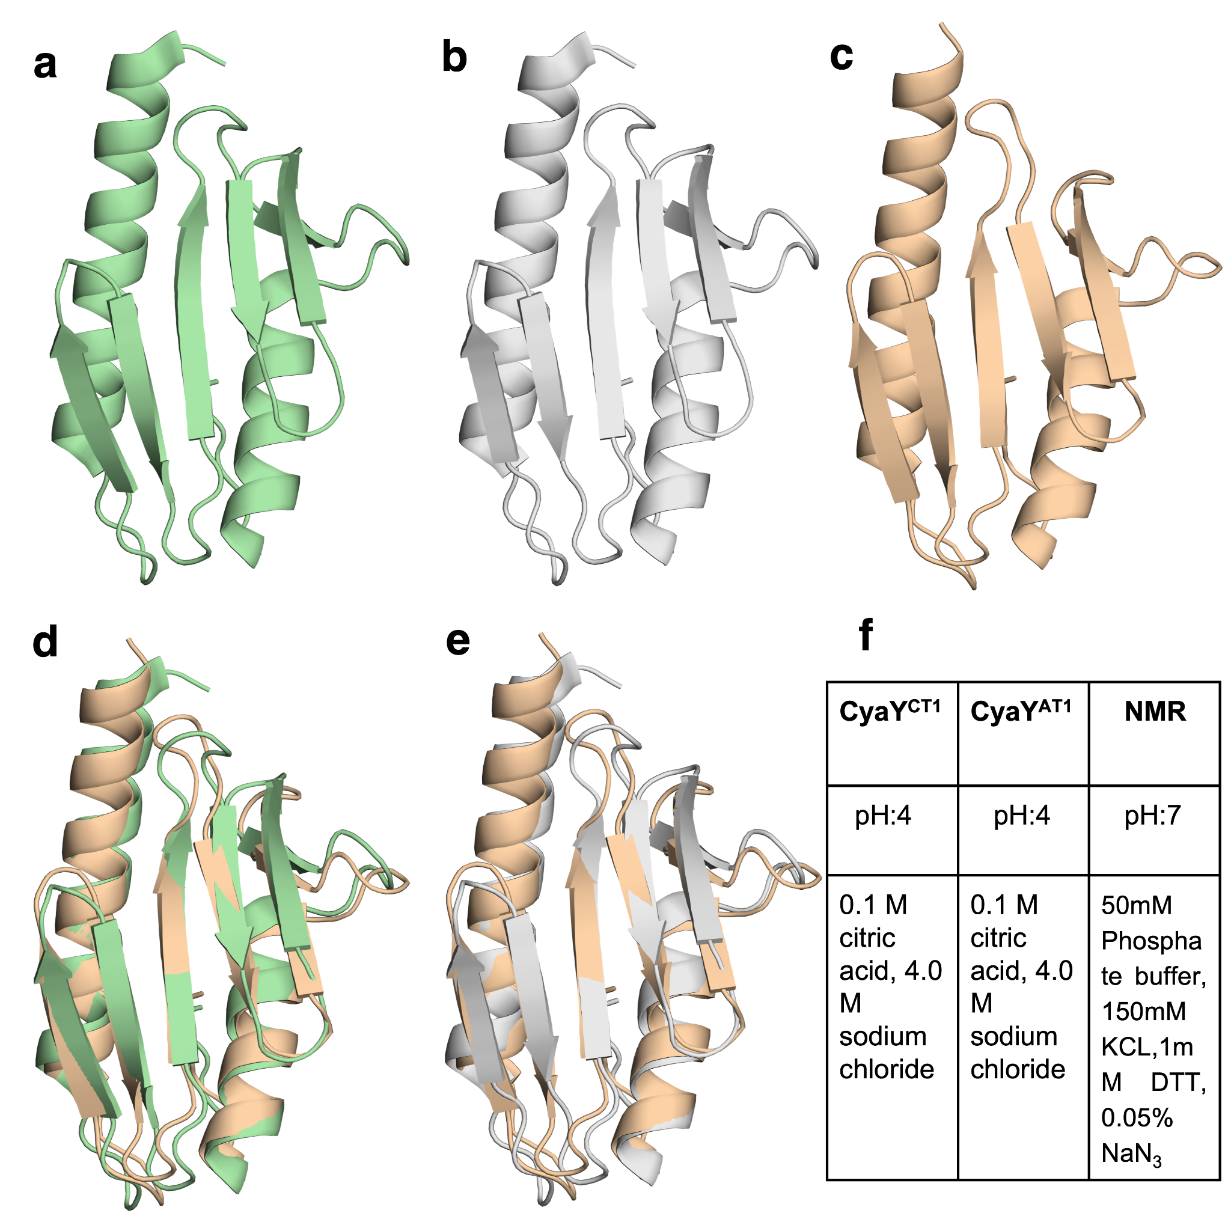
Supplementary Fig. 2: (a-c) Secondary structure representation of CyaY proteins in CyaY^{AT1} and CyaY^{CT1} and NMR, respectively. (d) Superimposition of CyaY^{AT1} with NMR structure. (e) Superimposition of CyaY^{CT1} with the NMR structure. (d) A table showing the experimental conditions for each individual structure.

Hydrogen bonds (CyaY^{AT1})
prod1 |  |  | prod2 |  |  | prod3
Donor | Acceptor | Occupancy | Donor | Acceptor | Occupancy | Donor | Acceptor | Occupancy
Asp11-Main | His7-Main | 55.60% | Asp11-Main | His7-Main | 55.11%
Trp14-Main | Ala10-Main | 53.40% | Trp14-Main | Ala10-Main | 54.71% | Trp14-Main | Ala10-Main | 53.43%
Thr40-Main | Glu33-Main | 53.40% | Thr40-Main | Glu33-Main | 54.91% | Thr40-Main | Glu33-Main | 60.08%
Ile41-Main | Ile49-Main | 68.00% | Ile41-Main | Ile49-Main | 70.14%
Thr42-Main | Asp31-Main | 52.40% | Thr42-Main | Asp31-Main | 55.11% | Thr42-Main | Asp31-Main | 54.05%
Set47-Side | Asn45-Side | 67.40% | Ser47-Side | Asn45-Side | 68.94% | Ser47-Side | Asn45-Side | 69.65%
Ile51-Main | Leu39-Main | 61.00% |  |  |  | Ile51-Main | Leu39-Main | 69.44%
Asn52-Main | Trp61-Main | 55.80% |  |  |  | Asn52-Main | Trp61-Main | 52.18%
Arg53-Side | Asp11-Side | 51.60% | Arg53-Side | Asp11-Side | 50.10% | Arg53-Side | Asp11-Side | 50.52%
Gln54-Main | Gln59-Main | 65.00% | Gln54-Main | Gln59-Main | 64.73% | Gln54-Main | Gln59-Main | 60.08%
His58-Side | Asp3-Side | 51.40% | His58-Side | Asp3-Side | 54.31% | Hıs58-Side | Asp3-Side | 55.72%
Trp61-Main | Asn52-Main | 55.00% | Trp61-Main | Asn52-Main | 58.12% | Trp61-Main | Asn52-Main | 63.20%
Leu62-Main | Tyr69-Main | 56.40% | Leu62-Main | Tyr69-Main | 60.32% | Leu62-Main | Tyr69-Main | 53.22%
Ala63-Main | Ile50-Main | 55.80% | Ala63-Main | Ile50-Main | 58.92% | Ala63-Main | Ile50-Main | 56.13%
 |  |  | Phe71-Main | Val60-Main | 57.31% | Phe71-Main | Val60-Main | 50.73%
Ala99-Main | Ala95-Main | 53.20% | Ala99-Main | Ala95-Main | 57.52%
Phe105-Main | Glu92-Side | 57.20% | Phe105-Main | Glu92-Side | 56.11% | Phe105-Main | Glu92-Side | 69.44%
Arg106-Side | Asp89-Side | 60.20% | Arg106-Side | Asp89-Side | 51.30% | Arg106-Side | Asp89-Side | 67.15%

Supplementary Table 1: Occupancy of hydrogen bond interactions for CyaY^{AT1} during 50 ns MD simulation for 3 production runs. Each production run is named as prod1, prod2 and prod3, respectively.

Salt bridges (CyaY^{AT1})
prod1 | prod2 | prod3
Glu5-Arg8 | Glu5-Arg8 | Glu5-Arg8
Asp11-Arg8 | Asp11-Arg8 | Asp11-Arg8
Asp11-Arg53 | Asp11-Arg53 | Asp11-Arg53
Glu19-Arg20 | Glu19-Arg20 | Glu19-Arg20
Asp23-Arg20 | Asp23-Arg20
Glu33-Lys48 | Glu33-Lys48 | Glu33-Lys48
Asp72-Lys74 | Asp72-Lys74 | Asp72-Lys74
Asp81-Arg82 | Asp81-Arg82 | Asp81-Arg82
Asp89-Arg106 | Asp89-Arg106 | Asp89-Arg106
Glu92-Arg20 | Glu92-Arg20
 | Glu92-Arg106 | Glu92-Arg106

Supplementary Table 2: Salt bridges for CyaY^{AT1} during 50 ns MD simulation for 3 production runs. Each production run is named as prod1, prod2 and prod3, respectively.

Hydrogen bonds (CyaY^{CT1})
prod1 |  |  | prod2 |  |  | prod3
Donor | Acceptor | Occupancy | Donor | Acceptor | Occupancy | Donor | Acceptor | Occupancy
Trp14-Main | Ala10-Main | 56.48% | Trp14-Main | Ala10-Main | 52.40% | Trp14-Main | Ala10-Main | 54.00%
Arg20-Side | Arg106-Side | 83.40% |  |  |  | Arg20-Side | Arg106-Side | 65.40%
Thr40-Main | Glu33-Main | 53.24% | Thr40-Main | Glu33-Main | 55.20% | Thr40-Main | Glu33-Main | 52.00%
Ile41-Main | Ile49-Main | 65.59% | Ile41-Main | Ile49-Main | 59.00% | Ile41-Main | Ile49-Main | 67.60%
Thr42-Main | Asp31-Main | 52.63% | Thr42-Main | Asp31-Main | 50.80% | Thr42-Main | Asp31-Main | 52.20%
Ser47-Side | Asn45-Side | 66.60% | Ser47-Side | Asn45-Side | 66.80% | Ser47-Side | Asn45-Side | 63.00%
Ile51-Main | Leu39-Main | 69.64% | Ile51-Main | Leu39-Main | 69.20% | Ile51-Main | Leu39-Main | 68.40%
Asn52-Main | Trp61-Main | 60.32% | Asn52-Main | Trp61-Main | 64.60% | Asn52-Main | Trp61-Main | 53.40%
Gln54-Main | Gln59-Main | 56.28% | Gln54-Main | Gln59-Main | 61.60% | Gln54-Main | Gln59-Main | 59.60%
His58-Side | Asp3-Side | 56.28% | His58-Side | Asp3-Side | 53.80% | His58-Side | Asp3-Side | 54.60%
Leu62-Main | Tyr69-Main | 61.34% | Leu62-Main | Tyr69-Main | 57.40% | Leu62-Main | Tyr69-Main | 58.60%
Ala63-Main | Ile50-Main | 62.96% | Ala63-Main | Ile50-Main | 59.60% | Ala63-Main | Ile50-Main | 60.40%
Phe71-Main | Val60-Main | 57.49% |  |  |  | Phe71-Main | Val60-Main | 51.80%
Asp72-Main | Ile79-Main | 55.06% |  |  |  | Asp72-Main | Ile79-Main | 50.20%
 |  |  | Cys80-Main | Glu85-Main | 60.40% | Cys80-Main | Glu85-Main | 57.80%
Ala95-Main | Leu91-Main | 54.66% | Ala95-Main | Leu91-Main | 50.20% | Ala95-Main | Leu91-Main | 50.20%
Arg106-Side | Glu92-Side | 104.86% | Arg106-Side | Glu92-Side | 115.00% | Arg106-Side | Glu92-Side | 98.40%

Supplementary Table 3: Occupancy of hydrogen bond interactions for CyaY^{CT1} during 50 ns MD simulation for 3 production runs. Each production run is named as prod1, prod2 and prod3, respectively.

Salt bridges (CyaY^{CT1})
prod1 | prod2 | prod3
Glu5-Arg8 | Glu5-Arg8 | Glu5-Arg8
Asp11-Arg8 | Asp11-Arg8 | Asp11-Arg8
Asp11-Arg53 | Asp11-Arg53 | Asp11-Arg53
Glu19-Arg20 | Glu19-Arg20 | Glu19-Arg20
Asp23-Arg20 | Asp23-Arg20 | Asp23-Arg20
Glu33-Lys48 | Glu33-Lys48 | Glu33-Lys48
Asp72-Lys74 | Asp72-Lys74 | Asp72-Lys74
Asp81-lys74 | Asp81-lys74 | Asp81-lys74
Asp81-Arg82 | Asp81-Arg82 | Asp81-Arg82
Glu92-Arg20 | Glu92-Arg20
Glu92-Arg106 | Glu92-Arg106 | Glu92-Arg106

Supplementary Table 4: Salt bridges for CyaY^{CT1} during 50 ns MD simulation for 3 production runs. Each production run is named as prod1, prod2 and prod3, respectively.

