Supplementary Information
A Mn₃O₄-based antioxidant nanoplatform loaded with Tacrolimus to ameliorate chronic kidney disease in mice by reducing inflammation and oxidative stress

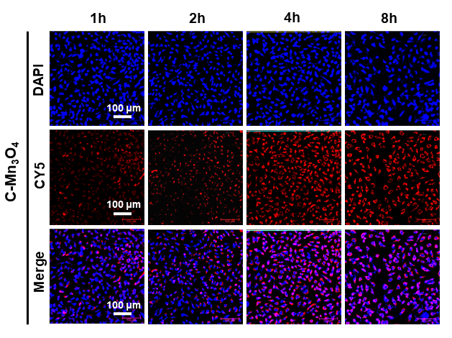
Fig. S1 Fluorescence CLSM images of HEK-293T cells stained with DAPI and CY5 stained to assess the cellular uptake of C-Mn₃O₄.

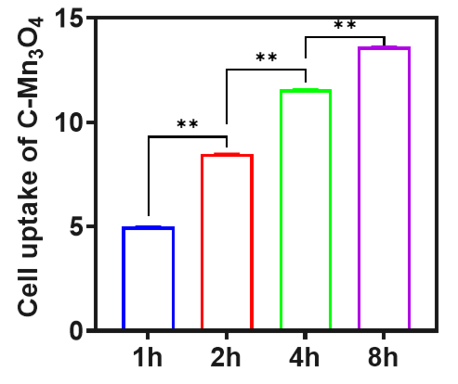
Fig. S2 Fluorescence quantitative analysis of C-Mn₃O₄ cell uptake.

