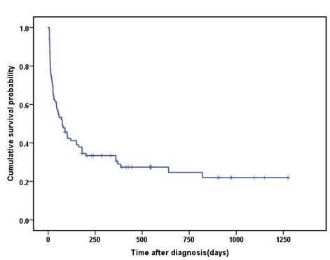
Supplementary Figure 1：The cumulative survival probability function of sHLH patients.
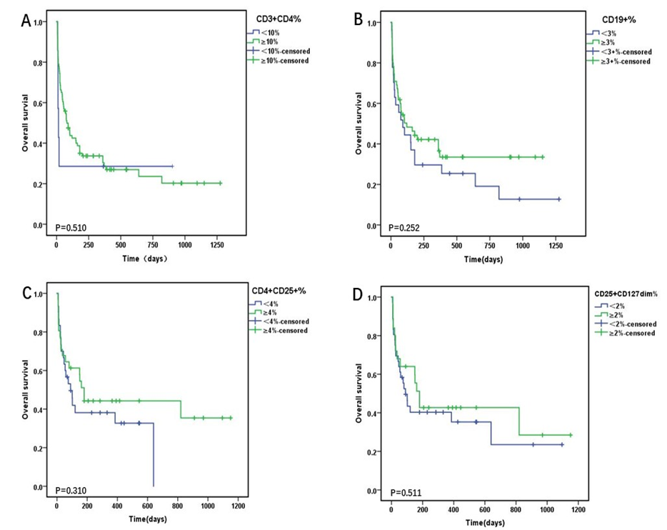
Supplementary Figure 2：Kaplan-Meier curves for overall survival probability according to (A)CD3+CD4%, (B) CD19+%, (C) CD4+CD25+% , and (D) CD25+CD127dim%. Cum, cumulative.
Supplementary Table 1: Univariate and multivariate Cox proportional hazard regression models for survival time of 1~30 days and>30 days sHLH patients.
Variable | Category | UnivariateHR (95% CI) | P | MultivariateHR (95% CI) | P
age | ＜55versus≥55 | 0.55(0.283-1.067) | 0.077 | 0.41（0.168-0.992） | 0.048
gender | female versus male | 1.16(0.599-2.231) | 0.666
WBC | ＜2.2versus≥2.2 | 0.79(0.386-1.597) | 0.505
HGB | ＜70versus≥70 | 2.55(1.156-5.615) | 0.020 | 3.16（1.295-7.687） | 0.011
PLT | ＜33versus≥33 | 2.57(1.300-5.092) | 0.007 | 1.86（0.789-4.376） | 0.156
CD3+% | ＜50%versus≥50% | 2.10（0.913-4.837） | 0.081 | 6.81（2.449-18.951） | 0.000
CD3+CD4+% | ＜10%versus≥10% | 2.81(1.080-7.328) | 0.034 | 1.807（0.544-5.999） | 0.334
CD3+CD8+% | ＜20%versus≥20% | 1.99(0.967-4.075) | 0.062 | 0.872（0.314-2.416） | 0.792
CD19% | ＜3%versus≥3% | 1.327(0.602-2.925) | 0.482
CD3-CD16+CD56+% | ＜2%versus≥2% | 2.93(1.227-6.990) | 0.016 | 3.10（1.184-8.132） | 0.021
CD4+/ CD8+ | ＜80%versus≥80% | 0.64（0.303-1.352） | 0.242
CD4+CD25+% | ＜4%versus≥4% | 0.994(0.395-2.505) | 0.990
CD25+CD127dim% | ＜2%versus≥2% | 1.128(0.437-2.909) | 0.804
CI: confidence interval; HR: hazard ratio.

Supplementary Table 2: Univariate and multivariate Cox proportional hazard regression models for survival time of 1~60 days and>60 days sHLH patients.
Variable | Category | Univariate  HR (95% CI) | P | Multivariate  HR (95% CI) | P
age | ＜55versus≥55 | 0.63（0.342-1.143） | 0.127
gender | female versus male | 1.29（0.713-2.328） | 0.402
WBC | ＜2.2versus≥2.2 | 0.72（0.378-1.375） | 0.321
HGB | ＜70versus≥70 | 2.06（0.955-4.441） | 0.065 | 2.58（1.133-5.880） | 0.024
PLT | ＜33versus≥33 | 1.95（1.018-3.715） | 0.044 | 1.64（0.746-3.600） | 0.219
CD3+% | ＜50%versus≥50% | 2.37(1.129-4.954) | 0.022 | 4.02（1.580-10.222） | 0.003
CD3+CD4+% | ＜10%versus≥10% | 2.34(0.912-5.979) | 0.077 | 1.44（0.474-4.390） | 0.519
CD3+CD8+% | ＜20%versus≥20% | 1.45(0.730-2.876) | 0.289
CD19% | ＜3%versus≥3% | 1.23(0.606-2.504) | 0.564
CD3-CD16+CD56+% | ＜2%versus≥2% | 2.75(1.233-6.115) | 0.013 | 3.34（1.481-7.545） | 0.004
CD4+/ CD8+ | ＜80%versus≥80% | 0.67(0.348-1.309) | 0.245
CD4+CD25+% | ＜4%versus≥4% | 1.20(0.537-2.678) | 0.658
CD25+CD127dim% | ＜2%versus≥2% | 1.20(0.525-2.740) | 0.667
CI: confidence interval; HR: hazard ratio.

Supplementary Table 3: Univariate and multivariate Cox proportional hazard regression models for survival time of 1~90 days and>90 days sHLH patients.
Variable | Category | Univariate  HR (95% CI) | P | Multivariate  HR (95% CI) | P
age | ＜55versus≥55 | 0.65（0.370-1.146） | 0.136
gender | female versus male | 1.19（0.686-2.050） | 0.542
WBC | ＜2.2versus≥2.2 | 0.77（0.429-1.393） | 0.391
HGB | ＜70versus≥70 | 2.06（0.999-4.239） | 0.05 | 2.43(1.120-5.273) | 0.025
PLT | ＜33versus≥33 | 1.96（1.073-3.577) | 0.029 | 1.81(0.887-3.678) | 0.103
CD3+% | ＜50%versus≥50% | 2.08（1.004-4.293） | 0.049 | 3.22(1.302-7.983) | 0.011
CD3+CD4+% | ＜10%versus≥10% | 2.03（0.799-5.134） | 0.137
CD3+CD8+% | ＜20%versus≥20% | 1.46（0.776-2.751） | 0.24
CD19% | ＜3%versus≥3% | 1.21（0.627-2.321） | 0.574
CD3-CD16+CD56+% | ＜2%versus≥2% | 2.82（1.330-5.985） | 0.007 | 3.16(1.473-6.787) | 0.003
CD4+/ CD8+ | ＜80%versus≥80% | 0.68（0.365-1.252） | 0.213
CD4+CD25+% | ＜4%versus≥4% | 1.30(0.609-2.784) | 0.496
CD25+CD127dim% | ＜2%versus≥2% | 1.47(0.658-3.262) | 0.35
CI: confidence interval; HR: hazard ratio.

