Electronic Supplementary Material for:
Reproductive inefficiency and increased behavioral variation are associated with large group size in the orchid bee, Euglossa dilemma
Nicholas W. Saleh, Jaelle Delva, Santiago R. Ramírez, Karen M. Kapheim, Thomas Chouvenc
The images below are screenshots from video recordings of the “small” nest Nest 21_10. The nest ID, date, and time stamps are present on all recordings, as shown in these screenshots. These screenshots highlight moments from the typical sequence of reproductive behaviors between one dominant and one subordinate bee during the completion of a single brood cell.
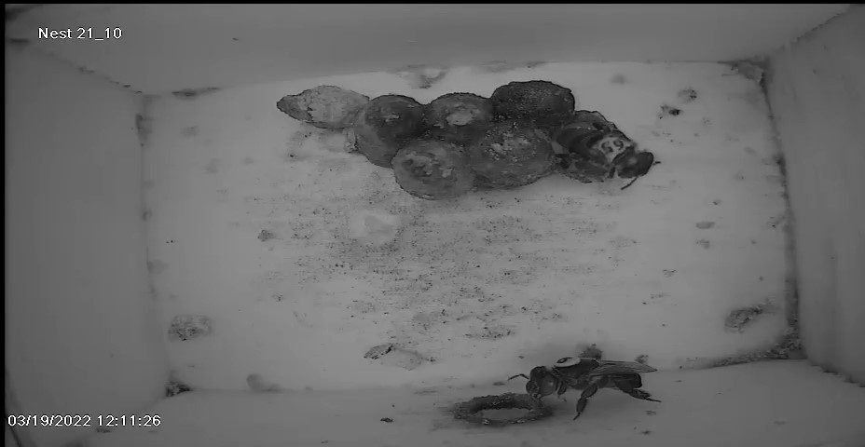
Figure S1. The dominant bee (individual 9) is shown at the nest entrance while the subordinate bee (individual 65) is depositing pollen into an open brood cell on the right.

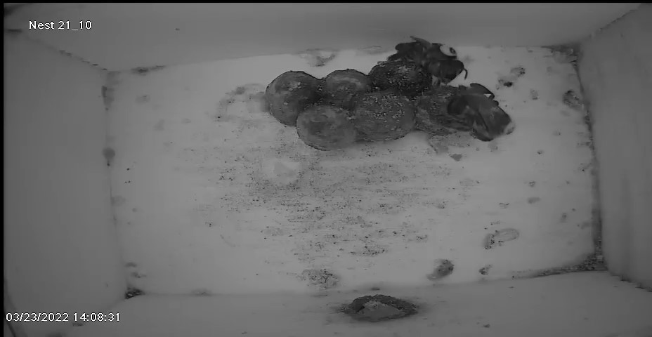
Figure S2. The dominant bee (individual 9) is shown on the brood cells while the subordinate bee (individual 65) is laying an egg into brood cell on the right, after provisioning is completed.
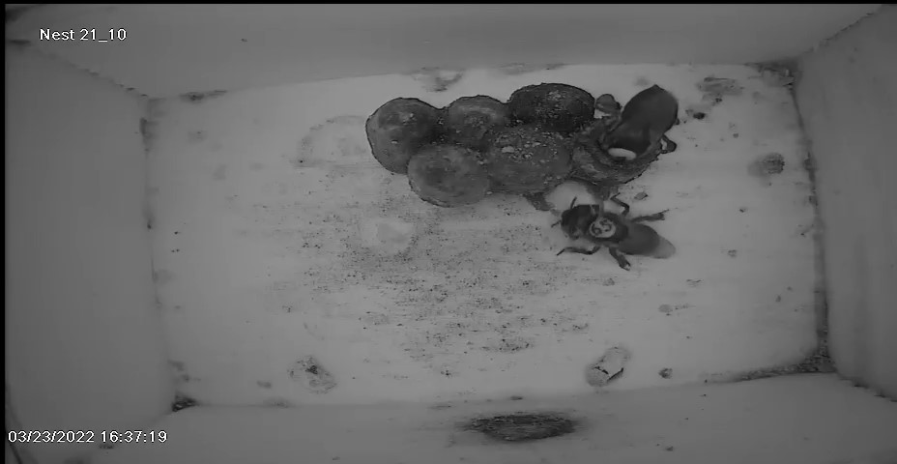
Figure S3. The dominant bee (individual 9) is shown in the process of oophagy while the subordinate bee (individual 65) is beginning construction of the next brood cell.

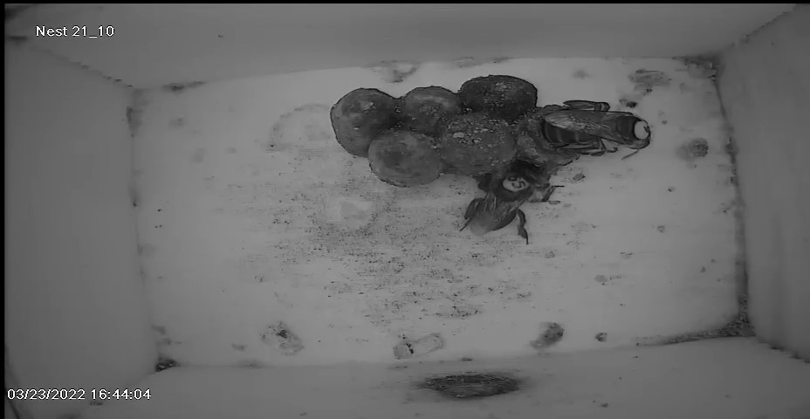
Figure S4. The dominant bee (individual 9) is shown laying an egg after oophagy is complete, while the subordinate bee (individual 65) is continuing construction of the next brood cell.
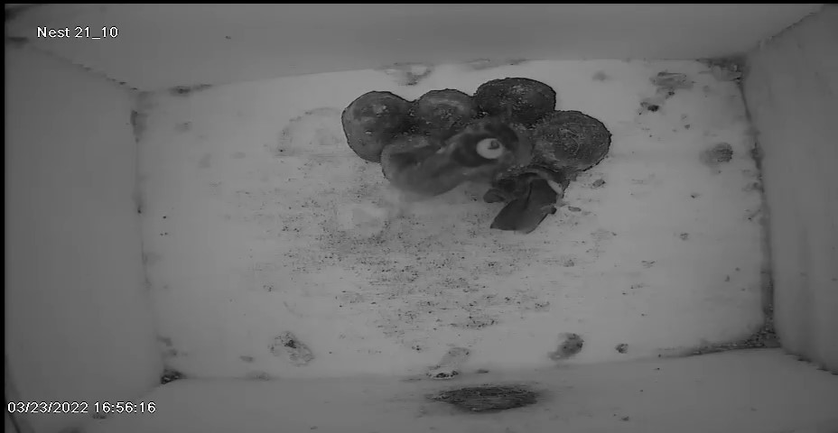
Figure S5. The dominant bee (individual 9) is shown on the brood cells after oophagy and replacement egg laying is complete, while the subordinate bee (individual 65) is continuing construction of the next brood cell.

