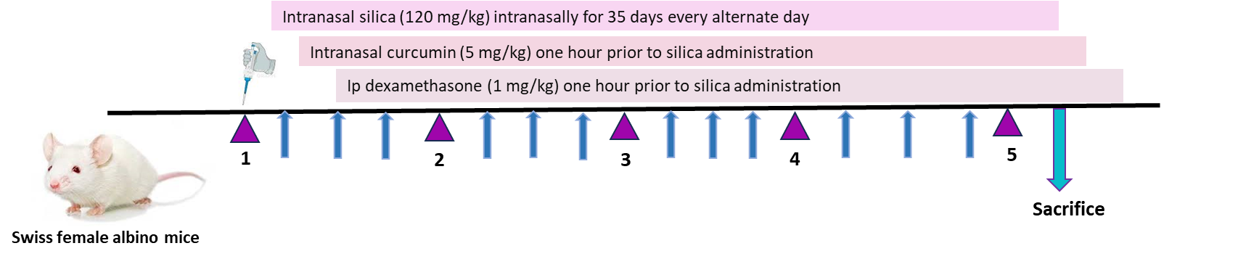

Experimental protocol of silica exposure
Table.1

