Supplementary Materials

Supplementary Table 1. Percentage changes in difference between involved and uninvolved free light chain according to kidney response at 6 months*
 | Total cohort  (n=138) | Kidney response  (n=47) | No kidney response  (n=62) | P value
dFLC change at 3 monthsª
Continuous variables (%) | -78.9 (-97.0, -45.9) | -89.3 (-97.8, -53.6) | -72.6 (-90.8, -45.9) | 0.10
Categorical variables |  |  |  | 0.05
Decrease < 90% | 74 (61.7) | 24 (52.2) | 43 (70.5)
Decrease > 90% | 46 (38.3) | 22 (47.8) | 18 (29.5)
dFLC change at 6 months^{b}
Continuous variables (%) | -85.8 (-96.9, -65.2) | -90.7 (-98.8, -80.0) | -83.3 (-94.5, -59.9) | 0.02
Categorical variables |  |  |  | 0.15
Decrease < 90% | 60 (54.5) | 22 (46.8) | 37 (60.7)
Decrease > 90% | 50 (45.5) | 25 (53.2) | 24 (39.3)
* Data are median (IQR) or numbers (percentages). Differences in baseline characteristics among kidney stage groups were assessed with the use of Kruskal-Wallis test for continuous variables and chi-square test for categorical variables.
ª 18 missing data in total cohort. One patient had missing data among those who did not achieve kidney response at 6 months.
^{b} 28 missing data in total cohort. One patient had missing data among those who achieved kidney response at 6 months, and another had missing data among those who did not.
Abbreviation: dFLC, difference between involved and uninvolved free light chain
Supplementary Table 2. Baseline characteristics of the patients according to first-line therapy*
 | Total (N=138) | ASCT  (N=41) | Bortezomib-based  (N=54) | Other chemotherapy†  (N=43) | P value‡ | P₁ value§ | P₂ value¶
Demographic features
Age (year) | 64 (56, 70) | 58 (52, 63) | 67 (60, 74)ª | 67 (60, 73)^{b} | <0.01 | <0.01 | 0.95
Male sex | 72 (52.2) | 24 (58.5) | 27 (50.0) | 21 (48.8) | 0.62 | 0.33 | 0.91
BMI (kg/m²) | 22.8 (20.9, 24.9) | 23.3 (21.2, 25.2) | 22.4 (20.6, 24.6) | 22.6 (21.2, 24.8) | 0.57 | 0.33 | 0.62
Comorbidities
Diabetes | 20 (14.5) | 4 (9.8) | 7 (13.0) | 9 (20.9) | 0.32 | 0.30 | 0.29
Hypertension | 28 (20.3) | 7 (17.1) | 7 (13.0) | 14 (32.6) | 0.05 | 0.54 | 0.02
Organ involvement
Heart | 99 (71.7) | 24 (58.5) | 52 (96.3) | 23 (53.5) | <0.01 | 0.03 | <0.01
GI tract | 21 (15.2) | 4 (9.8) | 12 (22.2) | 5 (11.6) | 0.18 | 0.25 | 0.17
Nerve | 102 (73.9) | 26 (63.4) | 45 (83.3) | 31 (72.1) | 0.09 | 0.07 | 0.18
Liver | 25 (18.1) | 6 (14.6) | 10 (18.5) | 9 (20.9) | 0.75 | 0.49 | 0.77
Others | 23 (16.7) | 7 (17.1) | 11 (20.4) | 5 (11.6) | 0.52 | 0.93 | 0.25
Concomitant Multiple myeloma | 62 (45.3) | 14 (34.1) | 33 (61.1) | 15 (35.7) | 0.01 | 0.09 | 0.01
Laboratory findings
Hemoglobin (g/dL) | 12.3 (10.5, 13.8) | 12.8 (10.5, 14.0) | 11.8 (10.3, 13.3) | 12.4 (11.2, 13.9) | 0.26 | 0.49 | 0.12
Albumin (g/dL) | 2.7 (2.1, 3.4) | 2.4 (2.0, 3.2) | 2.6 (2.1, 3.4) | 2.7 (2.3, 3.4) | 0.47 | 0.30 | 0.51
dFLC, serum (mg/L) | 162.2 (63.1, 482.8) | 154.4 (56.5, 365.5) | 233.2 (106.9, 602.6)ª | 90.4 (32.9, 316.8) | 0.01 | 0.49 | <0.01
Affected LC |  |  |  |  | 0.58 | 0.93 | 0.29
Lambda chain | 115 (83.3) | 34 (82.9) | 47 (87.0) | 34 (79.1)
Kappa chain | 23 (16.7) | 7 (17.1) | 7 (13.0) | 9 (20.9)
Parameters of kidney disease
Proteinuria (g/day) | 3.8 (2.0, 5.9) | 4.4 (2.8, 6.1) | 4.0 (1.8, 6.3) | 3.2 (2.2, 4.9) | 0.32 | 0.29 | 0.32
Serum Creatinine (mg/dL) | 0.95 (0.77, 1.26) | 0.87 (0.73, 1.06) | 1.10 (0.82, 1.57)ª | 0.95 (0.75, 1.25) | 0.02 | 0.02 | 0.16
eGFR (mL/min/1.73m²) | 79 (52, 94) | 90 (74, 104) | 68 (39, 89)ª | 81 (55, 91) | <0.01 | <0.01 | 0.25
Revised mayo stage |  |  |  |  | <0.01 | 0.01 | <0.01
Stage Ⅰ | 31 (22.6) | 15 (37.5) | 1 (1.9) | 15 (34.9)
Stage Ⅱ | 27 (19.7) | 15 (25.0) | 8 (14.8) | 9 (20.9)
Stage Ⅲ | 43 (31.4) | 11 (27.5) | 25 (46.3) | 7 (16.3)
Stage Ⅳ | 36 (26.3) | 4 (10.0) | 20 (37.0) | 12 (27.9)
* Data are median (IQR) or numbers (percentages).
† Other chemotherapy included immunomodulatory agent (thalidomide or lenalidomide), daratumumab, and conventional therapy (cyclophosphamide, melphalan, steroid only etc.).
‡ Differences in baseline characteristics among treatment groups were assessed with the use of Kruskal-Wallis test for continuous variables and chi-square test for categorical variables.
§ P₁ value obtained by Mann-Whitney U-test or chi-square test between two groups (ASCT vs. bortezomib-based + other chemotherapy).
¶ P₂ value obtained by Mann-Whitney U-test or chi-square test between two groups (bortezomib-based vs. other chemotherapy) except for patients who underwent ASCT.
ª ASCT vs Bortezomib-based : P < 0.017 by Kruskal-Wallis test.
^{b} ASCT vs other chemotherapy : P < 0.017 by Kruskal-Wallis test.
Abbreviation: ASCT, autologous stem cell transplantation; BMI, body mass index; dFLC, difference between involved and uninvolved free light chain; eGFR, estimated glomerular filtration rate; GI, gastrointestinal; IQR, interquartile range; LC, light chain

Supplementary Table 3. First-line therapy and the risk of progression to end-stage kidney disease
 | Progression to ESKD
 | No. of patients | No. (%) | HR (95% CI)* | P value
Types of therapy
Other chemotherapy¶ | 43 | 4 (9.3) | Ref.
Bortezomib-based | 54 | 9 (16.7) | 2.20 (0.72, 6.69) | 0.16
ASCT | 41 | 4 (9.8) | 1.05 (0.29, 3.83) | 0.94
ASCT
Chemotherapy† | 97 | 13 (13.4) | Ref.
ASCT | 41 | 4 (9.8) | 1.53 (0.53, 4.41) | 0.43
Chemotherapy‡
Other chemotherapy | 43 | 4 (9.3) | Ref.
Bortezomib | 54 | 9 (16.7) | 2.07 (0.70, 6.12) | 0.19
Hazard ratios and P values were estimated with a Substitution hazards model.
¶ Other chemotherapy included immunomodulatory drugs (thalidomide or lenalidomide), daratumumab, and conventional chemotherapy (cyclophosphamide, melphalan, steroid only, etc.).
† Included all types of chemotherapy (bortezomib-based and other chemotherapy).
‡ Except for patients who underwent ASCT as first-line therapy.
Abbreviation: ASCT, autologous stem cell transplantation; CI, confidence interval; ESKD, end-stage kidney disease; HR, hazard ratio; Ref., reference

Supplementary Table 4. Hematologic and kidney response and the risk of progression to end-stage kidney disease according to first-line therapy
 |  | Progression to ESKD |  | Univariate |  | Multivariate*
 |  |  | No. / total no. (%) | HR (95% CI)¶ | P value | HR (95% CI)¶ | P value | P for interaction†
Kidney stage
ASCT | Ⅰ |  | 3/21 (14.3) | – | – | Ref. |  | <0.01
 | Ⅱ |  | 1/19 (5.3) | – | – | 0.93  (0.36, 2.42) | 0.80
 | Ⅲ |  | 0/1 (0) | – | – | 0.00  (0.00, 0.00) | <0.01
Chemotherapy‡ | Ⅰ |  | 2/49 (4.1)§ | Ref. |  | Ref.
 | Ⅱ |  | 9/38 (23.7)§ | 7.68  (1.83, 32.20) | 0.01 | 8.47  (2.14, 33.49) | <0.01
 | Ⅲ |  | 2/10 (20.0)§ | 6.12  (0.88, 42.60) | 0.07 | 5.21  (0.66, 41.30) | 0.12
Kidney response
ASCT | Response |  | 1/17 (5.9) | Ref. |  | – | – | 0.67
 | Stable disease |  | 1/11 (9.1) | 1.25  (0.09, 17.20) | 0.87 | – | –
 | Progression |  | 2/12 (16.7) | 4.05  (0.46, 35.80) | 0.21 | – | –
Chemotherapy | Response |  | 1/30 (3.3)§ | Ref. |  | Ref.
 | Stable disease |  | 6/19 (31.6)§ | 8.23  (1.05, 64.70) | 0.05 | 10.15  (1.42, 72.47) | 0.02
 | Progression |  | 5/20 (25.0)§ | 9.58  (1.08, 85.10) | 0.04 | 12.58  (1.00, 157.97) | 0.05
dFLC change at 3 months
ASCT | Decrease < 90% |  | 4/24 (16.7) | – | – | – | – | –
 | Decrease > 90% |  | 0/14 (0) | – | – | – | –
Chemotherapy | Decrease < 90% |  | 8/50 (16.0) | Ref. |  | Ref.
 | Decrease > 90% |  | 5/32 (15.6) | 0.91  (0.31, 2.70) | 0.86 | 0.58  (0.17, 1.96) | 0.38
dFLC change at 3 months** |  |  |  |  |  |  |  | 0.45
ASCT |  |  |  | 0.97  (0.79, 1.20) | 0.78 | 0.87  (0.76, 1.00) | 0.05
Chemotherapy |  |  |  | 0.94  (0.80, 1.11) | 0.47 | 0.84  (0.69, 1.01) | 0.07
dFLC change at 6 months |  |  |  |  |  |  |  | –
ASCT | Decrease < 90% |  | 4/21 (19.0) | – | – | – | –
 | Decrease > 90% |  | 0/18 (0) | – | – | – | –
Chemotherapy | Decrease < 90% |  | 8/39 (20.5) | Ref. |  | Ref.
 | Decrease > 90% |  | 4/32 (12.5) | 0.52  (0.16, 1.65) | 0.27 | 0.25  (0.04, 1.41) | 0.12
dFLC change at 6 months** |  |  |  |  |  |  |  | 0.31
ASCT |  |  |  | 0.78  (0.64, 0.95) | 0.01 | 0.80  (0.70, 0.91) | <0.01
Chemotherapy |  |  |  | 0.95  (0.87, 1.03) | 0.19 | 0.90  (0.78, 1.03) | 0.14
Hematologic response  at 3 months |  |  |  |  |  |  |  | 0.88
ASCT | PR/NR  /Progression |  | 2/18 (11.1) | Ref. |  | Ref.
 | CR/VGPR |  | 2/22 (9.1) | 1.26  (0.24, 6.55) | 0.79 | 0.35  (0.09, 1.39) | 0.10
Chemotherapy | PR/NR  /Progression |  | 8/45 (17.8) | Ref. |  | Ref.
 | CR/VGPR |  | 5/37 (13.5) | 0.63  (0.22, 1.80) | 0.39 | 0.56  (0.16, 2.00) | 0.37
Hematologic response  at 6 months |  |  |  |  |  |  |  | 0.70
ASCT | PR/NR  /Progression |  | 2/12 (16.7) | Ref. |  | Ref.
 | CR/VGPR |  | 2/28 (7.1) | 0.64  (0.12, 3.48) | 0.61 | 0.21  (0.06, 0.74) | 0.02
Chemotherapy | PR/NR  /Progression |  | 6/31 (19.4) | Ref. |  | Ref.
 | CR/VGPR |  | 6/40 (15.0) | 0.60  (0.21, 1.76) | 0.35 | 0.53  (0.13, 2.18) | 0.38
*Model included age, sex, DM, hemoglobin, and initial kidney stage.
¶ Hazard ratios and P values were estimated with a Substitution hazards model.
† P value for interaction between either kidney stage, dFLC change, hematologic or kidney responses and first-line therapy (ASCT vs. all types of chemotherapy).
‡ Chemotherapy included bortezomib-based, immunomodulatory drugs (thalidomide or lenalidomide), daratumumab, and conventional therapy (cyclophosphamide, melphalan, steroid only, etc.).
§ Significantly different incidence of ESKD among response groups.
** Every 10 unit increase.
Abbreviation: ASCT, autologous stem cell transplantation; CI, confidence interval; CR, Complete response; dFLC, difference between involved and uninvolved free light chain; ESKD, End-stage kidney disease; HR, hazard ratio; NR, No response; PR, Partial response; Ref., reference; VGPR, Very good partial response

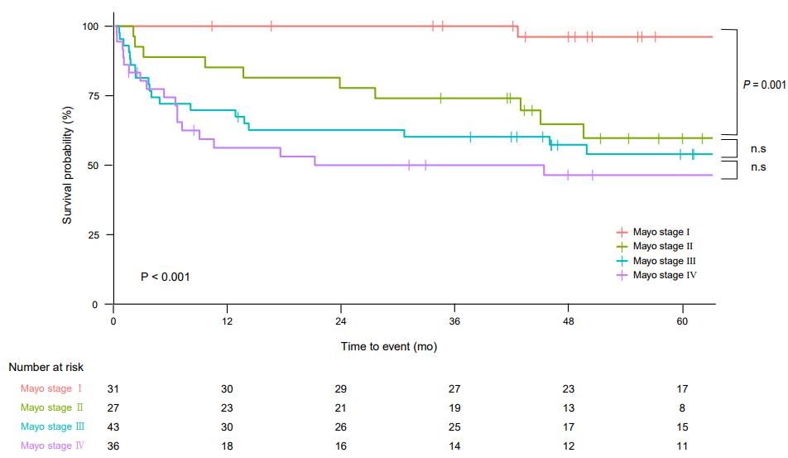
Supplementary Figure 1. Overall survival according to the revised Mayo stages
The overall survival differed according to the revised Mayo stages (P < 0.001 by log-rank test).
Specifically, the revised Mayo stage Ⅰ had significantly longer overall survival than stage Ⅱ (P = 0.003), Ⅲ (P < 0.001), and Ⅳ (P < 0.001).
n.s., no significance

