Dynamics of microbiome composition during anaerobic digestion of different renewable resources.

Nicoletta Favale^{1#}, Stefania Costa^{1,2#}, Daniela Summa^{1,2}, Silvia Sabbioni³, Elisabetta Mamolini¹, Elena Tamburini^{4§} and Chiara Scapoli^{1§}*

¹Department of Life Sciences and Biotechnology – Section of Biology and Evolution, University of Ferrara, Italy
²Department of Chemical, Pharmaceutical and Agricultural Sciences, University of Ferrara, Ferrara, Italy
³ Department of Life Sciences and Biotechnology – Section of Pathology and Applied Microbiology, University of Ferrara, Italy
⁴Department of Environmental Sciences and Prevention, University of Ferrara, Ferrara, Italy

# Equally contributed to the manuscript and share the first authorship
§ These authors share the senior authorship
* Correspondence: chiara.scapoli@unife.it; Tel.: +39-0532-455744
ORCID Chiara Scapoli https://orcid.org/0000-0003-4058-4787

Supplementary Materials

Tab. S1. WMS sequencing statistics of the different biomass samples. The Illumina BaseSpace cloud platform (https://basespace.illumina.com/) was used to convert the raw Illumina output to the Fastq format and to assign reads to each individual (demultiplexing) according to sequencing barcodes. The quality control (QC) of the reads was done with FastQC. Trimmomatic was used to trim from raw data bases with poor quality and read with length < 100bp. Parameters were defined as CROP:149, HEADCROP:0, SLIDINGWINDOW:5:20, MINLEN:100.

ID | Type | time (day) | N°total reads | N°total reads after QC | N° reads in  Megan6 | N° reads in MetaPhlAn3 | N° reads in MetaPhlAn4
cg0 | cereal grains | 0 | 18,897,616 | 15,908,962 | 1,448,052 | 1,877,598 | 9,132,716
cg5 | cereal grains | 5 | 26,492,778 | 22,047,356 | 2,553,455 | 3,159,655 | 12,323,140
cg10 | cereal grains | 10 | 26,258,986 | 22,387,354 | 2,519,760 | 2,630,039 | 14,525,088
cg15 | cereal grains | 15 | 22,899,684 | 17,694,408 | 2,227,338 | 2,231,028 | 13,479,282
cg20 | cereal grains | 20 | 26,059,344 | 21,574,746 | 2,867,308 | 3,095,100 | 14,851,235
cg25 | cereal grains | 25 | 26,706,876 | 22,972,946 | 3,811,316 | 4,116,713 | 17,178,119
cg30 | cereal grains | 30 | 19,517,202 | 16,795,456 | 2,743,271 | 3,044,401 | 12,110,207
gp0 | grape pomace | 0 | 17,664,238 | 14,712,222 | 1,584,435 | 2,079,219 | 10,246,218
gp5 | grape pomace | 5 | 18,475,674 | 15,460,760 | 1,511,903 | 1,959,058 | 9,748,187
gp10 | grape pomace | 10 | 18,536,204 | 15,525,942 | 1,510,242 | 1,947,529 | 9,988,444
gp15 | grape pomace | 15 | 27,620,968 | 22,990,654 | 2,482,551 | 3,222,064 | 14,830,579
gp20 | grape pomace | 20 | 18,618,078 | 15,231,334 | 1,788,966 | 2,399,142 | 10,202,510
gp25 | grape pomace | 25 | 20,273,238 | 16,880,884 | 1,990,287 | 2,609,187 | 11,384,762
gp30 | grape pomace | 30 | 18,048,604 | 15,055,188 | 2,029,344 | 2,772,438 | 1,003,0524
inoc | inoculum | 0 | 17,695,418 | 16,032,204 | 1,625,222 | 2,231,808 | 10,911,061

Fig. S1. Percentage of unclassified reads retrieved in the taxonomical analysis using BLASTN (yellow), MetaPhlAn3 (blue) and MetaPhlAn4 (pink).

b)
a)

Fig. S2. Inoculum composition: a) phyla, b) species obtained with MetaPhlAn3

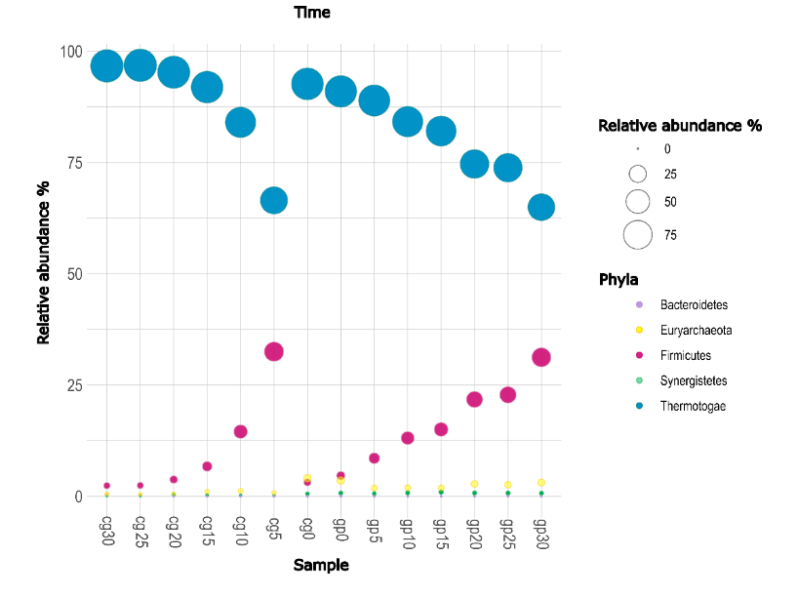
Fig. S3. Phyla identified among the samples from the two different biogas production substrates obtained with MetaPhlAn3.

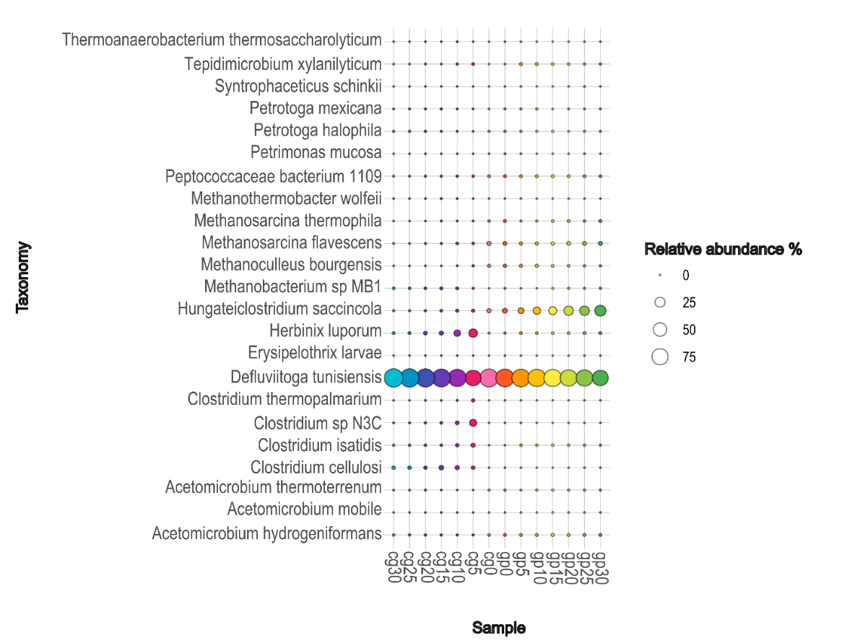
Fig. S4. Taxonomical profile, in terms of species, of sample from cereal grains (cg0-30) and grape pomace (gp0-30) obtained with MetaPhlAn3.
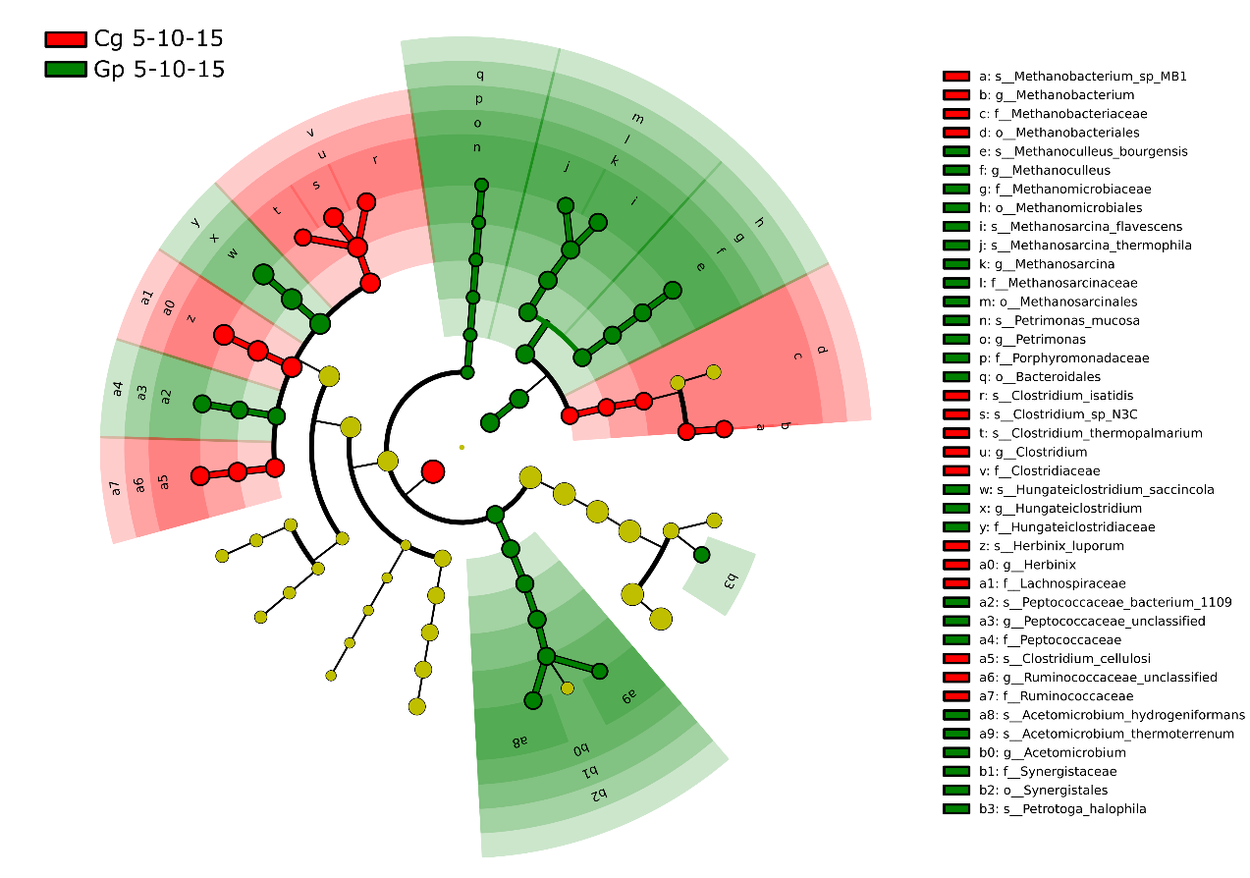

Fig. S5 Cladogram obtained from LEfSe analyses on MetaPhlAn3 data, showing the comparison between the two biomasses at the early stage of biogas production (cg5-10-15 vs gp5-10-15); taxonomic levels are represented by rings with phyla in the outermost ring and species in the innermost ring. Each circle represents a member within that level. Taxa with enriched level in CG samples are coloured in red, enriched taxa in GP samples are coloured in green, unenriched taxa are ochre coloured.
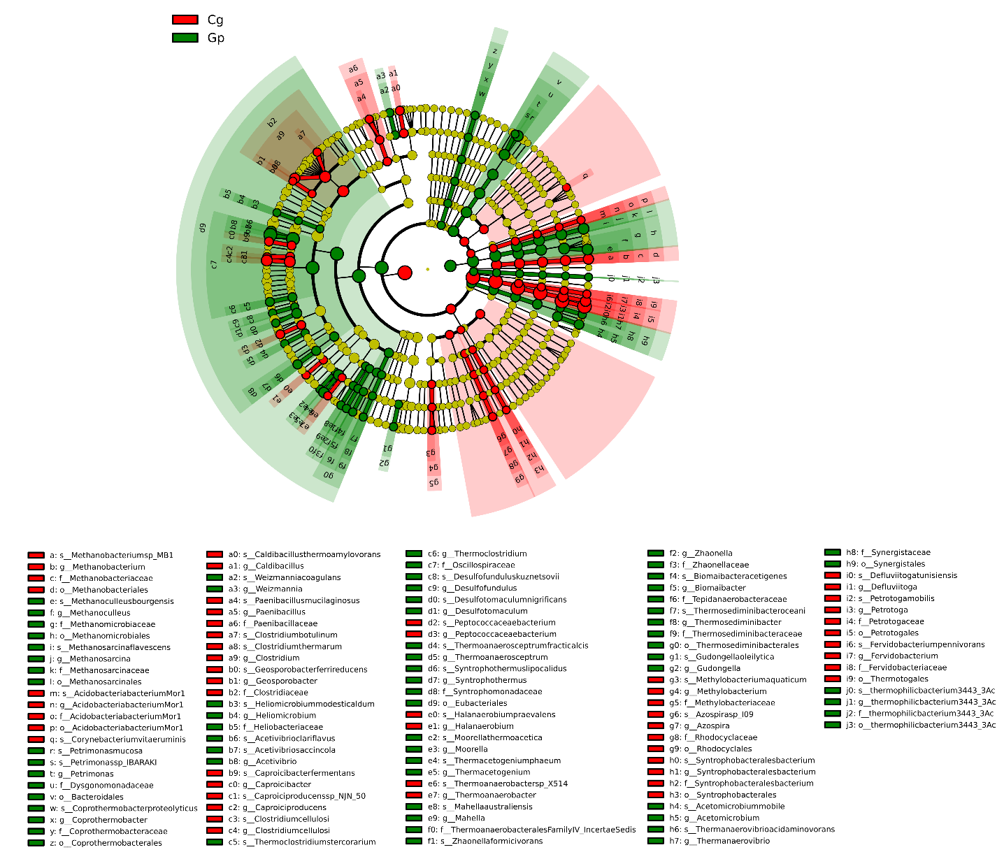

Fig. S6 Cladogram obtained from LEfSe analyses on BlastN+MEGAN6 data, showing the comparison between the two biomasses (cg vs gp); taxonomic levels are represented by rings with phyla in the outermost ring and species in the innermost ring. Each circle represents a member within that level. Taxa with enriched level in CG samples are coloured in red, enriched taxa in GP samples are coloured in green, unenriched taxa are ochre coloured.

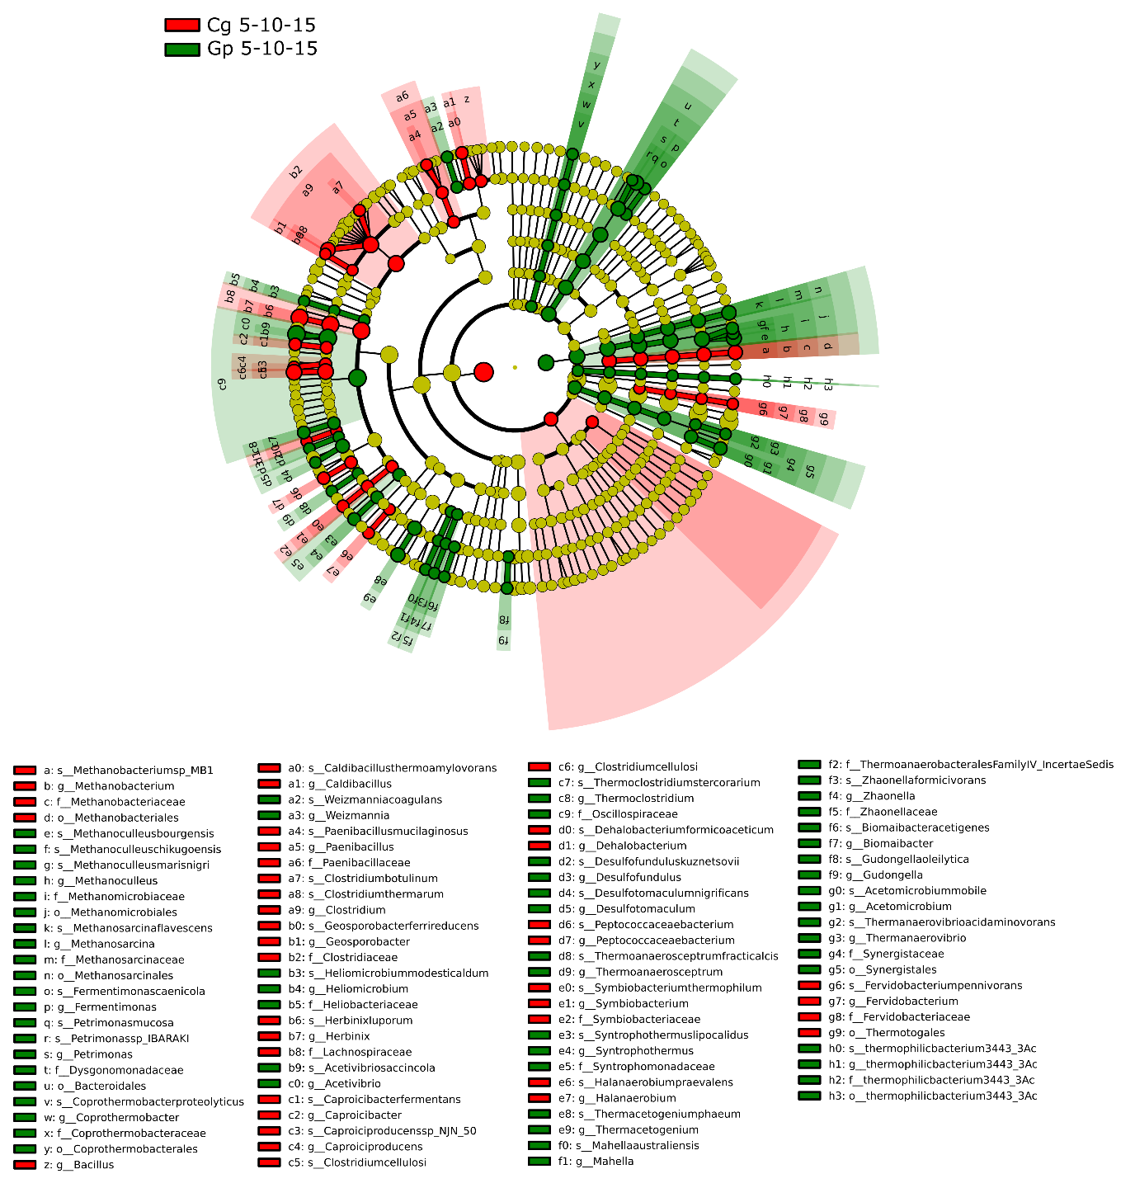
Fig S7 Cladogram obtained from LEfSe analyses on BlastN+MEGAN6 data, showing the comparison between the two biomasses at the early stage of biogas production (cg5-10-15 vs gp5-10-15); taxonomic levels are represented by rings with phyla in the outermost ring and species in the innermost ring. Each circle represents a member within that level. Taxa with enriched level in CG samples are coloured in red, enriched taxa in GP samples are coloured in green, unenriched taxa are ochre coloured.

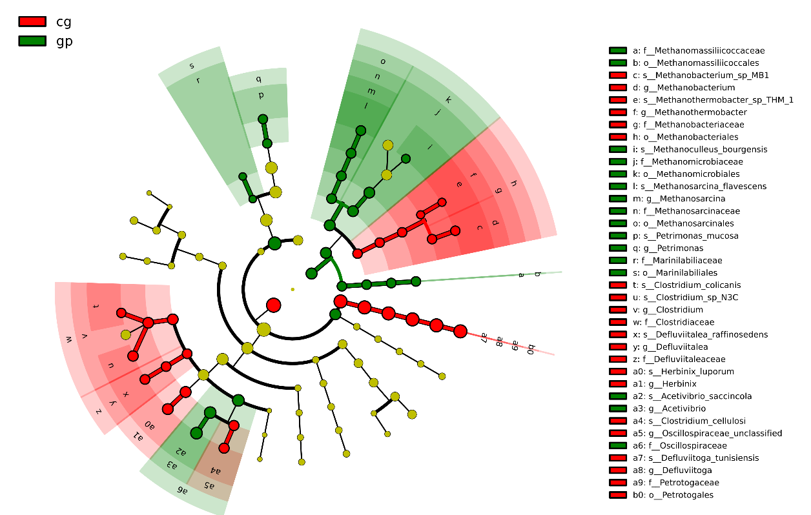
Fig. S8 Cladogram obtained from LEfSe analyses on MetaPhlAn4 data, showing the comparison between the two biomasses (cg vs gp); taxonomic levels are represented by rings with phyla in the outermost ring and species in the innermost ring. Each circle represents a member within that level. Taxa with enriched level in CG samples are coloured in red, enriched taxa in GP samples are coloured in green, unenriched taxa are ochre coloured.

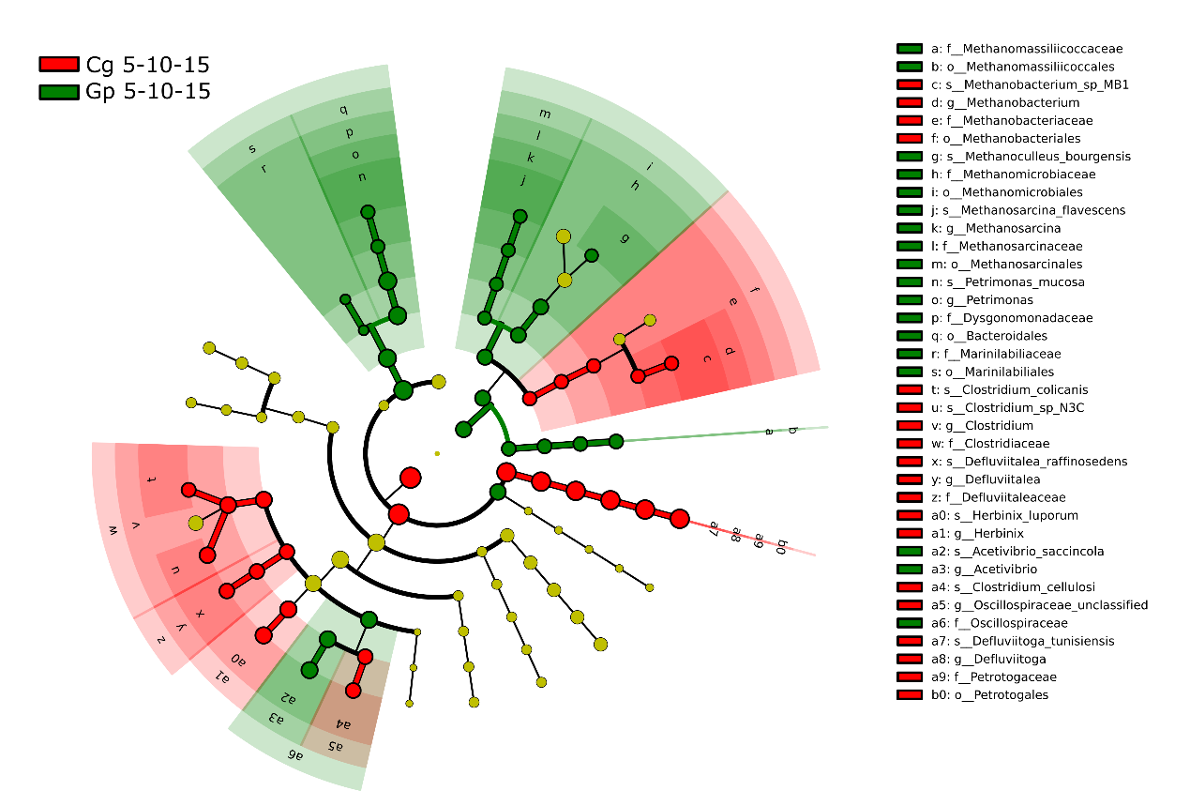
Fig. S9 Cladogram obtained from LEfSe analyses on MetaPhlAn4 data, showing the comparison between the two biomasses at the early stage of biogas production (cg5-10-15 vs gp5-10-15); taxonomic levels are represented by rings with phyla in the outermost ring and species in the innermost ring. Each circle represents a member within that level. Taxa with enriched level in CG samples are coloured in red, enriched taxa in GP samples are coloured in green, unenriched taxa are ochre coloured.

