Supporting information for

Triplet-induced stable organic emissive radicals in host-guest room temperature phosphorescence materials

Gengchen Li,¹ Wenbo Dai,^{1, 2} Yijia Wang,³ Yuan Zheng,⁴ Yongfeng Zhang,¹ Yeyun Zhao,¹ Xin Cheng,¹ Ruiyang Wan,¹ Li Wang,⁴ Yunxiang, Lei,^{2*} Peng Sun,⁵ Jianbing Shi,¹ Bin Tong,¹ Zhengxu Cai,^{1*} and Yuping Dong¹

¹Beijing Key Laboratory of Construction Tailorable Advanced Functional, Materials and Green Applications, School of Materials Science and Engineering, Beijing Institute of Technology, Beijing 100081, China.
²College of Chemistry and Materials Engineering, Wenzhou University, Wenzhou 325035, China
³Key Laboratory of Cluster Science of Ministry of Education, Key Laboratory of Medicinal Molecule Science and Pharmaceutics Engineering of Ministry of Industry and Information Technology, Beijing Key Laboratory of Photoelectronic/Electro-photonic Conversion Materials, School of Chemistry and Chemical Engineering, Beijing Institute of Technology, Beijing 100081, China.
⁴Department of Chemistry, Capital Normal University, Beijing, 100048, China.
⁵Advanced Research Institute of Multidisciplinary Sciences, Beijing Institute of Technology, 100081 Beijing, China.
*E-mail: yunxianglei@wzu.edu.cn, caizx@bit.edu.cn

Table of Content

- Synthesis and characterization of guest compound S2

- Supplementary information of the hosts, guest, and host-guest materials S7

- Reference S18

- Synthesis and characterization of guest compound
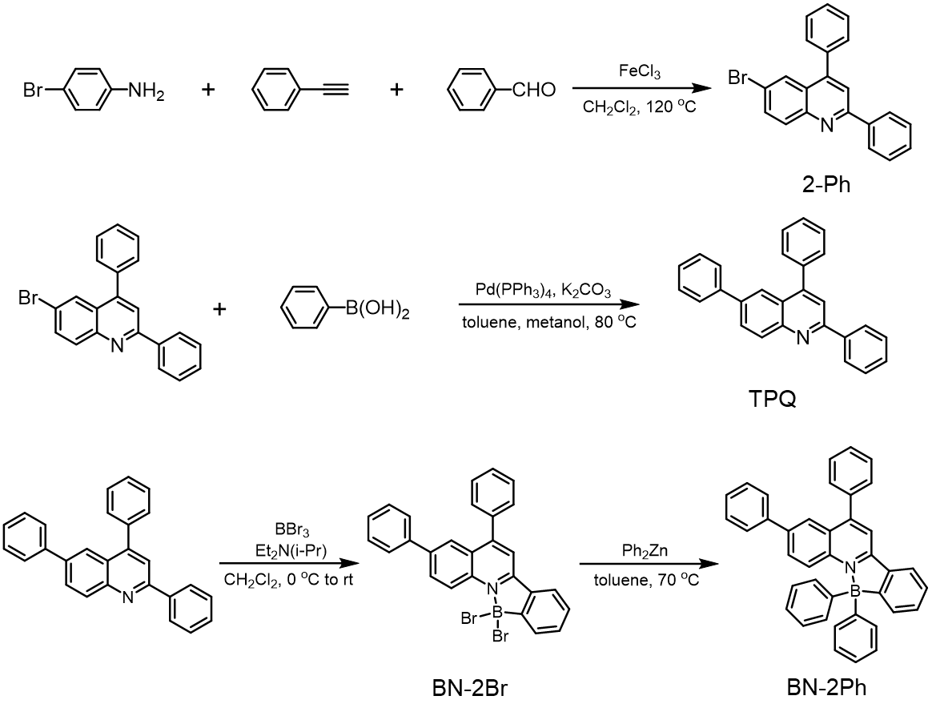
Scheme S1. Synthetic routes and molecule structure of BN-2Ph.

Synthesis and characterization of BN-2Ph:
To a 100 mL round-bottom flask were added 4-bromoaniline (1.72 g, 10 mmol), phenylacetylene (1.01 g, 10 mmol), benzaldehyde (1.06 g, 10 mmol), FeCl₃ (162 mg, 1 mmol), and 1, 2-dichloroethane (15 mL). The reaction mixture was stirred at 120 ºC for 12 h. Then, it was cooled to room temperature and the solvent was evaporated, the residue was purified by column chromatograph (hexane/DCM, v/v=3:1) to afford the compound 2-Ph. The synthesis and characterization of 2-Ph is followed by our previous work¹.
To a 125 mL round-bottom flask were added 2-Ph (0.54 g, 1.5 mmol), boronic acid (0.27 g, 2.25 mmol), Pd(PPh₃)₄ (0.17 g, 0.15 mmol), K₂CO₃ (0.21 g, 1.5 mmol). 21 mL toluene and 9 mL methanol were added into the mixture, then heated under reflux for 14 h at 80 ºC in N₂ atmosphere. Then the solution was cooled to room temperature, and DCM was added to dissolve the product. After the filtrate was concentrated, the crude product was purified by column chromatography (hexane/ethyl acetate) to afford TPQ. Moreover, the compound was purified twice through column chromatography followed by precipitation using dichloromethane and hexane mixed solution.
To a 100 mL round-bottom flask were added TPQ (500 mg, 1.40 mmol), Et₂N(i-Pr) (231.4 μL, 1.40 mmol) and dichloromethane (DCM, 10mL). The mixture was then added BBr₃ (390.70 μL, 4.20 mmol) drop by drop in 0 ºC ice water bath. The reaction mixture was stirred at room temperature for 24h. Then the reaction was quenched by saturation K₂CO₃ water solution. The organic layer was extracted by DCM and separated. The organic layer was then wash by water and salt solution, and dried by MgSO₄. After the filtrate was concentrated, the collected solids were filtered and washed with hexane to obtain the intermediate BN-2Br compound.
To a 50 mL reaction tube were added BN-2Br (350 mg, 0.66 mmol), and toluene (15 mL) to dissolve the compound. Then Ph₂Zn was added in the reaction tube in the glove box. The reaction mixture was stirred and heated at 70 ºC for 5 min, and add water to quench the reaction. The organic layer was separated and extracted by DCM twice, washed by water and salt solution, and dried by MgSO₄. The filtrate was concentrated, then purified by column chromatography (hexane/DCM) to afford BN-2Ph.
BN-2Br (yellow powder, 0.41 g, yield: 56%): ¹H NMR (400 MHz, CDCl₃): δ 9.45 (d, J = 8.0 Hz, 1H), 8.32 (dd, J = 12.0, 4.0 Hz, 1H), 8.19 (s, 1H), 8.00 (d, J = 4.0 Hz, 1H), 7.96 (s, 1H), 7.90 (d, J = 8.0 Hz, 1H), 7.67 – 7.59 (m, 8H), 7.50 – 7.42 (m, 4H). ¹³C NMR (101 MHz, CDCl₃) δ 157.92, 156.18, 140.82, 140.18, 139.15, 136.48, 133.74, 133.60, 132.26, 130.38, 130.22, 129.33, 129.25, 129.21, 128.57, 128.49, 127.69, 127.49, 124.96, 124.90, 122.56, 116.04. MS (MALDI) m/z calcd. For C₂₇H₁₈BBr₂N 526.99 [M]⁺, found 526.00 [M–H]⁺.
BN-2Ph (white powder, 0.21 g, yield：61%): ¹H NMR (400 MHz, CDCl₃): δ 8.34 (d, J = 8.8 Hz, 1H), 8.14 (s, 1H), 8.12 (d, J = 2 Hz, 1H), 8.00 (d, J = 8.0 Hz, 1H), 7.79 (dd, J = 9.2, 2.0 Hz, 1H), 7.73 – 7.61 (m, 6H), 7.50 (d, J = 7.2 Hz, 2H), 7.44 – 7.31 (m, 9H), 7.20 (t, J = 7.6 Hz, 4H), 7.13 (t, J = 7.2 Hz, 2H). ¹³C NMR (101 MHz, CDCl₃) δ 158.94, 154.43, 141.57, 139.53, 139.47, 137.17, 136.05, 133.49, 131.94, 131.01, 129.93, 129.58, 129.46, 129.06, 129.00, 128.03, 127.30, 126.84, 125.82, 125.32, 125.28, 124.58, 122.22, 116.48. MS (HR) m/z calcd. For C₃₉H₂₈BN 521.23 [M]⁺, found 521.23 [M]⁺.

Figure S1. The ¹H NMR spectra of BN-2Br in CDCl₃, 298 K.

Figure S2. The ¹³C NMR spectra of BN-2Br in CDCl₃, 298 K.

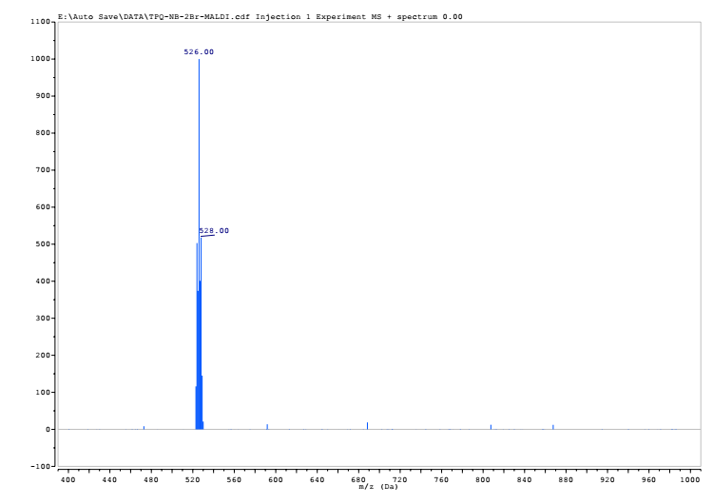
Figure S3. The mass spectra of BN-2Br.

Figure S4. The ¹H NMR spectra of BN-2Ph in CDCl₃, 298 K.

Figure S5. The ¹³C NMR spectra of BN-2Ph in CDCl₃, 298 K.

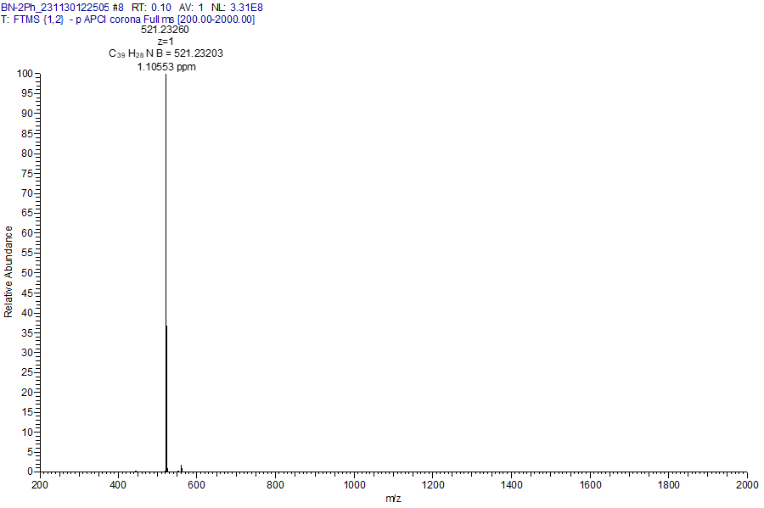
Figure S6. The mass spectra of BN-2Ph.

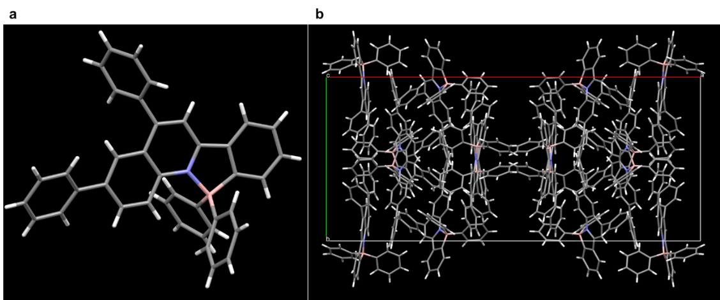
Figure S7. a) The single crystal structure and b) the unit cell of BN-2Ph crystal.

Table S1. Single crystal data of BN-2Ph, which have been deposited at the Cambridge Crystallographic Data Centre (CCDC number: 2311893).
Sample | BN-2Ph
CCDC | 2311893
Empirical formula | C₃₉H₂₈BN
Formula weight | 521.23
Temperature/K | 296K
Crystal system | Monoclinic
Space group | C2/c
a/Å | 42.767(3)
b/Å | 17.7275(12)
c/Å | 17.8667(12)
α/° | 90
β/° | 109.868(2)
γ/° | 90
Volume/Å³ | 12739.4(15)
Z | 16
ρ_{calc}g/cm³ | 1.087
μ/mm⁻¹ | 0.299
F(000) | 4384.0
Goodness-of-fit on F² | 1.131
Final R indexes [I>=2σ (I)] | R₁ = 0.0711,  wR₂ = 0.1715
Final R indexes [all data] | R₁ = 0.1292,  wR₂ = 0.2014

- Supplementary information of the hosts, guest, and host-guest materials

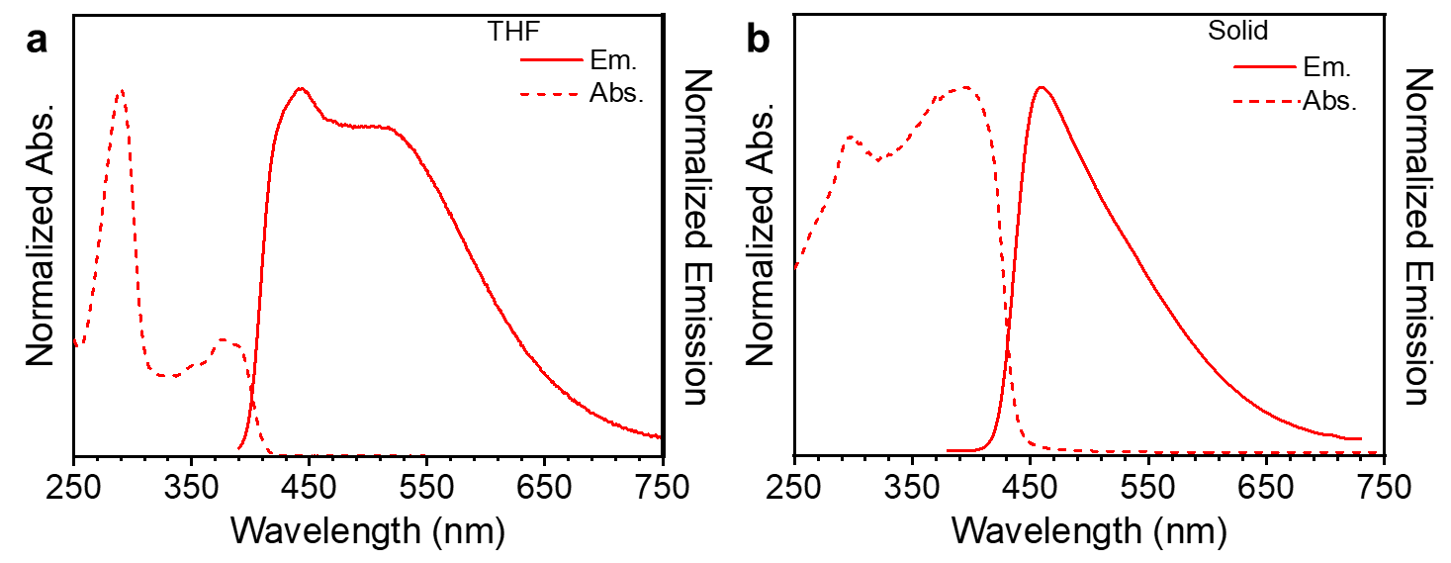
Figure S8. UV-vis absorption and photoluminescence (PL) spectra of BN-2Ph in a) solution (1×10⁻⁵ M in tetrahydrofuran (THF)) and b) solid state.

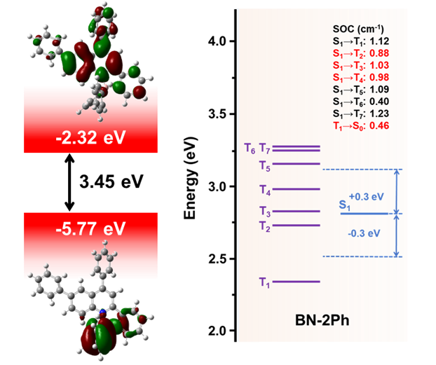
Figure S9. The frontier molecule orbital and their corresponding energy level, and the time-dependent density functional theory (TD-DFT) calculated spin orbital coupling (SOC) constant of BN-2Ph.

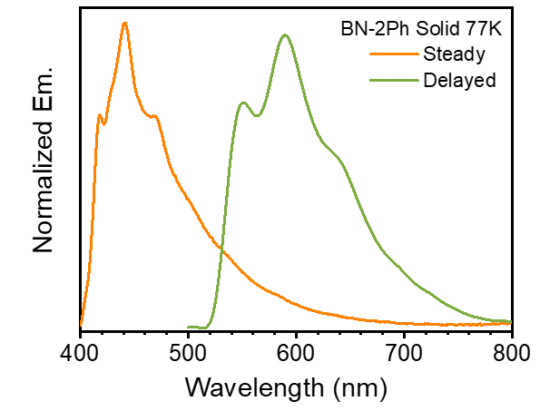
Figure S10. Steady and delayed PL spectra of BN-2Ph solid in 77 K.

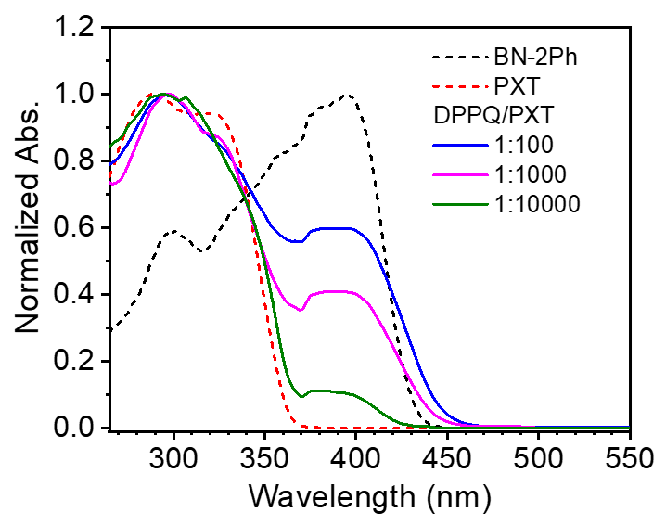
Figure S11. Solid UV-vis absorption spectra of PXT, BN-2Ph, and BN-2Ph/PXT doped materials with different molar ratio.

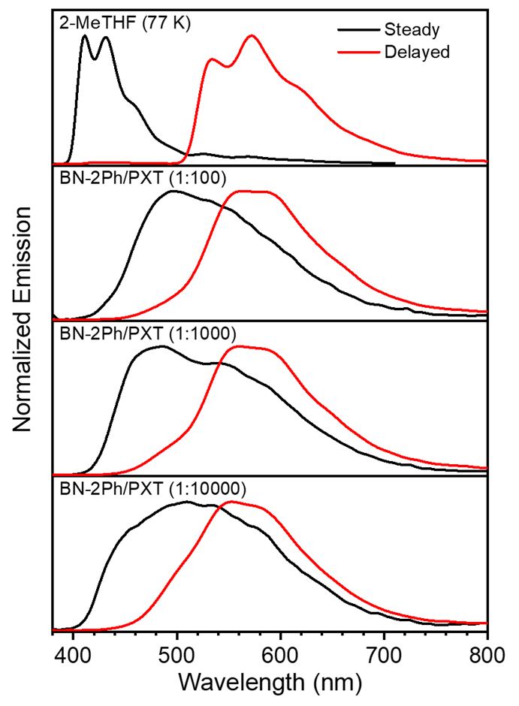
Figure S12. Steady-state PL and delayed emission (delayed time: 5 ms) spectra of BN-2Ph/PXT crystalline materials at different molar ratios at room temperature and BN-2Ph solution (1×10⁻⁵ M in 2Me-THF) at 77 K (λ_{ex}: 365 nm).

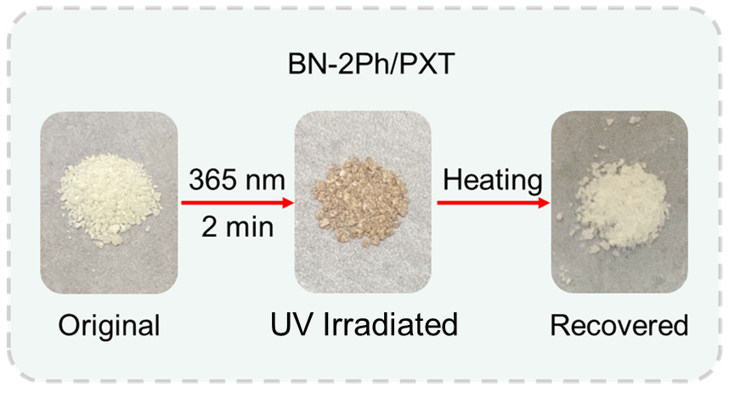
Figure S13. Photograph of BN-2Ph/PXT powder before and after UV irradiation, then recovery by heating.

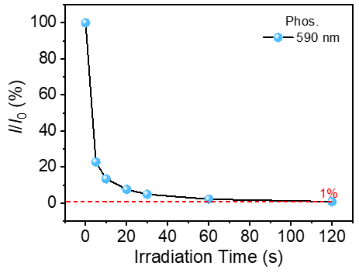
Figure S14. Phosphorescence intensity of BN-2Ph/PXT powder under UV light varies with the irradiation time.

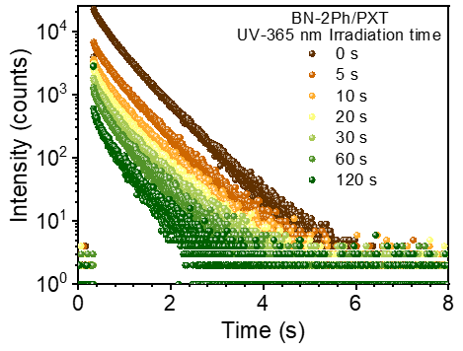
Figure S15. The phosphorescence lifetime of BN-2Ph/PXT powder under different time UV irradiation.

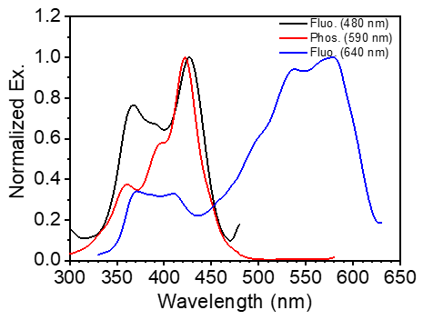
Figure S16. Excitation spectra of different emission peak of irradiated BN-2Ph/PXT.

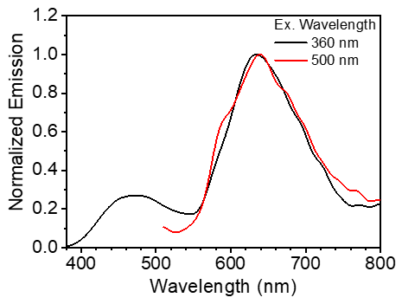

Figure S17. Steady spectra of irradiated BN-2Ph/PXT powder under different excitation wavelength.

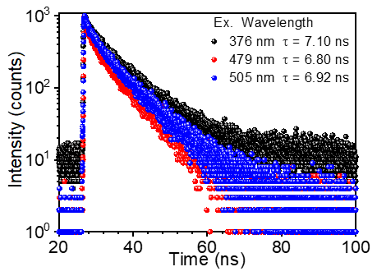
Figure S18. Lifetime of the new appeared peak of irradiated BN-2Ph/PXT under different excitation.

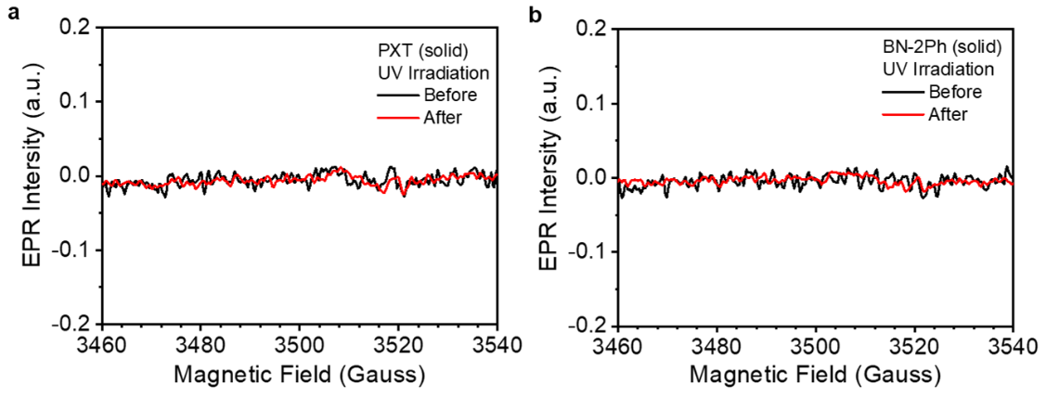
Figure S19. Electron paramagnetic resonance (EPR) spectra of a) PXT and b) BN-2Ph in solid state before and after UV irradiation.

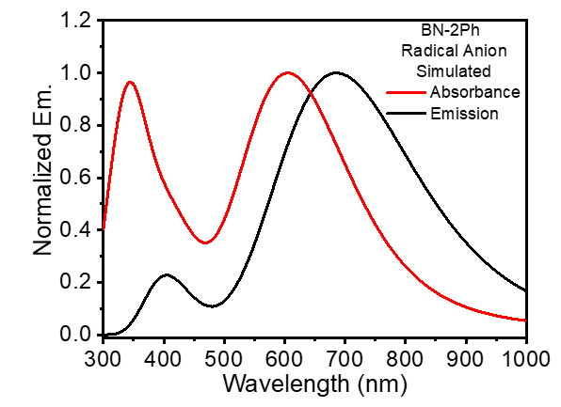
Figure S20. Simulated absorbance and emission spectra of BN-2Ph anion radical.

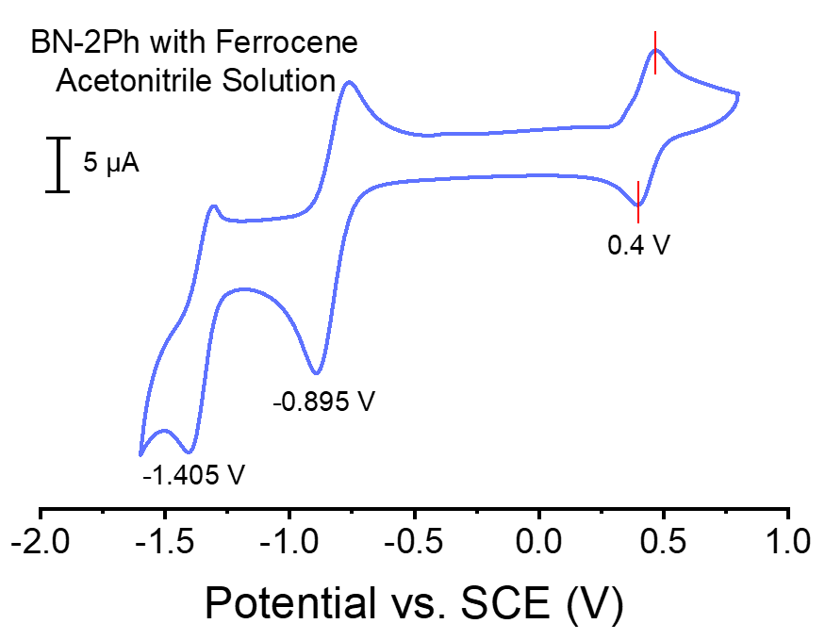
Figure S21. Cyclic voltammograms (CVs) of BN-2Ph with Tetrabutylammonium hexafluorophosphate in acetonitrile solution with ferrocene as internal standard. CVs acquired with a glassy carbon working electrode, Ag/AgCl reference electrode and platinum counter electrode at a scan rate of 0.1 V s⁻¹.

Figure S22. CVs of PXT with Tetrabutylammonium hexafluorophosphate in acetonitrile solution with ferrocene as internal standard. CVs acquired with a glassy carbon working electrode, Ag/AgCl reference electrode and platinum counter electrode at a scan rate of 0.1 V s⁻¹.

Table S2. Chemical structure, HOMO, LUMO energy level of hosts and guest; properties of doped material; and SOMO, SUMO energy level of radical anion.
Sample | PXT | TPA | BPA | MPX | BN-2Ph | BN-2Ph•—
Structure |  | 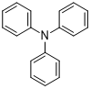
LUMO (SUMO)  [eV] | -0.88 | -0.82 | -1.24 | -1.09 | -2.32 | 1.59
HOMO (SOMO)  [eV] | -5.71 | -5.24 | -7.02 | -5.62 | -5.77 | -0.40
PL property as host | Fluo & Phos | Phos | Fluo & Phos | Fluo | — | —
Generation of radical | √ | √ | × | × | — | —

Table S3. Photophysical properties of BN-2Ph/PXT doped system
Sample | τ_{F}  [ns] | Ф_{F}  [%] | τ_{P}  [ms] | Ф_{P}  [%] | k_{r}^{F}  [s⁻¹] | Ф_{ISC}  [%] | k_{ISC}  [s⁻¹] | k_{r}^{P}  [s⁻¹] | k_{nr}^{P}  [s⁻¹]
BN-2Ph/  PXT | 3.05 | 7.37 | 453 | 22.61 | 2.42×10⁷ | 92.63 | 7.41×10⁷ | 0.49 | 1.71
BN-2Ph•—/  PXT | 6.80 | 10.16 | — | — | 1.49×10⁷ | — | — | — | —
Note: host: guest = 1000:1 (molar ratio). k_{r}^{F}, k_{ISC}, k_{r}^{P}, k_{nr}^{P} are the radiative rate constant of prompt fluorescence, rate constant of ISC, radiative rate constant of phosphorescence, and non-radiative rate constant of phosphorescence of T₁, respectively. k_{r}^{F} = Φ_{F}/τ_{F}; Φ_{ISC} = 1-Φ_{F}-Φ_{IC} ≈ 1-Φ_{F}; k_{ISC} = Φ_{P}/τ_{F}; k_{r}^{P} = Φ_{P}/τ_{P}; k_{nr}^{P} = (1-Φ_{P})/τ_{P}.

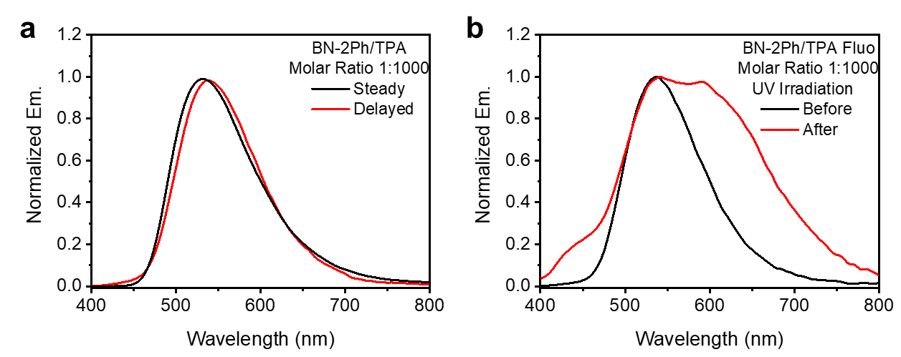
Figure S23. a) Steady-state and delayed PL spectra of BN-2Ph/TPA powder. b) Steady state PL spectra of BN-2Ph/TPA powder before and after UV irradiation. Inset: chemical structure of TPA.

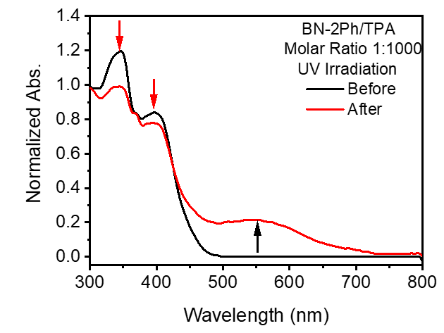
Figure S24. UV-vis absorption spectra of BN-2Ph/TPA powder before and after UV irradiation.

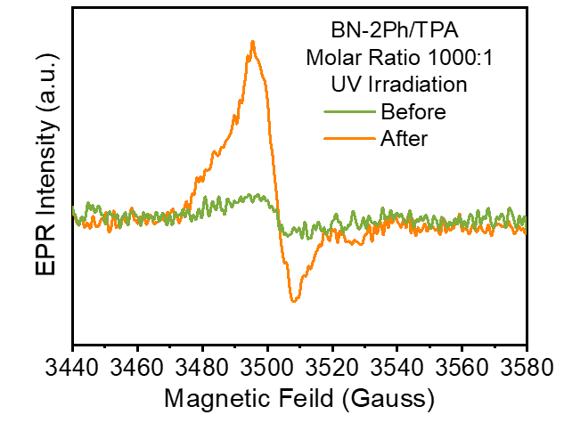
Figure S25. EPR spectra of BN-2Ph/TPA powder before and after UV irradiation.

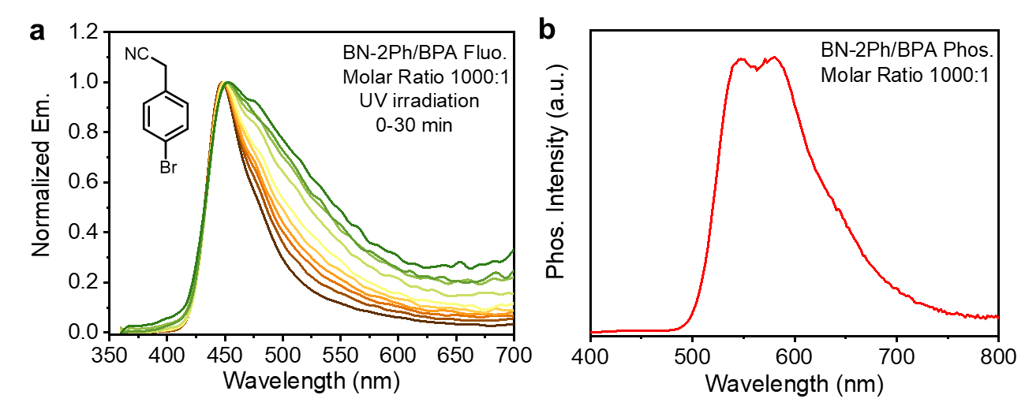
Figure S26 a) Steady-state and b) delayed PL spectra of BN-2Ph/BPA powder. Inset: chemical structure of BPA.

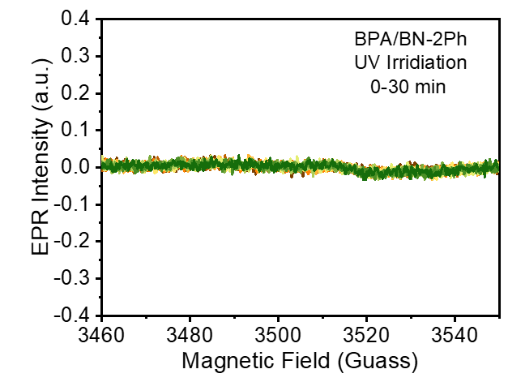
Figure S27. EPR spectra of BN-2Ph/BPA powder before and after UV irradiation.

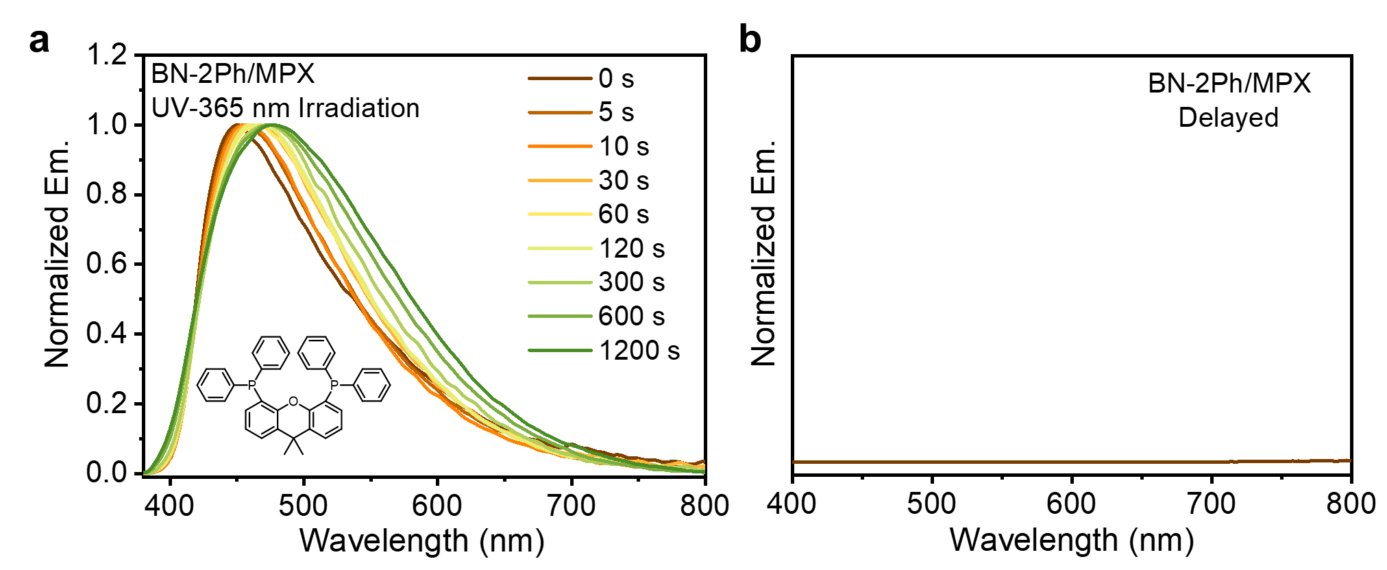
Figure S28 a) Steady-state and b) delayed spectra of BN-2Ph/MPX powder. Inset: chemical structure of MPX.

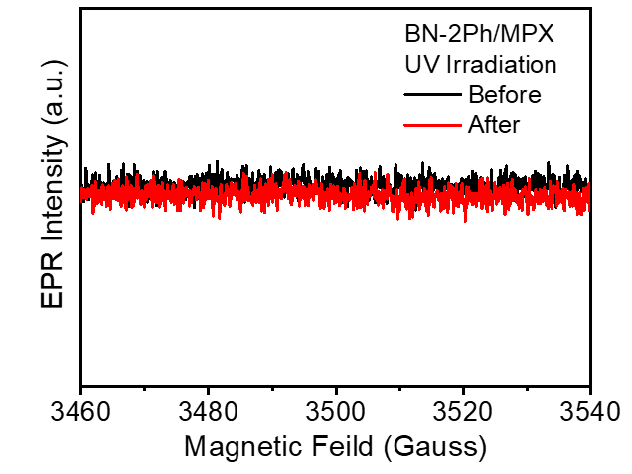
Figure S29. EPR spectra of BN-2Ph/MPX powder before and after UV irradiation.
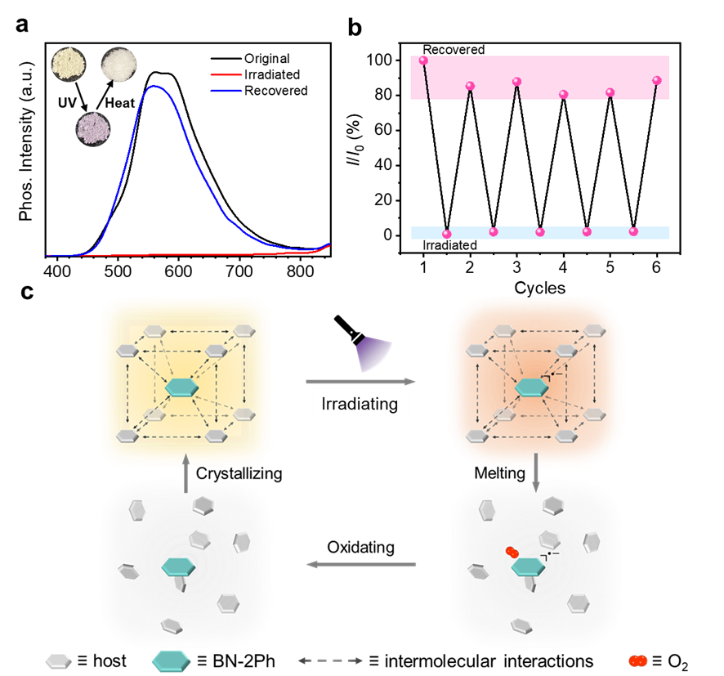
Figure S30. Recovery and re-generation of the anion radical and the recycle property. a) The delayed spectra of the original, irradiated and recovered BN-2Ph/PXT doped material. Inset: photo of the original, stimulated and recovered BN-2Ph/PXT doped system. b) Plots of I/I₀ ratio versus the cycle number of BN-2Ph/PXT doped material with the cycle of UV irradiation and heating. c) The schematic diagram of the controllable and adjustable luminescence of the BN-2Ph/PXT doped material.

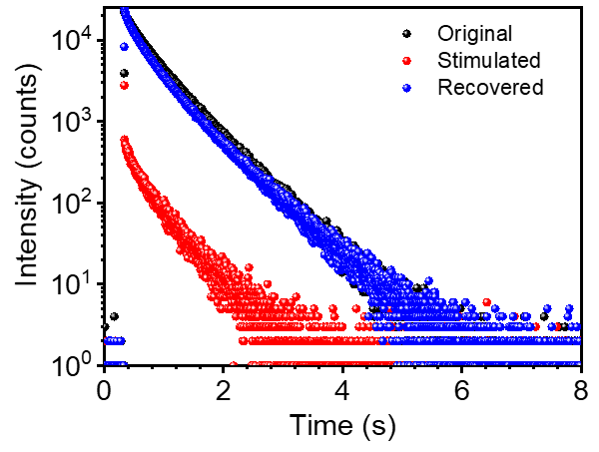
Figure S31. The phosphorescence lifetime of original, UV irradiated and heat recovered BN-2Ph/PXT powder.

- Reference

1. Dai W, et al. Triphenylquinoline (TPQ)-Based Dual-State Emissive Probe for Cell Imaging in Multicellular Tumor Spheroids. ACS Appl. Bio. Mater. 2, 3686-3692 (2019).

