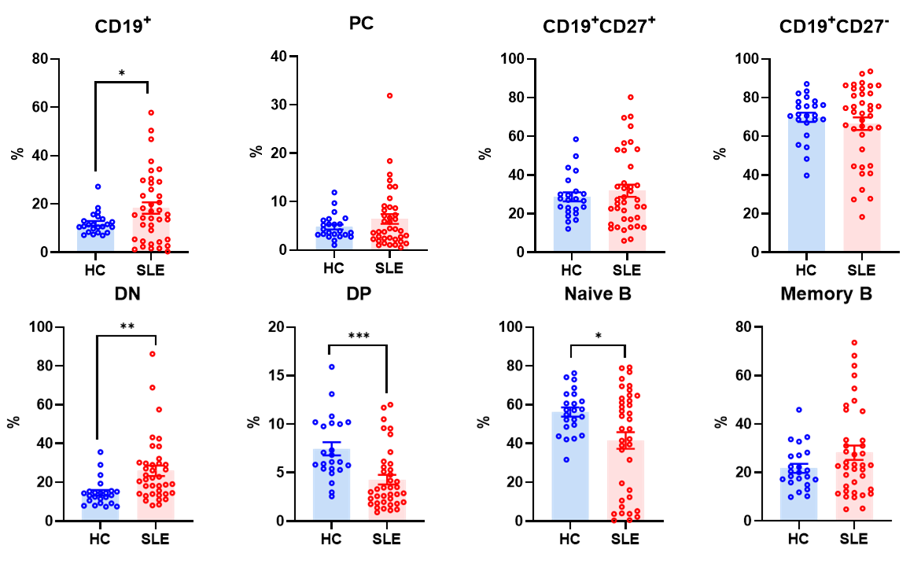
FigS1 Frequency of B-cell subsets in peripheral blood of SLE (n = 38) and HC (n = 23).
All data are shown as the Mean ± SEM and analyzed by an unpaired two-tailed Student’s t-test or a one-way analysis of variance (ANOVA). ****P < 0.0001. ***P < 0.001. **P < 0.01. *P < 0.05.

