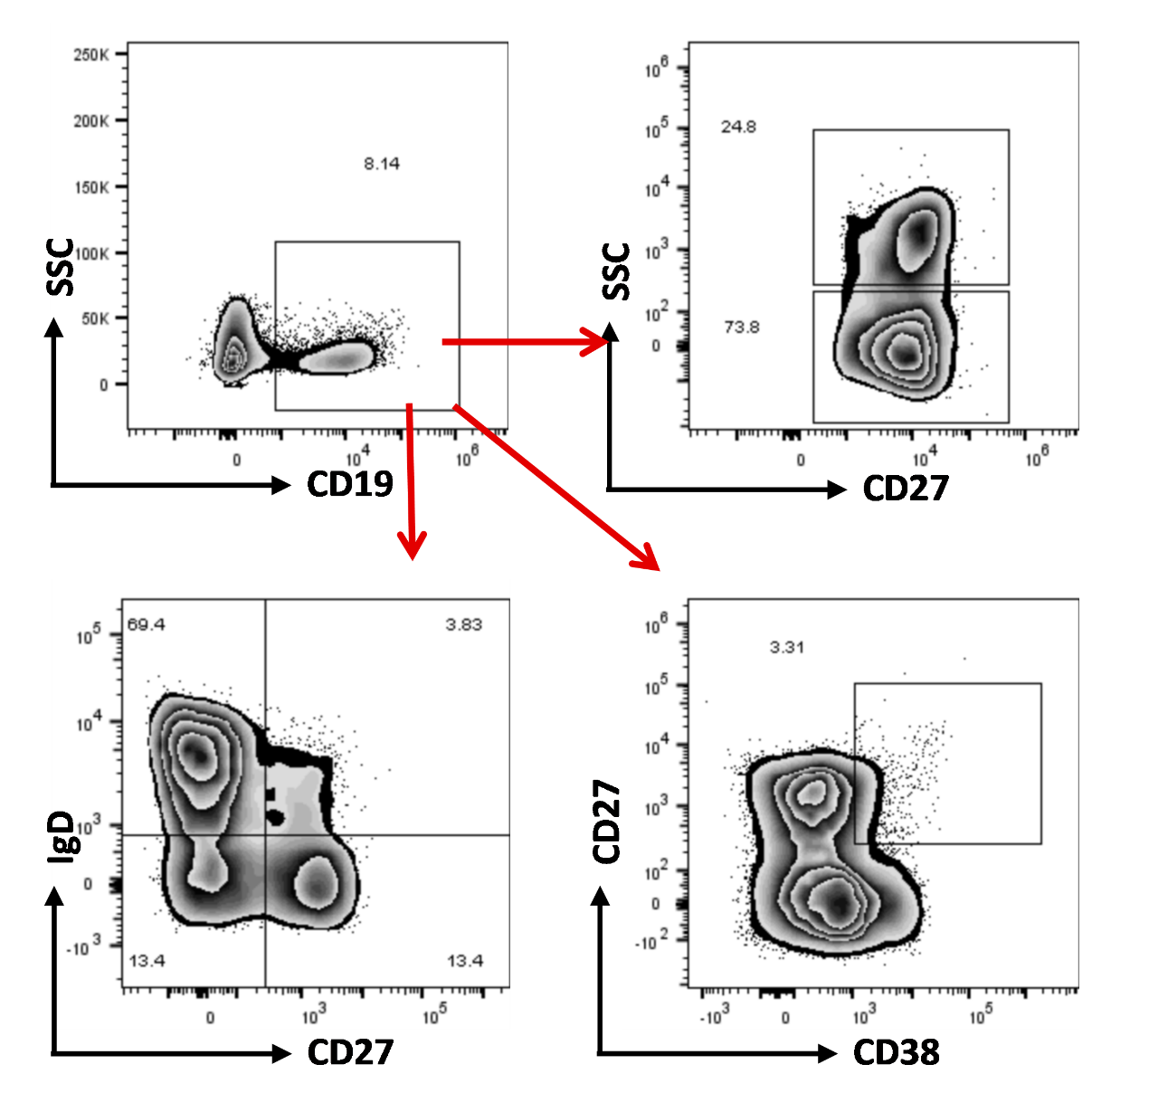
FigS2 Gating strategy of B cell subsets in PMBCs.

