Supplementary Material to: “Assessment of the impact of the Three Gorges Project on the ecosystem service value”

Qianxi Liu^{a,b}, Di Liu^{a,b,*}, Conglin Zhang^{c,}*

ª State Key Laboratory of Urban and Regional Ecology, Research Center for Eco-Environmental Sciences, Chinese Academy of Science, Beijing 100085, China
^{b} University of Chinese Academy of Sciences, Beijing 100049, China
^{c} Institutes of Science and Development, Chinese Academy of Sciences, Beijing 100190, China
*Corresponding author: Di Liu (diliu@recces.ac.cn); Conglin Zhang(zhangconglin@casisd.cn)

Table S1. SEM Pathways, impact assumptions, and related underlying mechanisms in the conceptual model.
Pathway | Impact assumption | Related underlying mechanism
ECO → ESV | The net effect of economic development on ESV might be positive. | (a)The economic development increase the amount of ESV at the village scale by driving change of land use and marketization of ESV (Zhang et al., 2020).  (b) Economic development intensifies urbanization, and the impact of urbanization on ESV can be positive or negative, depending on the study area and scale (Cao et al., 2021; Song et al., 2021).
MET → ESV | The effect of meteorological environment on ESV might be negative. | (a) Meteorological factors have a strong correlation with ESV ( Fang et al., 2018).  (b) Ecotone shift as a consequence of weather extremes resulted in accelerated soil erosion and altered the performance of ecosystem services(AnkeJentsch et al., 2008).  (c) The correlation between precipitation and ESV may be opposite to that of average temperature and ESV (Wang et al., 2016).
LULC → ESV | The effect of land use and land cover on ESV might be negative. | Differences in land use and land cover configuration result in changes to ecosystem services (Xie et al.,2022).
Abbreviations: ECO, economic development; MET, meteorological environment; LULC, land use and land cover; ESV, ecosystem service value.

Table S2. Ranges of simulated values of ecosystem services at the grid and sub-watershed scales
Ecosystem service | Unit | Grid scale | Sub-watershed scale
FP | CNY | -1.83 - 2.35 | -1.05 - 3.06
RM | CNY | -2.44 - 1.56 | -1.12 - 2.86
WS | CNY | -2.61 - 4.57 | -3.49 - 0.87
GR | CNY | -2.76 - 1.33 | -1.15 - 2.66
CR | CNY | -1.91 - 1.76 | -1.05 - 3.13
PE | CNY | -1.98 - 3.32 | -1.16 - 2.28
HR | CNY | -1.17 - 9.10 | -1.07 - 3.04
SC | CNY | -2.08 - 1.69 | -1.17 - 2.36
MN | CNY | -3.05 - 0.68 | -1.08 - 3.08
BD | CNY | -1.92 - 4.57 | -1.09 - 3.06
AL | CNY | -1.99 - 3.00 | -1.08 - 3.08

Table S3. Reliability and convergent validity indicators for measurement models in the partial least squares structural equation model.
Variable | $$CA$$ | $$CR$$ | $$AVE$$
ECO | 0.983 | 0.988 | 0.953
ESV | 1.000 | 1.000 | 1.000
LULC | 0.980 | 0.983 | 0.880
MET | 0.816 | 0.877 | 0.642
Note: Refer to Section 2.1.2 for index definitions. Abbreviations: ECO, economic development; MET, meteorological environment; LULC, land use and land cover; ESV, ecosystem service value.

Table S4. Differential validity indicators for measurement models in the partial least squares structural equation model.
 | Convergent validity | Differential validity
Variable | $$AVE$$ | $$ECO$$ | $$ESV$$ | $$LULC$$ | $$MET$$
ECO | 0.953 | 0.976
ESV | 1.000 | 0.844 | 1.000
LULC | 0.880 | -0.963 | -0.905 | 0.938
MET | 0.642 | 0.664 | 0.490 | -0.627 | 0.801
Note: The diagonal bold text is the root value of AVE, and the lower triangle is the Pearson correlation coefficient. Refer to Section 2.1.2 for index definitions. Abbreviations: ECO, economic development; MET, meteorological environment; LULC, land use and land cover; ESV, ecosystem service value.
Table S5. Differential validity indicators for measurement models in the partial least squares structural equation model.
 | Differential validity
Variable | $$ECO$$ | $$ESV$$ | $$LULC$$ | $$MET$$
Water Field | -0.977 | -0.853 | 0.982 | -0.671
Dryland | -0.972 | -0.901 | 0.992 | -0.621
Shrubland | -0.835 | -0.579 | 0.849 | -0.637
Open woodland | -0.887 | -0.661 | 0.892 | -0.657
High-coverage grass | -0.964 | -0.928 | 0.974 | -0.604
Low-coverage grass | -0.862 | -0.885 | 0.932 | -0.512
Water | -0.922 | -0.936 | 0.977 | -0.560
Bare land | -0.800 | -0.976 | 0.894 | -0.472
ESV | 0.844 | 1.000 | -0.905 | 0.490
GDP | 0.930 | 0.771 | -0.896 | 0.678
Primary industry | 0.992 | 0.845 | -0.958 | 0.651
Secondary industry | 0.991 | 0.853 | -0.953 | 0.597
Tertiary industry | 0.990 | 0.824 | -0.952 | 0.666
Precipitation A | 0.526 | 0.366 | -0.445 | 0.795
Precipitation B | 0.431 | 0.248 | -0.356 | 0.698
Temperature A | 0.585 | 0.480 | -0.550 | 0.850
Temperature B | 0.567 | 0.435 | -0.616 | 0.852
Note: The bold font are Factor loadings and the regular font are Cross loadings. Refer to Section 2.1.2 for index definitions. Abbreviations: ECO, economic development; MET, meteorological environment; LULC, land use and land cover; ESV, ecosystem service value. A represents meteorological station (number 57545) in the study area. B represents meteorological station (number 57612) in the study area

Table S6. Significance indicators for measurement models in the partial least squares structural equation model.
Variable | $$Original Sample$$ | $$T Statistics$$ | $$P Values$$
Water Field <- LULC | 0.982 | 121.540 | 0.000
Dryland <- LULC | 0.992 | 216.525 | 0.000
Shrubland <- LULC | 0.849 | 13.458 | 0.000
Open woodland <- LULC | 0.892 | 19.238 | 0.000
High-coverage grass <- LULC | 0.974 | 78.754 | 0.000
Low-coverage grass <- LULC | 0.932 | 23.558 | 0.000
Water <- LULC | 0.977 | 68.638 | 0.000
Urban land <- LULC | 0.894 | 44.318 | 0.000
Rural settlements <- LULC | 1.000
Bare land <- LULC | 0.930 | 28.347 | 0.000
ESV <- ESV | 0.795 | 5.316 | 0.000
GDP <- ECO | 0.698 | 2.572 | 0.010
Precipitation A <- MET | 0.850 | 8.294 | 0.000
Precipitation B <- MET | 0.852 | 7.897 | 0.000
Temperature A <- MET | 0.992 | 331.769 | 0.000
Temperature B<- MET | 0.991 | 299.385 | 0.000
Primary industry <- ECO | 0.990 | 293.141 | 0.000
Secondary industry<- ECO | 0.982 | 121.540 | 0.000
Tertiary industry <- ECO | 0.992 | 216.525 | 0.000
Note: Refer to Section 2.1.2 for index definitions. Abbreviations: ECO, economic development; MET, meteorological environment; LULC, land use and land cover; ESV, ecosystem service value.

Table S7. Inspection indicators for measurement and structural models in the partial least squares structural equation model.
Variable | $$CA$$ | $$CR$$ | $$AVE$$ | $$R^{2}$$ | Q² | GOF
ECO | 0.983 | 0.988 | 0.953 | N.A. | N.A.ª | N.A.
ESV | 1.000 | 1.000 | 1.000 | 0.805 | 0.718 | 0.699
LULC | 0.980 | 0.983 | 0.880 | 0.920 | 0.800 | 0.799
MET | 0.816 | 0.877 | 0.642 | 0.411 | 0.269 | 0.357
Note: ª N.A. indicates that data is not available. Refer to Section 2.1.2 for index definitions. Abbreviations: ECO, economic development; GEO, geomorphic features; MET, meteorological environment; LULC, land use and land cover; ESV, ecosystem service value.

Table S8. Pathways coefficients for the structural equation model
Pathways | Effect | $$Standard error$$ | $$P−value$$
ECO→MET | 0.664 | 0.124 | 0.000
ECO→LULC | -0.963 | 0.011 | 0.000
ECO→ESV | 0.844 | 0.042 | 0.000
MET→LULC | 0.021 | 0.066 | 0.750
MET→ESV | -0.125 | 0.149 | 0.400
LULC→ESV | -1.257 | 0.521 | 0.016
ECO→MET→ESV | -0.066 | 0.083 | 0.431
ECO→MET→LULC | 0.014 | 0.048 | 0.770
ECO→MET→LULC→ESV | -0.018 | 0.064 | 0.783
ECO→LULC→ESV | 1.228 | 0.508 | 0.016
MET→LULC→ESV | -0.026 | 0.087 | 0.762

Table S9. Indirect and total effects of the original model values and the bootstrap-estimated values on the ESV
Paths | Indirect effects |  | Total effects
Paths | Original | Bootstrap | Original | Bootstrap
ECO→MET | N.A.ª | N.A. | 0.664 | 0.664 (0.350,0.847)^{b}
ECO→LULC | 0.014 | 0.014 (-0.086,0.117) | -0.963 | -0.963 (-0.978,-0.934)
ECO→ESV | 1.145 | 1.145 (0.171,2.108) | 0.844 | 0.844 (0.703,0.901)
MET→LULC | N.A. | N.A. | 0.021 | 0.021 (-0.122,0.152)
MET→ESV | -0.026 | -0.026 (-0.226,0.141) | -0.125 | -0.125 (-0.369,0.232)
LULC→ESV | N.A. | N.A. | -1.257 | -1.257 (-2.286,-0.309)
ª N.A. indicates that data is not available in the structural model.
^{b} Numbers in parentheses represent the 95% confidence intervals.

Maps of SOM
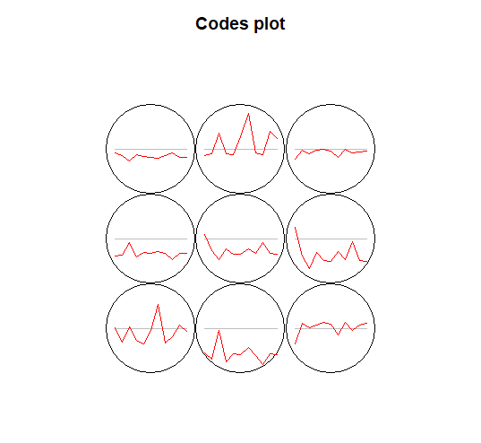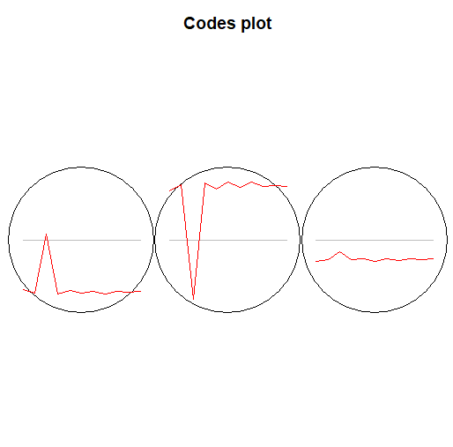
Fig. S1. Map of Changes
The map of “Changes” showed the training process of SOM. The trend of distance decreased with iteration, and finally converged to the smooth. The left one was at the grid scale, and the other was at the sub-watershed scale.

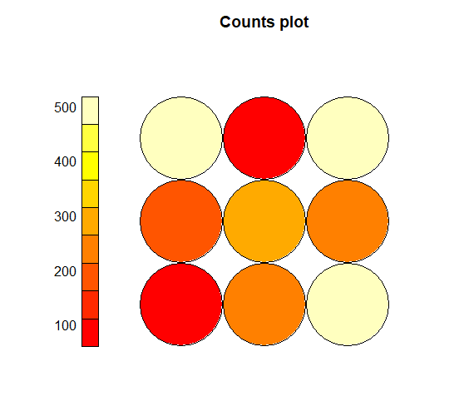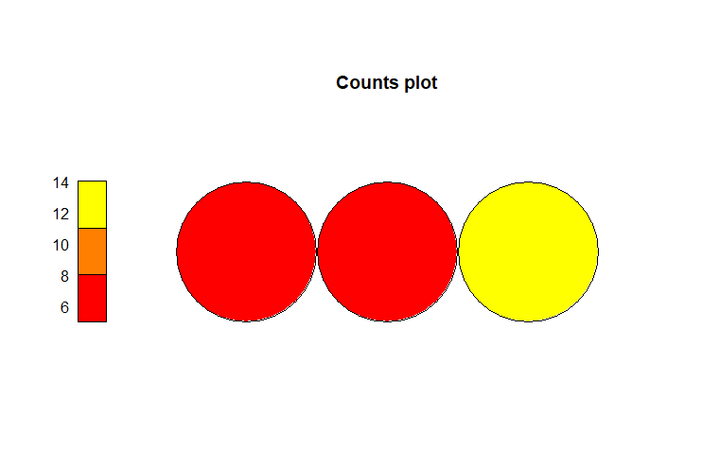
Fig. S2. Map of “Counts”
The map of “Counts” showed the number of samples contained in each SOM centroid. The left one was at the grid scale, and the other was at the sub-watershed scale.

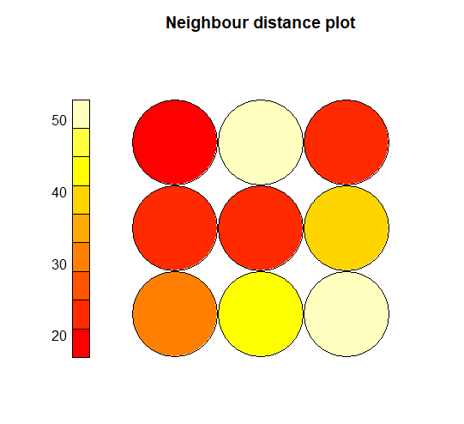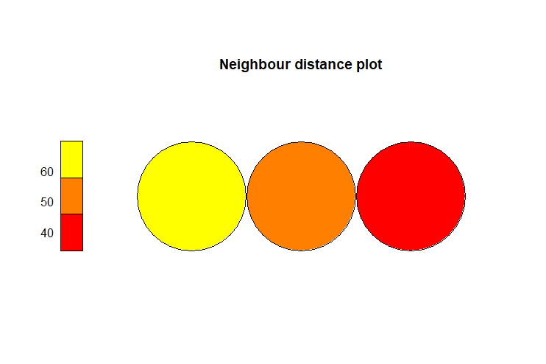
Fig. S3. Map of “Distance”
The map of “Distance” showed the proximity distance for each SOM centroid. The higher value of the color, the greater difference with the surrounding centroid, the more likely to be a boundary point. The left one was at the grid scale, and the other was at the sub-watershed scale.

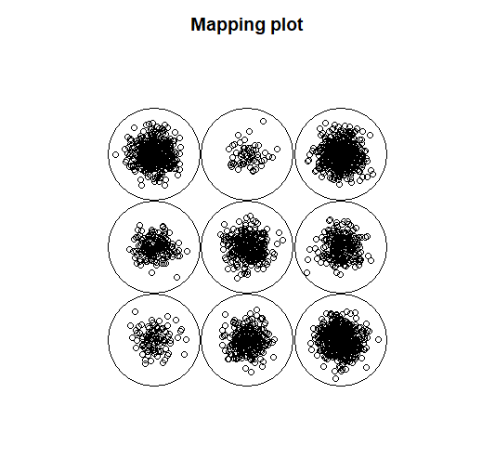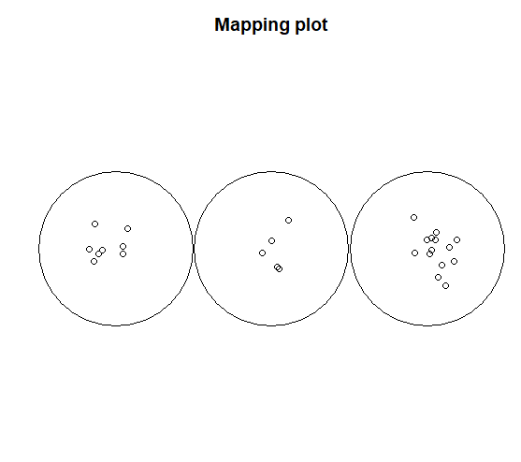
Fig. S4. Map of “Mapping”
The map of “Mapping” showed the mapping of each sample. The darker of the color, the more of samples included. The left one was at the grid scale, and the other was at the sub-watershed scale.

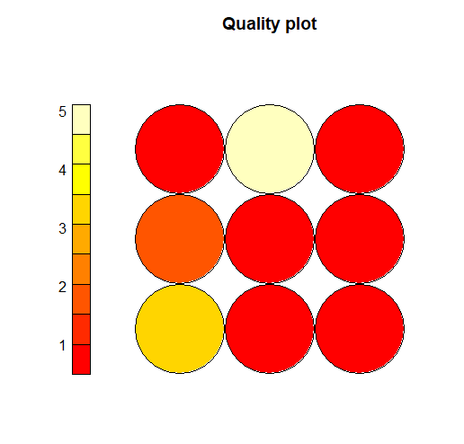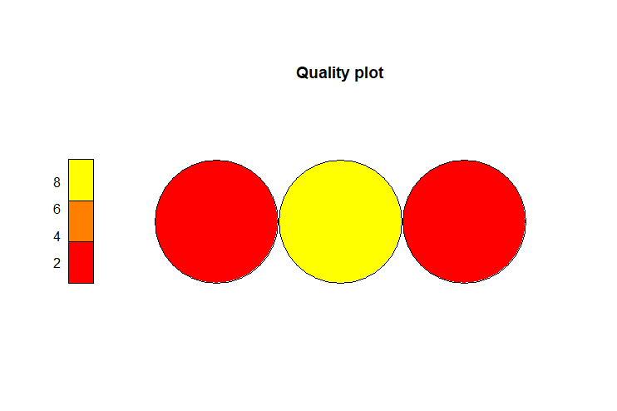
Fig. S5. Map of “Quality”
The map of “Quality” showed the convergence and quality of the SOM centroid. The smaller of value, the better of demonstration. The left one was at the grid scale, and the other was at the sub-watershed scale.

Characteristics of ecosystem services bundles
In terms of the grid scale, the characteristics of the eight ES bundles are as follows.
(1) Food consumption bundle (B1): This bundle presented as negative value of WS, and with low HR, but pretty high value of other ecosystem services. (Fig. 4).
(2) Food replenishment bundle (B2): This bundle presented as high value of FP and MN, but with negative value of others (Fig. 4).
(3) Hydrological culture-driven bundle (B3): This bundle was characterized as high WS and the highest value of HR and AL. This bundle was closely related to hydrological regulation and culture provision (Fig. 4).
(4) Water-dominated bundle (B4): This bundle had negative values of all types of ecosystem services except for WS. Besides, the provisioning ability of water was at the average level of 9 bundles (Fig. 4).
(5) Maintenance cycle bundle (B5):This bundle was characterized as high value of GR and MN (Fig. 4).
(6) Nutrient providing bundle (B6): This bundle provided high MN, and with the ability to produce food. But this bundle had low values of other ecosystem services (Fig. 4).
(7) Water replenishment bundle (B7): This bundle was featured by only WS having positive value (Fig. 4).
(8) Cultural support bundle (B8):This bundle was featured by providing multiple ecosystem services, including RM, WS, GR, CR, PE, SC, MN, BD and AL (Fig. 4).
(9) Water support bundle (B9):This bundle was characterized as high WS and low HR and FP (Fig. 4).

In terms of the sub-watershed scale, the characteristics of the six ES bundles are as follows.
(1) Water replenishment bundle (Bⅰ):This bundle was characterized by the highest WS, but with the lowest other 10 ecosystem services, quite similar with B7 (Fig. 6).
(2) Water depletion bundle(Bⅰi):This bundle was characterized by spatial multiple ecosystem services except for WS (Fig. 6).
(3) Water depletion bundle(Bⅰi):This bundle was characterized by much higher WS and lower value of other ecosystem services (Fig. 6).
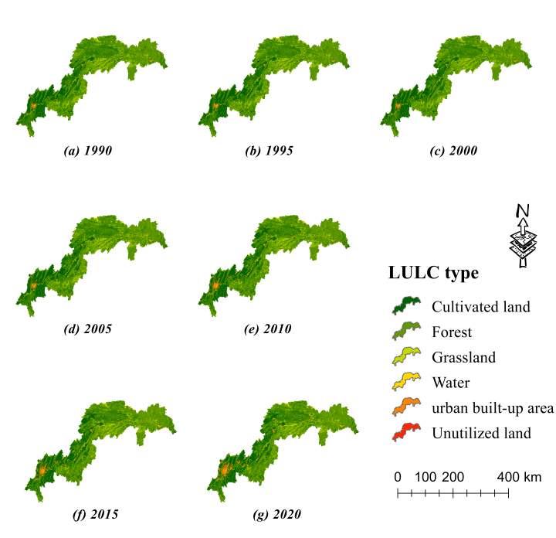
Fig. S6. Map of LULC in the TGRA from 1990 to 2020

References:
Zhang, Z, Xia, F, Yang, D, Huo, J, Wang, G, Chen, H, 2020. Spatiotemporal characteristics in ecosystem service value and its interaction with human activities in Xinjiang, China. Ecol Indic, 105826.
Cao, Y.; Kong, L.; Zhang, L.; Ouyang, Z. The balance between economic development and ecosystem service value in the process of land urbanization: A case study of China’s land urbanization from 2000 to 2015. Land Use Pol. 2021, 108, 105536.
Song, F.; Su, F.; Mi, C.; Sun, D. Analysis of driving forces on wetland ecosystem services value change: A case in Northeast China. Sci. Total Environ. 2021, 751, 141778.
Fang, L.; Wang, L.; Chen, W.; Sun, J.; Cao, Q.; Wang, S.; Wang, L. Identifying the impacts of natural and human factors on ecosystem service in the Yangtze and Yellow River Basins. J. Clean Prod. 2021, 314, 127995.
Jentsch, A.; Kreyling, J.; Beierkuhnlein, C. Research frontiers in climate change: Effects of extreme meteorological events on ecosystems. Comptes Rendus Geoscience 2008, 340(9-10), 624-628.
Wang, H.; Zhou, S.; Li, X.; Liu, H.; Chi, D.; Xu, K. The influence of climate change and human activities on ecosystem service value. Ecol. Eng. 2016, 87, 224-239.
Xie, L.; Wang, H.; Liu, S. The ecosystem service values simulation and driving force analysis based on land use/land cover: A case study in inland rivers in arid areas of the Aksu River Basin, China. Ecol. Indic. 2022, 138, 108828.

