Interfacial Manipulation via In-Situ Grown ZnSe Overlayer toward Highly Reversible Zn Metal Anodes
Xianzhong Yang¹, Chao Li¹, Zhongti Sun¹, Shuai Yang², Zixiong Shi¹, Rong Huang¹, Bingzhi Liu^{1,3}, Shuo Li¹, Yuhan Wu¹, Menglei Wang¹, Yiwen Su¹, Shixue Dou⁴, and Jingyu Sun^{1,3}*

¹College of Energy, Soochow Institute for Energy and Materials Innovations (SIEMIS), Jiangsu Provincial Key Laboratory for Advanced Carbon Materials and Wearable Energy Technologies, Soochow University, Suzhou 215006, P. R. China.
²Beijing Academy of Quantum Information Sciences, Beijing 100193, P. R. China.
³Beijing Graphene Institute (BGI), Beijing 100095, P. R. China.
⁴Institute for Superconducting and Electronic Materials, University of Wollongong, Wollongong, NSW 2522, Australia.
*Corresponding author. E-mail: sunjy86@suda.edu.cn.

Supplementary Figures

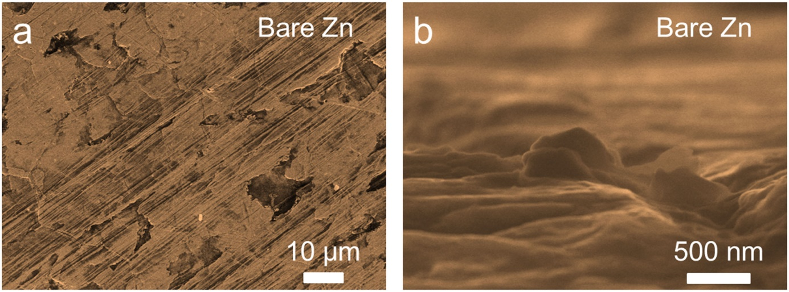
Supplementary Figure 1. (a) Top-view and (b) side-view SEM images of bare Zn foil.

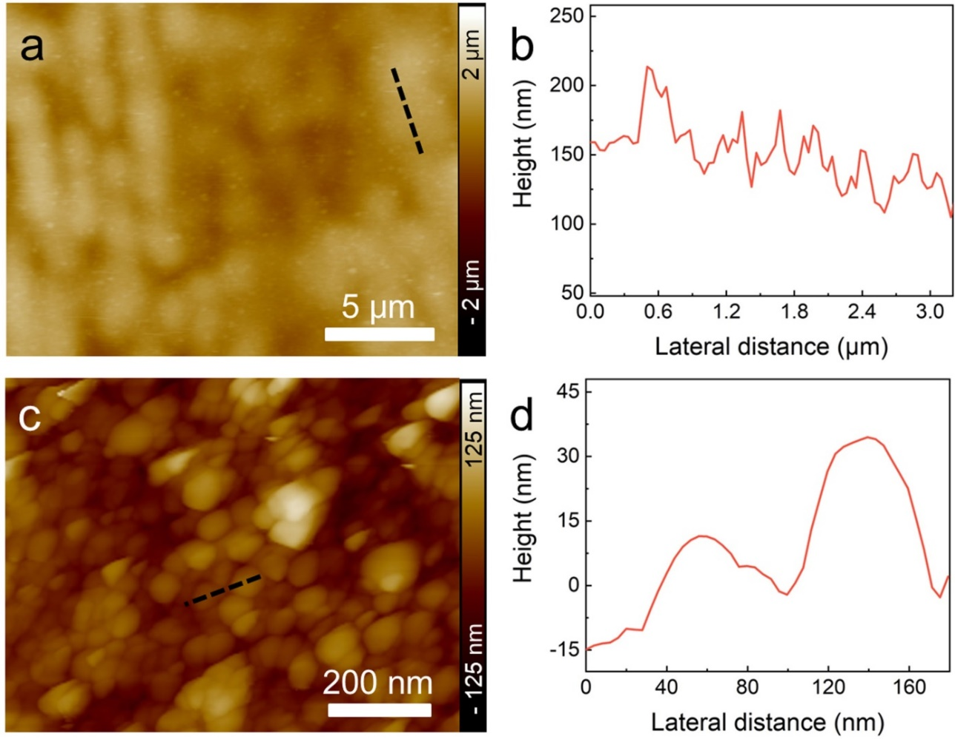
Supplementary Figure 2. (a) Low magnification AFM image of ZnSe@Zn foil. (b) Height profile along the black dotted line marked in (a). (c) High magnification AFM image of ZnSe@Zn foil. (d) Height profile along the black dotted line marked in (c).

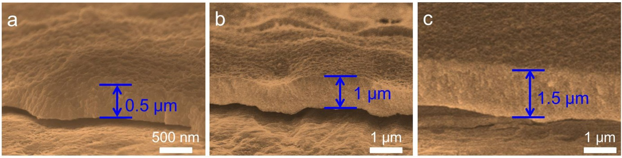
Supplementary Figure 3. Side-view SEM images of ZnSe@Zn foil with varied thicknesses of ZnSe overlayer: (a) 0.5 μm; (b) 1 μm; (c) 1.5 μm.

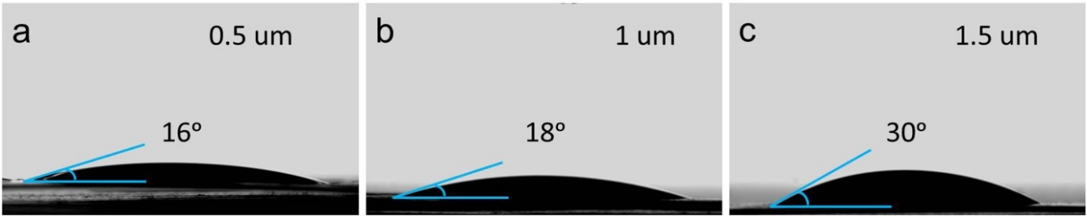
Supplementary Figure 4. Contact angles of ZnSO₄ electrolyte on ZnSe@Zn foil with different thicknesses: (a) 0.5 μm; (b) 1 μm; (c) 1.5 μm.

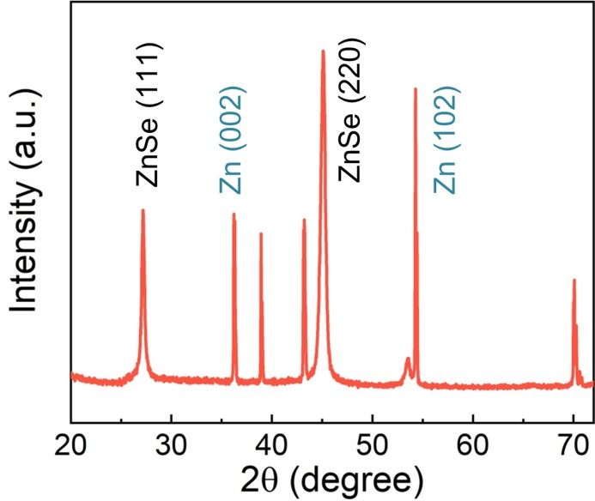
Supplementary Figure 5. XRD pattern of ZnSe@Zn foil (ZnSe thickness: 1.5 μm).

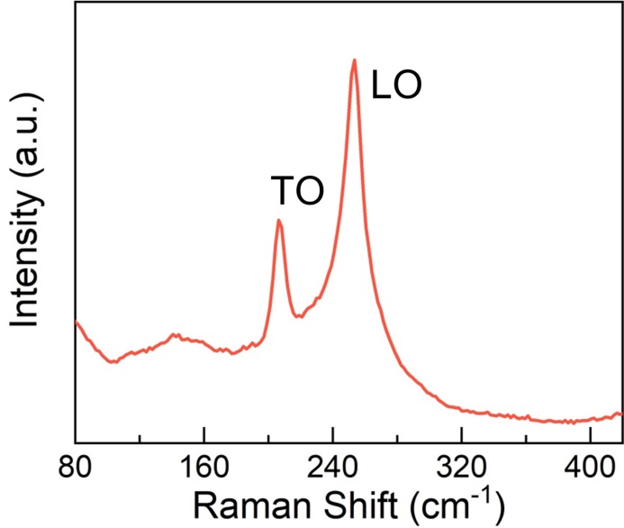
Supplementary Figure 6. Raman spectrum of ZnSe@Zn foil. The Raman peaks located at 207 cm^{–1} and 253 cm^{–1} are respectively assigned to transverse optical (TO) and longitudinal optical (LO) phonon modes of the ZnSe crystal^{1, 2}.

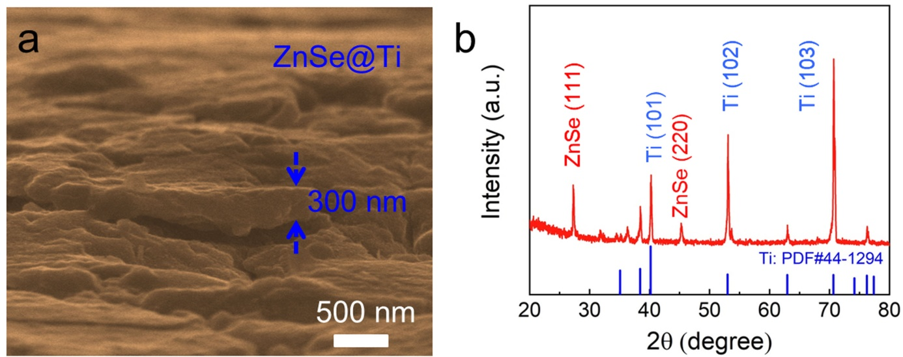
Supplementary Figure 7. (a) SEM image of ZnSe coated Ti foil. (b) XRD pattern of ZnSe coated Ti foil.

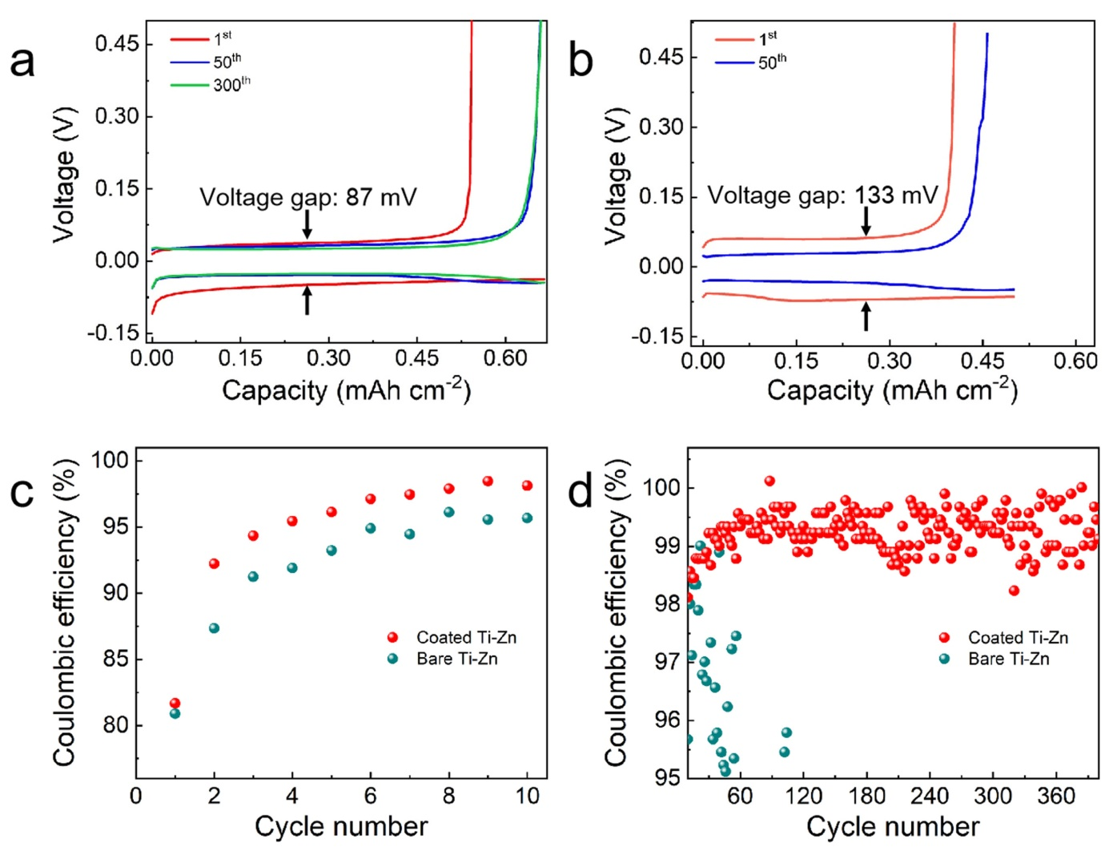
Supplementary Figure 8. (a) Charge-discharge voltage profiles of (a) ZnSe coated Ti-Zn cell and (b) bare Ti-Zn cell at the 1st, 50th, and 300th cycles. The current density and areal capacity are 2.0 mA cm^{–2} and 0.5 mAh cm^{–2}, respectively. (c,d) Enlarged images of Coulombic efficiencies shown in Fig. 2c in the main text: (c) the 1st-10th and (d) the 10th-400th cycles.

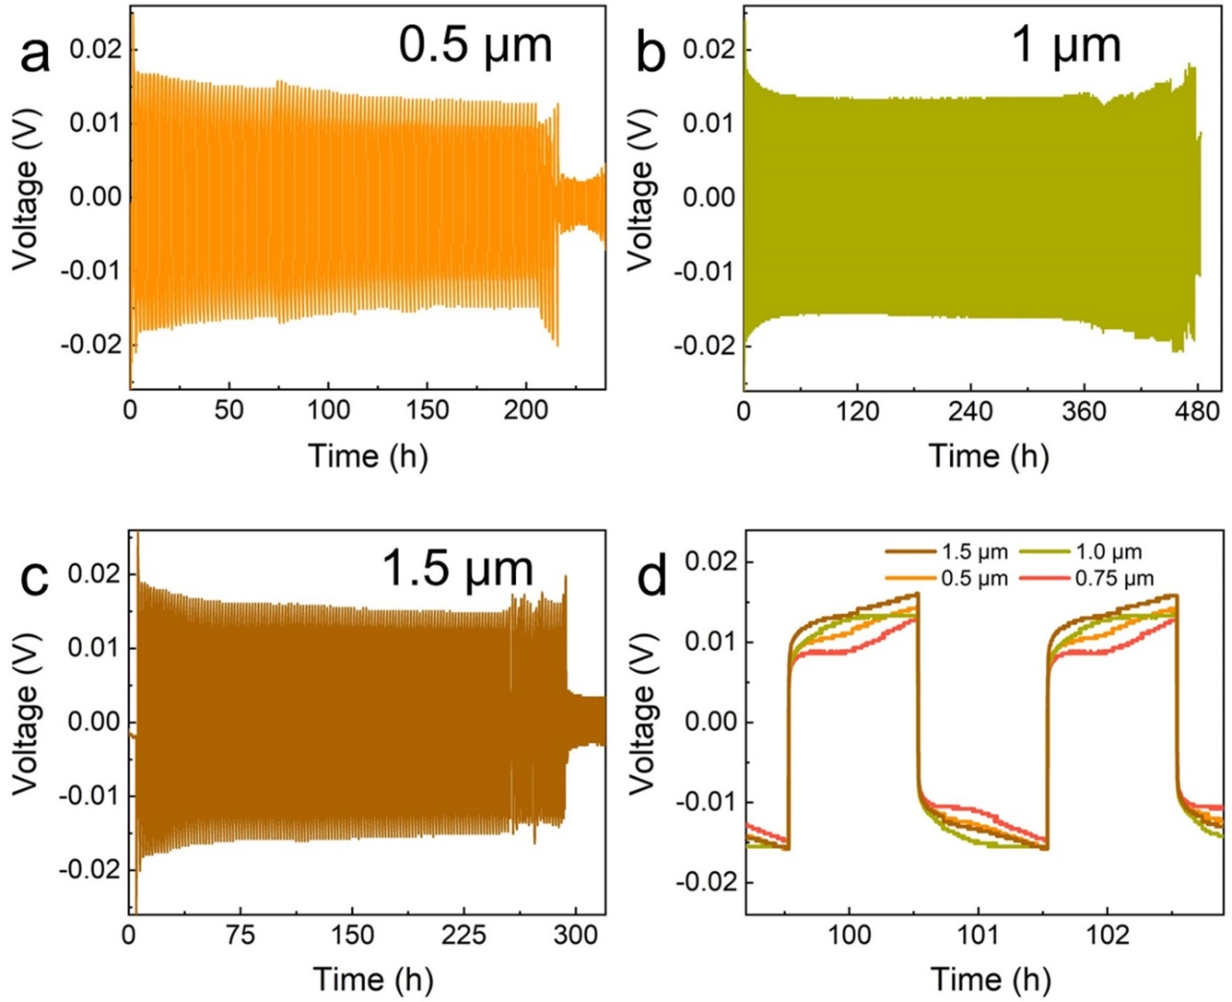
Supplementary Figure 9. Long-term galvanostatic cycling of symmetric cells at a current density of 1.0 mA cm⁻² and a capacity of 1.0 mAh cm⁻². The thickness of the ZnSe is (a) 0.5 μm, (b) 1 μm and (c) 1.5 μm, respectively. (d) Detailed voltage profiles of symmetric cells shown in (a)-(c) at specific cycling time.

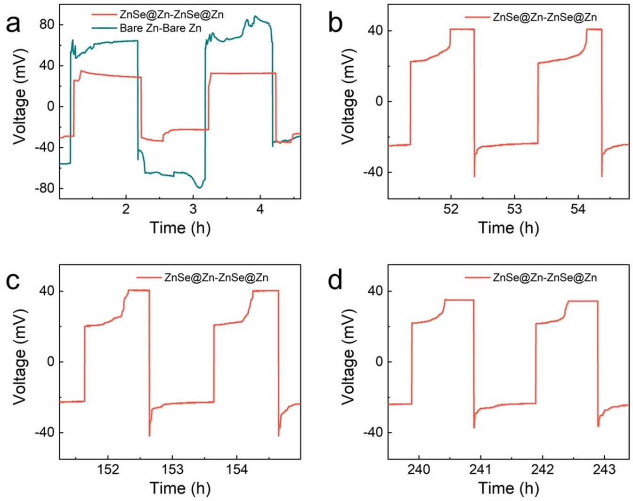
Supplementary Figure 10. Detailed voltage profiles of ZnSe@Zn-ZnSe@Zn symmetric cells shown in Fig. 2d in the main text: (a) the 1st-2nd cycles. (b) the 26th-27th cycles. (c) the 76th-77th cycles. (d) the 120th-121th cycles.

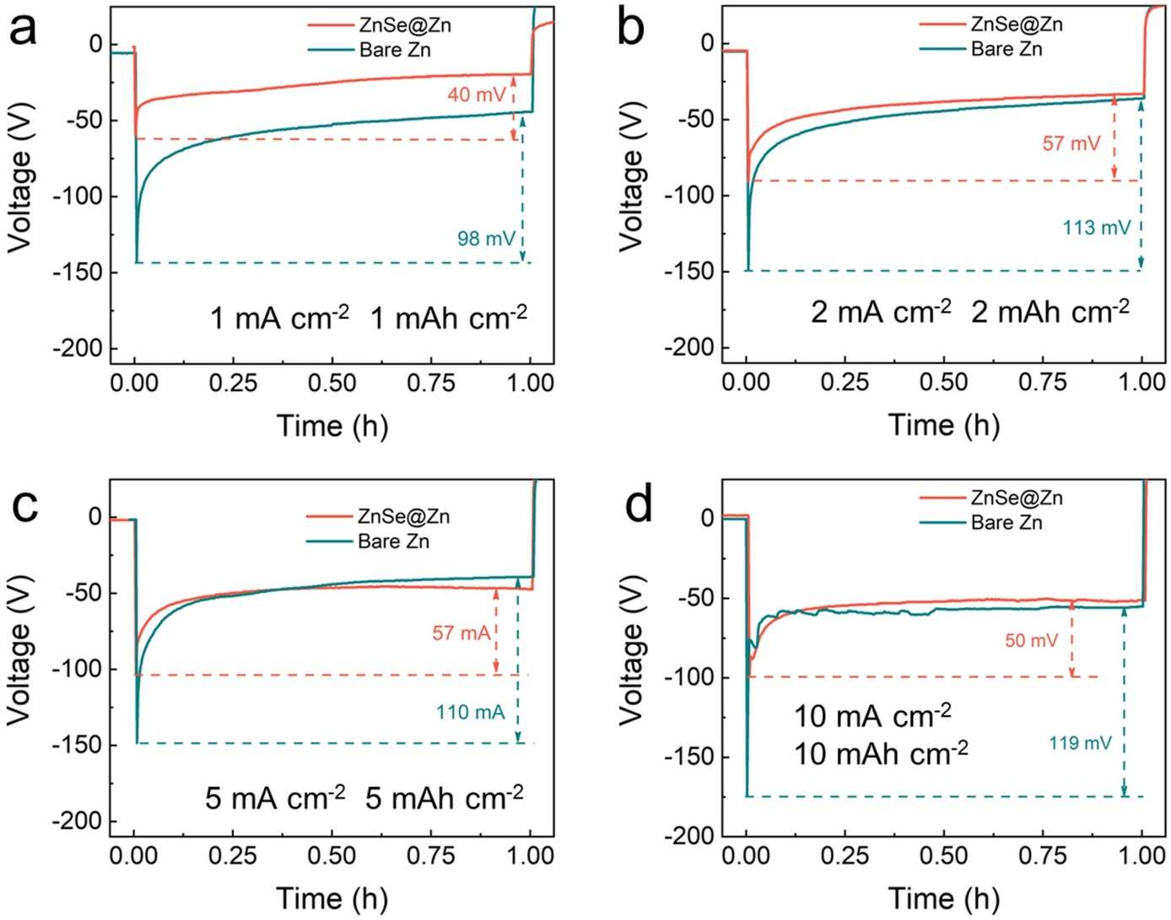

Supplementary Figure 11. Nucleation overpotential for bare Zn and ZnSe@Zn symmetric cells at different current densities and areal capacities: (a) 1.0 mA cm^{–2}, 1.0 mAh cm^{–2}; (b) 2.0 mA cm^{–2}, 2.0 mAh cm^{–2}; (c) 5.0 mA cm^{–2}, 5.0 mAh cm^{–2}; and (d) 10.0 mA cm^{–2}, 10.0 mAh cm^{–2}.

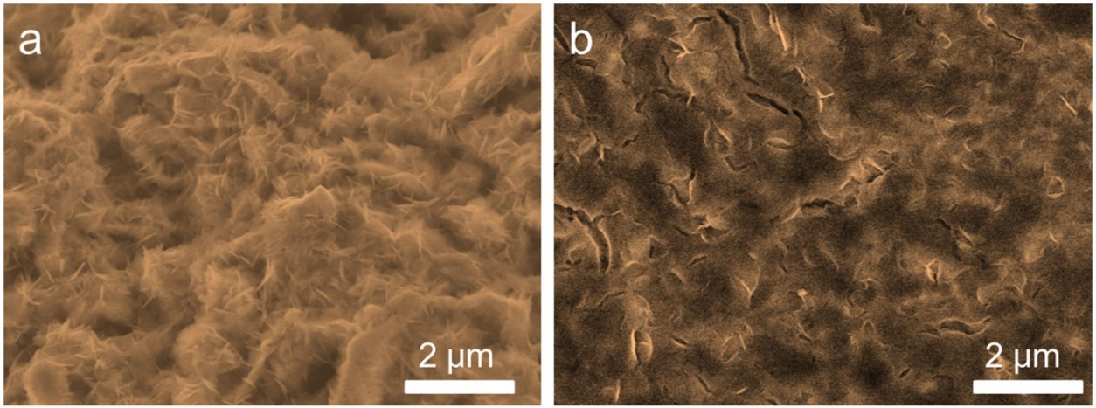
Supplementary Figure 12. High magnification top-view SEM images of (a) bare Zn electrode and (b) ZnSe@Zn electrode after 40 stripping/plating cycles in transparent cell. The current density and areal capacity are 1.0 mA cm^{–2} and 1.0 mAh cm^{–2}, respectively.

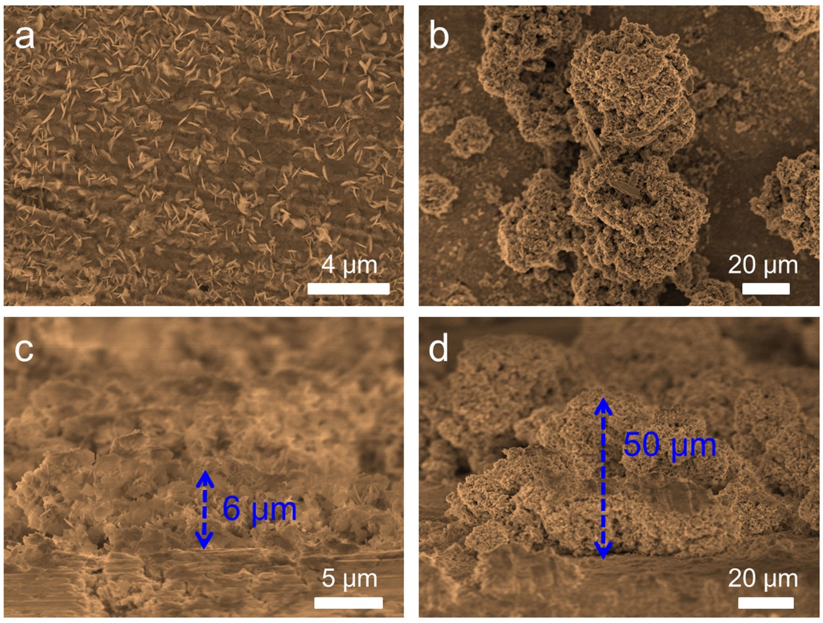
Supplementary Figure 13. Top-view SEM images of (a) ZnSe@Zn electrode and (b) bare Zn electrode after 10 stripping/plating cycles with a current density of 5.0 mA cm^{–2} and a capacity of 5.0 mAh cm^{–2} in transparent cells. Side-view SEM images of (c) ZnSe@Zn electrode and (d) bare Zn electrode after 10 stripping/plating cycles with a current density of 5.0 mA cm^{–2} and a capacity of 5.0 mAh cm^{–2} in transparent cells.
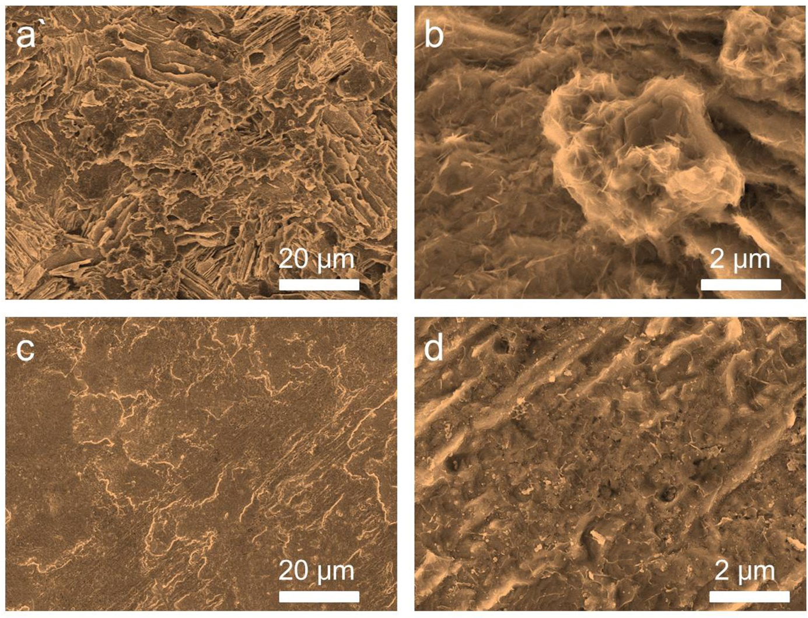
Supplementary Figure 14. (a) Low magnification and (b) high magnification top-view SEM images of bare Zn electrodes after 40 cycles in symmetric coin cells. (c) Low magnification and (d) high magnification top-view SEM images of ZnSe@Zn electrodes after 40 cycles in symmetric coin cells. The current density and areal capacity are 1.0 mA cm^{–2} and 1.0 mAh cm^{–2}, respectively.

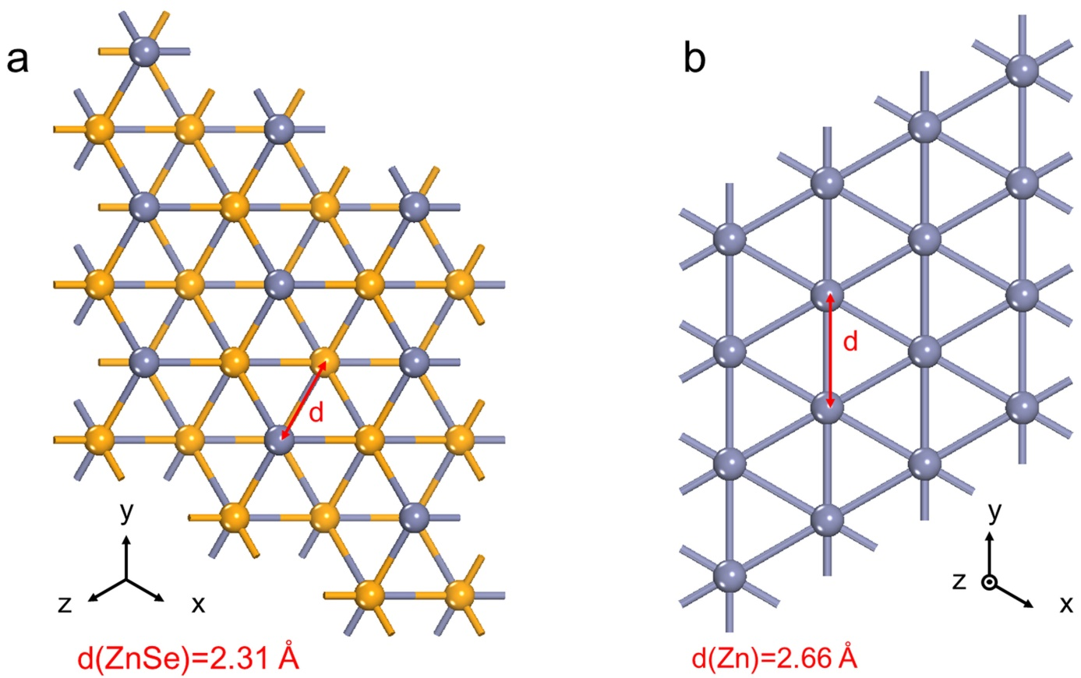
Supplementary Figure 15. (a) ZnSe(111) plane. (b) Zn(002) plane. The gray and orange ball represents the Zn and Se atom, respectively.

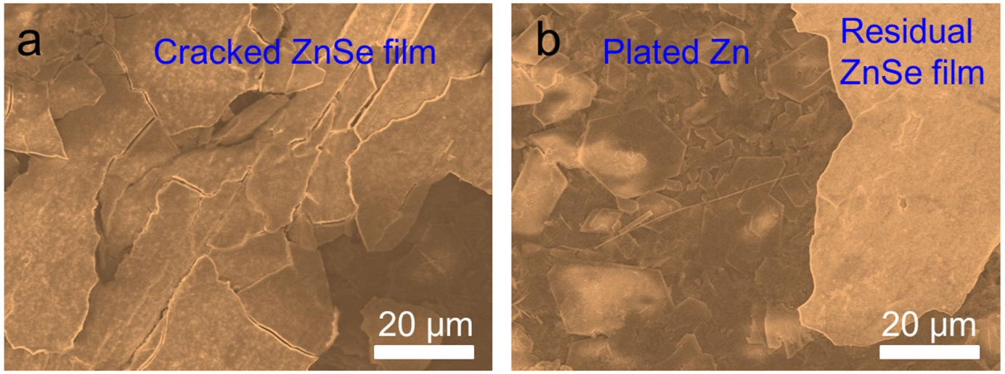
Supplementary Figure 16. Top-view SEM images of ZnSe@Zn electrodes after 10 cycles with a current density of 1.0 mA cm^{–2} and a capacity of 1.0 mAh cm^{–2}. (a) Cracked ZnSe film. (b)Residual ZnSe film.

ZnSe is a nonconductive coating layer, so Zn²⁺ ion can’t be reduced at the surface of ZnSe. Zn²⁺ ions will pass through ZnSe layer under electric field³. The Zn nucleates and grows between ZnSe layer and Zn metal, which gradually results in the cracking and detachment of ZnSe layer as shown above. Impressively, the deposited Zn under ZnSe layer exhibits a highly oriented plate-like morphology without dendritic formation.

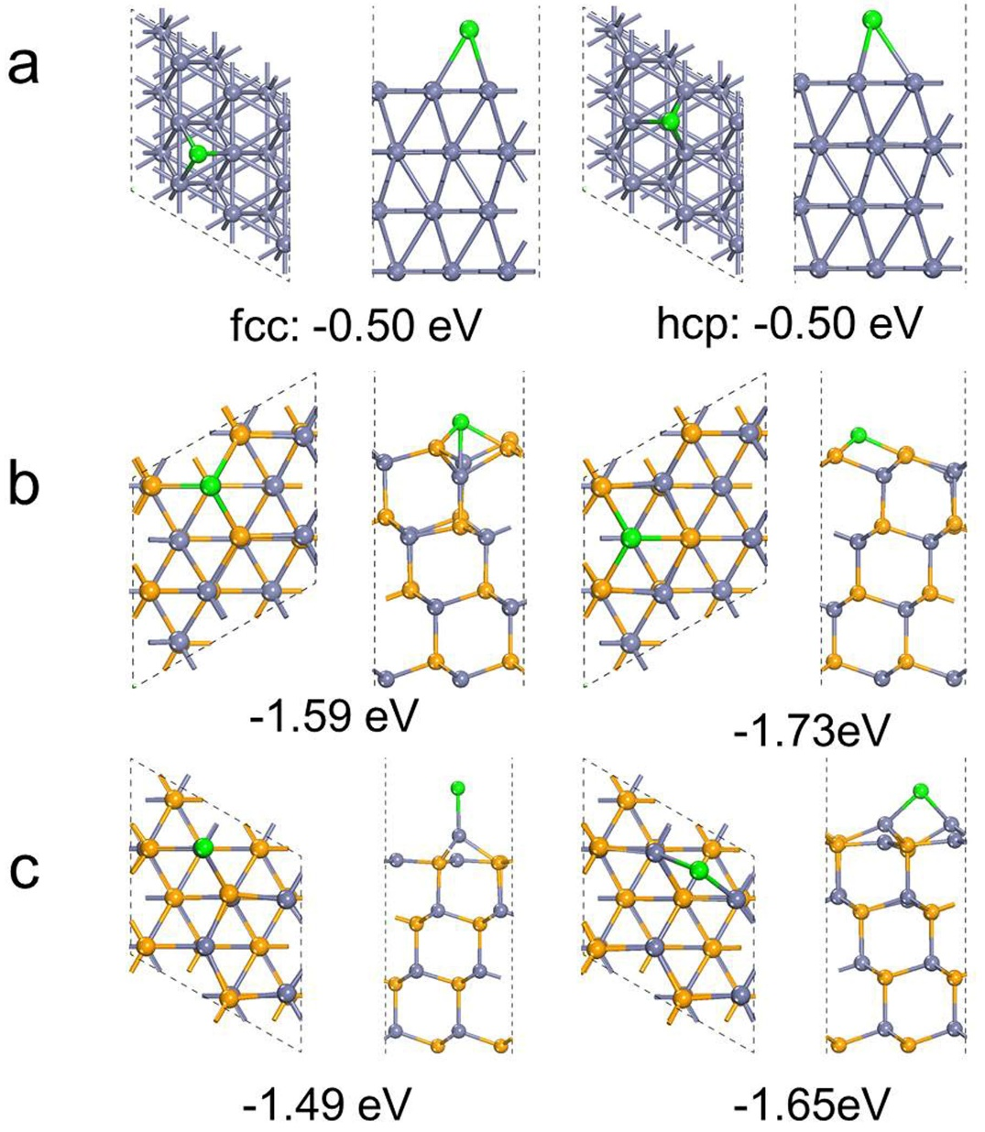
Supplementary Figure 17. Optimized adsorption models of Zn atom on the Zn(001) and ZnSe(111) using DFT method. (a) Zn(001) plane. (b) Se-exposed ZnSe(111) plane. (c) Zn-exposed ZnSe(111) plane. The green, gray, and orange ball represents the Zn adatom, Zn atom and Se atom, respectively.

The adsorption of Zn atom on the Zn (001) and ZnSe (111) surface was evaluated in the s upplementary Fig. 17. For the Zn (001) surface (supplementary Fig. 17a), two possible adsorption sites were considered, that is, fcc (face cubic-centered) and hcp (hexagonal close-packed) hollow site. They own similar adsorption energy with -0.5 eV. While for ZnSe (111) surface, there exists two kinds of exposed surfaces, namely, Zn-exposed and Se-exposed surface due to the polarized surface. For the Se-exposed ZnSe (111) surface (supplementary Fig. 17b), after relaxation, two possible adsorption sites emerged. One is the Zn atom adsorbed on the top of subsurface Zn atom with adsorption energy of -1.59 eV, the other is the hollow site with -1.73 eV, and they are all connected with three Se atoms. For the Zn-exposed surface (supplementary Fig. 17c), the stable adsorption site of Zn atom was on the bridge site connected two Zn atoms with adsorption energy of -1.65 eV. The top site is the meta-stable site with adsorption energy of -1.49 eV.

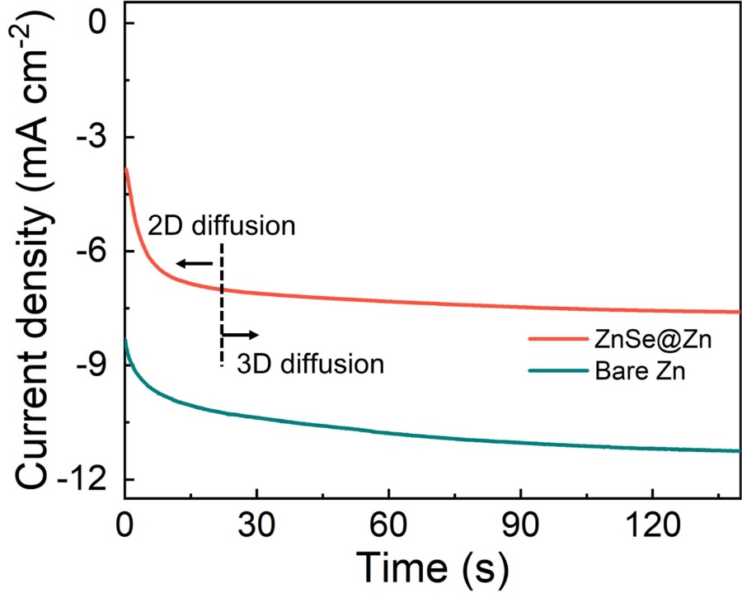
Supplementary Figure 18. Chronoamperometry curves of ZnSe@Zn and bare Zn symmetric cells at a constant potential of –150 mV.

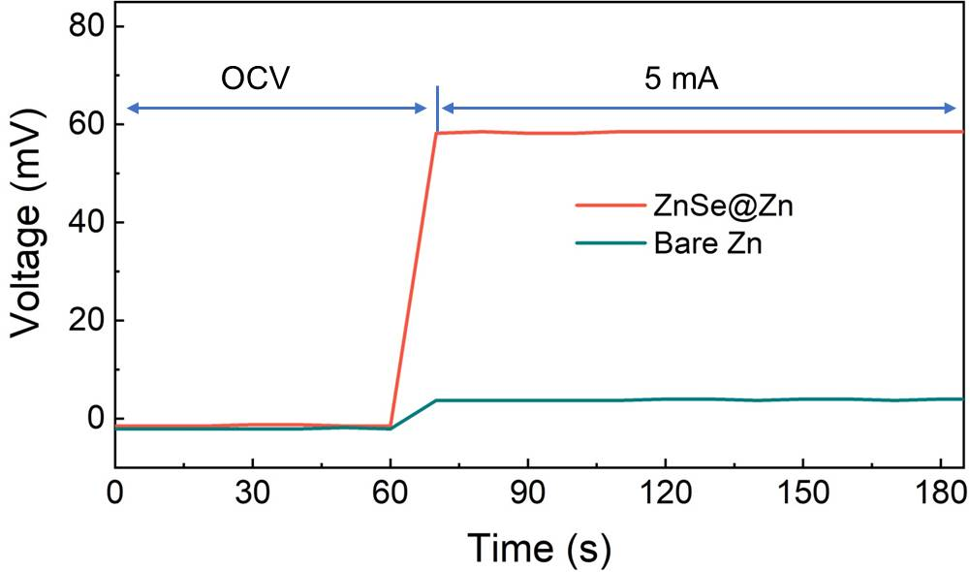
Supplementary Figure 19. Conductivity measurements of bare Zn and ZnSe@Zn foils using blocking electrodes with an applied current of 5 mA.

The bare Zn and ZnSe@Zn plates were fabricated into coin cells using blocking electrodes without electrolyte to measure the electron conductivity of ZnSe by galvanostatic charge. The bias between two electrodes for bare Zn increases only 3.7 mV, while it increases 58.5 mV for ZnSe@Zn plate. The resistivity can be calculated using following formula: ρ=$\frac{R*S}{L}$ , where R, S, L are the resistance, area and thickness of ZnSe layer, respectively. The resistivity is estimated as ~1.9 × 10⁵ Ω cm, so the conductivity is ~5.2×10^{–6} S cm^{–1}.

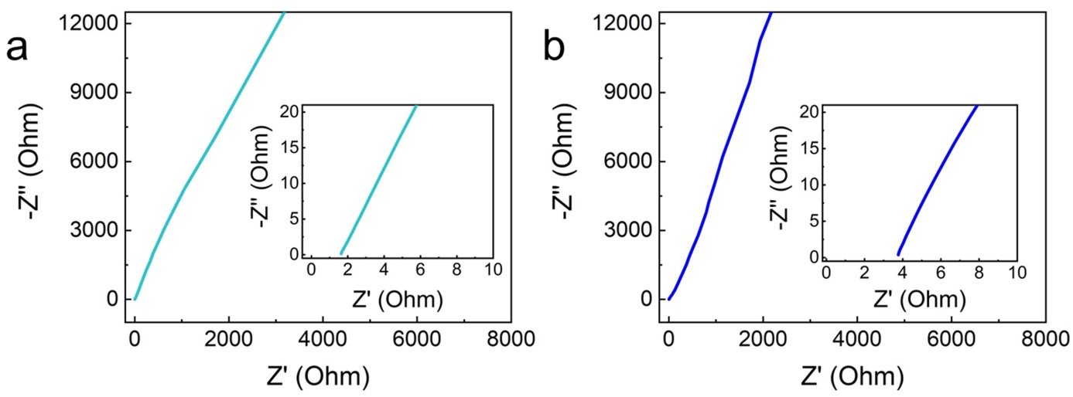
Supplementary Figure 20. (a) Nyquist plot of Ti-Ti symmetric cells. (b) Nyquist plot of ZnSe@Ti-ZnSe@Ti symmetric cells.

The electrochemical impedance spectra (EIS) were carried out to evaluate the ionic conductivity of ZnSe layer^{3, 4}. The resistance of ZnSe layer can be obtained from the Nyquist plots in supplementary Fig. 20. R (ZnSe) = R (total) – R (glass fiber) = 2.14 Ω. Thus the ionic conductivity of the ZnSe layer could be calculated to be about 1.7 × 10^{–5} S cm^{–1} by the following equation: σ =$\frac{L}{R*S}$ , in which L is the thickness of the ZnSe layer (1.5 μm), S is the contact area (1.33 cm²), and R = 2.14 Ω.

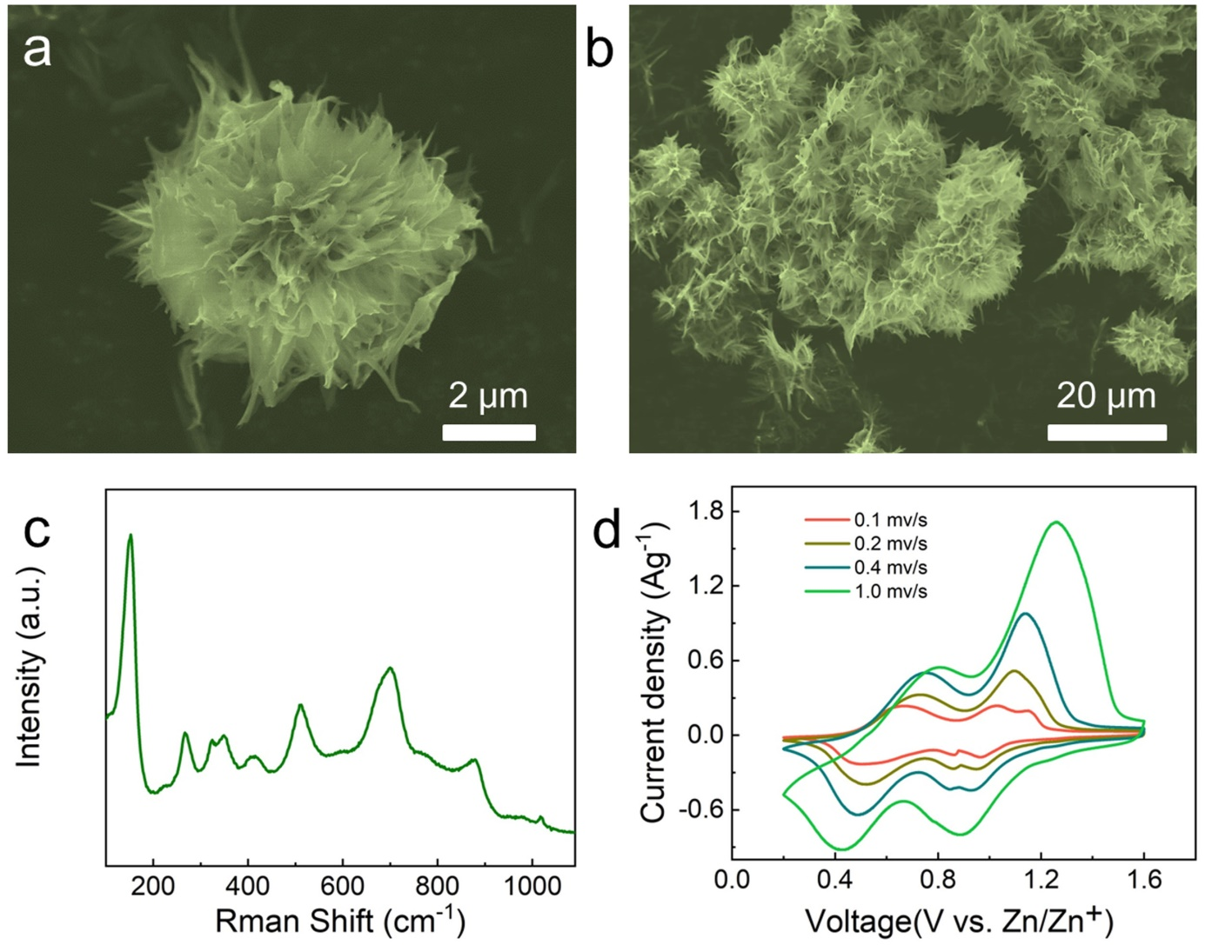
Supplementary Figure 21. (a,b) SEM images of KVOH. (c) Raman spectrum of KVOH. (d) CV curves of ZnSe@Zn-KVOH full cell at different scan rates.

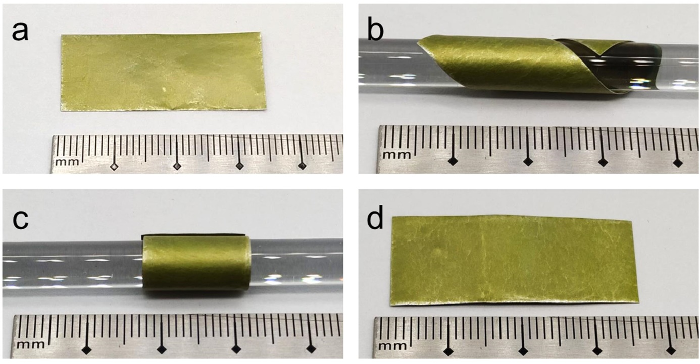
Supplementary Figure 22. (a) Digital photo of ZnSe@Zn foil before rolling and twisting. (b,c) Digital photos of the rolling and twisting states of ZnSe@Zn foil. (d) Digital photo of ZnSe@Zn foil after rolling and twisting.

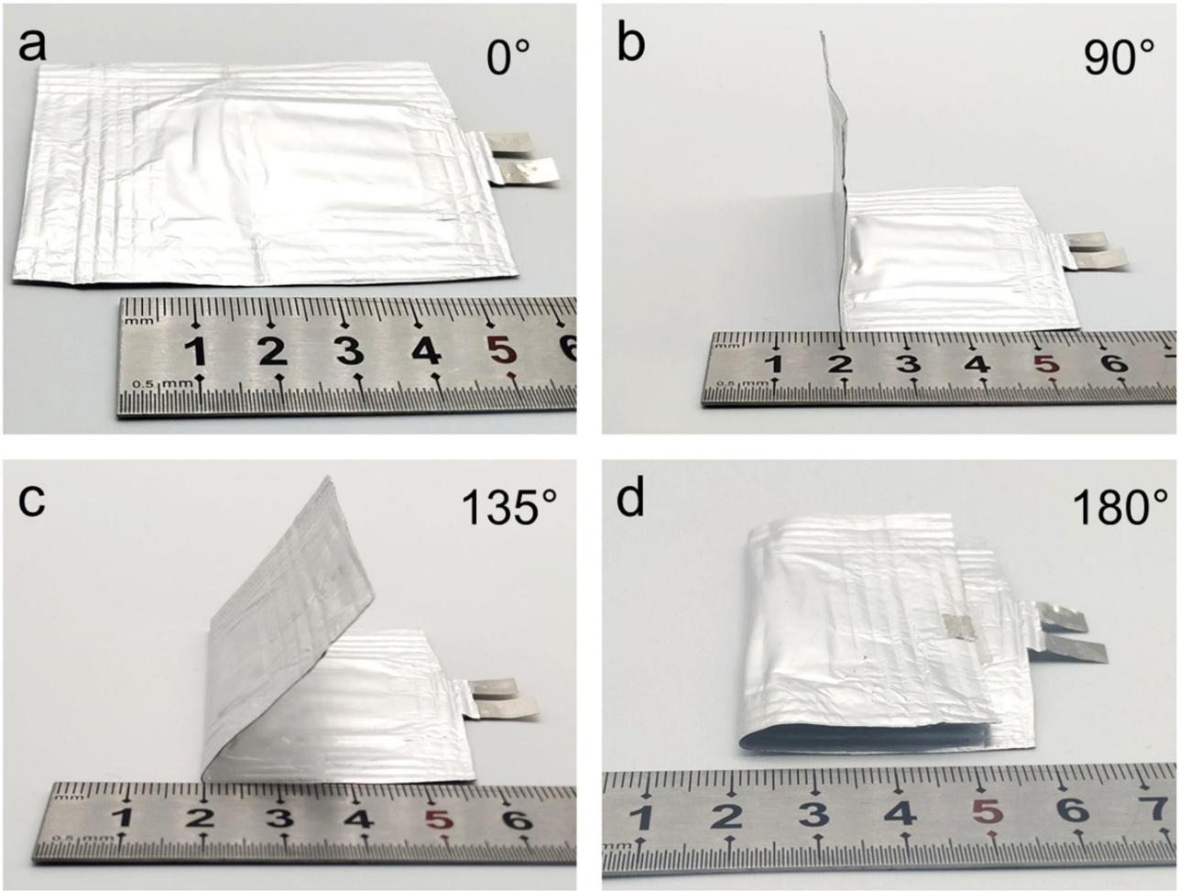
Supplementary Figure 23. Digital photos of ﬂexible ZnSe@Zn-KVOH pouch cell under various bending angles: (a) 0ᵒ, (b) 90ᵒ, (c) 135ᵒ, (d) 180ᵒ.

Supplementary Tables

Supplementary Table 1. Performance comparison of reported dendrite-free Zn anode strategies.
Strategies | Areal current  (mA cm⁻²) | Areal capacity  (mAh cm⁻²) | Voltage hysteresis (mV) | Lifespan | Ref.
ZnSe | 1 | 1 | 30 | 868 | This work
ZnSe | 10 | 10 | 84 | 265 | This work
Nanoporous CaCO₃-coated Zn | 0.25 | 0.05 | 104 | 836 | ⁵
TiO₂ film coated Zn | 1 | 1 | 114 | 150 | ⁶
ZF@F-TiO₂ | 1 | 1 | 60 | 460 | ⁷
ZF@F-TiO₂ | 2 | 2 | 80 | 280 | ⁷
Nanoporous ZnO | 5 | 1.25 | 84 | 500 | ⁸
ZnO array | 1 | 1 | 78 | 400 | ⁹
ZnO array | 5 | 2.5 | 102 | 100 | ⁹
ZnS | 2 | 2 | 70 | 1100 | ³
Kaolin layer | 4.4 | 1.1 | 140 | 800 | ¹⁰
NaTi₂(PO₄)₃ | 1 | 1 | 50 | 260 | ¹¹
In | 1 | 1 | 108 | 520 | ¹²
MXene | 0.2 | 0.2 | 50 | 800 | ¹³
Polyamide | 0.5 | 0.25 | 200 | 8000 | ¹⁴
Polyamide | 10 | 10 | 160 | 150 | ¹⁴
Cyanoacrylate Adhesive | 0.5 | 0.25 | 100 | 800 | ⁴
Cyanoacrylate Adhesive | 2 | 1 | 110 | 400 | ⁴

Supplementary Table 2. The fitting resistance results for symmetric cells based on ZnSe@Zn and bare Zn electrode at different temperatures.
Symmetrical cells | Resistance | 15℃ | 20℃ | 25℃ | 30℃ | 40℃ | 60℃
Zn-Zn | R_{ct} (Ω) | 4119 | 1870 | 1123 | 921 | 394 | 74
ZnSe@Zn-ZnSe@Zn | R_{ct} (Ω) | 530 | 411 | 295 | 240 | 139 | 44

References

1. Xiang B, et al. Green-light-emitting ZnSe nanowires fabricated via vapor phase growth. Appl. Phys. Lett. 82, 3330-3332 (2003).

2. Shakir M, Kushwaha SK, Maurya KK, Bhagavannarayana G, Wahab MA. Characterization of ZnSe nanoparticles synthesized by microwave heating process. Solid State Commun. 149, 2047-2049 (2009).

3. Hao J, et al. An in-depth study of Zn metal surface chemistry for advanced aqueous Zn-ion batteries. Adv. Mater. 32, 2003021 (2020).

4. Cao Z, et al. Eliminating Zn dendrites by commercial cyanoacrylate adhesive for zinc ion battery. Energy Storage Mater. 36, 132-138 (2021).

5. Kang L, et al. Nanoporous CaCO₃ coatings enabled uniform Zn stripping/plating for long-life zinc rechargeable aqueous batteries. Adv. Energy Mater. 8, 1801090 (2018).

6. Zhao K, et al. Ultrathin surface coating enables stabilized zinc metal anode. Adv. Mater. Interfaces 5, 1800848 (2018).

7. Zhang Q, et al. Revealing the role of crystal orientation of protective layers for stable zinc anode. Nat. Commun. 11, 3961 (2020).

8. Xie X, et al. Manipulating the ion-transfer kinetics and interface stability for high-performance zinc metal anodes. Energy Environ. Sci. 13, 503-510 (2020).

9. Kim JY, Liu G, Shim GY, Kim H, Lee JK. Functionalized Zn@ZnO Hexagonal Pyramid Array for Dendrite‐Free and Ultrastable Zinc Metal Anodes. Adv. Funct. Mater. 30, 2004210 (2020).

10. Deng C, et al. A sieve‐functional and uniform‐porous kaolin layer toward stable zinc metal anode. Adv. Funct. Mater. 30, 2000599 (2020).

11. Liu M, Cai J, Ao H, Hou Z, Zhu Y, Qian Y. NaTi₂(PO₄)₃ Solid‐State Electrolyte Protection Layer on Zn Metal Anode for Superior Long‐Life Aqueous Zinc‐Ion Batteries. Adv. Funct. Mater. 30, 2004885 (2020).

12. Han D, et al. A corrosion-resistant and dendrite-free zinc metal anode in aqueous systems. Small 16, 2001736 (2020).

13. Zhang N, Huang S, Yuan Z, Zhu J, Zhao Z, Niu Z. Direct self-assembly of MXene on Zn anodes for dendrite-free aqueous zinc-ion batteries. Angew. Chem. Int. Ed. 60, 2861-2865 (2020).

14. Zhao Z, et al. Long-life and deeply rechargeable aqueous Zn anodes enabled by a multifunctional brightener-inspired interphase. Energy Environ. Sci. 12, 1938-1949 (2019).

