Supporting information:

Preparation of Biodegradable Chitosan Semi-Interpenetrating Network Hydrogel and Its Application for Gastric Retention
DONG Pei^{1,3}，ZHANG Peng^{1,3}，SHENG Yang^{1,3}，SUN Yixin^{1,3}，Mark Bradley^{2,3}, ZHANG RONG^{1,3}
1. School of Materials Science and Engineering, Changzhou University, Changzhou 213164, Jiangsu, P. R. China
2. Precision Healthcare University Research Institute，Queen Mary University of London，67-75 New Road, London E1 1HH, UK
3. Advanced Functional Materials of Jiangsu Joint Laboratory for International Cooperation, Changzhou University, Changzhou 213164, China
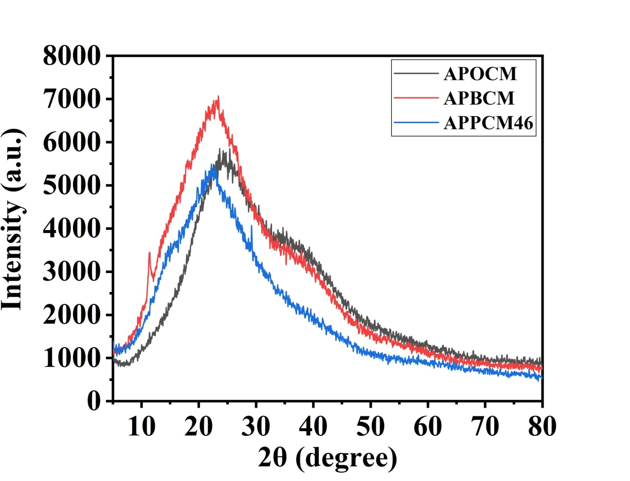

Fig. S1 XRD spectrum of APOCM (hydrogel crosslinked with POGMA), APBCM (hydrogel crosslinked with PBAE) and APPCM-4:6 (hydrogel crosslinked with POGMA/PBAE=4/6) hydrogels dried in air.

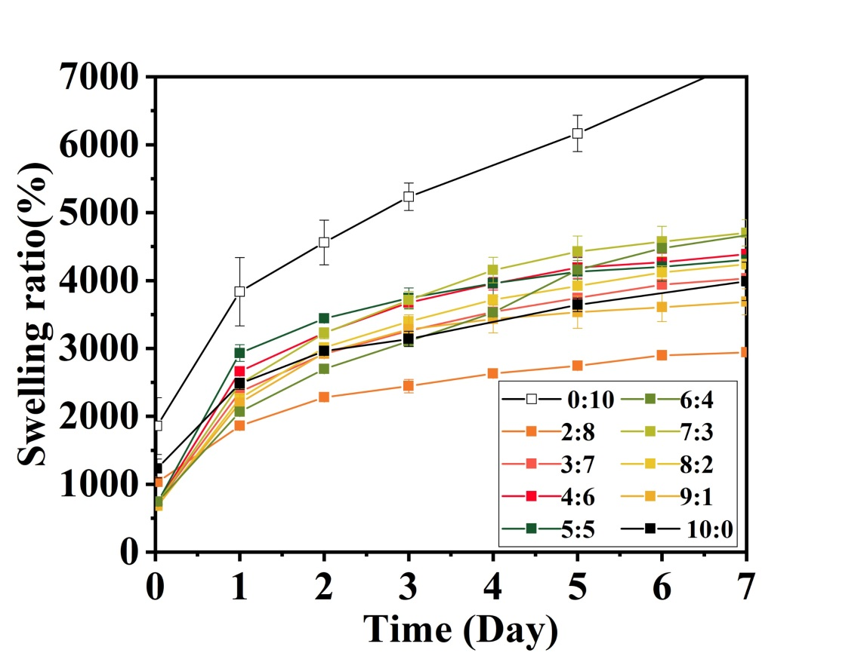

Fig. S2 Swelling ratio of hydrogels in SGF at 37 ºC.

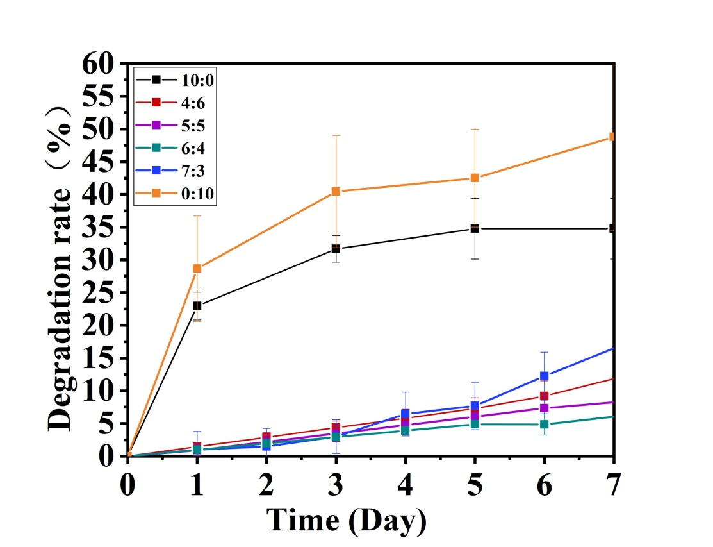

Fig. S3 Degradation ratio of hydrogels in SGF at 37 ºC.
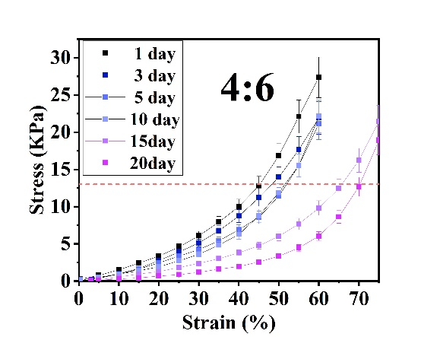
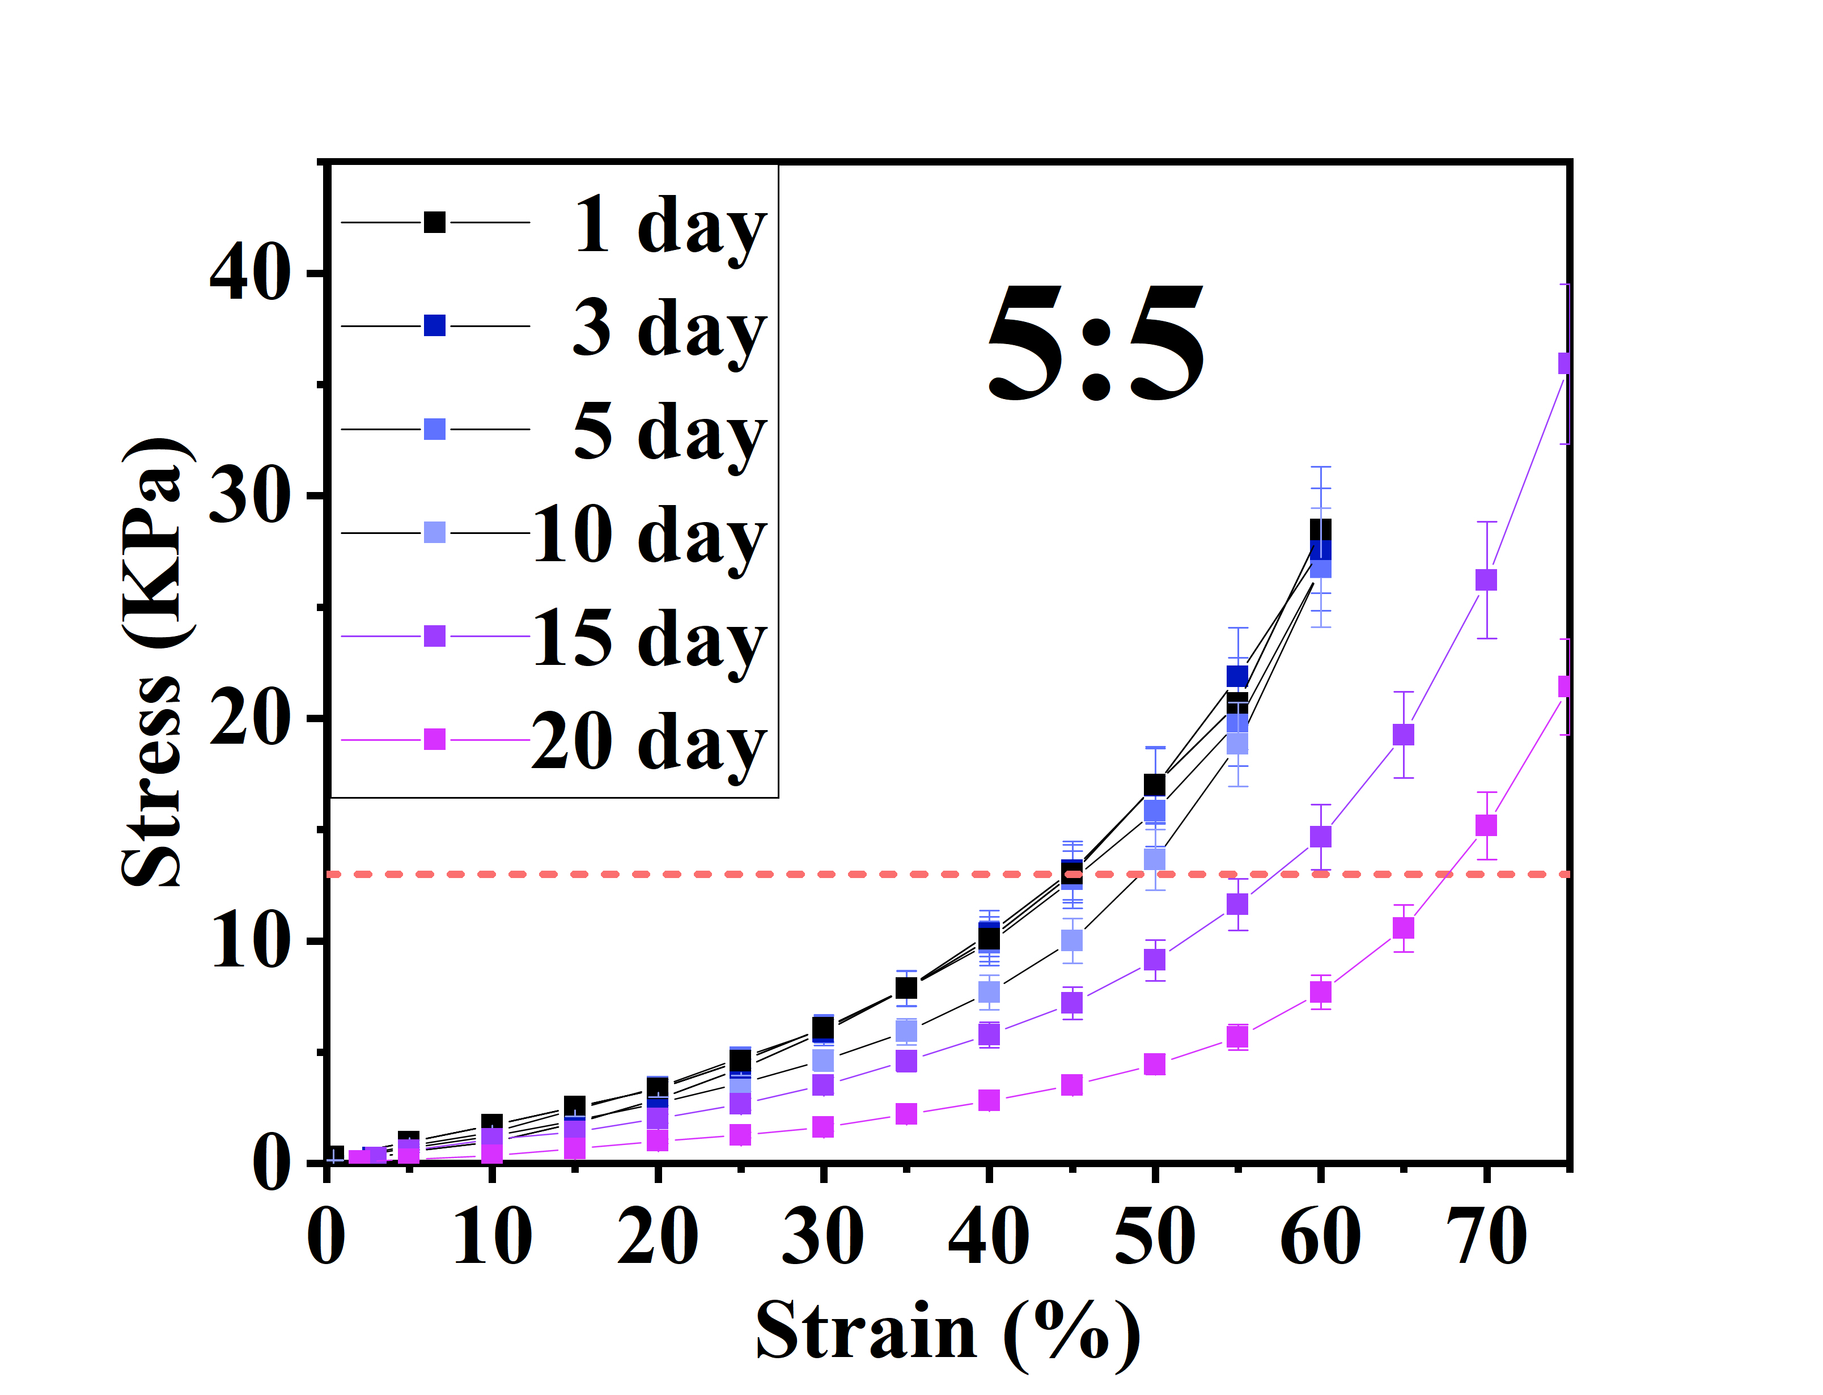
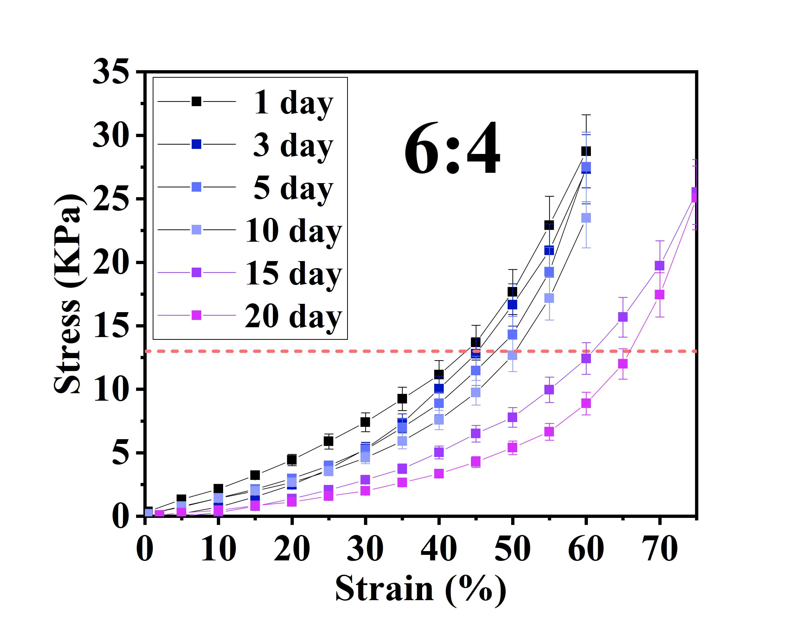
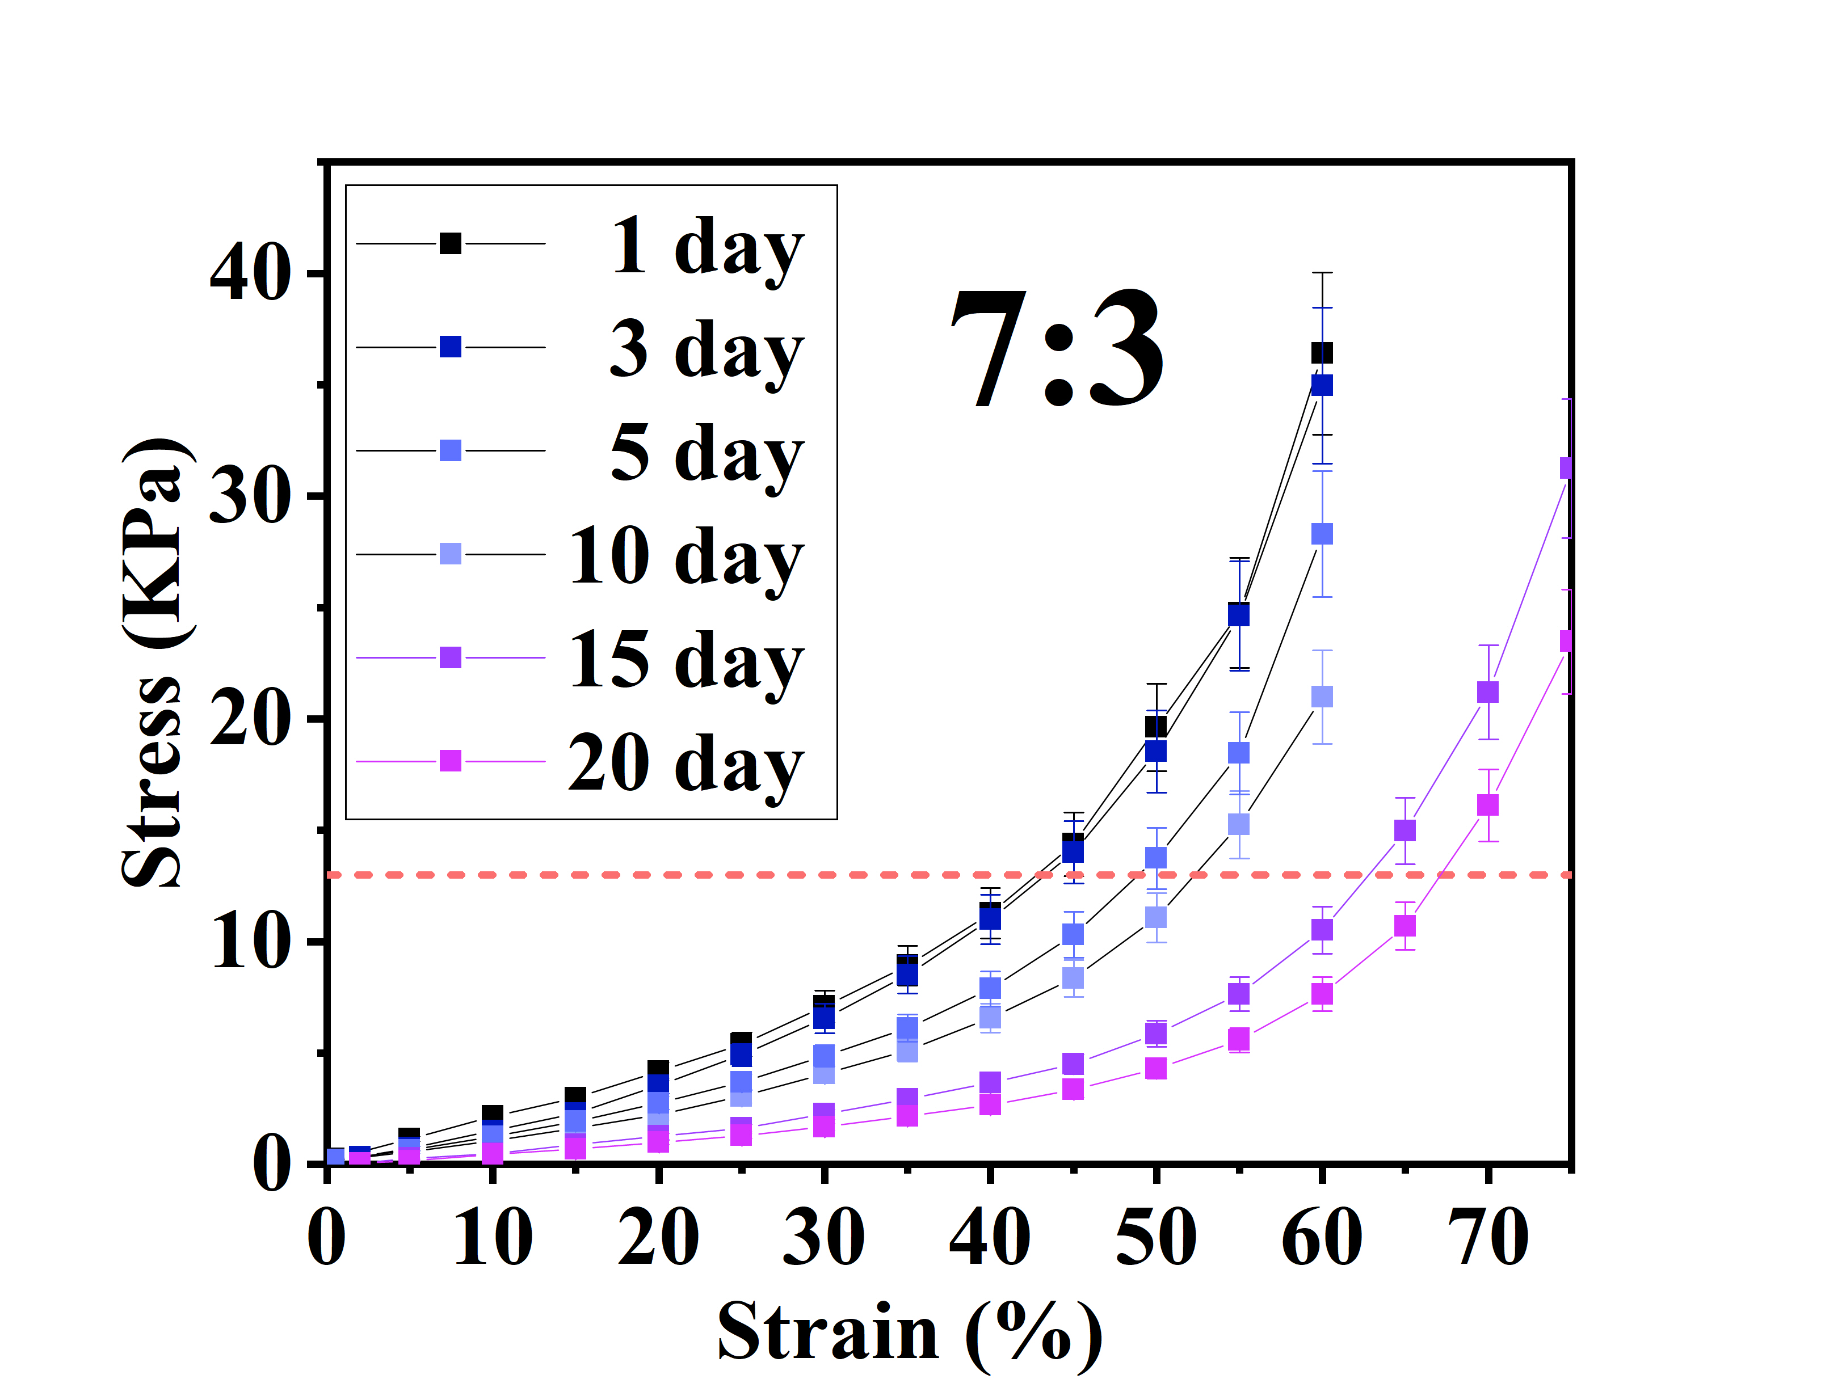

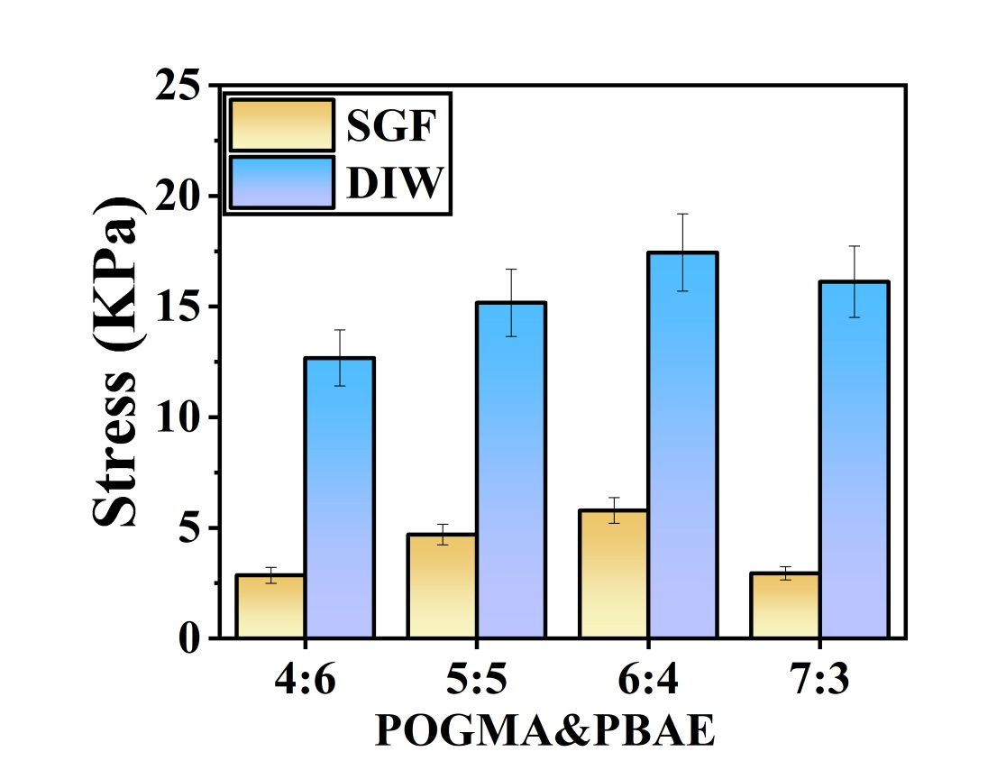
Fig. S4 Changes in the compression performance over time for hydrogels with crosslinker ratios of 4:6-7:3 soaked in deionized water at 37 ºC.

Fig. S5 The compressive stress of hydrogels prepared with different ratios of two crosslinkers soaked in SGF and deionized water (DIW) at 37 ºC for 20 days respectively.

