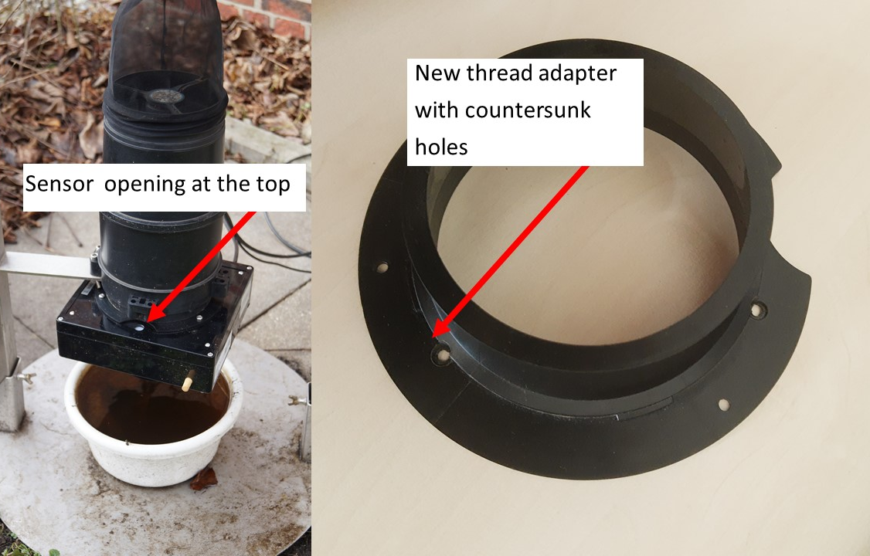
Figure S1: Exposed sensor opening (left) and altered thread adapter (right)

Table. S1: Transmission success rate of the BG-Counter
Location | Trap | Days transmitted | Days captured | Transmission succcess
Berlin | CO₂-Pro-gravid | 9 | 9 | 100
Buchholz | CO₂-Pro-gravid | 9 | 11 | 81.8
Buchholz | CO₂-Pro | 14 | 15 | 93.3
Düsseldorf | CO₂-Pro-gravid | 3 | 3 | 100
Friedberg | CO₂-Pro-gravid | 5 | 5 | 100
Fürth | CO₂-Pro-gravid | 74 | 152 | 48.7
Großheide | CO₂-Pro-gravid | 7 | 7 | 100
Großheide | CO₂-Pro | 11 | 11 | 100
Hamburg 1 | CO₂-Pro-gravid | 109 | 109 | 100
Hamburg 1 | CO₂-Pro | 104 | 104 | 100
Hamburg 2 | CO₂-Pro-gravid | 32 | 32 | 100
Hamburg 2 | CO₂-Pro | 34 | 34 | 100
Hamburg 3 | CO₂-Pro | 36 | 62 | 58.1
Konstanz | CO₂-Pro-gravid | 5 | 7 | 71.4
Landau | CO₂-Pro-gravid | 23 | 23 | 100
Landau | CO₂-Pro | 22 | 22 | 100
March | CO₂-Pro-gravid | 19 | 19 | 100
Neu Wulmsdorf | CO₂-Pro-gravid | 18 | 18 | 100
Neu Wulmsdorf | CO₂-Pro | 11 | 13 | 84.6
Regensburg | CO₂-Pro-gravid | 5 | 11 | 45.5
Tübingen | CO₂-Pro-gravid | 60 | 71 | 84.5
Tübingen | CO₂-Pro | 50 | 50 | 100
Varel 1 | CO₂-Pro-gravid | 33 | 33 | 100
Varel 2 | CO₂-Pro-gravid | 3 | 17 | 17.6
Weinheim | CO₂-Pro-gravid | 78 | 78 | 100
Weinheim | CO₂-Pro | 78 | 78 | 100
Wittenberg | CO₂-Pro | 2 | 6 | 33.3
Mean |  | 31.6  (CI:19 - 44.2) | 37  (CI:21.8 - 52.3) | 85.9  (CI:76.4 - 95.4)

