Table 1 – Baseline characteristics. Percentages have been rounded to the nearest whole number. ¹ Defined as glomerular filtration rate < 30 ml/min ; ² Defined as severe cytolysis (TGO or TGP > 5 times the normal value (NV) or severe cholestasis (ALP > 5 times the NV or Bilirubin > 3 times the NV) ; ³ Defined as left ventricular ejection fraction less than 40% ; ⁴ Defined as dyspnea at rest due to pulmonary cause ; ⁵ Defined as hemoglobin rate < 120 g/l ; ⁶ Defined as platelet count > 400 G/l ; ⁷ Defined as lymphocyte count < 1 G/l ; ⁸ Defined as CRP > 10 mg/l and albuminemia < 35 g/l

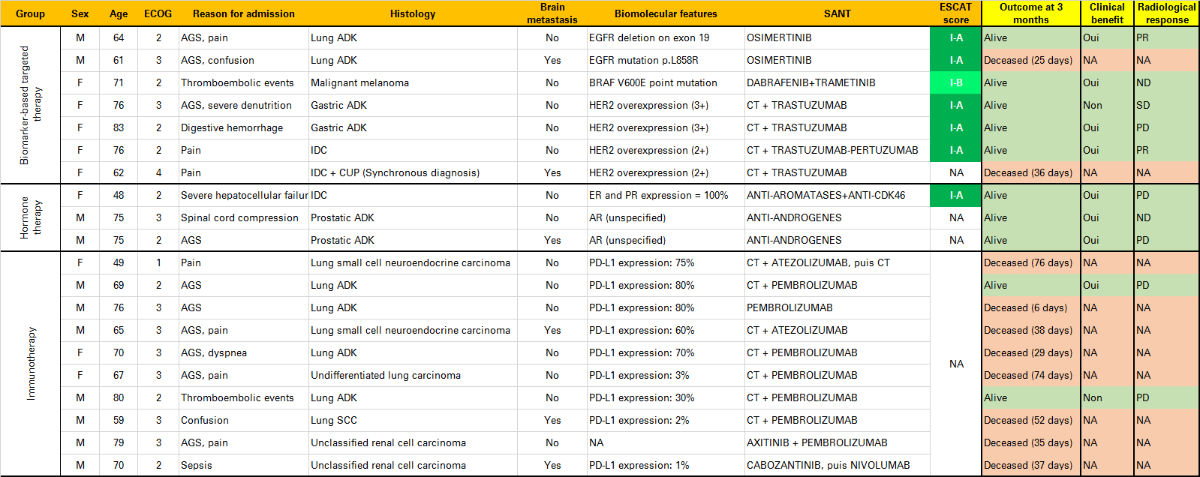
Table 2 – Description of characteristics and outcomes of patients receiving treatments based on biomarkers. AGS: Alteration of General State, CT=Chemotherapy, NA=Not available, ADK=Adenocarcinoma, SCC=squamous cell carcinoma, IDC=Invasive Ductal Carcinoma, CUP=Cancer of Unknown Primary, ER=Estrogene Receptors, PR=Progesterone Receptors, AR=Androgene Receptors, ESCAT=ESMO Scale for Clinical Actionability of molecular Targets, PR=Partial Response, SD = Stable Disease, PD = Progressive Disease.

Table 3.

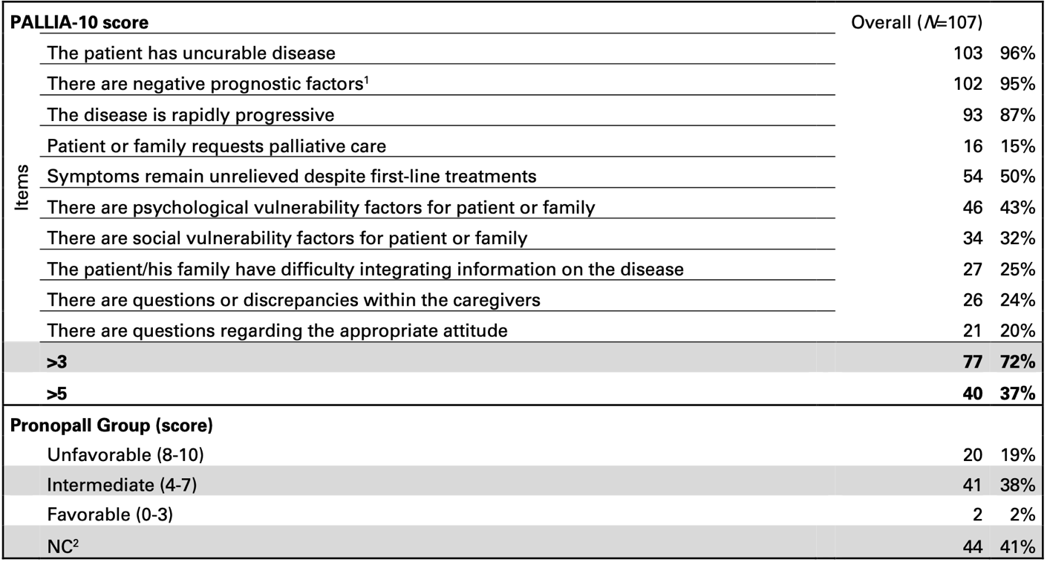
Table 3 – Prognostic scores. ¹Hypoalbuminemia, or inflammatory syndrome, or lymphopenia, or ECOG Performance Status >3 ; ²Not classifiable (LDH value at diagnosis not available)

