Table.04 Docking Result of top identified hits and co-crystalize ligands
Compound ID | PUBCHEM ID | Chemical Structure | Dock Score (kcal/mol)
Compound ID | PUBCHEM ID | Chemical Structure | 2NSD | 4FDO
MK1 | CHEMBL568332 | 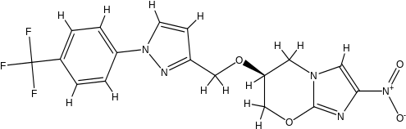 | -7.4 | -6.9
MK2 | CHEMBL565803 | 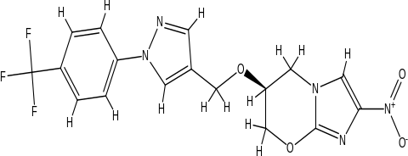 | -8.8 | -7.7
MK3 | CHEMBL566642 | 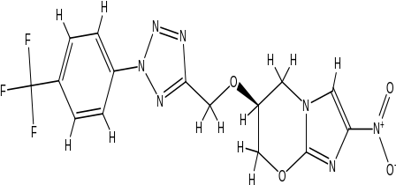 | -9.2 | -8.3
MK4 | CHEMBL566196 | 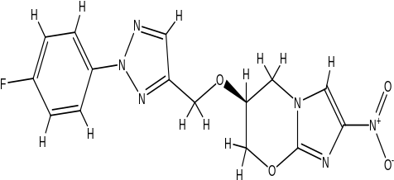 | -8.9 | -8.1
MK5 | CHEMBL566195 | 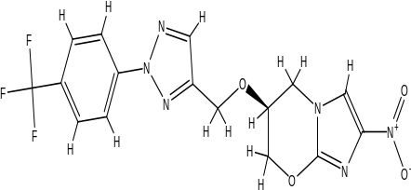 | -7.8 | -6.9
MK6 | CHEMBL565805 | 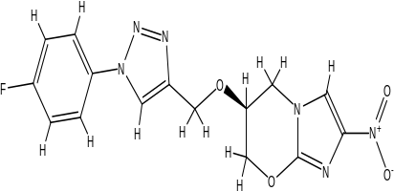 | -8.3 | -6.9
MK7 | CHEMBL567052 | 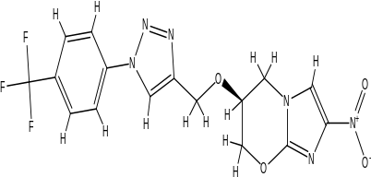 | -7.8 | -6.7
MK8 | CHEMBL567682 | 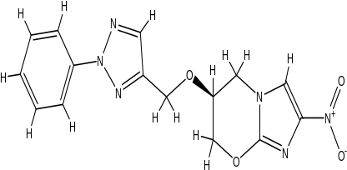 | -8.3 | -8.1
MK9 | CHEMBL565804 | 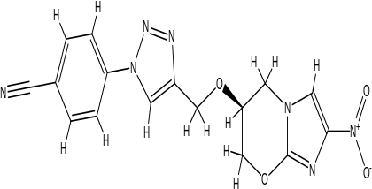 | -7.4 | -6.8
10 | Co-Crystallize ligand of 2NSD | 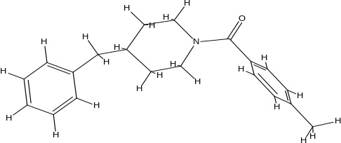 | -6.5 | --
11 | Co-Crystallize ligand of 4FDO | 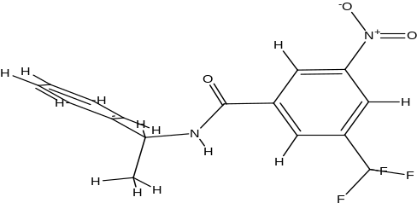 | -- | -8.5
56 | Reference Compound | 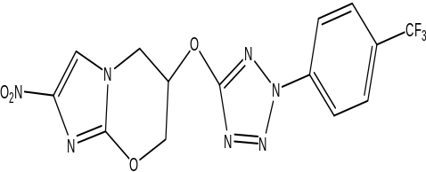 | -8.2 | -9.6

