Supplementary Information
Computational investigation of novel multi-targeted anti-tubercular agents by combined atom-based 3D-QSAR analysis, molecular docking, ADME-Tox, MD simulation and Density Functional Theory (DFT) approaches
Debadash Panigrahi^{a,b*}, Susanta Kumar Sahuª
ªUniversity Department of Pharmaceutical Sciences, Utkal University, VaniVihar, Bhubaneswar, Odisha, India,751004
^{b} Drug Research Laboratory, Nodal Research Centre, College of Pharmaceutical Sciences, Baliguali, Puri- Konark Marine Drive road, Puri, Odisha, India, 752004

Table S1. Chemical Structure, QSAR set, Observed and Predicted activities (pIC50) of the 58, 2-nitroimidazooxazines derivatives

S.No | Chemical Structure | QSAR Set | Experimental  pIC50 | Predicted  pIC50 | Predicted Error | Pharmacophore set
 | 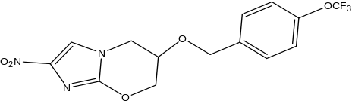 | Training | 6.301 | 6.38926 | 0.0882348 | Inactive
 | 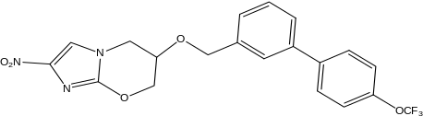 | Test | 6.959 | 6.25581 | -0.702794 | Inactive
 | 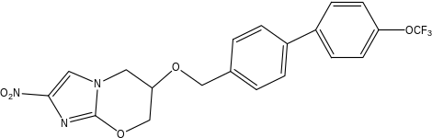 | Training | 7.456 | 7.52455 | 0.068619 | Active
 | 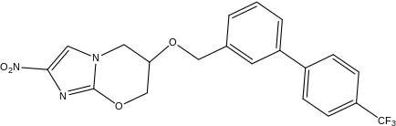 | Training | 6.921 | 6.94398 | 0.0231568 | Inactive
 | 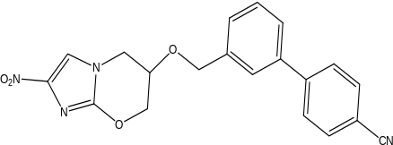 | Test | 6.638 | 6.88755 | 0.249279 | Active
 | 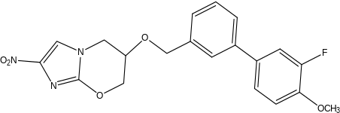 | Test | 6.721 | 7.37897 | 0.657722 | Inactive
 | 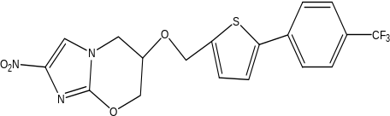 | Training | 6.796 | 6.91609 | 0.120213 | Inactive
 | 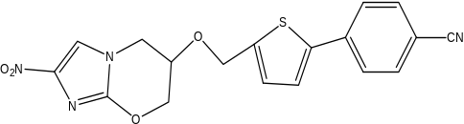 | Training | 7.26 | 7.28841 | 0.0287682 | Inactive
 | 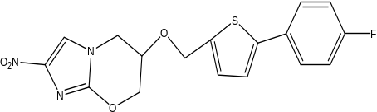 | Training | 7.301 | 7.04531 | -0.255719 | Active
 | 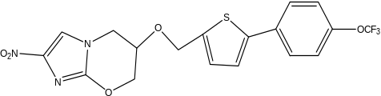 | Training | 6.071 | 6.01655 | -0.0540337 | Inactive
 | 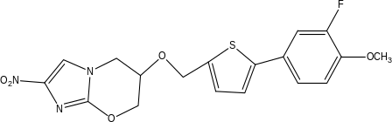 | Training | 7.222 | 6.86542 | -0.356433 | Active
 | 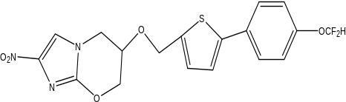 | Training | 6.066 | 6.44087 | 0.375364 | Inactive
 | 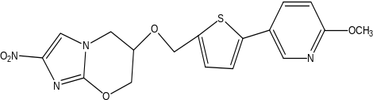 | Training | 6.658 | 6.49436 | -0.163216 | Active
 | 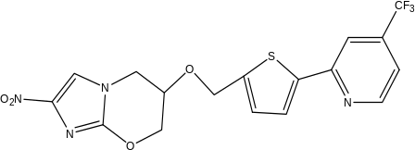 | Training | 6.553 | 6.46806 | -0.0847781 | Inactive
 | 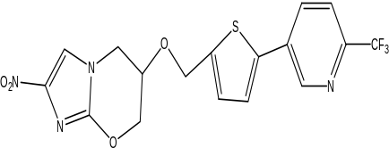 | Test | 7.301 | 6.52934 | -0.771685 | Active
 | 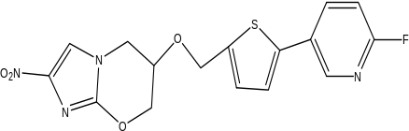 | Training | 6.066 | 6.30124 | 0.23574 | Inactive
 | 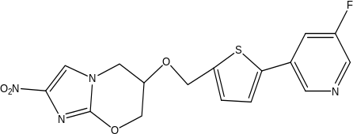 | Test | 6.06 | 6.54071 | 0.480228 | Inactive
 | 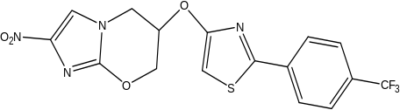 | Training | 5.854 | 5.85724 | 0.00336465 | Inactive
 | 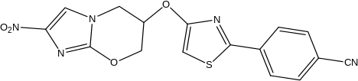 | Test | 6.174 | 5.8588 | -0.31513 | Active
 | 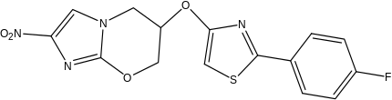 | Test | 6.456 | 5.87722 | -0.578714 | Inactive
 | 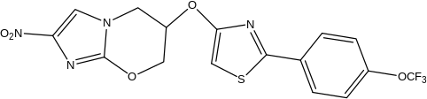 | Test | 5.921 | 5.84828 | -0.0725359 | Active
 | 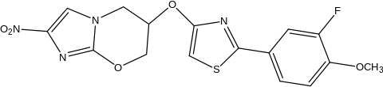 | Test | 6.699 | 5.89563 | -0.80334 | Inactive
 | 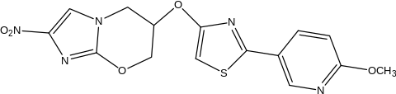 | Training | 5.854 | 5.89563 | 0.041758 | Active
 | 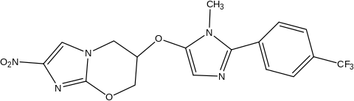 | Training | 6.187 | 6.11499 | -0.0720944 | Inactive
 | 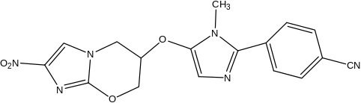 | Training | 5.553 | 5.63855 | 0.0857094 | Inactive
 | 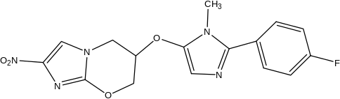 | Training | 5.721 | 5.67918 | -0.0420668 | Active
 | 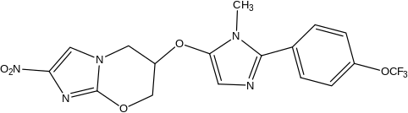 | Training | 5.959 | 6.00851 | 0.0499068 | Inactive
 | 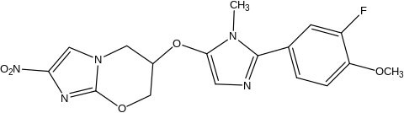 | Test | 5.854 | 5.79994 | -0.0539286 | Inactive
 | 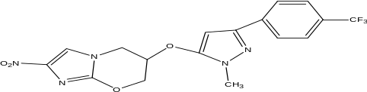 | Test | 7.222 | 7.04643 | -0.175416 | Active
 | 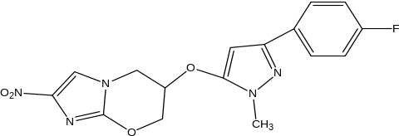 | Training | 6.444 | 6.56636 | 0.122665 | Inactive
 | 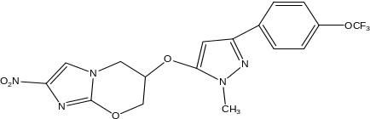 | Training | 7.222 | 7.17928 | -0.0425693 | Active
 | 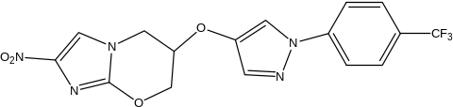 | Training | 6.268 | 6.18335 | -0.0842533 | Inactive
 | 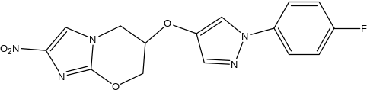 | Training | 6.097 | 6.14477 | 0.0478594 | Inactive
 | 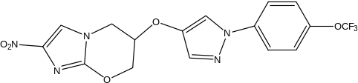 | Training | 6.824 | 6.74383 | -0.0800742 | Inactive
 | 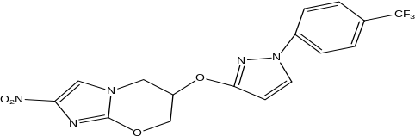 | Training | 7.347 | 7.40962 | 0.0628343 | Active
 | 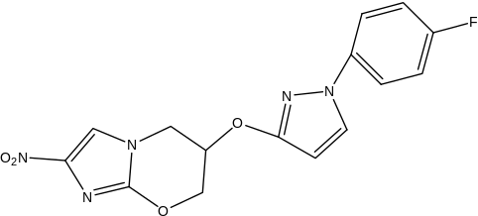 | Training | 6.959 | 6.95113 | -0.00747828 | Inactive
 | 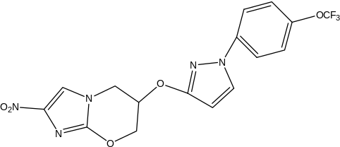 | Training | 7.301 | 7.44334 | 0.142313 | Active
 | 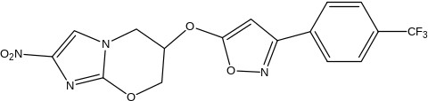 | Training | 6.77 | 6.73625 | -0.0332967 | Inactive
 | 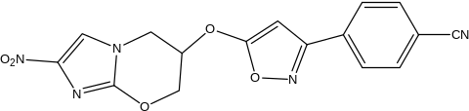 | Training | 5.854 | 5.88357 | 0.0296959 | Active
 | 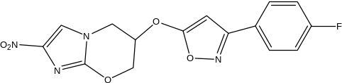 | Training | 5.824 | 5.88357 | 0.0596592 | Inactive
 | 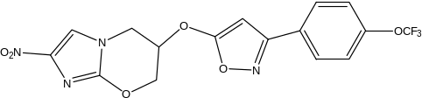 | Test | 6.26 | 6.8702 | 0.610559 | Active
 | 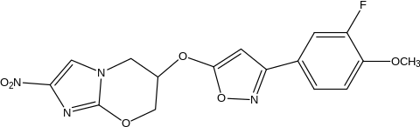 | Test | 5.959 | 6.01904 | 0.0604306 | Inactive
 | 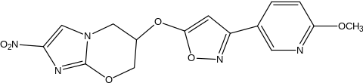 | Test | 5.699 | 5.8668 | 0.16783 | Inactive
 | 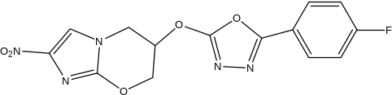 | Test | 5.62 | 6.31998 | 0.700195 | Inactive
 | 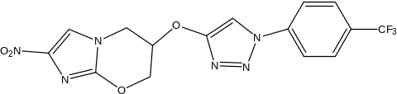 | Test | 6.959 | 6.61071 | -0.347902 | Active
 | 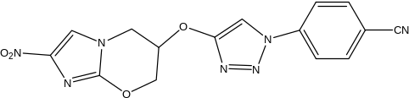 | Training | 6.051 | 5.94966 | -0.100946 | Inactive
 | 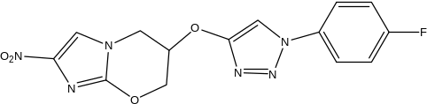 | Training | 5.921 | 5.92724 | 0.00642604 | Inactive
 | 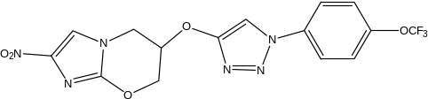 | Training | 7.125 | 7.07447 | -0.0504667 | Active
 | 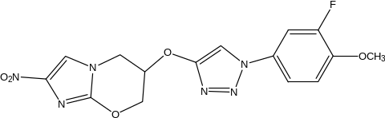 | Training | 6.066 | 6.06225 | -0.00325525 | Inactive
 | 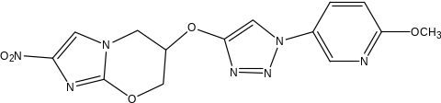 | Training | 5.796 | 5.84675 | 0.0508671 | Inactive
 | 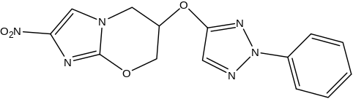 | Training | 6.602 | 6.56474 | -0.0373248 | Inactive
 | 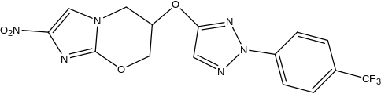 | Test | 7.301 | 7.24393 | -0.0570964 | Active
 | 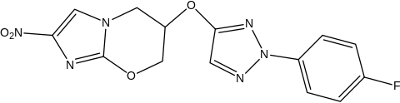 | Training | 6.77 | 6.9496 | 0.180054 | Inactive
 | 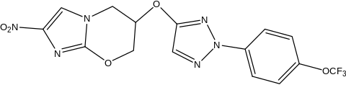 | Training | 7.523 | 7.47824 | -0.0446392 | Active
 | 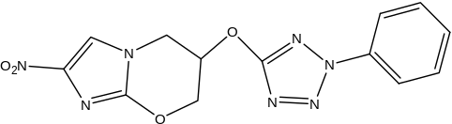 | Training | 5.921 | 5.79341 | -0.127411 | Active
 | 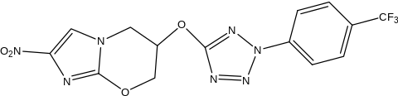 | Training | 6.699 | 6.75369 | 0.0547151 | Inactive
 | 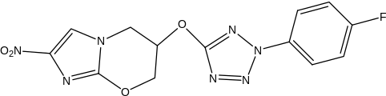 | Training | 6.538 | 6.33208 | -0.205525 | Inactive
 | 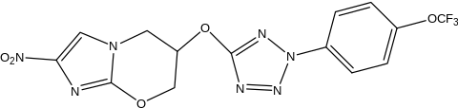 | Training | 7.456 | 7.42359 | -0.032343 | Active

Table S2. Molecular Docking Result

Compound | Docking score (Kcal/mol)
Compound | InhA (2NSD) | DprE1(4FDO)
 | -7.1 | -8
 | -7.5 | -5.9
 | -7.8 | -6.8
 | -8.2 | -7
 | -8.3 | -6.4
 | -7.7 | -6.3
 | -8.1 | -7.4
 | -7.6 | -6.5
 | -7.1 | -7.8
 | -7.2 | -6.6
 | -7.3 | -6.1
 | -7.3 | -6.2
 | -6.8 | -6.8
 | -7.5 | -8.8
 | -7.6 | -7.4
 | -7.1 | -7.9
 | -7 | -6.3
 | -7.5 | -7.8
 | -7.3 | -7
 | -6.9 | -8.2
 | -7 | -6.5
 | -7 | -7
 | -7 | -6.8
 | -7.8 | -7.4
 | -7.6 | -6.6
 | -7.1 | -7.6
 | -7.3 | -6.7
 | -7.3 | -6.5
 | -8 | -8.7
 | -7.3 | -8.6
 | -7.5 | -8
 | -7.8 | -7.9
 | -7 | -8.5
 | -7.1 | -7.4
 | -7.8 | -7.8
 | -7 | -8.2
 | -7 | -7.4
 | -7.8 | -8.4
 | -7.9 | -6.7
 | -7.9 | -7.5
 | -7.2 | -7
 | -7.2 | -7.5
 | -6.9 | -6.6
 | -7.2 | -8.2
 | -7.8 | -8.3
 | -7.5 | -7.1
 | -7.1 | -8.2
 | -7.3 | -7.1
 | -7.2 | -8.1
 | -6.7 | -6.5
 | -6.8 | -8.2
 | -7.9 | -8.6
 | -6.9 | -8.6
 | -7.3 | -7.1
 | -6.9 | -7.9
 | -8.2 | -9.6
 | -7 | -8.1
 | -7.1 | -7.2

Fig. S1

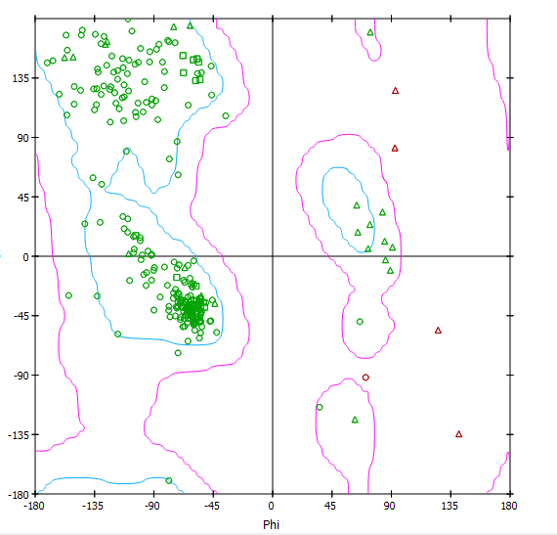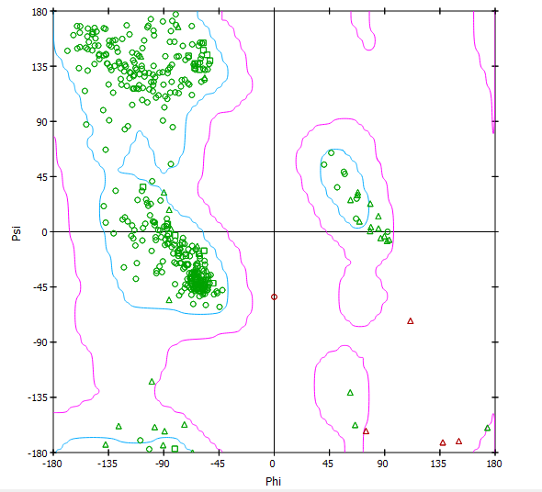
Ramachandran Plot of 2NSD Ramachandran Plot of 4FDO

