Supporting information
Health Beneficial Effects and Chemical Profiles of Special Oolong Teas
Narawadee Rujanapun ¹, Wuttichai Jaidee ¹, Thidarat Duangyod ^{1,2}, Pravaree Phuneerub ^{1,2}, Chakree Wattanasiri ^{1,2}, Napassawan Paojumroom ¹, Tharakorn Maneerat ^{1,3}, Chuchawal Pringpuangkeo ⁴, Rawiwan Charoensup ^{1,2,}*
*Correspondence: rawiwan.cha@mfu.ac.th
¹ Medicinal Plant Innovation Center of Mae Fah Luang University, Mae Fah Luang University, Chiang Rai 57100, Thailand.
² School of Integrative Medicine, Mae Fah Luang University, Chiang Rai 57100, Thailand
³ School of Science, Mae Fah Luang University, Chiang Rai 57100, Thailand
⁴ Doi Chang Tea Co., Ltd., Mae Lao district, Chiang Rai 57250, Thailand.
Full list of author information is available at the end of the article

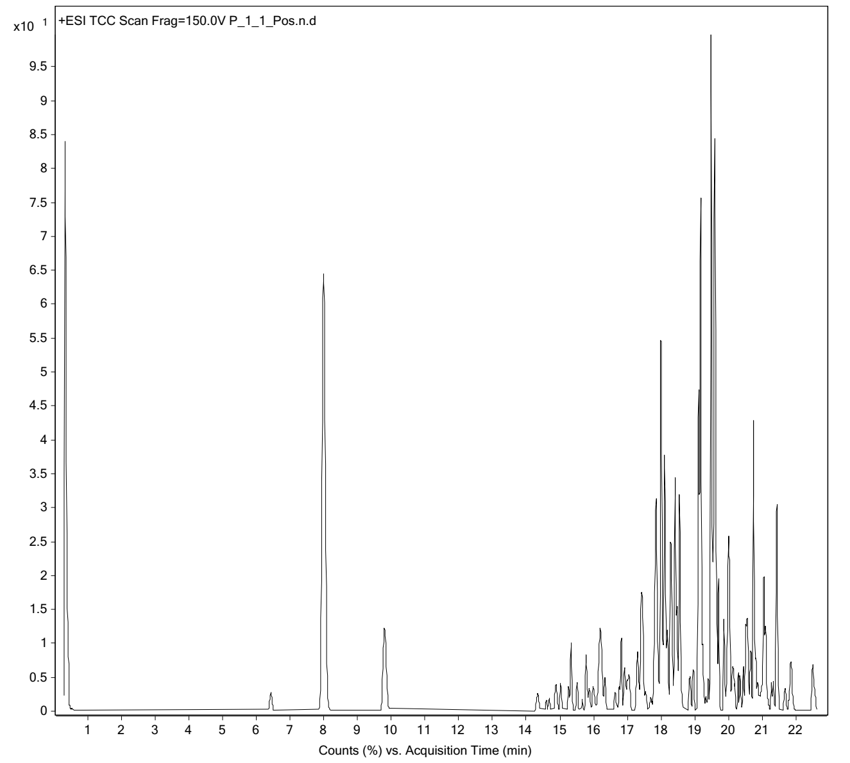
Fig. S1. Total ion chromatograms in positive mode of Peaceful rest tea (PR).
Table S1. List of identified compounds with retention time, accurate mass, and mass error of PR.
No. | Identified Compound | t_{R} (min) | m/z | Adduct | Error  (ppm)
1 | Choline | 1.32 | 104.1072 | M+H | -2.15
2 | Theanine | 1.365 | 175.1079 | M+H | -1.14
3 | Caffeine | 7.41 | 195.0879 | M+H | -1.63
4 | Epiafzelechin | 18.41 | 275.1619 | M+H | -0.53
5 | Gallocatechin (GC) | 6.43 | 307.0813 | M+H | -0.3
6 | Theanine glucoside | 18.86 | 337.0751 | M+H | 0
7 | 3-p-Coumaroylquinic acid | 20.57 | 339.2871 | M+H | -0.46
8 | 5-O-Caffeoylquinic | 15.24 | 355.1729 | M+H | -0.44
9 | Epicatechingallate (ECG) | 20.12 | 443.3347 | M+H | 4.77
10 | Kaempferol 3-O-galactoside | 19.54 | 449.2876 | M+H | 4.98
11 | Epigallocatechin 3-coumaroate | 18.54 | 453.1678 | M+H | 0
12 | Epigallocatechingallae (EGCG) | 19.49 | 459.3556 | M+H | 0
13 | Catechin-5-O-gallate | 14.68 | 465.0793 | M+Na | -0.18
14 | Linalool primeveroside | 16.33 | 471.0920 | M+Na | -0.95
15 | Epigallocatechin 3-methylgallate | 20.00 | 473.3455 | M+H | 0
16 | Epigallocatechin-3-gallate | 9.08 | 481.0744 | M+Na | -0.32
17 | Procyanidin B2 | 16.11 | 579.2200 | M+H | 0
18 | Kaempferol 3-O-glucosylrutinoside | 19.60 | 757.4615 | M+H | 2.66
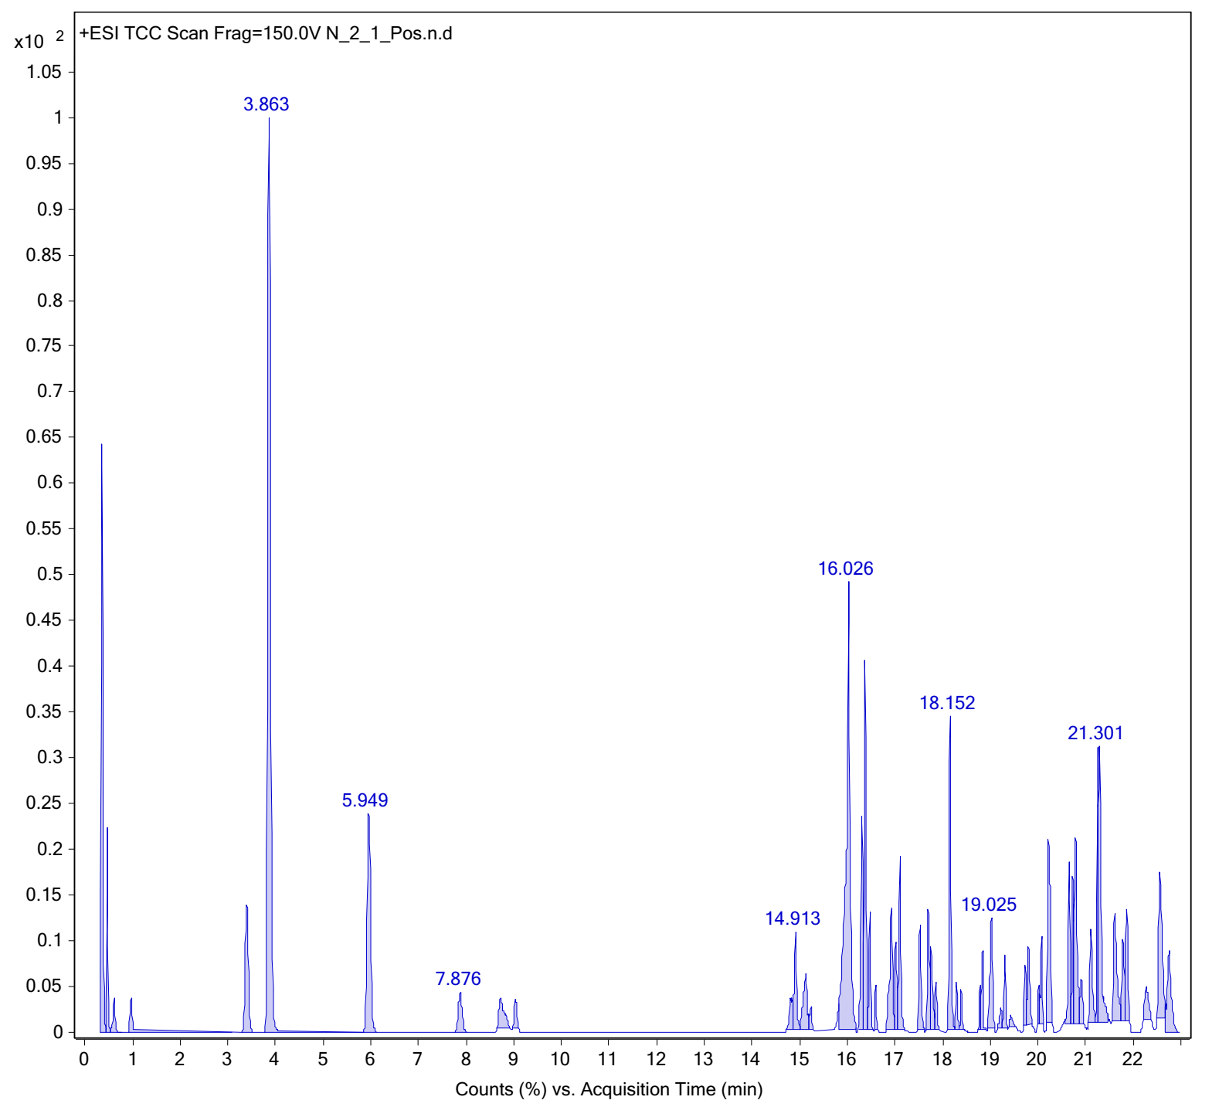
Fig. S2. Total ion chromatograms in positive mode of Eternity tea (EN).
Table S2. List of identified compounds with retention time, accurate mass, and mass error of EN.
No. | Identified Compound | t_{R} (min) | m/z | Adduct | Error  (ppm)
1 | Choline | 0.32 | 104.1068 | M+H | 1.79
2 | Theanine | 0.35 | 175.1079 | M+H | -0.95
3 | Caffeine | 3.81 | 195.0878 | M+H | -0.81
4 | Epiafzelechin | 8.73 | 275.1867 | M+H | -0.33
5 | Epicatechin (EC) | 5.70 | 291.0867 | M+H | 0.79
6 | Gallocatechin (GC) | 3.34 | 307.0815 | M+H | -0.93
7 | Theanine glucoside | 0.46 | 337.1069 | M+H | 0
8 | 1-Caffeoylquinic acid | 9.69 | 355.1730 | M+H | -0.79
9 | Benzyl primeveroside | 16.46 | 425.1366 | M+H | -1.58
10 | Epigallocatechin 3-coumaroate | 17.01 | 453.1677 | M+H | 4.41
11 | Gallocatechingallate | 5.95 | 459.0924 | M+H | -0.39
12 | Quercetin 3-O-glucuronide | 3.34 | 479.0921 | M+H | 0

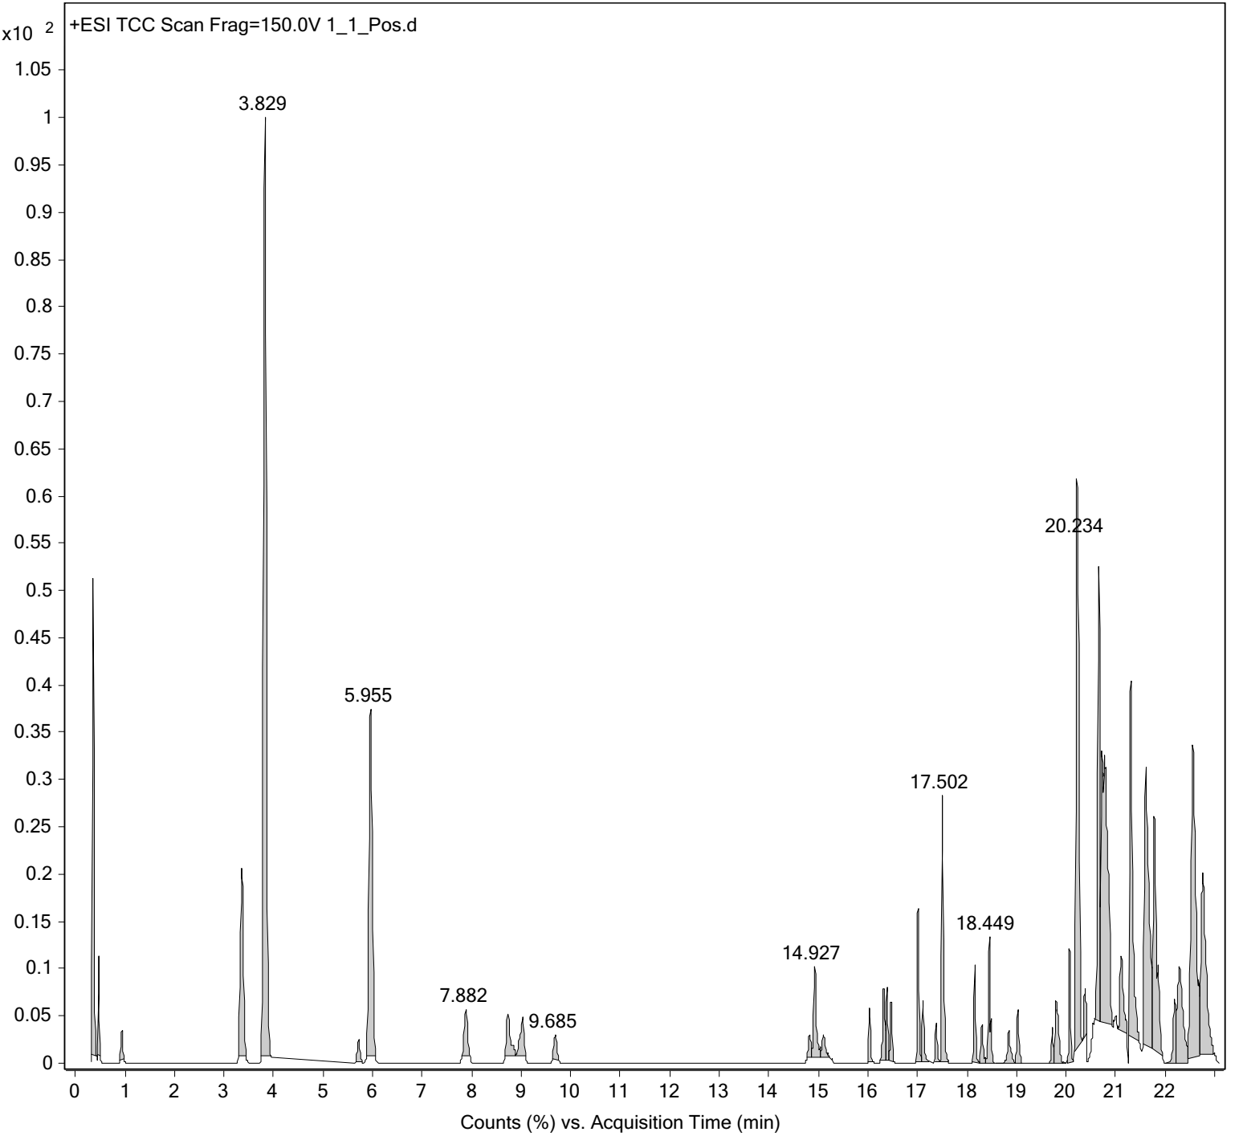
Fig. S3. Total ion chromatograms in positive mode of Oolong tea.
Table S3. List of identified compounds with retention time, accurate mass, and mass error of Oolong tea.
No. | Identified Compound | t_{R} (min) | m/z | Adduct | Error  (ppm)
1 | Choline | 0.32 | 104.1069 | M+H | 1.15
2 | Theanine | 0.46 | 175.1078 | M+H | -0.7
3 | Caffeine | 3.85 | 195.0878 | M+H | -0.89
4 | Epiafzelechin | 8.73 | 275.1867 | M+H | -0.33
5 | Gallocatechin (GC) | 3.35 | 307.0814 | M+H | -0.37
6 | Gallocatechingallate | 5.95 | 459.0924 | M+H | -0.55

