Results Report
Perceptions of Vape and Vape Products
February 28th 2024, 9:35 pm MST
Q1 - What is your sex?
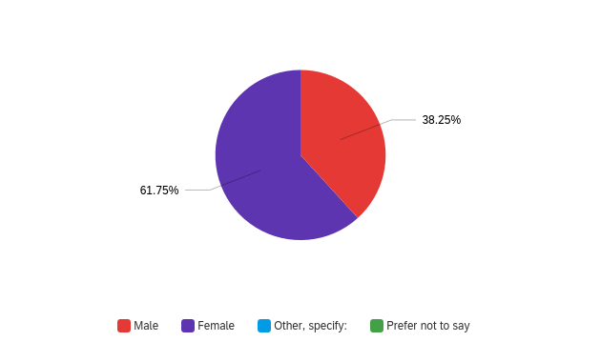

# | Field | Minimum | Maximum | Mean | Std Deviation | Variance | Count
1 | What is your sex? - Selected Choice | 1.00 | 2.00 | 1.62 | 0.49 | 0.24 | 183

# | Answer | % | Count
1 | Male | 38.25% | 70
2 | Female | 61.75% | 113
3 | Other, specify: | 0.00% | 0
4 | Prefer not to say | 0.00% | 0
 | Total | 100% | 183

Q1_3_TEXT - Other, specify:
Other, specify: - Text

Q2 - Do you identify as LatinX?
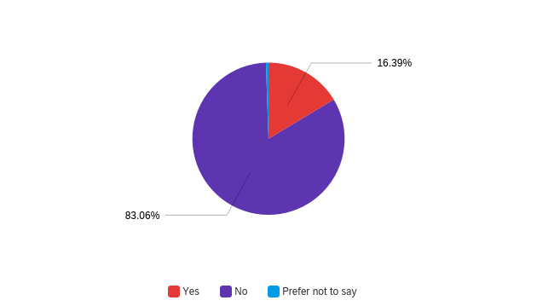

# | Field | Minimum | Maximum | Mean | Std Deviation | Variance | Count
1 | Do you identify as LatinX? | 1.00 | 3.00 | 1.84 | 0.38 | 0.14 | 183

# | Answer | % | Count
1 | Yes | 16.39% | 30
2 | No | 83.06% | 152
3 | Prefer not to say | 0.55% | 1
 | Total | 100% | 183

Q3 - What is your race?
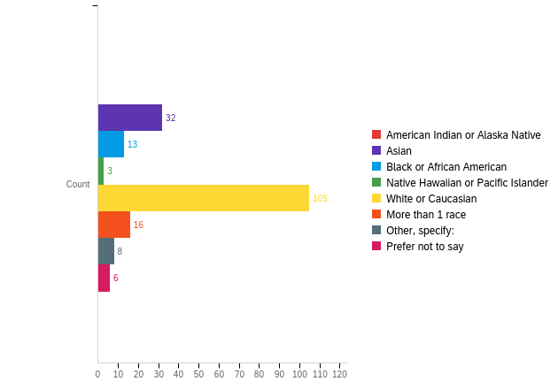

# | Field | Minimum | Maximum | Mean | Std Deviation | Variance | Count
1 | What is your race? - Selected Choice | 2.00 | 8.00 | 4.59 | 1.50 | 2.26 | 183

# | Answer | % | Count
1 | American Indian or Alaska Native | 0.00% | 0
2 | Asian | 17.49% | 32
3 | Black or African American | 7.10% | 13
4 | Native Hawaiian or Pacific Islander | 1.64% | 3
5 | White or Caucasian | 57.38% | 105
6 | More than 1 race | 8.74% | 16
7 | Other, specify: | 4.37% | 8
8 | Prefer not to say | 3.28% | 6
 | Total | 100% | 183

Q3_7_TEXT - Other, specify:
Other, specify: - Text
Middle eastern/North African
middle eastern
Middle eastern
Middle eastern
ubove
Middle Eastern
Jewish, Eastern European
Middle Eastern

Q2 - Are you currently a student?
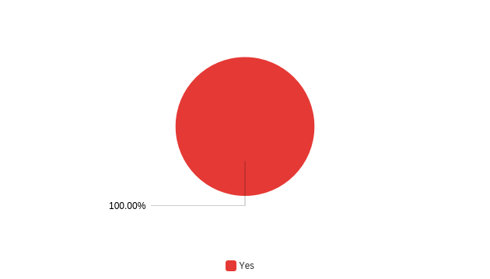

# | Field | Minimum | Maximum | Mean | Std Deviation | Variance | Count
1 | Are you currently a student? | 2.00 | 2.00 | 2.00 | 0.00 | 0.00 | 183

# | Answer | % | Count
2 | Yes | 100.00% | 183
 | Total | 100% | 183

Q3 - Please select your class level...
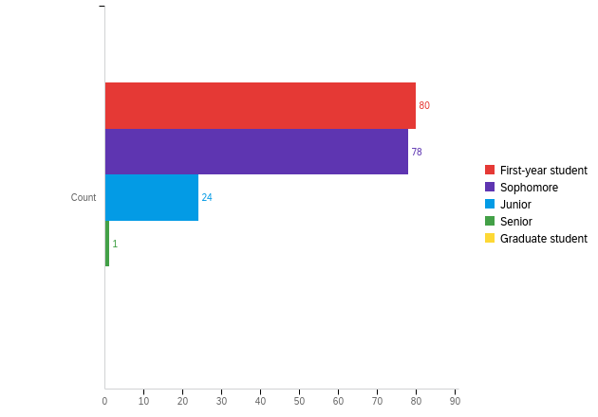

# | Field | Minimum | Maximum | Mean | Std Deviation | Variance | Count
1 | Please select your class level... | 1.00 | 4.00 | 1.70 | 0.71 | 0.50 | 183

# | Answer | % | Count
1 | First-year student | 43.72% | 80
2 | Sophomore | 42.62% | 78
3 | Junior | 13.11% | 24
4 | Senior | 0.55% | 1
5 | Graduate student | 0.00% | 0
 | Total | 100% | 183

Q4 - Please indicate your status...
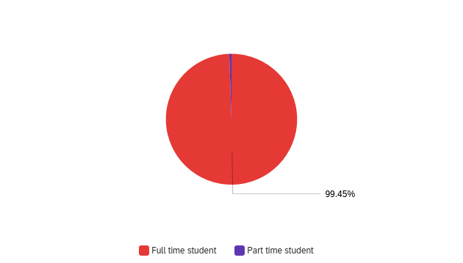

# | Field | Minimum | Maximum | Mean | Std Deviation | Variance | Count
1 | Please indicate your status... | 1.00 | 2.00 | 1.01 | 0.07 | 0.01 | 183

# | Answer | % | Count
1 | Full time student | 99.45% | 182
2 | Part time student | 0.55% | 1
 | Total | 100% | 183

Q5 - Please select the age group to which you belong…
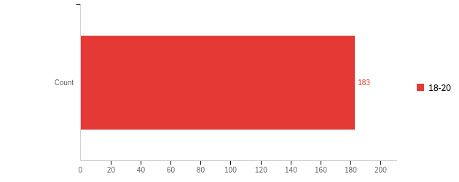

# | Field | Minimum | Maximum | Mean | Std Deviation | Variance | Count
1 | Please select the age group to which you belong… | 1.00 | 1.00 | 1.00 | 0.00 | 0.00 | 183

# | Answer | % | Count
1 | 18-20 | 100.00% | 183
 | Total | 100% | 183

Q6 - Have you ever smoked cigarettes?
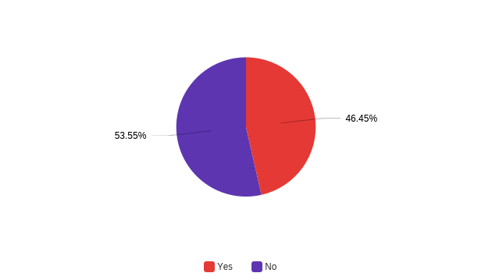

# | Field | Minimum | Maximum | Mean | Std Deviation | Variance | Count
1 | Have you ever smoked cigarettes? | 1.00 | 2.00 | 1.54 | 0.50 | 0.25 | 183

# | Answer | % | Count
1 | Yes | 46.45% | 85
2 | No | 53.55% | 98
 | Total | 100% | 183

Q7 - Do you currently smoke cigarettes?
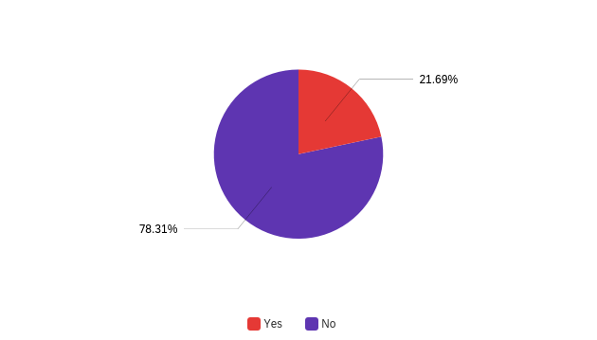

# | Field | Minimum | Maximum | Mean | Std Deviation | Variance | Count
1 | Do you currently smoke cigarettes? | 1.00 | 2.00 | 1.78 | 0.41 | 0.17 | 83

# | Answer | % | Count
1 | Yes | 21.69% | 18
2 | No | 78.31% | 65
 | Total | 100% | 83

Q8 - How frequently do you smoke cigarettes?
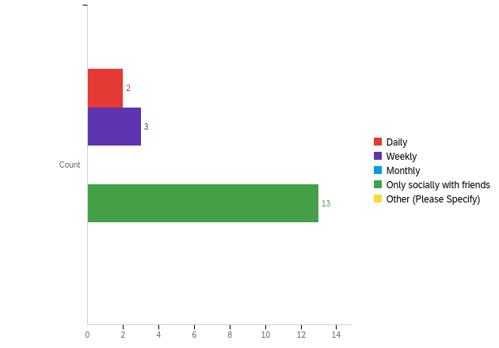

# | Field | Minimum | Maximum | Mean | Std Deviation | Variance | Count
1 | How frequently do you smoke cigarettes? | 1.00 | 4.00 | 3.33 | 1.11 | 1.22 | 18

# | Answer | % | Count
1 | Daily | 11.11% | 2
2 | Weekly | 16.67% | 3
3 | Monthly | 0.00% | 0
4 | Only socially with friends | 72.22% | 13
5 | Other (Please Specify) | 0.00% | 0
 | Total | 100% | 18

Q9 - Do you currently vape, or have you ever vaped or used electronic cigarettes?
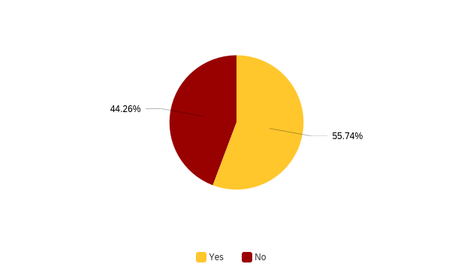

# | Field | Minimum | Maximum | Mean | Std Deviation | Variance | Count
1 | Do you currently vape, or have you ever vaped or used electronic cigarettes? | 1.00 | 2.00 | 1.44 | 0.50 | 0.25 | 183

# | Answer | % | Count
1 | Yes | 55.74% | 102
2 | No | 44.26% | 81
 | Total | 100% | 183

Q10 - At what age did you first vape?
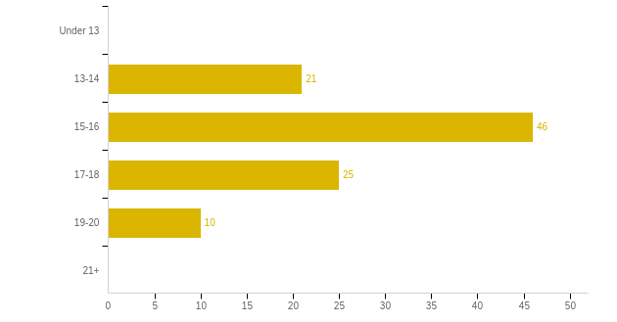

# | Field | Minimum | Maximum | Mean | Std Deviation | Variance | Count
1 | At what age did you first vape? | 2.00 | 5.00 | 3.24 | 0.89 | 0.79 | 102

# | Answer | % | Count
1 | Under 13 | 0.00% | 0
2 | 13-14 | 20.59% | 21
3 | 15-16 | 45.10% | 46
4 | 17-18 | 24.51% | 25
5 | 19-20 | 9.80% | 10
6 | 21+ | 0.00% | 0
 | Total | 100% | 102

Q11 - What type of vape product did you first use?
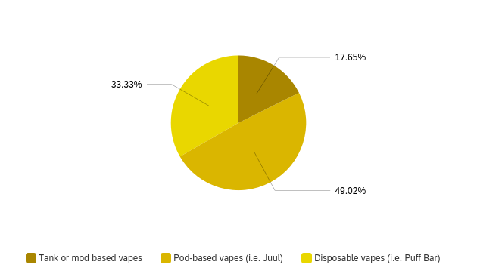

# | Answer | % | Count
1 | Tank or mod based vapes | 17.65% | 18
2 | Pod-based vapes (i.e. Juul) | 49.02% | 50
3 | Disposable vapes (i.e. Puff Bar) | 33.33% | 34
 | Total | 100% | 102

Q12 - Have you ever used, or do you currently use disposable vapes such as Puff Bars?
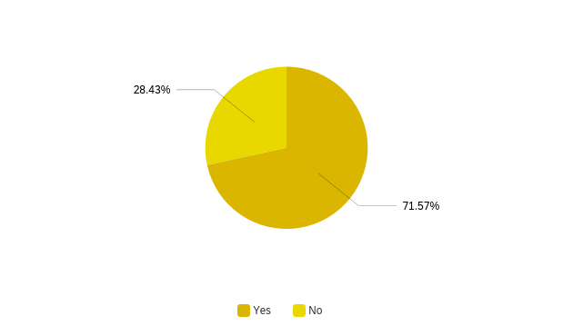

# | Field | Minimum | Maximum | Mean | Std Deviation | Variance | Count
1 | Have you ever used, or do you currently use disposable vapes such as Puff Bars? | 1.00 | 2.00 | 1.28 | 0.45 | 0.20 | 102

# | Answer | % | Count
1 | Yes | 71.57% | 73
2 | No | 28.43% | 29
 | Total | 100% | 102

Q13 - Of vape products which do/did you most commonly use?
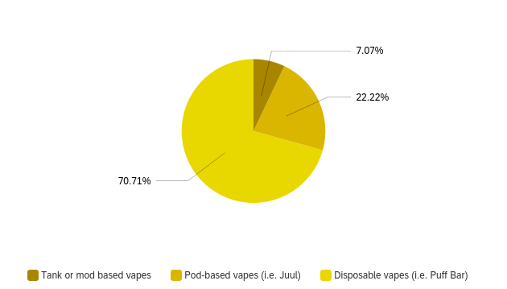

# | Field | Minimum | Maximum | Mean | Std Deviation | Variance | Count
1 | Of vape products which do/did you most commonly use? | 1.00 | 3.00 | 2.64 | 0.61 | 0.37 | 99

# | Answer | % | Count
1 | Tank or mod based vapes | 7.07% | 7
2 | Pod-based vapes (i.e. Juul) | 22.22% | 22
3 | Disposable vapes (i.e. Puff Bar) | 70.71% | 70
 | Total | 100% | 99

Q14 - At what age did you first use a disposable vape?
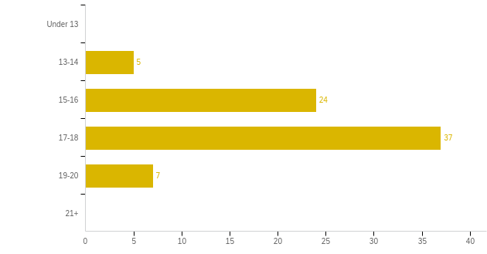

# | Answer | % | Count
1 | Under 13 | 0.00% | 0
2 | 13-14 | 6.85% | 5
3 | 15-16 | 32.88% | 24
4 | 17-18 | 50.68% | 37
5 | 19-20 | 9.59% | 7
6 | 21+ | 0.00% | 0
 | Total | 100% | 73

Q15 - Approximately what year was it that you first used a disposable vape?
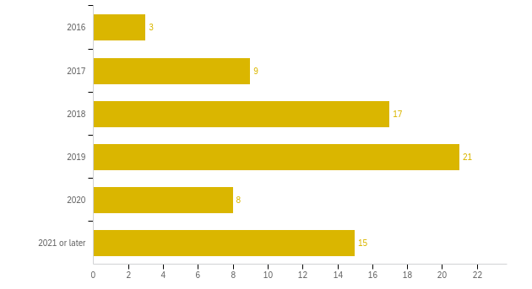

# | Field | Minimum | Maximum | Mean | Std Deviation | Variance | Count
1 | Approximately what year was it that you first used a disposable vape? | 1.00 | 6.00 | 3.92 | 1.42 | 2.02 | 73

# | Answer | % | Count
1 | 2016 | 4.11% | 3
2 | 2017 | 12.33% | 9
3 | 2018 | 23.29% | 17
4 | 2019 | 28.77% | 21
5 | 2020 | 10.96% | 8
6 | 2021 or later | 20.55% | 15
 | Total | 100% | 73

Q16 - Of disposable vapes, which flavor do you most commonly use?
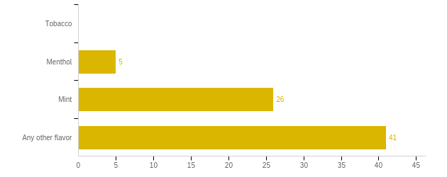

# | Field | Minimum | Maximum | Mean | Std Deviation | Variance | Count
1 | Of disposable vapes, which flavor do you most commonly use? | 2.00 | 4.00 | 3.50 | 0.62 | 0.39 | 72

# | Answer | % | Count
1 | Tobacco | 0.00% | 0
2 | Menthol | 6.94% | 5
3 | Mint | 36.11% | 26
4 | Any other flavor | 56.94% | 41
 | Total | 100% | 72

Q17 - Select the aspects of disposable vapes that make them more attractive to you as opposed to other vape products.
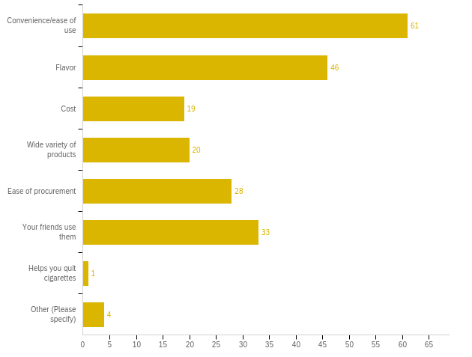

# | Answer | % | Count
1 | Convenience/ease of use | 28.77% | 61
2 | Flavor | 21.70% | 46
3 | Cost | 8.96% | 19
4 | Wide variety of products | 9.43% | 20
5 | Ease of procurement | 13.21% | 28
6 | Your friends use them | 15.57% | 33
7 | Helps you quit cigarettes | 0.47% | 1
8 | Other (Please specify) | 1.89% | 4
 | Total | 100% | 212

Q17_8_TEXT - Other (Please specify)
Other (Please specify) - Text
Stress relief
Don’t have to charge
the icy mint
Where I lived they didn't sell pod vapes

Q34 - Which of the following is the most attractive aspect of disposable vapes that makes them more attractive to you as opposed to other vape products?
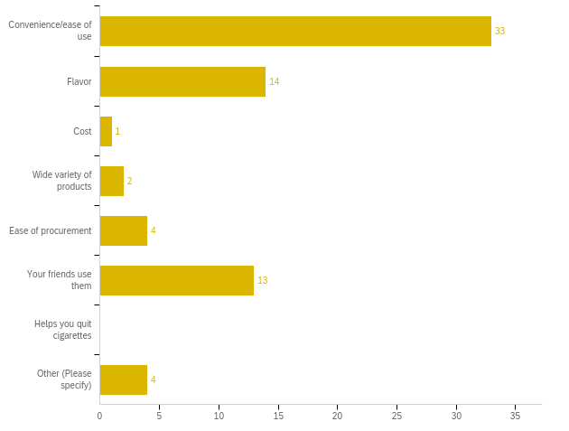

# | Field | Minimum | Maximum | Mean | Std Deviation | Variance | Count
1 | Which of the following is the most attractive aspect of disposable vapes that makes them more attractive to you as opposed to other vape products? - Selected Choice | 1.00 | 8.00 | 2.85 | 2.31 | 5.34 | 71

# | Answer | % | Count
1 | Convenience/ease of use | 46.48% | 33
2 | Flavor | 19.72% | 14
3 | Cost | 1.41% | 1
4 | Wide variety of products | 2.82% | 2
5 | Ease of procurement | 5.63% | 4
6 | Your friends use them | 18.31% | 13
7 | Helps you quit cigarettes | 0.00% | 0
8 | Other (Please specify) | 5.63% | 4
 | Total | 100% | 71

Q34_8_TEXT - Other (Please specify)
Other (Please specify) - Text
buzz
Don’t have to buy a device. So it feels like more a short term thing
I don't prefer disposable vapes
I had never seen pod based

Q18 - Select all the disposable vape brands you have used.
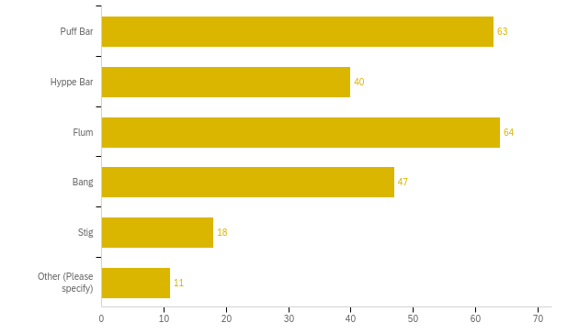

# | Answer | % | Count
1 | Puff Bar | 25.93% | 63
2 | Hyppe Bar | 16.46% | 40
3 | Flum | 26.34% | 64
4 | Bang | 19.34% | 47
5 | Stig | 7.41% | 18
6 | Other (Please specify) | 4.53% | 11
 | Total | 100% | 243

Q18_6_TEXT - Other (Please specify)
Other (Please specify) - Text
Stiiizy
Posh
i never really bought my own, i would just use whatever brand my friend had
Eon, Hyde, Luto
Elfbar
Elfbar
elf, hyde
Eflbar
Gang
Mr. Vapor, Breeze
There's like at least ten more

Q19 - Of these disposable vape brands, which do/did you most commonly use?
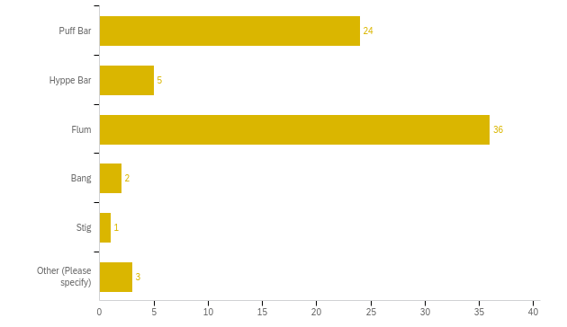

# | Field | Minimum | Maximum | Mean | Std Deviation | Variance | Count
1 | Of these disposable vape brands, which do/did you most commonly use? - Selected Choice | 1.00 | 6.00 | 2.44 | 1.25 | 1.57 | 71

# | Answer | % | Count
1 | Puff Bar | 33.80% | 24
2 | Hyppe Bar | 7.04% | 5
3 | Flum | 50.70% | 36
4 | Bang | 2.82% | 2
5 | Stig | 1.41% | 1
6 | Other (Please specify) | 4.23% | 3
 | Total | 100% | 71

Q19_6_TEXT - Other (Please specify)
Other (Please specify) - Text
elf
Breeze

Q20 - How often did or do you vape? (not puffs taken per day but "sessions" of using a vape)
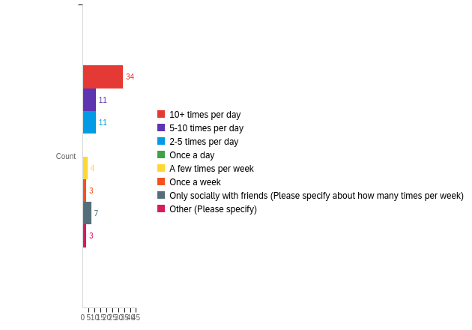

# | Field | Minimum | Maximum | Mean | Std Deviation | Variance | Count
1 | How often did or do you vape? (not puffs taken per day but &quot;sessions&quot; of using a vape) - Selected Choice | 1.00 | 8.00 | 2.74 | 2.26 | 5.10 | 73

# | Answer | % | Count
1 | 10+ times per day | 46.58% | 34
2 | 5-10 times per day | 15.07% | 11
3 | 2-5 times per day | 15.07% | 11
4 | Once a day | 0.00% | 0
5 | A few times per week | 5.48% | 4
6 | Once a week | 4.11% | 3
7 | Only socially with friends (Please specify about how many times per week) | 9.59% | 7
8 | Other (Please specify) | 4.11% | 3
 | Total | 100% | 73

Q20_7_TEXT - Only socially with friends (Please specify about how many times per week)
Only socially with friends (Please specify about how many times per week) - Text
2/3
1
4
1
possibly once a week? really depends. i don’t own one
1
Once a week or so

Q20_8_TEXT - Other (Please specify)
Other (Please specify) - Text
randomly
Only tried it once
Probably 1-2 times a month

Q21 - Where did or do you most commonly get your vape products?
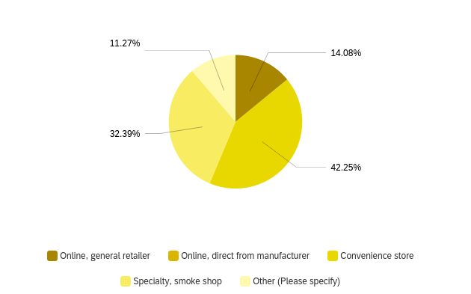

# | Field | Minimum | Maximum | Mean | Std Deviation | Variance | Count
1 | Where did or do you most commonly get your vape products? - Selected Choice | 1.00 | 5.00 | 3.27 | 1.13 | 1.27 | 71

# | Answer | % | Count
1 | Online, general retailer | 14.08% | 10
2 | Online, direct from manufacturer | 0.00% | 0
3 | Convenience store | 42.25% | 30
4 | Specialty, smoke shop | 32.39% | 23
5 | Other (Please specify) | 11.27% | 8
 | Total | 100% | 71

Q21_5_TEXT - Other (Please specify)
Other (Please specify) - Text
friends
friends
Smoked socially used other peioles
duffl
Duffl
friend
I just hit my friends vapes
Friends

Q22 - On average, how much did/do you typically spend on vape products monthly?
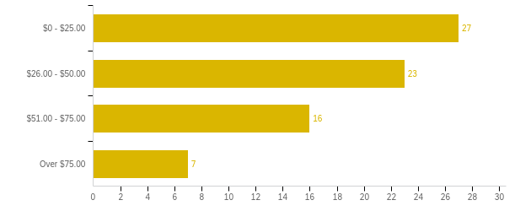

# | Field | Minimum | Maximum | Mean | Std Deviation | Variance | Count
1 | On average, how much did/do you typically spend on vape products monthly? | 1.00 | 4.00 | 2.04 | 0.99 | 0.97 | 73

# | Answer | % | Count
1 | $0 - $25.00 | 36.99% | 27
2 | $26.00 - $50.00 | 31.51% | 23
3 | $51.00 - $75.00 | 21.92% | 16
4 | Over $75.00 | 9.59% | 7
 | Total | 100% | 73

