Promotion of wound healing by insulin-like growth factor-1-loaded Bombyx mori L. silk fibroin films in diabetic mice

Meng-Jin Lin^{1,2}, Mei-Chun Lu¹, Yun-Chen Chan¹ and Hwan-You Chang^{2*}

¹ Miaoli District Agricultural Research and Extension Station, Council of Agriculture, Executive Yuan, Miaoli, R. O. C. (Taiwan).
² Institute of Molecular Medicine, National Tsing Hua University, Hsinchu, R. O. C. (Taiwan).

* Corresponding authors:
Hwan-You Chang,
Institute of Molecular Medicine, National Tsing Hua University
101 Kuang Fu Road Sec. 2, Hsin Chu, R. O. C. (Taiwan).
Tel.: +886-3-574-2909.
E-mail: hychang@life.nthu.edu.tw

Supplementary Information

We cultured cells in regular and high glucose conditions to simulate diabetes. Compared to regular medium, the hyperglycemic medium inhibited wound closure of BALB/3T3 cells by 14% and 42% at 48 h and 72 h, respectively (Figure S1a). We compared the effects of IGF-1 alone, SF-film, and SF-film–IGF-1 on wound closure and proliferation of BALB/3T3 fibroblasts in regular and hyperglycemic medium. The SF-film alone was sufficient to stimulate BALB/3T3 fibroblast proliferation in regular culture medium (Figure S1b). Further, we investigated whether SF-film–IGF-1 promotes wound healing in diabetic mice. As shown in Figure 5, the wound area of db/db mice treated with 3.25 pmol IGF-1 was smaller than that in the control group. Despite the wound-healing effects of 3.25 pmol IGF-1, an increase in IGF-1 dose to 65.0 pmol did not yield a better outcome (Figure S2a). Comparable results were observed after treatment with SF-film–IGF-1 loaded with either 3.25 or 65.0 pmol IGF-1 for eight days (Figure S2b). We also examined wound histology by Masson's trichrome staining. There were no significant difference between any of the SF-film treated groups, with or without IGF-1groups were observed in the area of regenerated adipose and granulation tissues (Figure S3a, b).

a
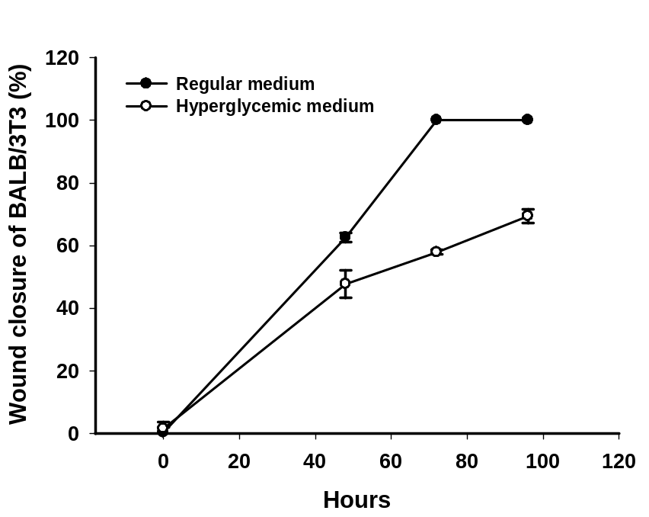
***
***
b
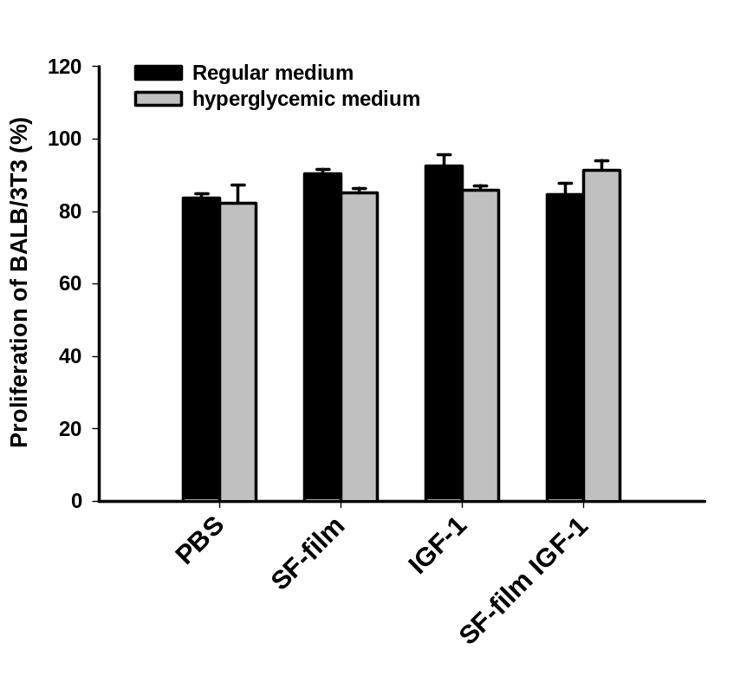
*
*

Figure S1. Migration and proliferation of BALB/3T3 fibroblasts in response to insulin-like growth factor 1 (IGF-1), silk fibroin (SF)-film, and IGF-1-loaded SF-film treatment. (a) Quantification of cell wound closure in regular and hyperglycemic media. Significant differences between regular and hyperglycemic culture medium were determined by Dunnett’s multiple comparison post hoc test. *p < 0.05, **p < 0.01 and, *** p < 0.001; n = 4; mean ± SEM. (b) Cell proliferation after IGF-1, SF-film, or IGF-1 loaded SF-film treatment in regular or hyperglycemic medium. Significant differences between PBS and the other treatments were determined by Dunnett’s multiple comparison post hoc test. *p < 0.05; n = 4; mean ± SEM.

a
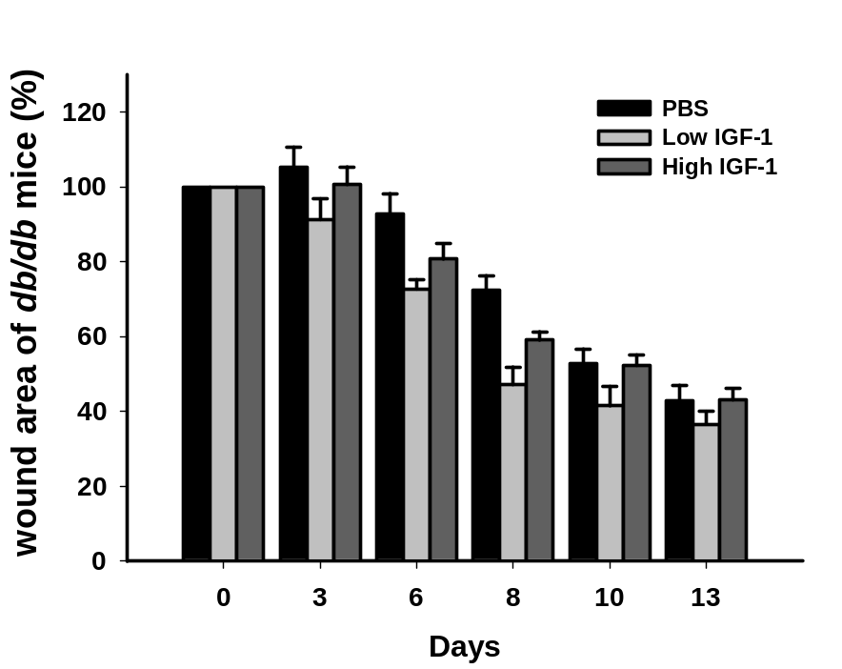
*
*
**
b
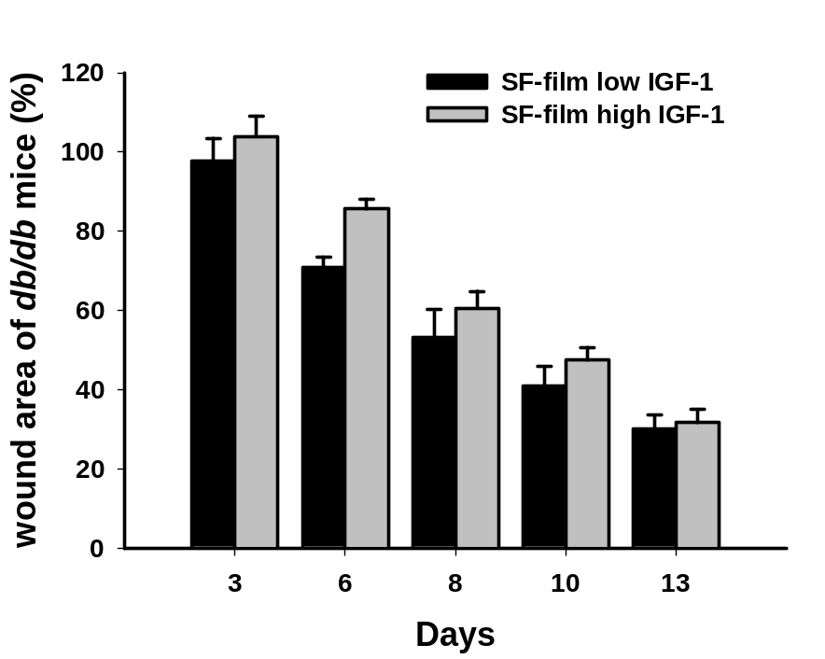
**

Figure S2. Time-course analysis of diabetic wound healing after insulin-like growth factor 1 (IGF-1), silk fibroin (SF)-film, and IGF-1-loaded SF-film treatment. (a) Quantification of wound closure from day 0 to day 13 post-wounding upon treatment with high and low doses of IGF-1. Significant differences between PBS and IGF-1 treatments were determined by Dunnett’s multiple comparison post hoc test. *p < 0.05, and **p < 0.01; n = 5; mean ± SEM. (b) Quantification of wound closure from day 0 to day 13 post-wounding upon treatment with high and low doses of IGF-1-loaded SF-films. Significant differences between high and low dose treatments were determined by Dunnett’s multiple comparison post hoc test. *p < 0.05, and **p < 0.01; n = 5; mean ± SEM.

a
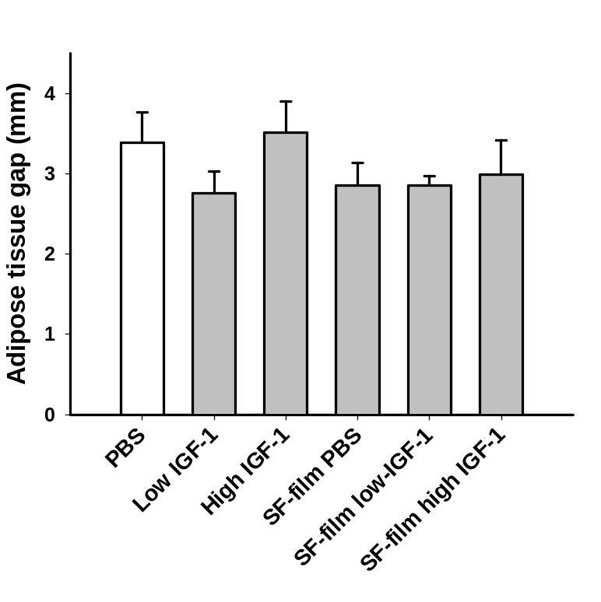
b
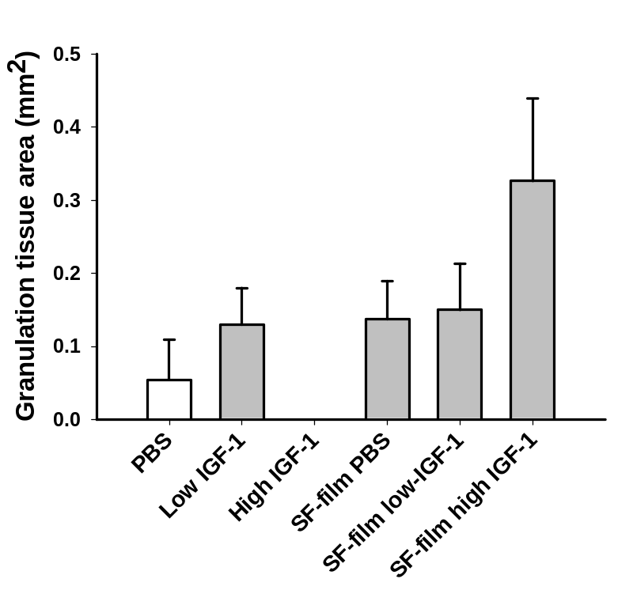

Figure S3. Analysis of tissue regeneration in diabetic wounds after insulin-like growth factor 1 (IGF-1)-loaded silk fibroin (SF)-film treatment. Tissues at day 13 post-wounding were histologically sectioned and subjected to Masson's trichrome staining. Quantification of (a) adipose tissue gaps and (b) granulation tissue areas. No significant differences between PBS and other treatments were determined by Dunnett’s multiple comparison post hoc test (n = 5); mean ± SEM.

