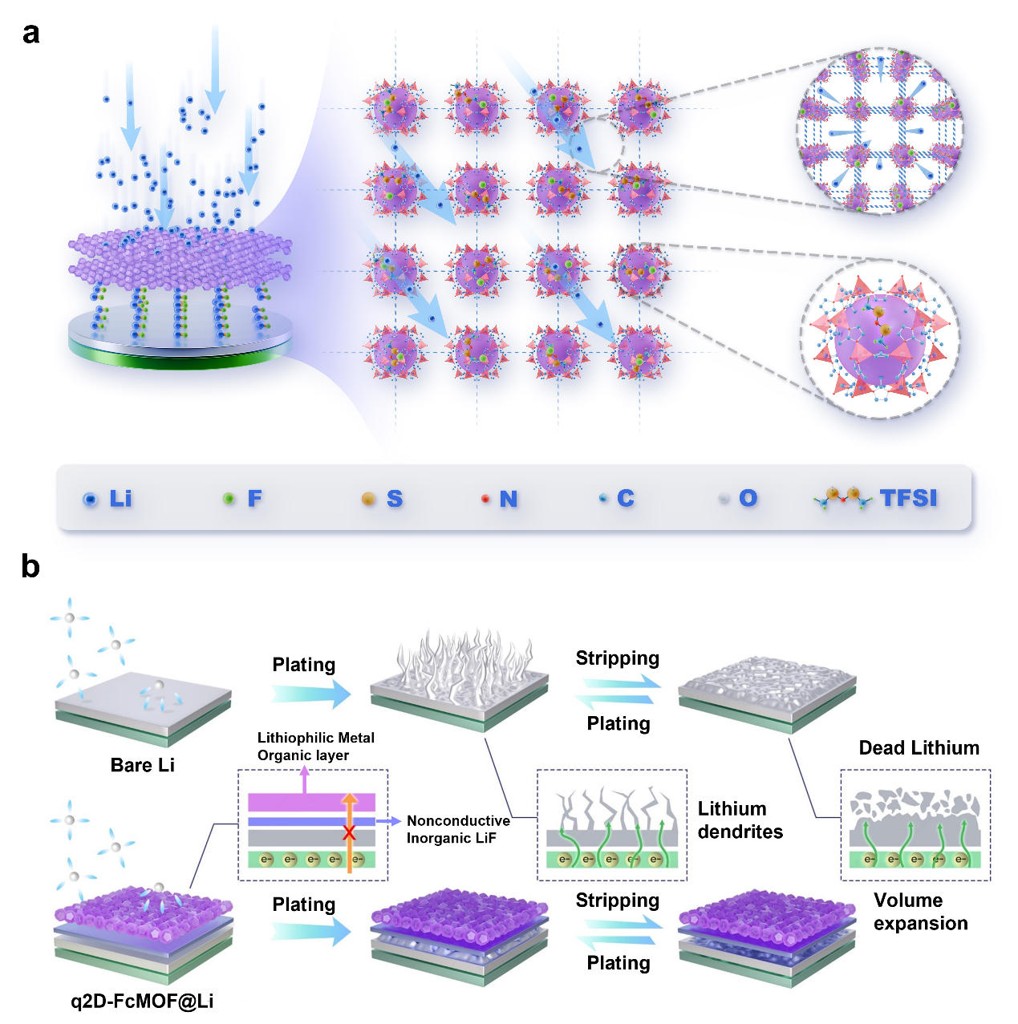
Scheme 1 Schematic illustration of organometallic frame/inorganic LiF hybrid double-layer ASEI formed on Li with uniform nucleation site and ionic channels for fast Li⁺ transport.
Scheme 2 Schematic illustration of Li deposition behaviors on bare Li and q2D-FcMOF@Li.

