Supporting information
Quasi-two-dimensional self-assembled fluorinated MOF to construct organic/inorganic hybrid double layer with burst Li+ transmission channels

Lingchen Kongª, Yu Li^{d}, Cong Peng^{d}, Ziyue Zhaoª, Junwei Xiaoª, Wei Feng^{a,b,c,*}

ª School of Materials Science and Engineering and Tianjin Key Laboratory of Composite and Functional Materials, Tianjin University, Tianjin 300350, P. R. China
^{b} Tianjin Key Laboratory of Composite and Functional Materials, Tianjin 300354, P. R China
^{c} Key Laboratory of Advanced Ceramics and Machining Technology, Ministry of Education, Tianjin 300354, P. R China
^{d} Institute of advanced technology and equipment, Beijing University of Chemical Technology, Beijing 100029, P. R. China
* Corresponding author. E-mail: weifeng@tju.edu.cn (W. Feng).

- Experimental section
1.1 Materials
Zn(CH₃COO)₂·2H₂O, 2-methylimidazole, Co(CH₃COO)₂·4H₂O, ZrCl₄, terephthalic acid, 4,4’-bipyridine, NiSO₄·6H₂O, N,N-dimethylformamide, pyridine, dimethyl formamide (DMF) was purchased from Aladdin Biochemical Technology Co., Ltd. (Shanghai, China). Ar gas, N₂ gas, F₂ gas were purchased from Vista Technology Co., Ltd. (Tianjin, China). N-methylpyrrolidone, lithium electrode, LFP, NCM811, LiNO₃ was purchased from Kelud Chemical Technology Co., LTD. (Shanghai, China). Fluorinated graphite was purchased from Zhongshan Photoelectric Materials Co. Ltd (Shandong, China). Unless otherwise noted, all reagents and solvents were obtained from commercial sources and used directly without further purification.
1.2 Preparation of fluorinated quasi-two-dimensional organometallic frame microporous carbon
Synthesis of ZIF-8: 1.50 g Zn(CH₃COO)₂·2H₂O was dissolved in 25 mL of deionized water and slowly added to 25 mL of deionized water containing 5.60 g 2-methylimidazole, stirred for 2 min, left at room temperature for 4 h, centrifuged and collected samples, washed the product with water several times, and ZIF-8 crystals were obtained after drying.
Synthesis of ZIF-67: 1.70 g Co(CH₃COO)₂·4H₂O was dissolved in 25 mL of deionized water and slowly added to 25 mL of deionized water containing 5.60 g 2-methylimidazole, stirred for 2 min, left at room temperature for 4 h, centrifuged and collected samples, washed the product with water several times, and ZIF-67 crystals were obtained after drying.
Synthesis of UIO-66: 0.31 g ZrCl₄ and 0.23 g terephthalic acid were dissolved in 70 mL DMF successively, stirred for 2 min, sealed in Teflon hydrothermal synthesis reactor (capacity: 100 mL) at 120 ℃ for 24 h, cooled to room temperature, centrifuged and collected samples. After washing the product with with water, DMF and ethanol for several times, UIO-66 crystals were obtained after drying.
Synthesis of Ni-MOF: 1.56 g 4,4 '-bipyridine and 2.62 g NiSO₄·6H₂O were dissolved in 50 mL water, then 5 mL pyridine was dropped under stirring conditions, and 25 mL anhydrous ethanol was added. After the solution was continuously stirred for 5 min, it was sealed in a Teflon hydrothermal synthesis reactor (capacity: 100 mL) and reacted at 100 ℃ for 24 h. After cooling to room temperature, the green solid product was centrifuged to collect, washed with the product water and ethanol several times, and Ni-MOF crystals were collected after drying.
Synthesis of quasi-two-dimensional ZIF-8 (q2D-Z8): Taking the q2D-Z8 as an example, the prepared 500 mg ZIF-8 was dispersed into 50 mL deionized water, and then 10 mg ml⁻¹ colloidal solution was obtained after ultrasonic treatment for 5 min. Transfer 20 mL colloidal solution into 50 mL beaker, then cover the mouth of the cup with plastic wrap to prevent boiling liquid nitrogen from splashing into the cup, and maintain the same pressure of beaker with atmospheric pressure by piercing the hole. Slowly immersed in liquid nitrogen for 5 minutes, after the water in the beaker condenses into ice, transfer the cup to the freeze-drying machine immediately, and freeze dry for 24 hours to allow the ice to fully sublimate. The condensation temperature was set at -70 ℃ and the pressure was about 5 Pa. After lyophilization, the flake products were collected and labeled q2D-Z8.
Synthesis of quasi-two-dimensional ZIF-67, UIO-66, Ni-MOF: The synthesis of quasi-two-dimensional ZIF-67, UIO-66 and Ni-MOF was prepared by the same ice template method as q2D-Z8. The products were labeled q2D-Z67, q2D-U66, and q2D-NiMOF.
Synthesis of q2D-cZ8: Taking the preparation of q2D-cZ8 as an example, the q2D-Z8 precursor was placed in a porcelain boat, then placed in a quartz tube. This tube was inserted into a tubular furnace in Ar atmosphere (flow rate of 300 sccm), heated to 600 °C at a rate of 5 °C min⁻¹, maintained at a constant temperature of 600 °C for 120 min, and cooled naturally to room temperature. q2D-Z67, q2D-U66 and q2D-NiMOF were used as the precursor in the preparation process of q2D-cZ67, q2D-cU66 and q2D-cNiMOF, respectively. The carbonization temperature, carbonization time and heating rate were the same as that of q2D-cZ8 sample.
Synthesis of F-HNG: The fluorination equipment used is the same as the previously published article [1]. The fluorination of q2D-cZ8 samples proceeded through a custom-made Monel reactor. Before using the equipment, to remove residual fluorine in the reactor and pipeline, nitrogen was employed to purge for 30 minutes. After the purge, sealed HNG sample in the reactor, and pumped down to a near-vacuum state (0.04 Torr). Then the reactor was heated to 120 °C. When reaching the set temperature, the reactor was filled with a mixture of F₂ and N₂ by volume ratio 1:4 gas to atmospheric pressure and the fluorination reaction lasted for 1 h. The fluorinated samples produced were labeled q2D-FcZ8. At the end of the reaction, N₂ gas flow was filled into the reactor and pipeline to push out the fluorine gas, and the product was cooled in N₂ to the ambient temperature and removed from the reactor. The gas not involved in the reaction was discharged to the atmosphere through the first absorption tower containing Soda lime (CaO, 75 wt%, NaOH, 3 wt%, KOH, 1 wt%, H₂O, 20 wt%, Aladdin Reagent (China) Co., Ltd.) and the second absorption tower containing activated carbon (XFNANO Materials Tech Co., Ltd.). q2D-cZ67, q2D-cU66 and q2D-cNiMOF were used as carbon precursors in the preparation process of q2D-FcZ67, q2D-FcU66 and q2D-FcNiMOF, respectively, and the fluorination temperature and fluorination time were the same as that of q2D-FcZ8.
1.3 Electrode preparation and electrochemical measurements
Synthesis of q2D-FcZ8@Li anode: 50 mg q2D-FcZ8 NPs were dispersed in 5 mL DME by ultrasonic treatment for 5 min, and stirred overnight to form a uniform suspension. Then, the suspension is uniformly dropped on the surface of the Li metal, and the double-layer ASEI is formed by the interaction of q2D-FcZ8 and Li on the hot plate at 120 ℃. The non-reactive q2D-FcZ8 is washed with DME after 12 h, and the DME is dried on the hot plate at 60 ℃ to obtain the q2D-FcZ8@Li anode.
Synthesis of q2D-FcZ67@Li, q2D-FcU66@Li, q2D-FcNiMOF@Li, CFx@Li anode: The preparation process of q2D-FcZ67@Li, q2D-FcU66@Li, q2D-FcNiMOF@Li and CF_{x}@Li anode is the same as q2D-FcZ8@Li, while the dispersions used are q2D-cZ67, q2D-cU66, q2D-cNiMOF and fluorinated graphite., respectively.
Cells assembly and constant current test: All the cells assembly takes place in an Ar-filled glove box (H₂O<0.01 ppm, O₂<0.01 ppm).
(1) Li||Cu cell: The half cell is assembled by Li foil or modified Li as the anode, Celgard 2034 film as the separator, Cu foil as the cathode. Using 1 M LiTFSI DOL/DME (volume ratio: 1:1) with 2% LiNO₃ or 1 M LiPF₆ EC/DEC/DMC (volume ratio: 1:1:1) as electrolyte assemble the coin battery (CR2032), and study the plating/stripping process of Li. Constant current charge/discharge tests were carried out on LAND multichannel battery systems at different current densities (1 ~ 4 mA cm⁻²) and capacities.
(2) Symmetrical Li||Li cell: The symmetrical cell is assembled by the same Li foil or modified lithium as the anode and cathode, Celgard 2034 film as the separator. Using 1 M LiTFSI DOL/DME (volume ratio: 1:1) with 2% LiNO₃ as electrolyte assemble coin battery (CR2032), and study the plating/stripping process of Li. Constant current charge/discharge tests were carried out on LAND multichannel battery systems at different current densities (1 ~ 10 mA cm⁻²) and capacities.
(3) Li||LFP cell: LFP, super P and PVDF are mixed with a mass ratio of 8:1:1, dispersed in NMP to form a homogenous slurry, which was then cast on an Al foil and vacuum dried at 80 °C for 12 h. The average weight load of the active substance on the Al foil was approximately 3.5 or 15 mg cm⁻². The active material was cropped with Al foil into a 15 mm diameter circle and transferred to an Ar-filled glove box. The Li||LFP coin battery (CR2032) was assembled by pairing the LFP cathode with Li foil or modified Li anode, using Celgard 2034 film as the separator, 1 M LiTFSI DOL/DME (volume ratio: 1:1) with 2% LiNO₃ as the electrolyte. Constant current charge/discharge tests were performed on LAND multichannel battery systems, cycling at different current densities and in the voltage range of 2.5 to 4.2 V (vs. Li/Li⁺).
(4) Li||NCM811 cell: NCM811, super P and PVDF are mixed with a mass ratio of 96:2:2, dispersed in NMP to form a homogenous slurry, which was then cast on an Al foil and vacuum dried at 80 °C for 12 h. The average weight load of the active substance on the Al foil was approximately 3.5 mg cm⁻². The active material was cropped with Al foil into a 15 mm diameter circle and transferred to an Ar-filled glove box. The Li||NCM811 coin battery (CR2032) was assembled by pairing the NCM811 cathode with Li foil or modified Li anode, using Celgard 2034 film as the separator, 1 M LiPF₆ EC/DEC/DMC (volume ratio: 1:1:1) as the electrolyte. Constant current charge/discharge tests were performed on LAND multichannel battery systems, cycling at different current densities and in the voltage range of 3.0 to 4.3 V (vs. Li/Li⁺).
1.4 Materials characterization
Scanning electron microscopy (SEM) measurements were performed with TESCAN MIRA field emission scanning electron microscope. Transmission electron microscopy (TEM), high resolution transmission electron microscopy (HRTEM), high-annular dark-field scanning transmission electron microscopy (STEM) and element mapping analysis were conducted on TF30 electron microscope operating at 200 kV. Fourier transform infrared (FTIR) spectra in the range of 4000-500 cm⁻¹ were measured using an infrared spectrophotometer (FT/IR-300E; JASCO Corporation). X-ray diffraction (XRD) spectra were measured using an X-ray area detector (D/Max-25; Rigaku) under Cu Kα radiation (λ = 1.5406 Å, 40 kV, and 40 mA) with a scanning range of 10° to 90°. X-ray photoelectron spectroscopy (XPS) analysis was performed using a spectrometer (Thermo Scientific K-Alpha⁺) with an Al anode source operated at 15 kV to analyze the chemical composition of the materials. Raman spectra (HORIBA LabRAM HR Evolution) were recorded using a charge-coupled multichannel detector. Specific surface area, pore volume, and pore size distribution were determined using the Brunauer-Emmett-Teller and Barrett-Joyner-Halenda methods (ASAP 2460 3.01; Micromeritics) at 120 °C. The adsorption gas N₂ was tested at 77 K. The Zn K-edge were acquired in fluorescence mode using a Si (111) double-crystal monochromator and a 21 Ge-element detector for fluorescent X-rays in SPring-8. The EXAFS raw data were then background-subtracted, normalized and Fourier transformed by the standard procedures with the IFEFFIT package. Ar ion sputtering was employed as the XPS depth profile analysis for 0 ~ 18 min, Li was deposited (capacity of 1 mAh cm⁻²) directly on the Li foil at a current density of 1 mA cm-2 after 50 cycles. The group types of SEI layer at different depths were analyzed by Time-of-Flight Secondary Ion Mass Spectrometry (TOF-SIMS) under vacuum conditions using PHI nanoTOFII time-of-flight simulation instrument. Titration Gas Chromatography (TGC) was used to determine the amount of "dead Li0" in a battery after 200 cycles.
- Theoretical calculations section
2.1 Calculation of density functional theory
Calculation of adsorption energy and transition state of lithium were performed within the framework of the density functional theory (DFT) as implemented in the Vienna Ab initio Software Package (VASP 5.3.5) code within the Perdew-Burke-Ernzerhof (PBE) generalized gradient approximation and the projected augmented wave (PAW) method [2-3]. The cutoff energy for the plane-wave basis set was set to 400 eV. Monkhorst-Pack (MP) grids was used to sample the Brillouin zone of the surface unit cell for the optimization of FcMOF and the structure of FcMOF after adsorption of Li atoms [4]. The FcMOF model was optimized with 3 × 3 × 3 Monkhorst-Pack grid. The convergence criterion for the electronic self-consistent iteration and force was set to 10⁻⁵ eV and 0.01 eV/Å, respectively [5].
The free energies of adsorbates and transition states at temperature T were estimated according to the harmonic approximation, and the entropy is evaluated using the following equation:
$S\left(T\right)=k_{B} \sum_{i}^{harm DOF}{\left[\frac{ε_{i}}{k_{B}T(e^{{ε_{i}}/{k_{B}T}}-1)}-\ln{(1-e^{{{-ε}_{i}}/{k_{B}T}})}\right]}$ (1)
where k_{B} is Boltzmann’s constant and DOF is the number of harmonic energies (ε_{i}) used in the summation denoted as the degree of freedom, which is generally 3N, where N is the number of atoms in the adsorbates or transition states. Meanwhile, the free energies of gas phase species are corrected as:
$G_{g}\left(T\right)=E_{elec}+E_{ZPE}+\int{C_{p}dT-TS(T)}$ (2)
where C_{p} is the gas phase heat capacity as a function of temperature derived from Shomate equations and the corresponding parameters in the equations were obtained from NIST. Define the adsorption energy of lithium atom as:
$E_{adsorb}={\left(E_{total}-E_{pre}-nE_{Li} \right)}/n$ (3)
where E_{pre} is the energy before the material adsorbed lithium atom, E_{total} is the system energy after the material adsorbed lithium atoms, E_{Li} is the energy of an isolated Li atom, and n is the number of adsorbed Li atoms. Based on the adsorption energy calculation formula, when E＜0 indicates successful adsorption.
2.2 Simulation of lithium-ion distribution
The concentration evolution of Li⁺ during charge and discharge and the deposition behavior of Li metal are very complicated. In this chapter, a simplified model is carried out by COMSOL Multiphysics 5.5. The electrochemical deposition process of Li metal was simulated by current distribution model. The Nernst-Planck equation is used to describe the mass transfer and charge conservation of active Li⁺ in the electrolyte. The mass transfer of ions is considered, including diffusion due to concentration gradient and electromigration due to electricity. A square area of 20.0 × 20.0 μm² was established as the study area, and the current density was set to 8 mA cm⁻². Three Li metal deposition sites are set uniform on the surface of Li metal, and the deposition sites are set as columnar bulges. Assume that the ionic diffusion coefficients of Li⁺ and anion in the electrolyte are 5 × 10⁻⁷ cm² s⁻¹ and 2 × 10⁻⁶ cm² s⁻¹, respectively [6]. For the unmodified Li electrode, a spontaneous SEI layer with a thickness of 0.5 μm is introduced, and for q2D-FcMOF@Li, a double-layer structure of 0.5 μm and 4.5 μm is introduced in place of the SEI layer, and the initial concentration of Li⁺ is set to 1 M.
- Growth mechanism of q2D-MOF via freeze-drying
First, MOF NPs is dispersed in deionized water. Under the condition of rapid vaporization of liquid nitrogen, the growing polycrystalline ice gradually repels MOF NPs into the liquid phase. Due to the nucleation sites of the ice are dispersed and the presence of extremely thin spaces at the interface between ice and water creates a capillary effect. Driven by the pressure difference, MOF NPs is absorbed into the channel between adjacent ice crystals, resulting in abundant MOF NPs dispersed in the liquid phase between the ice sheets. The channel between the ice crystals shrinks as the ice template continues to grow and MOF NPs is confined to the channel between the ice crystals. In the final stage, the size of the channel is only comparable to MOF NPs, and the shape of the aggregated MOF NPs is limited by the shape of the channel, forming the shape of the ice sheet is a two-dimensional gap. After the MOF NPs was removed from the ice template under the condition of freeze-drying, the MOF NPs was extruded with each other, and finally the form of MOF NPS with quasi-two-dimensional ordered superstructure was obtained.
- Figure part
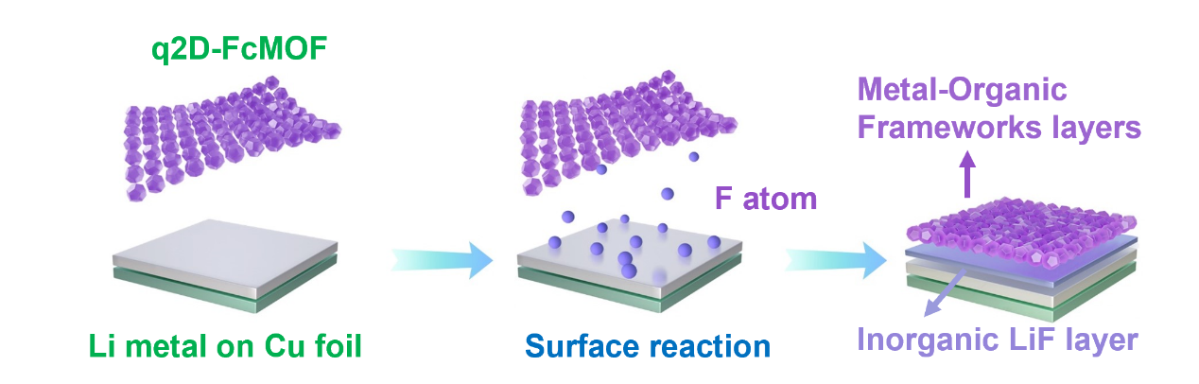
Fig. S1 Schematic illustration of q2D-FcMOF@Li preparation and its protective effect for Li-metal anodes.

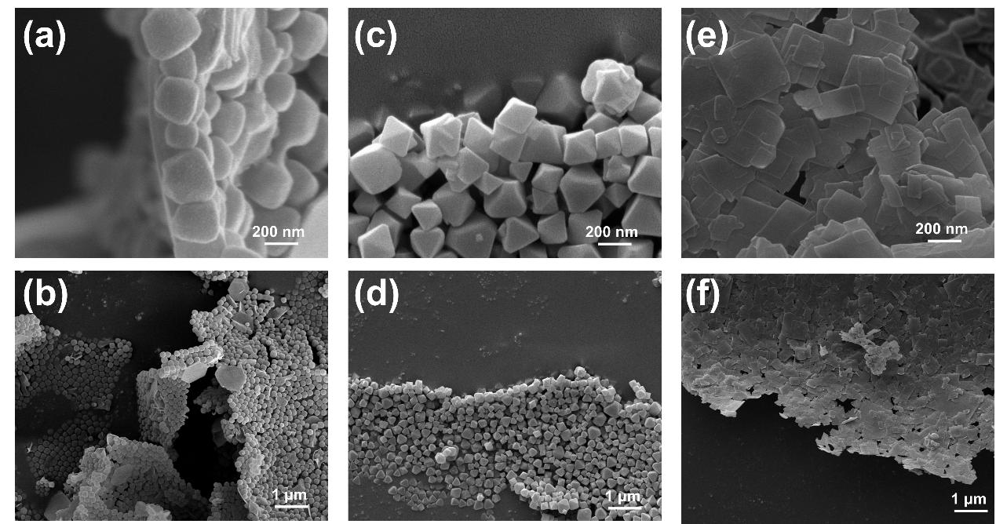
Fig. S2 (a, b) SEM image of q2D-cZ67. (c, d) SEM image of q2D-U66. (e, f) SEM image of q2D-NiMOF.

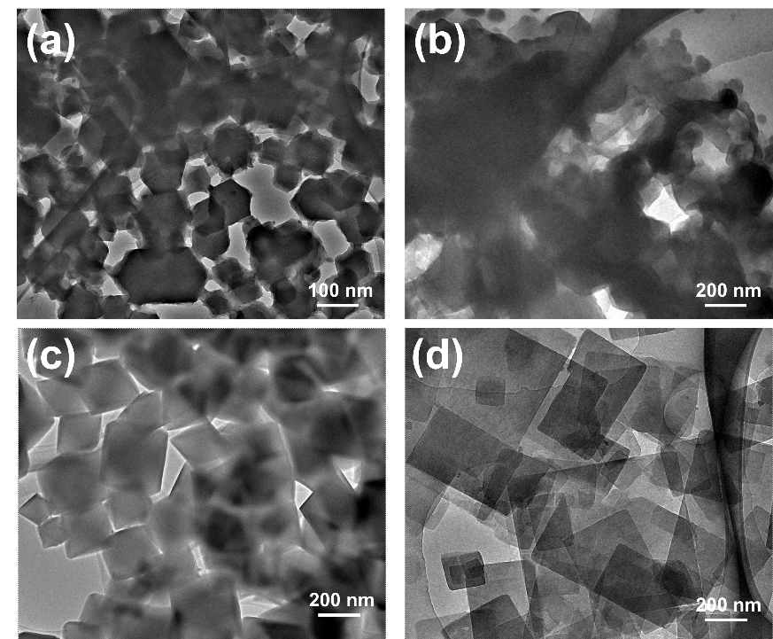
Fig. S3 (a) TEM images of q2D-cZ8. (b) TEM images of q2D-cZ67. (c) TEM images of q2D-cU66. (d) TEM images of q2D-NiMOF.

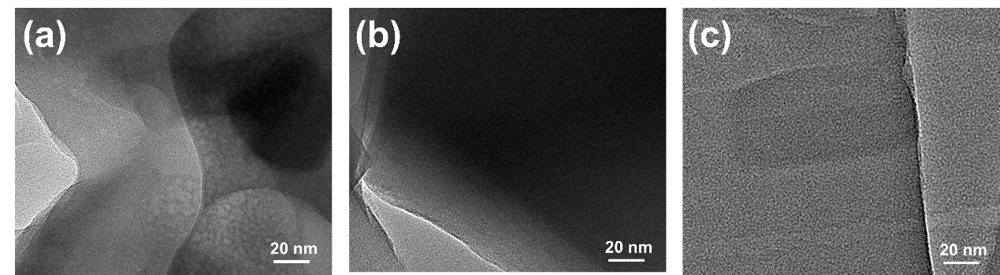
Fig. S4 (a) High-resolution TEM images of q2D-cZ67. (b) High-resolution TEM images of q2D-cU66. (c) High-resolution TEM images of q2D-NiMOF.

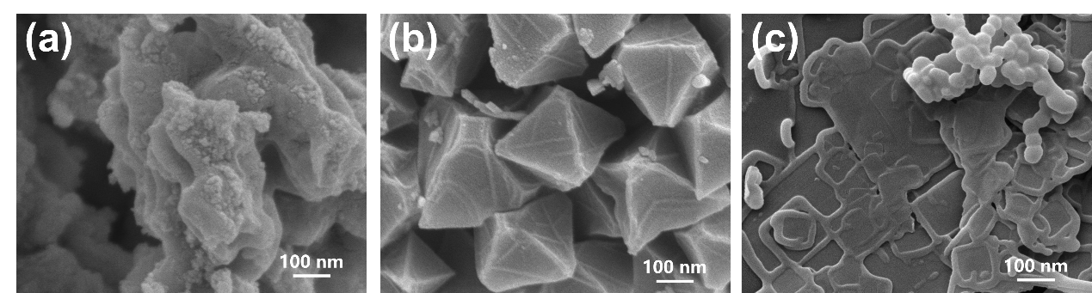
Fig. S5 (a) SEM image of q2D-FcZ67. (b) SEM image of q2D-FcU66. (c) SEM image of q2D-FcNiMOF.

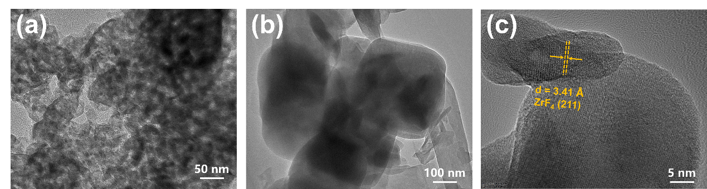
Fig. S6 (a) TEM image of q2D-FcZ8. (b) TEM image of q2D-FcU66. (c) High-resolution TEM image of q2D-FcU66.

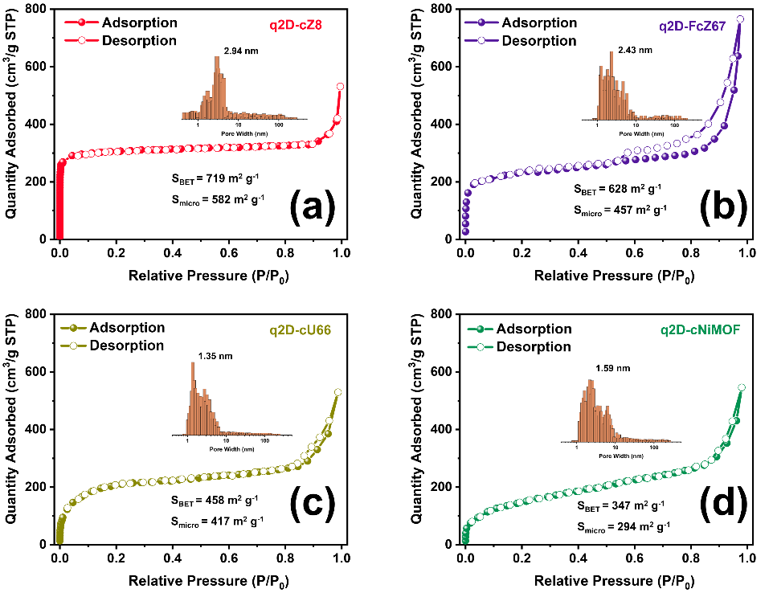
Fig. S7 Nitrogen isotherms and the pore size distribution of (a) q2D-cZ8, (b) q2D-cZ67, (c) q2D-cU66, (d) q2D-cNiMOF.

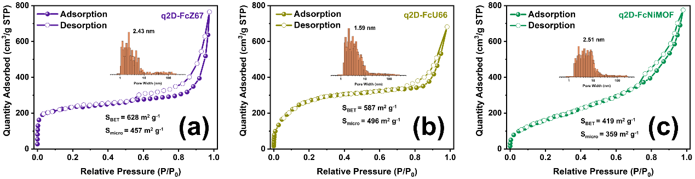
Fig. S8 Nitrogen isotherms and the pore size distribution of (a) q2D-FcZ67, (b) q2D-cU66, (c) q2D-FcNiMOF.

The hysteresis loop could be observed under both relatively low and high-pressure ranges in q2D-cZ8, q2D-cZ67, q2D-cU66, which is the isotherm of type iv characteristics, indicating that hierarchical porous structure is well developed. The pore distribution of the fluorinated product is resemblant to the precursor, indicating that the hierarchical porous structure is still preserved. Isothermal adsorption curve of q2D-cNiMOF can be identified as type II hysteresis loop, which can be distributed into slit pores formed by aggregations of flexible blocks, applying equally to q2D-FcNiMOF. Micropores and mesoporous pores were found to exist in q2D-cNiMOF, these holes are mainly from smaller sized fragments building more accessible pores in highly clustered products.

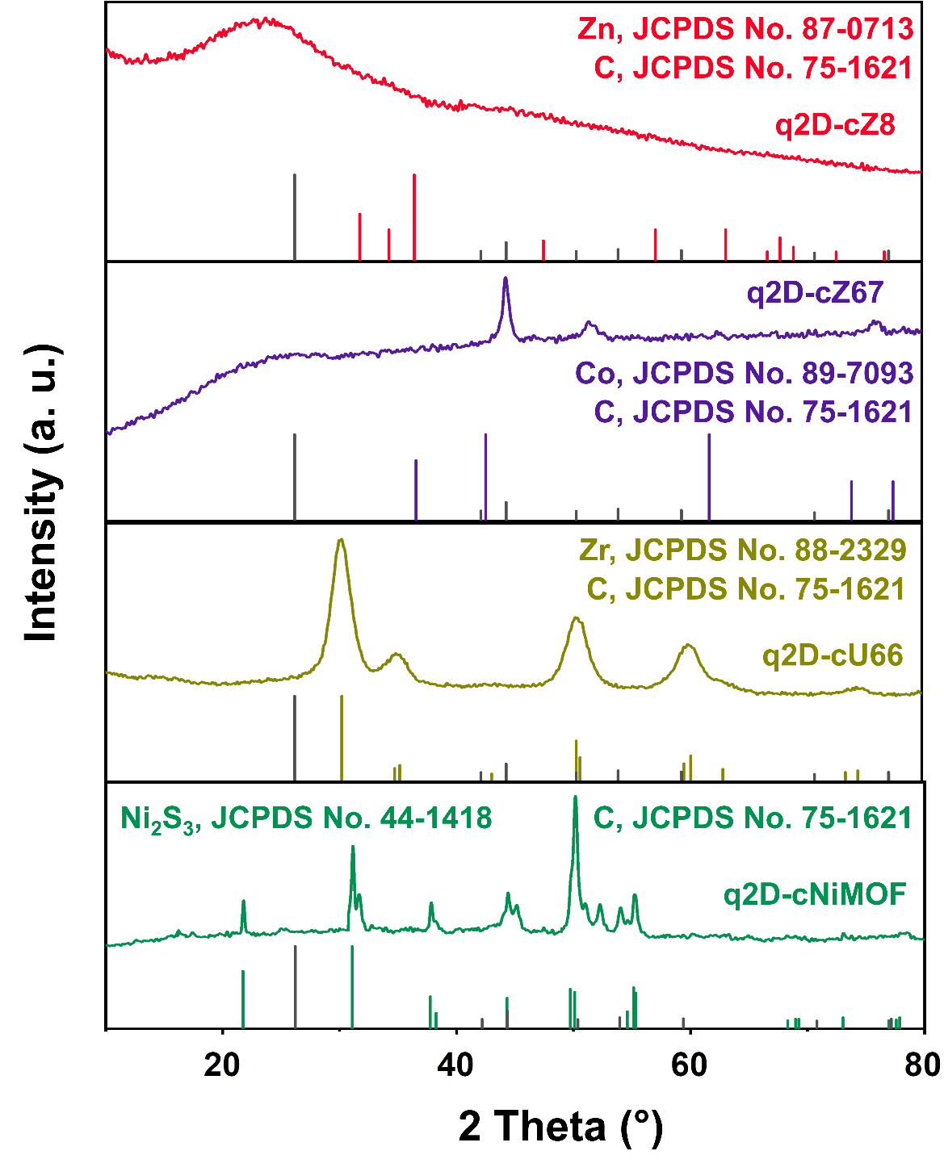
Fig. S9 XRD patterns of q2D-cMOF.

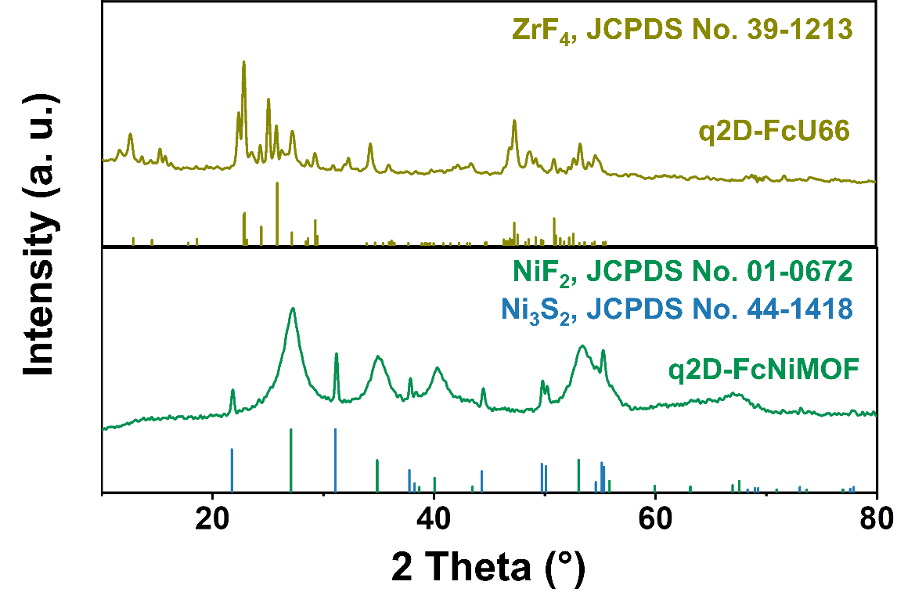
Fig. S10 XRD patterns of q2D-FcU66 and q2D-FcNiMOF.

Ni₂S₃ as the skeleton component of q2D-NiMOF nanoplates can still observe the corresponding sharp peak after fluorination, which are scattered in the broad peaks of NiF₂. It can be considered that Ni²⁺ and Ni³⁺ exist simultaneously in q2D-cNiMOF.

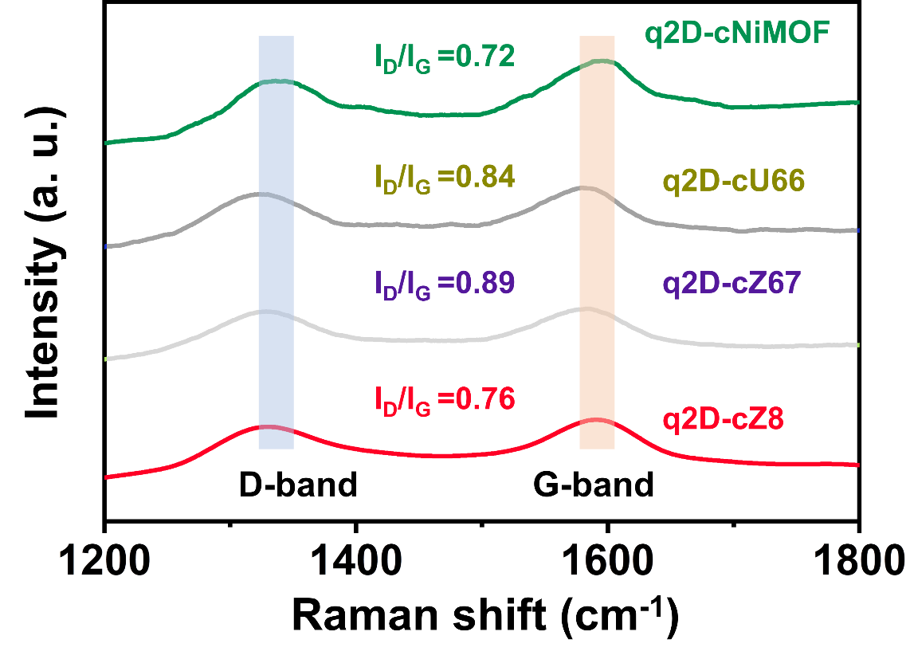
Fig. S11 Raman spectra of q2D-cMOF.

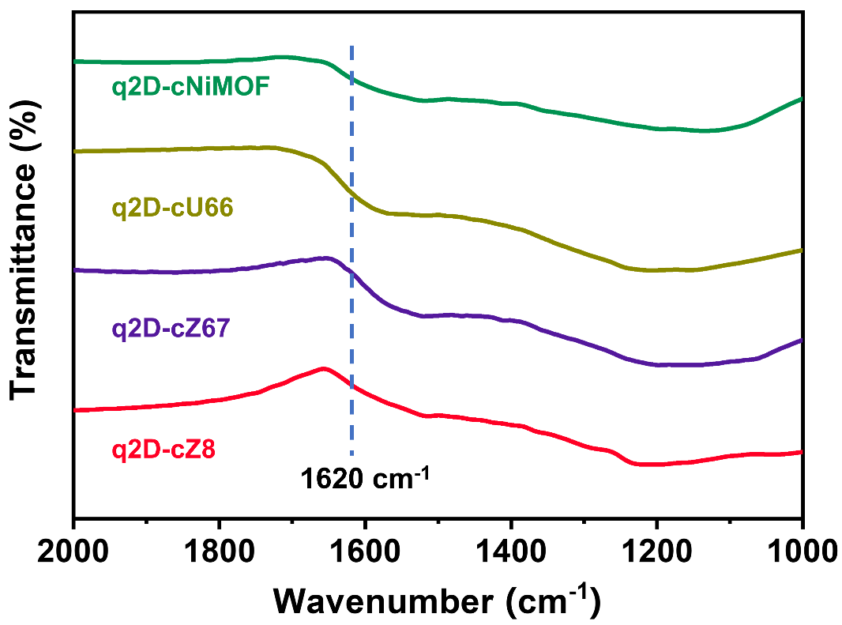
Fig. S12 FTIR spectra of q2D-cMOF.

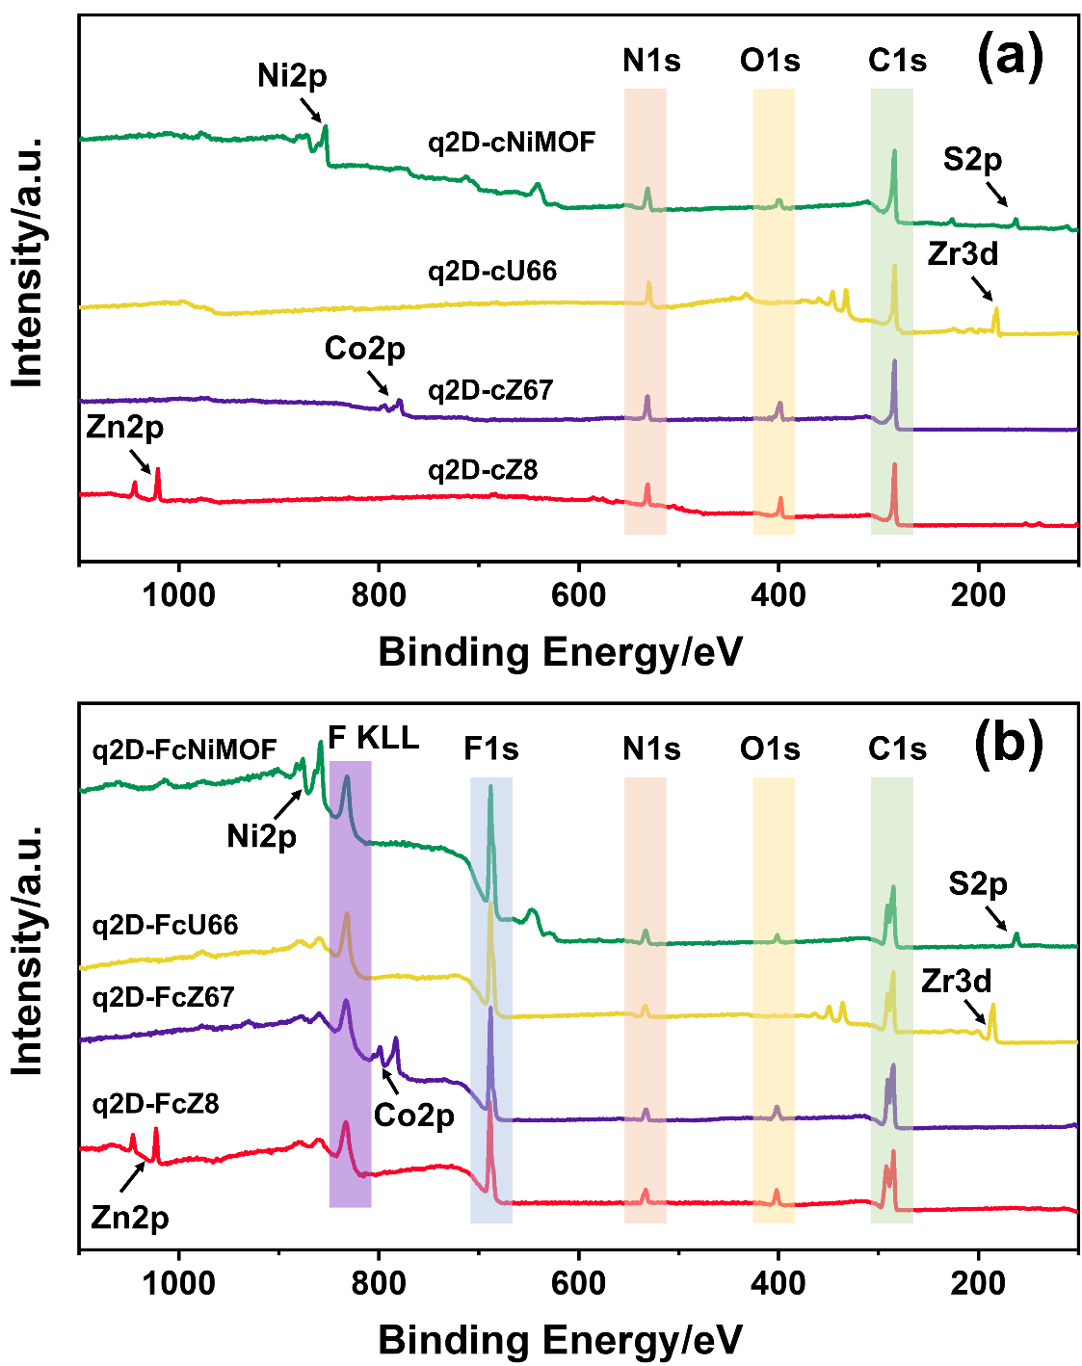
Fig. S13 XPS survey spectra of (a) q2D-cMOF. (b) q2D-FcMOF.

Owing to the disparate organic molecules employed in synthesis, q2D-cZ8 and q2D-cZ67 have additional N, and q2D-cNiMOF has additional N and S, which is consistent with the synthetic raw used.

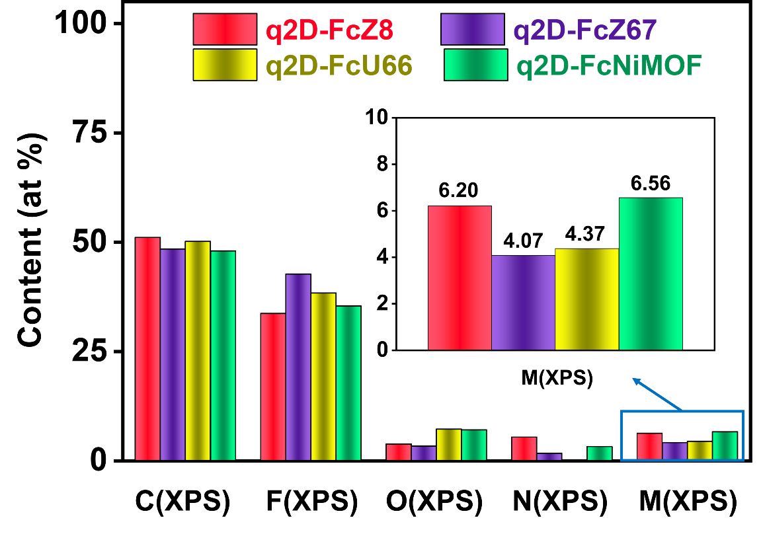
Fig. S14 Composition contents of q2D-cMOF from the XPS spectra.

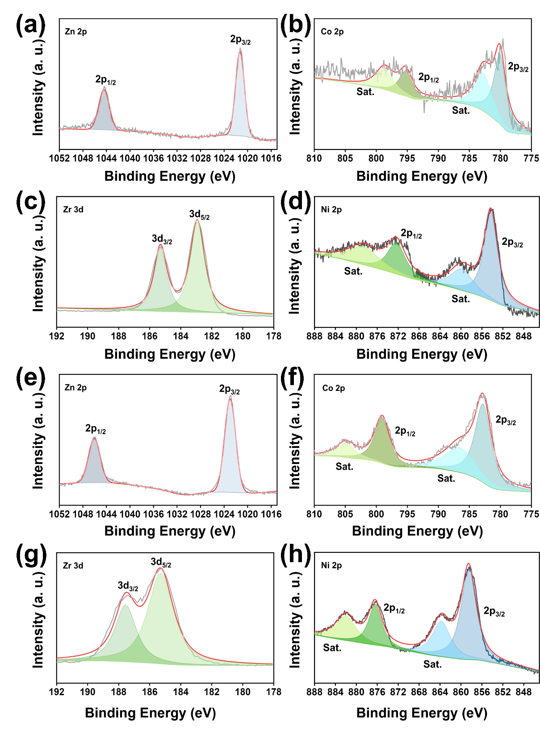
Fig. S15 Zn2p XPS spectra of (a) q2D-cZ8, (e) q2D-FcZ8. Co2p XPS spectra of (b) q2D-cZ67, (f) q2D-FcZ67. Zr3d XPS spectra of (c) q2D-cU66, (g) q2D-FcU66. Ni2p XPS spectra of (d) q2D-cNiMOF, (h) q2D-FcNiMOF.

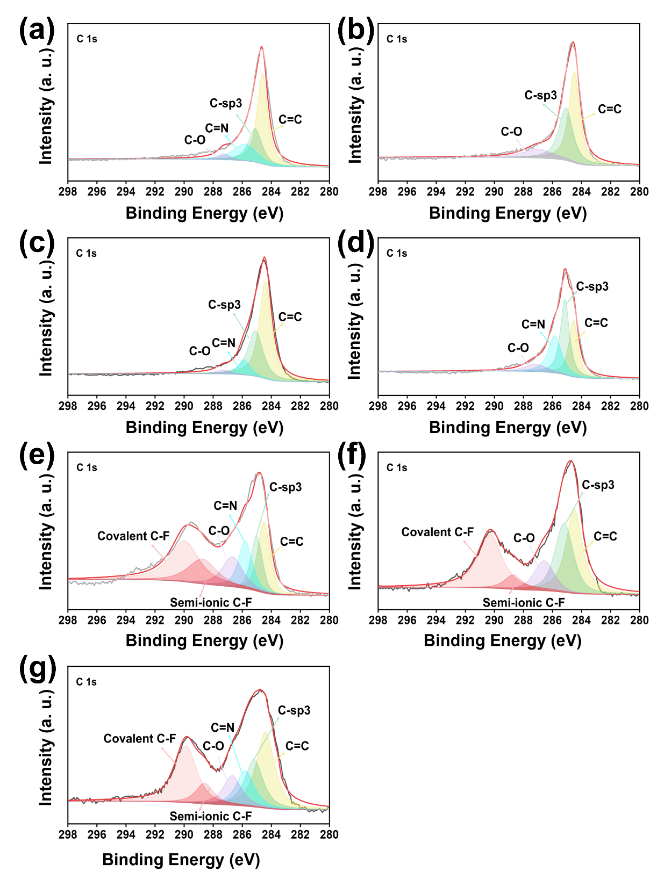
Fig. S16 C1s XPS spectra of (a) q2D-cZ67, (b) q2D-cU66, (c) q2D-cNiMOF, (d) q2D-cZ8, (e) q2D-FcZ67, (f) q2D-cU66, (g) q2D-FcNiMOF.

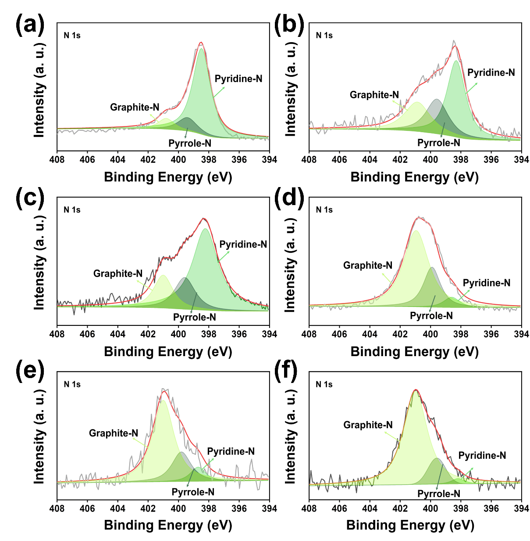
Fig. S17 N1s XPS spectra of (a) q2D-cZ8, (b) q2D-cZ67, (c) q2D-cNiMOF, (d) q2D-FcZ8, (e) q2D-FcZ67, (f) q2D-FcNiMOF.

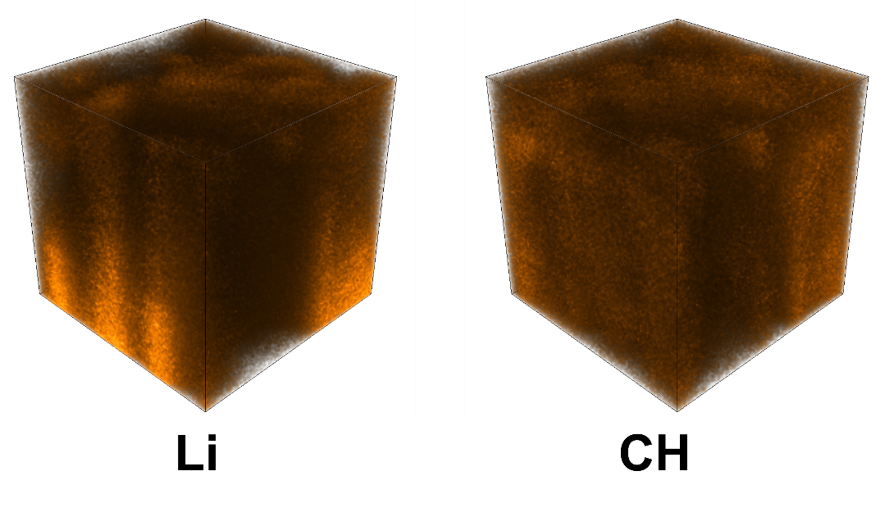
Fig. S18 3D rendering of the TOF-SIMS of the double-layer ASEI on the q2D-FcZ8@Li after cycling of Li and CH groups under Cs+ sputtering.

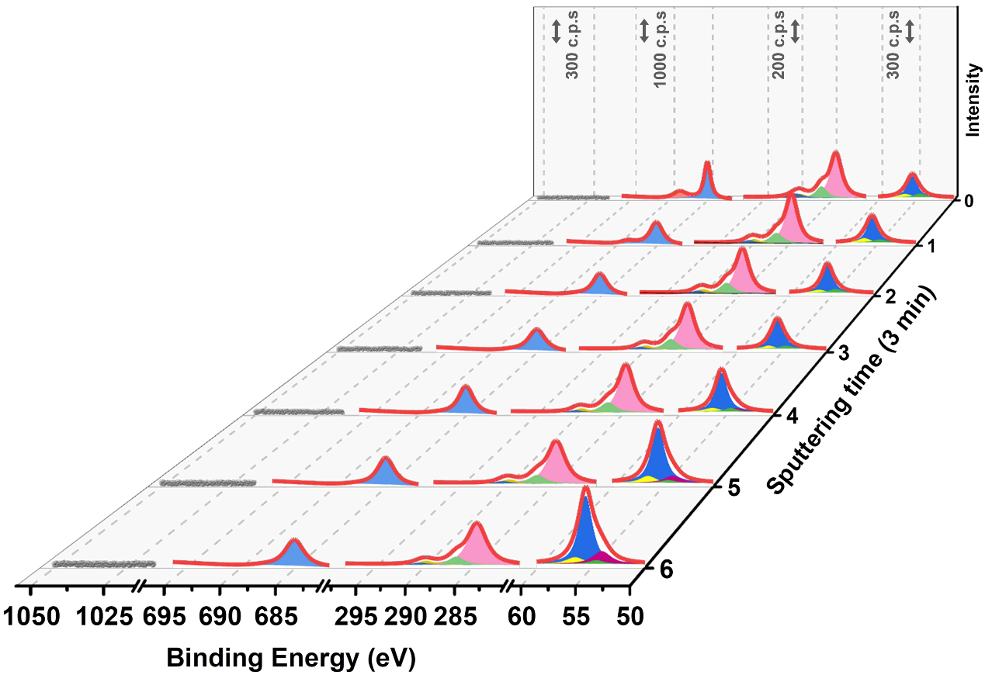
Fig. S19 XPS spectra at various depths of the SEI on the Li deposition: Zn2p, C1s, F1s, and Li1s spectra of bare Li after 50th cycling.

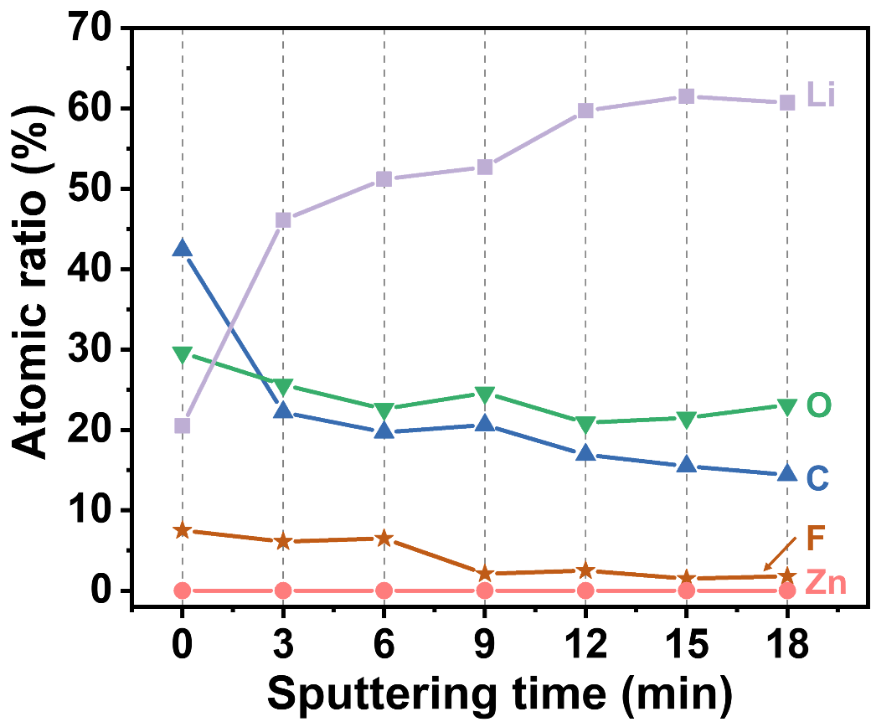
Fig. S20 The element atomic concentration of the SEI layer obtained in the XPS depth profiles for bare Li after 50th cycling.

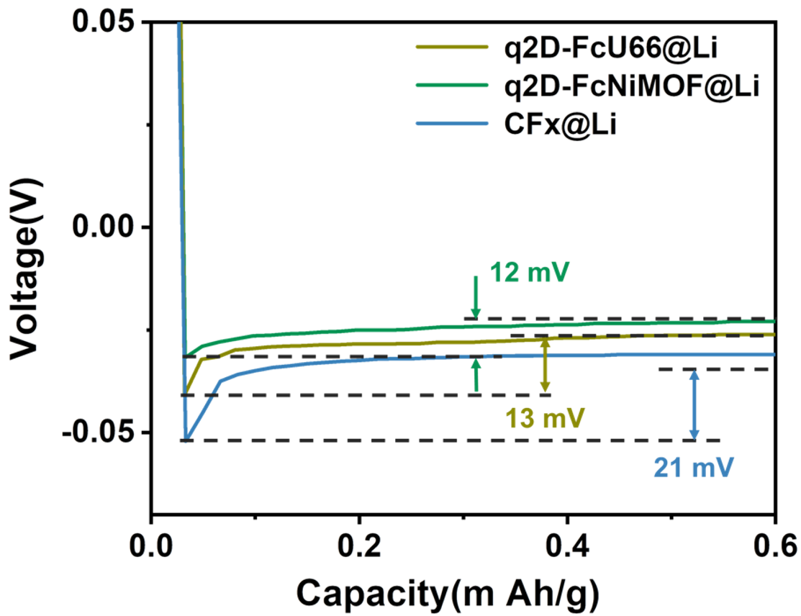
Fig. S21 Li nucleation overpotentials of asymmetric CF_{x}@Li||Cu, q2D-FcU66@Li||Cu, q2D-FcNiMOF@Li||Cu, cell in ether electrolytes with a capacity of 1 mAh cm⁻² at 1 mA cm⁻².

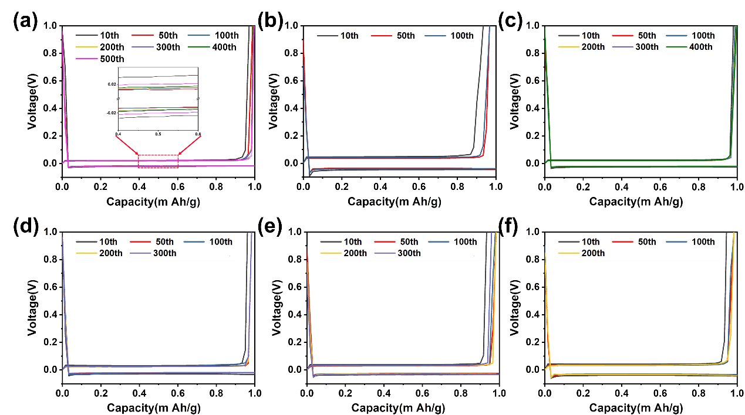
Fig. S22 Voltage profiles of Li plating/stripping at different cycle (a) q2D-FcZ8@Li||Cu, (b) Li||Cu, (c) q2D-FcZ67@Li||Cu, (d) q2D-FcU66@Li||Cu, (e) q2D-FcNiMOF@Li||Cu, (f) CF_{x}@Li||Cu in Fig. 4a.

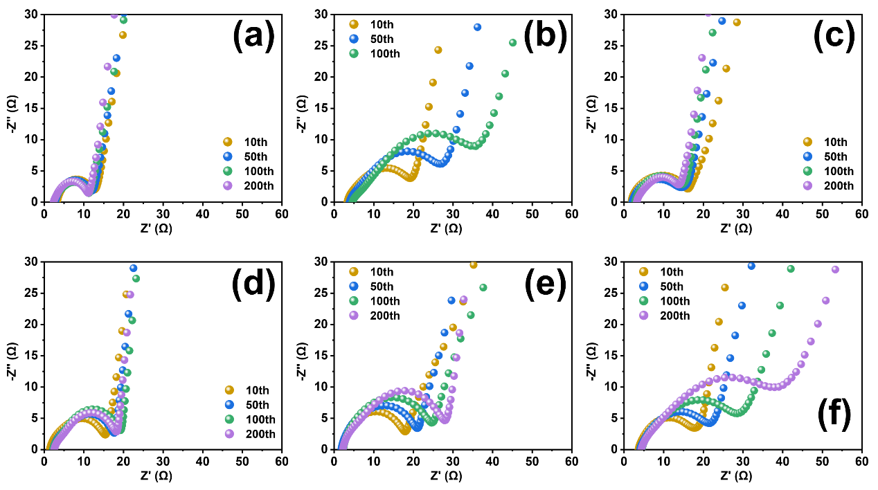
Fig. S23 Nyquist plots of (a) q2D-FcZ8@Li||Cu, (b) Li||Cu, (c) q2D-FcZ67@Li||Cu, (d) q2D-FcNiMOF@Li||Cu, (e) q2D-FcNiMOF@Li||Cu, (f) CFx@Li||Cu at different cycle in Fig. 4a.

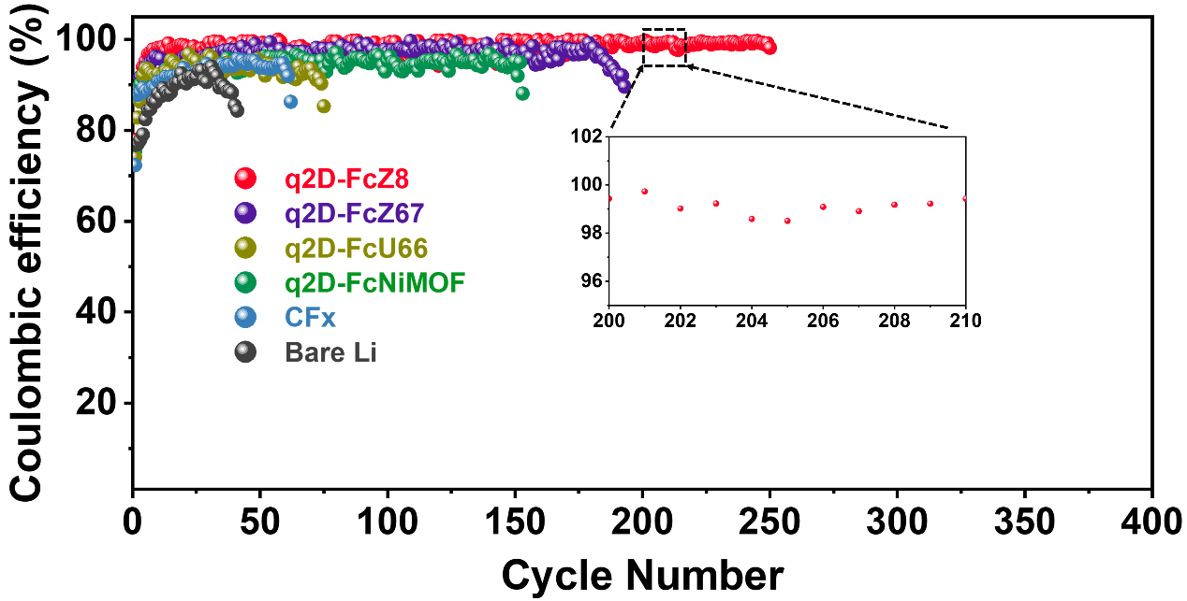
Fig. S24 Coulombic efficiency of asymmetric Li||Cu cell in ether electrolytes with a capacity of 2 mAh cm⁻² at 4 mA cm⁻².

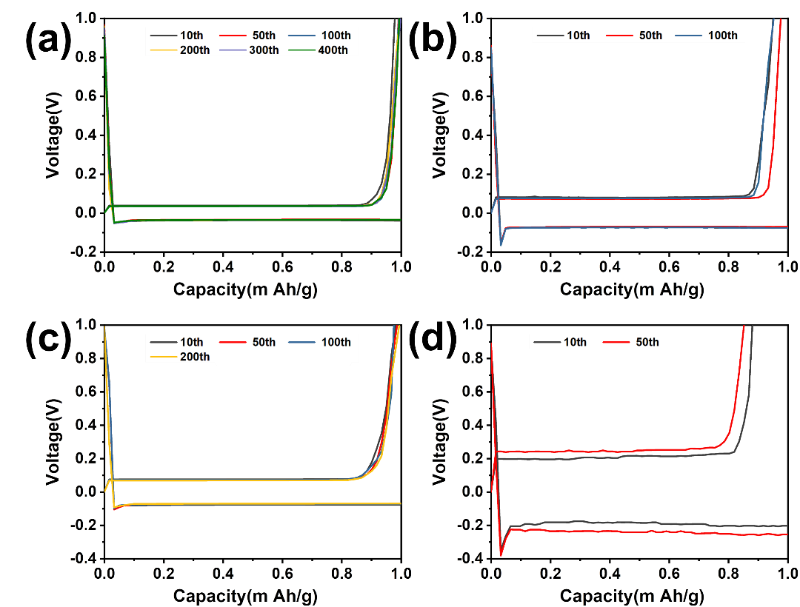
Fig. S25 Voltage profiles of (a) q2D-FcZ8@Li||Cu, (b) Li||Cu plating/stripping at different cycle number in Fig. 4c. Voltage profiles of (c) q2D-FcZ8@Li||Cu, (d) Li||Cu plating/stripping at different cycle number in Fig. S24.

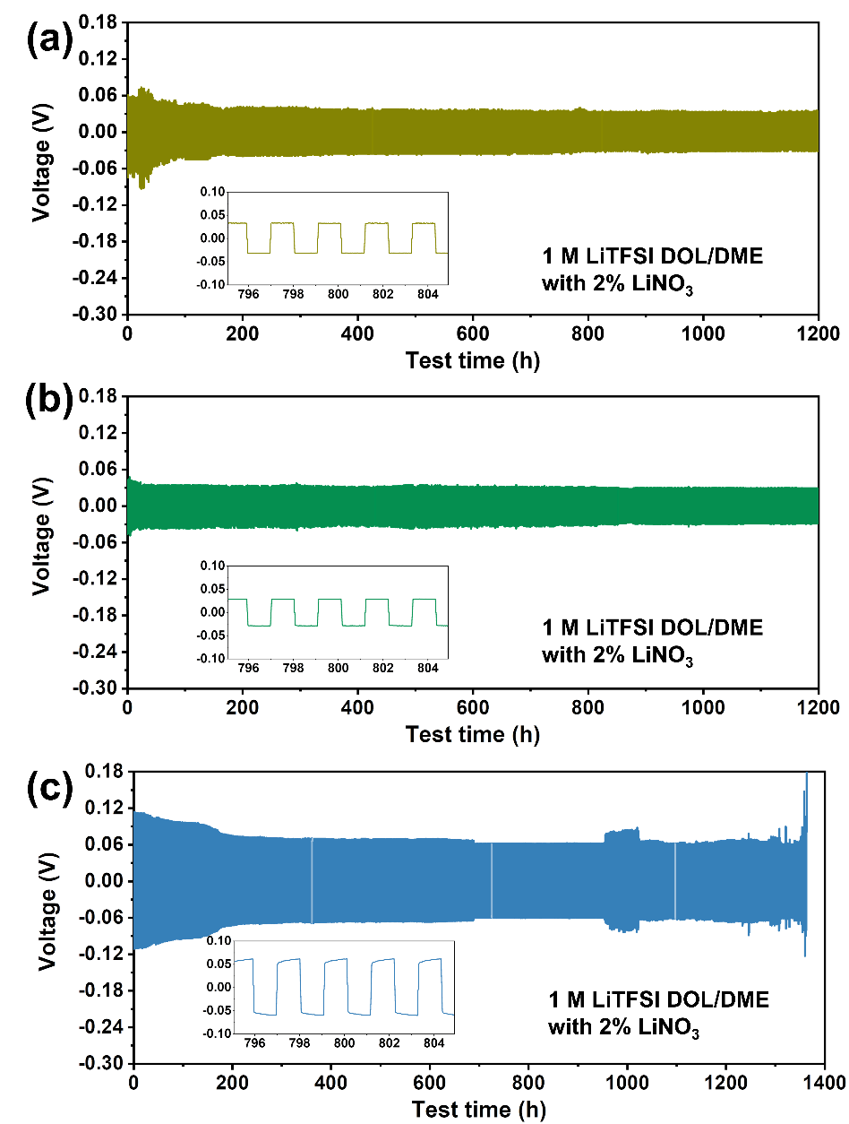
Fig. S26 Galvanostatic cycling voltage profiles in symmetric cells of (a) q2D-FcU66@Li, (b) q2D-FcNiMOF@Li, (c) CF_{x}@Li with a capacity of 1 mAh cm⁻² at 1 mA cm⁻².

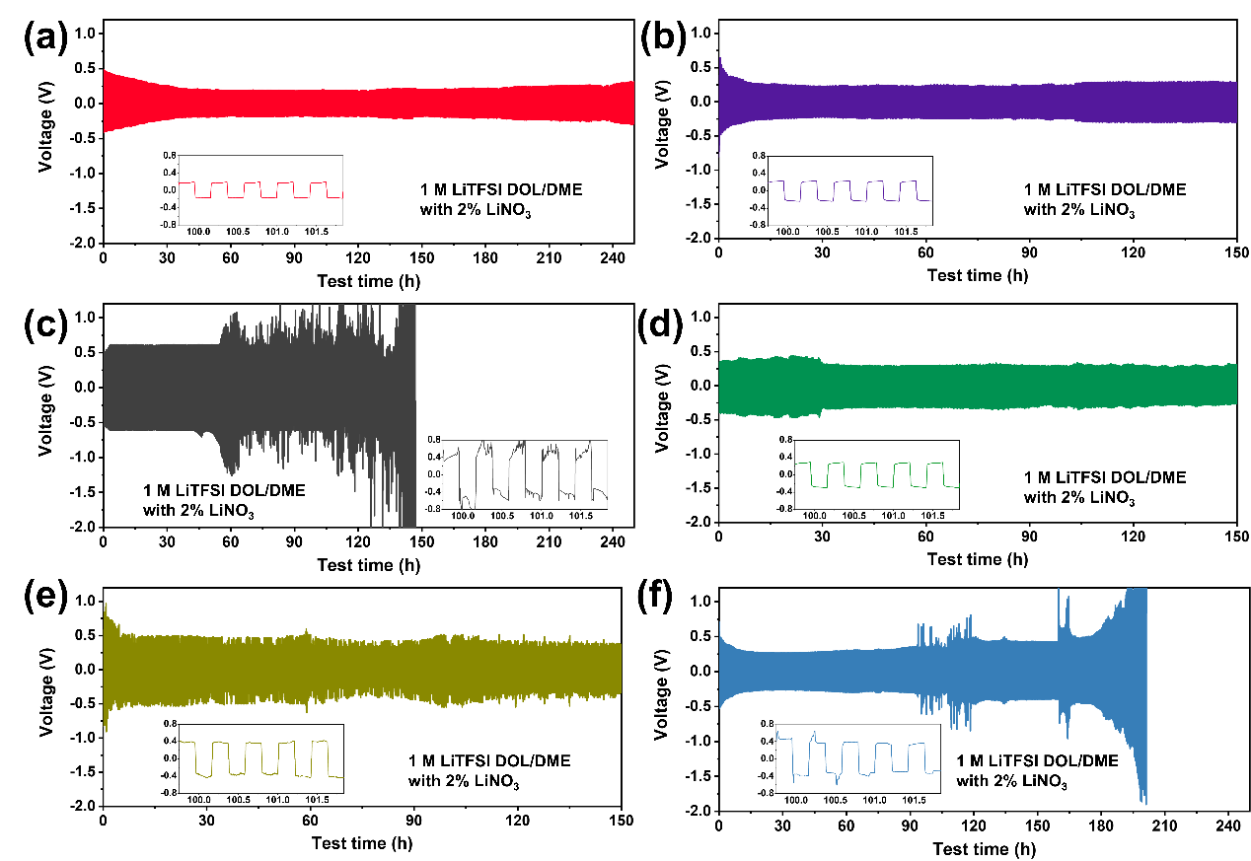
Fig. S27 Galvanostatic cycling voltage profiles in symmetric cells of (a) q2D-FcZ8@Li, (b) q2D-FcZ67@Li, (c) bare Li, (d) q2D-FcNiMOF@Li, (e) q2D-FcU66@Li, (f) CF_{x}@Li with a capacity of 2 mAh cm⁻² at 10 mA cm⁻².

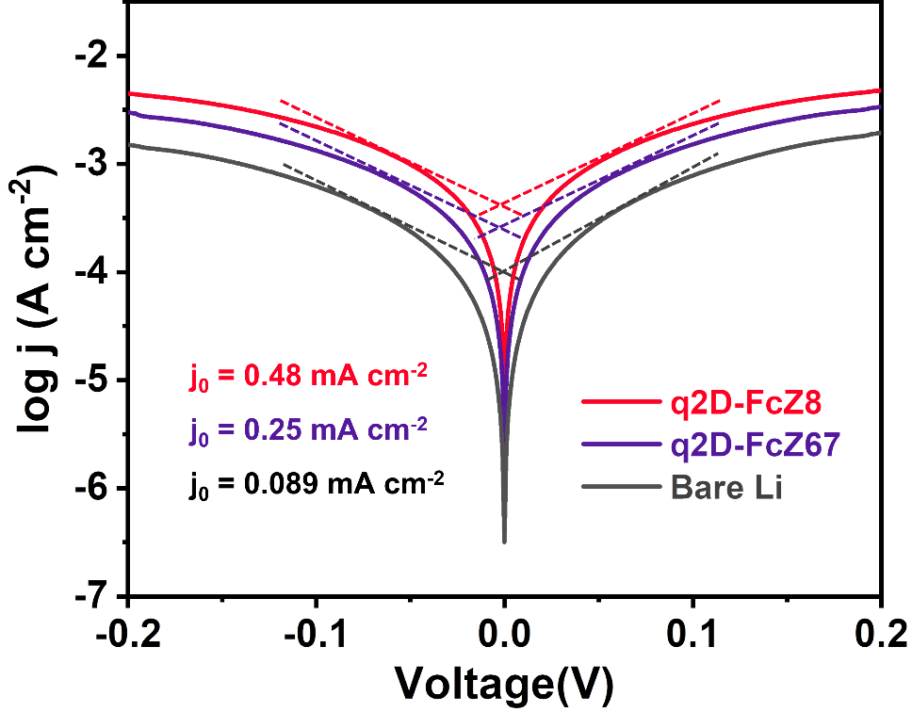
Fig. S28 Tafel plots of symmetric cells with q2D-FcZ8@Li, q2D-FcZ67@Li, bare Li in exchange current density test.

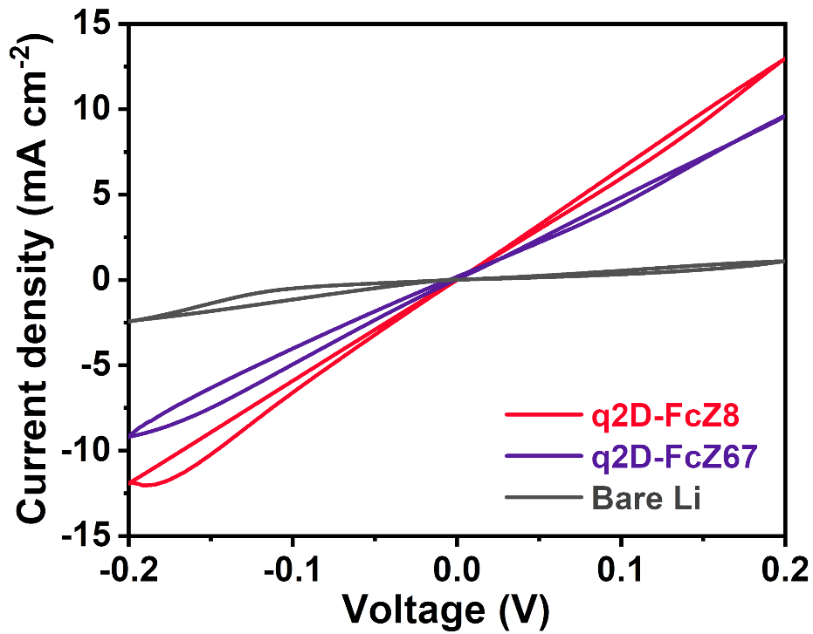
Fig. S29 CV plots of symmetric cells with q2D-FcZ8@Li, q2D-FcZ67@Li, bare Li.

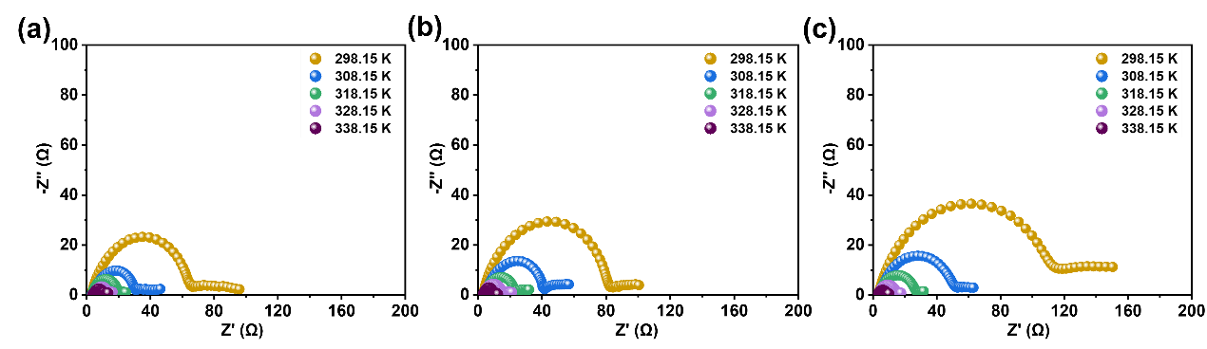
Fig. S30 Nyquist plots of symmetric cells with q2D-FcZ8@Li, q2D-FcZ67@Li, bare Li from 298.15 to 339.15 K.

The Nyquist plot of the Li symmetric cell before cycling shows a typical semicircle in the middle and high frequency region and an obvious diffusion tail in the low frequency region.

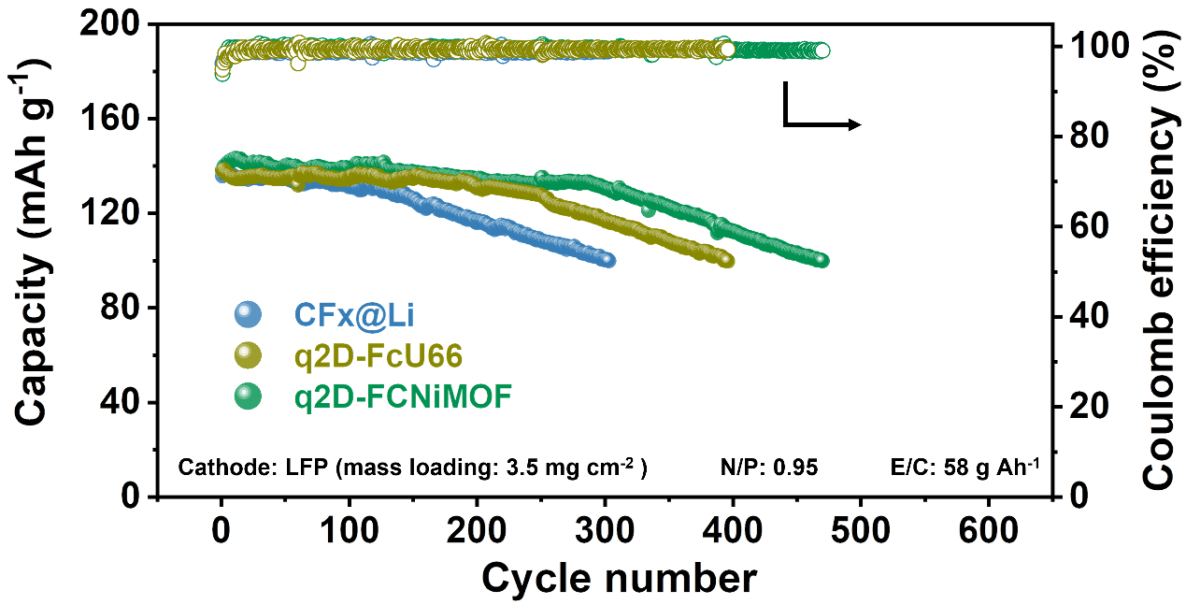
Fig. S31 Long-term cycling performance of q2D-FcU66@Li||LFP, q2D-FcNiMOF@Li||LFP, CF_{x}@Li||LFP at 1 C.

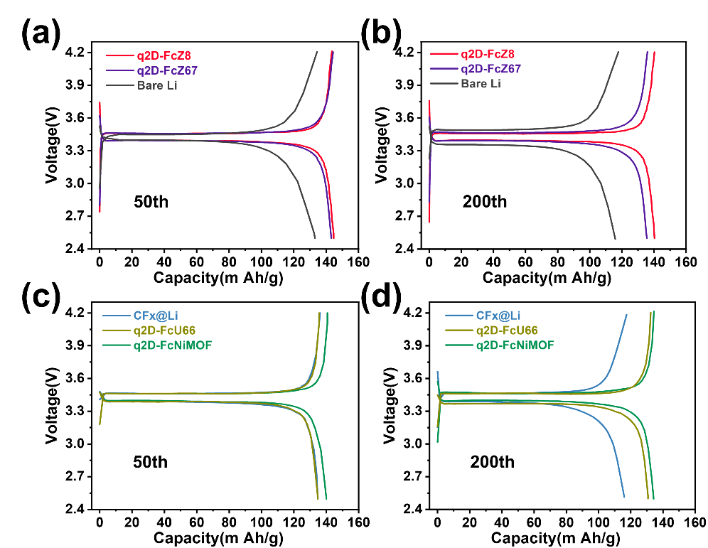
Fig. S32 Voltage profiles of 50th charge/discharge (a) q2D-FcZ8@Li||LFP, q2D-FcZ67@Li||LFP, Li||LFP, (b) q2D-FcU66@Li||LFP, q2D-FcNiMOF@Li||LFP, CF_{x}@Li||LFP. Voltage profiles of 200th charge/discharge (c) q2D-FcZ8@Li||LFP, q2D-FcZ67@Li||LFP, Li||LFP, (d) q2D-FcU66@Li||LFP, q2D-FcNiMOF@Li||LFP, CF_{x}@Li||LFP.

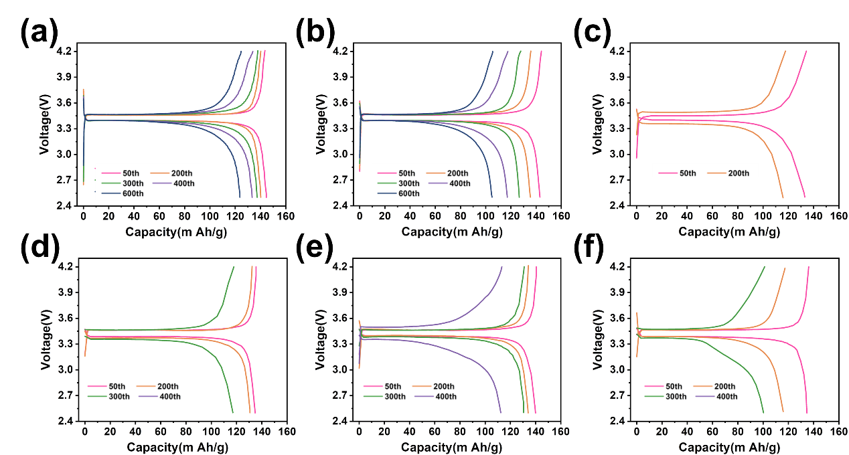
Fig. S33 Voltage profiles of (a) q2D-FcZ8@Li||LFP, (b) q2D-FcZ67@Li||LFP, (c) Li||LFP, (d) q2D-FcU66@Li||LFP, (e) q2D-FcNiMOF@Li||LFP, (f) CF_{x}@Li||LFP at different charge/discharge cycles.

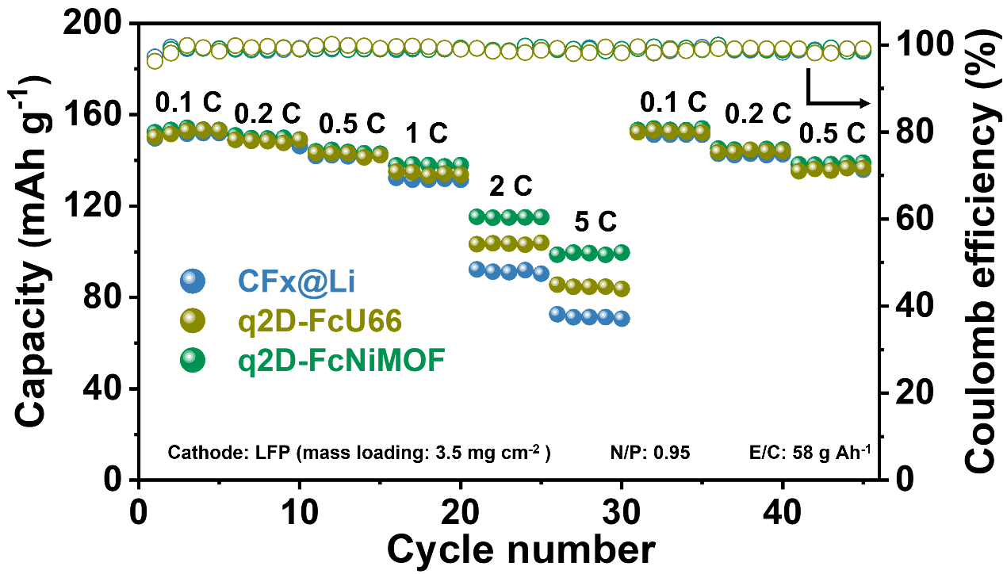
Fig. S34 Rate performance of q2D-FcU66@Li||LFP, q2D-FcNiMOF@Li||LFP, CF_{x}@Li||LFP.

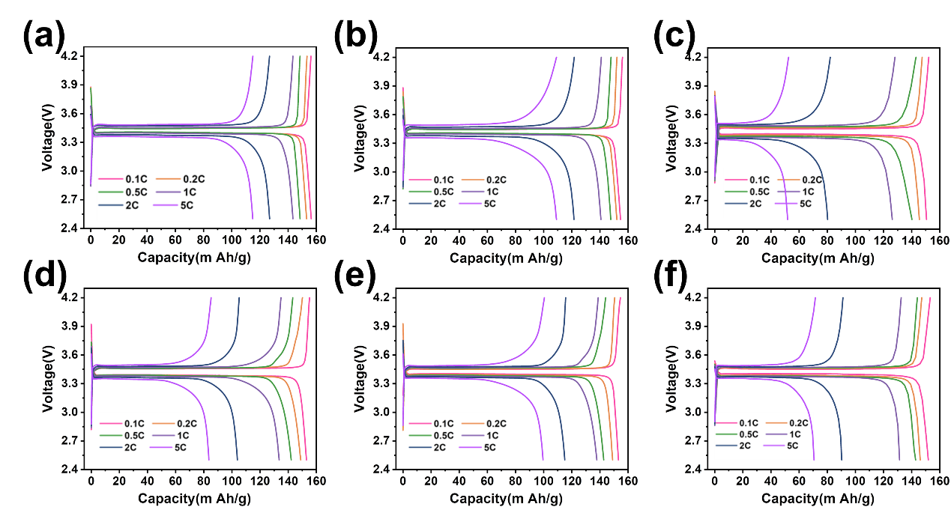
Fig. S35 Voltage profiles charge/discharge of (a) q2D-FcZ8@Li||LFP, (b) q2D-FcZ67@Li||LFP, (c) Li||LFP, (d) q2D-FcU66@Li||LFP, (e) q2D-FcNiMOF@Li||LFP, (f) CF_{x}@Li||LFP at different current density.

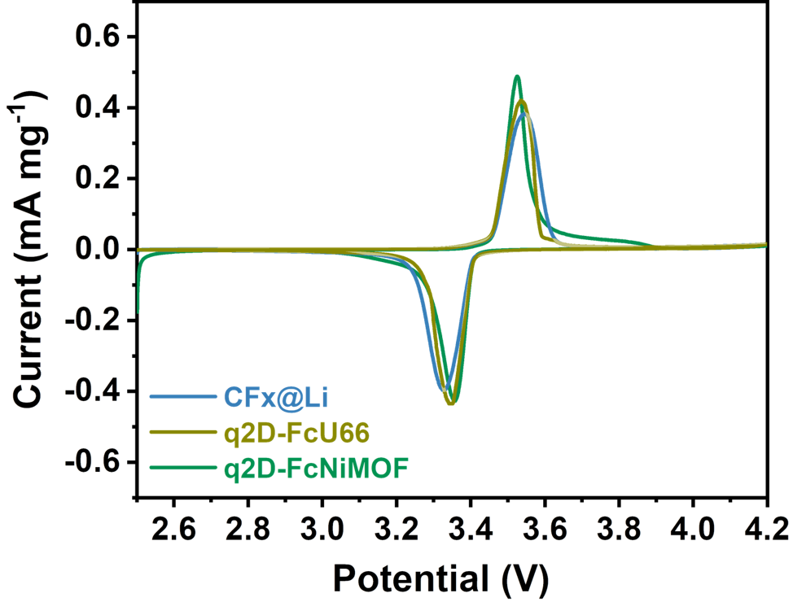
Fig. S36 CV curves of q2D-FcU66@Li||LFP, q2D-FcNiMOF@Li||LFP, CFx@Li||LFP with a scan rate of 0.05 mV s⁻¹.

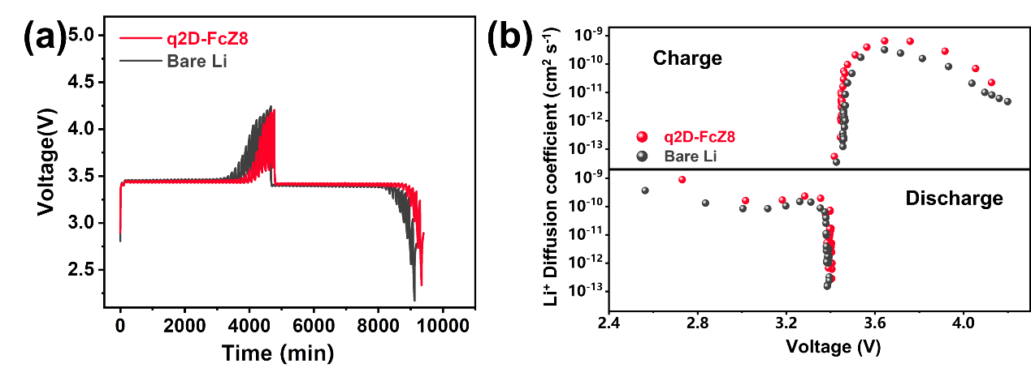
Fig. S37 (a) GITT test curves of q2D-FcZ8@||LFP and Li||LFP at charge/discharge rates of 0.05 C. (b) D_{Li+} calculated according to the GITT data of Fig. S37a.

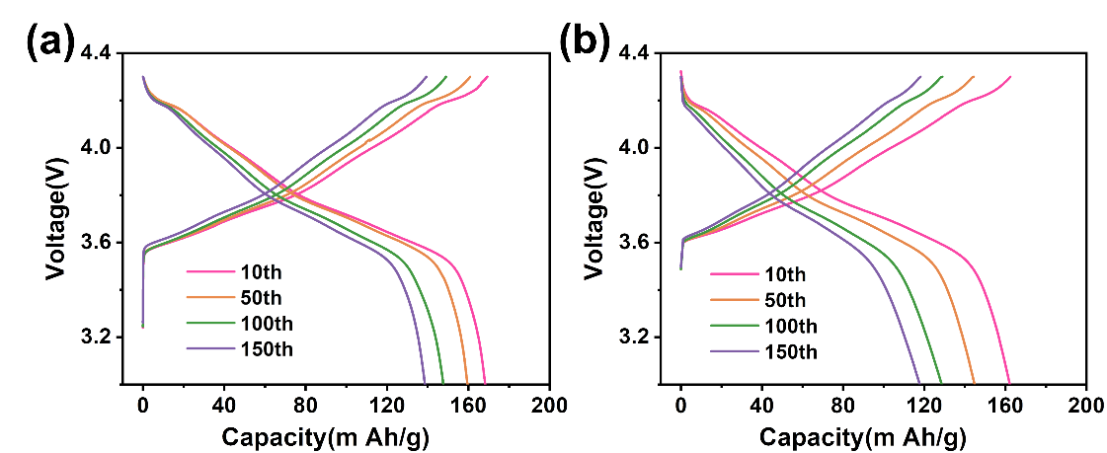
Fig. S38 Voltage profiles of (a) q2D-FcZ8@Li||NCM811, (b) Li||NCM811 at different charge/discharge cycles at 0.5 C.
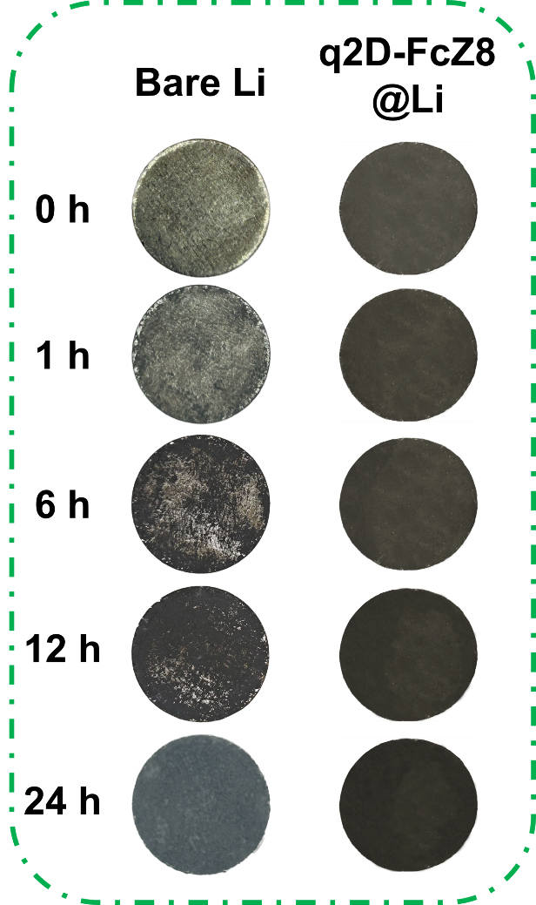
Fig. S39 Optical photographs of Li and q2D-FcZ8@Li after exposure to air for different time periods.

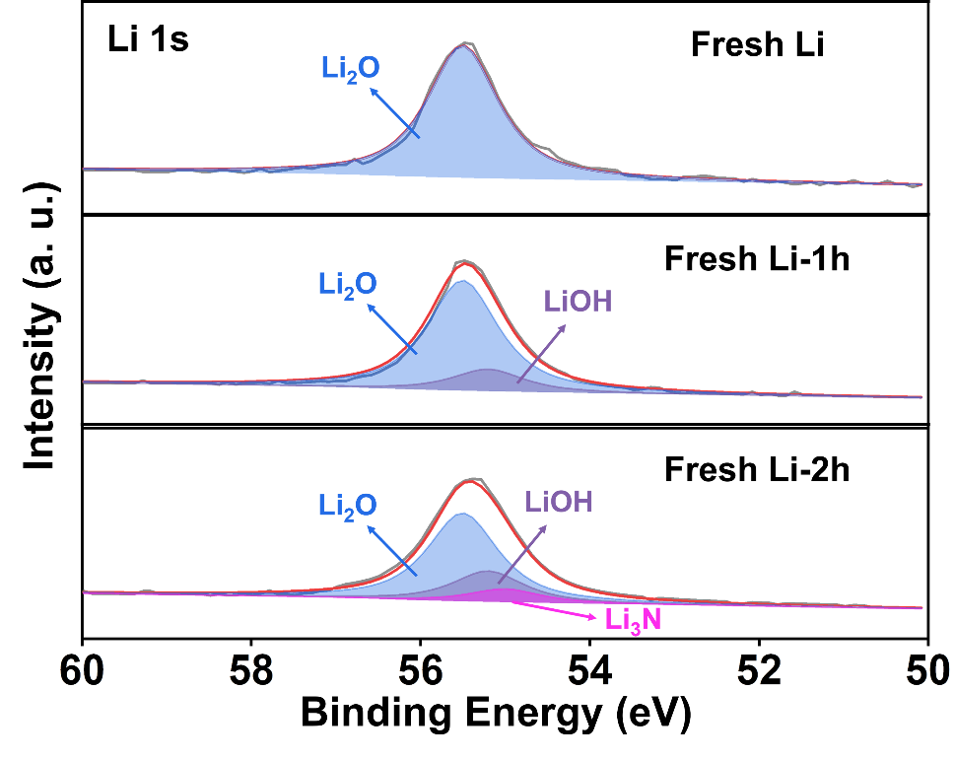
Fig. S40 Li1s XPS spectra of air-exposed bare Li for different time periods.

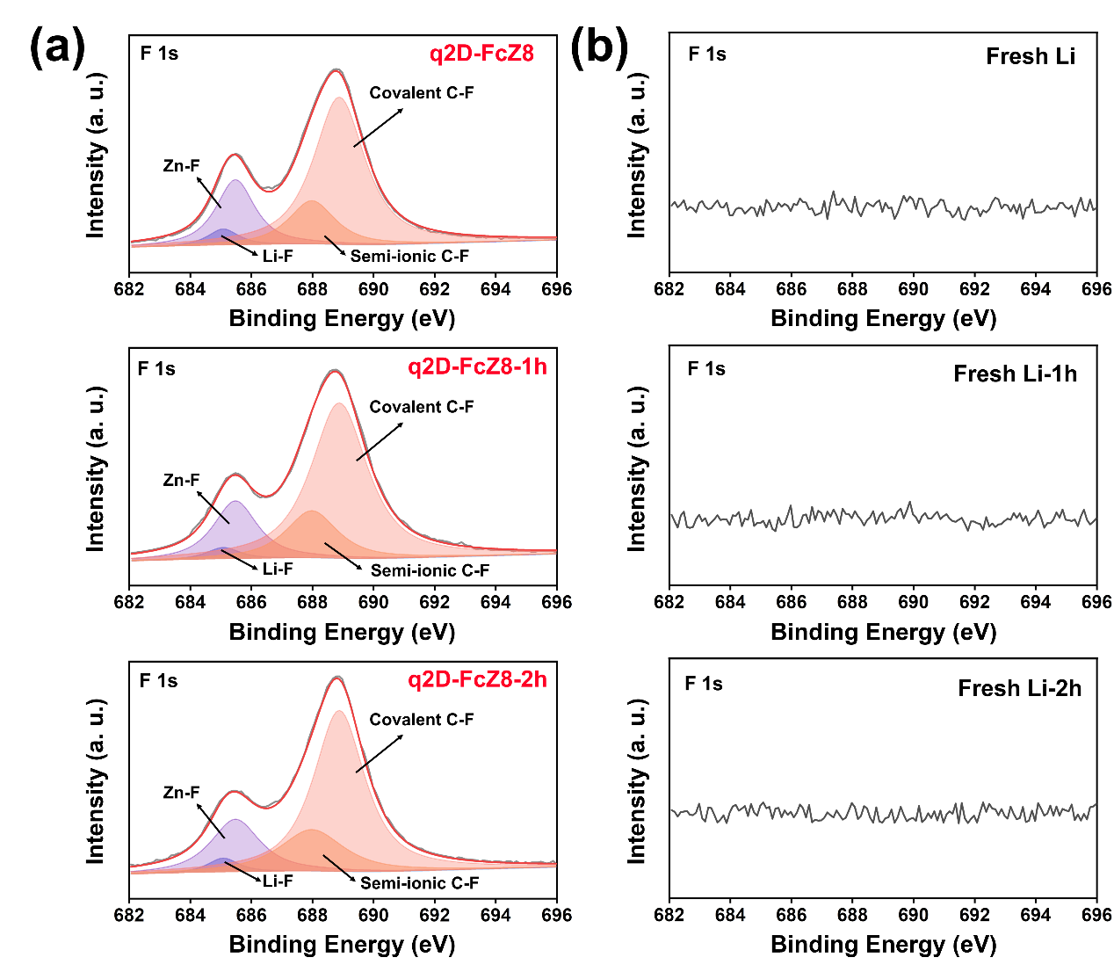
Fig. S41 F1s XPS spectra of air-exposed (a) q2D-FcZ8@Li and (b) bare Li for different time periods.

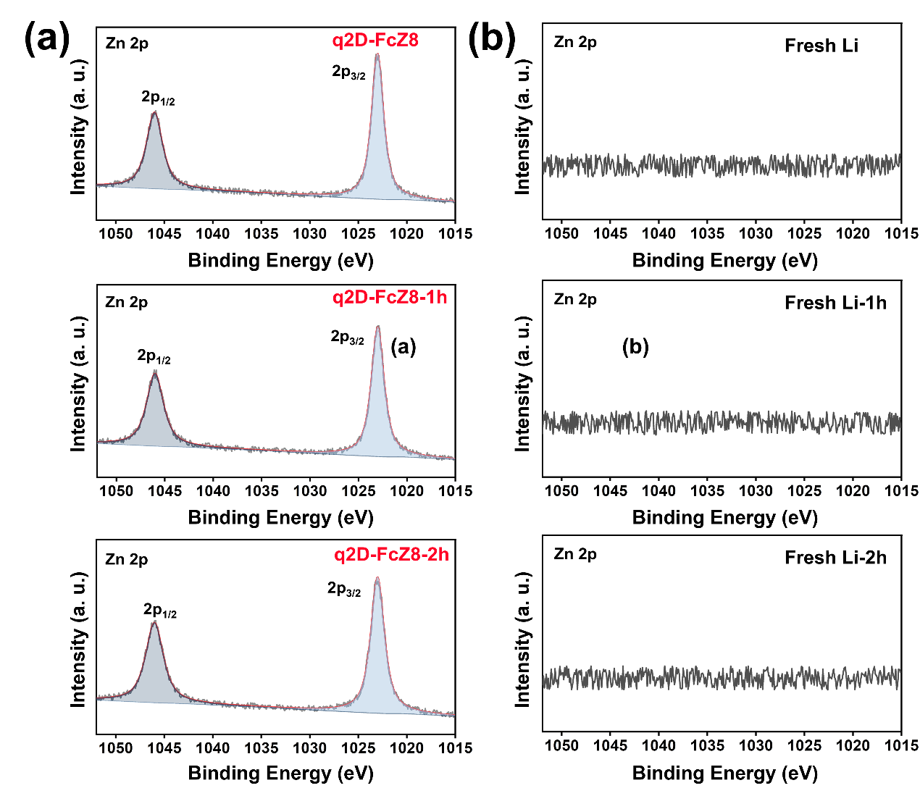
Fig. S42 Zn2p XPS spectra of air-exposed (a) q2D-FcZ8@Li and (b) bare Li for different time periods.

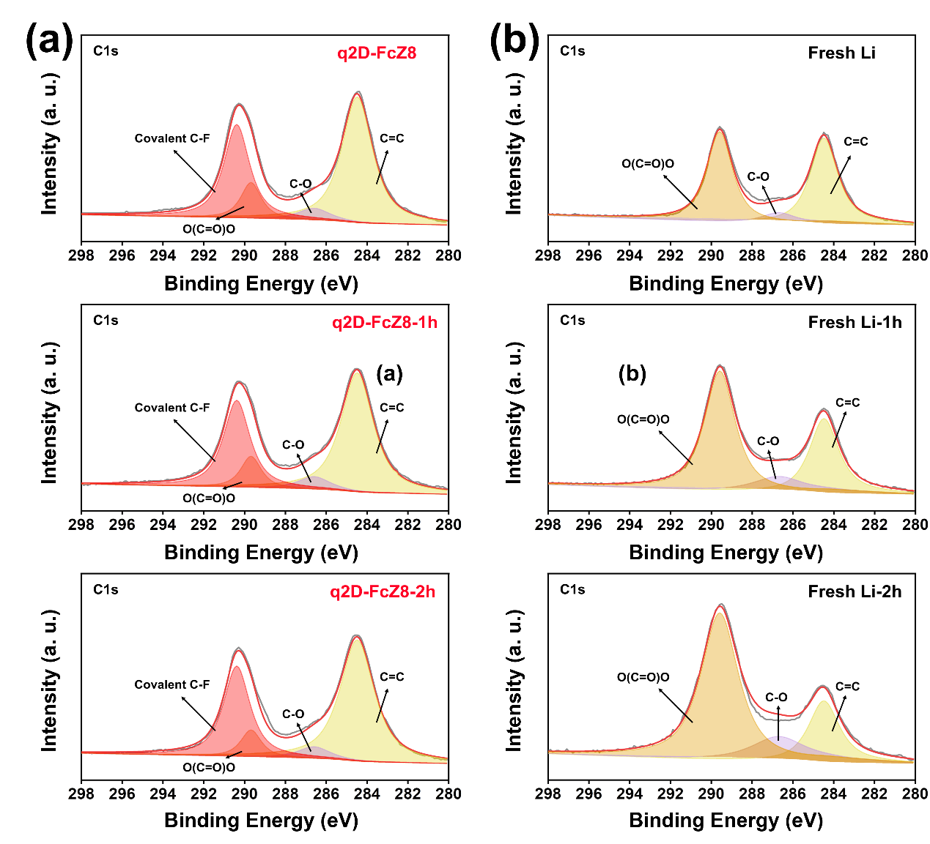
Fig. S43 C1s XPS spectra of air-exposed (a) q2D-FcZ8@Li and (b) bare Li for different time periods.
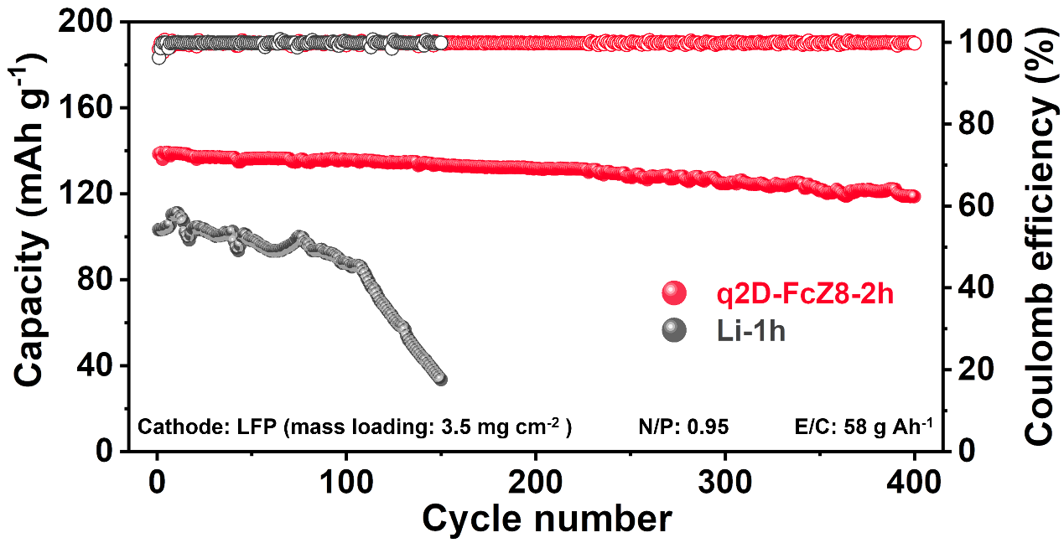
Fig. S44 Galvanostatic cycling voltage profiles in q2D-FcZ8@Li-2h and Li-1h symmetric cells with a capacity of 1 mAh cm⁻² at 1 mA cm⁻²

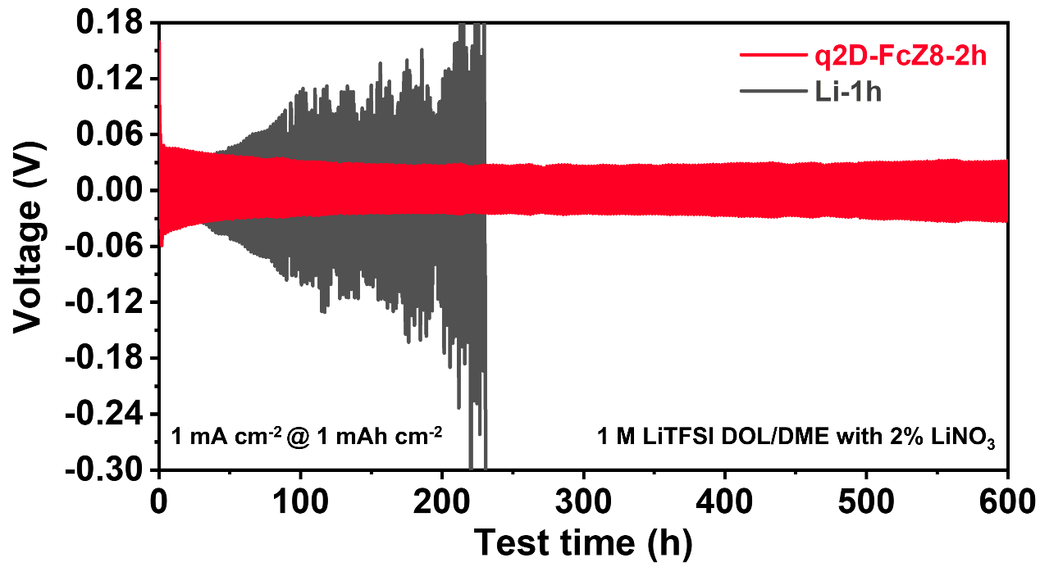
Fig. S45 Full cell performance comparison with q2D-FcZ8@Li-2h||LFP and Li-1h||LFP at 1 C.

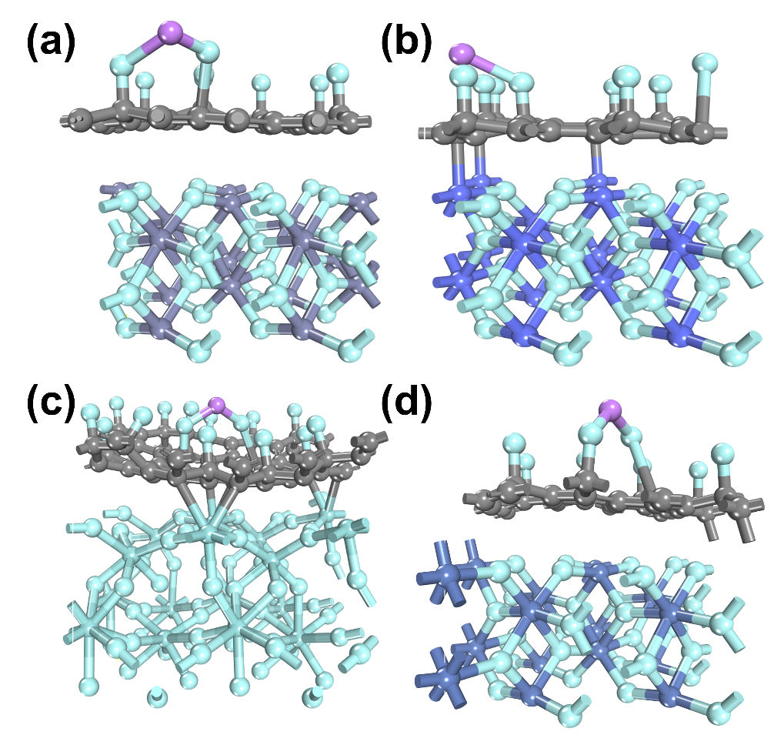
Fig. S46 The maximum adsorption energy of (a) q2D-FcZ8, (b) q2D-FcZ67, (c) q2D-FcU66, (d) q2D-FcNiMOF on Li atom.

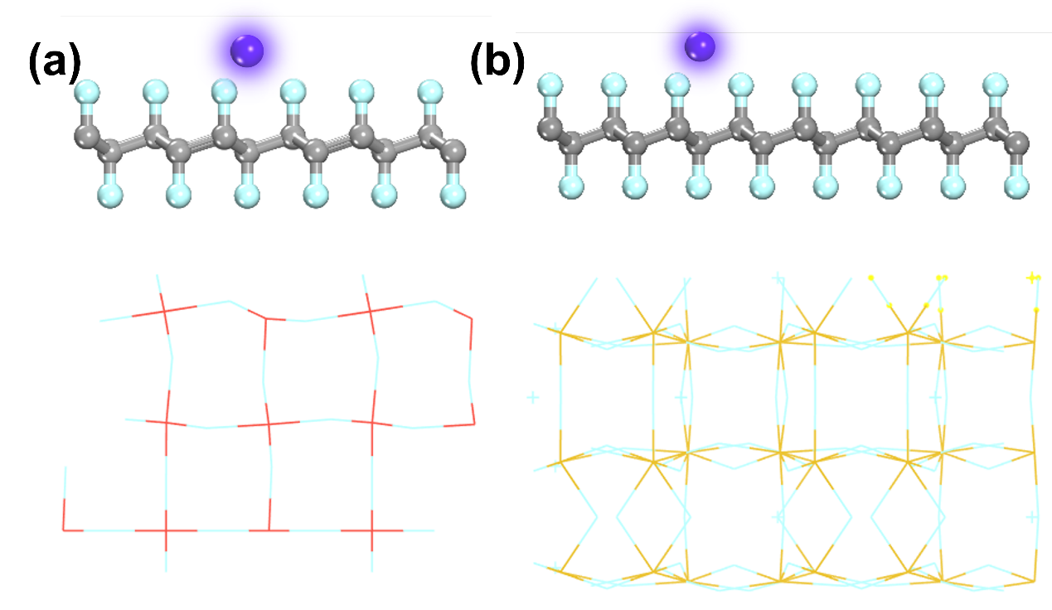
Fig. S47 A side view of (a) Fig. 6b, (b) Fig. 6d.

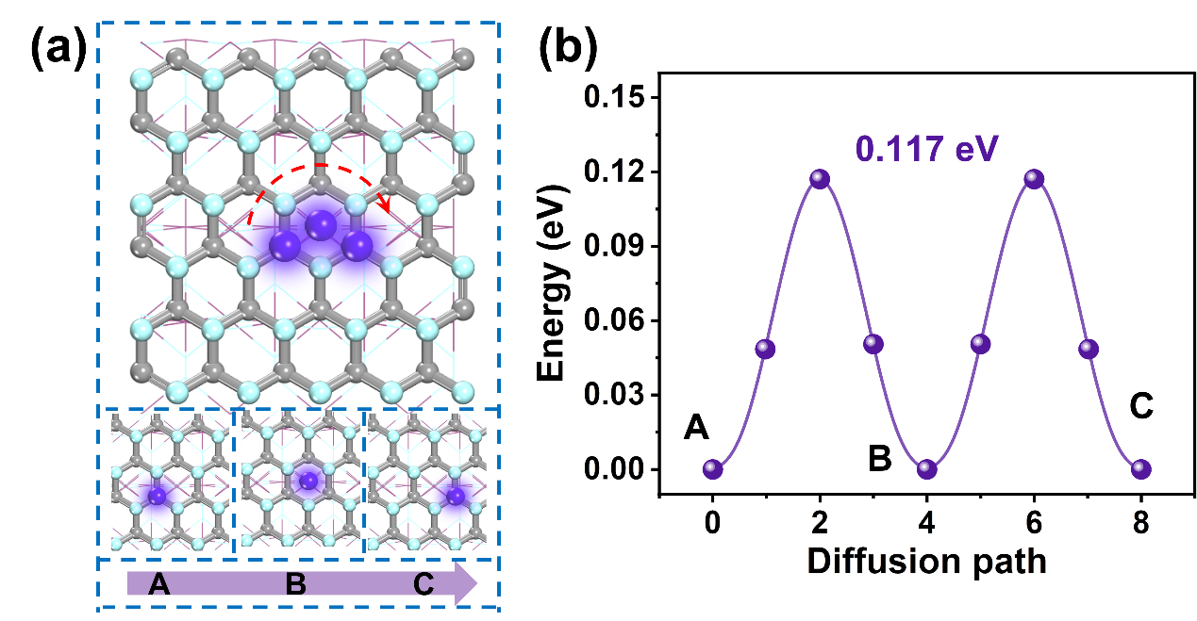
Fig. S48 Li⁺ migration path behaviors inside the (a) q2D-FcZ67 with corresponding (b) diffusion barrier energy along the surface direction.

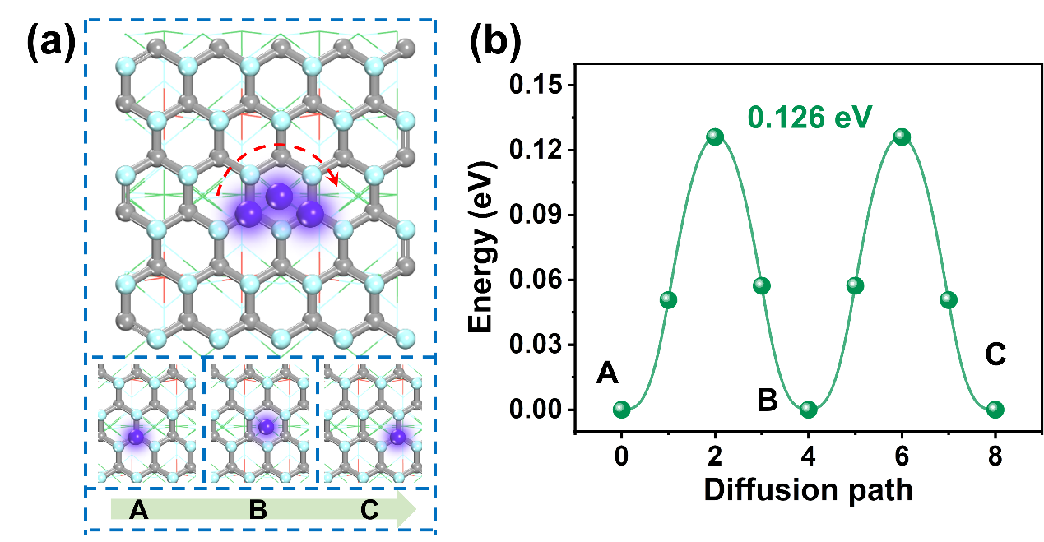
Fig. S49 Li⁺ migration path behaviors inside the (a) q2D-FcNiMOF with corresponding (b) diffusion barrier energy along the surface direction.

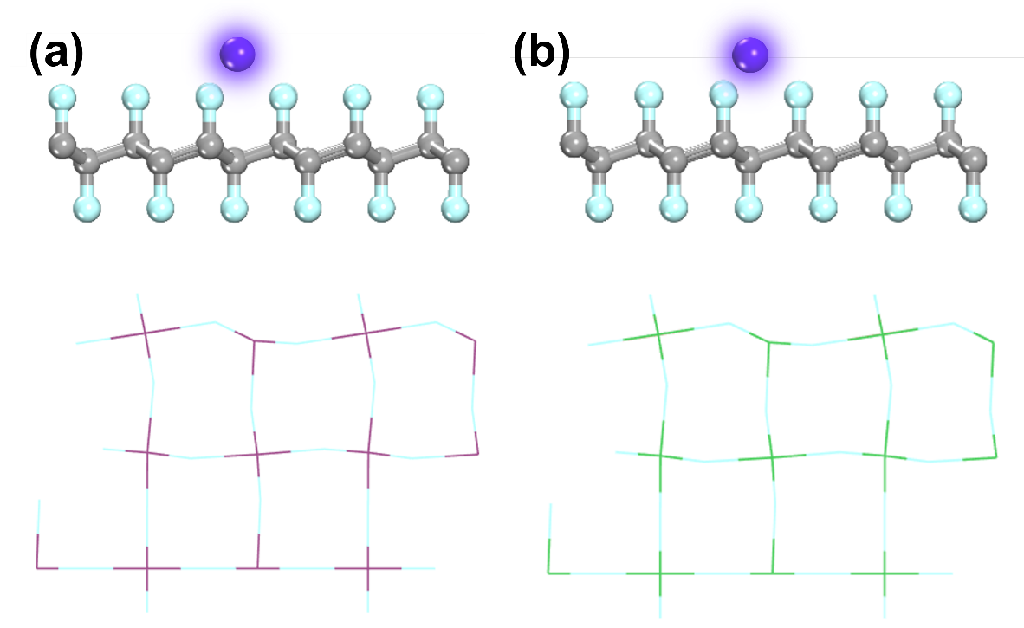
Fig. S50 A side view of (a) Fig. S48, (b) Fig. S49.

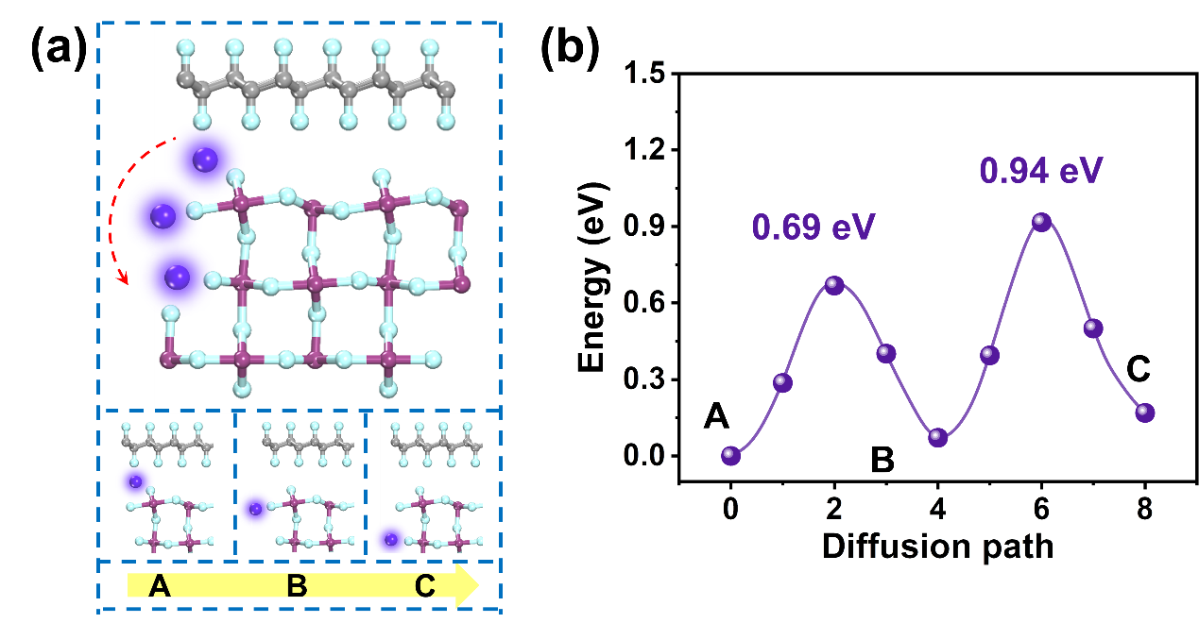
Fig. S51 Li⁺ migration path behaviors inside the (a) q2D-FcZ67 with corresponding (b) diffusion barrier energy along the vertical direction.

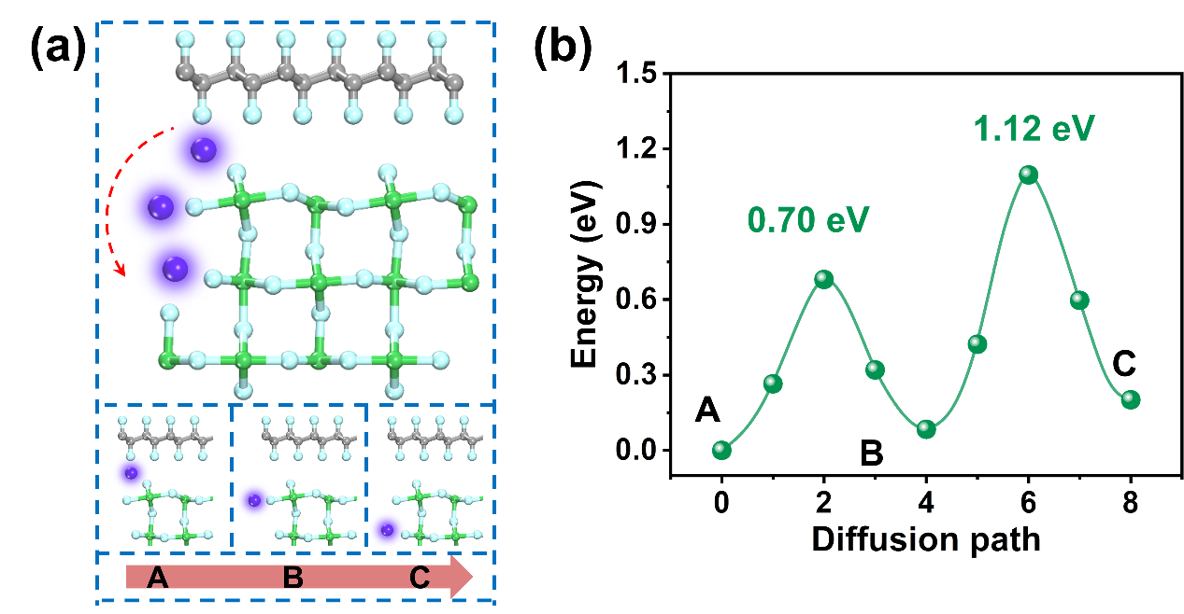
Fig. S52 Li⁺ migration path behaviors inside the (a) q2D-FcNiMOF with corresponding (b) diffusion barrier energy along the vertical direction.

References
- Kong L, Li Y, Peng C, et al. Defective nano-structure regulating CF bond for lithium/fluorinated carbon batteries with dual high-performance[J]. Nano Energy, 2022, 104: 107905.
- Perdew J P, Burke K, Ernzerhof M. Generalized gradient approximation made simple[J]. Physical review letters, 1996, 77(18): 3865.
- Blöchl P E. Projector augmented-wave method[J]. Physical review B, 1994, 50(24): 17953.
- Chadi D J. Special points for Brillouin-zone integrations[J]. Physical Review B, 1977, 16(4): 1746.
- Hu C, Gong L, Xiao Y, et al. High‐performance, long-life, rechargeable Li-CO₂ batteries based on a 3D holey graphene cathode implanted with single iron atoms[J]. Advanced Materials, 2020, 32(16): 1907436.
- Feng Y, Zhong B, Zhang R, et al. Achieving high-power and dendrite‐free lithium metal anodes via interfacial ion‐transport-rectifying pump[J]. Advanced Energy Materials, 2023, 13(12): 2203912.

