Supplementary Information

Histological classification of non-small cell lung cancer using Gabor filtering Minkowski functionals and Neighborhood Component Analysis on CT images.

Kentaro Yamagishi, Norihito Naruto, Tatsuji Mizukami, Junichi Saito & Kyo Noguchi.

The representative ROI images of each analytical step.

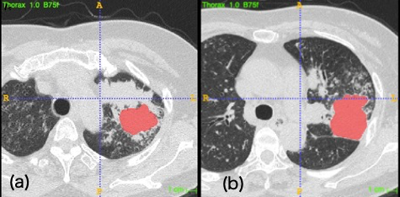
Supplementary Figure S1. Single slice ROIs of the same AD delineated by (a) Obs. 1 and (b) Obs. 2.

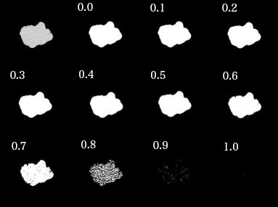
Supplementary Figure S2: ROI of Supplementary Fig. S1(a) on original and each thresholding image.

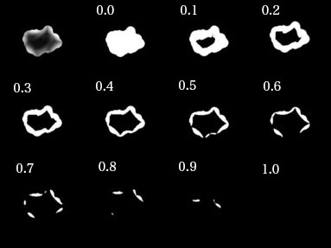
Supplementary Figure S3. ROI of Supplementary Fig. S1(a) on $G_{0,0}^{SRI}$and each thresholding image.

Two-stage feature selection method
First, features were scored using mRMR (Supplementary Fig. S4). Second, NCA was performed for the extracted features (Supplementary Fig. S5). The classifier performances of three favorable models are summarized in Supplementary Table S1.

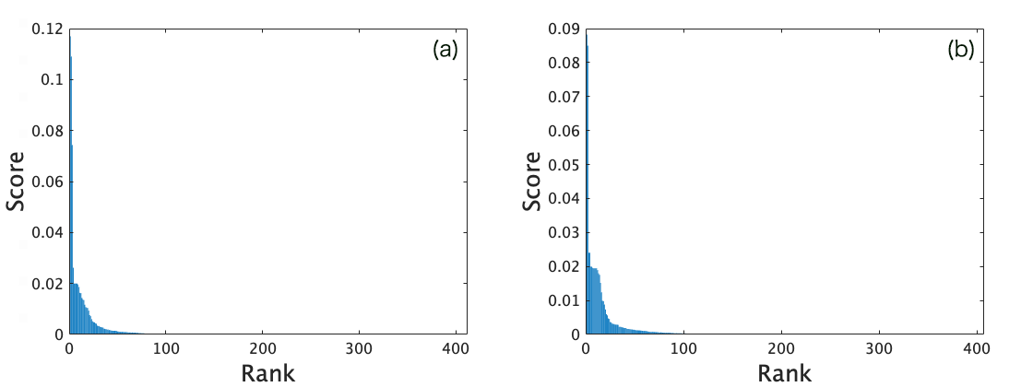
Supplementary Figure S4. Feature scores of SRI GF MFs estimated using mRMR in (a) Obs. 1 and (b) Obs. 2. The 100 top-scored features were extracted for each observer.
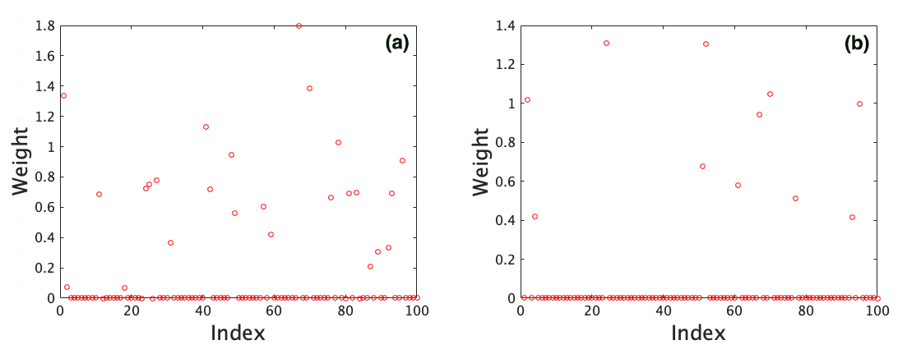

Supplementary Figure S5. NCA performed for the 100 top-scored features of mRMR in (a) Obs. 1 and (b) Obs. 2. The features with the weights of more than 0.5 were selected.

Supplementary Table S1. The performances of three favorable models in SRI GF case.
Observer | Classifier | Accuracy(%)(mean±s.d.) | AUC(mean±s.d.)
1 | 1-NN(ED) | 81.41±1.83 | 0.814±0.020
1 | 1-NN(MD) | 85.93±1.99 | 0.856±0.021
1 | Ensemble KNN | 81.40±2.58 | 0.876±0.024
2 | 1-NN(ED) | 64.55±2.34 | 0.645±0.024
2 | 1-NN(MD) | 60.46±1.45 | 0.606±0.017
2 | Ensemble KNN | 64.66±2.98 | 0.687±0.022

