Supplementary Files
AGE |  | 1. What is your age? | ( ) 60 to 74 years old ⁰
 |  | 1. What is your age? | ( ) 75 to 84 years old ¹
 |  | 1. What is your age? | ( ) ≥ 85 years old ³
SELF-PERCEPTION  OF HEALTH |  | 2. Overall, comparing with other people of your age, would you say that your health is: | ( ) Excellent, very good or good⁰
 |  |  | ( ) Fair or poor¹
FUNCTIONAL  DISABILITIES | INSTRUMENTAL Activities of Daily Living  Positive answers are worth 4 points each. However, the maximum score of the item is 4 points, even if the elderly answered yes to all questions 3, 4 and 5. | 3. Did you stop shopping because of your health or physical condition?  ( )Yes⁴ ( ) No or does not go shopping for reasons other than health
FUNCTIONAL  DISABILITIES |  | 4. Did you stop managing your money, keeping track of expenses or paying the bills of your home because of your health or physical condition?  ( )Yes⁴ ( ) No or does not control money for reasons other than health
FUNCTIONAL  DISABILITIES |  | 5. Did you stop doing light housework, such as washing dishes or cleaning the house because of your health or physical condition?  ( )Yes⁴ ( )No or no longer does housework for reasons other than health
FUNCTIONAL  DISABILITIES | BASIC  Activities of Daily Living | 6. Did you stop taking a bath or a shower alone because of your health or physical condition?  ( )Yes⁶ ( )No
COGNITION |  | 7. Has any relative or friend mentioned forgetfulness of the patient?  ( ) Yes ¹ ( ) No
8. Is this forgetfulness worsening in the last month?
( ) Yes ¹ ( ) No
9. Is this forgetfulness impeding the performance of some daily activity?
( ) Yes ² ( ) No
MOOD |  | 10. Have you felt dismayed, sad or hopeless in the last month?  ( ) Yes ² ( ) No
11. Have you lost interest or pleasure in previously enjoyable activities in the last month?
( ) Yes ² ( ) No
MOBILITY | Reach, graspingness, and pincer grip | 12. Are you unable to raise the arms above shoulder level? ( ) Yes ¹ ( )No
MOBILITY | Reach, graspingness, and pincer grip | 13. Are you unable to handle or grasp small objects?  ( ) Yes ¹ ( ) No
MOBILITY | Aerobic and muscle capacity | 14. Do you have any of the four conditions listed below?  - Unintentional weight loss of 4.5 kg or 5% of body weight in the last year or 6 kg in the last 6 months or 3 kg in the last month ( );  - Body Mass Index (BMI) less than 22 kg/m² ( );  - Calf circumference at < 31 cm ( );  - Time spent on the Gait Speed (4m) > 5 seconds ( ).  ( ) Yes ² ( )No
MOBILITY | Gait | 15. Do you have any walking problem which prevents you from performing any daily activity? ( ) Yes ² ( ) No
MOBILITY | Gait | 16. Did you have two or more falls in the last year? ( ) Yes ² ( )Não
MOBILITY | Sphincteric continence | 17. Do you lose urine or feces accidentally?  ( ) Yes ² ( ) No
COMMUNICATION | Vision | 18. Do you have vision problems that can prevent you from performing any daily activity? Use of glasses/contact lenses allowed.  ( ) Yes ² ( ) No
COMMUNICATION | Hearing | 19. Do you have hearing problems that can prevent you from performing any daily activity? Use of hearing aids allowed.  ( ) Yes ² ( ) No
MULTIPLE COMORBIDITIESS | Polipathology | 20. Do you have any of the three conditions listed below?  • Five or more chronic diseases ( );  • Daily use of five or more different drugs ( );  • Hospitalization in the last six months ( ).  ( )Yes⁴ ( ) No
Supplementary Figure 1. Clinical-Functional Vulnerability Index-20
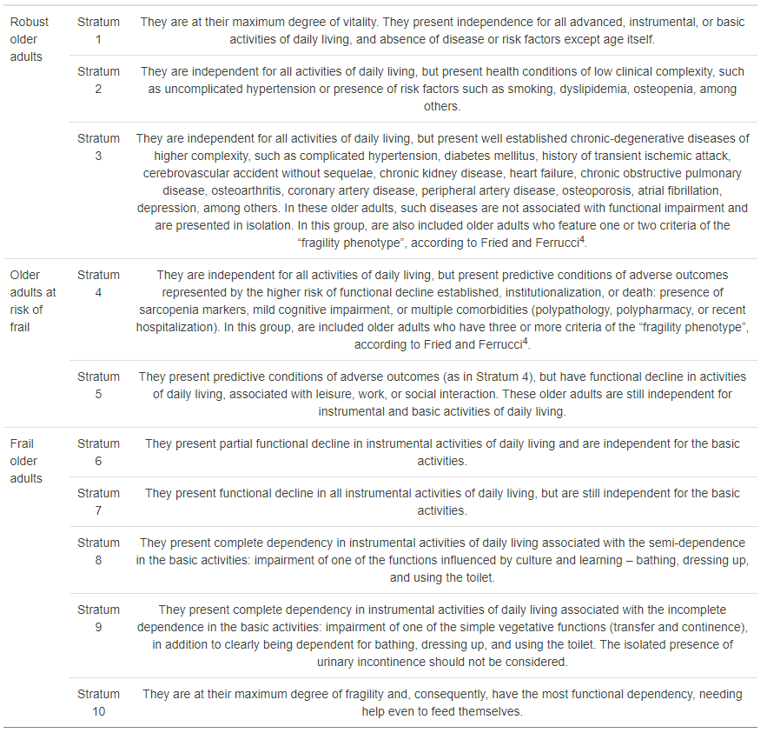
Supplementary Figure 2. Clinical-Functional classification of older adults

Supplementary Table 1. Vaccine types deployed to ILPI residents
Vaccine | n | %
First dose
ChAdOx1-S | 653 | 91.8
CoronaVac | 54 | 7.5
Comirnaty | 0 | 0
Ad26.COV2.S | 0 | 0
Missing data | 5 | 0.7
Second dose
ChAdOx1-S | 652 | 91.8
CoronaVac | 52 | 7.4
Comirnaty | 0 | 0
Ad26.COV2.S | 0 | 0
Missing data | 6 | 0.8
Deaths | 2 | -
Third dose
CoronaVac | 0 | 0
ChAdOx1-S | 3 | 0.5
Comirnaty | 550 | 90.5
Ad26.COV2.S | 5 | 0.8
Missing data | 50 | 8.2
Deaths | 104 | -

