Supplementary Information for

Tanc2-dependent direct and regulated mTOR inhibition balances mTORC1/2 signaling in developing mouse and human neurons

Sun-Gyun Kim,¹ Suho Lee,¹ Yangsik Kim,² Jieun Park,³ Doyeon Woo,⁴ Dayeon Kim,⁵ Yan Li,¹ Wangyong Shin,³ Hyunjeong Kang,³ Chaehyun Yook,³ Minji Lee,⁴ Kyungdeok Kim,³ Junyeop Daniel Roh,³ Hwajin Jung,¹ Seung Min Um,³ Jinju Han,⁵ Won Do Heo,^{3,4} and Eunjoon Kim^{1,3,#}

¹Center for Synaptic Brain Dysfunctions, Institute for Basic Science (IBS), Daejeon 34141, Korea; ²Graduate School of Medical Science and Engineering, Korea Advanced Institute for Science and Technology (KAIST); ³Department of Biological Sciences, KAIST, Daejeon 34141, Korea; ⁴Center for Cognition and Sociality, Institute for Basic Science (IBS), Daejeon 34141, Korea; ⁵Graduate School of Medical Science and Engineering, KAIST, Daejeon 34141, Korea; #Corresponding author.

Methods
Materials
Reagents were obtained from the following sources: Pan-Tanc antibody has been previously described ¹; rabbit polyclonal antibodies to Akt (#9272), phosphor-Akt (#9271), Erk1/2 (#9102), phospho-Erk1/2 (#9101), GSK-3β (#9315), phospho-GSK-3β (#9336), PTEN (#9559), phospho-PTEN (#9549), PI3K (#4257), phospho-PI3K (#4228), TSC1 (#6935), TSC2 (#4308), phospho-TSC2 (#3617), mTOR (#2983), mTOR (#2972, used for immunoprecipitation), phospho-mTOR (#2971), S6 (#2217), phospho-S6 (#4858), 4E-BP (#9644), phospho-4E-BP (#2855), S6K (#2708), phosphor-S6K (#9205), and PRAS40 (#2691) from Cell Signaling Technology; Raptor (#09-217), phospho-Raptor (#09-107), and Deptor (#abs222) antibodies (Millipore); Flag M2 (F1804) and α-tubulin (T9026) antibodies (Sigma Aldrich); HA antibodies (M180-3) (MBL); GFP antibodies (sc-9996; Santa Cruz); HRP-labeled anti-mouse and anti-rabbit secondary antibodies (Thermo Scientific); IRDye 800CW-conjugated and 680RD-conjugated goat anti-mouse and goat anti-rabbit antibodies (LI-COR Biosciences); DMEM (Invitrogen); CHAPS detergent (Thermo Scientific); rapamycin (LC Labs); ketamine (Yuhan Co).
DNA constructs
The p3XFlag-Tanc1 and Tanc2 constructs were described previously ¹. Human Tanc2 deletion mutants (aa 127-835, 836-1358, and 1234-1990) were subcloned into p3XFlag-CMV-7.1 (Sigma). Tanc2 R760C, A794V, and H1689R were generated by PCR and subcloned into p3xFlag-CMV vector. The full-length human Tanc2 gene was fully synthesized by overlapping PCR and subcloned into p3xFlag-CMV vector. The following constructs were purchased from Addgene: pAAV-CAG-GFP, pRK5-myc-mTOR, pRK5-myc-mTOR (aa 1-1482), pRK5-myc-mTOR (aa 1271-2008), pRK5-myc-mTOR (aa 1750-2549), pRK5-HA-Raptor, pRK5-HA-YFP-Deptor, pRK5-Flag-Deptor (DEP domains), pRK5-Flag-Deptor (PDZ domain). pEYFP-mTOR and pAAV-CAG-GFP-mTOR were generated using pRK5-myc-mTOR as template and subcloned into pEYFP-C1 (Clontech) and pAAV-CAG-GFP vector. pECFP-Tanc2 (aa 1-1990; human), pAAV-CAG-EGFP-Tanc2 (aa 1-1990), pGST-Tanc2 (aa 1-1990), pGST-Tanc2-N (aa 1-1358), and pGST-Tanc2-C (aa 1359-1990) were generated using p3XFlag-Tanc2 (aa 1-1990) as template and subcloning into pECFP-C1 (Clontech), pAAV-CAG-EGFP (Addgene #28014), and pGEX-6P-1 (GE Healthcare) vectors. Mouse Tanc1 shRNA (target sequence:5’-cgaagaaggagcagagata), Tanc2 shRNA (target sequence:5’-gctcagagatccagaataa), and Deptor shRNA (target sequence: 5’-cgcaaggaagacattcacgat) were subcloned into pAAV-U6-GFP vector. Human Tanc2 shRNA#1 (target sequence: 5’- gctcagagatccagaataa) and shRNA#2 (target sequence: 5’-ggacagaggttttaaataa) were subcloned into pLKO.1 (Addgene #10878) vector. All constructs were verified by DNA sequencing (Cosmo Genetech).
Virus production and injection
AAV1-hSyn-Cre-eGFP (pENN.AAV.hSyn.HI.eGFP-Cre.WPRE.SV40) and AAV1-hSyn-ΔCre-eGFP (pENN.AAV.hSyn.eGFP.WPRE.bGH) were a gift from James M. Wilson (Addgene #105539-AAV1, #105540-AAV1). For the preparation of AAV particles, we used HEK293T cells. For a single virus preparation, three of 150 pi dishes were used. When cells grew up until 90% confluency, 10 µg of target plasmid, 20 µg of PHP.eB plasmid, and 10 µg of pAAV-helper plasmid were co-transfected in a 150-pi dishes using polyetherimide (PEI) (Polysciences, #23966-1) transfection method with the N:P ratio of 25. Twenty-four hours after transfection, the medium was changed with fresh DMEM + 5% FBS (fetal bovine serum). Seventy-two hours after transfection, the medium was collected at 4 ºC for the next step, and replaced with fresh DMEM (Dulbecco's Modified Eagle's Medium) + 5% FBS. After 120 hours post-transfection, the medium and cells were harvested together and separated by centrifugation. The supernatant was mixed with 1/5 volume of 40% w/v PEG 8000 (Sigma, #89510) / 2.5M NaCl solution. After 2 hrs of incubation on ice, the mixtures were centrifuged at 4000 x g for 30 min. Pellets were suspended in 6 ml SAN digestion buffer with 100 U/ml SAN (HL-SAN, Arcticzymes, #70910-202; Buffer: 23 mM Tris-HCl, pH = 8.5 / 5 mM MgCl2/0.5 M NaCl) and incubated at 37 ℃ for 1 hour. AAV virus particles were separated by iodixanol gradient (Optiprep; Sigma D1556) by ultra-centrifugation at 350,000 x g for 2 hours. Collected virus particles from the 42/60% iodixanol interface were diluted with DPBS (Dulbecco's phosphate-buffered saline) and dialyzed using Amicon Ultra-15 with 100 kDa cutoff. Injection of AAV1-hSyn1-Cre/ΔCre-GFP into the mouse hippocampus was performed using stereotaxic apparatus (Kopf Instruments) and mice anesthetized with isofluorane (Piramal healthcare). Virus solutions were injected into the hippocampus dCA3 region in mice at postnatal day 6 (AP: Lambda+1.7, ML: +-1.7, DV : -1.9) at the speed of 100 nL/min. To designate the exact injection site with naïve eyes, AAV1-hSyn-ΔCre-eGFP virus mixed to AAV1-hSyn-Cre-eGFP with 1:3~1:5 ratio. Virus-injected brains were sliced (100 µm thickness) using a vibratome (Leica VT1200) in ice-cold dissection buffer (212 mM sucrose, 25 mM NaHCO₃, 5 mM KCl, 1.25 mM NaH2PO₄, 0.5 mM CaCl₂, 3.5 mM MgSO₄, 10 mM D-glucose, 1.25 L-ascorbic acid, 2 mM Na-pyruvate). Five slices were collected for GFP control and Cre-GFP, which were further dissected for GFP-positive regions. The dissected tissues were fractionated for crude synaptosomes preparation and then subjected to immunoblotting.
GST protein purification
Expression constructs for GST alone, GST-Tanc2, GST-Tanc2-N (aa 1-1358), GST-Tanc2-C (aa 1359-1990) were transformed into BL-21 (DE3) E.coli. Cells were cultured in 2 x YT medium with ampicillin until OD600 reached 0.6 at 37° C, and then protein expression was induced with 0.5 mM IPTG for 6 hours at 25°C. Cells were lysed in lysis buffer (1% Triton X-100, 150 mM NaCl, 20 mM Tris pH7.4, 1 mM MgCl₂, 1 mM EGTA, 1 mM PMSF) with sonication and centrifuged at 20,000 x g for 15 min at 4 ºC. The supernatant was incubated with glutathione sepharose 4B beads (GE Healthcare) for 1 hour.
Tanc2 and mTORC1 protein purification in HEK293T cells
GFP, GFP-Tanc2, or GFP-mTOR + HA-Raptor were overexpressed in HEK293T cells by transfection using Lipofectamine 3000 for 48 hours. GFP- or GFP-Tanc2-expressing cells were lysed with RIPA buffer, and the lysates were incubated with anti-GFP antibodies trapped in agarose beads (Chromotech, GFP-Trap_A) for 2 hours at 4 °C. The immunoprecipitated complexes were washed 3 times with RIPA buffer, and the immobilized proteins were eluted by 0.2 mM glycine-HCl, pH 2.5 for the in vitro kinase assay. For mTORC1 purification, GFP-mTOR and HA-Raptor expressed in HEK293T cells were stimulated with 10 µg/ml insulin (Sigma #I9278) for 30 min prior to lysis in mTOR lysis buffer (40 mM HEPES, 2mM EDTA, 10 mM β-glycerophosphate, pH 7.4, and 0.3% CHAPS). The lysates were incubated with anti-GFP antibodies trapped in agarose beads for 2 hours at 4 °C, and then sequentially rinsed with low salt mTOR wash buffer (40 mM HEPES, 150 mM NaCl, 2 mM EDTA, 10 mM β-glycerophosphate, pH7.4, 0.3% CHAPS), high salt mTOR wash buffer(40 mM HEPES, 400 mM NaCl, 2 mM EDTA, 10 mM β-glycerophosphate, pH 7.4, 0.3% CHAPS), and mTOR wash buffer (25 mM HEPES, 20 mM KCl, pH 7.4).
In vitro direct binding test
GST, GST-Tanc2-N, GST-Tanc2-C, or GST-Tanc2 (full-length) proteins immobilized to agarose beads were incubated with the mTOR recombinant protein (0.5 µg; Origene #TP320457) in RIPA buffer for 2 hr at 4 °C. Protein complexes in the agrose beads were washed with RIPA buffer three times and subjected to SDS-PAGE for Coomassie blue staining or immunoblotting.
In vitro mTOR kinase assay
GTP-bound Rheb (Rheb-GTP) was prepared by mixing Rheb protein (2.5 µg; Origene #TP300307), GTPγS (0.1 mM; Sigma #G8634), and EDTA (10 mM), and incubating the mixture at 30 °C for 15 min, followed by the addition of 20 mM MgCl₂. Then, mTORC1 immobilized in beads, Rheb-GTP (100 ng), and GFP/GFP-Tanc2 (500 ng) were mixed in mTOR kinase assay buffer (25 mM HEPES, 20 mM KCl, 10 mM MgCl₂) and incubated for 20 min on ice prior to the start of the kinase assay. The enzyme reaction was initiated by adding mTOR assay start buffer (10 µl, 25 mM HEPES, 10 mM MgCl₂, 140 mM KCl) with or without ATP (500 µM) and S6K (200 ng, mTOR kinase substrate) (Origene #TP317324), followed by incubation at 30 °C for 60 min. The enzyme reaction was stopped by adding 4x SDS PAGE sample buffer.
Cell culture and transfection
HEK293T cells obtained from the American Type Culture Collection were cultured in DMEM medium supplemented with 10% (v/v) FBS (Invitrogen) and 1% (v/v) penicillin/streptomycin at 37 °C in a humidified 10% CO₂ atmosphere. For live imaging, 1.5 x 10⁴ cells were plated in each well of µ-Plate 96 plates. Cells were transfected with Lipofectamine (Invitrogen) according to the manufacturer’s instructions. After 24 hours adding the transfection mixture into a well, co-localization analysis proceeded. For immunoprecipitation, 1 x 10⁶ cells were plated in 60 mm dish and transfected as described above.
Cell lysis and immunoprecipitation
All cells were rinsed with ice-cold PBS (phosphate-buffered saline) before lysis. All cells exceptor for those used to isolate mTOR-containing complexes, were lysed in RIPA buffer (10 mM HEPES [pH 7.4], 150 mM NaCl, 1 mM EDTA, 0.1 mM MgCl₂, 1% nondiet P40 (NP40), 20 mM NaF, 1 mM NaVO₃, 1 μg/ml aprotinin, 1 μg/ml pepstatin, 10 μg/ml leupeptin, and 1 mM PMSF). The cell lysates were clarified by centrifugation at 13,000 rpm for 10 minutes, and the supernatant was collected. For Immunoprecipitations, cells were lysed with the RIPA buffer containing 0.3% CHAPS instead of 1% NP40. The lysates were incubated with primary antibodies at 4°C overnight, incubated with 50% slurry of protein A or G agarose beads (Incospharm) for 1–3 hours at 4°C, and washed three times in lysis buffer. Immunoprecipitated proteins were denatured by adding 20 μl of sample buffer and boiling for 5 min, and subjected to SDS-PAGE.
Immunoblot analysis
Protein concentrations were determined using the Pierce BCA protein assay kit (Thermo Scientific) according to the manufacturer’s protocol. Proteins resolved in SDS-PAGE were transferred to PVDF membrane (Millipore). After blocking with 5% non-fat milk or 5% BSA, the blots were incubated with primary antibodies overnight at 4°C, incubated with HRP- or IRDye-conjugated secondary antibodies for 1 hr at room temperature, and detected by using enhanced chemiluminescence (ThermoScientific) or Odyssey CLx imaging system (LI-COR Biosciences).
Live imaging and colocalization analysis
Serum starvation and re-feeding experiment were performed by plating HEK293T cells on 96-well plates and transfecting the cells as described above. After 24 hours of transfection, cells were washed with PBS and maintained with serum-free culture medium at 37 °C in a humidified 10% CO₂ air for 4–5 hours, then the medium was replaced with normal culture medium supplemented with serum, incubated for following 4 or 24 hours. For rapamycin treatment, transfected cells were treated first with 100 nM of rapamycin or vehicle (4% ethanol, 4% PEG400, 4% Tween 80, and sterile water) for 2 hours before the serum starvation procedure described above. Live-cell imaging for co-localization was performed using a Nikon A1R confocal microscope (Nikon Instruments) mounted in a Nikon Eclipse Ti body, and equipped with CFI Plan Apochromat VC objectives (60×/1.4-NA oil or 40×/0.95-NA air; Nikon) and a Chamlide TC system (maintained 37 °C and 10% or 10% CO₂; Live Cell Instrument, Inc). CFP and YFP images (512 x 512 pixels, 72.7 µm²) were taken using 457 and 514-nm laser lines, respectively. Colocalization images were quantified using Image J coloc2 plugin.
Ketamine treatment and synaptosome preparation
Mice received a single acute intraperitoneal (i.p.) injection of ketamine (10 mg/kg, i.p.) and were sacrificed at the indicated times. Brain tissues were collected for crude synaptosomal preparation. To purify crude synaptosomes, brain tissues (without cerebellum) from P13–14 mice were rapidly removed and homogenized in a solution containing 0.32 M sucrose, 20 mM HEPES (pH 7.4), 1 mM EDTA, 20 mM NaF, 1 μg/ml aprotinin, 1 μg/ml pepstatin, 10 μg/ml leupeptin, 1 mM PMSF, and 1 mM Na₃VO_{4.} The homogenate was centrifuged at 3,000 rpm at 4°C for 10 min. The pellet (P1, nuclear fraction) contains nuclei and large cell debris. The supernatant was centrifuged at 12,000 rpm at 4°C for 10 min. After centrifugation, the supernatant (cytosolic fraction) was removed, and the pellet (P2: crude synaptosomal fraction) was resuspended and lysed in RIPA buffer containing 0.3% CHAPS. Subsequently, P2 lysates were centrifuged for 15 min at 14,000 rpm at 4°C to remove insoluble debris.
Mice
Tanc2^{+/–} mice have been previously described (genetic background: C57BL/6J) ¹. All mice used in this study were generated by in vitro fertilization. To generate Tanc2 ^{fl/fl} mice, Tanc2 ^{tm2a(}KOMP)Wtsi ES cells were obtained from KOMP. The mutant Tanc2 allele was inserted in the intron located between exons 4 and 5 of the Tanc2 gene. Embryonic stem cells were injected into blastocysts to generate chimeric mice. Chimeric mice were further bred to C57BL/6J wild-type mice to generate F1 heterozygous Tanc2 ^{tm2a}(KOMP)Wtsi mice (Tanc2 ^{null/+} ). F1 mice were then bred with Protamine-Flp mice (C57BL/6J0 to remove the Frt-flanked gene trap cassette in the Tanc2 tm2a(KOMP)Wtsi allele, resulting in a conditional allele (Tanc2 ^{fl/+} ). Homozygous Tanc2 ^{fl/fl} mice were generated from Tanc2 ^{fl/+} intercrosses, which allow further conditional knockout in the presence of Cre expression. Tanc2 ^{fl/fl} mice were identified by PCR with primers (forward:
5’-CTGTGCATGAAAGCTTCTGG -3’ and reverse: 5’-TCTCCACCTCCCTGGTACTG-3’) to amplify a 222-bp fragment from the wild-type allele and a 440-bp fragment from the flox allele. Mice maintenance and procedures were performed in accordance with the Requirements of Animal Research at KAIST. Experimental procedures were approved by the Committee on Animal Research at KAIST (KA2016-31). Mice were fed ad libitum, and 2-5 animals were housed in a cage with a 12-h dark/12-h light cycle.
Behavioral tests
All behavioral tests were performed using age-matched mice (8–20 weeks) during the dark phase of the cycle (light-off periods). Mice had at least 24 h of rest time between tests. All experimental data were analyzed using Ethovision XT 10.1 software (Noldus) unless stated otherwise analysis. All tests were conducted in a blind manner.
Open-field test
Subjects were placed in a white acryl open field box (40 x 40 x 40 cm), and the movements were recorded for 60 min for adult mice. Illuminations were set at 0 or 100 lux. The distance moved and time spent in the center arena (central area of 20 x 20) were measured.
Laboras test
Various behaviors, including locomotion, immobility, climbing, grooming and rearing, were recorded automatically using Laboratory Animal Behavior Observation Registration and Analysis System (LABORASTM) by Metris ^{2,3}. Mice were housed in LABORAS recording cages. The cage is directly placed onto the sensing platform with the upper part of the cage, including the top, food hopper, and drinking bottle. The recording was conducted for 72 consecutive hours. Animals were tested at the age of 2–3 months.
Morris water maze test
Morris water maze testing was conducted in a round white pool 100 or 120 cm in diameter and 40 cm deep. The maze was placed alone in a room with four cues on its walls. The pool was filled with water until the top of the platform (10 cm in diameter) was submerged 1 cm below the water surface, and white paint was added. The pool temperature was maintained at 22 ± 0.5 °C by adding warm water. Each mouse was given 3 trials a day for 5 consecutive days. In each trial, mice were placed in three different quadrants in random order. Irrespective of the trial performance, mice were guided to the platform and allowed to remain there for at least 15 sec. In the probe test performed 24 h after the acquisition task, mice were placed in the center of the arena and allowed to swim for 1 min in the absence of the platform. The number of times the mice crossed the learned escape platform location as well as the time spent in the quadrant was measured. On the day after the probe test, mice were subjected to a reversal task in which the platform was placed in the quadrant opposite side of the arena and received three trials a day during three consecutive days. The procedure remained the same as that of the acquisition task.
Novel object recognition test
Each mouse was habituated in the open field box without objects for 30 min a day before the training session. At the training session, the mouse was placed in the open field arena containing two identical sample objects for 10 min. Twenty-four hours after the training, the mouse was returned to the open field arena with two objects, one is identical to the sample, and the other is novel. Object recognition was scored by the amount of time with the nose of the mouse pointed and located within 2 cm from the object.
Contextual fear conditioning test
Mice at 4–5 months of age were placed in the conditioning chamber (Coulbourn instruments) and after a 2-min adaptation period received three foot shocks (2 sec, 0.5 mA) at 2 min, 3 min, and 4 min. After the foot shock, mice remained in the chamber for an additional minute and then were returned to their home cage. After 24 hours, mice were placed back into the same context for 5 min, and freezing was monitored. Data acquisition and analysis were measured using FreezeFrame (Coulbourn Instruments)
Elevated plus-maze test
The apparatus used for the elevated plus-maze test consisted of two open and closed (30-cm walled) arms (5 x 30 cm each). The maze was elevated to a height 50 cm above the floor. Each mouse was placed in the central zone of the maze facing an enclosed arm and was recorded for 10 min. The frequency of entries and the amount of time spent in each arm were measured.
Light-dark test
The apparatus (40 x 20 x 20 cm) used for light-dark test was divided into two compartments; a smaller dark chamber that occupied roughly 1/3 of the total box, and a larger light chamber (200 lux), which was lit with a bright white light. There was a hole in between that allows mice to move freely between the compartments. The task ran for 10 min, and started after the mice were placed into the dark chamber. The anxiety parameters, time spent in the light compartment and the number of entries into the light compartment, were measured.
Three-chamber social interaction test
The 3-chambered social approach test, originally developed for social interaction of rodents ^{4,5}, was conducted as previously described ⁶. In brief, plastic containment cups in the corner of both side chambers were placed. Mice were habituated in the center chamber for 10 min for adaptation, followed by in all three chambers for 10 min. Following habituation, Stranger 1 mouse (129/SvJae strain) was placed in a small container located in the corner of one side chamber, and the Object was placed in another container in the opposite side chamber. Subject interaction was recorded for 10 min. Following the first test, the Object was replaced with Stranger 2 (129/SvJae) and subject interaction was recorded for 10 min.
Forced swim test
The apparatus, a glass beaker (15 cm diameter, 22 cm high), was filled with water (approximately 24 °C) to the height of 15 cm. The time spent floating on the water (immobility time, sec) during 6 min was manually scored.
Tail suspension test
Mice were individually suspended by their tails to a horizontal metal bar using adhesive tape. The distance between the tip of the nose of the mouse and the floor was 20 cm. The time spent immobile was recorded for 6 min and manually scored.
Field recordings
Acute hippocampal slices (300 μm thick, sagittal slice for CA1) were used for extracellular field recordings at 27–30 °C (TC-324B, Warner Instruments). For LTP experiments, 4–9 weeks old mice were used. After a stable baseline was recorded, LTP was induced by high-frequency stimulation (100 Hz, 1s for HFS-LTP) and theta-burst stimulation (10 trains/5 Hz; each train contains four pulses at 100 Hz) with 10-sec intervals. For LTD experiments, 2–3 weeks old mice were used. LTD was induced by DHPG (50 mM, 10 min for mGluR-LTD) and low-frequency stimulation (1 Hz, 900 stimuli for LFS-LTD) in the presence of picrotoxin (50 μM). Field EPSPs were evoked with a glass pipette containing external ACSF to activate SC-CA1 pyramidal synapses. Average responses (mean ± s.e.m.) were expressed as percentage of baseline response (at least 20 min of stable responses).
Rapamycin rescue
Rapamycin was freshly dissolved in a vehicle made of 4% ethanol, 4% PEG400, 4% Tween 80, and sterile water before use. For the Tanc2^{+/–} in vivo experiments, vehicle or rapamycin was administered intraperitoneally on the same 3 days every week for 1 month (i.e., every Monday, Wednesday, and Friday) with rapamycin daily at a dose of 5 mg/kg starting at P10.
Neuron culture and knockdown using AAV1 shRNAs
Cultured mouse neurons were prepared from fetal C57/BL6J mice at embryonic day 17. Briefly, dissected hippocampal tissues were digested with papain and plated on poly-D-lysine-coated 6-well culture plates with plating medium (Neurobasal-A medium supplemented with 2% B-27, 10% FBS, 1% GlutaMax, and 1 mM sodium pyruvate, all from Thermo Fisher Scientific) at the density of 6 x 10⁵ cells per well. Four hours after plating, the plating medium was replaced with FBS-free culture medium (Neurobasal-A medium supplemented with 2% B-27, 1% GlutaMax, and 1 mM sodium pyruvate) with following 50% replacements every 7 days. On DIV 7 or 21, AAV shRNA particles were added to neurons and incubated for 7 days. Then, virus-infected cells were rinsed with ice-cold Tyrode’s solution (136 mM NaCl, 2.5 mM KCl, 2 mM CaCl₂, 1.3 mM MgCl₂, 10 mM Na-HEPES, 10 mM D-Glucose, pH7.3). For crude synaptosome preparation, AAV-infected neurons were collected in HEPES-buffered sucrose solution (0.32 M sucrose, 4 mM HEPES, pH 7.4, 1 mM EDTA, 20 mM NaF, 1 μg/ml aprotinin, 1 μg/ml pepstatin, 10 μg/ml leupeptin, 1 mM PMSF, and 1 mM Na₃VO₄) and homogenized using Glass-Teflon homogenizer and centrifuged for 10 min at 900 x g at 4°C. The supernatants were centrifuged for 10 min at 10,000 x g at 4°C. After centrifugation, the supernatant (cytosolic fraction) was removed, and the pellet (P2: crude synaptosomes) was resuspended and lysed in 1 x SDS SDS sample buffer for immunoblotting.
Neuron and glia segregation culture
Cytosine arabinoside (1 mM, Ara-C, Sigma #C1768) was added to FBS-free culture medium during DIV3–14 for glia free neuron culture, and cytosine arabinoside was not added to 10% FBS-containing plating medium for glial cell culture. AAV-PHP.eB-shRNA particles were added to cultured neurons or glia at DIV 7, followed by cell harvest at DIV 14 for synaptosome preparation from neurons or total lysate preparation for glia.
Lentivirus production
Lentivirus was packaged in HEK293T cells grown in DMEM with 10% FBS. HEK293T cells were transfected with polyethylenimine (PEI) (Polysciences #23966). Per 150 mm plate, the following solution was prepared, incubated for 5 minutes at room temperature and added drop-wise to plates: 12.2 µg lentiviral DNA, 8.1 µg MDL, 3.1 µg Rev-RSV, 4.1 µg CMV-VSVG, 1 ml of Opti-MEM (Thermo Fisher #31985062), and 110 µl PEI (1 µg/µl) and mixed lightly. The culture medium was changed after four hours and the virus was harvested at 72 hours post-transfection. To collect viruses, the cell medium was collected and centrifuged at 19,400 rpm for two hours. The virus pellet was resuspended with DPBS. All the lentiviral vectors used contained the puromycin-resistance gene.
Human neuron culture and lentivirus infection
HUES6 obtained from HSCI iPS Core was maintained on MEF (ATCC, #SCRC-1040) in human embryonic stem cell (hESC) medium comprising DMEM/F12 (Gibco #12400024) with MEM NEAA (Gibco #11140050), 14.3 mM sodium bicarbonate (Sigma #S5761), 1mM L-glutamine (Sigma #S5792), 100μM β-Mercaptoethanol (Merck #M3148), 20 % of knockout serum replacement (Gibco #10828028), and 10 ng/ml bFGF (R&D systems #4114-TC) and passed using collagenase IV (Gibco #17104019). To generate floating embryoid bodies (EBs), hESC colonies were dissociated with collagenase IV and plated onto petridishes in hESC medium. A day after floating culture, to obtain neural progenitor cells (NPCs), the EBs were treated with LDN (Selleckchem #S2618) and SB-431542 (Cayman #CAY-13031) in DMEM/F12 + Glutamax (Gibco #10565042) plus N2 and B27 supplements (Gibco #17502048 and #12587010). The treatment was continued for 7 days, followed by plating onto growth factor reduced matrigel (BD #354230)-coated dishes in DMEM/F12 plus N2 and B27 supplements (N2B27 medium) and 1μg/ml laminin (Gibco #23017015) to facilitate the attachment of the EBs. Within a few days, rosettes were manually collected and dissociated with Accutase (Innovative Cell Technologies #AT104) and plated onto poly-L-ornithine (Sigma #P3655)/laminin-coated dishes with NPC medium (N2B27 medium plus 20 ng/ml bFGF). To differentiate NPCs into neurons, NPCs were plated into polyornithine/laminin-coated plates in N2B27 medium in the presence of 100 U/ml penicillin-streptomycin (Gibco #14140122), 200 nM ascorbic acid (Sigma), 500 μg/ml dcAMP (Selleckchem), 20 ng/ml BDNF (Peprotech #450-02), 20 ng/ml GDNF (Peprotech #450-10) and 1 μg/ml laminin as previously described ⁷. Protocols describing the use of human ESCs were approved in accordance with the ethical requirements and regulations of the Institutional Review Board of KAIST (IRB #KA2018-61). Lentivirus containing shRNA and puromycin resistant gene was infected to NPCs with MOI of ~1. Twenty-four hours post-infection, puromycin (Thermo Fisher #A1113803, 400 ng/ml) was added into NPC culture medium. Twenty-four hours after puromycin treatment, NPCs were differentiated into neurons.
Image acquisition and analysis
Fixed neurons were imaged with a 63X objective oil lens on a Zeiss LSM780 Confocal Microscope driven by ZEN software (Zeiss). Images were obtained as a 1 µm Z-stack with 0.5 µm spacing. For quantification of the spine/shaft fluorescence ratio, line plots of fluorescence intensity were generated across spine heads and the adjacent dendritic shafts using ZEN software. Fluorescence intensity at each compartment was quantified from the maximum intensity corresponding to the spine and the dendrite after background subtraction. Then, ratios were calculated as the ratio between the dendritic spine and shaft. More than 10 spines were measured for each neurons and each experiment was repeated at least three times in separate neuronal cultures.
Data acquisition, statistics, and analysis
All experiments were carried out in a blind manner. Statistical analysis was conducted using Prism 7.0 software (GraphPad Software, Inc.). Statitstical details are described in Supplementary Table 1.
Data availability
The data that support the findings of this study are available as Supplemental Information, including uncropped western blot images.
References
1. Han, S., et al. Regulation of dendritic spines, spatial memory, and embryonic development by the TANC family of PSD-95-interacting proteins. The Journal of neuroscience : the official journal of the Society for Neuroscience 30, 15102-15112 (2010).
2. Quinn, L.P., et al. Further validation of LABORAS using various dopaminergic manipulations in mice including MPTP-induced nigro-striatal degeneration. Journal of neuroscience methods 156, 218-227 (2006).
3. Quinn, L.P., et al. LABORAS: Initial pharmacological validation of a system allowing continuous monitoring of laboratory rodent behaviour. Journal of neuroscience methods 130, 83-92 (2003).
4. Silverman, J.L., Yang, M., Lord, C. & Crawley, J.N. Behavioural phenotyping assays for mouse models of autism. Nature reviews. Neuroscience 11, 490-502 (2010).
5. Crawley, J.N. Designing mouse behavioral tasks relevant to autistic-like behaviors. Mental retardation and developmental disabilities research reviews 10, 248-258 (2004).
6. Chung, W., et al. Social deficits in IRSp53 mutant mice improved by NMDAR and mGluR5 suppression. Nature neuroscience (2015).
7. Brennand, K.J., et al. Modelling schizophrenia using human induced pluripotent stem cells. Nature 473, 221-225 (2011).

Supplementary figures and legends
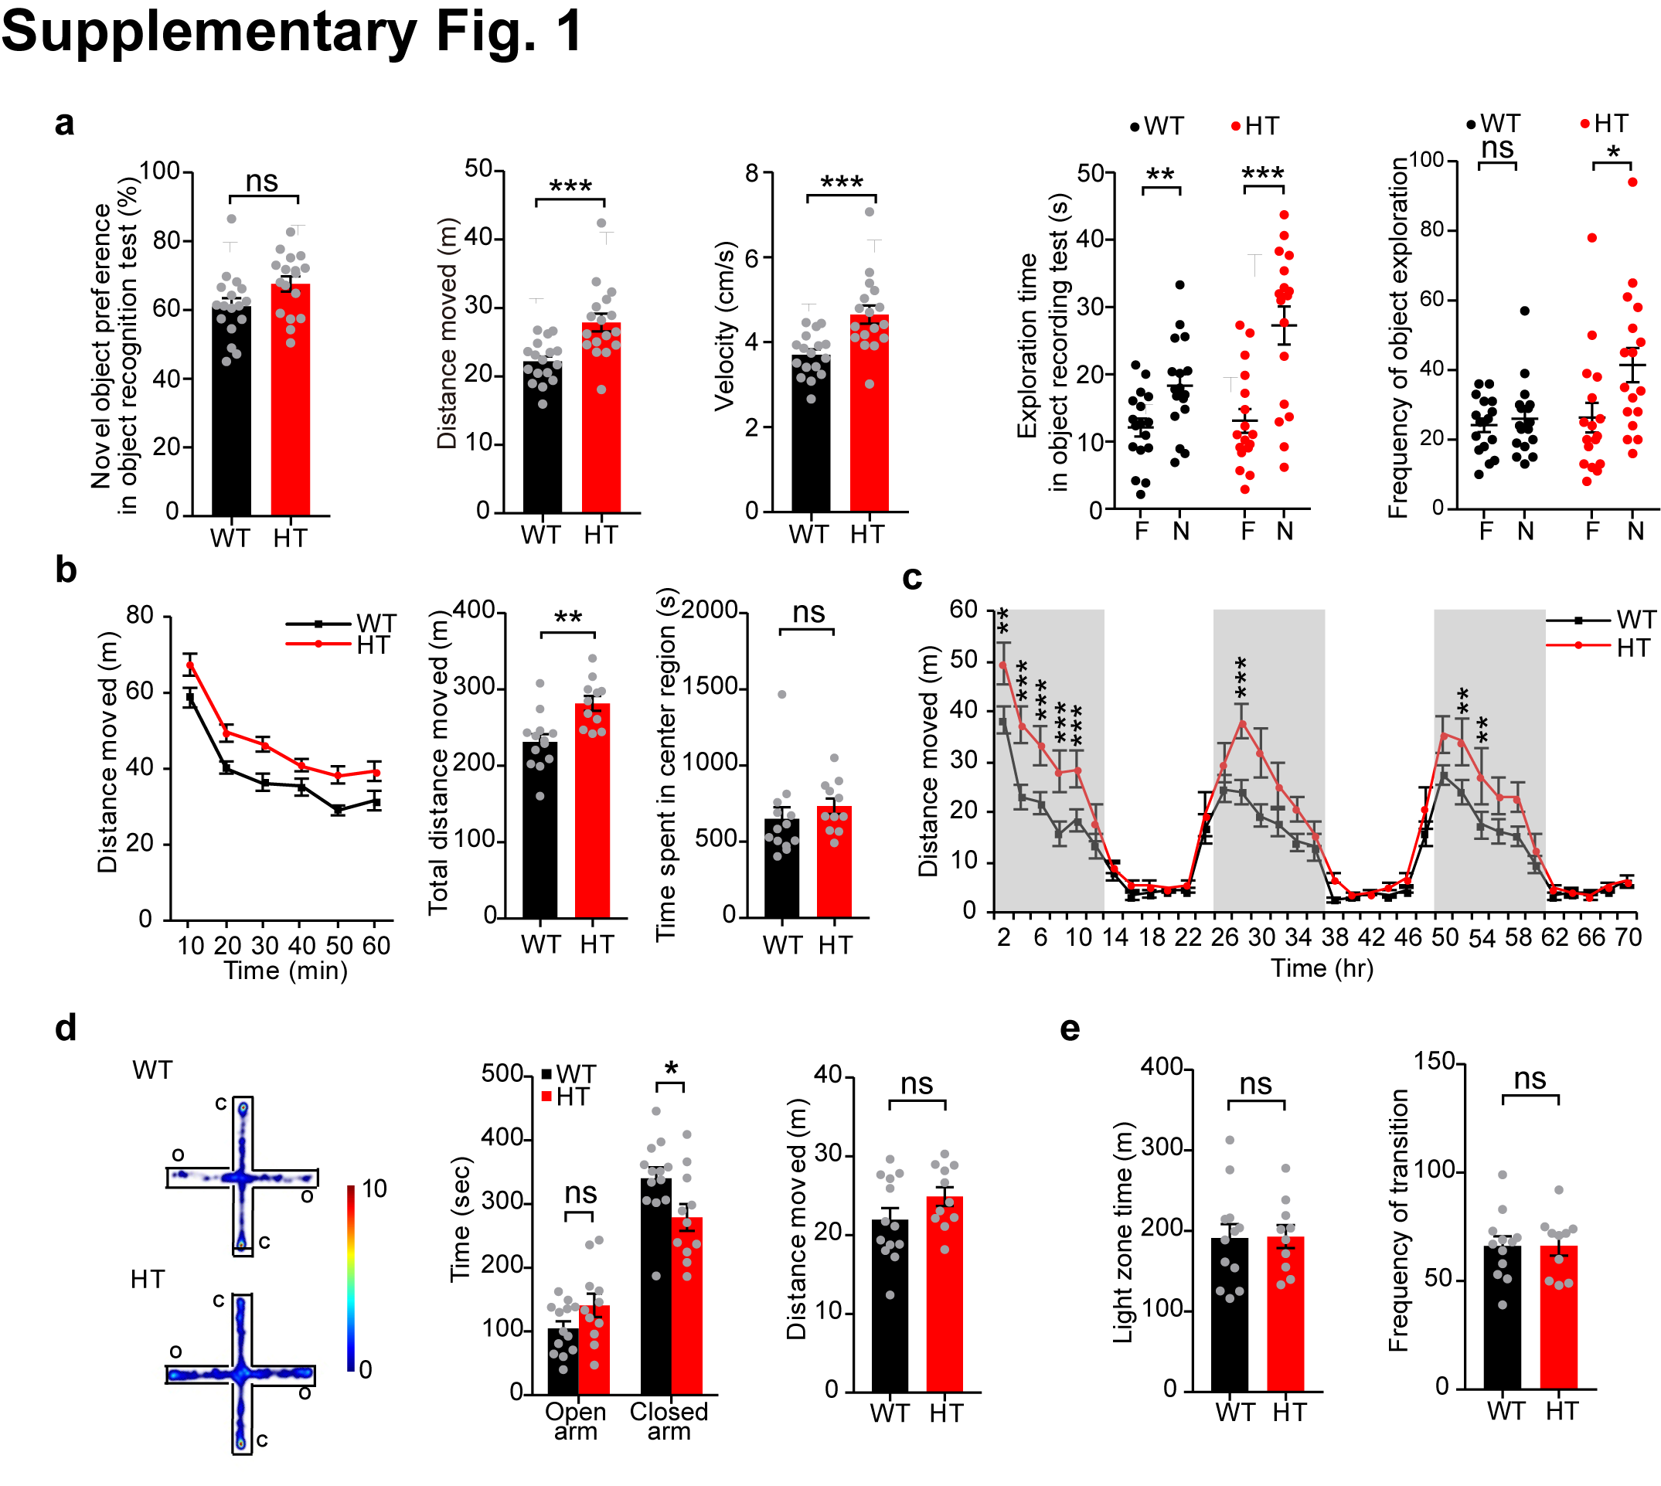
Supplementary Fig. 1. Impaired hyperactivity and moderate anxiolytic-like behavior in male Tanc2^{+/–} mice.
(a) Normal novel object-recognition memory in Tanc2^{+/–} mice (2–4 months; male) in the novel object-recognition test, as shown by novel object preference (% time spent in exploring a novel object relative to total time spent exploring both familiar and novel objects). F, familiar object; N, new object. Note that these mice also showed hyperactivity in the novel object arena, as supported by distance moved and movement velocity. The increased frequency of novel object exploration in the mutant mice might be attributable to the increased hyperactivity. (n = 17 [WT, HT], *P < 0.05, **P < 0.01, ***P < 0.001, ns, not significant, Student’s t-test).
(b) Hyperactivity of Tanc2^{+/–} mice (2–4 months; male) in the open-field test, as shown by distance moved over 60 minutes and total distance moved. Note also that the time spent in the center region of the open field arena was normal in Tanc2^{+/–} mice, indicative of normal anxiety-like behavior. (n = 13 [WT], 11 [HT], **P < 0.01, ns, not significant, two-way RM ANOVA and Student’s t-test).
(c) Hyperactivity of Tanc2^{+/–} mice (2–4 months; male) in the Laboras test, as shown by distance moved over 72 hours. The shaded areas represent light-off periods. (n = 16 [WT, HT], **P < 0.01, ***P < 0.001, ns, not significant, two-way RM ANOVA [genotype effect P < 0.05]).
(d) Moderate anxiolytic-like behavior of Tanc2^{+/–} mice (2–4 months; male) in the elevated plus-maze test, as shown by time spent in open and closed arms. There was no genotype difference in the total distance moved. (n = 13 [WT], 11 [HT], *P < 0.05, ns, not significant, two-way RM ANOVA).
(e) Normal anxiety-like behavior of Tanc2^{+/–} mice (2–4 months; male) in the light-dark test, as shown by time spent in the light chamber/zone and frequency of transitions between light and dark chambers. (n = 13 [WT], 10 [HT], ns, not significant, Student’s t-test).
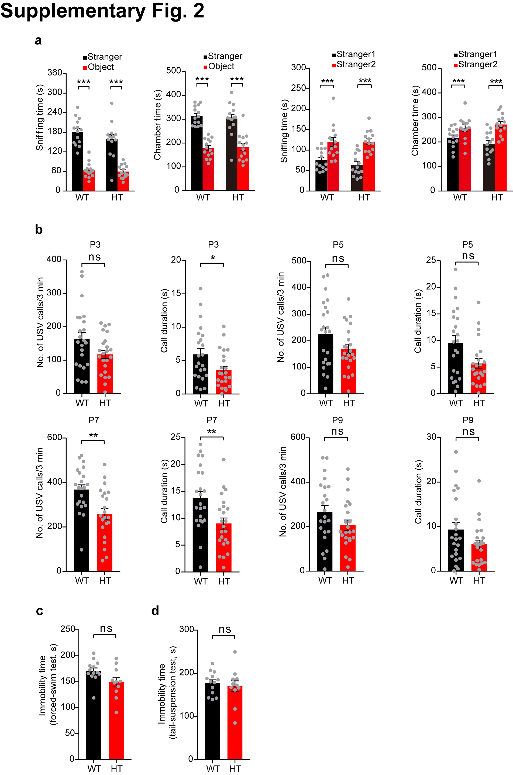
Supplementary Fig. 2. Suppressed pup ultrasonic vocalization but normal social interaction, social novelty recognition, and depression-like behavior in male Tanc2^{+/–} mice.
(a) Normal social interaction and social-novelty recognition in Tanc2^{+/–} mice (2–4 months; male) in the three-chamber social-interaction test, as shown by time spent in the chamber and in sniffing the target (stranger/object). Stranger 1, social stranger mouse; Object, inanimate object; Stranger 2, new social stranger mouse. (n = 14 mice [WT, HT], ***P < 0.001, Student’s t-test).
(b) Modestly suppressed ultrasonic vocalizations (USVs) in Tanc2^{+/–} pups (P3–9; male) separated from their mothers, as shown by the total number of USV calls and the duration of each call. (n = 23 pups [WT, HT], *P < 0.05, **P < 0.01, ns, not significant, Student’s t-test).
(c) Normal depression-like behavior of Tanc2^{+/–} mice (2–4 months; male) in the forced-swim test, as shown by immobility time. (n = 13 [WT], 11 [HT], ns, not significant, Student’s t-test).
(d) Normal depression-like behavior of Tanc2^{+/–} mice (2–4 months; male) in the tail-suspension test, as shown by immobility time. (n = 13 [WT], 11 [HT], ns, not significant, Student’s t-test).
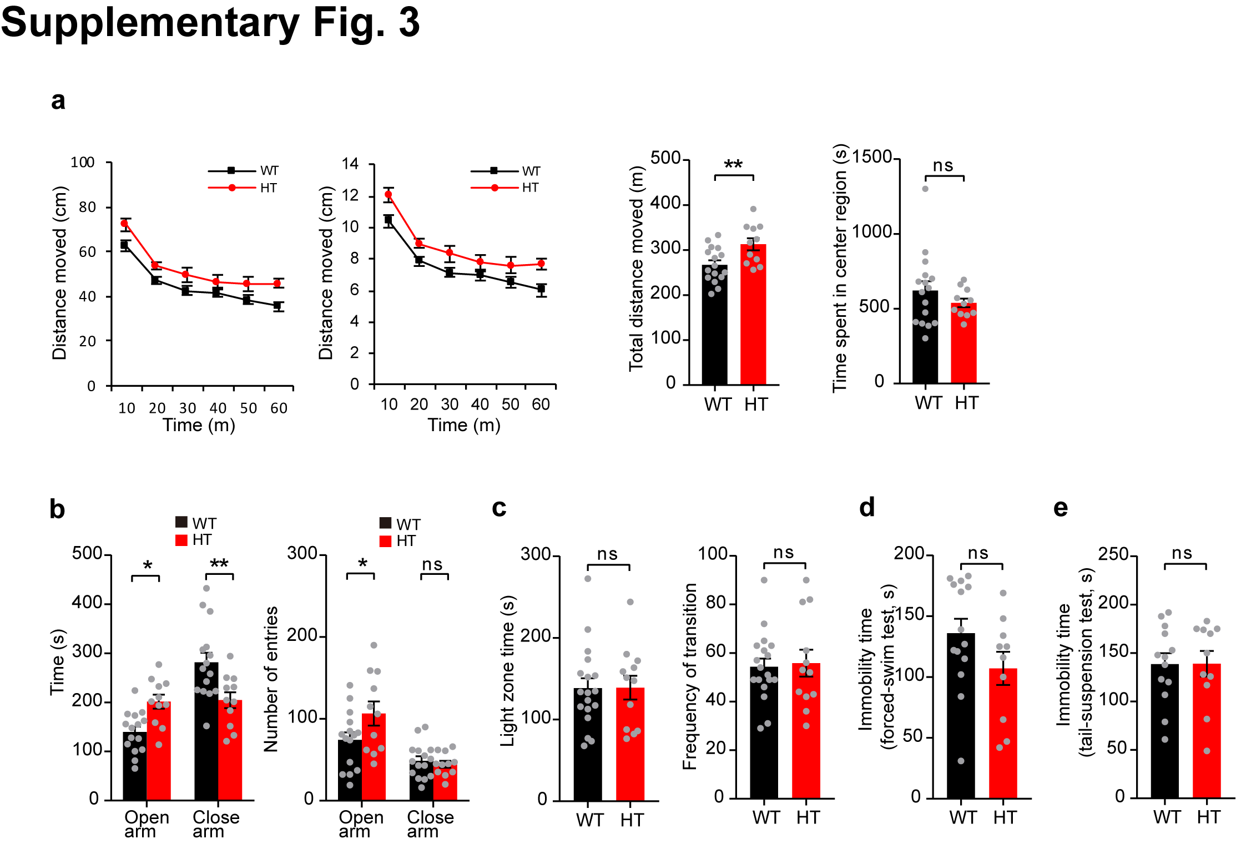
Supplementary Fig. 3. Female Tanc2^{+/–} mice display hyperactivity and anxiolytic-like behavior, but normal depression-like behavior.
(a) Hyperactivity of female Tanc2^{+/–} mice (2–4 months) in the open-field test, as shown by distance moved over 60 minutes and total distance moved. Note also that the time spent in the center region of the open field arena was normal in female Tanc2^{+/–} mice, indicative of normal anxiety-like behavior. (n = 16 mice [WT], and 11 mice [HT], **P < 0.01, ns, not significant, two-way RM ANOVA and Student’s t-test).
(b) Anxiolytic-like behavior of female Tanc2^{+/–} mice (2–4 months) in the elevated plus-maze test, as shown by time spent in open and closed arms. Note that the total distance moved in open arms was increased in the mutant mice. (n = 15 mice [WT], and 11 mice [HT], *P < 0.05, **P < 0.01, ns, not significant, two-way RM ANOVA).
(c) Normal anxiety-like behavior of female Tanc2^{+/–} mice (2–4 months) in the light-dark test, as shown by time spent in the light chamber and frequency of transitions between light and dark chambers. (n = 18 mice [WT], and 12 mice [HT], ns, not significant, Student’s t-test).
(d) Normal depression-like behavior of female Tanc2^{+/–} mice (2–4 months) in the forced-swim test, as shown by immobility time. (n = 14 mice [WT], and 10 mice [HT], ns, not significant, Student’s t-test).
(e) Normal depression-like behavior of Tanc2^{+/–} mice (2–4 months; female) in the tail-suspension test, as shown by immobility time. (n = 13 mice [WT], and 10 mice [HT], ns, not significant, Student’s t-test).

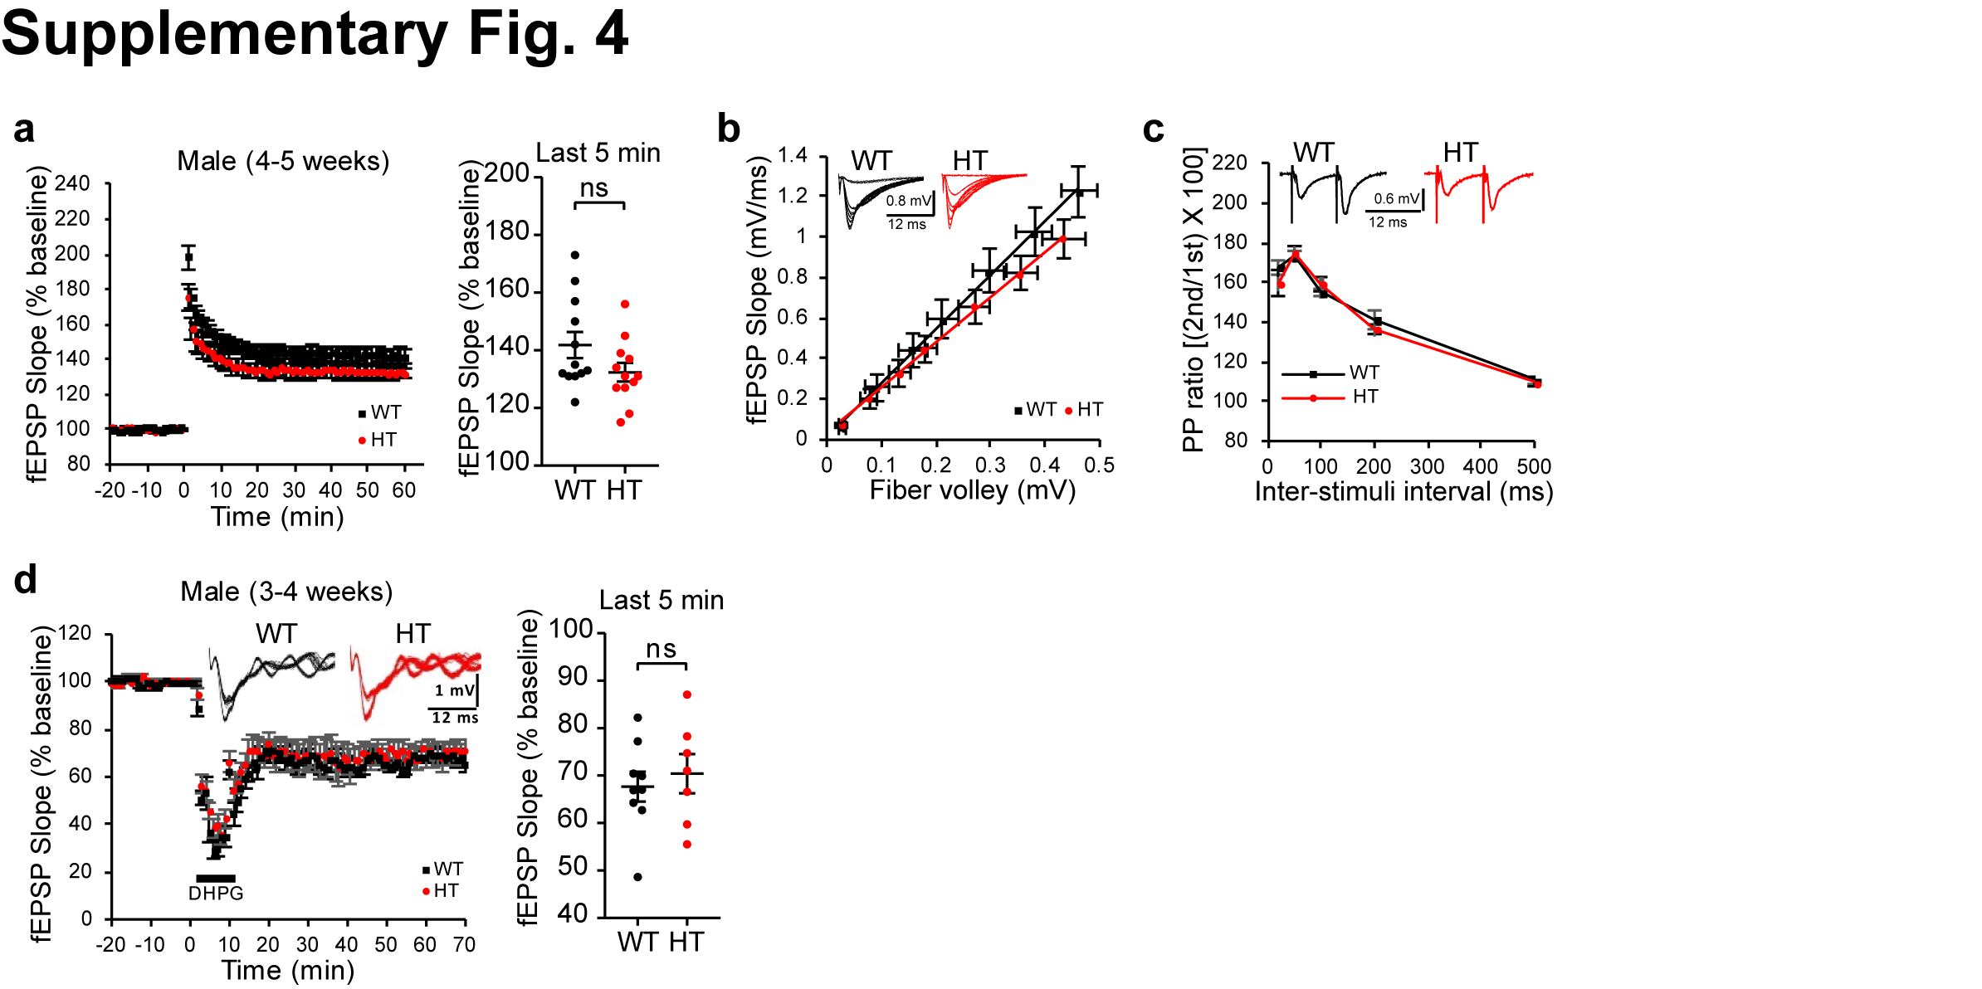
Supplementary Fig. 4. Normal HFS-LTP, mGluR-LTD, basal transmission, and PPF at Tanc2^{+/–} SC-CA1 synapses.
(a) Normal HFS-LTP at SC-CA1 synapses of 4–5-week-old Tanc2^{+/–} mice (male). n = 12, 6 [WT], and 12, 5 [HT], ns, not significant, Student’s t-test).
(b) Normal basal transmission at SC-CA1 synapses of Tanc2^{+/–} mice (3–4 weeks; male), as shown by initial fEPSP (field excitatory postsynaptic potential) slopes plotted against stimulus intensities (input-output). (n = 11, 4 [WT], and 13, 5 [HT], two-way RM ANOVA [main genotype effect P = 0.3725]).
(c) Normal paired-pulse facilitation at SC-CA1 synapses of Tanc2^{+/–} mice (3–4 weeks; male), as shown by paired-pulse ratios plotted against inter-pulse intervals. (n = 11, 4 [WT], and 13, 5 [HT], two-way RM ANOVA [main genotype effect P = 0.6515]).
(d) Normal mGluR-LTD induced by the group I mGluR agonist DHPG (50 μM, 10 min) at SC-CA1 synapses of Tanc2^{+/–} mice (3–4 weeks; male). (n = 9, 5 [WT], and 7, 4 [HT], ns, not significant, Student’s t-test).
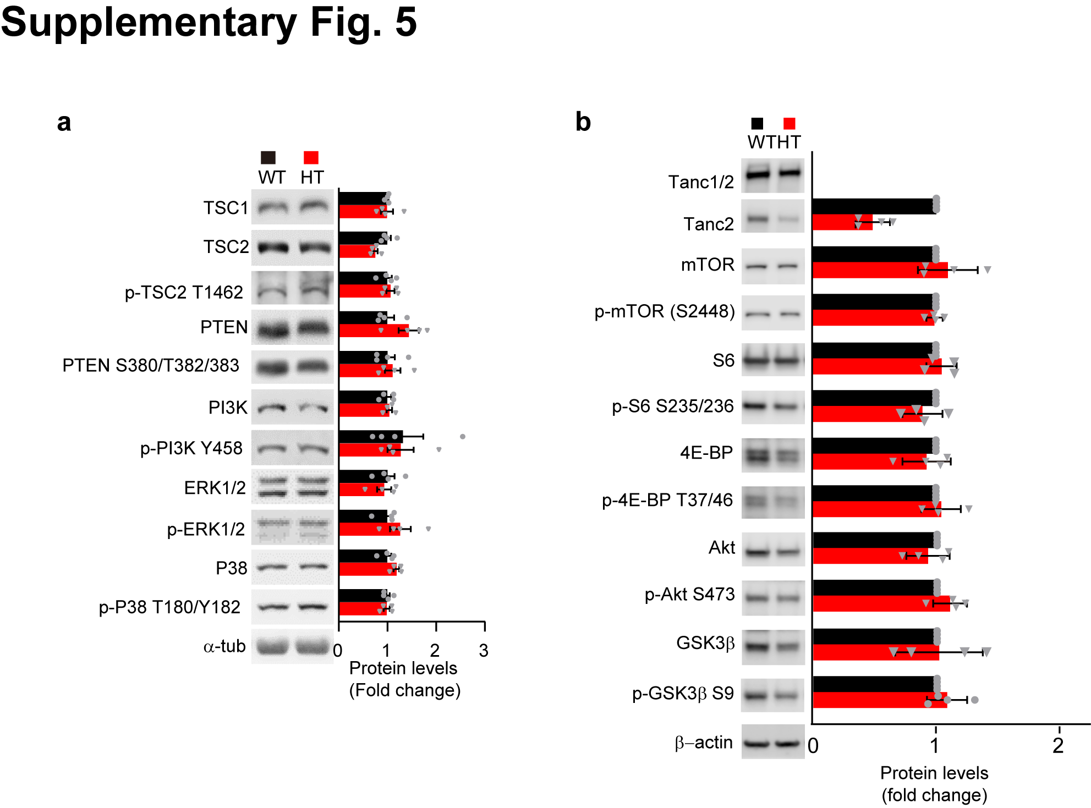
Supplementary Fig. 5. Normal mTOR-upstream activities in the P14 Tanc2^{+/–} brain, and normal mTOR and mTOR-downstream activities in the P28 Tanc2^{+/–} brain.
(a) Lack of changes in phosphorylated or total levels of PI3K, PTEN, and TSC2 proteins upstream of mTOR in the Tanc2^{+/–} brain (P14; male). Immunoblot signals were normalized to α-tubulin signals. (n = 4 mice [WT, HT], Student’s t-test).
(b) Normal phosphorylated and total levels of mTOR (S2448), S6 (S235/236), 4E-BP (T37/46), Akt (S473), and GSK3β (S9) in the Tanc2^{+/–} brain (P28; male). Immunoblot signals were normalized to α-tubulin signals. (n = 4 animals [WT, HT], Student’s t-test).
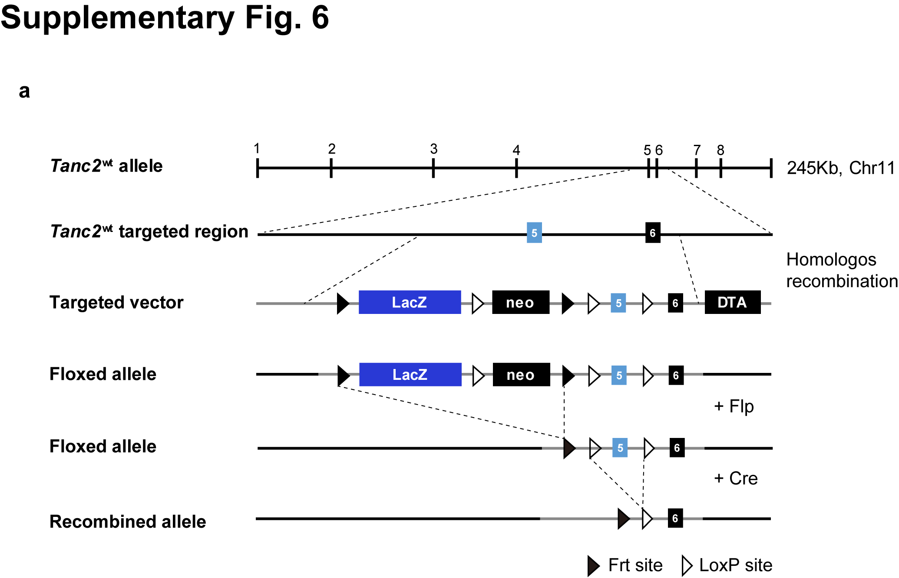
Supplementary Fig. 6. Conditional Tanc2 KO strategy.
(a) Scheme for the generation of Tanc2^{fl/fl} mice carrying floxed exon 5 of the Tanc2 gene. LacZ, β-galactosidase gene; neo, neomycin resistance cassette; DTA, diphtheria toxin gene; Flp, flippase; Cre, Cre recombinase; Frt site, site for flippase; LoxP site, cleavage site for cre recombinase action.
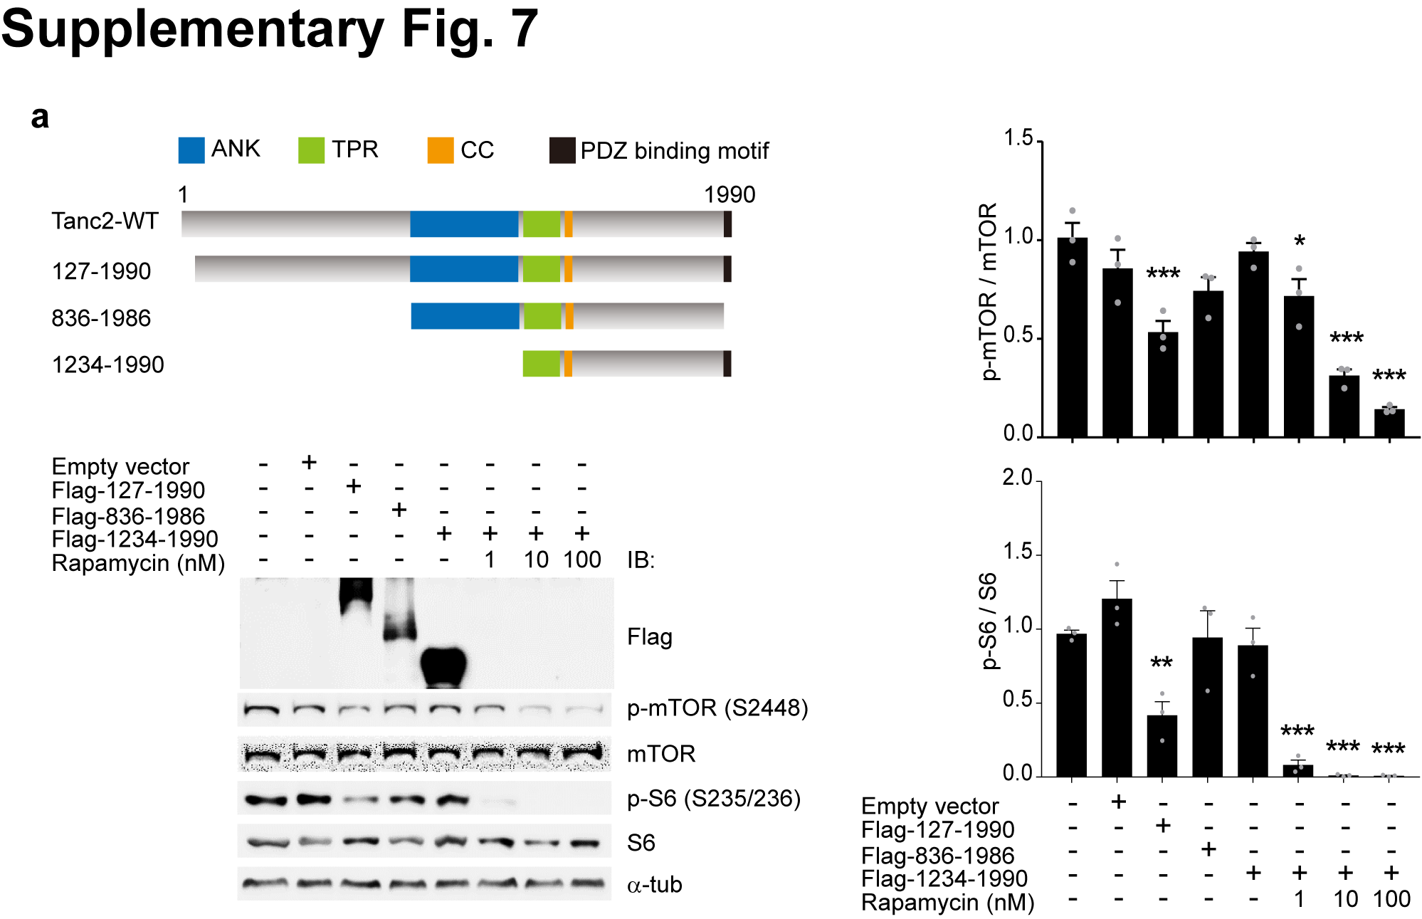
Supplementary Fig. 7. Tanc2 inhibits mTOR activity in heterologous cells.
(a) Tanc2 suppresses endogenous mTOR activity in HEK293T cells. HEK293T cells were transfected with near full-length Flag-Tanc2 (aa 127-1990; human) or Flag-Tanc2 deletion variants (aa 836–1986 and 1234–1990; human), followed by immunoblot analysis for phosphorylated (Ser-2448) and total mTOR. Cells in which mTOR was suppressed by rapamycin served as controls. Note that the near full-length variant significantly inhibited mTOR activity, whereas the shorter deletion variants (aa 836–1986, aa 1234–1990) did not. (n = 3 independent experiments, *P < 0.05, **P < 0.01, ***P < 0.001, one-way ANOVA with Bonferroni test).
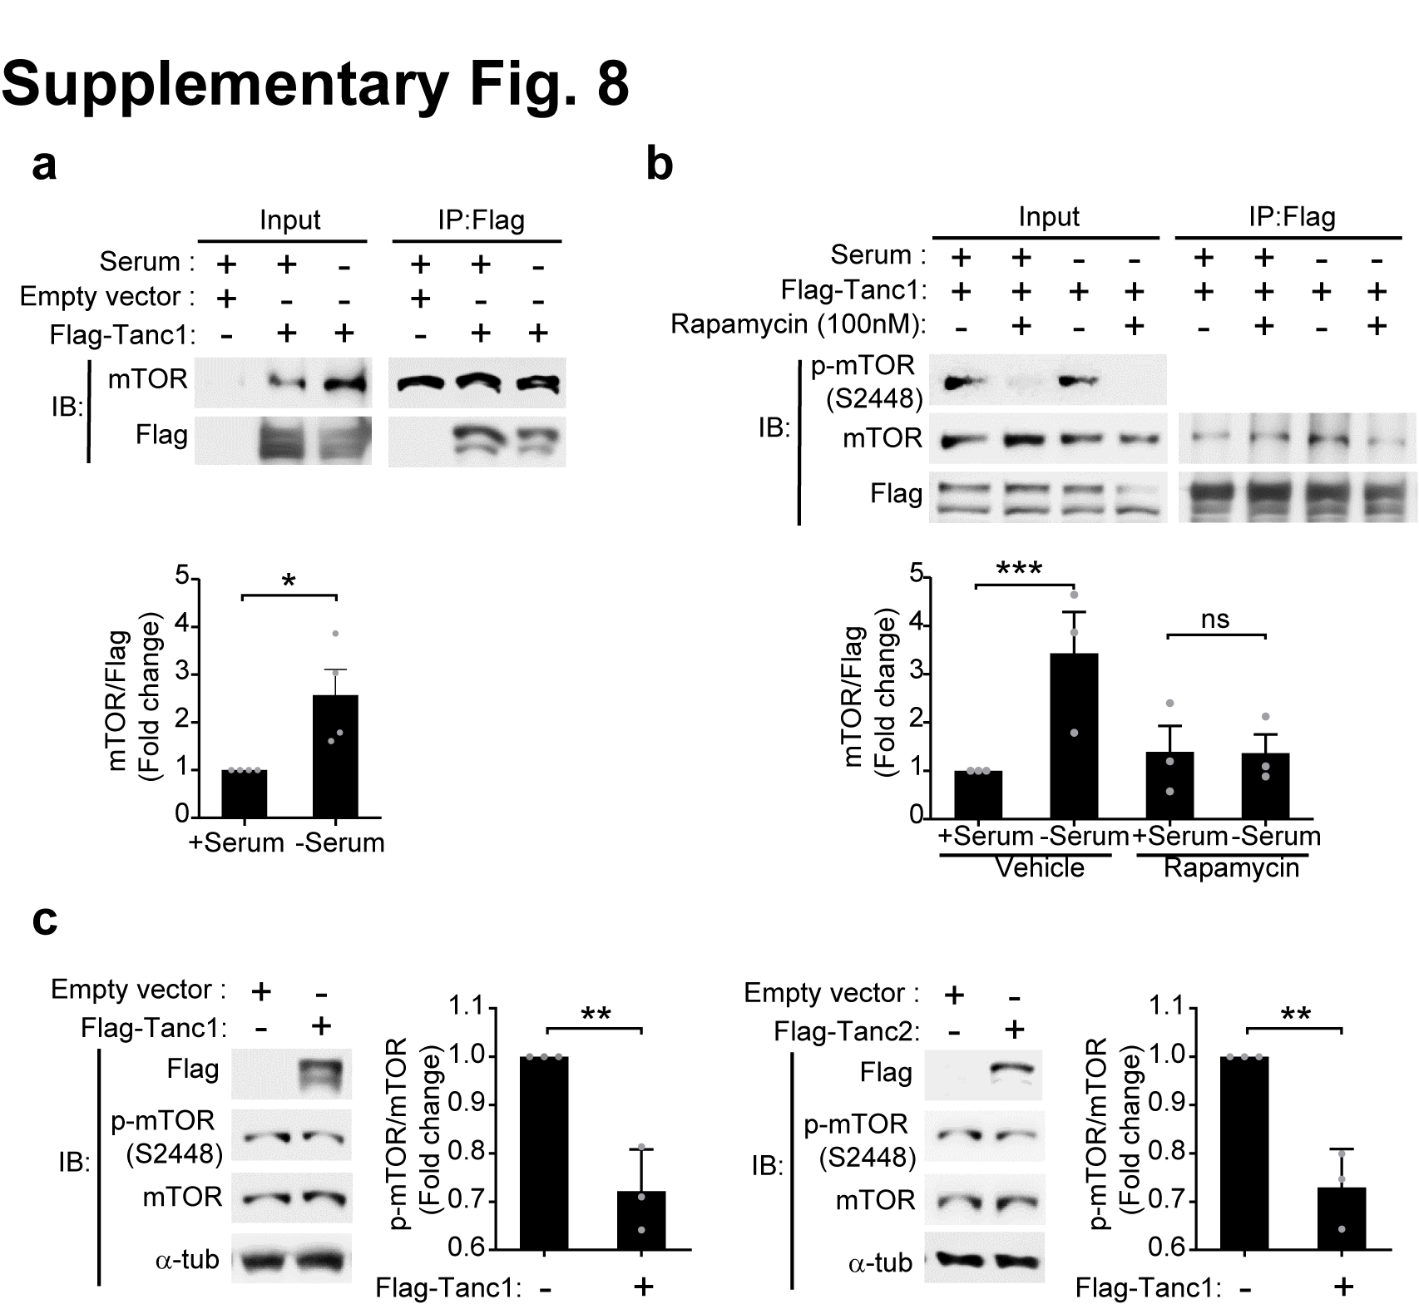
Supplementary Fig. 8. Tanc1 interacts with mTOR in a serum- and rapamycin-dependent manner and inhibits mTOR activity in heterologous Cells.
(a) Serum starvation (4 hours) promotes the interaction between Tanc1 and mTOR in heterologous cells, as demonstrated by coimmunoprecipitation. HEK293T cells expressing Flag-Tanc1 (human) were incubated with serum (or no serum; control) for 4 hours prior to coimmunoprecipitation and immunoblot experiments. mTOR signals were normalized to Tanc1 signals for quantification. (n =4 independent experiments, *P < 0.05, Student’s t-test).
(b) Rapamycin inhibits serum starvation-induced increases in the interaction between Tanc1 and mTOR in heterologous cells. Flag-Tanc1 was expressed in HEK293T cells in the presence of serum. Pretreatment of cells with rapamycin for 2 hours was followed by serum starvation for 4 hours; cell lysates were subjected to coIP and immunoblot experiments. mTOR signals were normalized to Tanc1 signals for quantification. (n =3 independent experiments, ***P < 0.05, ns, not significant, Student’s t-test).
(c) Overexpression of Tanc1 in HEK293T cells suppresses mTOR activity, as shown by the ratio of total to phosphorylated (active) mTOR. Tanc2 (human) was also used as a control. Flag-tagged Tanc1/Tanc2 were overexpressed in HEK293T cells, followed by immunoblotting for total and phosphorylated (Ser-2448) mTOR. mTOR signals were normalized to α-tubulin signals. (n =3 independent experiments, **P < 0.01, Student’s t-test).

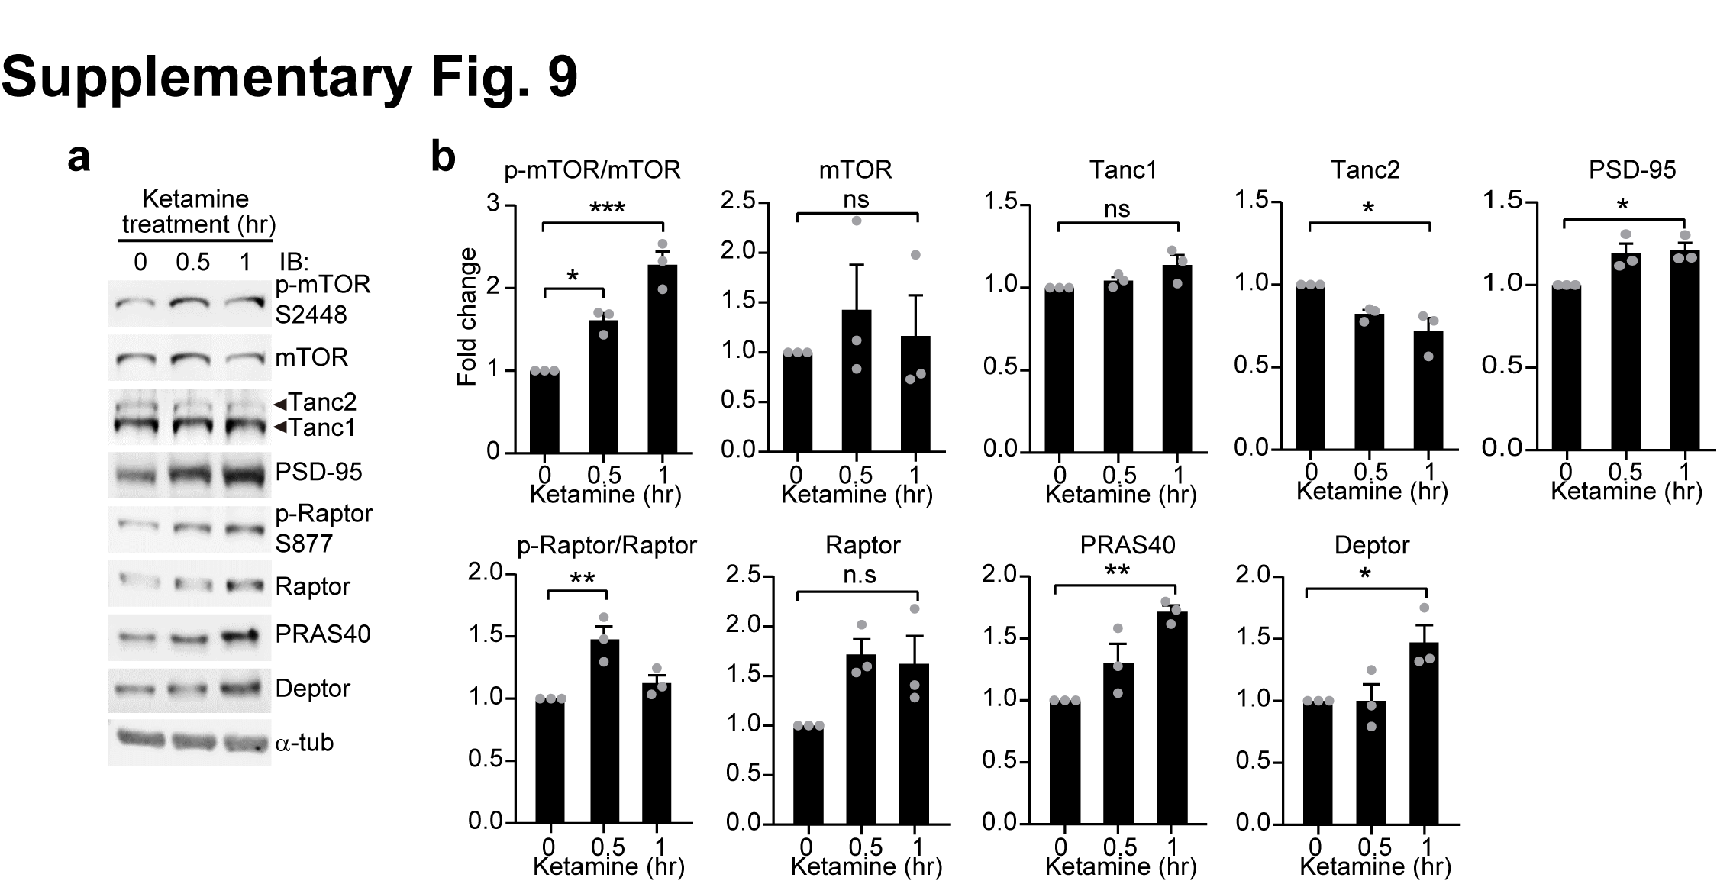
Supplementary Fig. 9. Ketamine induces changes in mTOR activity and synaptic levels of Tanc2-associated and mTORC proteins in the mouse brain.
(a and b) Ketamine induces mTOR activation in the mouse brain (P13–14; 10 mg/kg; i.p.), as shown by the time-dependent increases in the phosphorylation of mTOR and the mTORC1 protein Raptor in crude synaptosomes. Note that synaptic levels of other mTORC1/2 proteins (PRAS40 and Deptor) and PSD-95 also increased, whereas those of Tanc2 (but not Tanc1) were modestly decreased. (n =3 independent experiments, *P < 0.05, **P < 0.01, ***P < 0.001, ns, not significant, one-way ANOVA with Bonferroni test).
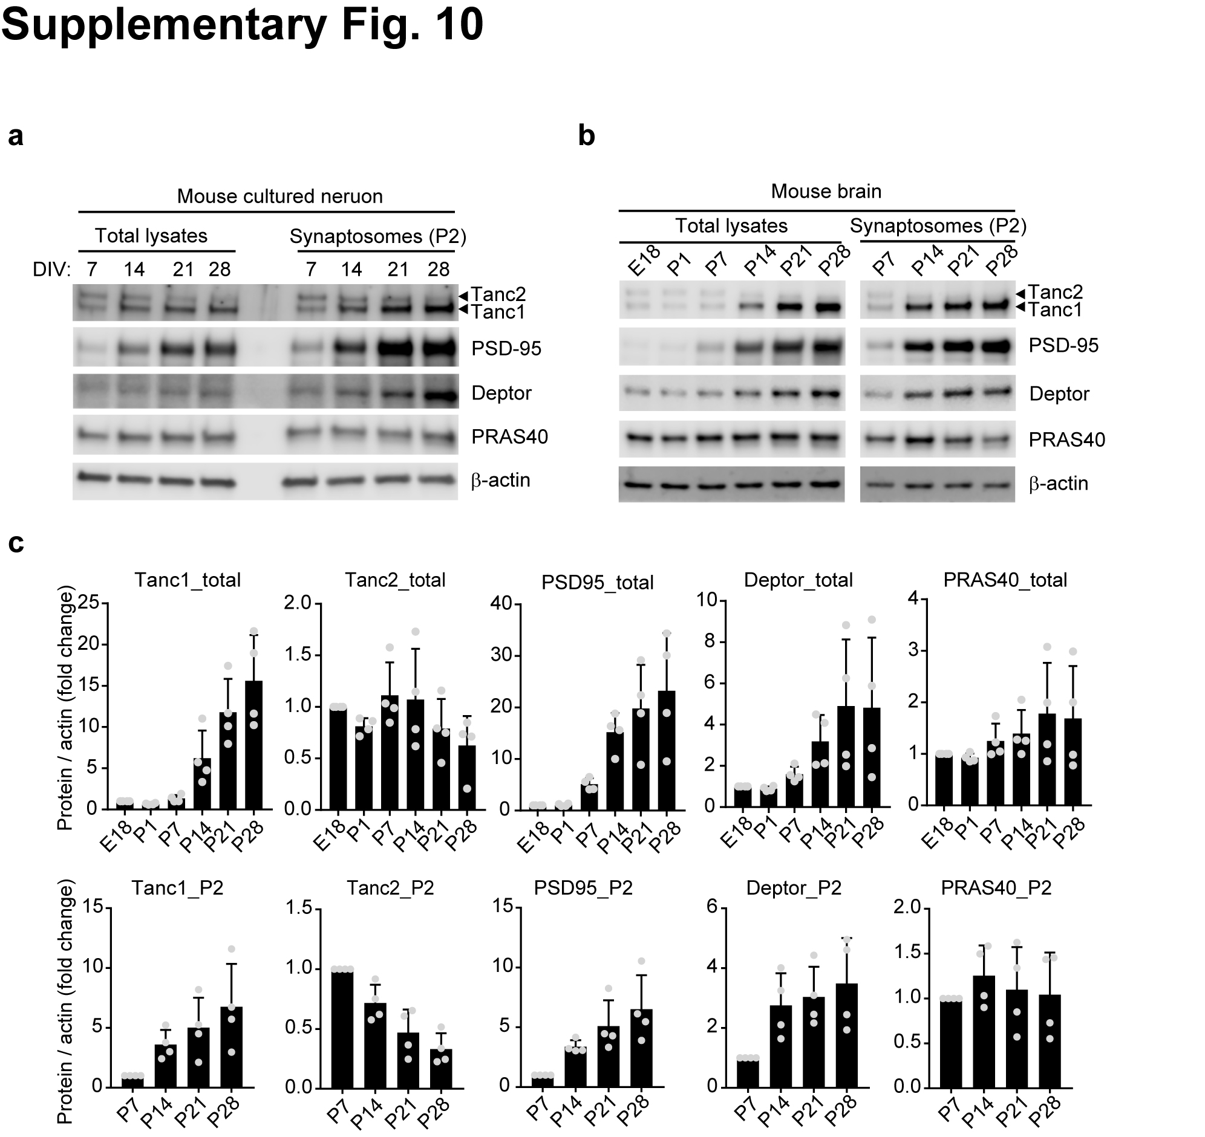
Supplementary Fig. 10. Temporal changes in total levels and synaptic enrichment of Tanc2, Deptor, and Tanc1 in cultured mouse hippocampal neurons and the mouse Brain.
(a) Western blot analyses of whole lysates from cultured mouse hippocampal neurons show Tanc2 protein levels that are largely stable across developmental stages (DIV/days in vitro 7–28) and stronger relative to Tanc1 at early stages, while Deptor and Tanc1 protein levels gradually increase. Western blot analyses of crude synaptosomes from cultured mouse hippocampal neurons show largely unchanged synaptic levels of Tanc2 proteins across the developmental stages, which contrasts with the increasing synaptic levels of Deptor and Tanc1 proteins. Total and synaptic levels of PRAS40 (a component of mTORC1) were largely unchanged across developmental stages. PSD-95 was used as a positive control for stage-dependent increases in total expression and synaptic enrichment, and β-actin was used as a loading control.
(b and c) Western blot analyses of whole lysates from the mouse brain show Tanc2 protein levels that are largely stable across developmental stages (E/embryonic day 18–P/postnatal day 28) and higher relative to Tanc1 at early stages, while Deptor and Tanc1 protein levels gradually increase. Western blot analyses of crude synaptosomes from the mouse brain show decreasing synaptic levels of Tanc2 proteins across the developmental stages, which contrasts with the increasing synaptic levels of Deptor and Tanc1 proteins. Total and syanpic levels of PRAS40 were largely unchanged across developmental stages. PSD-95 was used as a positive control for stage-dependent increases in total expression and synaptic enrichment, and β-actin was used as a loading control.
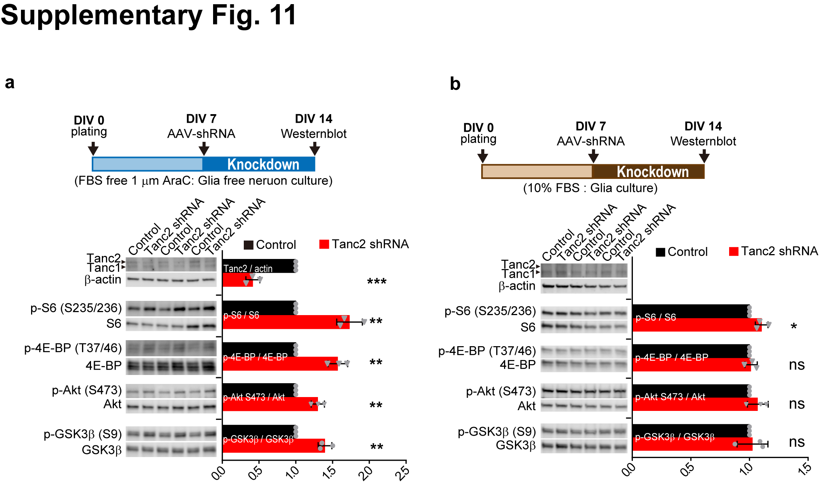
Supplementary Fig. 11. Acute Tanc2 knockdown in cultured mouse neurons, but not glial cells, leads to mTORC1/2 hyperactivity.
(a) Acute knockdown of Tanc2 in cultured mouse neurons by infection with AAV-shRNA (DIV7–14) leads to increased phosphorylation levels of S6 (S235/236), 4E-BP (T37/46), Akt (S473), and GSK3β (S9), indicative of mTORC1 and mTORC2 hyperactivity. (n = 3 independent experiments, **P < 0.01, ***P < 0.001, Student’s t-test).
(b) Acute knockdown of Tanc2 in cultured mouse glial cells by infection with AAV-shRNA (DIV7–14) does not affect the phosphorylation levels of S6 (S235/236), 4E-BP (T37/46), Akt (S473) or GSK3β (S9), except for a small increase in p-S6, suggesting that Tanc2 mainly suppresses mTORC1/2 signaling in neurons rather than glial cells. Note that Tanc2 expression is much weaker relative to Tanc1. (n = 3 independent experiments, *P < 0.05, ns, not significant, Student’s t-test).
Supplementary Fig. 12. Uncropped Western blot images for all main and supplementary figures.
(a) Cropped images are indicated in dottel lines.

