Additional files

Additional File 1
Several guideline documents on hepatitis C virus (HCV) treatment in Norway have been relevant in the period 2017–2019. The following sources are some of the key documents in choice of treatment (most are in Norwegian and some of these have restricted access):
Guidelines from the Norwegian association for infectious diseases, version 7 (2017):
https://www.hepatittfag.no/pdf-hcv
Version 8 (2019):
https://www.legeforeningen.no/contentassets/7bdf07c45b95411aa3c66e27822da583/veilederrevisjon-8-1.pdf
The treatment choice guidelines from the health authorities:
Period 01.03.2016–28.02.2017: http://innsiden.helsebergen.no/komiteer/legemiddelkomiteen/_layouts/WopiFrame.aspx?sourcedoc=/komiteer/legemiddelkomiteen/Dokumentbibliotek%20lager/Informasjon%20om%20LIS-anbud/2016/LISanbefalinger%20Hepatitt%20C%202016%20%20HBe.docx&action=default&Source=http%3A%2F%2Finnsiden%2Ehelse%2Dbergen%2Eno%2Fkomiteer%2Flegemiddelkomiteen%2FDokumentbibliotek%2520lager%2FForms%2FAllItems%2Easpx%3FRootFolder%3D%252Fkomiteer%252Flegemiddelkomiteen%252FDokumentbibliotek%2520lager%252FInformasjon%2520om%2520LIS%252Danbud%252F2016%26FolderCTID%3D0x012000872941027523124591CBCF04418E246C%26View%3D%7B4E86623D%2D3B87%2D484B%2DA087%2D07D7BB213411%7D&DefaultItemOpen=1
Period 01.03.2017–28.02.2018: http://innsiden.helsebergen.no/komiteer/legemiddelkomiteen/_layouts/WopiFrame.aspx?sourcedoc=/komiteer/legemiddelkomiteen/Dokumentbibliotek%20lager/Helseforetakenes%20LIS%20HCV%20anbefalinger%202017%20%20reviderte%20130617.pdf&action=default&Source=http%3A%2F%2Finnsiden%2Ehelse%2Dbergen%2Eno%2Fkomiteer%2Flegemiddelkomiteen%2FDokumentbibliotek%2520lager%2FForms%2FAllItems%2Easpx&DefaultItemOpen=1
Period 01.02.2018–31.01.2019: http://innsiden.helsebergen.no/komiteer/legemiddelkomiteen/_layouts/WopiFrame2.aspx?sourcedoc=/komiteer/legemiddelkomiteen/Dokumentbibliotek%20lager/Informasjon%20om%20LISanbud/2018/LIS%20HCV%20anbefalinger%202018.pdf&action=default&Source=http%3A%2F%2Finnsiden%2Ehelse%2Dbergen%2Eno%2Fkomiteer%2Flegemiddelkomiteen%2FDokumentbibliotek%2520lager%2FForms%2FAllItems%2Easpx%3FRootFolder%3D%252Fkomiteer%252Flegemiddelkomiteen%252FDokumentbibliotek%2520lager%252FInformasjon%2520om%2520LIS%252Danbud%252F2018%26FolderCTID%3D0x012000872941027523124591CBCF04418E246C%26View%3D%7B4E86623D%2D3B87%2D484B%2DA087%2D07D7BB213411%7D&DefaultItemOpen=1&DefaultItemOpen=1
Period 01.02.2019–31.01.2021: https://sykehusinnkjop.no/seksjon/avtalerlegemidler/Documents/Hepatitt%20B%20og%20C/Anbefaling%20LIS%201908%20hepatitt%20C.pdf

Additional file 2

Inclusion and exclusion criteria
Inclusion criteria were defined as follows: 1) receiving opioid agonist therapy (OAT) in the OAT outpatient clinics or people injecting drugs receiving healthcare from the two community care centers (CCCs); 2) having chronic hepatitis C virus (HCV) infection defined as detecting HCV with HCV polymerase chain reaction in two separate blood samples drawn with an interval of at least six months; 3) eligibility for treatment according to the Norwegian HCV treatment guidelines; and 4) willingness to sign a written informed consent to participate in the trial. We excluded people who 1) currently received treatment for HCV; 2) were co-infected with human immunodeficiency virus (HIV) or hepatitis B virus (positive surface antigen) at the time of inclusion; 3) had severe extrahepatic manifestations (e.g., cryoglobulinemia or membranoproliferative glomerulonephritis); 4) had chronic renal disease stages 4–5 (glomerular filtration rate < 30 ml/min/1.73 m2); and 5) had decompensated liver disease (Child–Pugh class B or C). Additionally, people who did not complete the HS questionnaire during the study period were excluded. For details on demographic and clinical variables, see Table 1.

Intervention
A total of 148 participants were randomized into the integrated HCV treatment group and 150 into the standard HCV treatment group (Fig. 1). Ultimately, one participant in the integrated treatment group and 2 in the standard treatment group were excluded due to death or lack of HS assessments. Unfortunately, four participants died, two in the integrated treatment and two in the standard care treatment.

Standard HCV treatment
Participants in the standard HCV treatment group were referred to the centralized outpatient infectious disease clinic at the collaborating referral hospital for HCV treatment. An appointment was given and usually scheduled within a few weeks after the referral; the participants were informed of this by mail. Their clinical assessment could involve additional blood samples and imaging before initiating HCV treatment. In the first year of the study, HCV consultation with a consultant in infectious diseases was mandatory, but with increasing clinical experience and growing evidence, the primary assessment became voluntary. Participants were offered follow-up assessments, including blood samples, during treatment in the infectious disease outpatient clinic every four weeks as well as a posttreatment assessment 12 weeks after completion. This typically involved a total of 4 to 5 consultation visits at the outpatient clinic. They were responsible for retrieving and adhering to their prescriptions, and attending assessment appointments. At 12 weeks after the end of treatment (EOT12), blood samples, including HCV polymerase chain reaction, were drawn at infectious disease outpatient clinics, OAT clinics, and CCCs. In addition, participants met at OAT clinics or CCCs to assess their levels of happiness.
In the standard HCV treatment, participants needed to travel to the hospital clinic and pay for the transport themselves, a distance that ranged from 1 to 25 km. They received standard follow-up in the OAT clinic for drug use disorders, and all other types of care – apart from HCV care – were integrated into the OAT follow-up. The OAT site staff encouraged participants to visit the infectious disease hospital clinics, but no further extensive follow-up was performed. There was a risk that scheduled appointments may overlap with other activities such as receiving OAT medication and other drug use treatment, since arrangements were not coordinated.

Intervention – integrated HCV treatment
All assessments and medications for participants in the integrated treatment groups were provided onsite at the OAT clinics or CCCs, including direct-acting antiviral therapies (DAAs), blood samples, and HS assessments. Compared with participants in the standard treatment group, participants in the integrated treatment group had no follow-ups in the referral hospital, and they received all assessments and medications at the local OAT clinics or CCC. In addition, they drew only two blood samples; prior to HCV treatment and at EOT12, and blood samples drawn every four weeks during the HCV treatment were not necessary. Integrated treatment was delivered at OAT clinics and CCC by multidisciplinary teams in both of the settings. The OAT clinics differed from the CCCs by offering OAT medications in addition to psychosocial approaches. The multidisciplinary teams at the OAT clinics were equipped with consultants in addiction medicine who were responsible for the OAT and other medical follow-ups and also psychologists providing mental health treatment. In both OAT and CCC settings, nurses and social workers, in cooperation with peer counsellors, provided most of the participants’ daily follow-ups. All these professionals were existing clinical staff who closely worked together with the research nurses in management of the interventions and evaluations during the study period. For those eligible for HCV treatment, DAAs were administered by a nurse at OAT clinics/CCCs after a prescription from a consultant in infectious diseases. Contrary to standard HCV treatment, all HCV treatment and scheduled follow-ups during treatment were given in parallel with the observed intake of OAT medications and other care, in line with the study protocol. The number of deliveries of OAT and DAA medications per week was adapted to the level of functioning of each participant. For the most severely ill participants with the lowest level of daily functioning and high intake of multiple drugs, OAT medications and HCV treatment were usually dispensed daily in the OAT clinic, and intake was observed by a nurse. The multidisciplinary team planned assessments with participants, or drop-in approaches were applied.

Randomization and masking
Selected participants were randomized at a 1:1 ratio using blocks of 10 stratified by city and assigned into integrated (n = 145) or standard treatment (n = 144) for the trial. Complete blinding was considered impractical and would have reduced external validity²², although some masking measures were taken²⁰. In short, randomization was disclosed to clinical staff providing treatment and follow-up. Participants were informed of key elements in the delivery of the respective intervention and follow-up to which they were assigned, but no information was shared on treatment and follow-up alternatives or the hypotheses for the study.

Measurement
We measured the level of happiness during the study period using the Happiness Scale (HS). The HS is a self-reported scale composed of a single direct question as following: “How happy are you with your life these days?”. The response options were denoted with numbers from 0 (“extremely unhappy”) to 10 (completely happy). The HS is a validated scale.^{3,23} The data collection software only allowed valid responses to the question and prompted empty questions before submission to minimise missing data. The response options were denoted with numbers from 0 to 10, multiplied by 10 and converted to a percentage scale from min-to-max.
We drew blood samples, including hepatitis B virus surface antigen, HIV antigen/antibodies, thrombocytes, and aspartate aminotransferase, as well as HCV antibodies and HCV polymerase chain reactions. Liver stiffness was measured by performing transient elastography at baseline (Additional file 3). Transient elastography calculates liver stiffness using the median value of ten repeated measurements on an empty stomach.²⁴

Statistical analyses
We used Stata SE version 17 (StataCorp, TX, USA) for descriptive analyses and linear mixed model analyses, and IBM SPSS version 26.0 for expectation–maximization calculation. The threshold for statistical significance was set to p < 0.05 for all analyses unless otherwise stated. All statistical analyses were conducted following CONSORT and SPIRIT guidelines.^{25,26} The sample size was calculated for the primary outcome of SVR in the INTRO-HCV trial.²⁰ None basic characteristics were significantly different, comparing the integrated treatment group to the standard treatment group, with a significance level of 0.05.
We dealt with any missing values in HS scores at baseline and EOT12 as “missing at random” when running expectation–maximization algorithm.²⁷ We identified missing values in 0.7% of HS scores at baseline and 32.5% at EOT12, and all were replaced with estimated values. The expectation–maximization algorithm for computing data iteratively performs maximum likelihood estimation in the presence of latent variables,²⁸ recommended for optimizing the mixed models. Sensitivity analyses without estimated values were conducted in all regression models.
The HS scores at baseline and EOT12 were calculated as described above (“Measurement” section). We created Pen’s parades in which the HS score at baseline were in sorted order from lowest to highest values and spikes were performed to express changes in HS scores from baseline to EOT12 in the integrated and standard HCV treatment groups. Additionally, linear mixed models were applied to investigate whether the treatment groups (dichotomized as standard (0) versus integrated (1)) affected the ΔHS scores from baseline to EOT12. The linear mixed models were random intercept fixed slope regression models. The restricted maximum likelihood was set as the estimator.²⁹ The full information of maximum likelihood ensured that all available HS scores were used. The linear mixed model analysis was performed as intention-to-treat and per-protocol analyses and as a sensitivity analysis without computed data. In addition, linear mixed model sensitivity analyses were performed to evaluate whether achieving SVR affected the HS score, adjusted for sex, age, educational attainment, injecting drug use, and drug use.

Additional file 3
Table 2. Primary end point analyses of mean scores of HS at baseline and EOT12 for the patients included in the intention-to-treat and per protocol analyses.
 | Happiness score (%) (mean (SD))
Intention-to-treat strata
Integrated HCV treatment, baseline (n = 145) |  | 49(26)
Standard HCV treatment, baseline (n = 144) |  | 52(25)
Integrated HCV treatment, EOT12 (n = 145) |  | 51(20)
Standard HCV treatment, EOT12 (n = 144) |  | 52(23)
Per-protocol strata
Integrated HCV treatment, baseline (N = 117) |  | 47 (26)
Standard HCV treatment, baseline (N = 102) |  | 51 (25)
Integrated HCV treatment, EOT12 (N = 117) |  | 51 (21)
Standard HCV treatment, EOT12 (N = 102) |  | 51 (24)

Legends: The table displays the mean scores of HS at baseline and EOT12 among participants who were included in the intention-to-treat and per protocol analyses. We present HS scores converted to a percentage scale from min-to-max. The HS score ranges from 0%, “extremely unhappy”, to 100%, “completely happy”. EOT12: 12 weeks after the end of treatment; SD: Standard deviation.

Additional file 4
Table 3. Linear mixed model of Δhappiness scores from baseline to EOT12 for integrated HCV treatment (intention-to-treat) (n = 289)
 | Effect estimates
 | Coefficient (95 % CI) | p-value
Time trend | 0 (–4; 3) | 0.797
Δhappiness score from baseline to EOT12
Standard HCV treatment | 0 (ref.) | -
Integrated HCV treatment | 3 (–2; 8) | 0.230
Legends: EOT12: 12 weeks after the end of HCV treatment.

The table displays a linear mixed model analysis (Restricted Maximum Likelihood) regression of the impact of integrated HCV treatment on changes in happiness scores (Δ happiness score) from baseline to EOT12 (intention-to-treat analysis). We present HS scores converted to a percentage scale from min-to-max. The happiness score ranges from 0%, extremely unhappy, to 100%, completely happy.

Additional file 5
Figure 3. Pen’s parades of happiness scores at baseline and EOT12 (n = 289).
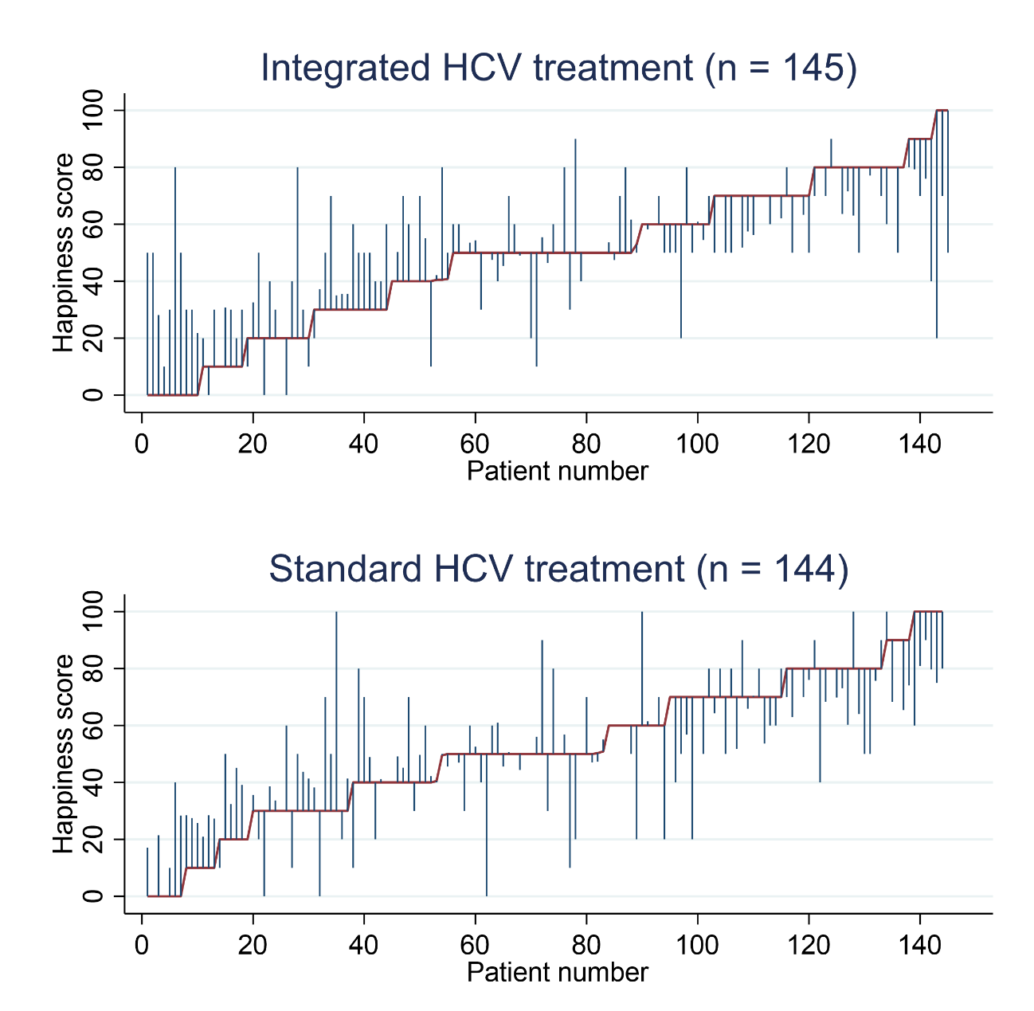
Legends: The figures display participants who received integrated and standard HCV treatment. The graphs demonstrate the happiness scores at baseline/prior to the HCV treatment and EOT12 (if conducted at least one measurement). The red line represents the happiness scores at baseline when the participants are in sorted order by happiness scores (from lowest (left) to highest (right) score). The blue spikes demonstrate the happiness score at EOT12. The length of the spikes marks the changes in the happiness score from baseline to EOT12. Participants without spikes did not complete happiness measurement at EOT12. EOT12: 12 weeks after the end of treatment.

Additional file 6
Table 4. Linear mixed model of Δhappiness score from baseline to EOT12 for integrated HCV treatment (per-protocol) (number of participants = 219, number of observations: 438)
 | Effect estimates
 | Coefficient (95 % CI) | p-value
Time trend | –1 (–3;5) | 0.747
ΔHappiness score from baseline to EOT12
Standard HCV treatment | 0 (ref.) | -
Integrated HCV treatment | 3 (–3;9) | 0.309

The table displays a linear mixed model analysis (Restricted Maximum Likelihood) regression of the impact of integrated HCV treatment on changes in happiness scores (Δhappiness score) from baseline to EOT12 (per-protocol analysis). The happiness score ranges from 0%, extremely unhappy, to 100%, completely happy.
EOT12: 12 weeks after the end of HCV treatment.

Additional File 7
Figure 4: A linear prediction of changes in happiness scores from baseline to EOT12 (per-protocol analysis) (number of participants = 212)
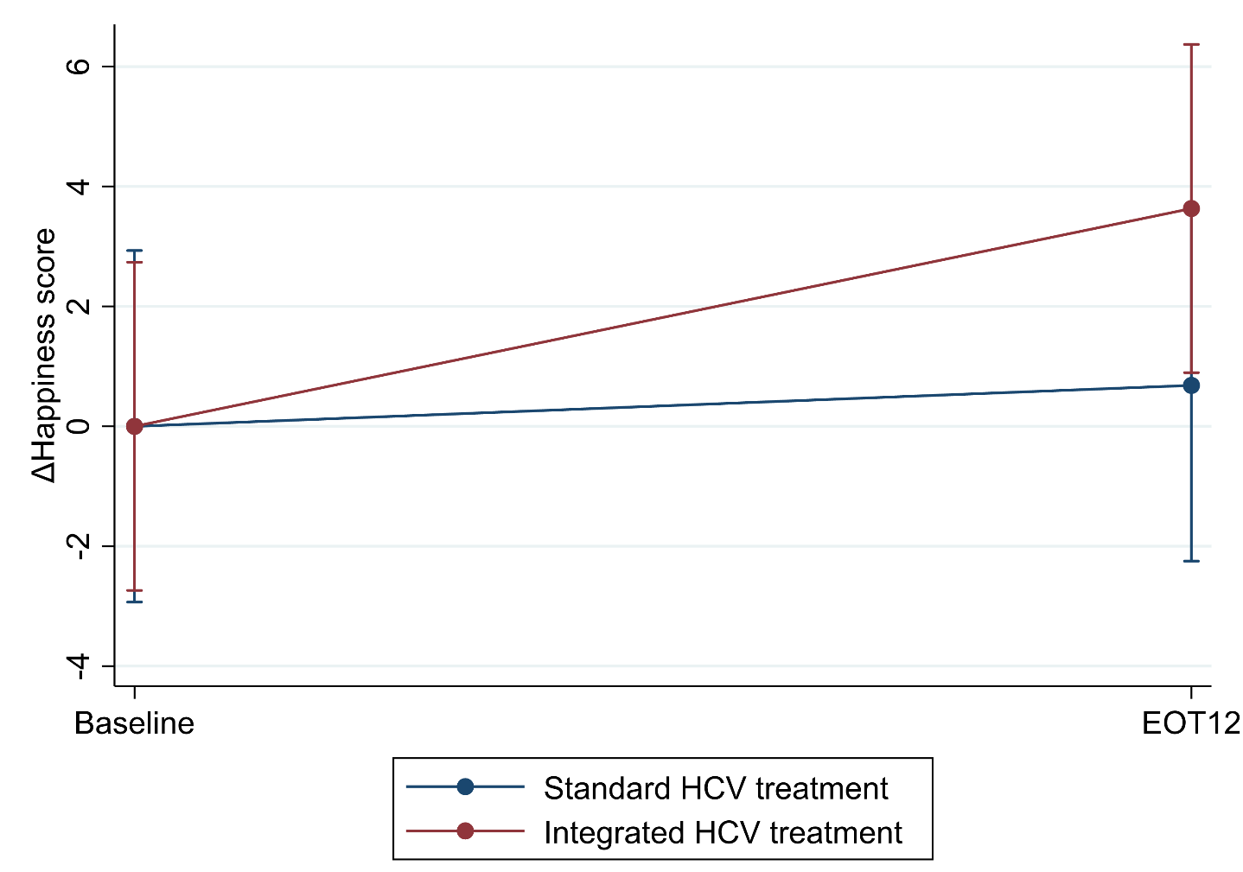
The figure displays the linear prediction (fixed portion) including 95 % confidence intervals of changes in happiness score (Δhappiness score) from baseline to EOT12 for integrated and standard HCV treatment groups (n = 212). EOT12: 12 weeks after the end of HCV treatment; HCV: Hepatitis C virus.

Additional File 8
Figure 5: Pen’s parades of happiness scores at baseline and EOT12 (number of participants = 212)
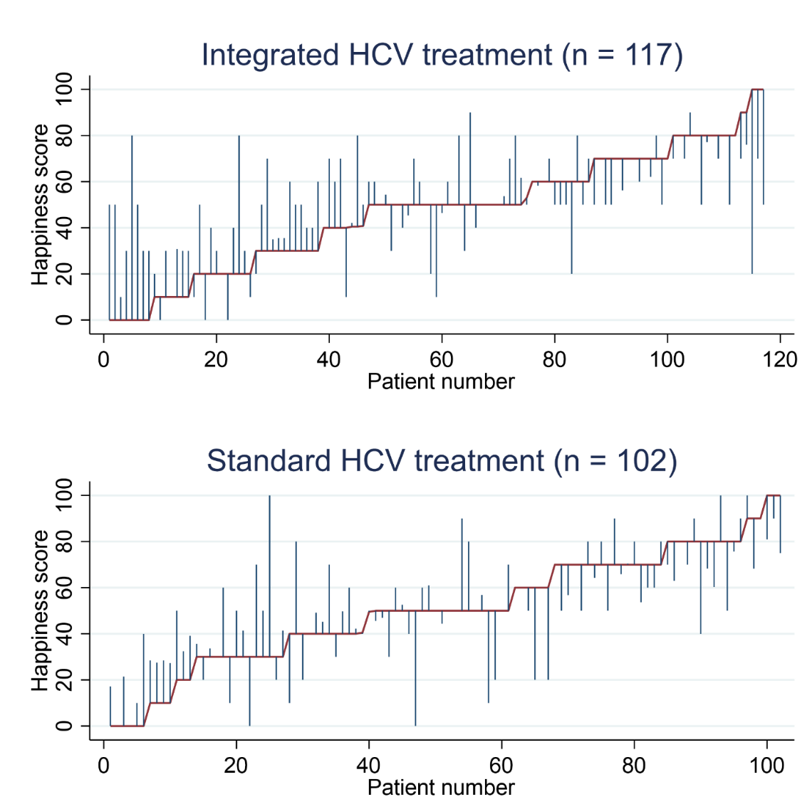
The figures display participants who received integrated and standard HCV treatment and were included in the per-protocol analysis. The graphs demonstrate the happiness scores at baseline/prior to the HCV treatment and EOT12. The red line represents the happiness scores at baseline when the participants are in sorted order by happiness scores (from lowest (left) to highest (right) score). The blue spikes demonstrate the happiness score at EOT12. The length of the spikes marks the changes in the happiness score from baseline to EOT12. Participants without spikes did not complete happiness assessment at EOT12. EOT12: 12 weeks after the end of treatment.

Additional file 9
Table 5: Linear mixed model of Δhappiness scores from baseline to EOT12 for integrated HCV treatment (intention-to-treat, sensitivity analysis without computed data) (number of participants = 193, number of observations: 386)
 | Effect estimates
 | Coefficient (95 % CI) | p-value
Time trend | –1 (–7;4) | 0.578
Δhappiness score from baseline to EOT12
Standard HCV treatment | 0.0 (ref.) | -
Integrated HCV treatment | 5 (–2;11) | 0.178

The table displays a linear mixed model analysis (Restricted Maximum Likelihood) regression of the impact of integrated HCV treatment on changes in happiness scores (Δhappiness score) from baseline to EOT12 (intention-to-treat analysis without computed data by the expectation–maximization algorithm). The happiness score ranges from 0%, extremely unhappy, to 100%, completely happy.
EOT12: 12 weeks after the end of HCV treatment.

Additional file 10
Table 6: Linear mixed model of Δhappiness scores from baseline to EOT12 for integrated HCV treatment (per-protocol, sensitivity analysis without computed data) (number of participants = 167, number of observations: 334)
 | Effect estimates
 | Coefficient (95 % CI) | p-value
Time trend | 0 (–5;6) | 0.919
Δhappiness score from baseline to EOT12
Standard HCV treatment | 0 (ref.) | -
Integrated HCV treatment | 4 (–4;11) | 0.303

The table displays a linear mixed model analysis (Restricted Maximum Likelihood) regression of the impact of integrated HCV treatment on changes in happiness scores (Δhappiness score) from baseline to EOT12 (per-protocol analysis without computed data by the expectation–maximization algorithm). The happiness score ranges from 0%, extremely unhappy, to 100%, completely happy. EOT12: 12 weeks after the end of HCV treatment.

Additional file 11
Table 7: Linear mixed model of the association between sociodemographic factors, injecting drug use, and drug use and happiness score (intention-to-treat) (number of participants = 289, number of observations: 578)
 | Baseline |  |  | Time trends  (from baseline to EOT12)
 |  | Coefficient  (95 % CI) | p-value | Coefficient  (95 % CI) | p-value
Time (from baseline to EOT12) |  | - | - | -7.3 (-20.7;6.1) | 0.284
Sex  Female |  | 2.0 (-4.3;8.2) | 0.542 | -0.5 (-6.3;5.4) | 0.876
Age groups  18-<30  30-<40  40-<50  50-<60  ≥ 60 |  | 0.0 (ref.)  3.9 (-5.3;13.2)  -4.8 (-14.3;4.6)  -0.7 (-10.6;9.2)  -8.4 (-22.7;5.8) | 0.407  0.314  0.887  0.246 | 0.0 (ref.)  -2.9 (-11.6;5.7)  1.0 (-7.8;9.8)  -1.2 (-10.5;8.1)  0.4 (-13.0;13.8) | 0.503  0.831  0.792  0.953
Educational attainment  Not completed primary school  Primary school (9 years)  High school (12 years)  ≤ 3 years of college or university  > 3 years of college or university |  | 0.0 (ref.)  9.2 (-1.8;20.2)  8.2 (-3.0;19.3)  -0.3 (-14.4;13.8)  7.7 (-14.6;29.9) | 0.100  0.152  0.964  0.497 | 0.0 (ref.)  1.1 (-9.2;11.3)  3.8 (-6.7;14.2)  -0.8 (-14.0;12.3)  5.9 (-15.0;26.7) | 0.839  0.477  0.902  0.579
Injecting drug use |  | -6.1 (-12.1;-0.2) | 0.044 | 3.1 (-2.5;8.8) | 0.273
Frequent drug use  Alcohol |  | 2.8 (-3.3;9.0) | 0.367 | 0.9 (-4.9;6.6) | 0.768
Benzodiazepines |  | -12.7 (-18.3;-7.0) | 0.000 | 4.6 (-0.7;9.9) | 0.092
Cannabis |  | -3.3 (-8.9;2.2) | 0.236 | 0.3 (-4.8;5.5) | 0.904
Opioids |  | -5.9 (-14.3;2.5) | 0.166 | 2.3 (-5.5;10.2) | 0.556
Stimulants (amphetamines and cocaine) |  | 11.9 (5.6;18.1) | 0.000 | 2.2 (-3.6;8.1) | 0.448
Achieved SVR |  | - | - | 3.1 (-1.9;8.2) | 0.223

The table displays a linear mixed model analysis (Restricted Maximum Likelihood) regression of the impact of sociodemographic factors, injecting drug use, and drug use on happiness scores at baseline and from baseline to EOT12 (intention-to-treat analysis) in the study sample. The happiness score ranges from 0%, extremely unhappy, to 100%, completely happy. “Educational attainment” was defined as the highest level of education completed.
“Injecting substance use” was defined as having injected any substance at least once during the 12 months leading up to the first health assessment (baseline).
Drug use was categorized according to the use during the past year.
Frequent drug use was defined as consuming at least one of the drugs in the five drug classes more than weekly during the year leading up to the first health assessment. Participants who did not use drugs or used them less than weekly during the year were categorized as having “no frequent use of drugs”.
Missing values were identified in 0.7% of happiness scores, 1.7 % of educational attainment, 2.8 % of injecting drug use and 3.5 % of drug use at baseline and 32.5% of happiness score at EOT12, and all were handled as “missing at random” and replaced with estimated values using expectation-maximization algorithm. Except for the “achieving SVR” predictor, we kept all the predictor variables constant at the baseline level in predicting changes in the happiness scores from baseline to EOT12. To explore whether predictors predicted changes in the happiness score from baseline to EOT12, the interaction between these factors and time (dichotomized as baseline (0) and EOT12 (1)) were added.
EOT12: 12 weeks after the end of HCV treatment;
HCV: Hepatitis C virus;
SVR: Sustained virological response.

Additional file 12
Table 8: Linear mixed model of the association between sociodemographic factors, injecting drug use, and drug use and happiness score (per protocol) (number of participants = 219, number of observations: 438)
 | Baseline |  |  |  | Time trends  (from baseline to EOT12)
 |  | Coefficient  (95 % CI) | p-value |  | Coefficient  (95 % CI) | p-value
Time (from baseline to EOT12) |  | - |  | - | 0.4 (-16.5;17.3) | 0.964
Sex  Female |  | 0.4 (-6.8;7.6) |  | 0.917 | 0.7 (-6.2;7.7) | 0.841
Age groups  18-<30  30-<40  40-<50  50-<60  ≥ 60 |  | 0.0 (ref.)  0.1 (-10.2;10.5)  -7.4 (-18.1;3.3)  -3.4 (-14.8;7.9)  -13.7 (-29.5;2.1) |  | 0.981  0.177  0.555  0.089 | 0.0 (ref.)  -1.2 (-11.3;8.8)  0.4 (-10.1;10.8)  0.7 (-10.4;11.8)  -2.2 (-17.6;13.2) | 0.810  0.943  0.897  0.781
Educational attainment  Not completed primary school  Primary school (9 years)  High school (12 years)  ≤ 3 years of college or university  > 3 years of college or university |  | 0.0 (ref.)  11.9 (-1.3;25.0)  13.6 (0.3;27.0)  -3.3 (-20.0;13.5)  26.8 (-1.9;55.5) |  | 0.076  0.045  0.701  0.067 | 0.0 (ref.)  -3.1 (-15.8;9.6)  -0.7 (-13.7;12.2)  -3.1 (-19.4;13.1)  -7.9 (-35.8;19.9) | 0.629  0.912  0.705  0.576
Injecting drug use |  | -5.7 (-12.5;1.1) |  | 0.098 | -1.8 (-4.9;8.5) | 0.594
Frequent drug use  Alcohol |  | 5.0 (-2.5;12.5) |  | 0.189 | 0.7 (-6.6;7.9) | 0.851
Benzodiazepines |  | -14.8 (-21.3;-8.2) |  | 0.000 | 7.1 (0.8;13.5) | 0.027
Cannabis |  | -2.6 (-9.1;3.9) |  | 0.433 | -1.7 (-8.0;4.6) | 0.604
Opioids |  | -7.5 (-17.8;2.8) |  | 0.152 | 2.7 (-7.3;12.7) | 0.595
Stimulants (amphetamines and cocaine) |  | 7.1 (0.0;14.2) |  | 0.051 | 5.2 (-1.7;12.0) | 0.141
Achieved SVR |  | - | - |  | -0.8 (-8.7;7.0) | 0.834

The table displays a linear mixed model analysis (Restricted Maximum Likelihood) regression of the impact of sociodemographic factors, injecting drug use, and drug use on happiness scores at baseline and from baseline to EOT12 (per protocol analysis) in the study sample. The happiness score ranges from 0%, extremely unhappy, to 100%, completely happy.
“Educational attainment” was defined as the highest level of education completed.
“Injecting substance use” was defined as having injected any substance at least once during the 12 months leading up to the first health assessment (baseline). Drug use was categorized according to the use during the past year.
Frequent drug use was defined as consuming at least one of the drugs in the five drug classes more than weekly during the year leading up to the first health assessment. Participants who did not use drugs or used them less than weekly during the year were categorized as having “no frequent use of drugs”. Missing values were identified in 0.7% of happiness scores, 1.7 % of educational attainment, 2.8 % of injecting drug use and 3.5 % of drug use at baseline and 32.5% of happiness score at EOT12, and all were handled as “missing at random” and replaced with estimated values using expectation-maximization algorithm.
Except for the “achieving SVR” predictor, we kept all the predictor variables constant at the baseline level in predicting changes in the happiness scores from baseline to EOT12. To explore whether predictors predicted changes in the happiness score from baseline to EOT12, the interaction between these factors and time (dichotomized as baseline (0) and EOT12 (1)) were added.
EOT12: 12 weeks after the end of HCV treatment.
HCV: Hepatitis C virus.
SVR: Sustained virological response.

