Supplementary Information
A Crystallographic Study Unveils a Novel Magnesium Transporting Rhodopsin
Ling-Ning Ko, Guo Zhen Lim, Ta Ko, Guan-Yi Li, Jui-Chien Chen and Chii-Shen Yang
Supplementary Figure

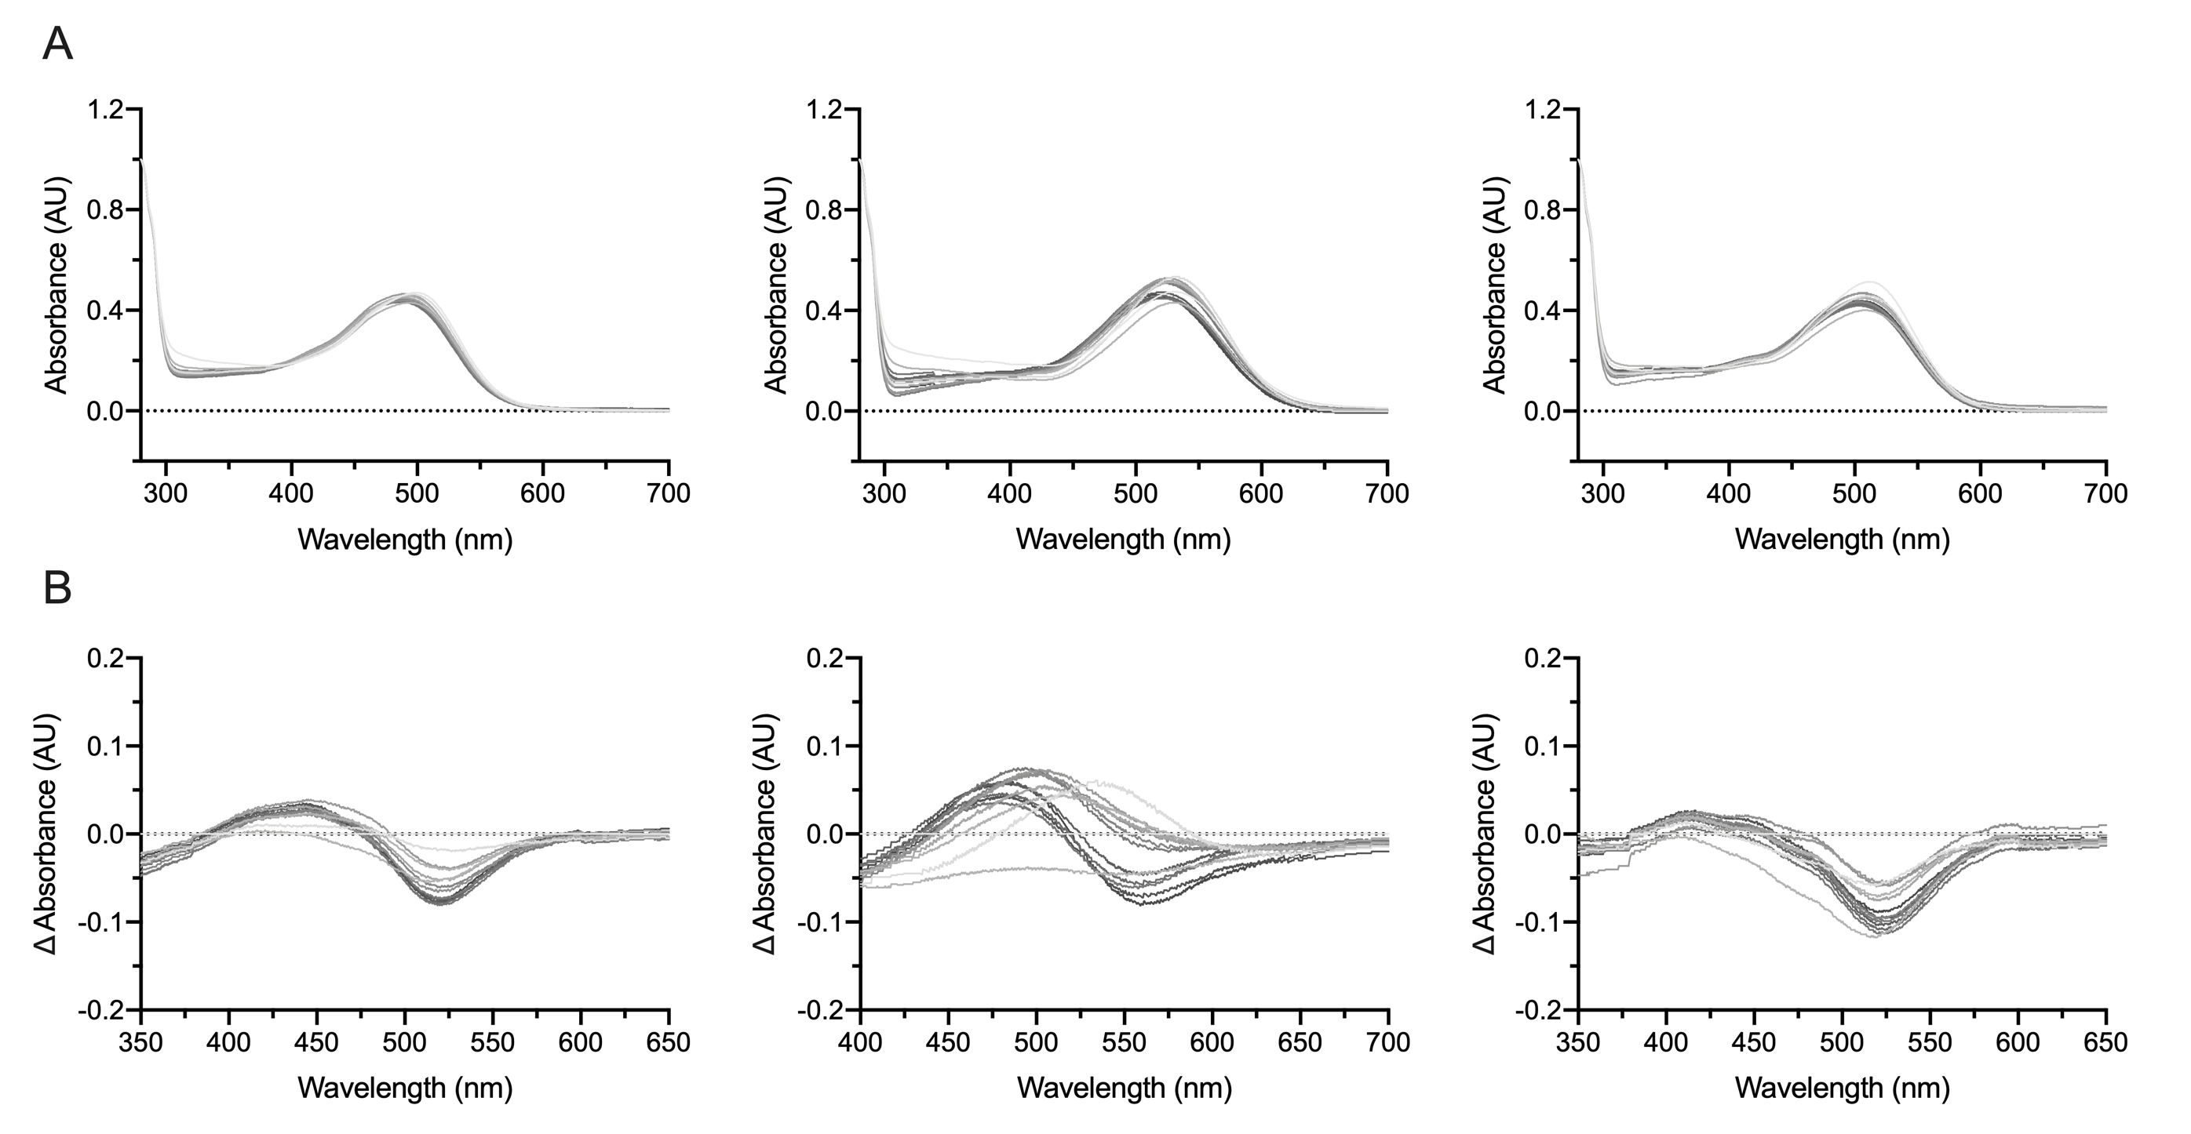
Supplementary Figure 1. Mg²⁺-dependent spectral shifts in the absorption spectrum of HwMR wild-type and its variants. (A) The spectral shifts of HwMR wild-type (left), D84N (middle), and T216A mutants (right) were recorded and normalized using A280 as a standard under different concentrations of MgCl₂ from 0.01 to 2 M. (B) The absorbances of HwMR wild-type (left), D84N (middle) and T216A mutants (right) were baselined with that of proteins in 0.01 M MgCl₂.

