Supplementary Materials
Implication of the ADCY1 Gene in Lithium Response in Bipolar Disorder by Genome-wide Association Meta-analysis

Contents
Supplementary Table 1. UCL Samples’ Demographics and Clinical Characteristics concerning Lithium Response
Supplementary Figure 1. Quantile-quantile Plot for the UCL+SongSub+ConLi+Gen GWAS Meta-analysis
Supplementary Figure 2. Quantile-quantile Plot for the UCL+SongOb+ConLi+Gen GWAS Meta-analysis
Supplementary Figure 3. Regional Association Plot on Chromosome 7 in which the Genome-wide Significant SNP is Located

Supplementary Table 1. UCL Samples’ Demographics and Clinical Characteristics concerning Lithium Response
Variables | N | Overall  N = 1259 | Lithium Responders  N = 440 (35%) | Lithium Non-responders  N = 819 (65%) | p-values
Age at interview | 1153 | 50.39 (12.84) | 50.34 (13.62) | 50.42 (12.40) | 0.921¹
Age of BD onset | 1198 | 24.66 (10.62) | 24.33 (10.68) | 24.82 (10.60) | 0.453¹
Sex | 1259 |  |  |  | 0.039 ²
Male |  | 499 (40%) | 192 (44%) | 307 (37%)
Female |  | 760 (60%) | 248 (56%) | 512 (63%)
BD type | 1259 |  |  |  | 0.189 ²
BD type 1 |  | 827 (66%) | 297 (68%) | 530 (65%)
BD type 2 |  | 169 (13%) | 63 (14%) | 106 (13%)
SABP |  | 96 (8%) | 34 (8%) | 62 (7%)
No information |  | 167 (13%) | 46 (10%) | 121 (15%)
BD, bipolar disorder; SABP, schizoaffective bipolar disord; SD, standard deviation
¹ Two Sample t-test; mean (SD)
² Pearson's Chi-squared test of independence; n (%)

Supplementary Figure 1. Quantile-quantile Plot for the UCL+Song^{Sub}+ConLi⁺Gen GWAS Meta-analysis
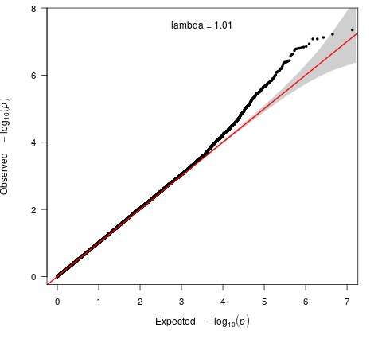

Supplementary Figure 2. Quantile-quantile Plot for the UCL+Song^{Ob}+ConLi⁺Gen GWAS Meta-analysis
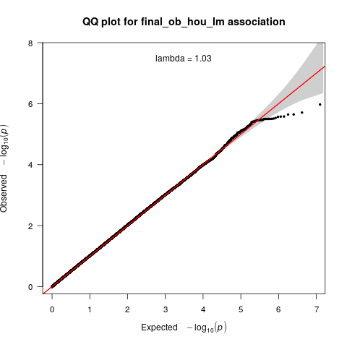

Supplementary Figure 3. Regional Association Plot on Chromosome 7 in which the Genome-wide Significant SNP is Located
