Appendices
Appendix 1: Flowchart of the prehabilitation program
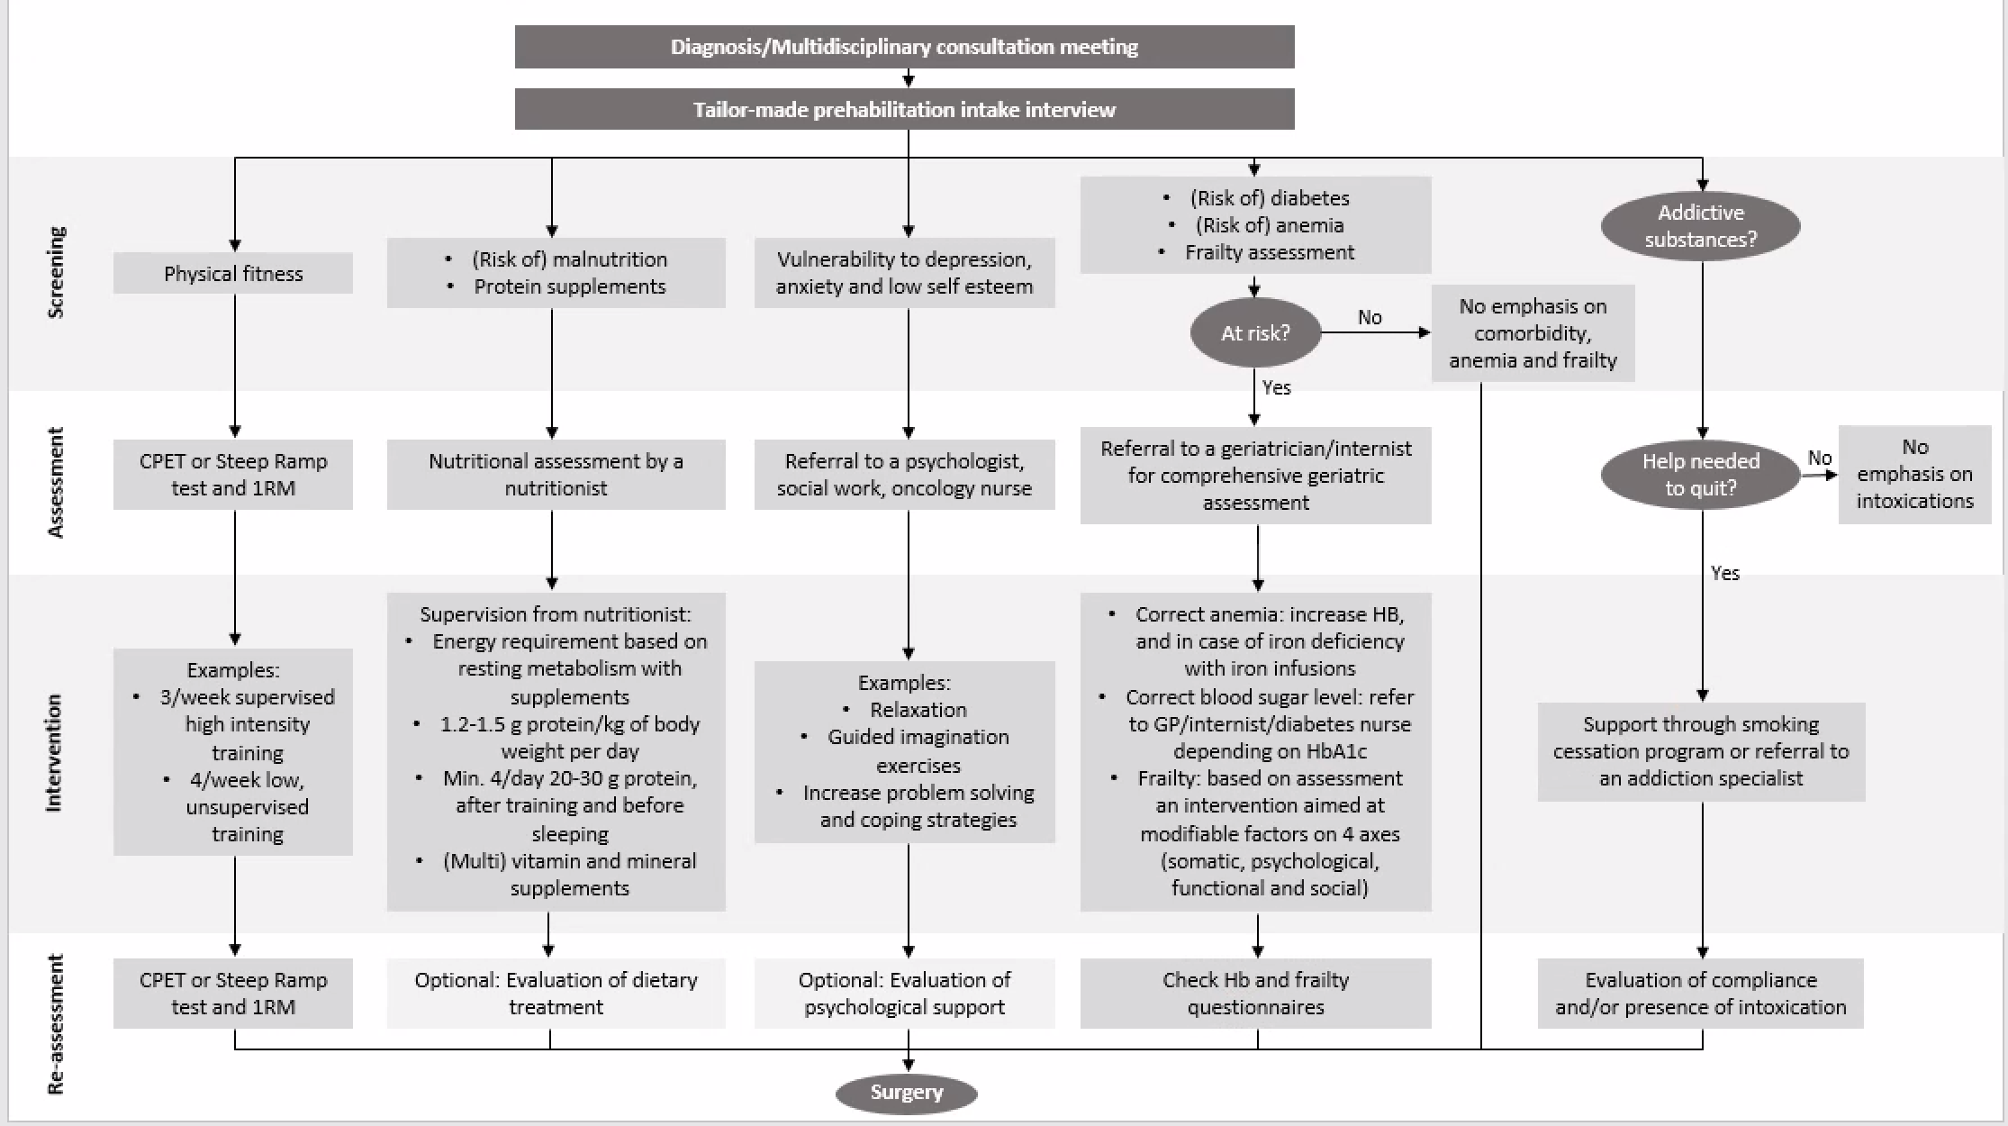
Appendix 2: Physical fitness
Definition and goals
Major colorectal surgery can lead to substantial morbidity and mortality, particularly in elderly and patients with comorbidities. Low cardiorespiratory fitness has been found to be a major risk factor for complications after colorectal surgery (24). Cardiorespiratory fitness is the maximum capacity of the body to take up oxygen and to transport it to the tissue (25). It’s expressed as VO2max (in ml/kg/min body weight) or metabolic equivalents (METs; where 1 MET is equal to the resting metabolism with an oxygen uptake (VO2) of about 3.5 ml/kg/min).
The goal is to make a preoperative risk assessment and to optimize the patient's cardiorespiratory fitness and muscle strength to reduce the risk of perioperative complications and to accelerate postoperative recovery of physical functioning.
Preoperative risk assessment
Cardiopulmonary exercise testing (CPET) is the gold standard for measuring cardiorespiratory fitness (24,25). It is increasingly used preoperatively with a subsequent risk assessment. Several studies show that patients have an increased risk of complications at VO2max <16-18 ml/kg/min and/or a VO2 <10-11 ml/kg/min at the ventilatory threshold (first threshold) (20,24,26,27). In a large cohort with CPET variables and BMI, patients with a VO2 at the ventilatory threshold ≤11.1 ml/kg/min had an odds ratio (OR) of 7.56 for complications during hospitalization after colorectal surgery, where this OR was 2.15 at a VO2max ≤18.2 ml/kg/min (1). However, a CPET is relatively time-consuming and requires medical supervision. Therefore, it does not seem cost-effective to administer a CPET preoperatively to every patient. In addition, a CPET is not available in every centre. With questionnaires, such as the "FitMáx"(28) or "veterans-specific activity questionnaire" (VSAQ), an estimate of the cardiorespiratory fitness can be made, after which only patients who score low undergo a CPET. In various studies, a cut-off value of ≤7 METs on the VSAQ was used for this purpose (20,26). In addition to a risk assessment, the CPET can also map (the severity of) cardiovascular and pulmonary comorbidities, which can then be adjusted for pre- or perioperative management (29). If a CPET is not feasible, it is advisable to use an alternative maximal test for risk assessment (e.g., the steep ramp test (SRT) or incremental shuttle walk test (iSWT)). Although a better SRT and iSWT performance is associated with better postoperative outcomes (30), an accurate cut-off point is not yet available for these tests.
Interventions
Every patient is informed about the importance of physical activity and physical fitness. Additionally, it is recommended to optimize the physical fitness of especially those patients with cardiopulmonary fitness, according to the CPET threshold values described above, preoperatively under the supervision of a (oncological or geriatric) physiotherapist specifically trained for prehabilitation. It is important to take into account the patient's wishes and capabilities. High-intensity interval training (HIIT) appears to be the most effective way to improve cardiorespiratory fitness (and muscle strength) in a short period (4-6 weeks). In a RCT, preoperative training for high-risk patients prior to colorectal surgery resulted in improved physical fitness after 3 weeks, which subsequently led to a significant reduction in the number of patients with postoperative complications (20).

There are many variations possible in the design of a preoperative physical training program. Intensity can be varied in different ways.
High-intensity interval training
High-intensity training program according to the adapted Meyer protocol (31) as described in van Wijk et al.(32)
- Particularly suitable for frail patients
- Baseline measurement: adapted SRT protocol (2 minutes unloaded cycling as warm-up, followed by a load increase of 10 watts (W) every 10 seconds until exhaustion (pedal frequency drops <60 rpm) despite verbal encouragement, followed by a cool-down. The highest achieved load (Wpeak) is the primary outcome measure of the SRT)
- 3-5 times a week 15-25 minutes SRT-based HIIT on a cycle ergometer
  - 3 minutes warm-up at 20 W
  - 30 seconds work interval at 60% of the SRT Wpeak
  - 60 seconds rest interval at 20 W
  - 8-14 intervals
  - Cooling down for at least 1 minute after the last rest interval
  - Based on the clinical judgment of the physiotherapist and/or the degree of experienced effort of the patient (ideally Borg scale 15-18 on the range 6-20), the load during the work intervals can be adjusted
- Measuring/monitoring progression: the SRT is repeated weekly to maintain the intensity at the right level

High-intensity training program according to the Wisløff protocol (33) as described in van Rooijen et al.(34)
- Particularly suitable for the non-frail patient
- Baseline measurement: maximum effort test, preferably CPET, to determine maximum heart rate (HRmax)
- 3 times a week a 38 minute HIIT training on a cycle ergometer, treadmill, or rowing ergometer
  - 6 min warm-up at 60-70% of HRmax
  - 4 min work interval where the last 2 min should reach 90-95% of HRmax (set/adjust the load of the work interval accordingly)
  - 3 min rest interval where HR should drop to 50-70% of HRmax
  - 4 intervals
  - 4 min cooling down at 50%-70% of HRmax
  - Based on the clinical judgment of the physiotherapist and/or the degree of experienced effort of the patient (Borg 15-18), the load during the work intervals can be made slightly less or more difficult

Muscle exercises
It is recommended to pay attention to (functional) muscle strength training in addition to improving cardiorespiratory fitness, in order to ensure the patient's mobility in daily life and facilitate a (sustainable) active lifestyle. Especially for frail patients, it is advisable to do this through functional exercises that can be incorporated into the patient's daily life and can be performed at home, such as those described in Van Wijk et al. (32)
- Chair squats/getting up from a chair
- Stair climbing/steps
- Lifting (groceries/boxes)

Especially for the non-frail patients, specific muscle groups can be trained by a physiotherapist, as described in Berkel et al. (20) and Van Rooijen et al. (34)
- 3 times a week exercises for different muscle groups
  - For example, leg press, chest press, abdominal crunch, lateral pull down, low row, and/or step up
  - 2 sets of 10 repetitions or 3 sets of 8 repetitions
  - Intensity based on the calculated 1RM at baseline (e.g., using the Oddvar-Holten diagram)
      - Week 1: 65% of calculated 1RM
      - Week 2: 70% of calculated 1RM
      - Week 3: 75% of calculated 1RM
      - Week 4: 80% of calculated 1RM
  - The last set of 10 repetitions should be achievable for the patient.
      - If not, the intensity should be decreased by 5-10% in the subsequent training
      - If the last set of 10 repetitions is too easy, the intensity should be increased by 5-10% in the subsequent training

Breathing exercises
It is recommended to meet patients undergoing abdominal surgery preoperatively to instruct them on breathing and breathing exercises. This reduces the risk of postoperative pulmonary complications. Preoperative breathing exercises supervised by a physiotherapist have a greater effect on preventing pulmonary complications than postoperative physiotherapy alone (35).
This preoperative physiotherapy session includes:
      - Identifying risk factors (smoking, lifestyle, pulmonary complications)
      - Teaching breathing techniques, consisting of:
        - 10 deep maximum inspirations, followed by holding the breath for 2-3 seconds
        - Teaching coughing techniques
        - Assessing cough strength using peak cough flow
Appendix 3: Nutritional status
Definition and objectives
The preoperative dietary treatment aims to improve a patient's poor nutritional status or to maintain a good nutritional status and to increase the effect of strength training (36). This way, patients enter surgery as fit as possible, improving their chances of recovery and reducing the risk of complications.
Triage
Triage determines which nutritional care is necessary within the prehabilitation process for every patient scheduled for surgery. Since patients with low functional reserve and low muscle mass (such as the elderly, patients with sarcopenia, and patients with an oncological condition (37,38) likely benefit the most from prehabilitation, screening for (the risk of) malnutrition (38,39) and protein intake is performed. For patients with an oncological condition, the PG-SGA SF(40-43) is recommended. Patients at risk for malnutrition or with a PG-SGA core of 4 or more should always be referred to a dietician for tailored advice.
The Dutch Dietary Guidelines are followed for every patient. In addition, sufficient protein intake is emphasized to increase the effect of strength training. If desired, these general recommendations for patients (without risk of malnutrition) can be given by other healthcare providers as well (in consultation with the dietician).
Nutritional assessment by dietician
After screening identifies a risk of malnutrition, the dietician performs a nutritional assessment. Nutritional assessment systematically evaluates and defines the nutritional status and nutritional needs to develop an adequate treatment plan (44). The European Society of Clinical Nutrition and Metabolism (ESPEN) has defined five nutrition-related disorders and conditions (45). These include malnutrition, sarcopenia and frailty, overweight and obesity, micronutrient deficiencies, and refeeding syndrome. Malnutrition and sarcopenia can be further categorized by cause and severity (46-49). The assessment of nutritional status and nutritional needs is based on history-taking and measurements. These can be categorized into three domains: "food intake, utilization and losses," "body composition and nutrient reserves," and "functional parameters" (50).
Interventions
Dietary treatment by a dietician
The optimal dietary treatment should be determined on an individual level. The following recommendations are made for preoperative optimization of the patient's condition:
- The patient's total energy requirement consists of a combination of resting metabolism and a supplement factor for activity and illness. To determine resting metabolism as accurate as possible, it is preferred to measure it using indirect calorimetry. If this is not feasible, resting metabolism can be estimated using the WHO or Harris and Benedict (1919) formula. An estimate should also be made for any energy losses that may occur (38,51-54)
- Exercise in combination with sufficient protein intake is essential to strengthen muscles. For prehabilitation, 1.5 grams of protein per kg fat free mass is considered as minimum, with 1.9 grams of protein per kg fat free mass being recommended (either 1.2-1.5 grams of protein per kg body weight) (1,55-59)
- Timing of meals affects muscle protein synthesis related to strength training. Therefore, it is recommended to use 20-30 grams of protein (of high quality) within 30-60 minutes after strength training. Additionally, for a maximum protein synthesis, it is recommended to use at least four servings of 20-30 grams of protein per day, starting with breakfast and the last serving 30 minutes before bedtime (36,59-63)
- If possible, the Dutch Dietary Guidelines are followed as much as possible. However, in cases of complex nutritional problems and poor nutritional status, the dietary advice may not always correspond to these guidelines. Supplementation of vitamins and minerals is only necessary in case of deficiencies and when intake is not or insufficiently possible. In that case, supplementation up to a maximum of 100% of the recommended daily needs is recommended. Vitamin D intake requires extra attention according to the advice of the Health Council (10-20 µg/day) (64-66)
If necessary, protein supplementation or medical nutrition can be used to meet the above recommendations.
Evaluation of dietary treatment
After the start of the dietary treatment in a prehabilitation program, it is recommended to evaluate the nutritional status (39). The content, duration, and frequency of dietary treatment and evaluation moments vary per target group and per patient. Various factors play a role in the choice of measurements that are carried out for follow-up purposes, such as the severity of malnutrition, the patient's ability to cope, costs, and the extent to which an instrument can measure a real change (responsiveness) (38). Measures in the domain of food intake and losses are particularly suitable for shorter-term follow-up measurements. However, more time is needed to measure relevant changes in body composition and functioning (67).

Appendix 4: Mental resilience
Definition and goals
Mental resilience refers to the cognitive, emotional, and social skills that enable a person to lead a meaningful and productive life and to successfully fulfil different social roles and functions during different stages of their life (68). The goal of increasing mental resilience for patients in prehabilitation is to increase coping skills to deal with the recently diagnosed cancer. Reducing possible anxiety and depressive symptoms leads to a greater perceived quality of life (69).
Interventions
Interventions described in the literature mainly concern: 1) Relaxation (breathing and progressive muscle tension exercises), 2) Guided imagery exercises (imagining periods before and after surgery and picturing a safe place) and 3) Increasing problem-solving and coping strategies. There are varying effects of perioperative psychological interventions described in the literature. The effects that are found are mainly visible on patient-reported outcome measures such as quality of life, anxiety and depressive symptoms, and self-efficacy. No effects were found on surgical outcomes such as length of stay and complications (70).
It seems particularly important to identify patients who are vulnerable for depression, anxiety, and low self-efficacy (69). This can be screened, for example, by the HADS. Ideally, these outcomes should be evaluated and discussed by an oncology nurse or nurse specialist. If necessary, a referral can then be made to a psychologist or medical social worker.
In two prehabilitation pilots conducted at the Máxima Medical Centre (Veldhoven, the Netherlands) for both CRC and lung cancer patients, it was not necessary to have all patients seen by a psychologist. A better indication is therefore the score on the screening instruments and a possible referral after the conversation with the oncology nurse (specialist). Then, a personalized offer of interventions can be considered (71). It is possible that in the future, more clarity will be gained about which psychological interventions are effective for prehabilitation.

Appendix 5: Frailty and comorbidity
Vulnerability
Definition and objectives
Frailty is the reduction of reserve capacity in different physiological systems, in which these reserves have dropped to a critical minimum (72). A small disturbance of this unstable physiological balance can lead to one or more geriatric syndromes, such as functional decline, falls, confusion, and incontinence. This involves a strong interdependence of the biological, psychological, and social domains. A change in one domain may have consequences for another domain. A geriatric syndrome is the result of several conditions occurring simultaneously and implies a multi-causal complaint or symptom (73). Frailty arises from a build-up of effects of aging, lifestyle factors, and diseases that manifest during life. Vulnerability is often subclinical and is not infrequently exacerbated by an acute condition or surgery and can subsequently lead to functional loss and complications. There is no gold standard for frailty screening. Instruments range from multidomain (GFI, TFI, G8, etc.) to monodomain.
The aim is to make an estimate of the extent to which the patient can withstand the intended treatment, or is at risk of complications, functional loss, and mortality. In addition, the aim is to identify potentially modifiable characteristics of frailty and try to optimize them as much as possible to minimize the risks mentioned above.
Interventions
• In case of positive identification by screening (e.g., GFI > 4; G8): referral to a clinical geriatrician/internal medicine physician specialised in geriatrics for a comprehensive geriatric assessment (CGA) (74,75)
• Based on the CGA, interventions focused on modifiable factors on the four axes (somatic, psychological, functional, and social):
o Sarcopenia, reduced mobility/high fall risk
o Malnutrition
o Unidentified comorbidities
o Polypharmacy and high-risk medication
o Delirium risk
o Affective problems/psychiatric comorbidities
o Decreased self-reliance (attention to small social network/living alone)

Comorbidity
Definitions and objectives
Comorbidity is defined as the presence of (chronic) comorbid conditions such as chronic heart failure, COPD, diabetes, dementia, etc., also indicated with a comorbidity index (76).
The aim is to make an estimate of the possible risks that the patient faces with a planned treatment and to weigh them against the risks of CRC and CRC treatment. It is also an opportunity to optimize the comorbid disease as much as possible in order to minimize the risk of complications or other negative outcomes.

Interventions
- Estimate mortality risk and current risk factors, based on for example the CCI, ASA classification and/or vulnerability, and weigh them against the risk of colorectal malignancy and the treatment deemed necessary
- Treat the identified comorbid disease as much as possible
  - Diabetes Mellitus: Measure HbA1c if glucose levels are elevated. Refer to a general practitioner/internist for patients:
    - Without diabetes with a threshold value > 42 mmol/mol (6%)
    - With non-insulin-dependent diabetes with a threshold value > 53 mmol/mol (7%)
    - With insulin-dependent diabetes < 10 years with a threshold value > 58 mmol/mol (7.5%)
    - With insulin-dependent diabetes ≥ 10 years with a threshold value > 65 mmol/mol (8.1%)

Appendix 6: Protocol for correction of iron deficiency
Definitions and objectives
About one third of patients with CRC have anaemia (77). In most cases, this concerns malignancy-related iron deficiency anaemia, which is multifactorial in nature (amongst others due to gastrointestinal bleeding, inflammation, and nutritional deficiencies) (78). In some cases, anaemia may have a different cause, such as chronic kidney disease, haemolysis, or bone marrow infiltration.
Preoperative anaemia is associated with fatigue (79) perioperative blood transfusions (80), postoperative morbidity and mortality (22,81,82) and reduced survival (83,84). Preoperative anaemia screening and treatment are therefore recommended (85).
Anaemia according to the World Health Organization (86):
- Haemoglobin < 8.0 mmol/L for men
- Haemoglobin < 7.5 mmol/L for women
The objective is to preoperatively optimize the haemoglobin concentration in patients with colon cancer. In other words, the aim is to increase haemoglobin levels if they are < 8.0 mmol/L in men and < 7.5 mmol/L in women.
Diagnostic procedure (see Flowchart below)
The diagnostic procedure should be requested as early as possible, for example immediately after colonoscopy by the gastroenterologist or case manager.
The diagnostic procedure consists of the following lab tests:
- Hb (mmol/L)
- MCV (fL)
- Iron (μmol/L)
- Ferritin (μg/L)
- Transferrin (g/L)
- Transferrin saturation (TSAT) (%)
- CRP (mg/L)
Iron deficiency can be subdivided into two categories; absolute and functional iron deficiency (78). In both cases, preoperative administration of intravenous iron is advised (see flowchart below) (85,87). If there is no iron deficiency, a consultation by an internist can be considered for further diagnostic evaluation. If the patient has already been referred to a geriatrician/specialist in elderly care, no separate referral to the internist is necessary.

Intervention for iron deficiency
Treatment with 1000 mg Ferinject (ferric(III)carboxymaltose) takes place in the outpatient clinic according to local hospital procedures. The use of Ferinject (iron(III)carboxymaltose) is recommended, because of the lower risk of allergic reactions compared to other intravenously administered iron-containing drugs.
Monitoring the effectiveness of the intervention
To monitor the treatment effect, haemoglobin is again determined preoperatively (+/- 3 weeks after administration of Ferinject).
Note: The aim of this protocol is to optimize the haemoglobin level. This does not mean striving for a haemoglobin level of ≥ 8.0 mmol/l for men or ≥ 7.5 mmol/l for women with transfusions and/or other blood products.
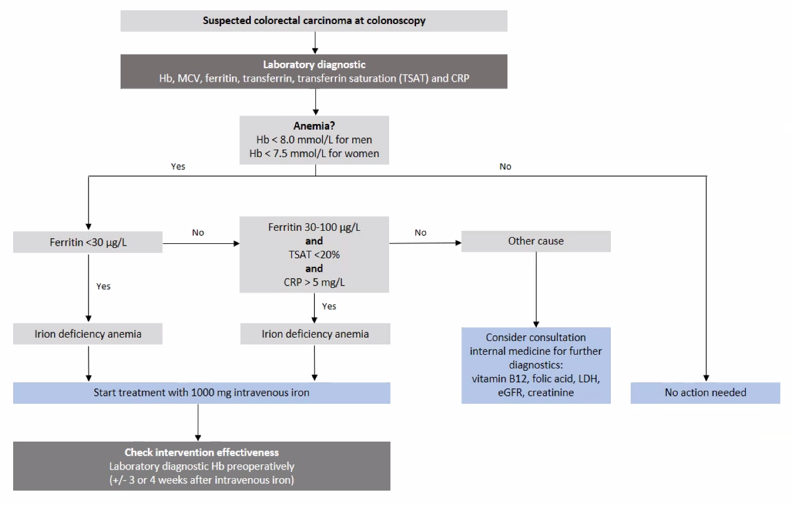
Appendix 7: Intoxications
Definitions and goals
Intoxications refers to the use of alcohol, nicotine, or other addictive substances, and polypharmacy. Polypharmacy is particularly relevant in vulnerable elderly patients and is screened and addressed through frailty screening. Attention is paid to high-risk medication (e.g. lithium/digoxin use with narrow therapeutic range). With regard to the use of alcohol, nicotine, or other addictive substances, the advice during prehabilitation is to quit. This is discussed with the patient during a screening or intake. It will then also be determined if additional help is needed. Additional help will be organized differently in each hospital. There can be a clinic in the hospital, a referral to an external help organization and sometimes the general practitioner plays a role in this. In any case, the time perspective of prehabilitation should be taken into account and in general it is preferred to quit as quickly as possible.

Interventions
Nicotine
Nicotine usage is related to the occurrence of postoperative complications (88,89). Although quitting smoking is always worth it, the earlier someone stops smoking preoperatively, the better. Nicotine replacement therapy is often used in combination with counselling. Depending on local arrangements, help and guidance will be organized. If this guidance is outsourced, ensure that there is an urgent referral given the time frame of the preoperative period.

Alcohol
The use of alcohol is, amongst others, related to an increased risk of postoperative delirium (90). During screening or intake, the patient is advised to quit using alcohol. If there is addictive behaviour, a patient can be referred to an addiction medicine physician.

Other addictive substances
During screening or intake, the patient is also advised to quit using other addictive substances. If there is addictive behaviour, a patient can be referred to an addiction medicine physician.

