Temperature and Degrees of Freedom of Potential Energy vs Its Kinetic Counterparts and Their Roles in Decoding Phase Transition

Ankai Wang and Shengli Zou*
Department of Chemistry, University of Central Florida, 4111 Libra Drive, Orlando, Florida 32816-2366, USA

Supplementary materials:
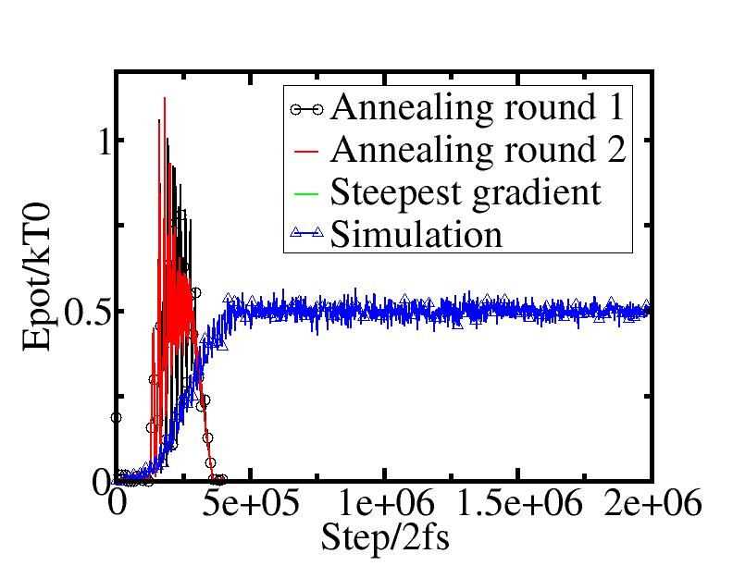
Figure S1. Averaged potential energy (E_{pot}/kT0) of atoms in a one-dimensional chain of 503 atoms during the first and second rounds of annealing with 400,000 steps, the energy minimization process using the steepest gradient method, and subsequent simulations spanning two million steps.

In our simulations, we set the potential energy of atoms at 0K to be zero, referencing all calculated potential energies to this value. All simulations are repeated three times to obtain the averaged data. In the simulations, we applied periodic boundary conditions to avoid boundary effect. To ensure energy minimization at 0K, we annealed the system twice and subsequently utilized the steepest gradient approach to minimize the system's energy. We used a simulation with one dimensional chain of 503 atoms as an example to explain the annealing and simulation steps and the results are shown in Figure S1. The total vibrational degrees of freedom for N atoms will be N-1 in a one-dimensional chain. Given that N is significantly larger than 1, we adopt N for convenience in our discussions. According to the equipartition theorem, the average vibrational energy of each atom will be kT, with half attributed to kinetic energy and the other half to potential energy. The time step of 2 fs is chosen in all the simulations.
Figure S1 displays the averaged potential energy (E_{pot}/kT0) of atoms in the chain throughout the first and second rounds of annealing, the energy minimization process employing the steepest gradient method, and subsequent simulations spanning two million steps.
In the annealing process, the chain undergoes a relaxation procedure with conserved constant energy from step 1 to 40,000. Subsequently, the temperature is lowered to 0K from step 40,000 to 60,000, followed by an increase to 0.1K after step 60,000 to 80,000. The temperature remains constant at 0.1K from step 80,000 to 120,000. From step 120,000 to 200,000, the temperature gradually increases to the constant temperature of T0=10K, then stays constant from step 200,000 to 280,000. Afterward, the temperature gradually drops to 0.1K until step 280,000 and stays constant at 0.1K until step 400,000. This annealing process is repeated for two rounds to ensure full relaxation of the structure and achieve a minimized energy configuration. More importantly, we utilized those steps to achieve equilibrium within the system.
After the two rounds of annealing, the steepest gradient approach is applied to further reduce the system's energy. The energy of the atoms approaches zero with the steepest gradient treatment, barely visible in the figure. In the simulation process, a similar approach is employed. The system undergoes a period of constant energy, followed by steps at very low constant temperature (first at T=0 and then at T=0.1K). The temperature gradually increases to T0=10K and remains constant until the end of the simulation. The constant temperature T0, simulation steps may vary in other simulations, however, the process is very similar. The annealing temperature T0=10K is applied for all the simulations.
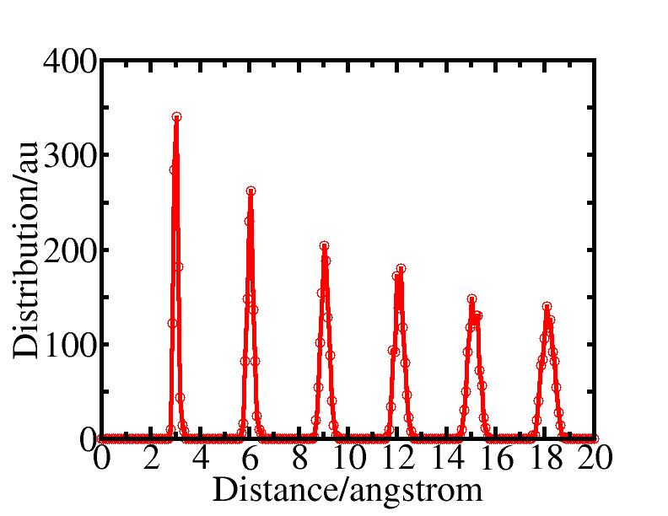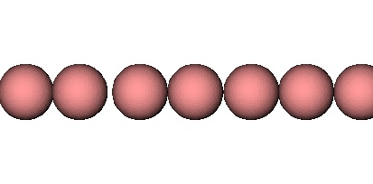
Figure S2. Distance distribution of atoms and a snapshot of the one-dimensional chain at a temperature of 100K. The distance between two neighboring atoms is about 3 Å.
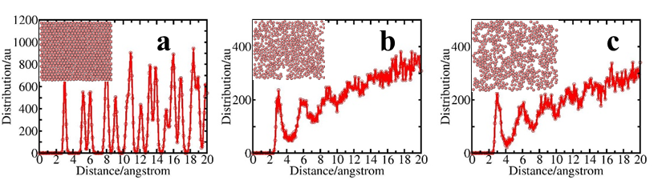
Figure S3. Distance distribution among atoms in a two dimensional array with respective snapshot at (a) T0=300K and r_{max}=4.5 Å of solid state and (b) T0=1100K in a liquid state when r_{max}=12 Å, and (c) T0=1100K at a dissociated (gas) state when r_{max}=4.5 Å.

Figure S3 illustrates the interatom distance distribution among atoms in a two-dimensional array including 506 atoms, along with three snapshots—(a) when the system is in a solid state at T0=300K and r_{max}=4.5 Å, and (b) in a liquid state at T0=1100K and r_{max}=12 Å. Figure S3c shows the case at T0=1100K while r_{max} is set as 4.5 Å when the system is at a dissociated (gas) state. The nearest distance between atoms is about 3 Å. The second nearest distance is 5.0 Å, and we chose r_{max}=4.5 Å in one of the simulations to maintain the coupling of atoms predominantly with their six nearest neighbors only.

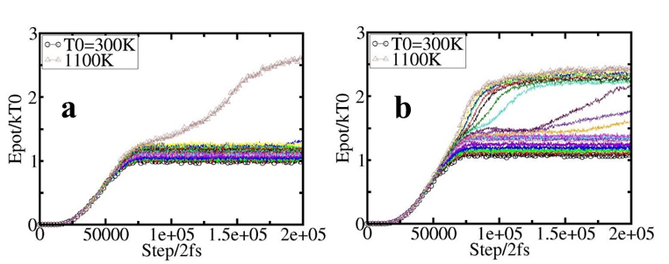
Figure S4. Averaged potential Energy of atoms in a two-dimensional array across temperatures (T0=300K to 1100K) and various time steps, with r_{max} set to (a) 4.5 and (b) 12 Å.
Figure S4 complements the data shown in Figures 3a and 3d and includes additional data from more temperatures.
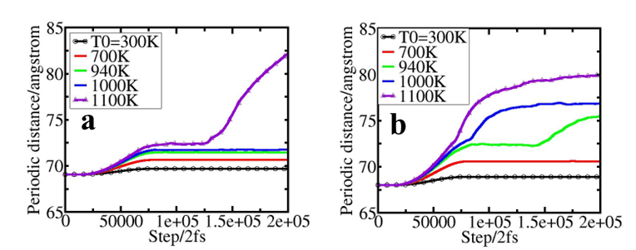
Figure S5. Periodic distance of the two-dimensional array across temperatures (T0=300K to 1100K) and various time steps, with r_{max} set to (a) 4.5 and (b) 12 Å.
Both averaged potential energy of atoms and periodic distance in Figure S4 and 5 keeps rising at T0=1100K when r_{max} is 4.5 Å, indicating the dissociation of the array at that temperature. When r_{max} is set to 12 Å, there is a sharp increase of both E_{pot} and periodic distance at constant temperature regime when T0 is larger than 900K and then becomes flat with increasing simulation steps, indicating the stability of the system in a liquid phase.

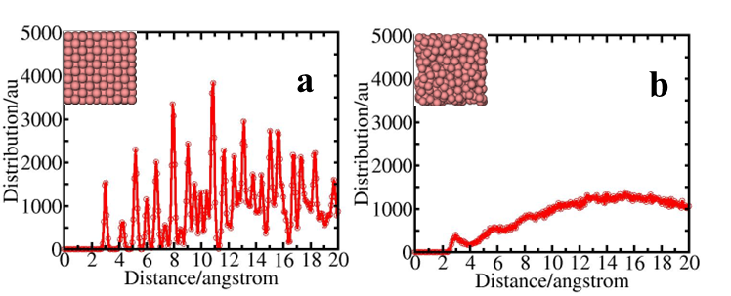
Figure S6. Distance distribution among atoms in three dimensions with respective snapshot at (a) T0=300K and r_{max}=4.0 Å of solid state and (b) T0=2000K in a liquid state when r_{max}=12 Å.
In three dimensional arrays, the nearest distance between atoms is about 3 Å, the second nearest distance is 4.2 Å, and we chose r_{max}=4.0 Å in one of the simulations to maintain the coupling of atoms predominantly with their nearest 12 neighbors only.
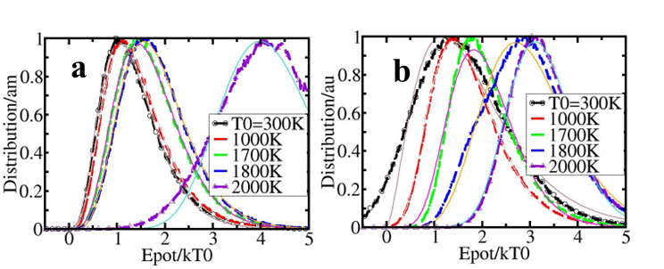
Figure S7. Simulated (dashed line) and fitted (solid line) distribution function of potential energy for atoms in three-dimensional arrays at various temperatures, T0 from 300 to 2000K, with r_{max} set to 4.0 and 12 Å, respectively.

Figure S7 illustrates both the simulated (dash line) and fitted (solid line) distribution functions of potential energy for atoms in three-dimensional arrays at various temperatures (T0) considering r_{max} values of 4.0 and 12 Å. At T=2000K with r_{max}=4.0 Å, the system experiences a breakdown, resulting in a non-smooth distribution function in Figure S7a. It is noteworthy that, at T0=300K with r_{max}=12 Å, the distribution function distinctly exhibits non-zero values in the negative energy region in Figure S7b.

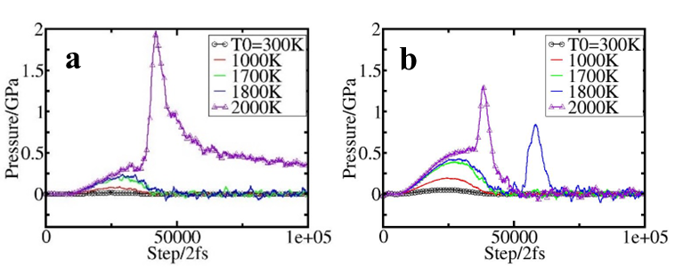
Figure S8. Pressure of the system in three-dimensional arrays at different temperatures (T0) ranging from 300 to 2000K with r_{max} set to 4.0 and 12 Å, respectively.
As shown in Figure S8a, the pressure exceeds 0.3 GPa at the end of the simulations at T0=2000K when r_{max} is set at 4.0 Å, indicating the dissociation of the system under these conditions. When r_{max} is changed to 12 Å in Figure S8b, pressures spike at the steps of atoms shifting from lattice positions to random positions during the phase transition at temperatures T0=1800 and 2000K. The pressure subsequently drops back and oscillates around one atm. A stable liquid phase is obtained.
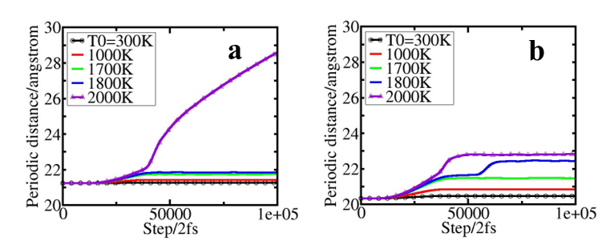
Figure S9. Periodic distance of the system in three-dimensional arrays at different temperatures (T0) ranging from 300 to 2000K with r_{max} set to 4.0 and 12 Å, respectively.
The change in periodic distance supports the same conclusion as pressure in Figure S8, where the system crashes at T0=2000K when r_{max} is set to 4.0 Å evidenced by the expanding periodic distance with increasing simulation step, and a stable liquid phase is obtained at the same temperature when r_{max} is changed to 12 Å indicated by the stable periodic distance. A sharp variation in periodic distance (volume) of the system can be observed at 1800K and at steps of 55,000 when r_{max}=12 Å, indicating a phase transition from solid to liquid.
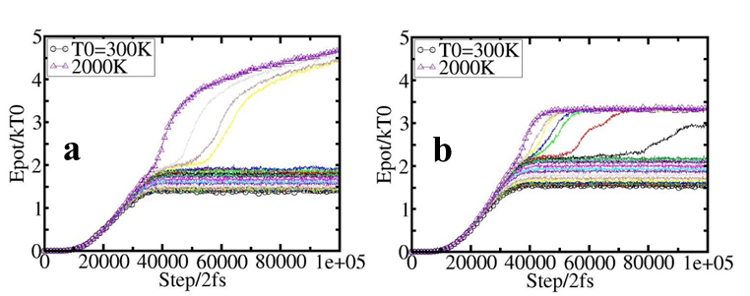
Figure S10. Averaged potential energy of atoms at various temperatures (T0) and time steps, with r_{max} set to (a) 4.0 and (b) 12 Å, respectively.
Averaged potential energies at different T0 in Figure S10 support the same conclusion as pressure (Figure S8) and periodic distance (Figure S9) variations.

