Supplemental Materials

Supplemental Table 1: Pre-training assessments by condition. Raw scores are reported as Mean (SD). WJ: Woodcock-Johnson, WISC: Wechsler Intelligence Scale for Children.
 | Listening Condition | Question-Asking Condition
WJ Science | 15.3 (3.4)  n = 51 | 16.7 (3.9)  n = 52
WISC Vocab | 17.7 (4.5)  n = 51 | 20.4 (6.3)  n = 52
WISC Matrix Reasoning | 13.3 (4.0)  n = 51 | 14.1 (4.3)  n = 52
WISC Digit Span | 17.5 (5.4)  n = 51 | 17.5 (5.3)  n = 52

Supplemental Figure 1: Spearman correlations among baseline cognitive skills, science learning, and willingness-to-pay by condition. D-Type: deprivation-type epistemic curiosity; I-Type: interest-type epistemic curiosity; WISC: Wechsler Intelligence Scale for Children (Vocabulary, Matrix Reasoning, Digit Span subtest); WJ: Woodcock-Johnson (Science subtest); WTP: Willingness-to-Pay task; Sci Learn: Science learning. QA: Question-asking (purple), L: Listening (teal). * p < .05, **p < .01, ***p < .001 uncorrected. Results presented in the main manuscript are boxed.

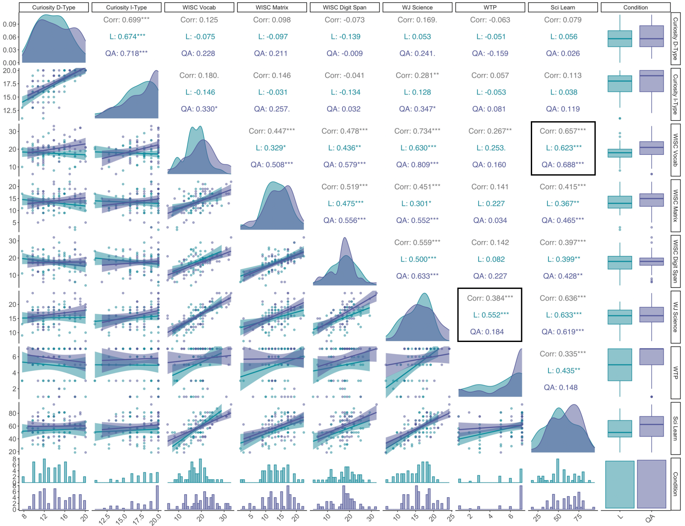

Supplemental Figure 2: Spearman correlations among demographics, stress measures, science learning, and willingness-to-pay by condition. We found no moderations of the condition effect on willingness-to-pay or science learning by demographics or stress exposure. All correlations are provided to fully report associations among these variables. WTP: Willingness-to-Pay task; Sci Learn: Science learning; Age (years); Income (dollars per year); Parent Education (average parent education in years), LES: Life Events Scale for Young Children stress in the past year; PSS: Perceived Stress Scale; ACEs: Child Adverse Childhood Experiences scale. QA: Question-asking (purple), L: Listening (teal). * p < .05, **p < .01, ***p < .001 uncorrected.

