Alignment, SAM file
Two-way sequences, FASTQ files

SRA Toolkit
Strain sequence, SRA file
BWA
Samtools
Reference genome, FASTA file
Conversion, BAM file
Samtools
Conversion, VCF file
Bcftools
Transformation, BCF file
Samtools
Sorting, BAM file
SnpSift

Information table, mutation and gene name
SnpSift
Annotation, file ANN.VCF
SnpEff
Filtering, VCF file

Figure S1. Mutation extraction diagram
Drug | Susceptible | Resistance
Isoniazid | 19113 | 8960
Rifampicin | 20613 | 7460
Ethambutol | 22245 | 5828
Pyrazinamide | 23799 | 4274
Streptomycin | 21560 | 6513
Ethionamide | 24482 | 3591
Fluoroquinolones | 25893 | 2180
Amikacin | 26746 | 1327
Capreomycin | 26659 | 1414
Kanamycin | 25914 | 2159

Table S1. Overview of phenotypes of isolates with respect to ant-TB drugs.
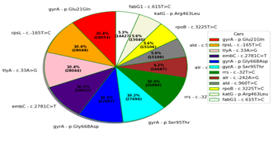
Figure S2. Diagram of the top 12 most relevant mutations in global resistance
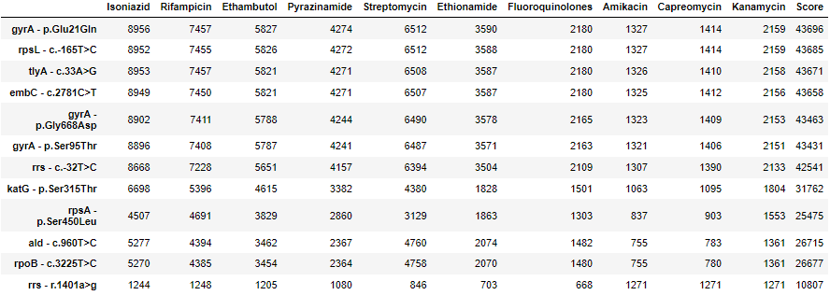
Table S2. Ranking and score top 12 most dangerous mutations in resistance
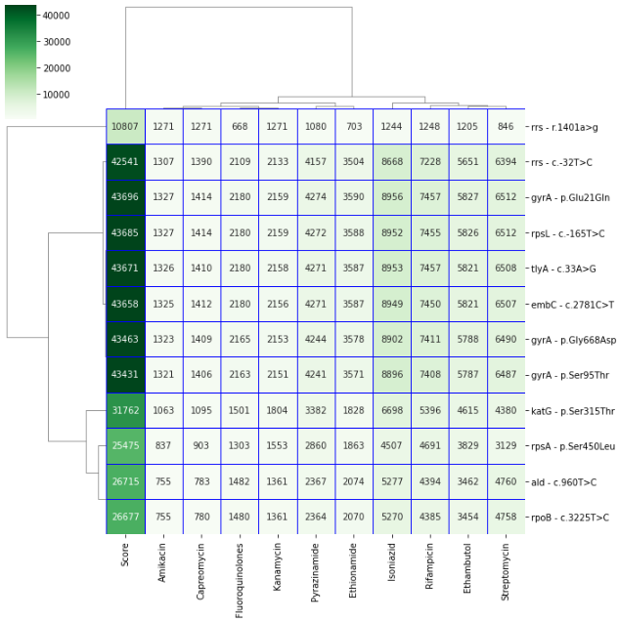
Figure S3. Clustring hierarchy top 12 most dangerous mutations in resistance
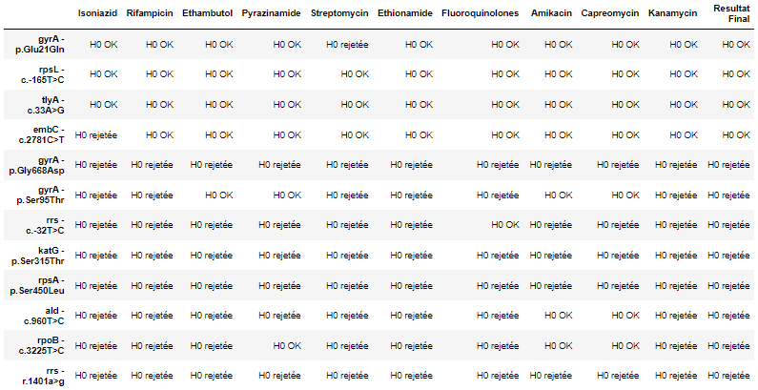
Table S3. Result of statistical tests Hypothesis H0 (the hypothesis indicates that these mutations are not the most dangerous i.e. the average impact rates are equal in all mutations and the statistical test is based on the p-value (0.02) to reject this hypothesis).

Genes
ahpC | embR | tlyA
fabG1 | iniA | rrs
inhA | iniC | eis
KatG | manB | gidB
ndh | rm1D | rpsL
rpoB | pncA | embC
embA | rpsA | gyrB
embB | gyrA

Table S4. List of 23 candidate genes responsible for the association with resistance.
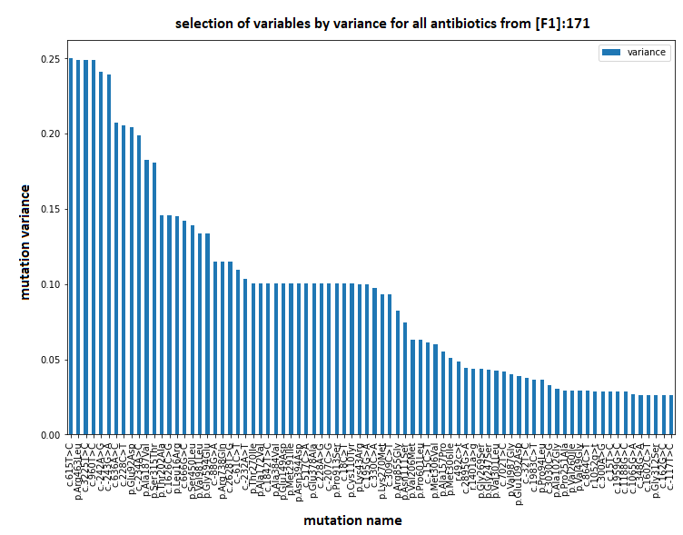
Figure S4. Selection from a threshold of variance from [F1] for all antibiotics [F3]
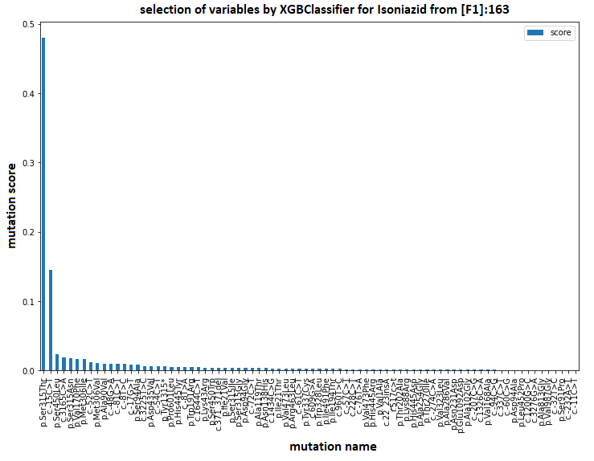  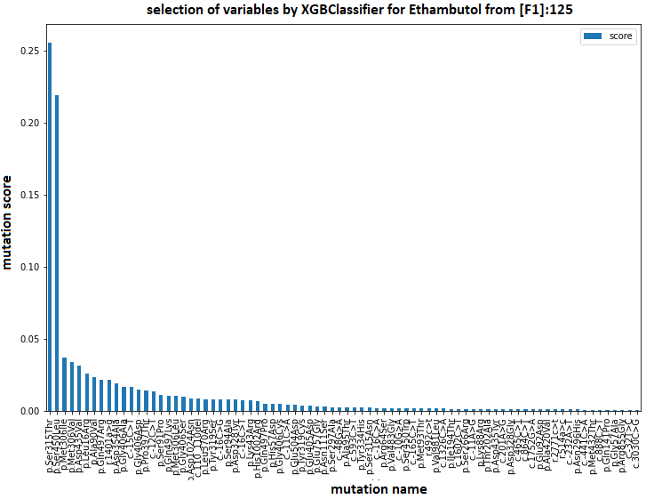  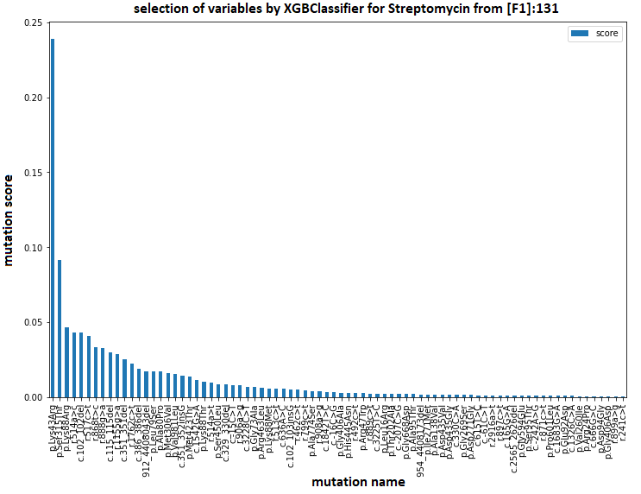  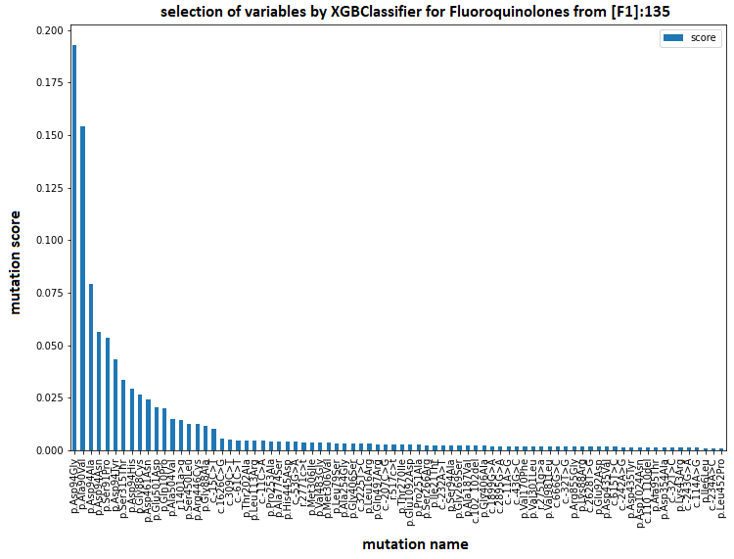  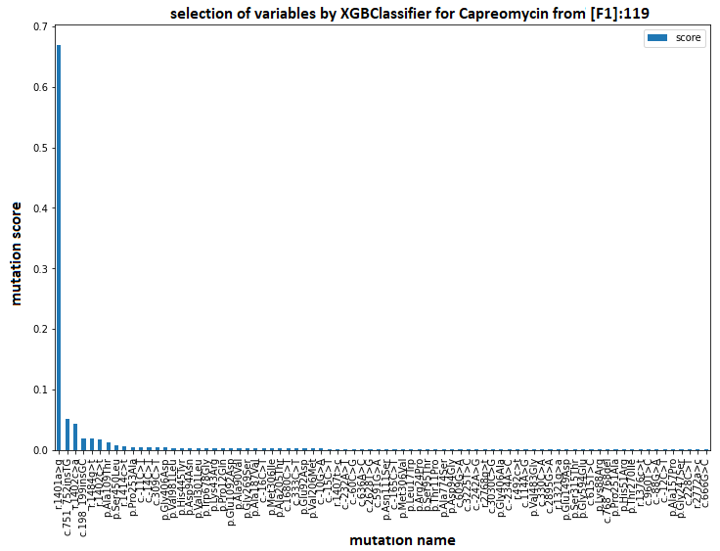 | 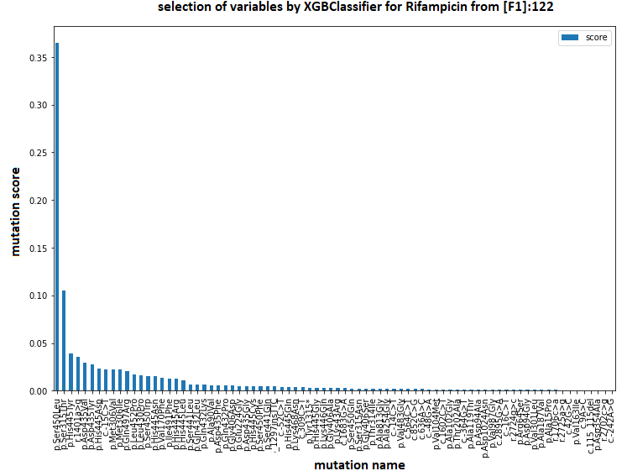  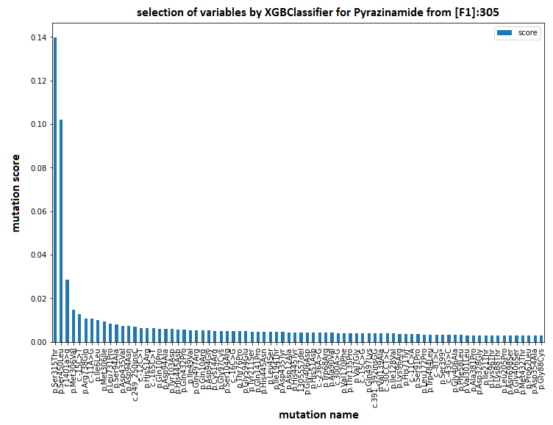  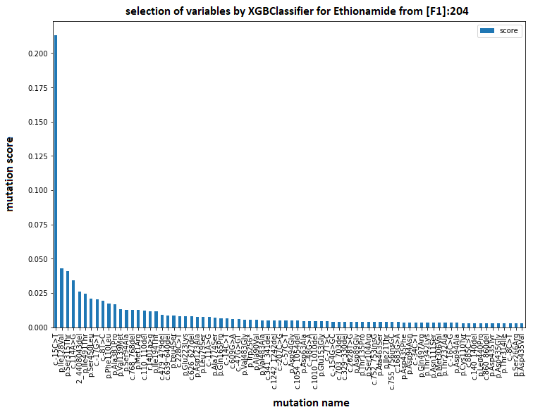  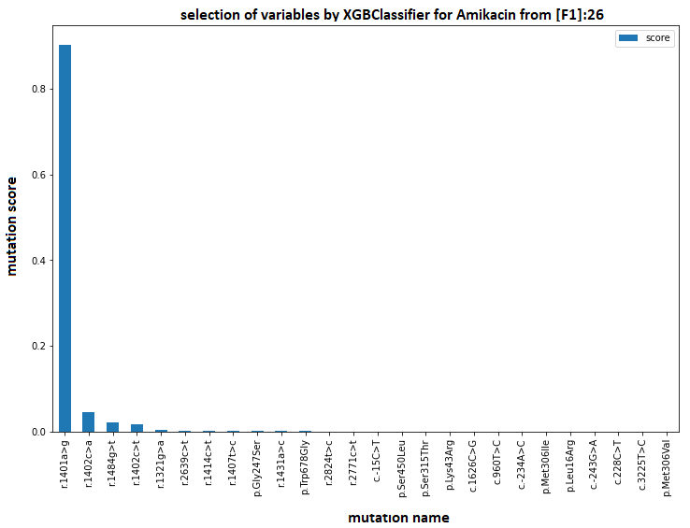  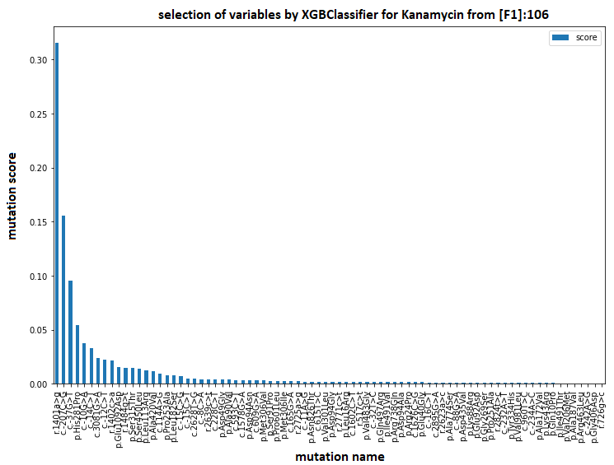

Figure S5. Selection from the XGboost model from [F1] for each antibiotic [F5].

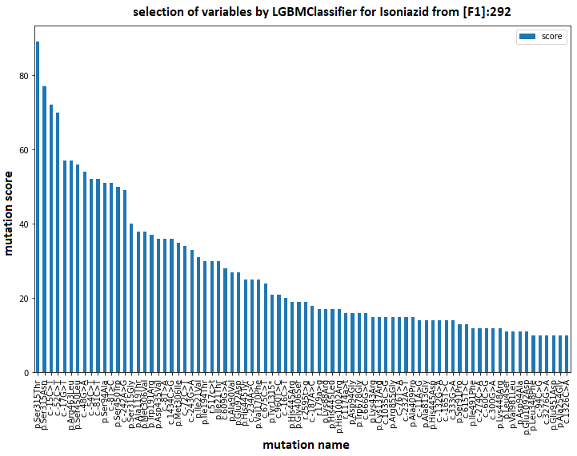  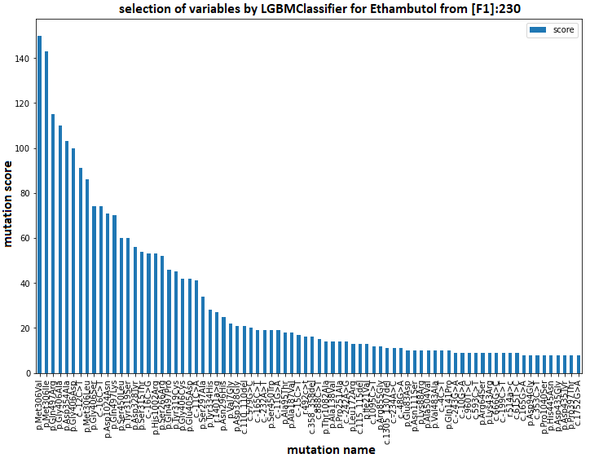  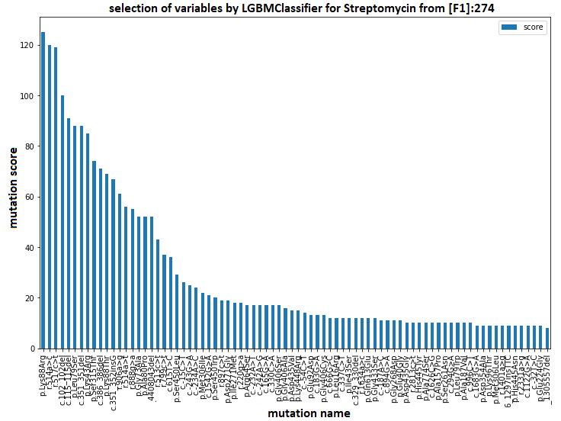  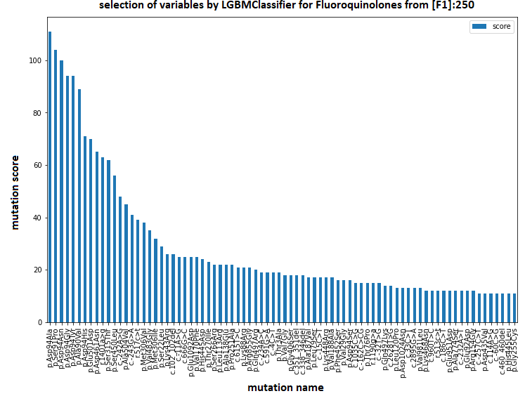  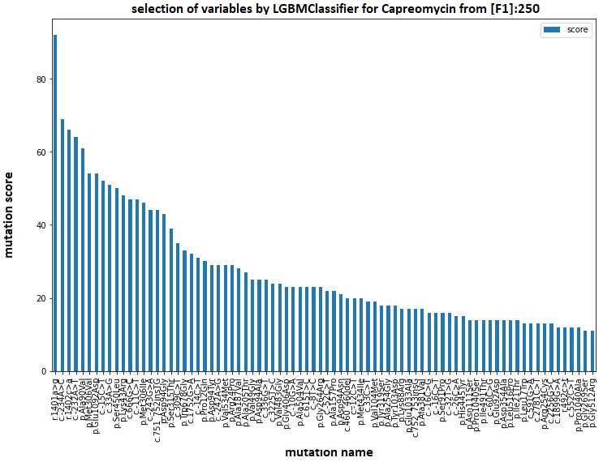 | 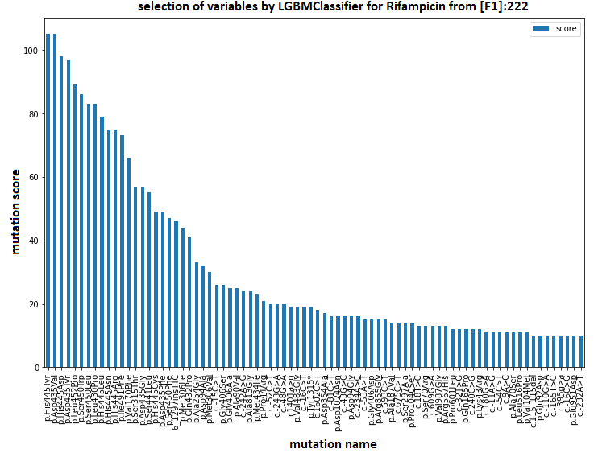  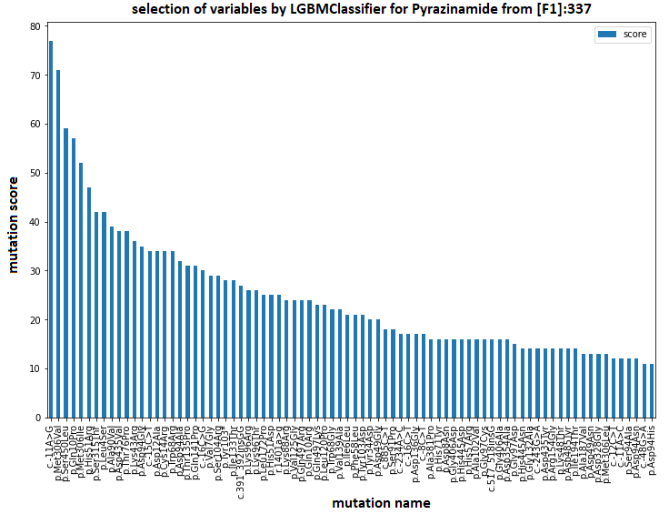  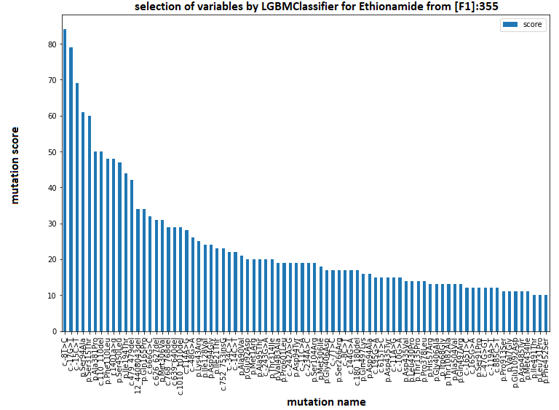  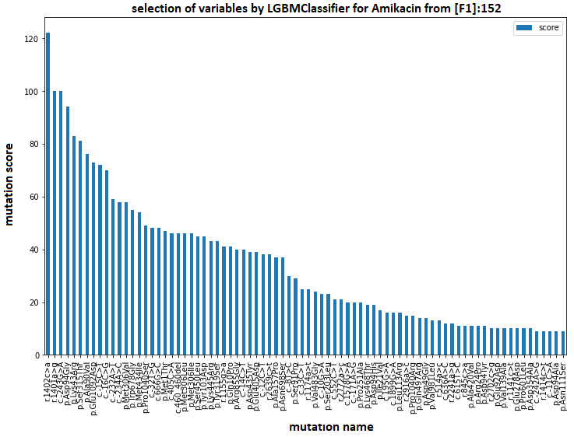  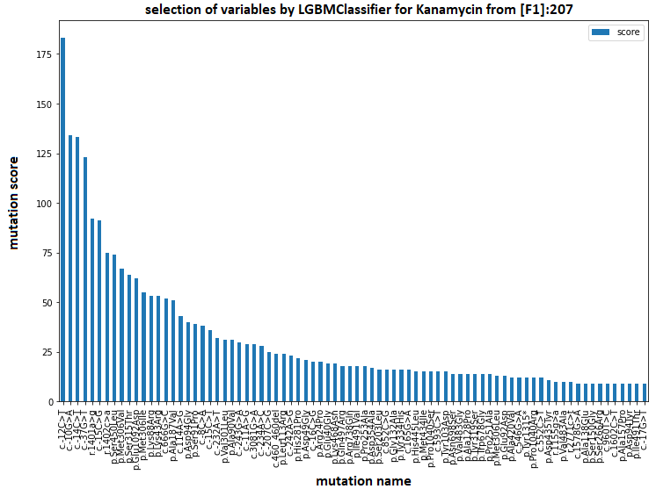

Figure S6. Selection from the LightGBM model from [F1] for each antibiotic [F6].

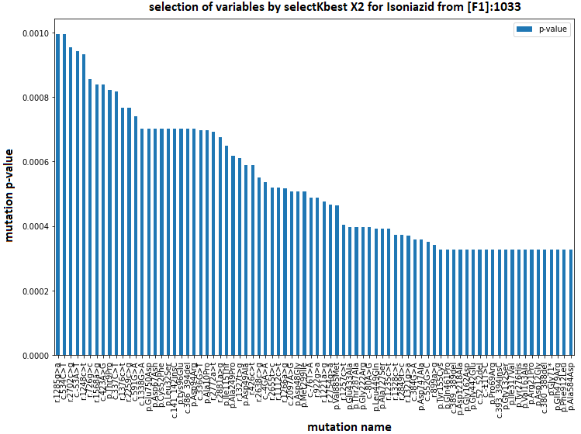  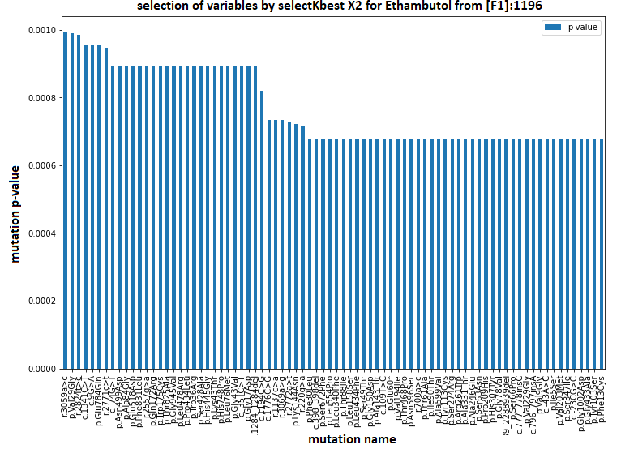  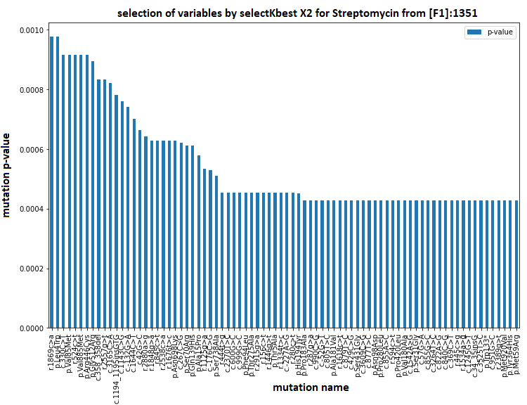  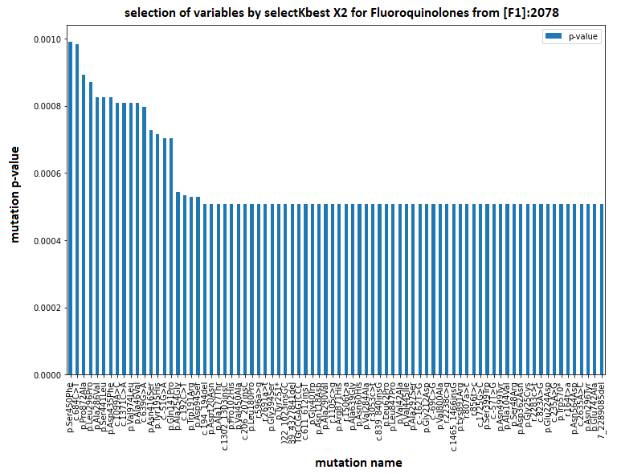  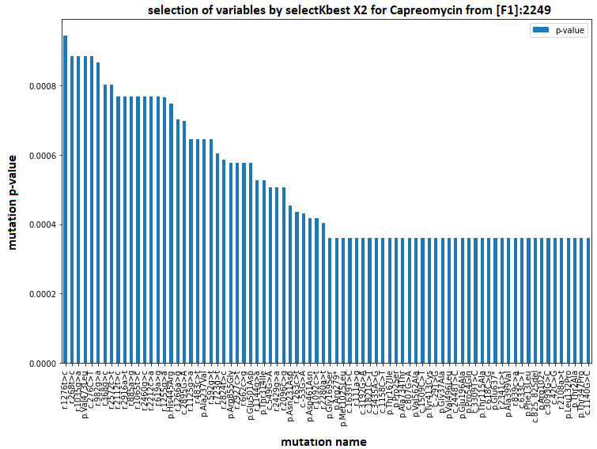 | 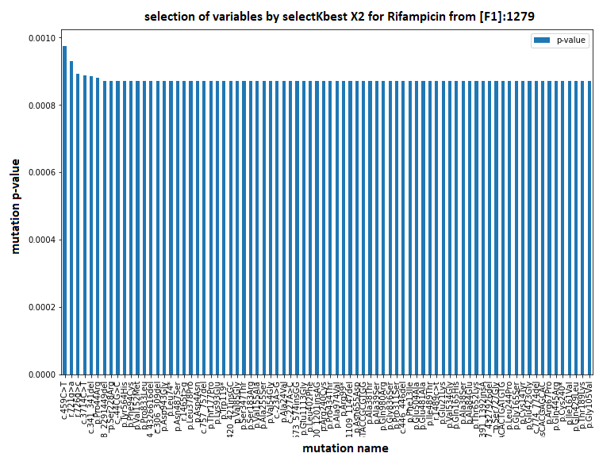  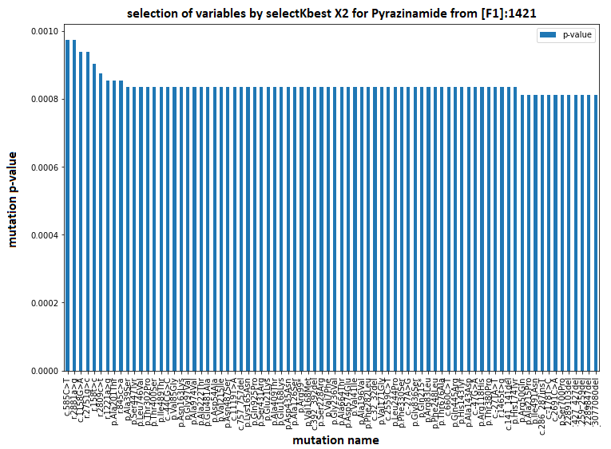  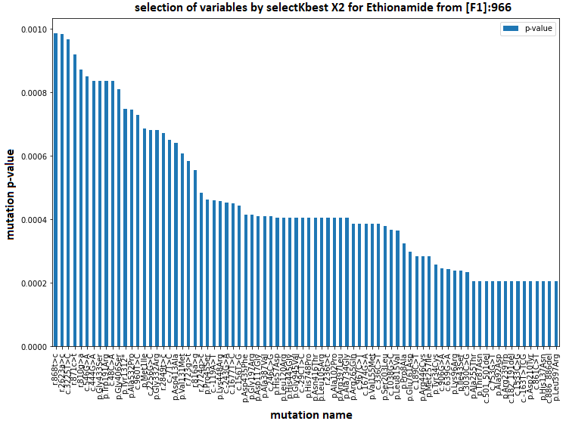  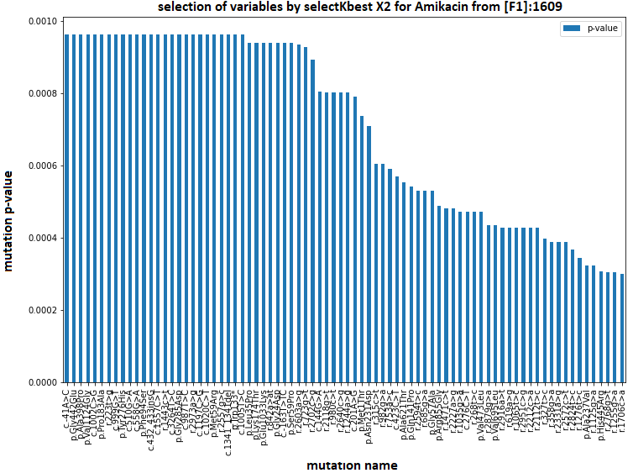  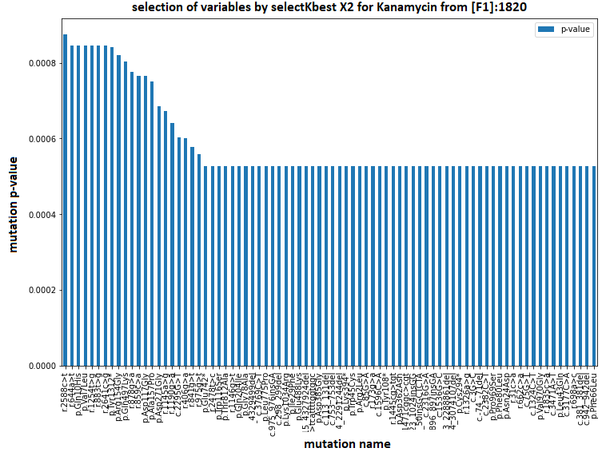

Figure S7. Selection of the "K" best variables based on the "X2" test from [F1] for each antibiotic [F4].
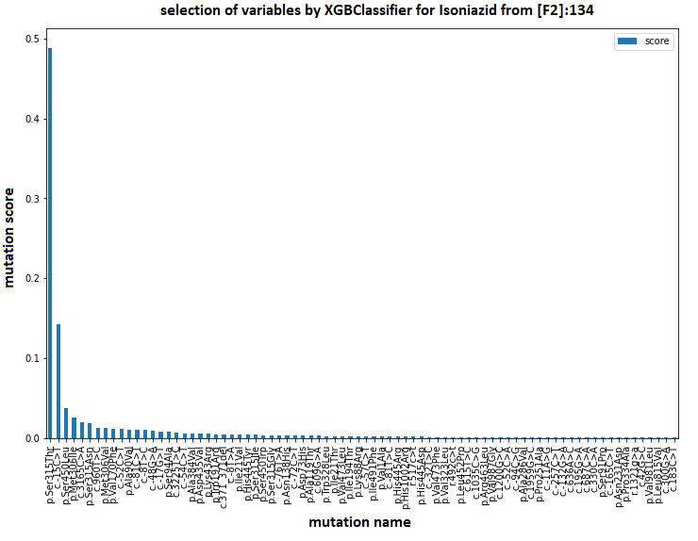  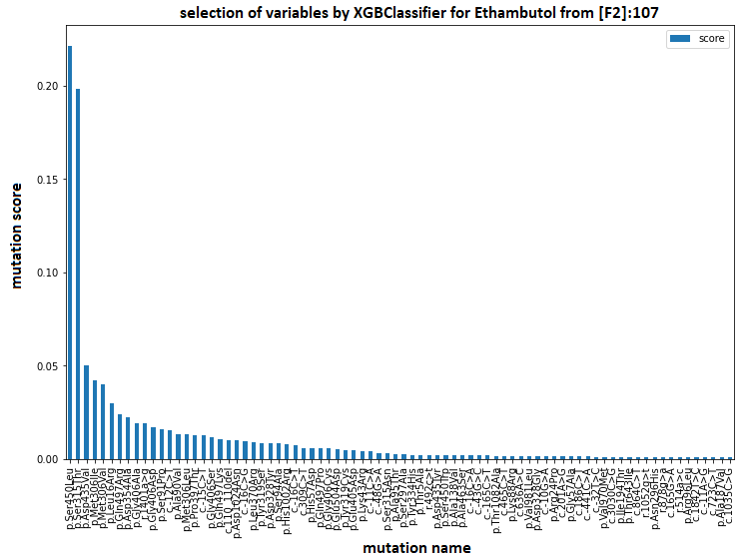  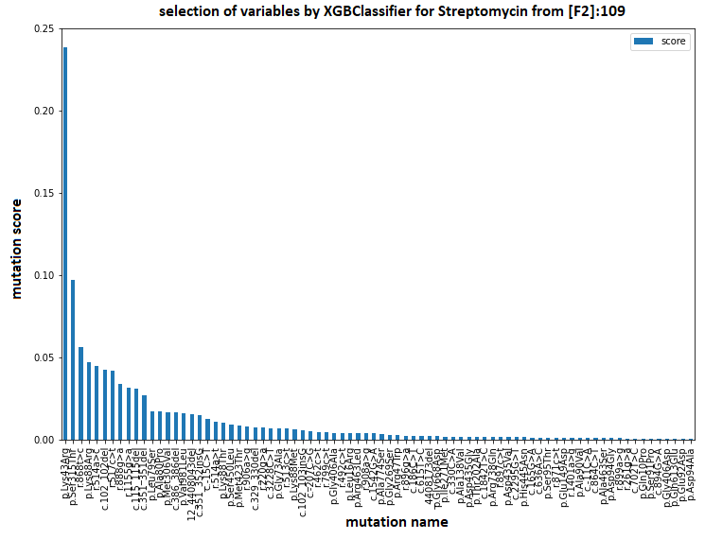  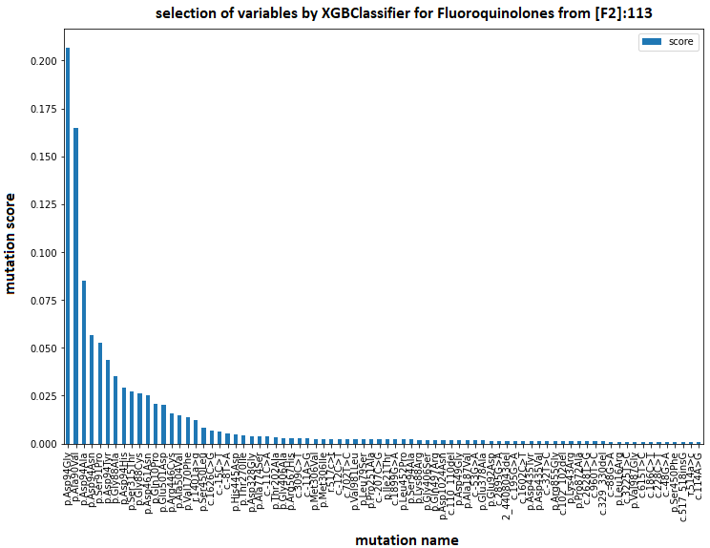  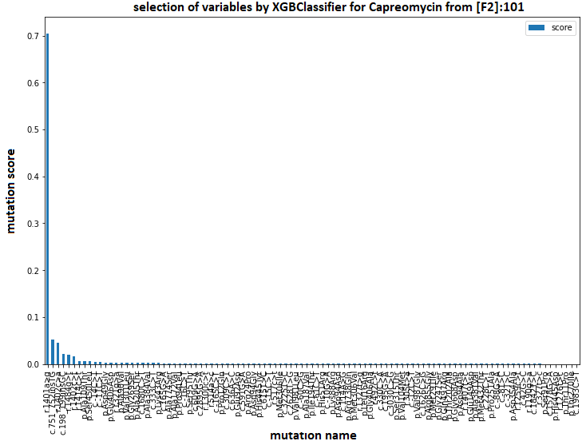 | 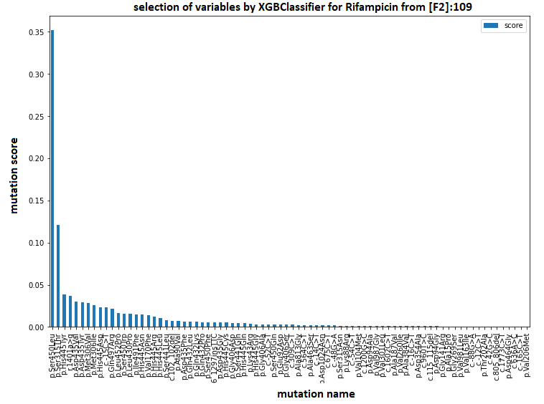  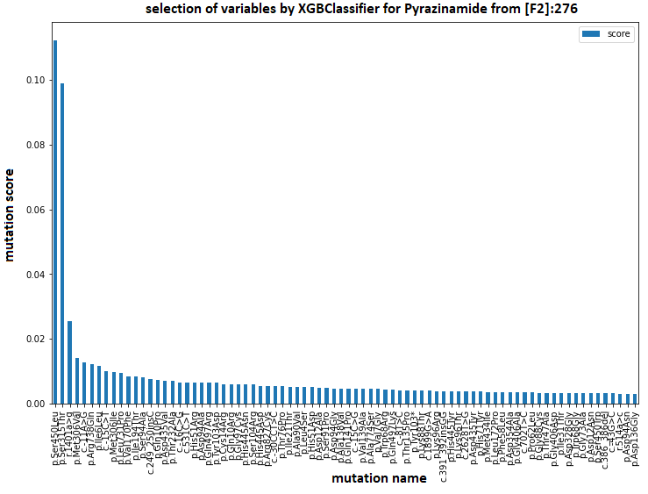  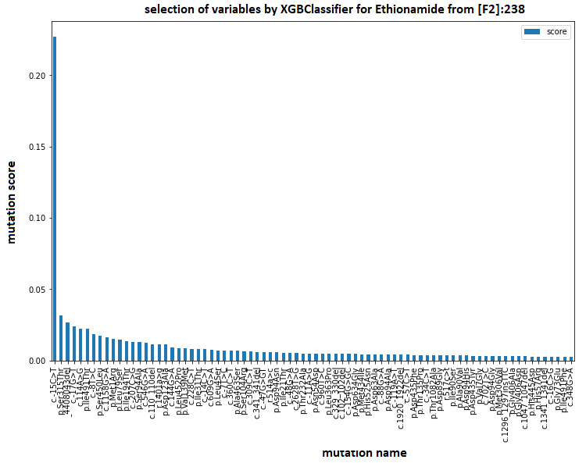  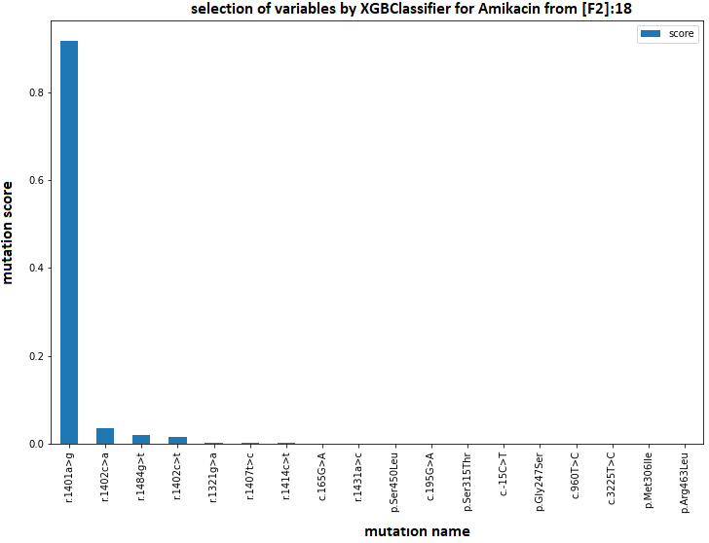  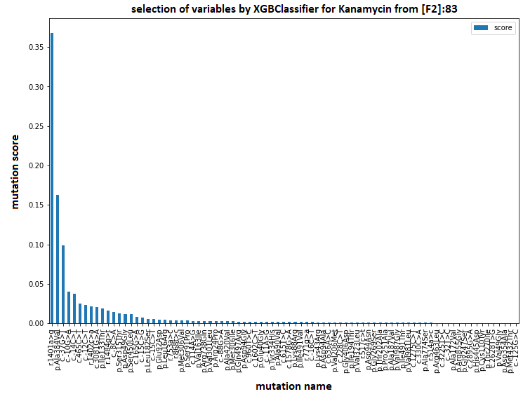

Figure S8. Selection from the XGboost model from [F2] for each antibiotic [F9].
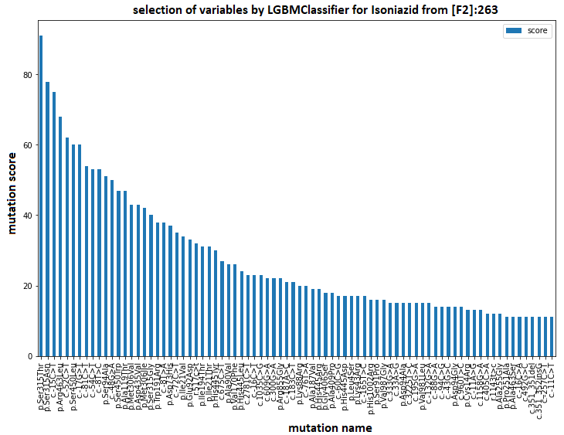  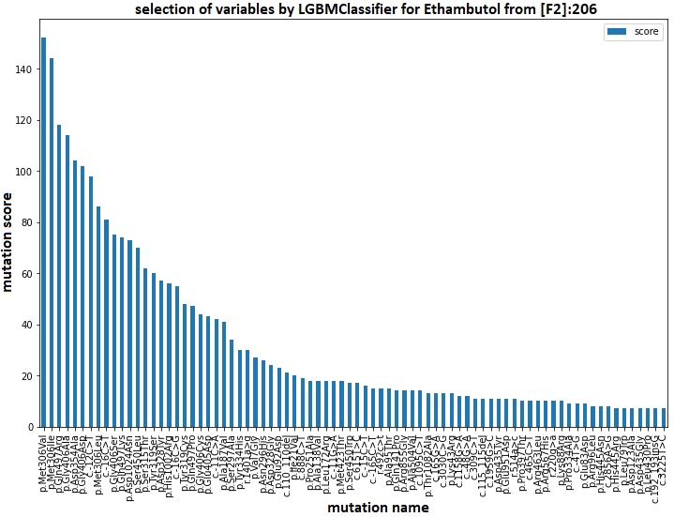  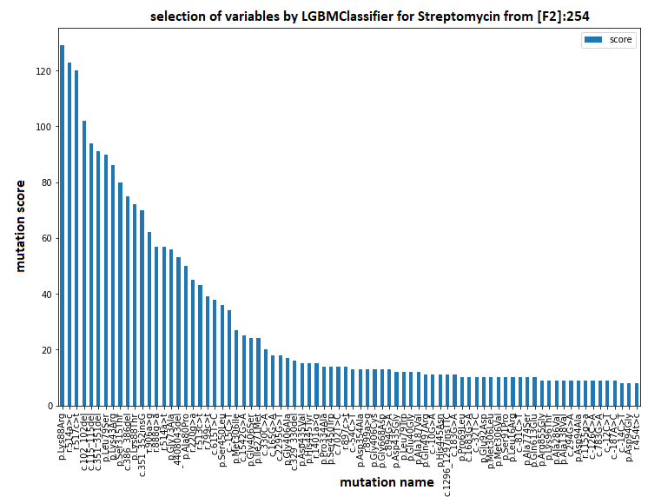  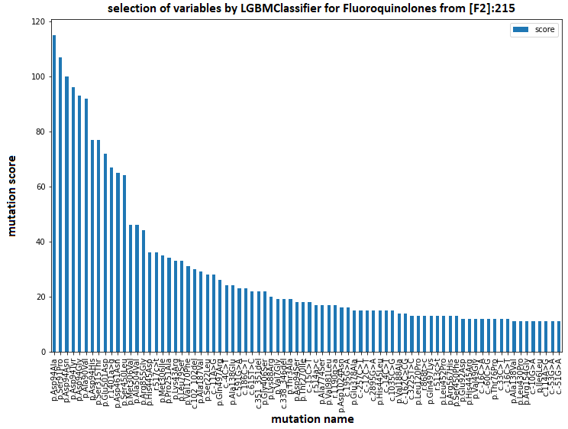  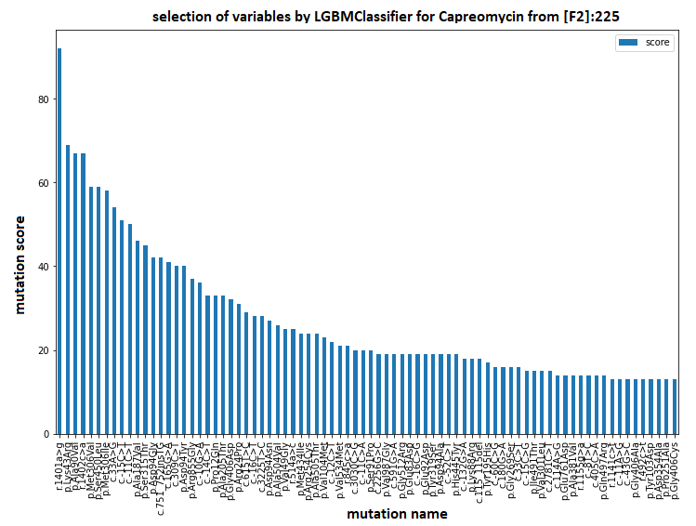 | 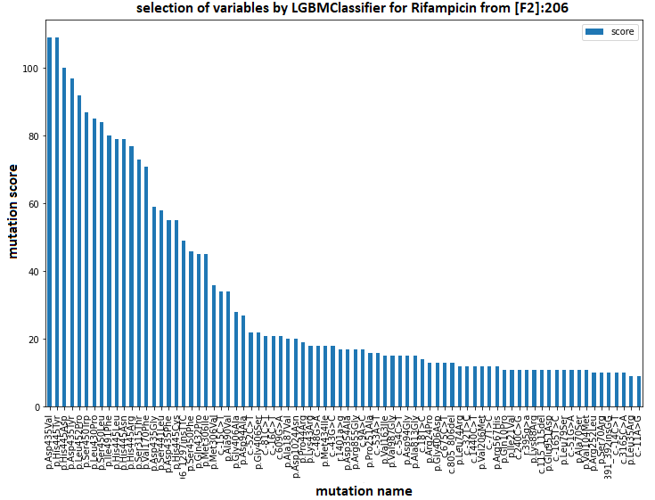  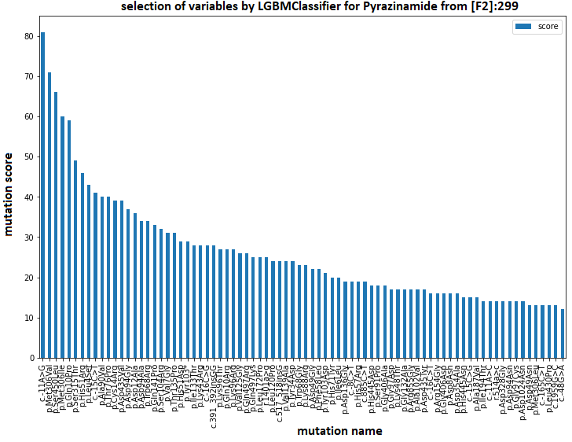  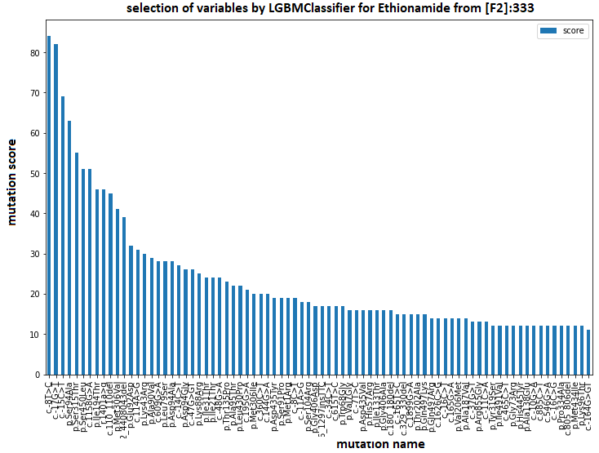  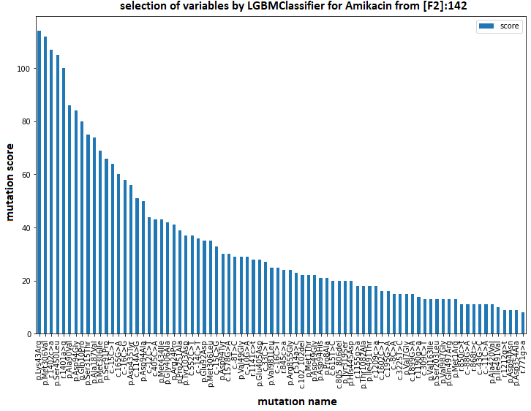  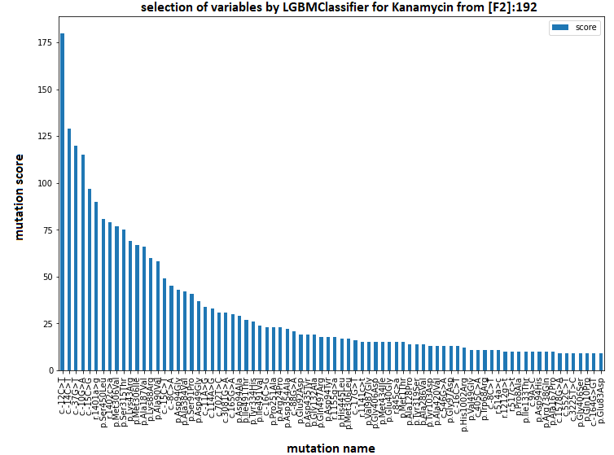

Figure S9. Selection from the LightGBM model from [F2] for each antibiotic [F10].
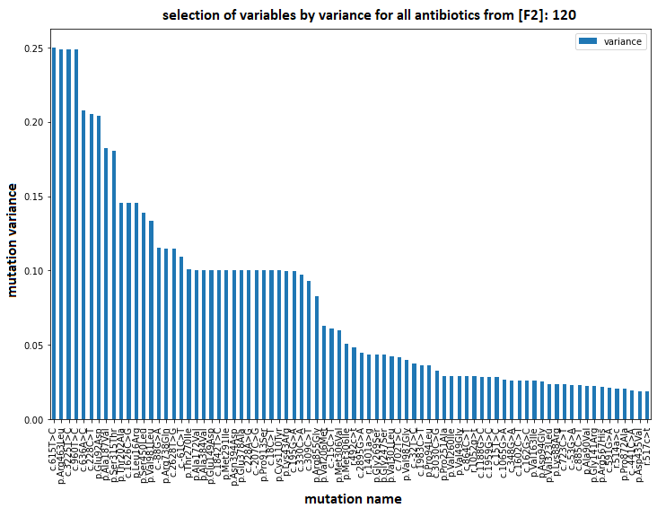
Figure S10. Selection from a threshold of variance from [F2] for all antibiotics [F7].
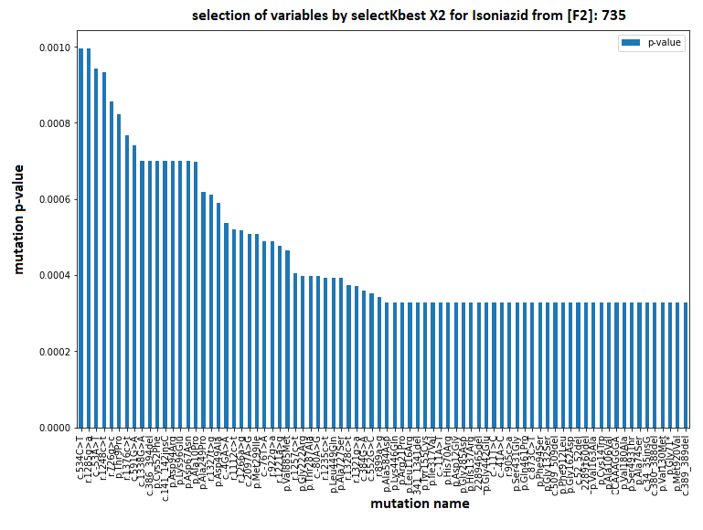  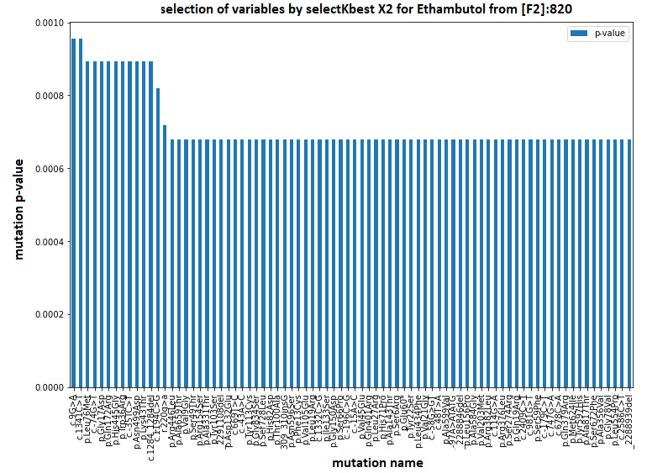  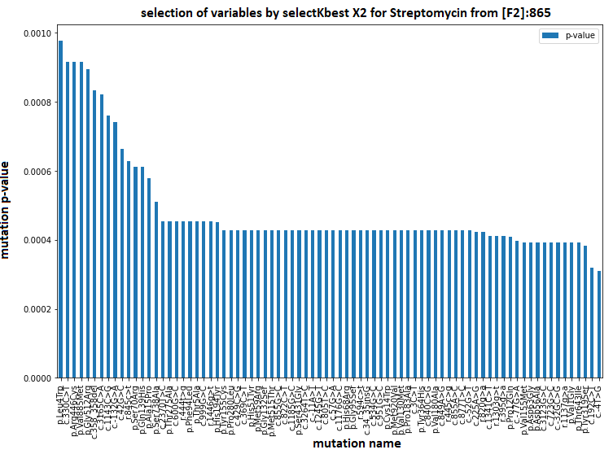  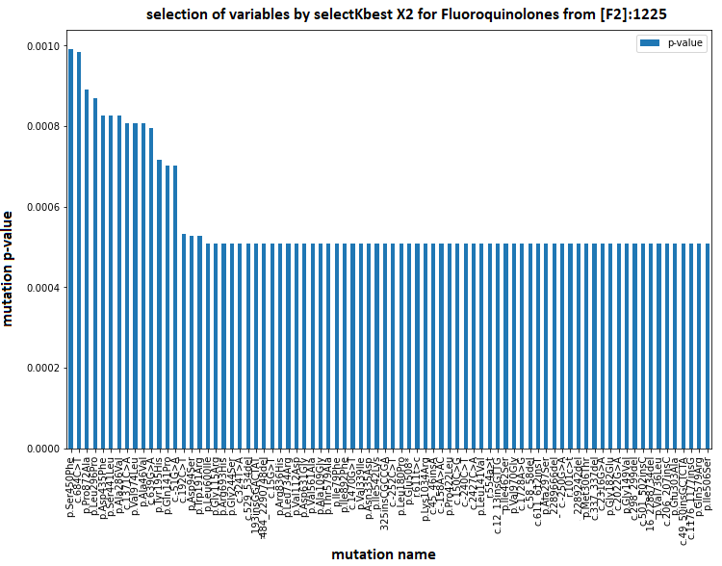  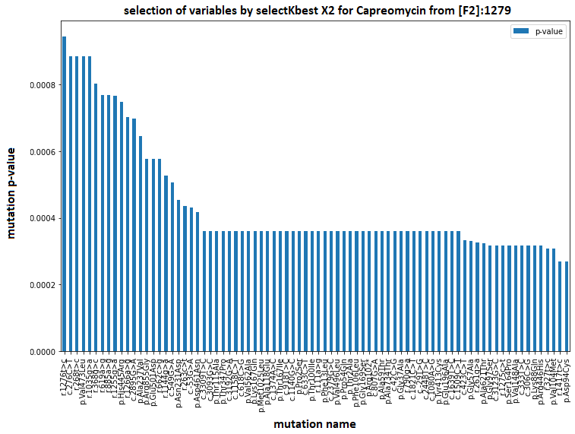 | 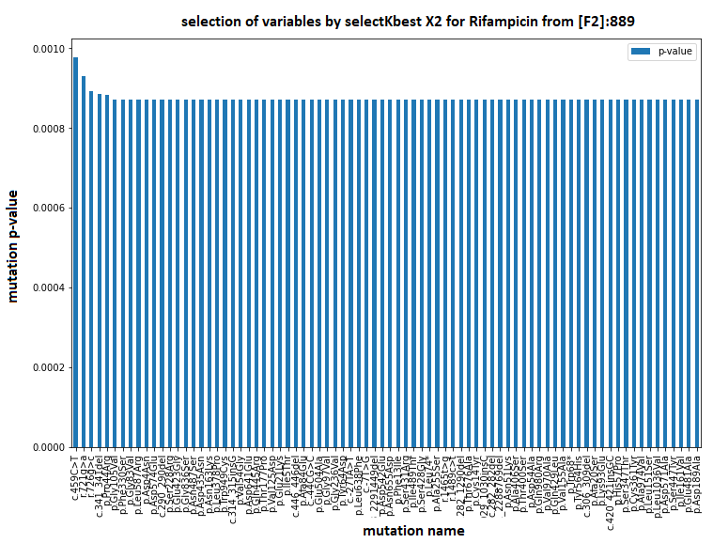  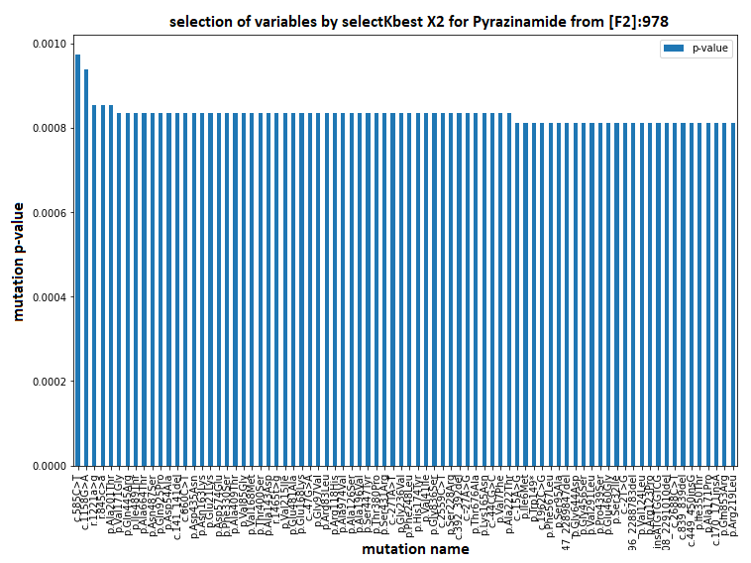  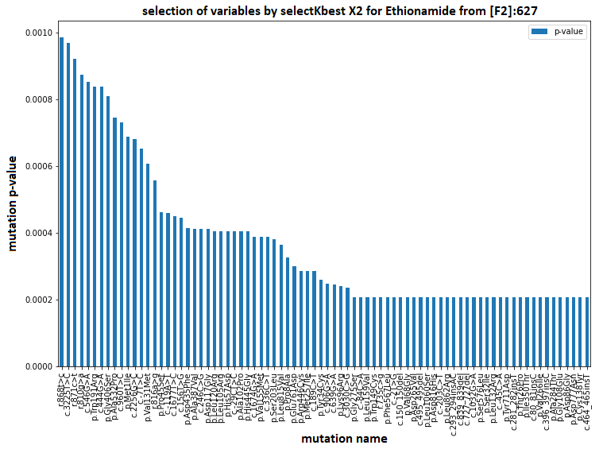  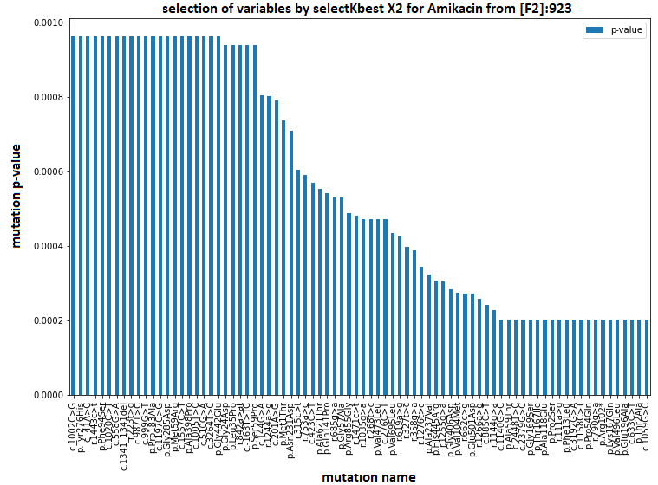  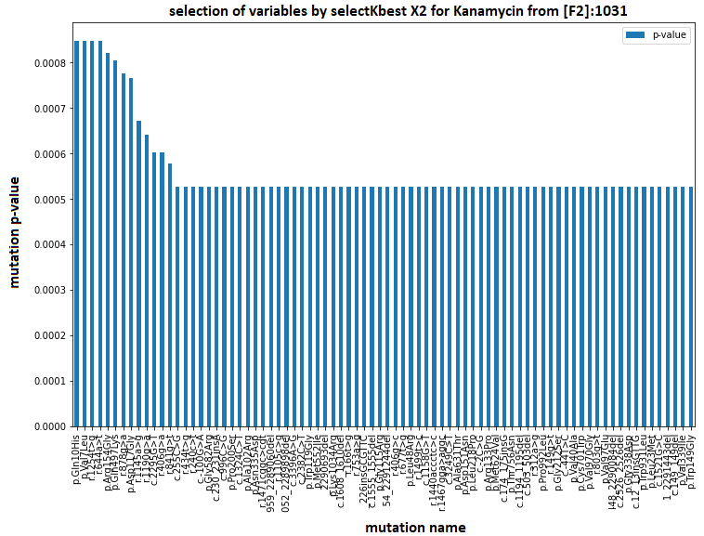

Figure S11. Selection of the "K" best variables based on the "X2" test from [F2] for each antibiotic [F8].

- Setting « Isoniazid »:
colsample_bylevel | colsample_bytree | gamma | learning_rate | max_depth | min_child_weight | n_estimators | reg_lambda | subsample
0.8 | 0.7 | 0.5 | 0.3 | 25 | 1 | 100 | 0 | 0.8
- Setting « Rifampicin »:
colsample_bylevel | colsample_bytree | gamma | learning_rate | max_depth | min_child_weight | n_estimators | reg_lambda | subsample
0.8 | 0.8 | 0 | 0.4 | 5 | 1 | 100 | 0 | 1
- Setting « Ethambutol »:
colsample_bylevel | colsample_bytree | gamma | learning_rate | max_depth | min_child_weight | n_estimators | reg_lambda | subsample
1 | 0.2 | 0.2 | 0.28 | 18 | 1 | 1000 | 1 | 0.8
- Setting « Pyrazinamide »:
colsample_bylevel | colsample_bytree | gamma | learning_rate | max_depth | min_child_weight | n_estimators | reg_lambda | subsample
0.7 | 0.4 | 0 | 0.3 | 5 | 1 | 1000 | 1 | 0.9
- Setting « Streptomycin »:
colsample_bylevel | colsample_bytree | gamma | learning_rate | max_depth | min_child_weight | n_estimators | reg_lambda | subsample
0.4 | 0.3 | 1 | 0.23 | 5 | 1 | 1000 | 2 | 0.6
- Setting « Ethionamide »:
colsample_bylevel | colsample_bytree | gamma | learning_rate | max_depth | min_child_weight | n_estimators | reg_lambda | subsample
0.1 | 0.2 | 0.1 | 0.46 | 16 | 1 | 1000 | 1 | 1
- Setting « Fluoroquinolones »:
colsample_bylevel | colsample_bytree | gamma | learning_rate | max_depth | min_child_weight | n_estimators | reg_lambda | subsample
0.9 | 0.9 | 0.2 | 0.47 | 24 | 1 | 100 | 5 | 1
- Setting « Amikacin »:
colsample_bylevel | colsample_bytree | gamma | learning_rate | max_depth | min_child_weight | n_estimators | reg_lambda | subsample
1 | 1 | 0.3 | 0.48 | 16 | 1 | 100 | 2 | 0.1
- Setting « Capreomycin »:
colsample_bylevel | colsample_bytree | gamma | learning_rate | max_depth | min_child_weight | n_estimators | reg_lambda | subsample
0.8 | 0.8 | 0 | 0.4 | 19 | 1 | 100 | 2 | 1

- Setting « Kanamycin »:
colsample_bylevel | colsample_bytree | gamma | learning_rate | max_depth | min_child_weight | n_estimators | reg_lambda | subsample
1 | 0.9 | 0.9 | 0.24 | 11 | 1 | 100 | 1 | 0.9

Table S5. Hypropt parameters of the XGBoost algorithm for each antibiotic.

- Setting « Isoniazid »:
colsample_bylevel | colsample_bytree | gamma | learning_rate | max_depth | min_child_weight | n_estimators | reg_lambda | subsample
0.6 | 1 | 0.4 | 0.3 | 4 | 1 | 1000 | 3 | 0.9
- Setting « Rifampicin »:
colsample_bylevel | colsample_bytree | gamma | learning_rate | max_depth | min_child_weight | n_estimators | reg_lambda | subsample
0.6 | 0.2 | 0.1 | 0.26 | 16 | 1 | 100 | 0 | 0.9
- Setting « Ethambutol »:
colsample_bylevel | colsample_bytree | gamma | learning_rate | max_depth | min_child_weight | n_estimators | reg_lambda | subsample
0.3 | 1 | 0 | 0.45 | 4 | 1 | 1000 | 3 | 1
- Setting « Pyrazinamide »:
colsample_bylevel | colsample_bytree | gamma | learning_rate | max_depth | min_child_weight | n_estimators | reg_lambda | subsample
0.3 | 0.3 | 0.3 | 0.23 | 20 | 2 | 1000 | 1 | 0.4
- Setting « Streptomycin »:
colsample_bylevel | colsample_bytree | gamma | learning_rate | max_depth | min_child_weight | n_estimators | reg_lambda | subsample
0.4 | 0.3 | 1 | 0.23 | 5 | 1 | 1000 | 2 | 0.6
- Setting « Ethionamide »:
colsample_bylevel | colsample_bytree | gamma | learning_rate | max_depth | min_child_weight | n_estimators | reg_lambda | subsample
0.8 | 0.2 | 0.2 | 0.3 | 8 | 1 | 1000 | 0 | 0.6
- Setting « Fluoroquinolones »:
colsample_bylevel | colsample_bytree | gamma | learning_rate | max_depth | min_child_weight | n_estimators | reg_lambda | subsample
0.7 | 0.1 | 0.6 | 0.22 | 5 | 1 | 1000 | 0 | 0.7
- Setting « Amikacin »:
colsample_bylevel | colsample_bytree | gamma | learning_rate | max_depth | min_child_weight | n_estimators | reg_lambda | subsample
0.7 | 0.1 | 0.6 | 0.22 | 5 | 1 | 1000 | 0 | 0.7
- Setting « Capreomycin »:
colsample_bylevel | colsample_bytree | gamma | learning_rate | max_depth | min_child_weight | n_estimators | reg_lambda | subsample
0.4 | 0.5 | 0.9 | 0.32 | 2 | 1 | 1000 | 2 | 0.4
- Setting « Kanamycin »:
colsample_bylevel | colsample_bytree | gamma | learning_rate | max_depth | min_child_weight | n_estimators | reg_lambda | subsample
0.3 | 1 | 1 | 0.45 | 17 | 1 | 100 | 4 | 0.5

Table S6. Hypropt parameters of the LighGBM algorithm for each antibiotic.

Caractéristique | valeur
Number of hidden layers | 5
Number of neurons | 100
Hidden layer activation function | Relu
Activation function of the output layer | Sigmoid
Kernel initialization | He_normal
Regularization | L2 (0.01)
Batch normalization | After activation function
Optimization | Adam (lr=0.01, beta_1=0.9, beta_2=0.999, decay=1e-4)
Batch size | 32
Loss function | Binary cross entropy

Table S7. Architecture of the deep learning model.

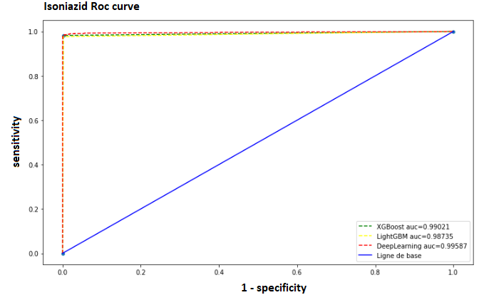 | 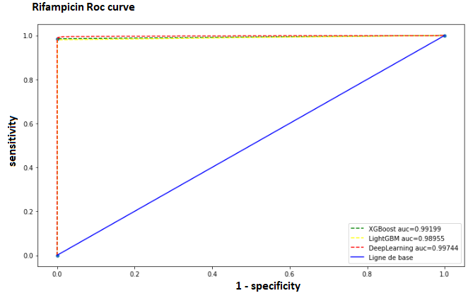
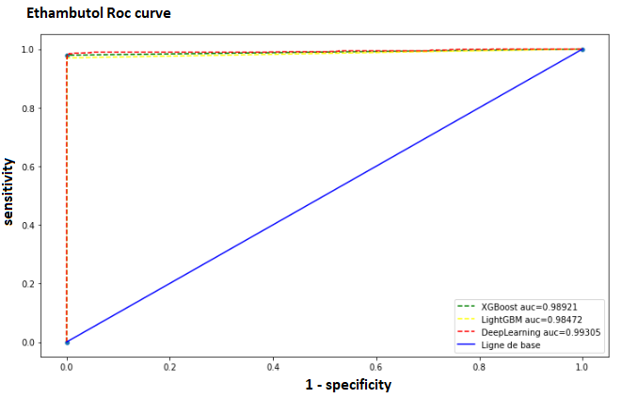 | 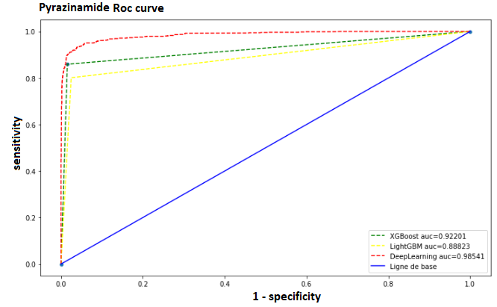
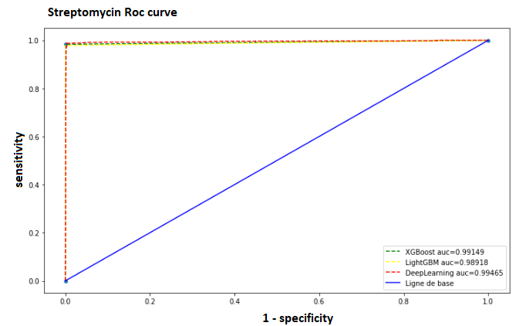 | 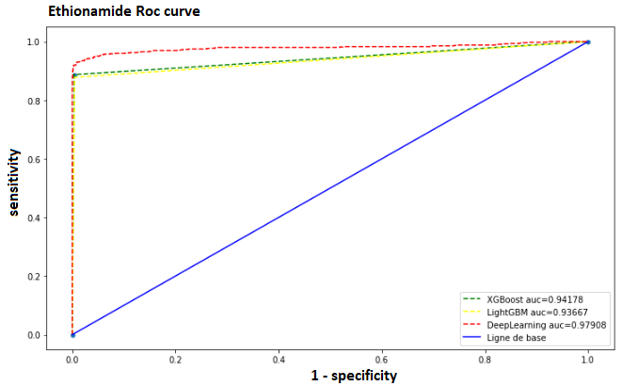
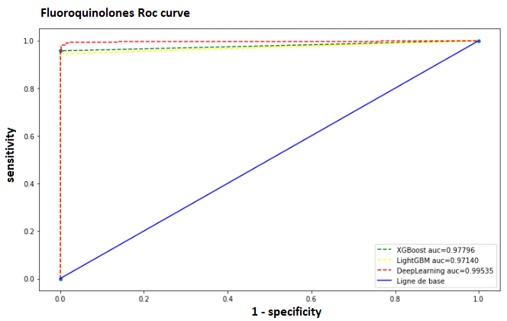 | 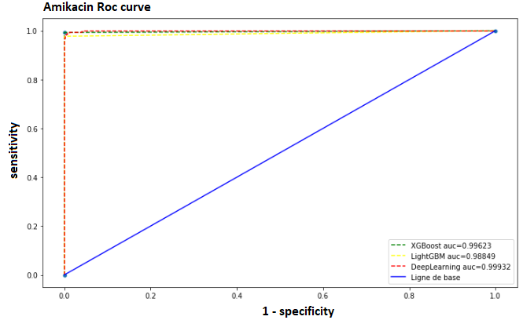
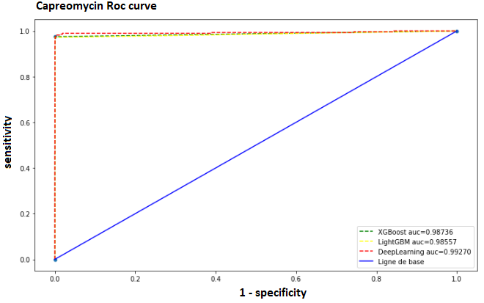 | 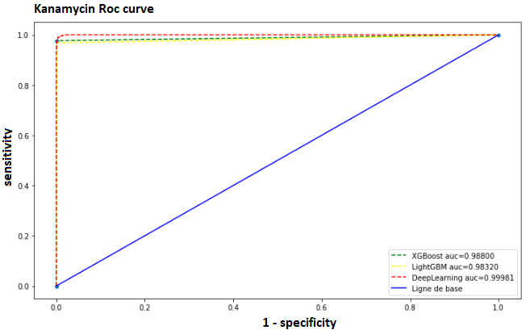

Figure S12. ROC curves of the algorithms for each antibiotic.

- Confusion matrix  - performance score  - Feature space: Space [F1] of the variables of all mutations.  - Learning curve  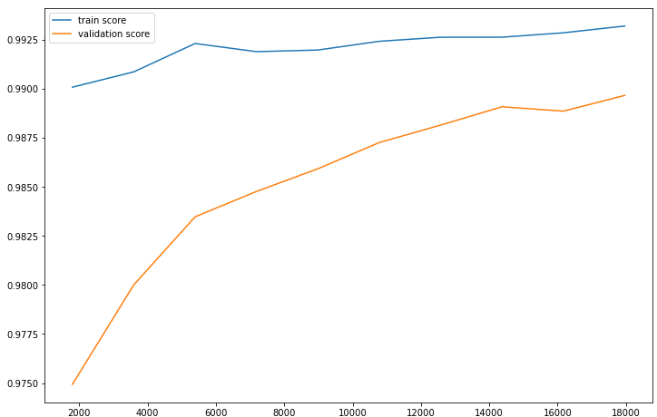 | - Confusion matrix  - performance score  - Feature space: Space [F2] of the variables of the mutations present in the 23 genes most known in antibiotic resistance.  - Learning curve  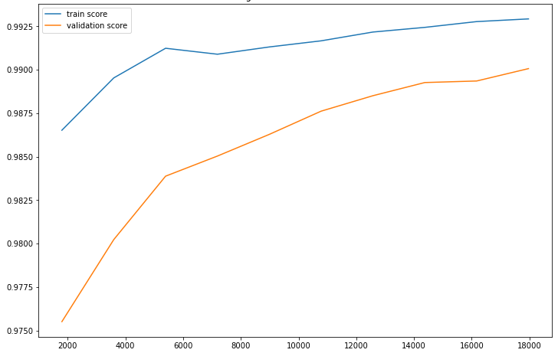
   |  | Reality
   |  | Negative | Positive
  Prediction | Negative | 3775 | 6
  Prediction | Positive | 41 | 1793
  Accuracy | Sensitivity | Specificity | Score f1 | AUC
  0.9776 % | 0.9966 % | 0.9892 % | 0.9870 % | 0.9880 %
   |  | Reality
   |  | Negative | Positive
  Prediction | Negative | 3776 | 5
  Prediction | Positive | 40 | 1794
  Accuracy | Sensitivity | Specificity | Score f1 | AUC
  0.9781 % | 0.9972 % | 0.9895 % | 0.9876 % | 0.9884 %
- Confusion matrix  - performance score  - Feature space: Space [F3] of the variables selected according to a variance threshold from [F1].  - Learning curve | - Confusion matrix  - performance score  - Feature space: Space [F4] of the "K" best variables selected based on the "X2" test from [F1].  - Learning curve  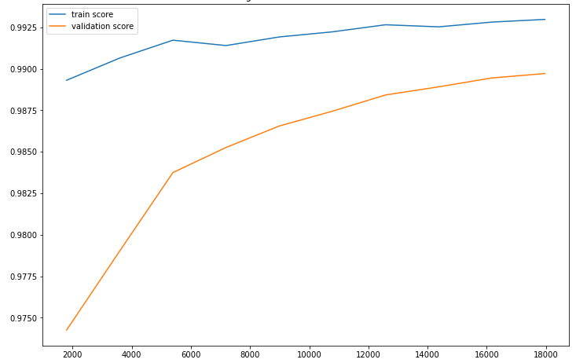
   |  | Reality
   |  | Negative | Positive
  Prediction | Negative | 3775 | 6
  Prediction | Positive | 41 | 1793
  Accuracy | Sensitivity | Specificity | Score f1 | AUC
  0.9776 % | 0.9966 % | 0.9892 % | 0.9870 % | 0.9880 %
   |  | Reality
   |  | Negative | Positive
  Prediction | Negative | 3777 | 4
  Prediction | Positive | 42 | 1792
  Accuracy | Sensitivity | Specificity | Score f1 | AUC
  0.9770 % | 0.9977 % | 0.9890 % | 0.9873 % | 0.9880 %
- Confusion matrix  - performance score  - Feature space: Space [F5] of the variables selected by the "XGBoost" model from [F1].  - Learning curve  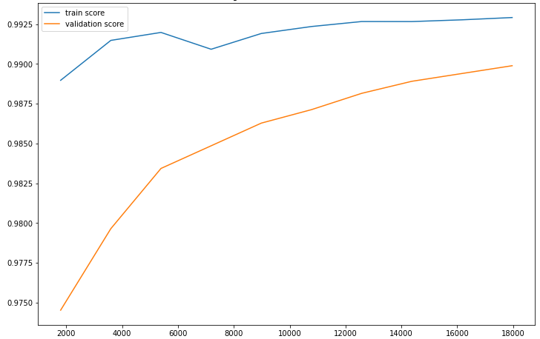 | - Confusion matrix  - performance score  - Feature space: Space [F7] of the selected variables according to a variance threshold from [F2].  - Learning curve
   |  | Reality
   |  | Negative | Positive
  Prediction | Negative | 3775 | 6
  Prediction | Positive | 41 | 1793
  Accuracy | Sensitivity | Specificity | Score f1 | AUC
  0.9776 % | 0.9966 % | 0.9892 % | 0.9870 % | 0.9880 %
   |  | Reality
   |  | Negative | Positive
  Prediction | Negative | 3776 | 5
  Prediction | Positive | 40 | 1794
  Accuracy | Sensitivity | Specificity | Score f1 | AUC
  0.9781 % | 0.9972 % | 0.9895 % | 0.9876 % | 0.9884 %
- Confusion matrix  - performance score  - Feature space: Space [F8] of the "K" best variables selected based on the "X2" test from [F2].  - Learning curve  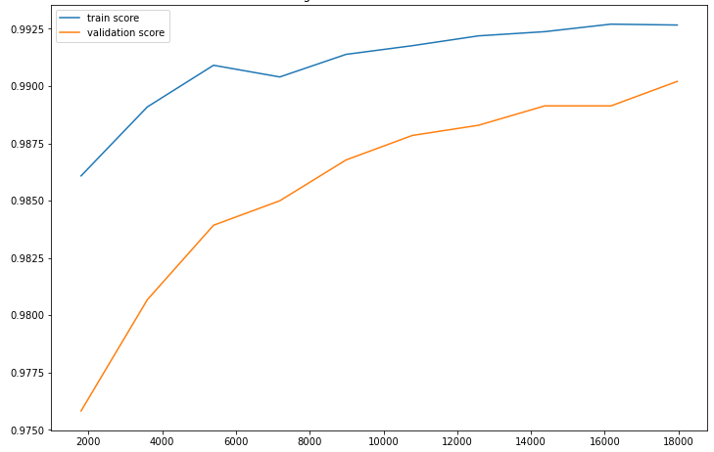 | - Confusion matrix  - performance score  - Feature space: Space [F9] of the variables selected by the "XGBoost" model from [F2].  - Learning curve  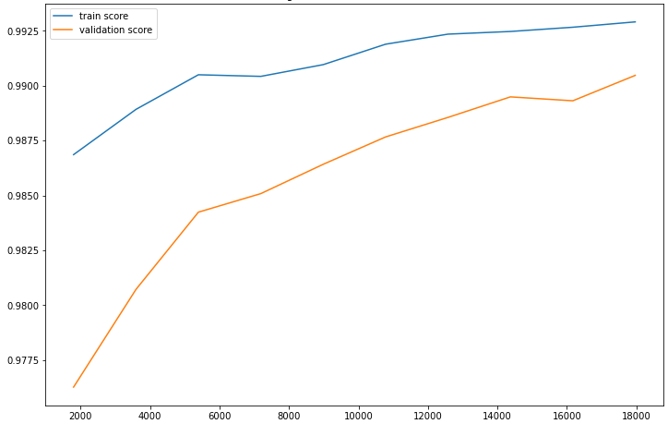
   |  | Reality
   |  | Negative | Positive
  Prediction | Negative | 3777 | 4
  Prediction | Positive | 41 | 1793
  Accuracy | Sensitivity | Specificity | Score f1 | AUC
  0.9776 % | 0.9977 % | 0.9892 % | 0.9876 % | 0.9882 %
   |  | Reality
   |  | Negative | Positive
  Prediction | Negative | 3776 | 5
  Prediction | Positive | 40 | 1794
  Accuracy | Sensitivity | Specificity | Score f1 | AUC
  0.9781 % | 0.9972 % | 0.9895 % | 0.9876 % | 0.9884 %

Table S8. Result of the XGBoost algorithm for the prediction of Isoniazid according to each feature space.

- Confusion matrix  - performance score  - Feature space: Space [F1] of the variables of all mutations.  - Learning curve  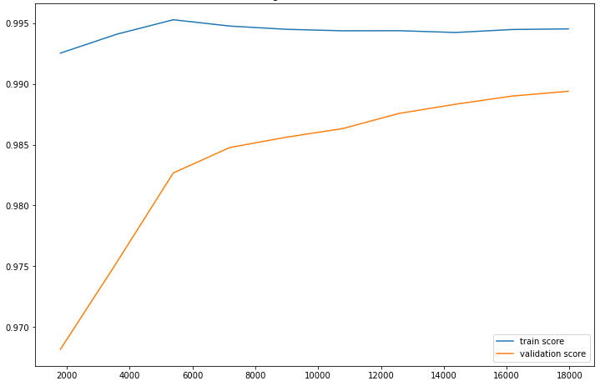 | - Confusion matrix  - performance score  - Feature space: Space [F2] of the variables of the mutations present in the 23 genes most known in antibiotic resistance.  - Learning curve  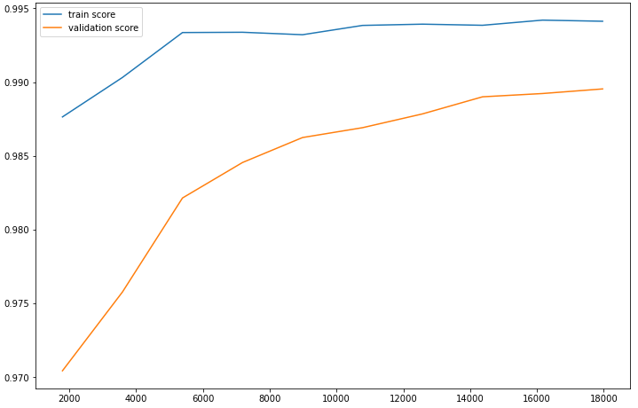
   |  | Reality
   |  | Negative | Positive
  Prediction | Negative | 3774 | 7
  Prediction | Positive | 46 | 1788
  Accuracy | Sensitivity | Specificity | Score f1 | AUC
  0.9749 % | 0.9961 % | 0.9879 % | 0.9853 % | 0.9865 %
   |  | Reality
   |  | Negative | Positive
  Prediction | Negative | 3776 | 5
  Prediction | Positive | 43 | 1791
  Accuracy | Sensitivity | Specificity | Score f1 | AUC
  0.9765 % | 0.9972 % | 0.9887 % | 0.9867 % | 0.9876 %
- Confusion matrix  - performance score  - Feature space: Space [F3] of the variables selected according to a variance threshold from [F1].  - Learning curve | - Confusion matrix  - performance score  - Feature space: Space [F4] of the "K" best variables selected based on the "X2" test from [F1].  - Learning curve  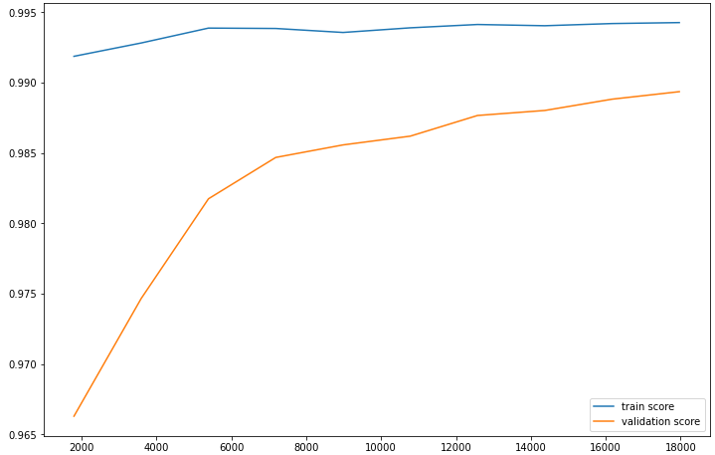
   |  | Reality
   |  | Negative | Positive
  Prediction | Negative | 3774 | 7
  Prediction | Positive | 46 | 1788
  Accuracy | Sensitivity | Specificity | Score f1 | AUC
  0.9749 % | 0.9961 % | 0.9879 % | 0.9853 % | 0.9865 %
   |  | Reality
   |  | Negative | Positive
  Prediction | Negative | 3774 | 7
  Prediction | Positive | 47 | 1787
  Accuracy | Sensitivity | Specificity | Score f1 | AUC
  0.9743 % | 0.9960 % | 0.9876 % | 0.9851 % | 0.9862 %
- Confusion matrix  - performance score  - Feature space: Space [F5] of the variables selected by the "LightGBM" model from [F1].  - Learning curve  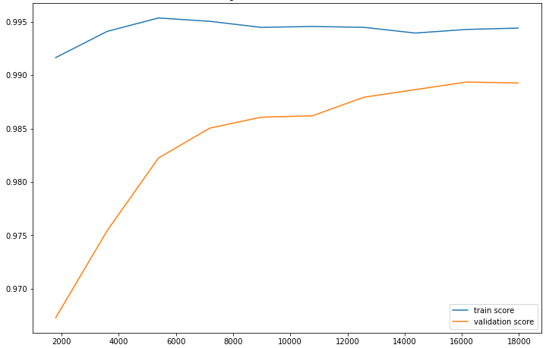 | - Confusion matrix  - performance score  - Feature space: Space [F7] of the selected variables according to a variance threshold from [F2].  - Learning curve
   |  | Reality
   |  | Negative | Positive
  Prediction | Negative | 3774 | 7
  Prediction | Positive | 46 | 1788
  Accuracy | Sensitivity | Specificity | Score f1 | AUC
  0.9749 % | 0.9961 % | 0.9879 % | 0.9853 % | 0.9865 %
   |  | Reality
   |  | Negative | Positive
  Prediction | Negative | 3776 | 5
  Prediction | Positive | 43 | 1791
  Accuracy | Sensitivity | Specificity | Score f1 | AUC
  0.9765 % | 0.9972 % | 0.9887 % | 0.9867 % | 0.9876 %
- Confusion matrix  - performance score  - Feature space: Space [F8] of the "K" best variables selected based on the "X2" test from [F2].  - Learning curve  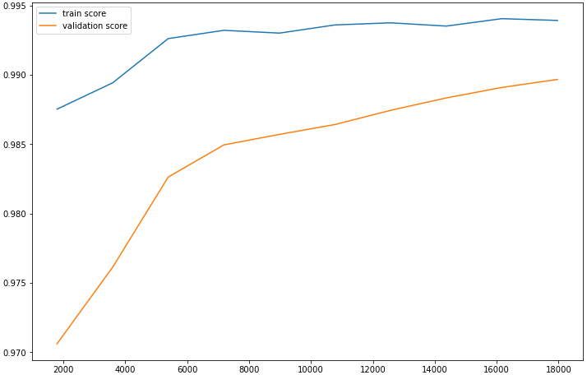 | - Confusion matrix  - performance score  - Feature space: Space [F9] of the variables selected by the " LightGBM " model from [F2].  - Learning curve  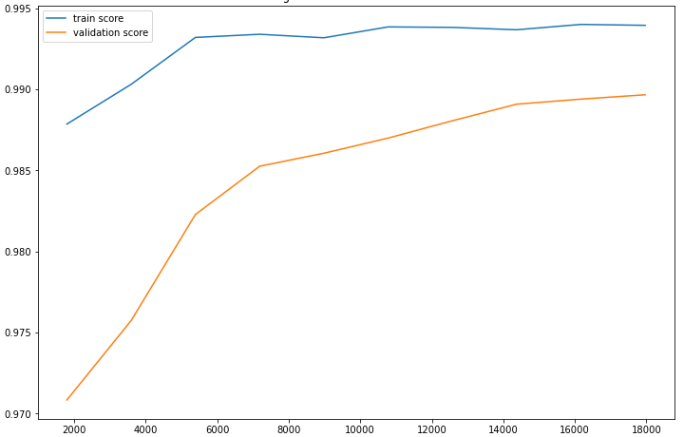
   |  | Reality
   |  | Negative | Positive
  Prediction | Negative | 3775 | 6
  Prediction | Positive | 43 | 1791
  Accuracy | Sensitivity | Specificity | Score f1 | AUC
  0.9765 % | 0.9966 % | 0.9887 % | 0.9865 % | 0.9874 %
   |  | Reality
   |  | Negative | Positive
  Prediction | Negative | 3775 | 6
  Prediction | Positive | 43 | 1791
  Accuracy | Sensitivity | Specificity | Score f1 | AUC
  0.9765 % | 0.9966 % | 0.9887 % | 0.9865 % | 0.9874 %

Table S9. Result of the LightGBM algorithm for the prediction of Isoniazid according to each feature space.

- Confusion matrix  - performance score  - Feature space: Space [F1] of the variables of all mutations.  - Learning curve  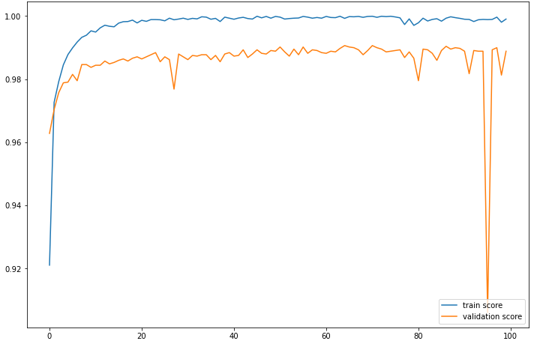 | - Confusion matrix  - performance score  - Feature space: Space [F2] of the variables of the mutations present in the 23 genes most known in antibiotic resistance.  - Learning curve  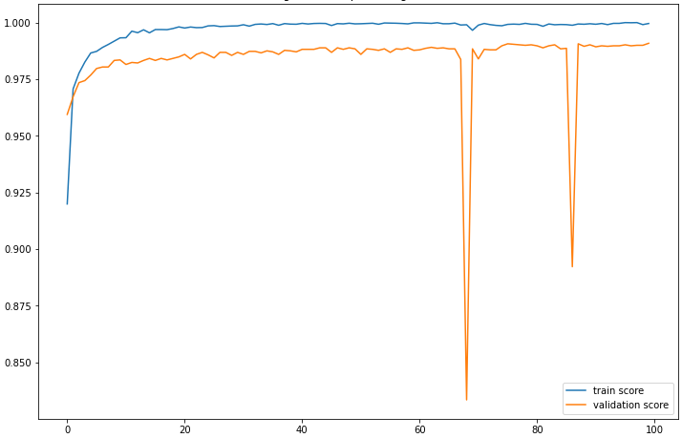
   |  | Reality
   |  | Negative | Positive
  Prediction | Negative | 3775 | 6
  Prediction | Positive | 46 | 1788
  Accuracy | Sensitivity | Specificity | Score f1 | AUC
  0.9749 % | 0.9966 % | 0.9879 % | 0.9856 % | 0.9975 %
   |  | Reality
   |  | Negative | Positive
  Prediction | Negative | 3774 | 7
  Prediction | Positive | 37 | 1797
  Accuracy | Sensitivity | Specificity | Score f1 | AUC
  0.9798 % | 0.9961 % | 0.9902 % | 0.9879 % | 0.9975 %
- Confusion matrix  - performance score  - Feature space: Space [F3] of the variables selected according to a variance threshold from [F1].  - Learning curve  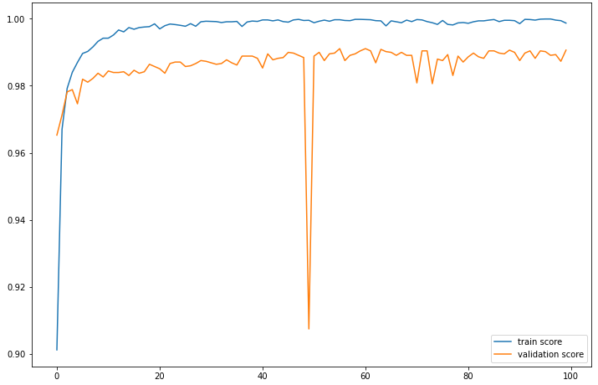 | - Confusion matrix  - performance score  - Feature space: Space [F4] of the "K" best variables selected based on the "X2" test from [F1].  - Learning curve  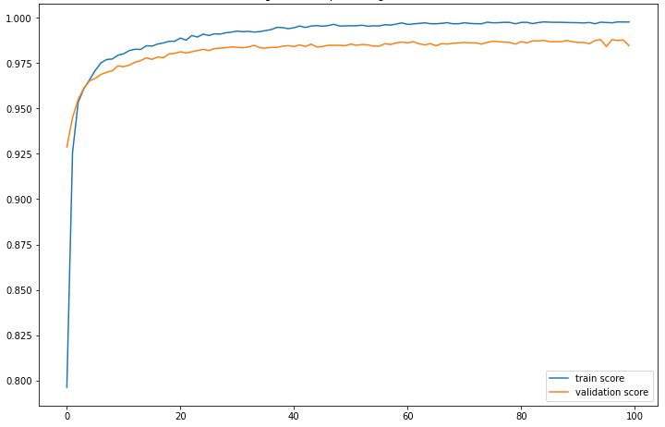
   |  | Reality
   |  | Negative | Positive
  Prediction | Negative | 3772 | 9
  Prediction | Positive | 33 | 1801
  Accuracy | Sensitivity | Specificity | Score f1 | AUC
  0.9820 % | 0.9950 % | 0.9913 % | 0.9884 % | 0.9971 %
   |  | Reality
   |  | Negative | Positive
  Prediction | Negative | 3765 | 16
  Prediction | Positive | 34 | 1800
  Accuracy | Sensitivity | Specificity | Score f1 | AUC
  0.9814 % | 0.9911 % | 0.9910 % | 0.9863 % | 0.9962 %
- Confusion matrix  - performance score  - Feature space: Space [F8] of the "K" best variables selected based on the "X2" test from [F2].  - Learning curve  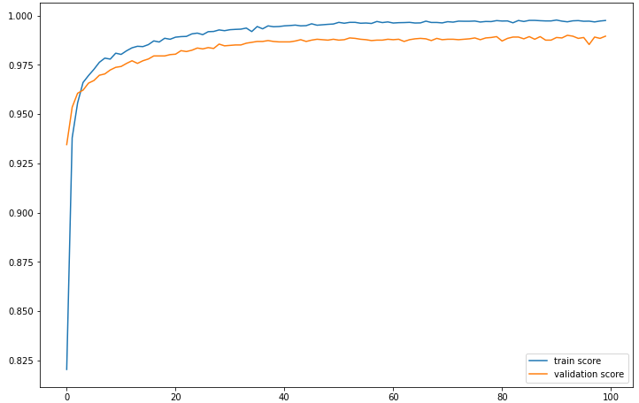 | - Confusion matrix  - performance score  - Feature space: Space [F7] of the selected variables according to a variance threshold from [F2].  - Learning curve  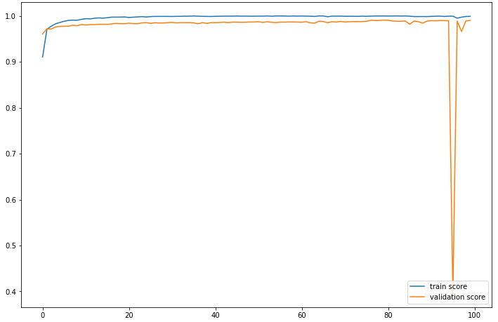
   |  | Reality
   |  | Negative | Positive
  Prediction | Negative | 3773 | 8
  Prediction | Positive | 38 | 1796
  Accuracy | Sensitivity | Specificity | Score f1 | AUC
  0.9792 % | 0.9955 % | 0.9900 % | 0.9873 % | 0.9959 %
   |  | Reality
   |  | Negative | Positive
  Prediction | Negative | 3775 | 6
  Prediction | Positive | 31 | 1803
  Accuracy | Sensitivity | Specificity | Score f1 | AUC
  0.9830 % | 0.9966 % | 0.9918 % | 0.9898 % | 0.9982 %

Table S10. Result of the DeepLearning algorithm for the prediction of Isoniazid according to each feature space.

- Confusion matrix  - performance score  - Feature space: Space [F1] of the variables of all mutations.  - Learning curve  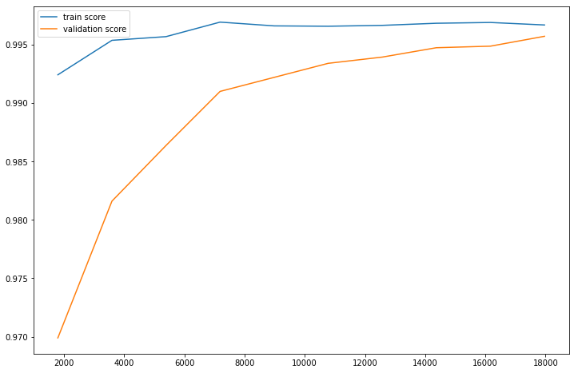 | - Confusion matrix  - performance score  - Feature space: Space [F2] of the variables of the mutations present in the 23 genes most known in antibiotic resistance.  - Learning curve  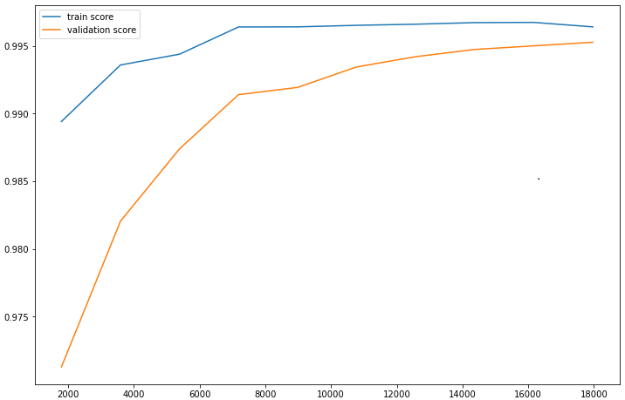
   |  | Reality
   |  | Negative | Positive
  Prediction | Negative | 4108 | 2
  Prediction | Positive | 25 | 1480
  Accuracy | Sensitivity | Specificity | Score f1 | AUC
  0.9833 % | 0.9986 % | 0.9939 % | 0.9909 % | 0.9914 %
   |  | Reality
   |  | Negative | Positive
  Prediction | Negative | 4108 | 2
  Prediction | Positive | 28 | 1477
  Accuracy | Sensitivity | Specificity | Score f1 | AUC
  0.9813 % | 0.9986 % | 0.9932 % | 0.9899 % | 0.9904 %
- Confusion matrix  - performance score  - Feature space: Space [F3] of the variables selected according to a variance threshold from [F1].  - Learning curve | - Confusion matrix  - performance score  - Feature space: Space [F4] of the "K" best variables selected based on the "X2" test from [F1].  - Learning curve  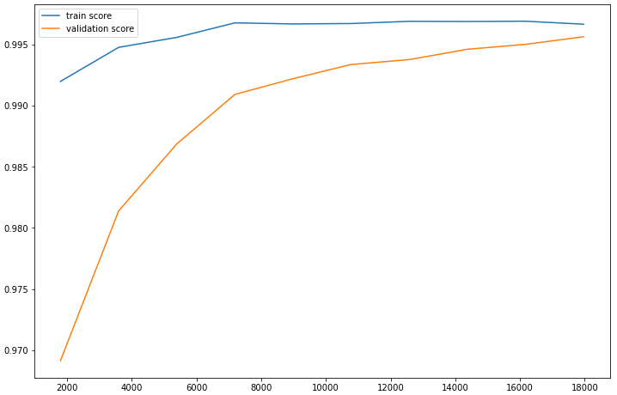
   |  | Reality
   |  | Negative | Positive
  Prediction | Negative | 4108 | 2
  Prediction | Positive | 25 | 1480
  Accuracy | Sensitivity | Specificity | Score f1 | AUC
  0.9833 % | 0.9986 % | 0.9939 % | 0.9909 % | 0.9914 %
   |  | Reality
   |  | Negative | Positive
  Prediction | Negative | 4108 | 2
  Prediction | Positive | 29 | 1476
  Accuracy | Sensitivity | Specificity | Score f1 | AUC
  0.9807 % | 0.9986 % | 0.9929 % | 0.9896 % | 0.9901 %
- Confusion matrix  - performance score  - Feature space: Space [F5] of the variables selected by the "XGBoost" model from [F1].  - Learning curve  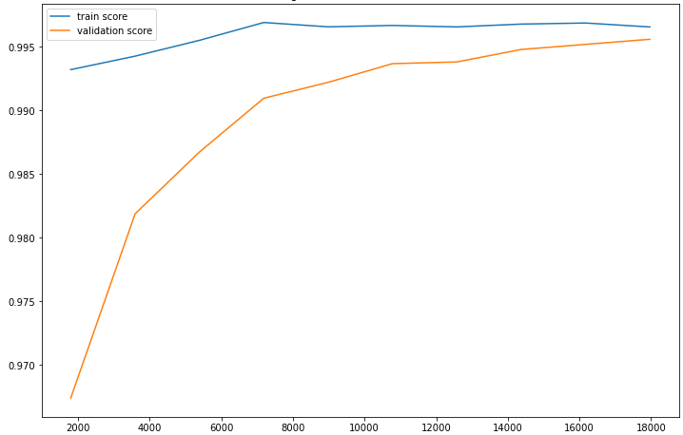 | - Confusion matrix  - performance score  - Feature space: Space [F7] of the selected variables according to a variance threshold from [F2].  - Learning curve
   |  | Reality
   |  | Negative | Positive
  Prediction | Negative | 4108 | 2
  Prediction | Positive | 25 | 1480
  Accuracy | Sensitivity | Specificity | Score f1 | AUC
  0.9833 % | 0.9986 % | 0.9939 % | 0.9909 % | 0.9914 %
   |  | Reality
   |  | Negative | Positive
  Prediction | Negative | 4108 | 2
  Prediction | Positive | 28 | 1477
  Accuracy | Sensitivity | Specificity | Score f1 | AUC
  0.9813 % | 0.9986 % | 0.9932 % | 0.9899 % | 0.9904 %
- Confusion matrix  - performance score  - Feature space: Space [F8] of the "K" best variables selected based on the "X2" test from [F2].  - Learning curve  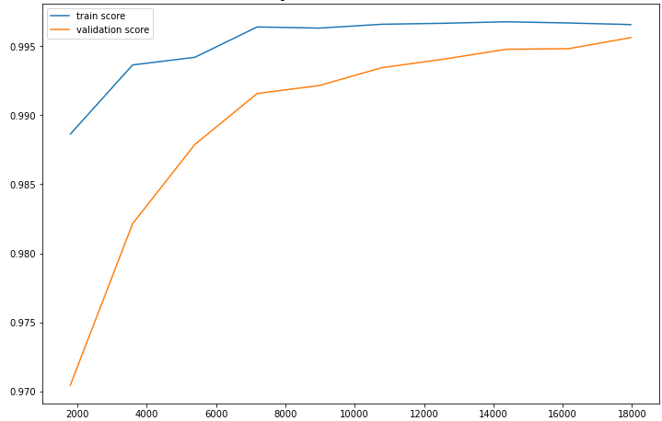 | - Confusion matrix  - performance score  - Feature space: Space [F9] of the variables selected by the "XGBoost" model from [F2].  - Learning curve  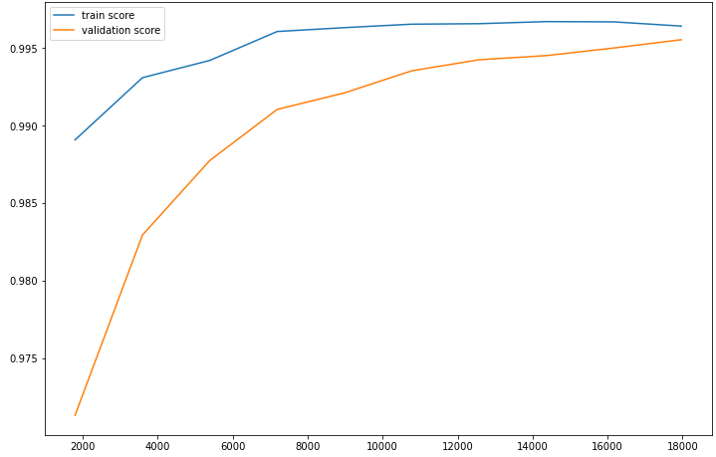
   |  | Reality
   |  | Negative | Positive
  Prediction | Negative | 4108 | 2
  Prediction | Positive | 28 | 1477
  Accuracy | Sensitivity | Specificity | Score f1 | AUC
  0.9813 % | 0.9986 % | 0.9932 % | 0.9899 % | 0.9904 %
   |  | Reality
   |  | Negative | Positive
  Prediction | Negative | 4108 | 2
  Prediction | Positive | 28 | 1477
  Accuracy | Sensitivity | Specificity | Score f1 | AUC
  0.9813 % | 0.9986 % | 0.9932 % | 0.9899 % | 0.9904 %

Table S11. Result of the XGBoost algorithm for the prediction of Rifampicin according to each feature space.

- Confusion matrix  - performance score  - Feature space: Space [F1] of the variables of all mutations.  - Learning curve  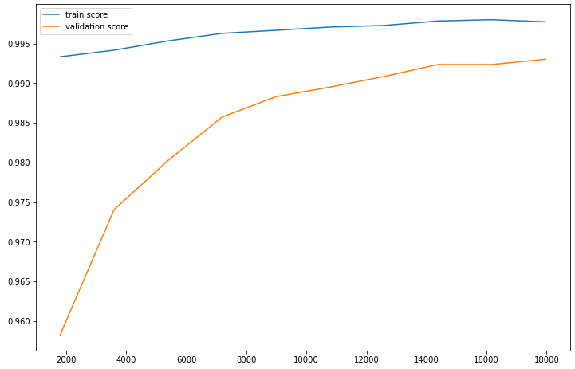 | - Confusion matrix  - performance score  - Feature space: Space [F2] of the variables of the mutations present in the 23 genes most known in antibiotic resistance.  - Learning curve  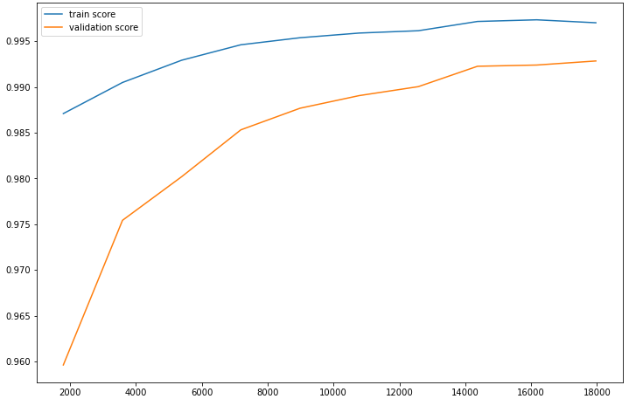
   |  | Reality
   |  | Negative | Positive
  Prediction | Negative | 4104 | 6
  Prediction | Positive | 33 | 1472
  Accuracy | Sensitivity | Specificity | Score f1 | AUC
  0.9780 % | 0.9959 % | 0.9920 % | 0.9869 % | 0.9883 %
   |  | Reality
   |  | Negative | Positive
  Prediction | Negative | 4107 | 3
  Prediction | Positive | 32 | 1473
  Accuracy | Sensitivity | Specificity | Score f1 | AUC
  0.9787 % | 0.9979 % | 0.9922 % | 0.9882 % | 0.9890 %
- Confusion matrix  - performance score  - Feature space: Space [F3] of the variables selected according to a variance threshold from [F1].  - Learning curve | - Confusion matrix  - performance score  - Feature space: Space [F4] of the "K" best variables selected based on the "X2" test from [F1].  - Learning curve  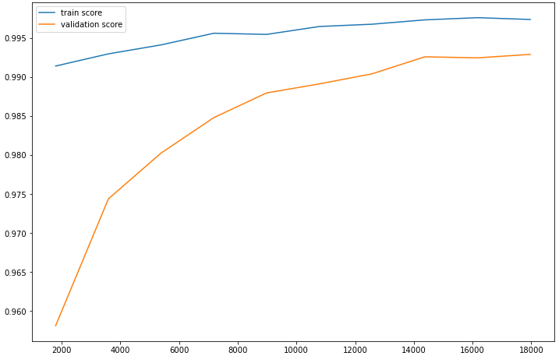
   |  | Reality
   |  | Negative | Positive
  Prediction | Negative | 4104 | 6
  Prediction | Positive | 33 | 1472
  Accuracy | Sensitivity | Specificity | Score f1 | AUC
  0.9780 % | 0.9959 % | 0.9920 % | 0.9869 % | 0.9883 %
   |  | Reality
   |  | Negative | Positive
  Prediction | Negative | 4107 | 3
  Prediction | Positive | 33 | 1472
  Accuracy | Sensitivity | Specificity | Score f1 | AUC
  0.9780 % | 0.9979 % | 0.9876 % | 0.9920 % | 0.9886 %
- Confusion matrix  - performance score  - Feature space: Space [F5] of the variables selected by the "LightGBM" model from [F1].  - Learning curve  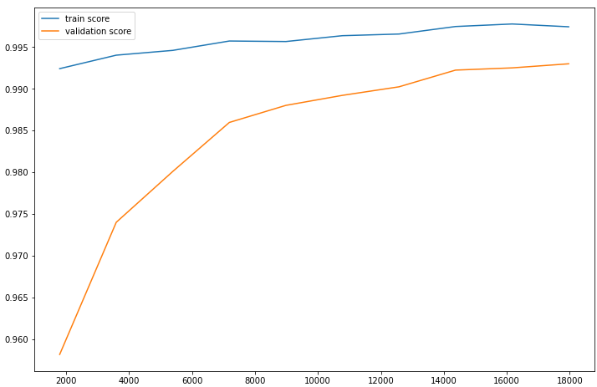 | - Confusion matrix  - performance score  - Feature space: Space [F7] of the selected variables according to a variance threshold from [F2].  - Learning curve
   |  | Reality
   |  | Negative | Positive
  Prediction | Negative | 4103 | 7
  Prediction | Positive | 31 | 1474
  Accuracy | Sensitivity | Specificity | Score f1 | AUC
  0.9794 % | 0.9952 % | 0.9925 % | 0.9872 % | 0.9888 %
   |  | Reality
   |  | Negative | Positive
  Prediction | Negative | 4107 | 3
  Prediction | Positive | 32 | 1473
  Accuracy | Sensitivity | Specificity | Score f1 | AUC
  0.9787 % | 0.9979 % | 0.9922 % | 0.9882 % | 0.9890 %
- Confusion matrix  - performance score  - Feature space: Space [F8] of the "K" best variables selected based on the "X2" test from [F2].  - Learning curve  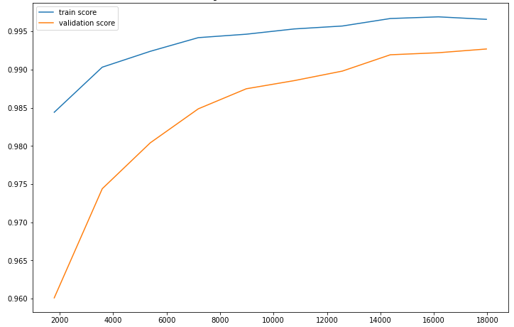 | - Confusion matrix  - performance score  - Feature space: Space [F9] of the variables selected by the " LightGBM " model from [F2].  - Learning curve  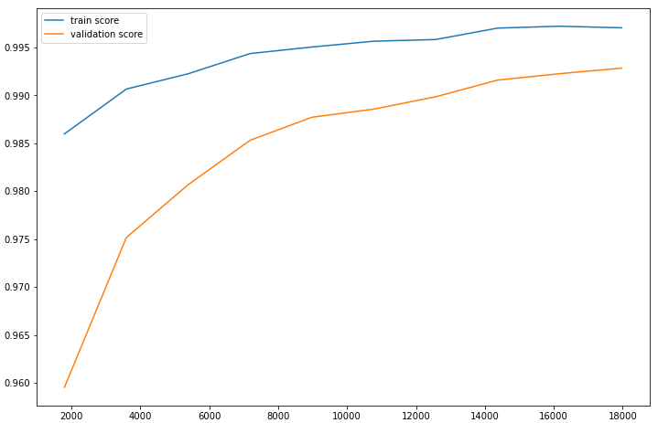
   |  | Reality
   |  | Negative | Positive
  Prediction | Negative | 4106 | 4
  Prediction | Positive | 35 | 1470
  Accuracy | Sensitivity | Specificity | Score f1 | AUC
  0.9767 % | 0.9972 % | 0.9915 % | 0.9865 % | 0.9878 %
   |  | Reality
   |  | Negative | Positive
  Prediction | Negative | 4104 | 6
  Prediction | Positive | 32 | 1473
  Accuracy | Sensitivity | Specificity | Score f1 | AUC
  0.9787 % | 0.9959 % | 0.9922 % | 0.9872 % | 0.9886 %

Table S12. Result of the LightGBM algorithm for the prediction of Rifampicin according to each feature space.

- Confusion matrix  - performance score  - Feature space: Space [F1] of the variables of all mutations.  - Learning curve  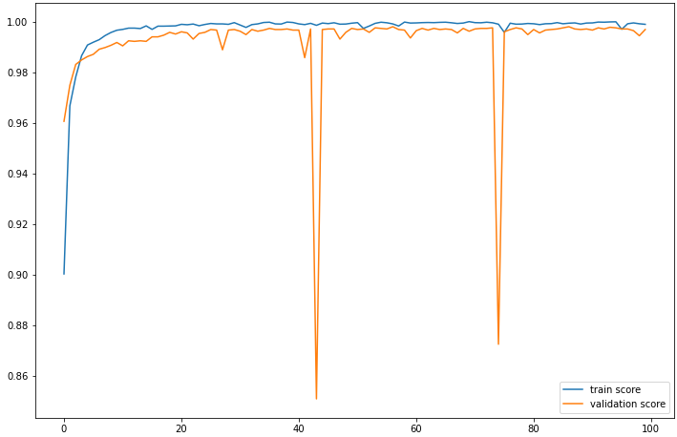 | - Confusion matrix  - performance score  - Feature space: Space [F2] of the variables of the mutations present in the 23 genes most known in antibiotic resistance.  - Learning curve  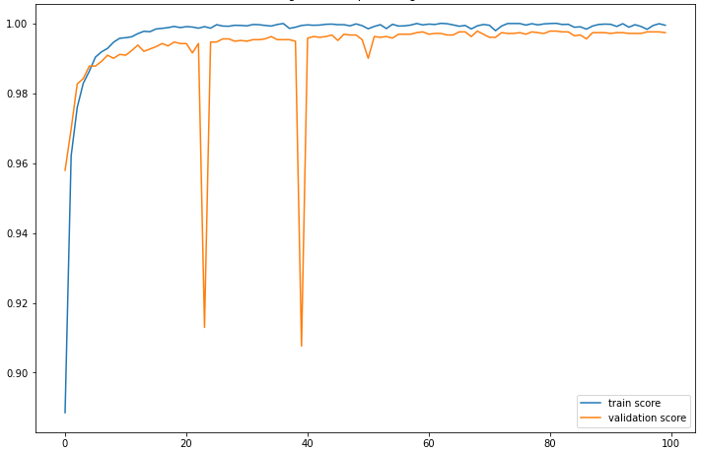
   |  | Reality
   |  | Negative | Positive
  Prediction | Negative | 4109 | 1
  Prediction | Positive | 17 | 1488
  Accuracy | Sensitivity | Specificity | Score f1 | AUC
  0.9887 % | 0.9993 % | 0.9958 % | 0.9939 % | 0.9981 %
   |  | Reality
   |  | Negative | Positive
  Prediction | Negative | 4110 | 0
  Prediction | Positive | 14 | 1491
  Accuracy | Sensitivity | Specificity | Score f1 | AUC
  0.9906 % | 1 % | 0.9966 % | 0.9953 % | 0.9989 %
- Confusion matrix  - performance score  - Feature space: Space [F3] of the variables selected according to a variance threshold from [F1].  - Learning curve  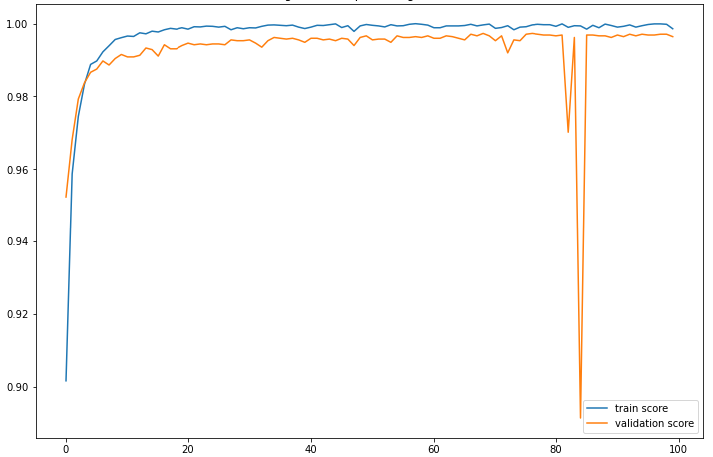 | - Confusion matrix  - performance score  - Feature space: Space [F4] of the "K" best variables selected based on the "X2" test from [F1].  - Learning curve  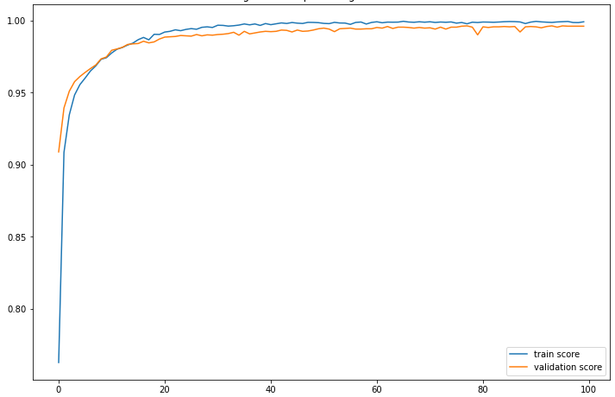
   |  | Reality
   |  | Negative | Positive
  Prediction | Negative | 4101 | 9
  Prediction | Positive | 9 | 1496
  Accuracy | Sensitivity | Specificity | Score f1 | AUC
  0.9940 % | 0.9940 % | 0.9978 % | 0.9940 % | 0.9988 %
   |  | Reality
   |  | Negative | Positive
  Prediction | Negative | 4104 | 6
  Prediction | Positive | 22 | 1483
  Accuracy | Sensitivity | Specificity | Score f1 | AUC
  0.9853 % | 0.9959 % | 0.9946 % | 0.9906 % | 0.9979 %
- Confusion matrix  - performance score  - Feature space: Space [F8] of the "K" best variables selected based on the "X2" test from [F2].  - Learning curve  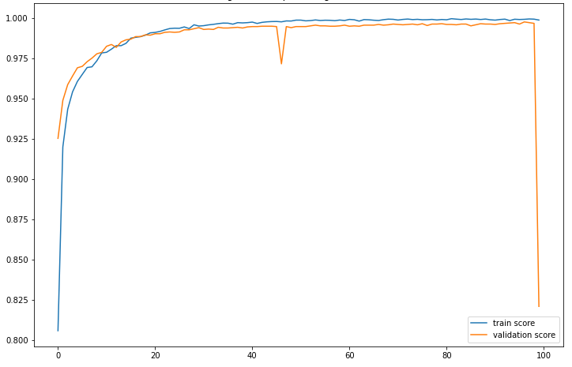 | - Confusion matrix  - performance score  - Feature space: Space [F7] of the selected variables according to a variance threshold from [F2].  - Learning curve  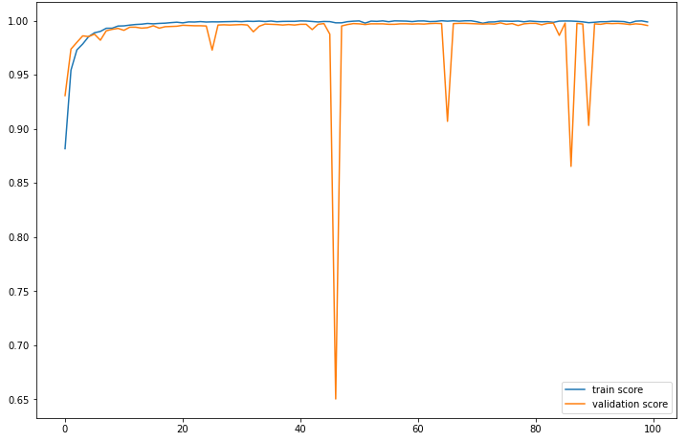
   |  | Reality
   |  | Negative | Positive
  Prediction | Negative | 3113 | 997
  Prediction | Positive | 12 | 1493
  Accuracy | Sensitivity | Specificity | Score f1 | AUC
  0.9920 % | 0.5995 % | 0.9961 % | 0.7474 % | 0.9950 %
   |  | Reality
   |  | Negative | Positive
  Prediction | Negative | 4102 | 8
  Prediction | Positive | 21 | 1484
  Accuracy | Sensitivity | Specificity | Score f1 | AUC
  0.9860 % | 0.9946 % | 0.9949 % | 0.9903 % | 0.9978 %

Table S13. Result of the DeepLearning algorithm for the prediction of Rifampicin according to each feature space.

- Confusion matrix  - performance score  - Feature space: Space [F1] of the variables of all mutations.  - Learning curve  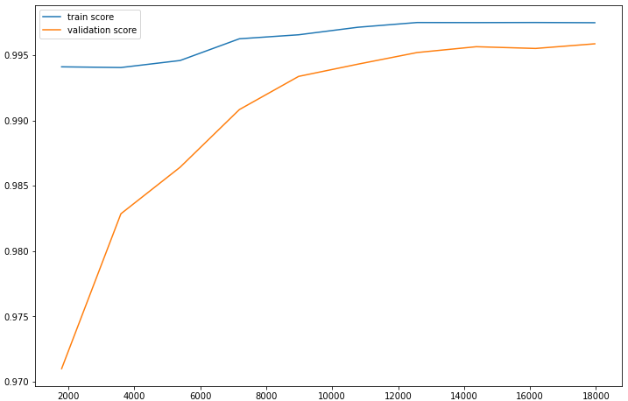 | - Confusion matrix  - performance score  - Feature space: Space [F2] of the variables of the mutations present in the 23 genes most known in antibiotic resistance.  - Learning curve  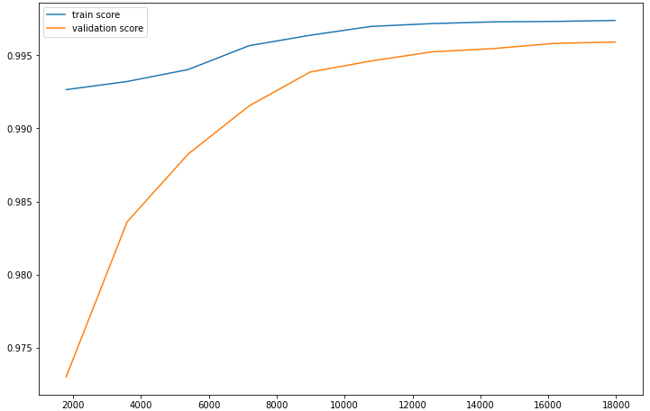
   |  | Reality
   |  | Negative | Positive
  Prediction | Negative | 4418 | 1
  Prediction | Positive | 25 | 1171
  Accuracy | Sensitivity | Specificity | Score f1 | AUC
  0.9790 % | 0.9991 % | 0.9943 % | 0.9890 % | 0.9894 %
   |  | Reality
   |  | Negative | Positive
  Prediction | Negative | 4416 | 3
  Prediction | Positive | 26 | 1170
  Accuracy | Sensitivity | Specificity | Score f1 | AUC
  0.9782 % | 0.9974 % | 0.9941 % | 0.9877 % | 0.9887 %
- Confusion matrix  - performance score  - Feature space: Space [F3] of the variables selected according to a variance threshold from [F1].  - Learning curve | - Confusion matrix  - performance score  - Feature space: Space [F4] of the "K" best variables selected based on the "X2" test from [F1].  - Learning curve  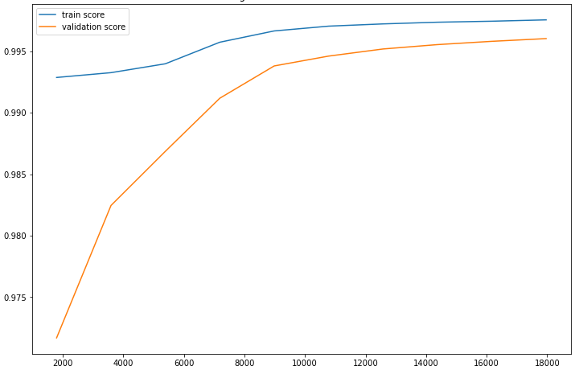
   |  | Reality
   |  | Negative | Positive
  Prediction | Negative | 4418 | 1
  Prediction | Positive | 25 | 1171
  Accuracy | Sensitivity | Specificity | Score f1 | AUC
  0.9790 % | 0.9991 % | 0.9943 % | 0.9890 % | 0.9894 %
   |  | Reality
   |  | Negative | Positive
  Prediction | Negative | 4417 | 2
  Prediction | Positive | 26 | 1170
  Accuracy | Sensitivity | Specificity | Score f1 | AUC
  0.9782 % | 0.9982 % | 0.9941 % | 0.9881 % | 0.9889 %
- Confusion matrix  - performance score  - Feature space: Space [F5] of the variables selected by the "XGBoost" model from [F1].  - Learning curve  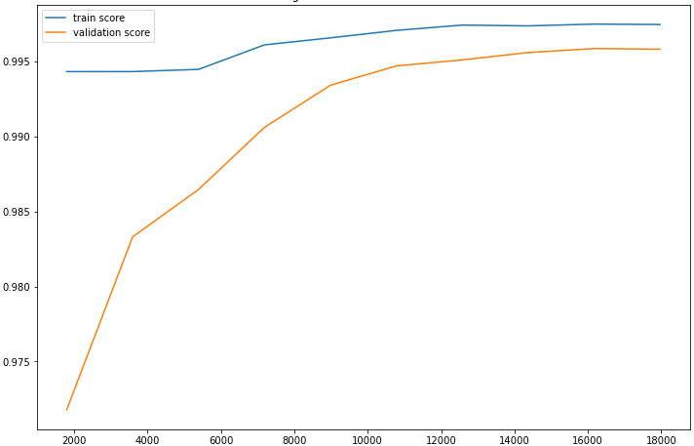 | - Confusion matrix  - performance score  - Feature space: Space [F7] of the selected variables according to a variance threshold from [F2].  - Learning curve
   |  | Reality
   |  | Negative | Positive
  Prediction | Negative | 4418 | 1
  Prediction | Positive | 25 | 1171
  Accuracy | Sensitivity | Specificity | Score f1 | AUC
  0.9790 % | 0.9991 % | 0.9943 % | 0.9890 % | 0.9894 %
   |  | Reality
   |  | Negative | Positive
  Prediction | Negative | 4416 | 3
  Prediction | Positive | 26 | 1170
  Accuracy | Sensitivity | Specificity | Score f1 | AUC
  0.9782 % | 0.9974 % | 0.9941 % | 0.9877 % | 0.9887 %
- Confusion matrix  - performance score  - Feature space: Space [F8] of the "K" best variables selected based on the "X2" test from [F2].  - Learning curve  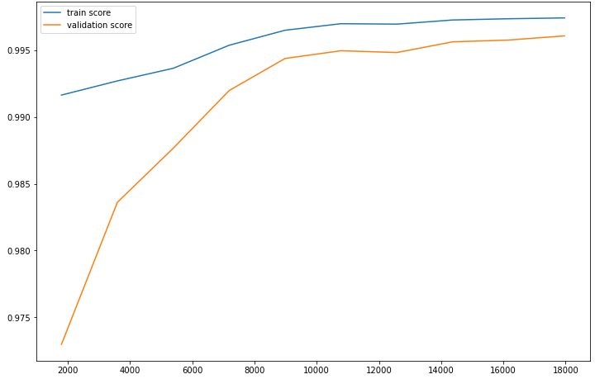 | - Confusion matrix  - performance score  - Feature space: Space [F9] of the variables selected by the "XGBoost" model from [F2].  - Learning curve  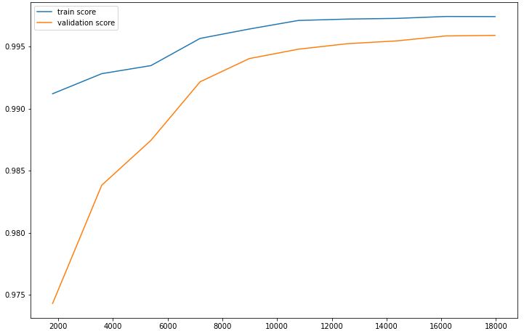
   |  | Reality
   |  | Negative | Positive
  Prediction | Negative | 4416 | 3
  Prediction | Positive | 26 | 1170
  Accuracy | Sensitivity | Specificity | Score f1 | AUC
  0.9782 % | 0.9974 % | 0.9941 % | 0.9877 % | 0.9887 %
   |  | Reality
   |  | Negative | Positive
  Prediction | Negative | 4415 | 4
  Prediction | Positive | 26 | 1170
  Accuracy | Sensitivity | Specificity | Score f1 | AUC
  0.9782 % | 0.9965 % | 0.9941 % | 0.9873 % | 0.9886 %

Table S14. Result of the XGBoost algorithm for the prediction of Ethambutol according to each feature space.

- Confusion matrix  - performance score  - Feature space: Space [F1] of the variables of all mutations.  - Learning curve  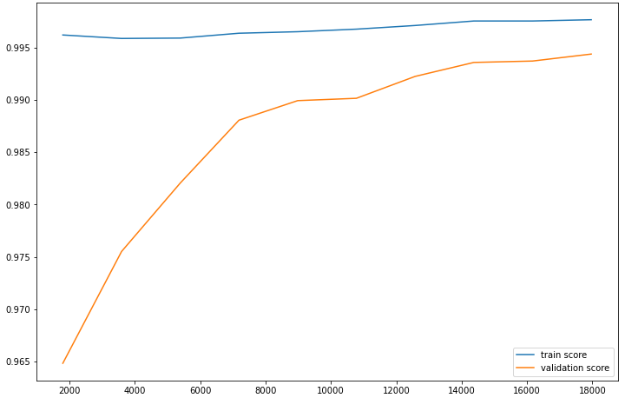 | - Confusion matrix  - performance score  - Feature space: Space [F2] of the variables of the mutations present in the 23 genes most known in antibiotic resistance.  - Learning curve  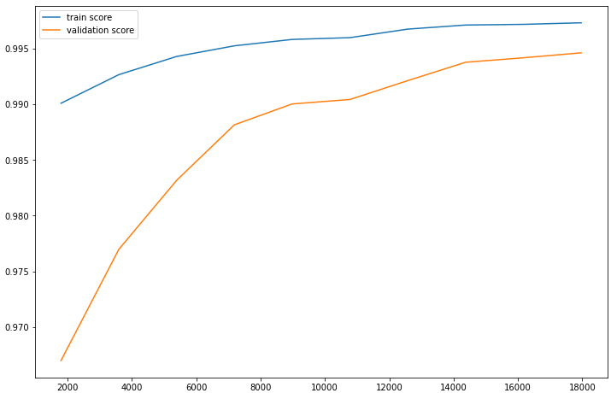
   |  | Reality
   |  | Negative | Positive
  Prediction | Negative | 4417 | 2
  Prediction | Positive | 31 | 1165
  Accuracy | Sensitivity | Specificity | Score f1 | AUC
  0.9740 % | 0.9982 % | 0.9930 % | 0.9860 % | 0.9868 %
   |  | Reality
   |  | Negative | Positive
  Prediction | Negative | 4418 | 1
  Prediction | Positive | 32 | 1164
  Accuracy | Sensitivity | Specificity | Score f1 | AUC
  0.9732 % | 0.9991 % | 0.9928 % | 0.9860 % | 0.9865 %
- Confusion matrix  - performance score  - Feature space: Space [F3] of the variables selected according to a variance threshold from [F1].  - Learning curve | - Confusion matrix  - performance score  - Feature space: Space [F4] of the "K" best variables selected based on the "X2" test from [F1].  - Learning curve  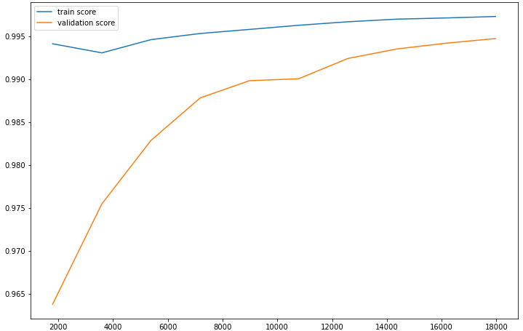
   |  | Reality
   |  | Negative | Positive
  Prediction | Negative | 4417 | 2
  Prediction | Positive | 31 | 1165
  Accuracy | Sensitivity | Specificity | Score f1 | AUC
  0.9740 % | 0.9982 % | 0.9930 % | 0.9860 % | 0.9868 %
   |  | Reality
   |  | Negative | Positive
  Prediction | Negative | 4418 | 1
  Prediction | Positive | 33 | 1163
  Accuracy | Sensitivity | Specificity | Score f1 | AUC
  0.9724 % | 0.9991 % | 0.9925 % | 0.9855 % | 0.9860 %
- Confusion matrix  - performance score  - Feature space: Space [F5] of the variables selected by the "LightGBM" model from [F1].  - Learning curve  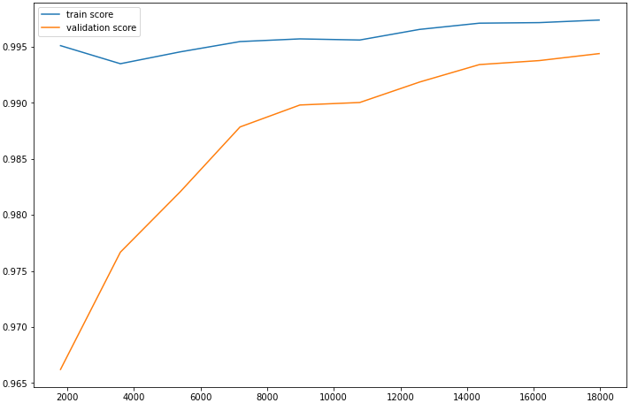 | - Confusion matrix  - performance score  - Feature space: Space [F7] of the selected variables according to a variance threshold from [F2].  - Learning curve
   |  | Reality
   |  | Negative | Positive
  Prediction | Negative | 4417 | 2
  Prediction | Positive | 32 | 1164
  Accuracy | Sensitivity | Specificity | Score f1 | AUC
  0.9732 % | 0.9982 % | 0.9928 % | 0.9865 % | 0.9863 %
   |  | Reality
   |  | Negative | Positive
  Prediction | Negative | 4418 | 1
  Prediction | Positive | 32 | 1164
  Accuracy | Sensitivity | Specificity | Score f1 | AUC
  0.9732 % | 0.9991 % | 0.9928 % | 0.9860 % | 0.9865 %
- Confusion matrix  - performance score  - Feature space: Space [F8] of the "K" best variables selected based on the "X2" test from [F2].  - Learning curve  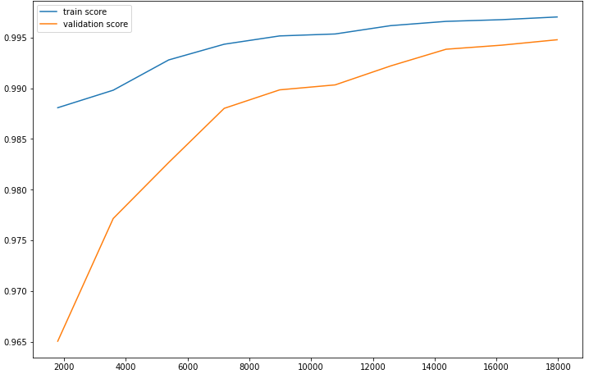 | - Confusion matrix  - performance score  - Feature space: Space [F9] of the variables selected by the " LightGBM " model from [F2].  - Learning curve
   |  | Reality
   |  | Negative | Positive
  Prediction | Negative | 4419 | 0
  Prediction | Positive | 33 | 1163
  Accuracy | Sensitivity | Specificity | Score f1 | AUC
  0.9724 % | 1 % | 0.9925 % | 0.9860 % | 0.9862 %
   |  | Reality
   |  | Negative | Positive
  Prediction | Negative | 4418 | 1
  Prediction | Positive | 33 | 1163
  Accuracy | Sensitivity | Specificity | Score f1 | AUC
  0.9724 % | 0.9991 % | 0.9925 % | 0.9855 % | 0.9860 %

Table S15. Result of the LightGBM algorithm for the prediction of Ethambutol according to each feature space.

- Confusion matrix  - performance score  - Feature space: Space [F1] of the variables of all mutations.  - Learning curve  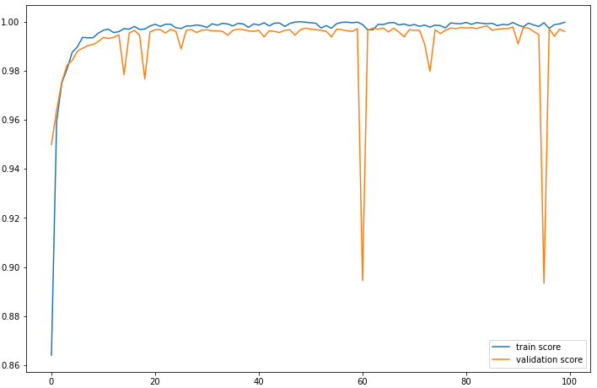 | - Confusion matrix  - performance score  - Feature space: Space [F2] of the variables of the mutations present in the 23 genes most known in antibiotic resistance.  - Learning curve  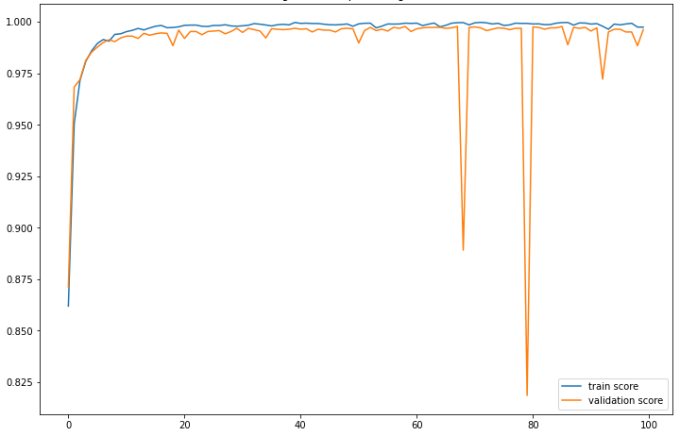
   |  | Reality
   |  | Negative | Positive
  Prediction | Negative | 4418 | 1
  Prediction | Positive | 26 | 1170
  Accuracy | Sensitivity | Specificity | Score f1 | AUC
  0.9782 % | 0.9991 % | 0.9941 % | 0.9885 % | 0.9966 %
   |  | Reality
   |  | Negative | Positive
  Prediction | Negative | 4117 | 2
  Prediction | Positive | 26 | 1170
  Accuracy | Sensitivity | Specificity | Score f1 | AUC
  0.9782 % | 0.9982 % | 0.9966 % | 0.9881 % | 0.9946 %
- Confusion matrix  - performance score  - Feature space: Space [F3] of the variables selected according to a variance threshold from [F1].  - Learning curve  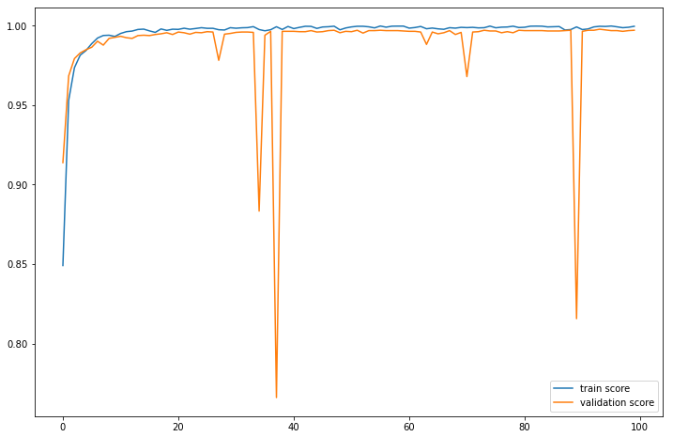 | - Confusion matrix  - performance score  - Feature space: Space [F4] of the "K" best variables selected based on the "X2" test from [F1].  - Learning curve  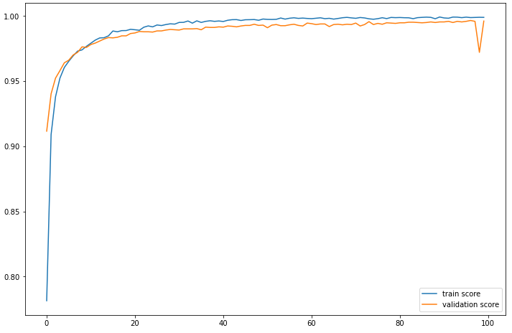
   |  | Reality
   |  | Negative | Positive
  Prediction | Negative | 4414 | 5
  Prediction | Positive | 21 | 1175
  Accuracy | Sensitivity | Specificity | Score f1 | AUC
  0.9824 % | 0.9957 % | 0.9952 % | 0.9890 % | 0.9966 %
   |  | Reality
   |  | Negative | Positive
  Prediction | Negative | 4413 | 6
  Prediction | Positive | 29 | 1167
  Accuracy | Sensitivity | Specificity | Score f1 | AUC
  0.9757 % | 0.9948 % | 0.9934 % | 0.9852 % | 0.9971 %
- Confusion matrix  - performance score  - Feature space: Space [F8] of the "K" best variables selected based on the "X2" test from [F2].  - Learning curve  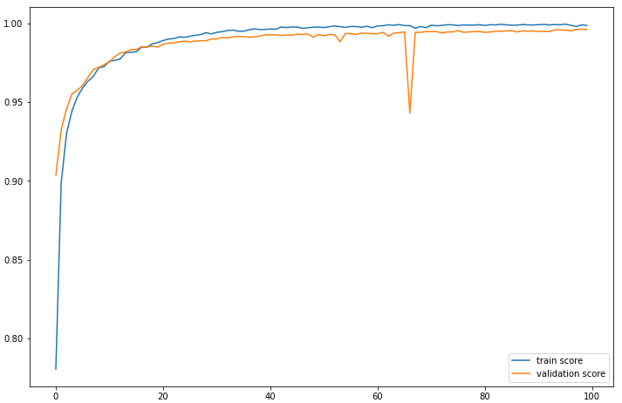 | - Confusion matrix  - performance score  - Feature space: Space [F7] of the selected variables according to a variance threshold from [F2].  - Learning curve  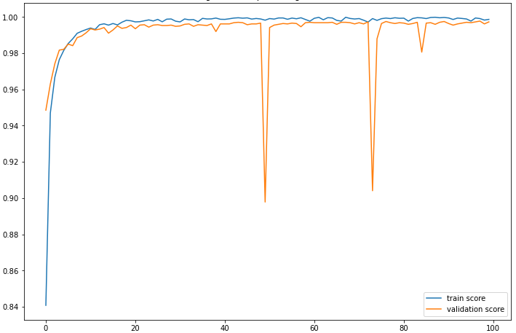
   |  | Reality
   |  | Negative | Positive
  Prediction | Negative | 4410 | 9
  Prediction | Positive | 33 | 1163
  Accuracy | Sensitivity | Specificity | Score f1 | AUC
  0.9724 % | 0.9923 % | 0.9925 % | 0.7474 % | 0.9939 %
   |  | Reality
   |  | Negative | Positive
  Prediction | Negative | 4414 | 5
  Prediction | Positive | 19 | 1177
  Accuracy | Sensitivity | Specificity | Score f1 | AUC
  0.9841 % | 0.9957 % | 0.9957 % | 0.9899 % | 0.9955 %

Table S16. Result of the DeepLearning algorithm for the prediction of Ethambutol according to each feature space.

- Confusion matrix  - performance score  - Feature space: Space [F1] of the variables of all mutations.  - Learning curve  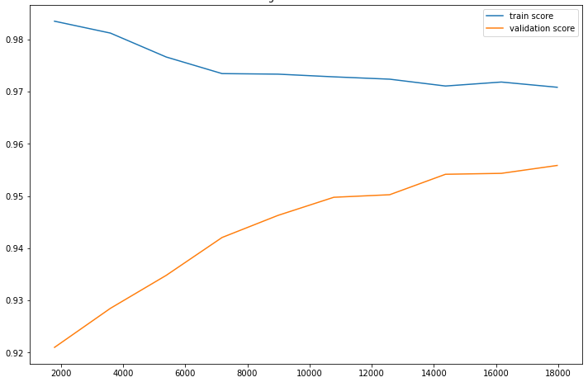 | - Confusion matrix  - performance score  - Feature space: Space [F2] of the variables of the mutations present in the 23 genes most known in antibiotic resistance.  - Learning curve  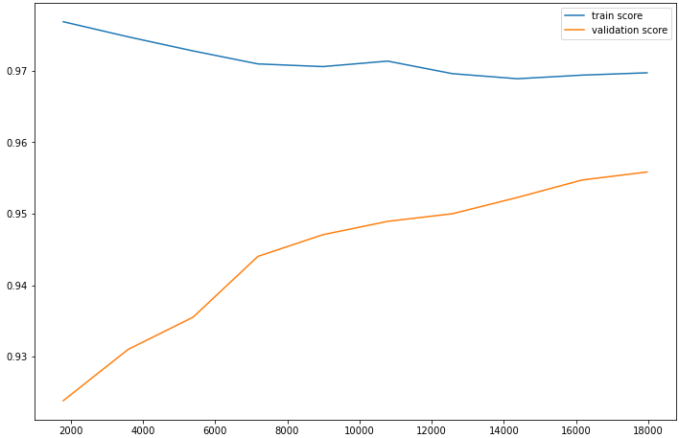
   |  | Reality
   |  | Negative | Positive
  Prediction | Negative | 4651 | 89
  Prediction | Positive | 166 | 709
  Accuracy | Sensitivity | Specificity | Score f1 | AUC
  0.8102 % | 0.8884 % | 0.9655 % | 0.8475 % | 0.8957 %
   |  | Reality
   |  | Negative | Positive
  Prediction | Negative | 4664 | 76
  Prediction | Positive | 168 | 707
  Accuracy | Sensitivity | Specificity | Score f1 | AUC
  0.8080 % | 0.9029 % | 0.9652 % | 0.8528 % | 0.8959 %
- Confusion matrix  - performance score  - Feature space: Space [F3] of the variables selected according to a variance threshold from [F1].  - Learning curve | - Confusion matrix  - performance score  - Feature space: Space [F4] of the "K" best variables selected based on the "X2" test from [F1].  - Learning curve  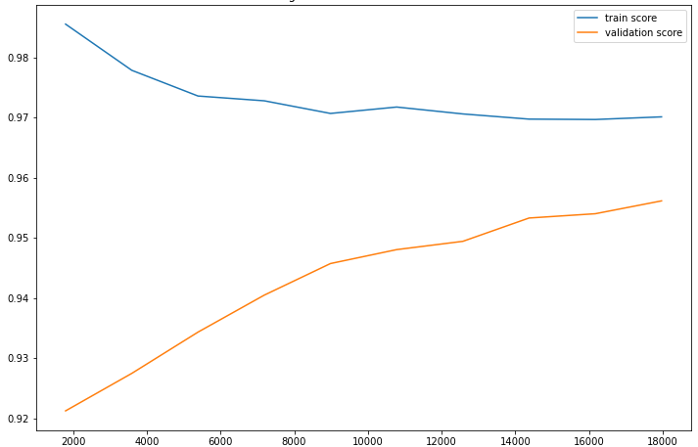
   |  | Reality
   |  | Negative | Positive
  Prediction | Negative | 4651 | 89
  Prediction | Positive | 166 | 709
  Accuracy | Sensitivity | Specificity | Score f1 | AUC
  0.8102 % | 0.8884 % | 0.9655 % | 0.8475 % | 0.8957 %
   |  | Reality
   |  | Negative | Positive
  Prediction | Negative | 4658 | 82
  Prediction | Positive | 173 | 702
  Accuracy | Sensitivity | Specificity | Score f1 | AUC
  0.8022 % | 0.8954 % | 0.9641 % | 0.8462 % | 0.8924 %
- Confusion matrix  - performance score  - Feature space: Space [F5] of the variables selected by the "XGBoost" model from [F1].  - Learning curve  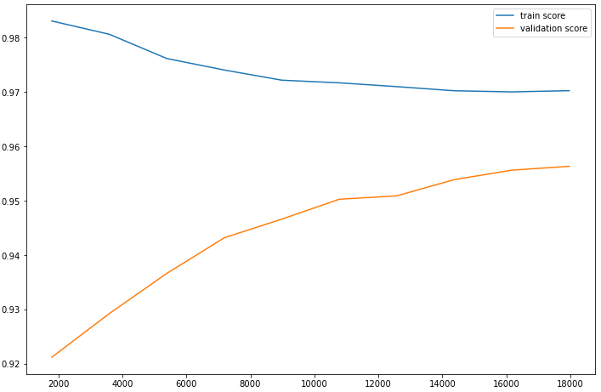 | - Confusion matrix  - performance score  - Feature space: Space [F7] of the selected variables according to a variance threshold from [F2].  - Learning curve
   |  | Reality
   |  | Negative | Positive
  Prediction | Negative | 4651 | 89
  Prediction | Positive | 166 | 709
  Accuracy | Sensitivity | Specificity | Score f1 | AUC
  0.8102 % | 0.8884 % | 0.9655 % | 0.8475 % | 0.8957 %
   |  | Reality
   |  | Negative | Positive
  Prediction | Negative | 4664 | 76
  Prediction | Positive | 168 | 707
  Accuracy | Sensitivity | Specificity | Score f1 | AUC
  0.8080 % | 0.9029 % | 0.9652 % | 0.8528 % | 0.8959 %
- Confusion matrix  - performance score  - Feature space: Space [F8] of the "K" best variables selected based on the "X2" test from [F2].  - Learning curve  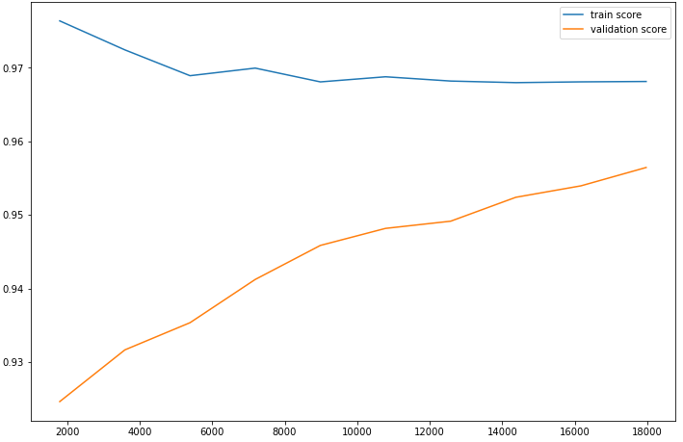 | - Confusion matrix  - performance score  - Feature space: Space [F9] of the variables selected by the "XGBoost" model from [F2].  - Learning curve  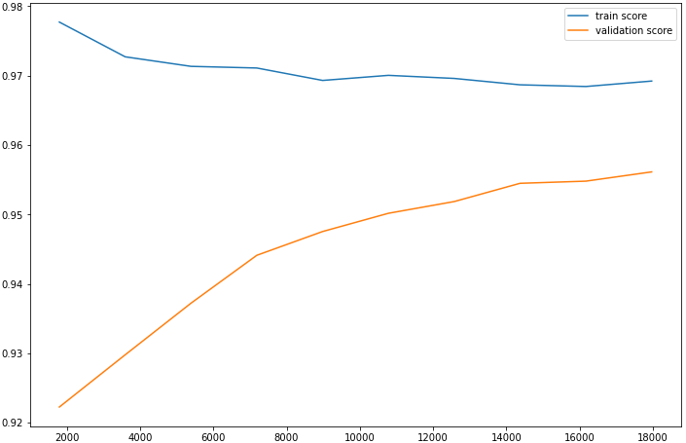
   |  | Reality
   |  | Negative | Positive
  Prediction | Negative | 4676 | 64
  Prediction | Positive | 181 | 694
  Accuracy | Sensitivity | Specificity | Score f1 | AUC
  0.7931 % | 0.9155 % | 0.9627 % | 0.8499 % | 0.8898 %
   |  | Reality
   |  | Negative | Positive
  Prediction | Negative | 4663 | 77
  Prediction | Positive | 169 | 706
  Accuracy | Sensitivity | Specificity | Score f1 | AUC
  0.8068 % | 0.9016 % | 0.9650 % | 0.8516 % | 0.8953 %

Table S17. Result of the XGBoost algorithm for the prediction of Pyrazinamide according to each feature space.

- Confusion matrix  - performance score  - Feature space: Space [F1] of the variables of all mutations.  - Learning curve  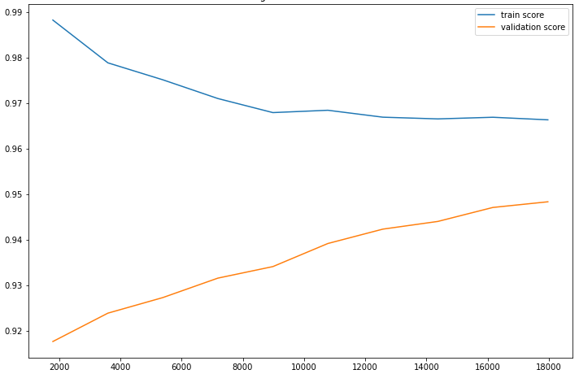 | - Confusion matrix  - performance score  - Feature space: Space [F2] of the variables of the mutations present in the 23 genes most known in antibiotic resistance.  - Learning curve  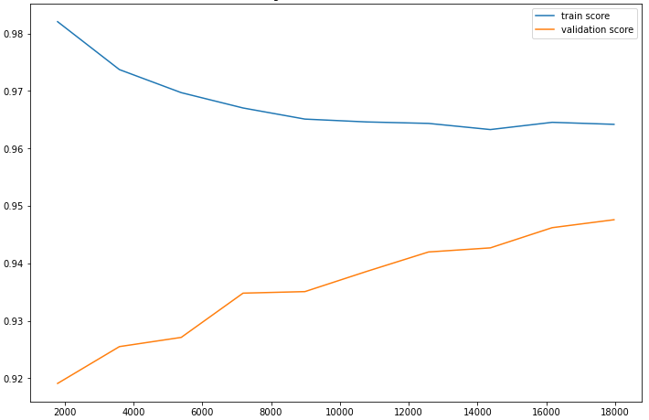
   |  | Reality
   |  | Negative | Positive
  Prediction | Negative | 4624 | 116
  Prediction | Positive | 192 | 683
  Accuracy | Sensitivity | Specificity | Score f1 | AUC
  0.7805 % | 0.8548 % | 0.9601 % | 0.8160 % | 0.8780 %
   |  | Reality
   |  | Negative | Positive
  Prediction | Negative | 4630 | 110
  Prediction | Positive | 190 | 685
  Accuracy | Sensitivity | Specificity | Score f1 | AUC
  0.7828 % | 0.8616 % | 0.9605 % | 0.8203 % | 0.8798 %
- Confusion matrix  - performance score  - Feature space: Space [F3] of the variables selected according to a variance threshold from [F1].  - Learning curve | - Confusion matrix  - performance score  - Feature space: Space [F4] of the "K" best variables selected based on the "X2" test from [F1].  - Learning curve  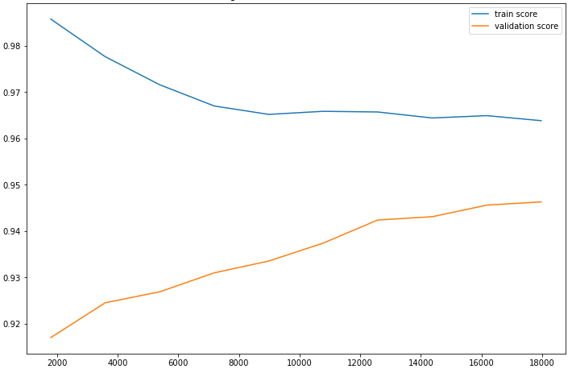
   |  | Reality
   |  | Negative | Positive
  Prediction | Negative | 4624 | 116
  Prediction | Positive | 192 | 683
  Accuracy | Sensitivity | Specificity | Score f1 | AUC
  0.7805 % | 0.8548 % | 0.9601 % | 0.8160 % | 0.8780 %
   |  | Reality
   |  | Negative | Positive
  Prediction | Negative | 4629 | 111
  Prediction | Positive | 199 | 676
  Accuracy | Sensitivity | Specificity | Score f1 | AUC
  0.7725 % | 0.8589 % | 0.9587 % | 0.8134 % | 0.8745 %
- Confusion matrix  - performance score  - Feature space: Space [F5] of the variables selected by the "LightGBM" model from [F1].  - Learning curve  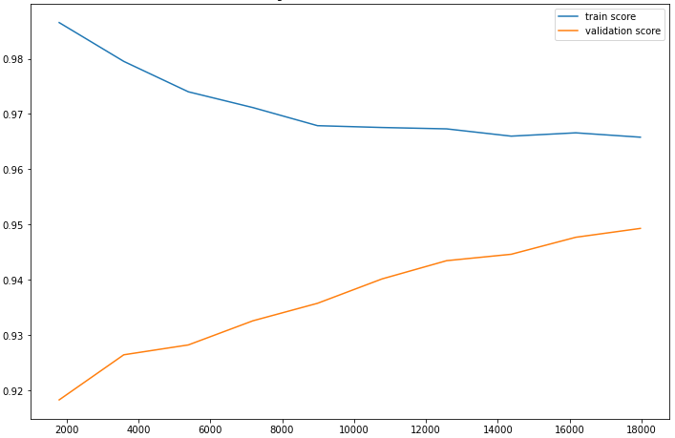 | - Confusion matrix  - performance score  - Feature space: Space [F7] of the selected variables according to a variance threshold from [F2].  - Learning curve
   |  | Reality
   |  | Negative | Positive
  Prediction | Negative | 4625 | 115
  Prediction | Positive | 188 | 687
  Accuracy | Sensitivity | Specificity | Score f1 | AUC
  0.7851 % | 0.8566 % | 0.9609 % | 0.8193 % | 0.8804 %
   |  | Reality
   |  | Negative | Positive
  Prediction | Negative | 4630 | 110
  Prediction | Positive | 190 | 685
  Accuracy | Sensitivity | Specificity | Score f1 | AUC
  0.7828 % | 0.8616 % | 0.9605 % | 0.8203 % | 0.8798 %
- Confusion matrix  - performance score  - Feature space: Space [F8] of the "K" best variables selected based on the "X2" test from [F2].  - Learning curve  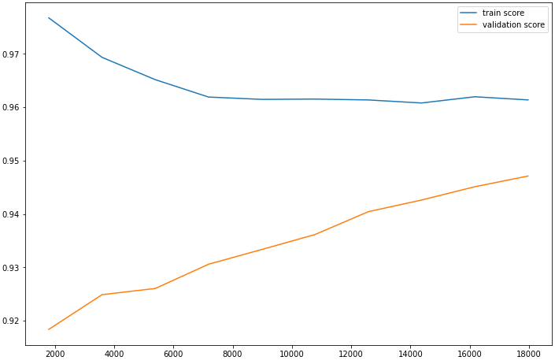 | - Confusion matrix  - performance score  - Feature space: Space [F9] of the variables selected by the "LightGBM" model from [F2].  - Learning curve  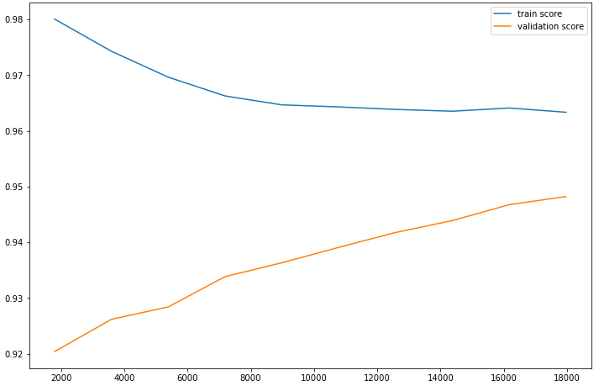
   |  | Reality
   |  | Negative | Positive
  Prediction | Negative | 4628 | 112
  Prediction | Positive | 198 | 677
  Accuracy | Sensitivity | Specificity | Score f1 | AUC
  0.7737 % | 0.8580 % | 0.9925 % | 0.9860 % | 0.8750 %
   |  | Reality
   |  | Negative | Positive
  Prediction | Negative | 4624 | 116
  Prediction | Positive | 194 | 681
  Accuracy | Sensitivity | Specificity | Score f1 | AUC
  0.7782 % | 0.8544 % | 0.9597 % | 0.8145 % | 0.8769 %

Table S18. Result of the LightGBM algorithm for the prediction of Pyrazinamide according to each feature space.

- Confusion matrix  - performance score  - Feature space: Space [F1] of the variables of all mutations.  - Learning curve  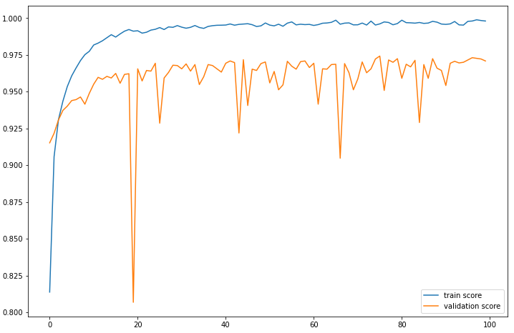 | - Confusion matrix  - performance score  - Feature space: Space [F2] of the variables of the mutations present in the 23 genes most known in antibiotic resistance.  - Learning curve  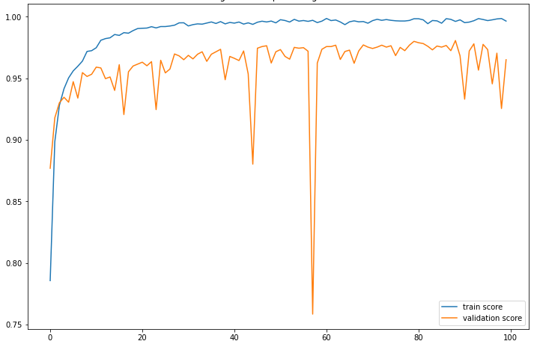
   |  | Reality
   |  | Negative | Positive
  Prediction | Negative | 4663 | 77
  Prediction | Positive | 92 | 783
  Accuracy | Sensitivity | Specificity | Score f1 | AUC
  0.8948 % | 0.9104 % | 0.9806 % | 0.9025 % | 0.9851 %
   |  | Reality
   |  | Negative | Positive
  Prediction | Negative | 4656 | 84
  Prediction | Positive | 130 | 745
  Accuracy | Sensitivity | Specificity | Score f1 | AUC
  0.8514 % | 0.8986 % | 0.9728 % | 0.8744 % | 0.9757 %
- Confusion matrix  - performance score  - Feature space: Space [F3] of the variables selected according to a variance threshold from [F1].  - Learning curve  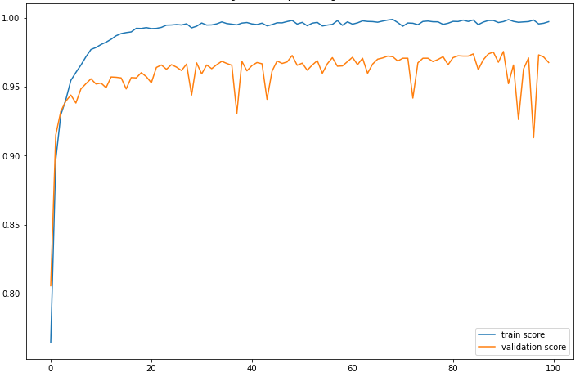 | - Confusion matrix  - performance score  - Feature space: Space [F4] of the "K" best variables selected based on the "X2" test from [F1].  - Learning curve  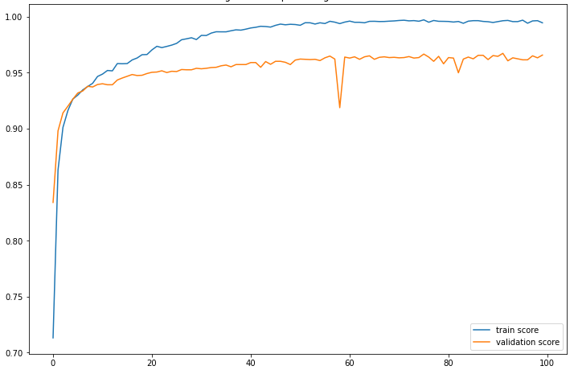
   |  | Reality
   |  | Negative | Positive
  Prediction | Negative | 4602 | 138
  Prediction | Positive | 76 | 799
  Accuracy | Sensitivity | Specificity | Score f1 | AUC
  0.9131 % | 0.8527 % | 0.9837 % | 0.8818 % | 0.9858 %
   |  | Reality
   |  | Negative | Positive
  Prediction | Negative | 4671 | 69
  Prediction | Positive | 155 | 720
  Accuracy | Sensitivity | Specificity | Score f1 | AUC
  0.8228 % | 0.9125 % | 0.9678 % | 0.8653 % | 0.9743 %
- Confusion matrix  - performance score  - Feature space: Space [F8] of the "K" best variables selected based on the "X2" test from [F2].  - Learning curve  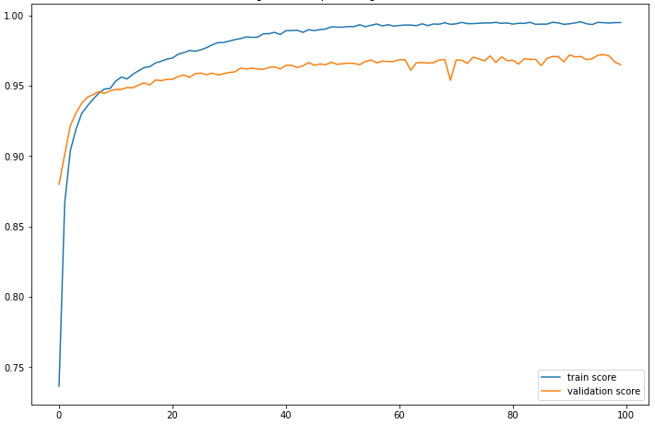 | - Confusion matrix  - performance score  - Feature space: Space [F7] of the selected variables according to a variance threshold from [F2].  - Learning curve  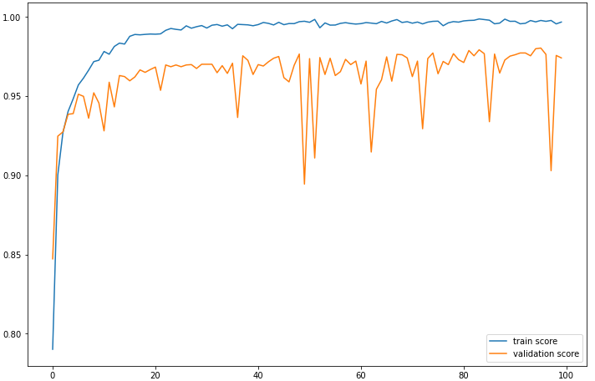
   |  | Reality
   |  | Negative | Positive
  Prediction | Negative | 4623 | 117
  Prediction | Positive | 86 | 789
  Accuracy | Sensitivity | Specificity | Score f1 | AUC
  0.9017 % | 0.8708 % | 0.9817 % | 0.8860 % | 0.9821 %
   |  | Reality
   |  | Negative | Positive
  Prediction | Negative | 4639 | 101
  Prediction | Positive | 87 | 788
  Accuracy | Sensitivity | Specificity | Score f1 | AUC
  0.9005 % | 0.8863 % | 0.9815 % | 0.9899 % | 0.9768 %

Table S19. Result of the DeepLearning algorithm for the prediction of Pyrazinamide according to each feature space.

- Confusion matrix  - performance score  - Feature space: Space [F1] of the variables of all mutations.  - Learning curve  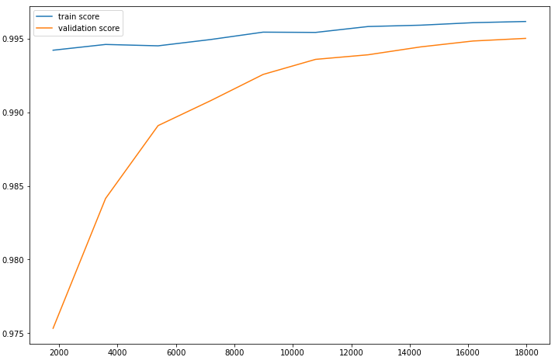 | - Confusion matrix  - performance score  - Feature space: Space [F2] of the variables of the mutations present in the 23 genes most known in antibiotic resistance.  - Learning curve  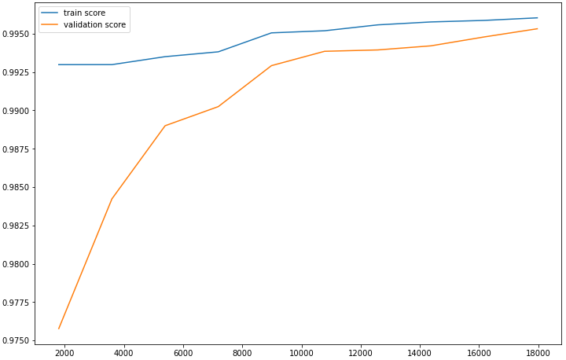
   |  | Reality
   |  | Negative | Positive
  Prediction | Negative | 4245 | 0
  Prediction | Positive | 22 | 1348
  Accuracy | Sensitivity | Specificity | Score f1 | AUC
  0.9839 % | 1 % | 0.9948 % | 0.9919 % | 0.9919 %
   |  | Reality
   |  | Negative | Positive
  Prediction | Negative | 4245 | 0
  Prediction | Positive | 22 | 1348
  Accuracy | Sensitivity | Specificity | Score f1 | AUC
  0.9839 % | 1 % | 0.9948 % | 0.9919 % | 0.9919 %
- Confusion matrix  - performance score  - Feature space: Space [F3] of the variables selected according to a variance threshold from [F1].  - Learning curve | - Confusion matrix  - performance score  - Feature space: Space [F4] of the "K" best variables selected based on the "X2" test from [F1].  - Learning curve  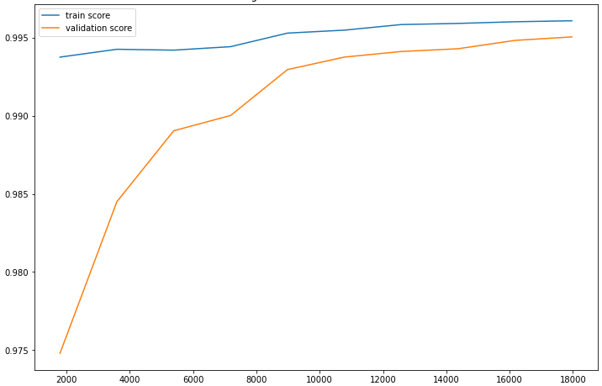
   |  | Reality
   |  | Negative | Positive
  Prediction | Negative | 4245 | 0
  Prediction | Positive | 22 | 1348
  Accuracy | Sensitivity | Specificity | Score f1 | AUC
  0.9839 % | 1 % | 0.9948 % | 0.9919 % | 0.9919 %
   |  | Reality
   |  | Negative | Positive
  Prediction | Negative | 4245 | 0
  Prediction | Positive | 21 | 1349
  Accuracy | Sensitivity | Specificity | Score f1 | AUC
  0.9846 % | 1 % | 0.9950 % | 0.9922 % | 0.9923 %
- Confusion matrix  - performance score  - Feature space: Space [F5] of the variables selected by the "XGBoost" model from [F1].  - Learning curve  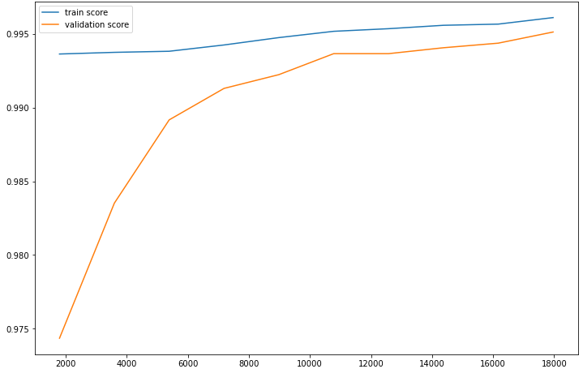 | - Confusion matrix  - performance score  - Feature space: Space [F7] of the selected variables according to a variance threshold from [F2].  - Learning curve
   |  | Reality
   |  | Negative | Positive
  Prediction | Negative | 4245 | 0
  Prediction | Positive | 21 | 1349
  Accuracy | Sensitivity | Specificity | Score f1 | AUC
  0.9846 % | 1 % | 0.9950 % | 0.9922 % | 0.9923 %
   |  | Reality
   |  | Negative | Positive
  Prediction | Negative | 4245 | 0
  Prediction | Positive | 22 | 1348
  Accuracy | Sensitivity | Specificity | Score f1 | AUC
  0.9839 % | 1 % | 0.9948 % | 0.9919 % | 0.9919 %
- Confusion matrix  - performance score  - Feature space: Space [F8] of the "K" best variables selected based on the "X2" test from [F2].  - Learning curve  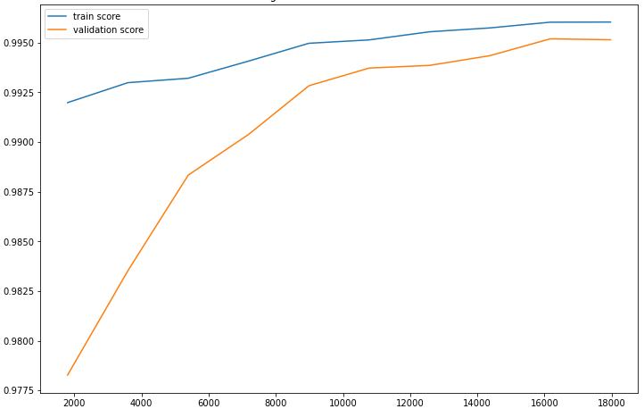 | - Confusion matrix  - performance score  - Feature space: Space [F9] of the variables selected by the "XGBoost" model from [F2].  - Learning curve  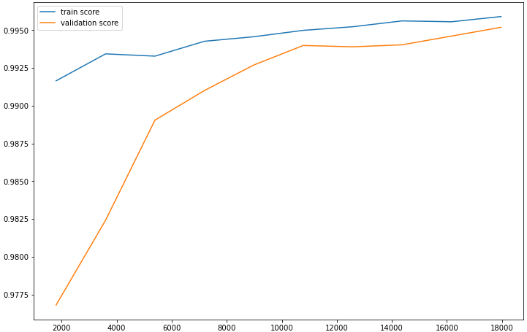
   |  | Reality
   |  | Negative | Positive
  Prediction | Negative | 4244 | 1
  Prediction | Positive | 21 | 1349
  Accuracy | Sensitivity | Specificity | Score f1 | AUC
  0.9846 % | 0.9992 % | 0.9627 % | 0.9919 % | 0.9922 %
   |  | Reality
   |  | Negative | Positive
  Prediction | Negative | 4245 | 0
  Prediction | Positive | 22 | 1348
  Accuracy | Sensitivity | Specificity | Score f1 | AUC
  0.9839 % | 1 % | 0.9948 % | 0.9919 % | 0.9919 %

Table S20. Result of the XGBoost algorithm for the prediction of Streptomycin according to each feature space.

- Confusion matrix  - performance score  - Feature space: Space [F1] of the variables of all mutations.  - Learning curve  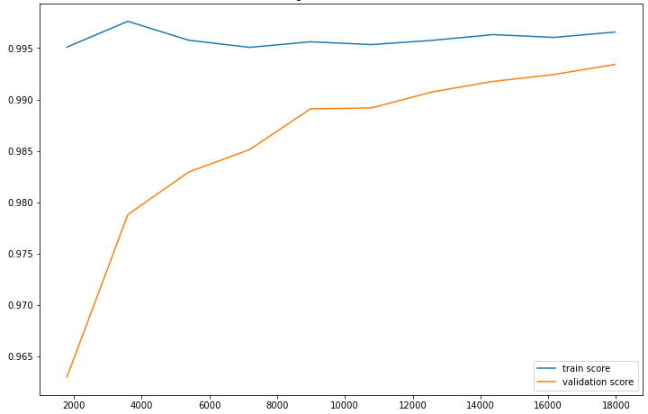 | - Confusion matrix  - performance score  - Feature space: Space [F2] of the variables of the mutations present in the 23 genes most known in antibiotic resistance.  - Learning curve  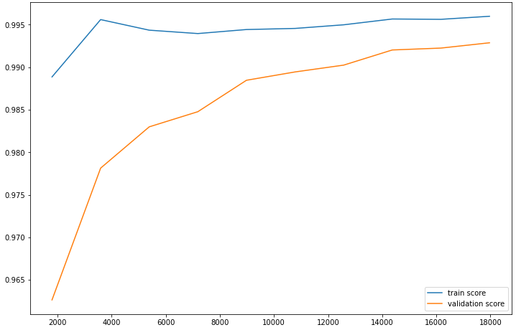
   |  | Reality
   |  | Negative | Positive
  Prediction | Negative | 4244 | 1
  Prediction | Positive | 28 | 1342
  Accuracy | Sensitivity | Specificity | Score f1 | AUC
  0.9795 % | 0.9992 % | 0.9934 % | 0.9893 % | 0.9896 %
   |  | Reality
   |  | Negative | Positive
  Prediction | Negative | 4244 | 1
  Prediction | Positive | 29 | 1341
  Accuracy | Sensitivity | Specificity | Score f1 | AUC
  0.9788 % | 0.9992 % | 0.9932 % | 0.9889 % | 0.9892 %
- Confusion matrix  - performance score  - Feature space: Space [F3] of the variables selected according to a variance threshold from [F1].  - Learning curve | - Confusion matrix  - performance score  - Feature space: Space [F4] of the "K" best variables selected based on the "X2" test from [F1].  - Learning curve  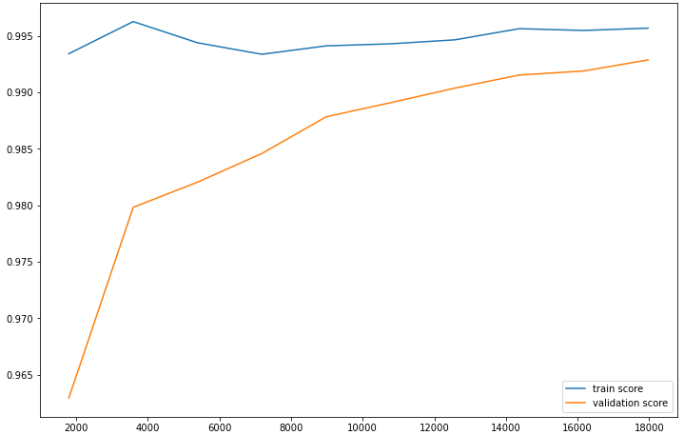
   |  | Reality
   |  | Negative | Positive
  Prediction | Negative | 4244 | 1
  Prediction | Positive | 28 | 1342
  Accuracy | Sensitivity | Specificity | Score f1 | AUC
  0.9795 % | 0.9992 % | 0.9934 % | 0.9893 % | 0.9896 %
   |  | Reality
   |  | Negative | Positive
  Prediction | Negative | 4241 | 4
  Prediction | Positive | 28 | 1342
  Accuracy | Sensitivity | Specificity | Score f1 | AUC
  0.9795 % | 0.9970 % | 0.9934 % | 0.9882 % | 0.9893 %
- Confusion matrix  - performance score  - Feature space: Space [F5] of the variables selected by the "LightGBM" model from [F1].  - Learning curve  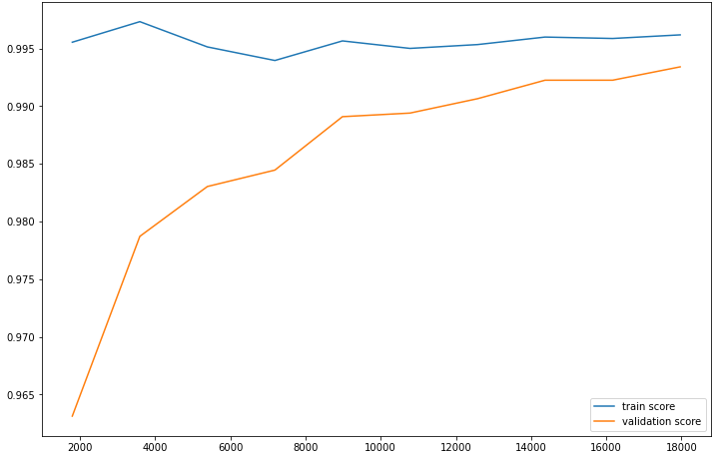 | - Confusion matrix  - performance score  - Feature space: Space [F7] of the selected variables according to a variance threshold from [F2].  - Learning curve
   |  | Reality
   |  | Negative | Positive
  Prediction | Negative | 4244 | 1
  Prediction | Positive | 28 | 1342
  Accuracy | Sensitivity | Specificity | Score f1 | AUC
  0.9795 % | 0.9992 % | 0.9934 % | 0.9893 % | 0.9896 %
   |  | Reality
   |  | Negative | Positive
  Prediction | Negative | 4244 | 1
  Prediction | Positive | 29 | 1341
  Accuracy | Sensitivity | Specificity | Score f1 | AUC
  0.9788 % | 0.9992 % | 0.9932 % | 0.9889 % | 0.9892 %
- Confusion matrix  - performance score  - Feature space: Space [F8] of the "K" best variables selected based on the "X2" test from [F2].  - Learning curve  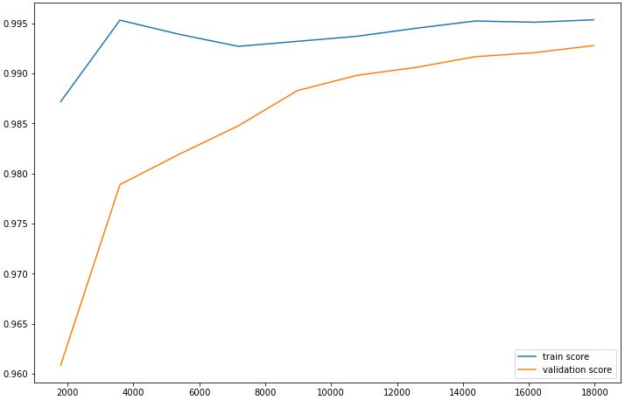 | - Confusion matrix  - performance score  - Feature space: Space [F9] of the variables selected by the "LightGBM" model from [F2].  - Learning curve  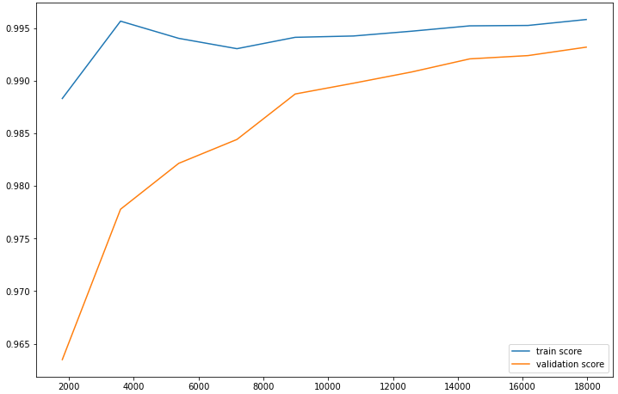
   |  | Reality
   |  | Negative | Positive
  Prediction | Negative | 4244 | 1
  Prediction | Positive | 29 | 1341
  Accuracy | Sensitivity | Specificity | Score f1 | AUC
  0.9788 % | 0.9992 % | 0.9932 % | 0.9889 % | 0.9892 %
   |  | Reality
   |  | Negative | Positive
  Prediction | Negative | 4242 | 3
  Prediction | Positive | 29 | 1341
  Accuracy | Sensitivity | Specificity | Score f1 | AUC
  0.9788 % | 0.9977 % | 0.9597 % | 0.9882 % | 0.9890 %

Table S21. Result of the LightGBM algorithm for the prediction of Streptomycin according to each feature space.

- Confusion matrix  - performance score  - Feature space: Space [F1] of the variables of all mutations.  - Learning curve  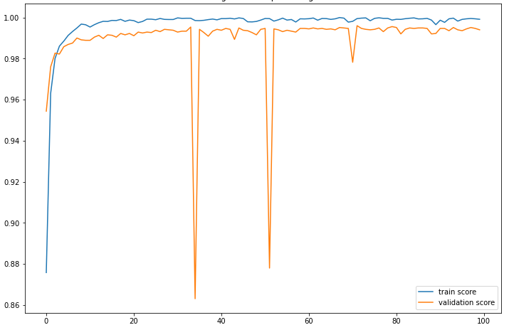 | - Confusion matrix  - performance score  - Feature space: Space [F2] of the variables of the mutations present in the 23 genes most known in antibiotic resistance.  - Learning curve  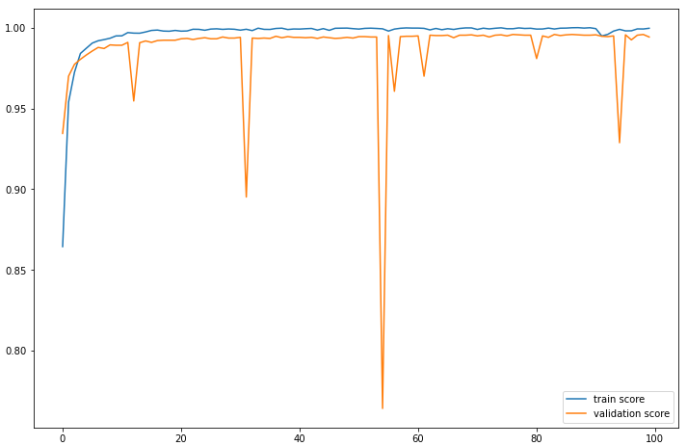
   |  | Reality
   |  | Negative | Positive
  Prediction | Negative | 4243 | 2
  Prediction | Positive | 22 | 1348
  Accuracy | Sensitivity | Specificity | Score f1 | AUC
  0.9839 % | 0.9985 % | 0.9948 % | 0.9025 % | 0.9970 %
   |  | Reality
   |  | Negative | Positive
  Prediction | Negative | 4245 | 0
  Prediction | Positive | 32 | 1338
  Accuracy | Sensitivity | Specificity | Score f1 | AUC
  0.9766 % | 1 % | 0.9925 % | 0.9881 % | 0.9972 %
- Confusion matrix  - performance score  - Feature space: Space [F3] of the variables selected according to a variance threshold from [F1].  - Learning curve  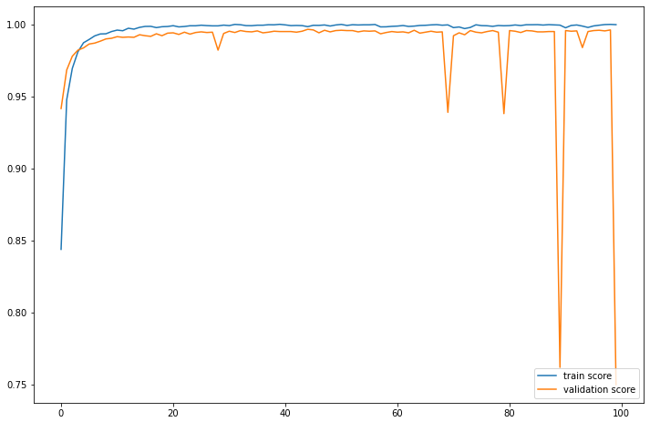 | - Confusion matrix  - performance score  - Feature space: Space [F4] of the "K" best variables selected based on the "X2" test from [F1].  - Learning curve  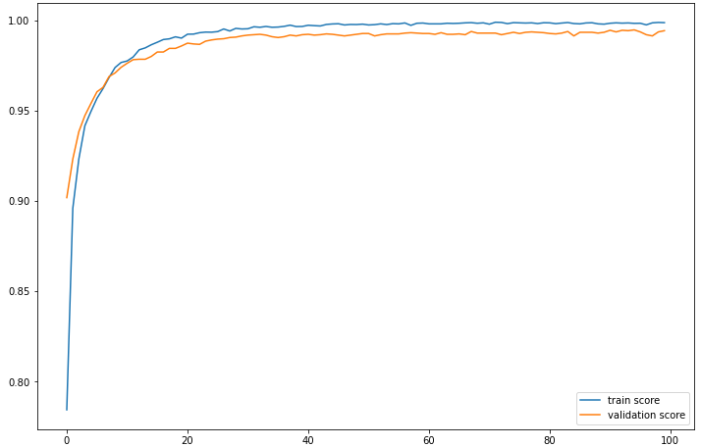
   |  | Reality
   |  | Negative | Positive
  Prediction | Negative | 3526 | 719
  Prediction | Positive | 682 | 688
  Accuracy | Sensitivity | Specificity | Score f1 | AUC
  0.5021 % | 0.4889 % | 0.8379 % | 0.8818 % | 0.7165 %
   |  | Reality
   |  | Negative | Positive
  Prediction | Negative | 4238 | 7
  Prediction | Positive | 22 | 1348
  Accuracy | Sensitivity | Specificity | Score f1 | AUC
  0.9839 % | 0.9948 % | 0.9948 % | 0.8653 % | 0.9948 %
- Confusion matrix  - performance score  - Feature space: Space [F8] of the "K" best variables selected based on the "X2" test from [F2].  - Learning curve  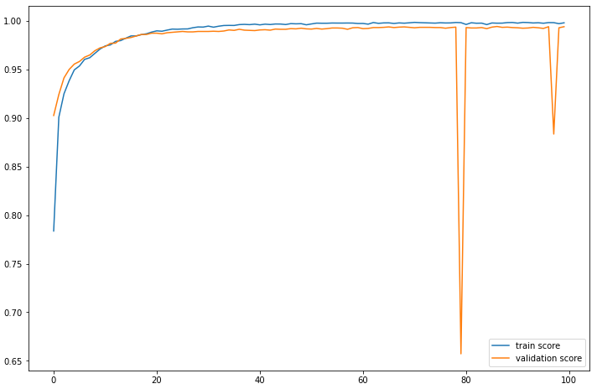 | - Confusion matrix  - performance score  - Feature space: Space [F7] of the selected variables according to a variance threshold from [F2].  - Learning curve  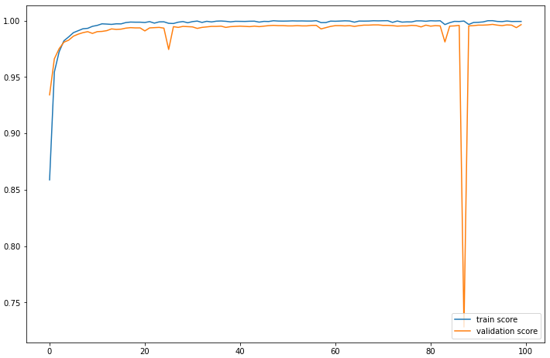
   |  | Reality
   |  | Negative | Positive
  Prediction | Negative | 4235 | 10
  Prediction | Positive | 18 | 1352
  Accuracy | Sensitivity | Specificity | Score f1 | AUC
  0.9868 % | 0.9926 % | 0.9957 % | 0.9897 % | 0.9960 %
   |  | Reality
   |  | Negative | Positive
  Prediction | Negative | 4245 | 0
  Prediction | Positive | 12 | 1358
  Accuracy | Sensitivity | Specificity | Score f1 | AUC
  0.9912 % | 1 % | 0.9971 % | 0.9899 % | 0.9966 %

Table S22. Result of the DeepLearning algorithm for the prediction of Streptomycin according to each feature space.

- Confusion matrix  - performance score  - Feature space: Space [F1] of the variables of all mutations.  - Learning curve  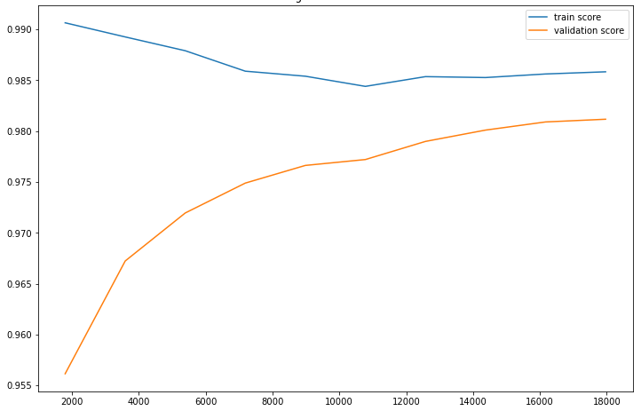 | - Confusion matrix  - performance score  - Feature space: Space [F2] of the variables of the mutations present in the 23 genes most known in antibiotic resistance.  - Learning curve  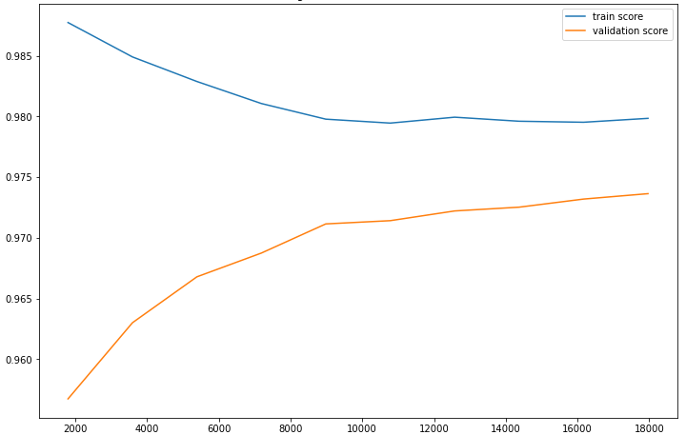
   |  | Reality
   |  | Negative | Positive
  Prediction | Negative | 4860 | 10
  Prediction | Positive | 99 | 646
  Accuracy | Sensitivity | Specificity | Score f1 | AUC
  0.8671 % | 0.9847 % | 0.9800 % | 0.9221 % | 0.9325 %
   |  | Reality
   |  | Negative | Positive
  Prediction | Negative | 4856 | 14
  Prediction | Positive | 139 | 606
  Accuracy | Sensitivity | Specificity | Score f1 | AUC
  0.8134 % | 0.9774 % | 0.9721 % | 0.8879 % | 0.9052 %
- Confusion matrix  - performance score  - Feature space: Space [F3] of the variables selected according to a variance threshold from [F1].  - Learning curve | - Confusion matrix  - performance score  - Feature space: Space [F4] of the "K" best variables selected based on the "X2" test from [F1].  - Learning curve  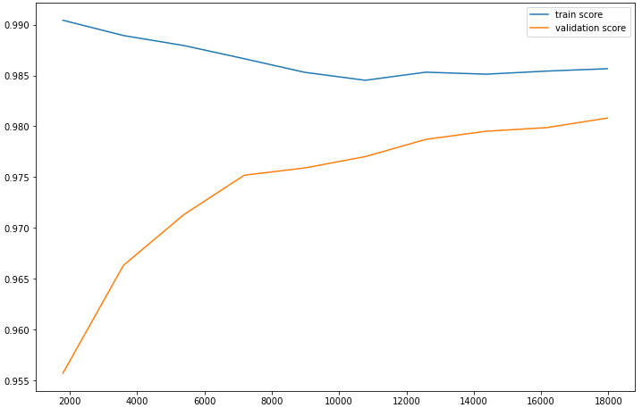
   |  | Reality
   |  | Negative | Positive
  Prediction | Negative | 4860 | 10
  Prediction | Positive | 99 | 646
  Accuracy | Sensitivity | Specificity | Score f1 | AUC
  0.8671 % | 0.9847 % | 0.9800 % | 0.9221 % | 0.9325 %
   |  | Reality
   |  | Negative | Positive
  Prediction | Negative | 4862 | 8
  Prediction | Positive | 100 | 645
  Accuracy | Sensitivity | Specificity | Score f1 | AUC
  0.8657 % | 0.9877 % | 0.9798 % | 0.9227 % | 0.9320 %
- Confusion matrix  - performance score  - Feature space: Space [F5] of the variables selected by the "XGBoost" model from [F1].  - Learning curve | - Confusion matrix  - performance score  - Feature space: Space [F7] of the selected variables according to a variance threshold from [F2].  - Learning curve
   |  | Reality
   |  | Negative | Positive
  Prediction | Negative | 4860 | 10
  Prediction | Positive | 99 | 646
  Accuracy | Sensitivity | Specificity | Score f1 | AUC
  0.8671 % | 0.9847 % | 0.9800 % | 0.9221 % | 0.9325 %
   |  | Reality
   |  | Negative | Positive
  Prediction | Negative | 4856 | 14
  Prediction | Positive | 139 | 606
  Accuracy | Sensitivity | Specificity | Score f1 | AUC
  0.8134 % | 0.9774 % | 0.9721 % | 0.8879 % | 0.9052 %
- Confusion matrix  - performance score  - Feature space: Space [F8] of the "K" best variables selected based on the "X2" test from [F2].  - Learning curve  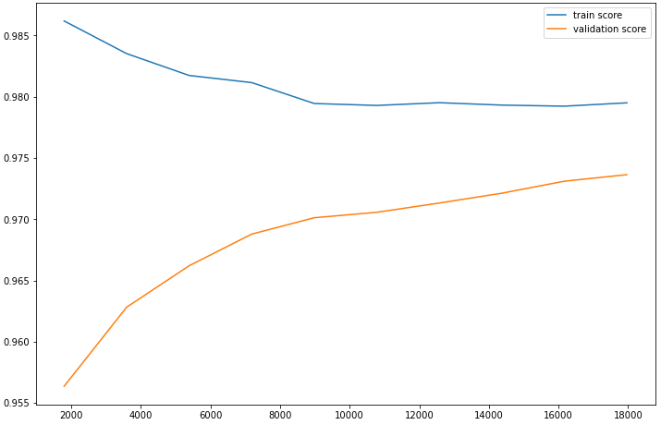 | - Confusion matrix  - performance score  - Feature space: Space [F9] of the variables selected by the "XGBoost" model from [F2].  - Learning curve
   |  | Reality
   |  | Negative | Positive
  Prediction | Negative | 4856 | 14
  Prediction | Positive | 140 | 605
  Accuracy | Sensitivity | Specificity | Score f1 | AUC
  0.8120 % | 0.9773 % | 0.9627 % | 0.8870 % | 0.9046 %
   |  | Reality
   |  | Negative | Positive
  Prediction | Negative | 4856 | 14
  Prediction | Positive | 139 | 606
  Accuracy | Sensitivity | Specificity | Score f1 | AUC
  0.8134 % | 0.9774 % | 0.9721 % | 0.8879 % | 0.9052 %

Table S23. Result of the XGBoost algorithm for the prediction of Ethionamide according to each feature space.

- Confusion matrix  - performance score  - Feature space: Space [F1] of the variables of all mutations.  - Learning curve  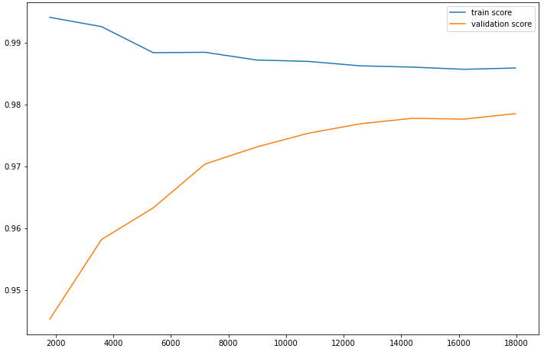 | - Confusion matrix  - performance score  - Feature space: Space [F2] of the variables of the mutations present in the 23 genes most known in antibiotic resistance.  - Learning curve  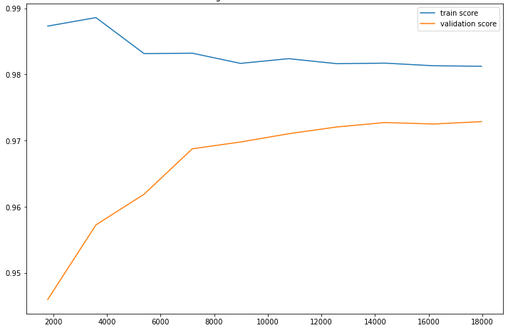
   |  | Reality
   |  | Negative | Positive
  Prediction | Negative | 4861 | 9
  Prediction | Positive | 112 | 633
  Accuracy | Sensitivity | Specificity | Score f1 | AUC
  0.8496 % | 0.9859 % | 0.9774 % | 0.9127 % | 0.9239 %
   |  | Reality
   |  | Negative | Positive
  Prediction | Negative | 4853 | 17
  Prediction | Positive | 135 | 610
  Accuracy | Sensitivity | Specificity | Score f1 | AUC
  0.8187 % | 0.9728 % | 0.9729 % | 0.8892 % | 0.9076 %
- Confusion matrix  - performance score  - Feature space: Space [F3] of the variables selected according to a variance threshold from [F1].  - Learning curve | - Confusion matrix  - performance score  - Feature space: Space [F4] of the "K" best variables selected based on the "X2" test from [F1].  - Learning curve  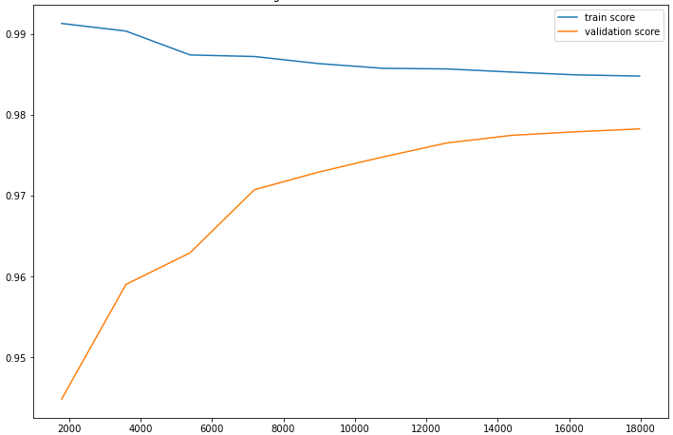
   |  | Reality
   |  | Negative | Positive
  Prediction | Negative | 4861 | 9
  Prediction | Positive | 112 | 633
  Accuracy | Sensitivity | Specificity | Score f1 | AUC
  0.8496 % | 0.9859 % | 0.9774 % | 0.9127 % | 0.9239 %
   |  | Reality
   |  | Negative | Positive
  Prediction | Negative | 4856 | 14
  Prediction | Positive | 117 | 628
  Accuracy | Sensitivity | Specificity | Score f1 | AUC
  0.8429 % | 0.9781 % | 0.9764 % | 0.9055 % | 0.9200 %
- Confusion matrix  - performance score  - Feature space: Space [F5] of the variables selected by the "LightGBM" model from [F1].  - Learning curve  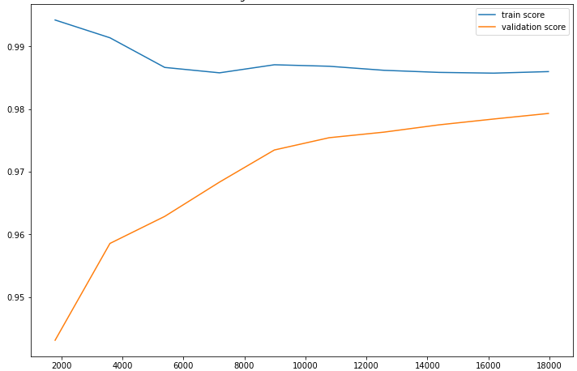 | - Confusion matrix  - performance score  - Feature space: Space [F7] of the selected variables according to a variance threshold from [F2].  - Learning curve
   |  | Reality
   |  | Negative | Positive
  Prediction | Negative | 4860 | 10
  Prediction | Positive | 111 | 634
  Accuracy | Sensitivity | Specificity | Score f1 | AUC
  0.8510 % | 0.9844 % | 0.9977 % | 0.9128 % | 0.9244 %
   |  | Reality
   |  | Negative | Positive
  Prediction | Negative | 4853 | 17
  Prediction | Positive | 135 | 610
  Accuracy | Sensitivity | Specificity | Score f1 | AUC
  0.8187 % | 0.9728 % | 0.9729 % | 0.8892 % | 0.9076 %
- Confusion matrix  - performance score  - Feature space: Space [F8] of the "K" best variables selected based on the "X2" test from [F2].  - Learning curve  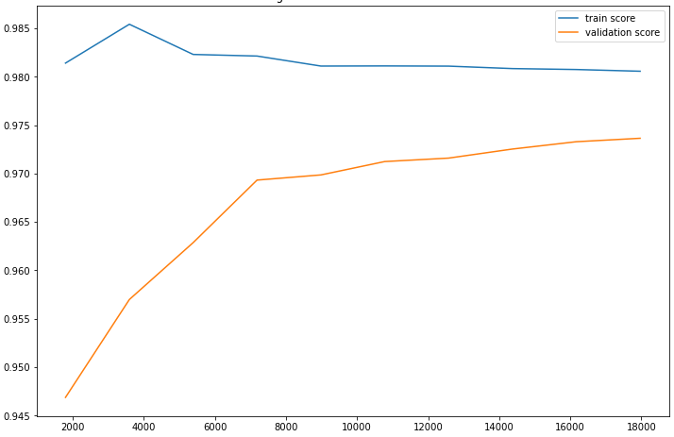 | - Confusion matrix  - performance score  - Feature space: Space [F9] of the variables selected by the "LightGBM" model from [F2].  - Learning curve  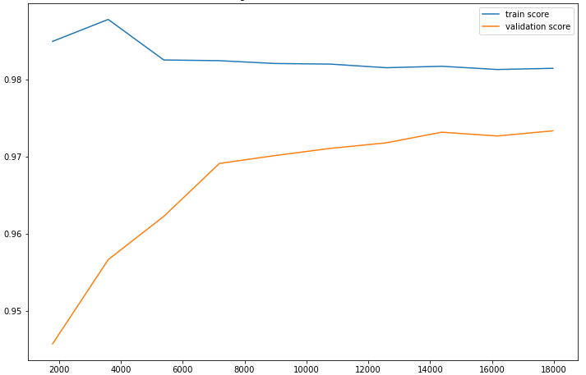
   |  | Reality
   |  | Negative | Positive
  Prediction | Negative | 4852 | 18
  Prediction | Positive | 135 | 610
  Accuracy | Sensitivity | Specificity | Score f1 | AUC
  0.8187 % | 0.9713 % | 0.9729 % | 0.8885 % | 0.9075 %
   |  | Reality
   |  | Negative | Positive
  Prediction | Negative | 4852 | 18
  Prediction | Positive | 134 | 611
  Accuracy | Sensitivity | Specificity | Score f1 | AUC
  0.8201 % | 0.9713 % | 0.9731 % | 0.8893 % | 0.9081 %

Table S24. Result of the LightGBM algorithm for the prediction of Ethionamide according to each feature space.

- Confusion matrix  - performance score  - Feature space: Space [F1] of the variables of all mutations.  - Learning curve  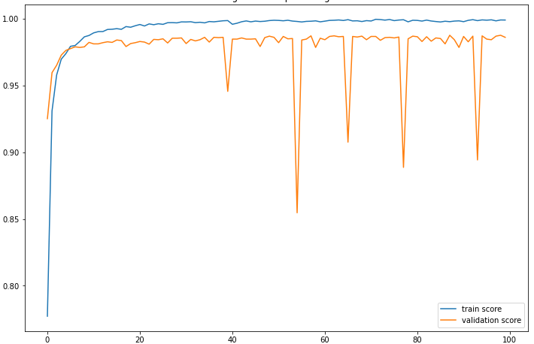 | - Confusion matrix  - performance score  - Feature space: Space [F2] of the variables of the mutations present in the 23 genes most known in antibiotic resistance.  - Learning curve  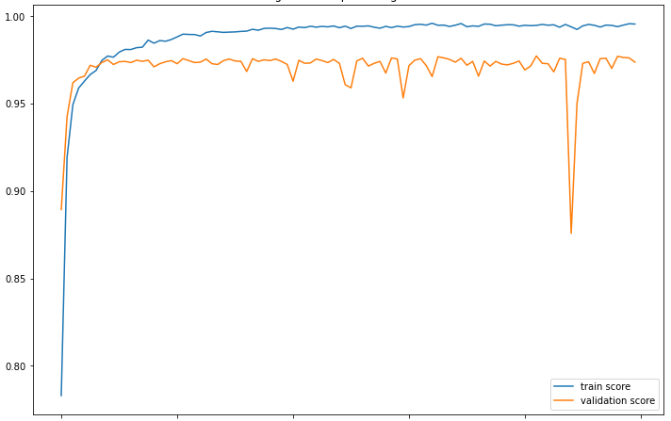
   |  | Reality
   |  | Negative | Positive
  Prediction | Negative | 4845 | 25
  Prediction | Positive | 68 | 677
  Accuracy | Sensitivity | Specificity | Score f1 | AUC
  0.9087 % | 0.9643 % | 0.9861 % | 0.9357 % | 0.9761 %
   |  | Reality
   |  | Negative | Positive
  Prediction | Negative | 4817 | 53
  Prediction | Positive | 101 | 644
  Accuracy | Sensitivity | Specificity | Score f1 | AUC
  0.8644 % | 0.9239 % | 0.9794 % | 0.8932 % | 0.9585 %
- Confusion matrix  - performance score  - Feature space: Space [F3] of the variables selected according to a variance threshold from [F1].  - Learning curve  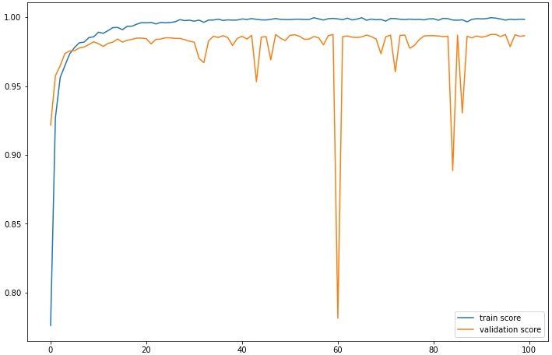 | - Confusion matrix  - performance score  - Feature space: Space [F4] of the "K" best variables selected based on the "X2" test from [F1].  - Learning curve  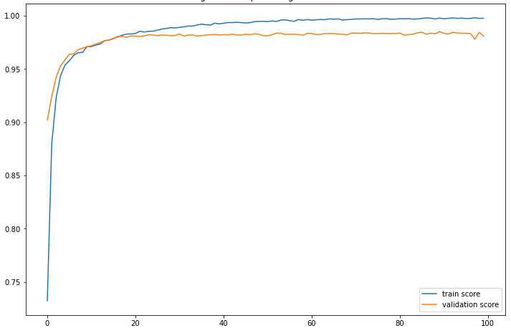
   |  | Reality
   |  | Negative | Positive
  Prediction | Negative | 4866 | 4
  Prediction | Positive | 74 | 671
  Accuracy | Sensitivity | Specificity | Score f1 | AUC
  0.9006 % | 0.9940 % | 0.9850 % | 0.8818 % | 0.9658 %
   |  | Reality
   |  | Negative | Positive
  Prediction | Negative | 4822 | 48
  Prediction | Positive | 60 | 685
  Accuracy | Sensitivity | Specificity | Score f1 | AUC
  0.9194 % | 0.9345 % | 0.9877 % | 0.9269 % | 0.9755 %
- Confusion matrix  - performance score  - Feature space: Space [F8] of the "K" best variables selected based on the "X2" test from [F2].  - Learning curve  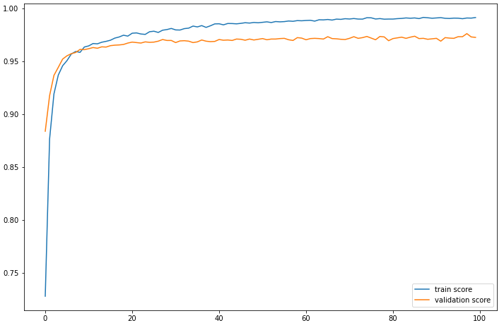 | - Confusion matrix  - performance score  - Feature space: Space [F7] of the selected variables according to a variance threshold from [F2].  - Learning curve  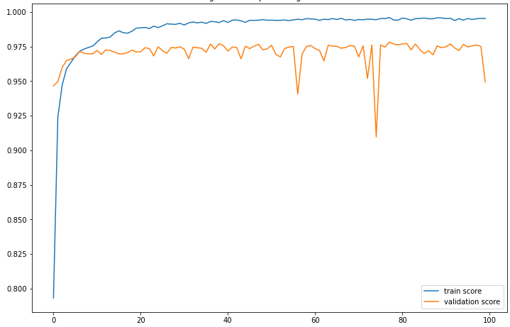
   |  | Reality
   |  | Negative | Positive
  Prediction | Negative | 4814 | 56
  Prediction | Positive | 108 | 637
  Accuracy | Sensitivity | Specificity | Score f1 | AUC
  0.8550 % | 0.9191 % | 0.9780 % | 0.8859 % | 0.9614 %
   |  | Reality
   |  | Negative | Positive
  Prediction | Negative | 4717 | 153
  Prediction | Positive | 127 | 618
  Accuracy | Sensitivity | Specificity | Score f1 | AUC
  0.8295 % | 0.8015 % | 0.9737 % | 0.8153 % | 0.9490 %

Table S25. Result of the DeepLearning algorithm for the prediction of Ethionamide according to each feature space.

- Confusion matrix  - performance score  - Feature space: Space [F1] of the variables of all mutations.  - Learning curve  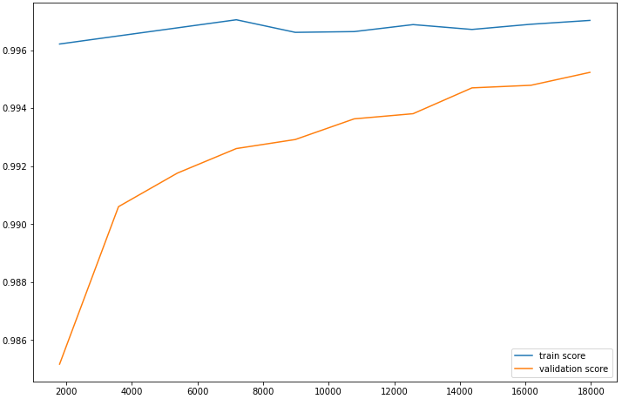 | - Confusion matrix  - performance score  - Feature space: Space [F2] of the variables of the mutations present in the 23 genes most known in antibiotic resistance.  - Learning curve  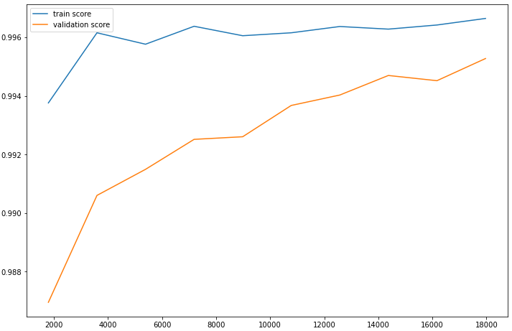
   |  | Reality
   |  | Negative | Positive
  Prediction | Negative | 5148 | 3
  Prediction | Positive | 23 | 441
  Accuracy | Sensitivity | Specificity | Score f1 | AUC
  0.9504 % | 0.9932 % | 0.9955 % | 0.9713 % | 0.9749 %
   |  | Reality
   |  | Negative | Positive
  Prediction | Negative | 5146 | 5
  Prediction | Positive | 24 | 440
  Accuracy | Sensitivity | Specificity | Score f1 | AUC
  0.9482 % | 0.9887 % | 0.9721 % | 0.9680 % | 0.9736 %
- Confusion matrix  - performance score  - Feature space: Space [F3] of the variables selected according to a variance threshold from [F1].  - Learning curve | - Confusion matrix  - performance score  - Feature space: Space [F4] of the "K" best variables selected based on the "X2" test from [F1].  - Learning curve  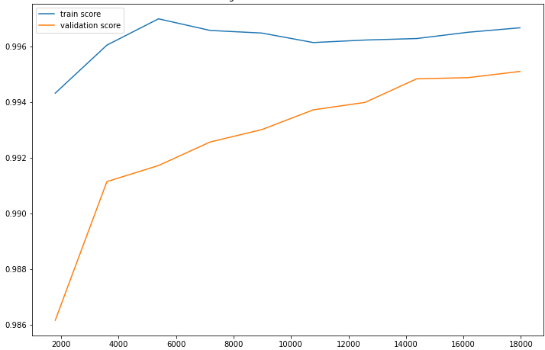
   |  | Reality
   |  | Negative | Positive
  Prediction | Negative | 5148 | 3
  Prediction | Positive | 23 | 441
  Accuracy | Sensitivity | Specificity | Score f1 | AUC
  0.9504 % | 0.9932 % | 0.9955 % | 0.9713 % | 0.9749 %
   |  | Reality
   |  | Negative | Positive
  Prediction | Negative | 5145 | 6
  Prediction | Positive | 24 | 440
  Accuracy | Sensitivity | Specificity | Score f1 | AUC
  0.9482 % | 0.9865 % | 0.9953 % | 0.9670 % | 0.9735 %
- Confusion matrix  - performance score  - Feature space: Space [F5] of the variables selected by the "XGBoost" model from [F1].  - Learning curve  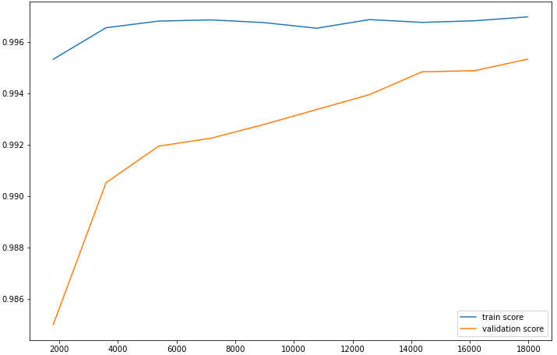 | - Confusion matrix  - performance score  - Feature space: Space [F7] of the selected variables according to a variance threshold from [F2].  - Learning curve
   |  | Reality
   |  | Negative | Positive
  Prediction | Negative | 5148 | 3
  Prediction | Positive | 23 | 441
  Accuracy | Sensitivity | Specificity | Score f1 | AUC
  0.9504 % | 0.9932 % | 0.9955 % | 0.9713 % | 0.9749 %
   |  | Reality
   |  | Negative | Positive
  Prediction | Negative | 5146 | 5
  Prediction | Positive | 24 | 440
  Accuracy | Sensitivity | Specificity | Score f1 | AUC
  0.9482 % | 0.9887 % | 0.9721 % | 0.9680 % | 0.9736 %
- Confusion matrix  - performance score  - Feature space: Space [F8] of the "K" best variables selected based on the "X2" test from [F2].  - Learning curve  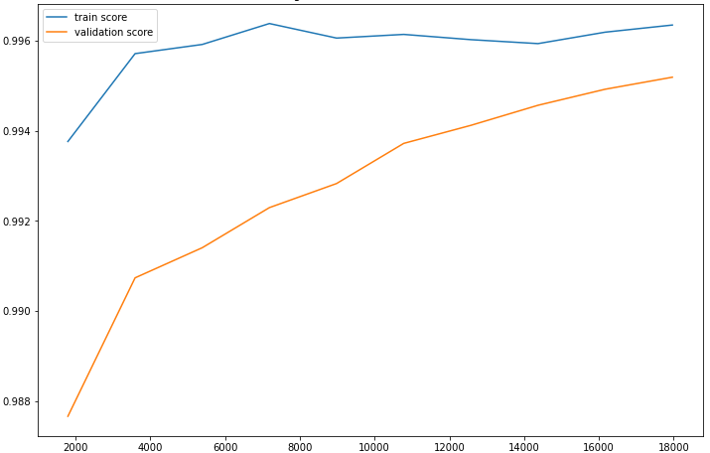 | - Confusion matrix  - performance score  - Feature space: Space [F9] of the variables selected by the "XGBoost" model from [F2].  - Learning curve
   |  | Reality
   |  | Negative | Positive
  Prediction | Negative | 5146 | 5
  Prediction | Positive | 26 | 438
  Accuracy | Sensitivity | Specificity | Score f1 | AUC
  0.9439 % | 0.9887 % | 0.9949 % | 0.9658 % | 0.9714 %
   |  | Reality
   |  | Negative | Positive
  Prediction | Negative | 5146 | 5
  Prediction | Positive | 24 | 440
  Accuracy | Sensitivity | Specificity | Score f1 | AUC
  0.9482 % | 0.9887 % | 0.9721 % | 0.9680 % | 0.9736 %

Table S26. Result of the XGBoost algorithm for the prediction of Fluoroquinolones according to each feature space.

- Confusion matrix  - performance score  - Feature space: Space [F1] of the variables of all mutations.  - Learning curve  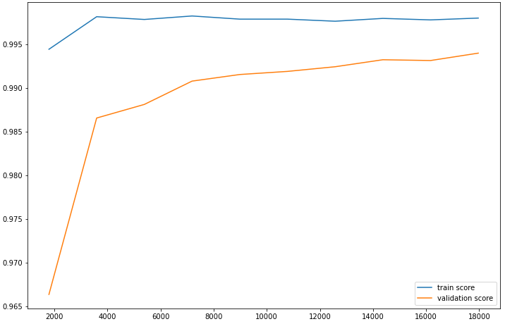 | - Confusion matrix  - performance score  - Feature space: Space [F2] of the variables of the mutations present in the 23 genes most known in antibiotic resistance.  - Learning curve  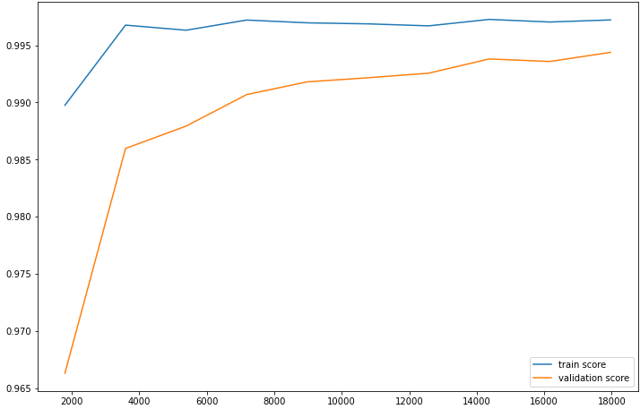
   |  | Reality
   |  | Negative | Positive
  Prediction | Negative | 5146 | 5
  Prediction | Positive | 28 | 436
  Accuracy | Sensitivity | Specificity | Score f1 | AUC
  0.9396 % | 0.9886 % | 0.9945 % | 0.9635 % | 0.9693 %
   |  | Reality
   |  | Negative | Positive
  Prediction | Negative | 5147 | 4
  Prediction | Positive | 28 | 436
  Accuracy | Sensitivity | Specificity | Score f1 | AUC
  0.9396 % | 0.9909 % | 0.9945 % | 0.9646 % | 0.9694 %
- Confusion matrix  - performance score  - Feature space: Space [F3] of the variables selected according to a variance threshold from [F1].  - Learning curve | - Confusion matrix  - performance score  - Feature space: Space [F4] of the "K" best variables selected based on the "X2" test from [F1].  - Learning curve
   |  | Reality
   |  | Negative | Positive
  Prediction | Negative | 5146 | 5
  Prediction | Positive | 28 | 436
  Accuracy | Sensitivity | Specificity | Score f1 | AUC
  0.9396 % | 0.9886 % | 0.9945 % | 0.9635 % | 0.9693 %
   |  | Reality
   |  | Negative | Positive
  Prediction | Negative | 5146 | 5
  Prediction | Positive | 28 | 436
  Accuracy | Sensitivity | Specificity | Score f1 | AUC
  0.9396 % | 0.9886 % | 0.9945 % | 0.9635 % | 0.9693 %
- Confusion matrix  - performance score  - Feature space: Space [F5] of the variables selected by the "LightGBM" model from [F1].  - Learning curve  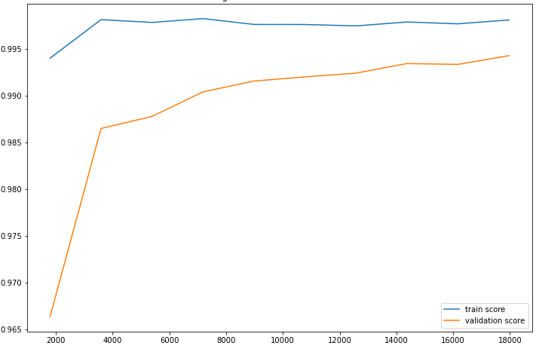 | - Confusion matrix  - performance score  - Feature space: Space [F7] of the selected variables according to a variance threshold from [F2].  - Learning curve
   |  | Reality
   |  | Negative | Positive
  Prediction | Negative | 5146 | 5
  Prediction | Positive | 27 | 437
  Accuracy | Sensitivity | Specificity | Score f1 | AUC
  0.9418 % | 0.9886 % | 0.9947 % | 0.9646 % | 0.9704 %
   |  | Reality
   |  | Negative | Positive
  Prediction | Negative | 5147 | 4
  Prediction | Positive | 28 | 436
  Accuracy | Sensitivity | Specificity | Score f1 | AUC
  0.9396 % | 0.9909 % | 0.9945 % | 0.9646 % | 0.9694 %
- Confusion matrix  - performance score  - Feature space: Space [F8] of the "K" best variables selected based on the "X2" test from [F2].  - Learning curve  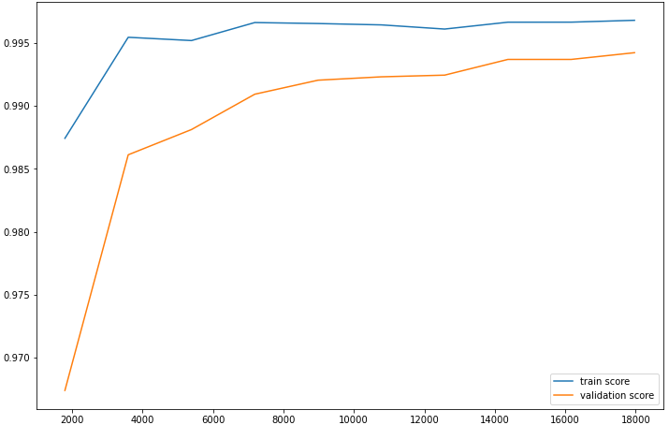 | - Confusion matrix  - performance score  - Feature space: Space [F9] of the variables selected by the "LightGBM" model from [F2].  - Learning curve  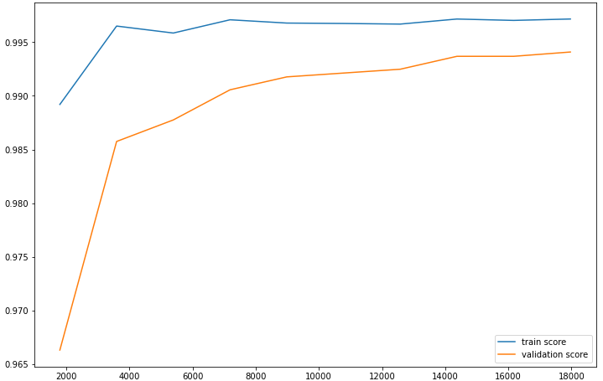
   |  | Reality
   |  | Negative | Positive
  Prediction | Negative | 5146 | 5
  Prediction | Positive | 26 | 438
  Accuracy | Sensitivity | Specificity | Score f1 | AUC
  0.9439 % | 0.9887 % | 0.9949 % | 0.9658 % | 0.9714 %
   |  | Reality
   |  | Negative | Positive
  Prediction | Negative | 5148 | 3
  Prediction | Positive | 28 | 436
  Accuracy | Sensitivity | Specificity | Score f1 | AUC
  0.9396 % | 0.9931 % | 0.9945 % | 0.9656 % | 0.9695 %

Table S27. Result of the LightGBM algorithm for the prediction of Fluoroquinolones according to each feature space.

- Confusion matrix  - performance score  - Feature space: Space [F1] of the variables of all mutations.  - Learning curve  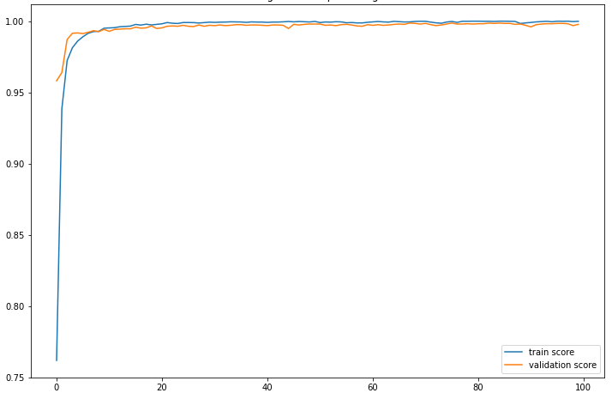 | - Confusion matrix  - performance score  - Feature space: Space [F2] of the variables of the mutations present in the 23 genes most known in antibiotic resistance.  - Learning curve  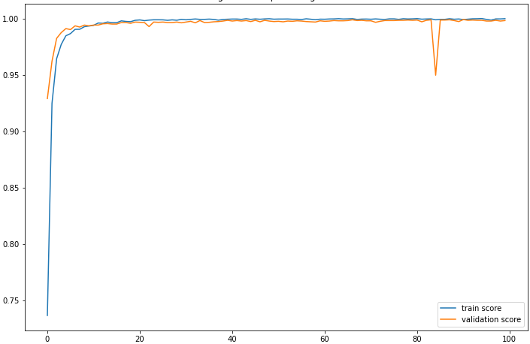
   |  | Reality
   |  | Negative | Positive
  Prediction | Negative | 5147 | 4
  Prediction | Positive | 13 | 451
  Accuracy | Sensitivity | Specificity | Score f1 | AUC
  0.9719 % | 0.9912 % | 0.9974 % | 0.9815 % | 0.9987 %
   |  | Reality
   |  | Negative | Positive
  Prediction | Negative | 5148 | 3
  Prediction | Positive | 7 | 457
  Accuracy | Sensitivity | Specificity | Score f1 | AUC
  0.9849 % | 0.9934 % | 0.9986 % | 0.9891 % | 0.9976 %
- Confusion matrix  - performance score  - Feature space: Space [F3] of the variables selected according to a variance threshold from [F1].  - Learning curve  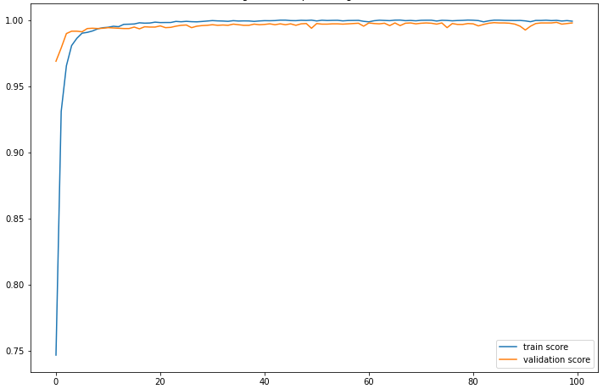 | - Confusion matrix  - performance score  - Feature space: Space [F4] of the "K" best variables selected based on the "X2" test from [F1].  - Learning curve  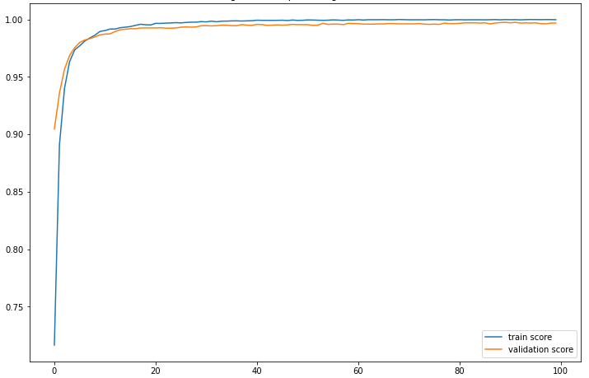
   |  | Reality
   |  | Negative | Positive
  Prediction | Negative | 5142 | 9
  Prediction | Positive | 9 | 455
  Accuracy | Sensitivity | Specificity | Score f1 | AUC
  0.9806 % | 0.9806 % | 0.9982 % | 0.8818 % | 0.9971 %
   |  | Reality
   |  | Negative | Positive
  Prediction | Negative | 5146 | 5
  Prediction | Positive | 12 | 452
  Accuracy | Sensitivity | Specificity | Score f1 | AUC
  0.9741 % | 0.9890 % | 0.9877 % | 0.9815 % | 0.9986 %
- Confusion matrix  - performance score  - Feature space: Space [F8] of the "K" best variables selected based on the "X2" test from [F2].  - Learning curve  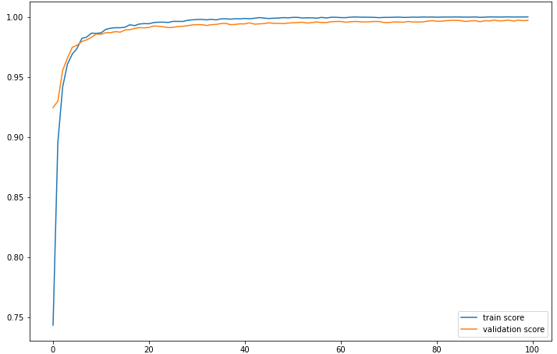 | - Confusion matrix  - performance score  - Feature space: Space [F7] of the selected variables according to a variance threshold from [F2].  - Learning curve  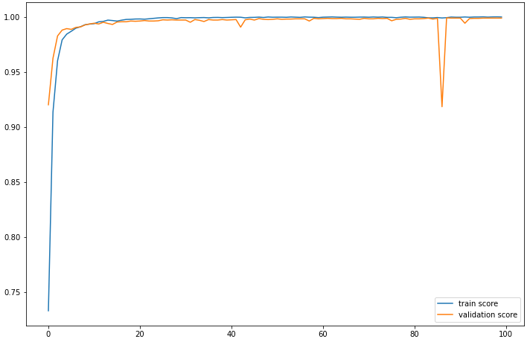
   |  | Reality
   |  | Negative | Positive
  Prediction | Negative | 5139 | 12
  Prediction | Positive | 11 | 453
  Accuracy | Sensitivity | Specificity | Score f1 | AUC
  0.9762 % | 0.9741 % | 0.9978 % | 0.9752 % | 0.9997 %
   |  | Reality
   |  | Negative | Positive
  Prediction | Negative | 5147 | 4
  Prediction | Positive | 7 | 457
  Accuracy | Sensitivity | Specificity | Score f1 | AUC
  0.9849 % | 0.9913 % | 0.9986 % | 0.8153 % | 0.9996 %

Table S28. Result of the DeepLearning algorithm for the prediction of Fluoroquinolones according to each feature space.

- Confusion matrix  - performance score  - Feature space: Space [F1] of the variables of all mutations.  - Learning curve  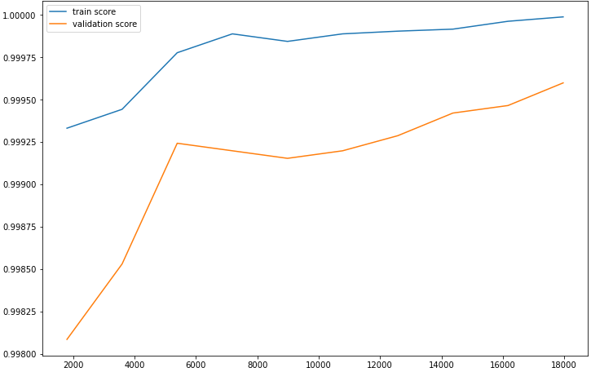 | - Confusion matrix  - performance score  - Feature space: Space [F2] of the variables of the mutations present in the 23 genes most known in antibiotic resistance.  - Learning curve  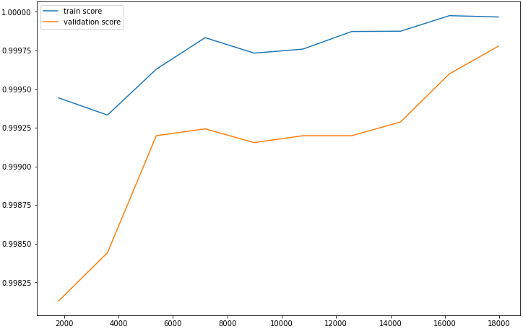
   |  | Reality
   |  | Negative | Positive
  Prediction | Negative | 5350 | 0
  Prediction | Positive | 4 | 261
  Accuracy | Sensitivity | Specificity | Score f1 | AUC
  0.9849 % | 1 % | 0.9992 % | 0.9923 % | 0.9924 %
   |  | Reality
   |  | Negative | Positive
  Prediction | Negative | 5350 | 0
  Prediction | Positive | 3 | 262
  Accuracy | Sensitivity | Specificity | Score f1 | AUC
  0.9886 % | 1 % | 0.9994 % | 0.9943 % | 0.9943 %
- Confusion matrix  - performance score  - Feature space: Space [F3] of the variables selected according to a variance threshold from [F1].  - Learning curve | - Confusion matrix  - performance score  - Feature space: Space [F4] of the "K" best variables selected based on the "X2" test from [F1].  - Learning curve  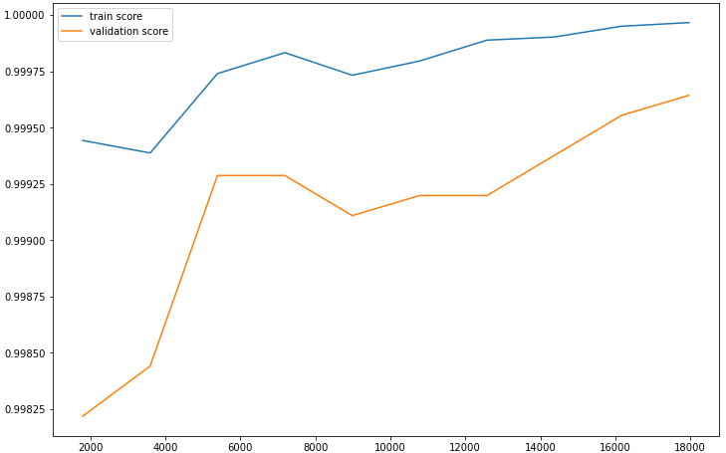
   |  | Reality
   |  | Negative | Positive
  Prediction | Negative | 5350 | 0
  Prediction | Positive | 4 | 261
  Accuracy | Sensitivity | Specificity | Score f1 | AUC
  0.9849 % | 1 % | 0.9992 % | 0.9923 % | 0.9924 %
   |  | Reality
   |  | Negative | Positive
  Prediction | Negative | 5350 | 0
  Prediction | Positive | 5 | 260
  Accuracy | Sensitivity | Specificity | Score f1 | AUC
  0.9811 % | 1 % | 0.9990 % | 0.9904 % | 0.9905 %
- Confusion matrix  - performance score  - Feature space: Space [F5] of the variables selected by the "XGBoost" model from [F1].  - Learning curve  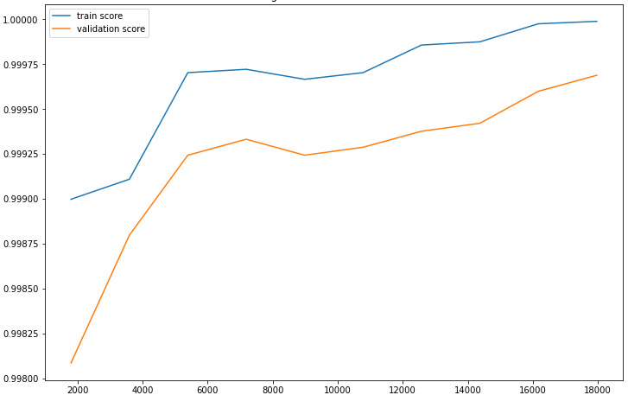 | - Confusion matrix  - performance score  - Feature space: Space [F7] of the selected variables according to a variance threshold from [F2].  - Learning curve
   |  | Reality
   |  | Negative | Positive
  Prediction | Negative | 5350 | 0
  Prediction | Positive | 4 | 261
  Accuracy | Sensitivity | Specificity | Score f1 | AUC
  0.9849 % | 1 % | 0.9992 % | 0.9923 % | 0.9924 %
   |  | Reality
   |  | Negative | Positive
  Prediction | Negative | 5350 | 0
  Prediction | Positive | 3 | 262
  Accuracy | Sensitivity | Specificity | Score f1 | AUC
  0.9886 % | 1 % | 0.9994 % | 0.9943 % | 0.9943 %
- Confusion matrix  - performance score  - Feature space: Space [F8] of the "K" best variables selected based on the "X2" test from [F2].  - Learning curve  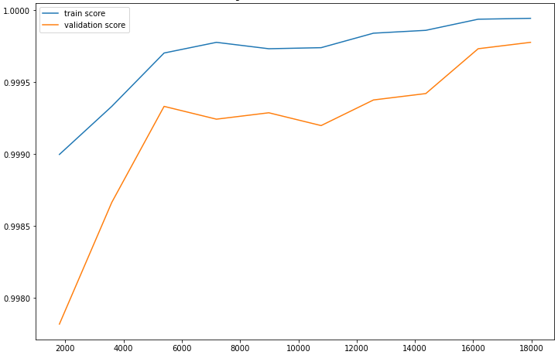 | - Confusion matrix  - performance score  - Feature space: Space [F9] of the variables selected by the "XGBoost" model from [F2].  - Learning curve  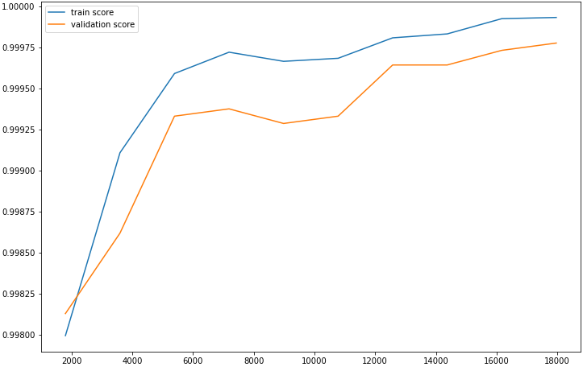
   |  | Reality
   |  | Negative | Positive
  Prediction | Negative | 5350 | 0
  Prediction | Positive | 2 | 263
  Accuracy | Sensitivity | Specificity | Score f1 | AUC
  0.9924 % | 1 % | 0.9996 % | 0.9962 % | 0.9962 %
   |  | Reality
   |  | Negative | Positive
  Prediction | Negative | 5350 | 0
  Prediction | Positive | 4 | 261
  Accuracy | Sensitivity | Specificity | Score f1 | AUC
  0.9849 % | 1 % | 0.9992 % | 0.9923 % | 0.9924 %

Table S29. Result of the XGBoost algorithm for the prediction of Amikacin according to each feature space.

- Confusion matrix  - performance score  - Feature space: Space [F1] of the variables of all mutations.  - Learning curve  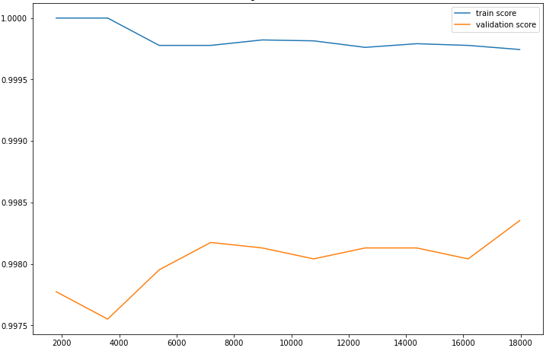 | - Confusion matrix  - performance score  - Feature space: Space [F2] of the variables of the mutations present in the 23 genes most known in antibiotic resistance.  - Learning curve  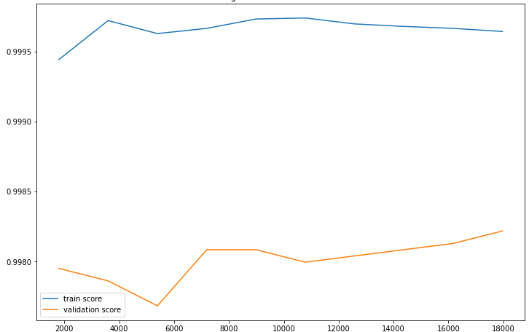
   |  | Reality
   |  | Negative | Positive
  Prediction | Negative | 5347 | 3
  Prediction | Positive | 6 | 259
  Accuracy | Sensitivity | Specificity | Score f1 | AUC
  0.9773 % | 0.9885 % | 0.9988 % | 0.9829 % | 0.9883 %
   |  | Reality
   |  | Negative | Positive
  Prediction | Negative | 5347 | 3
  Prediction | Positive | 6 | 259
  Accuracy | Sensitivity | Specificity | Score f1 | AUC
  0.9773 % | 0.9885 % | 0.9988 % | 0.9829 % | 0.9883 %
- Confusion matrix  - performance score  - Feature space: Space [F3] of the variables selected according to a variance threshold from [F1].  - Learning curve | - Confusion matrix  - performance score  - Feature space: Space [F4] of the "K" best variables selected based on the "X2" test from [F1].  - Learning curve  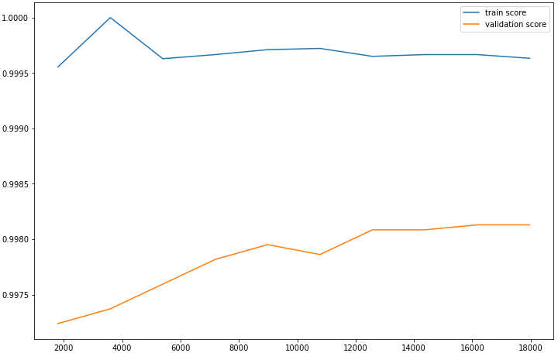
   |  | Reality
   |  | Negative | Positive
  Prediction | Negative | 5347 | 3
  Prediction | Positive | 6 | 259
  Accuracy | Sensitivity | Specificity | Score f1 | AUC
  0.9773 % | 0.9885 % | 0.9988 % | 0.9829 % | 0.9883 %
   |  | Reality
   |  | Negative | Positive
  Prediction | Negative | 5344 | 6
  Prediction | Positive | 6 | 259
  Accuracy | Sensitivity | Specificity | Score f1 | AUC
  0.9773 % | 0.9773 % | 0.9988 % | 0.9773 % | 0.9881 %
- Confusion matrix  - performance score  - Feature space: Space [F5] of the variables selected by the "LightGBM" model from [F1].  - Learning curve  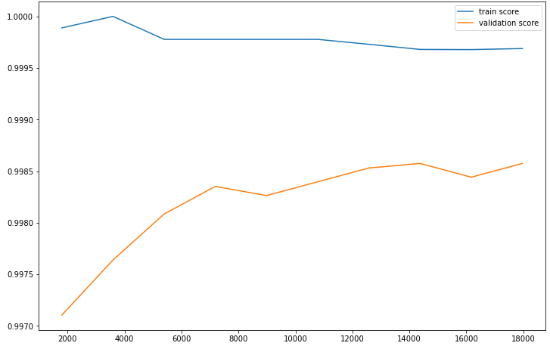 | - Confusion matrix  - performance score  - Feature space: Space [F7] of the selected variables according to a variance threshold from [F2].  - Learning curve
   |  | Reality
   |  | Negative | Positive
  Prediction | Negative | 5347 | 3
  Prediction | Positive | 6 | 259
  Accuracy | Sensitivity | Specificity | Score f1 | AUC
  0.9773 % | 0.9885 % | 0.9988 % | 0.9829 % | 0.9883 %
   |  | Reality
   |  | Negative | Positive
  Prediction | Negative | 5347 | 3
  Prediction | Positive | 6 | 259
  Accuracy | Sensitivity | Specificity | Score f1 | AUC
  0.9773 % | 0.9885 % | 0.9988 % | 0.9829 % | 0.9883 %
- Confusion matrix  - performance score  - Feature space: Space [F8] of the "K" best variables selected based on the "X2" test from [F2].  - Learning curve  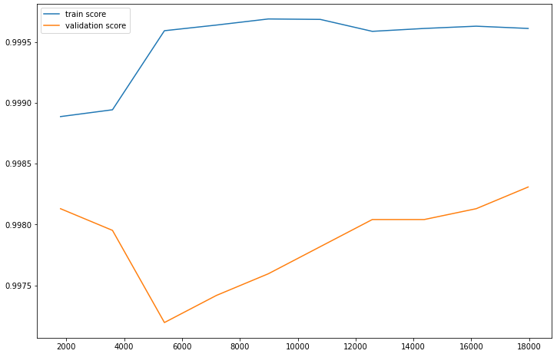 | - Confusion matrix  - performance score  - Feature space: Space [F9] of the variables selected by the "LightGBM" model from [F2].  - Learning curve  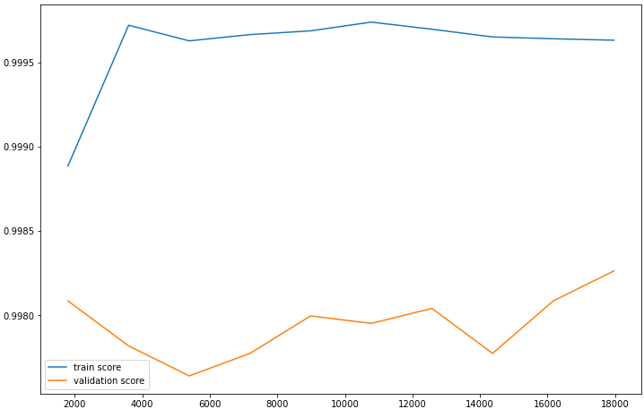
   |  | Reality
   |  | Negative | Positive
  Prediction | Negative | 5348 | 2
  Prediction | Positive | 6 | 259
  Accuracy | Sensitivity | Specificity | Score f1 | AUC
  0.9773 % | 0.9923 % | 0.9988 % | 0.9847 % | 0.9884 %
   |  | Reality
   |  | Negative | Positive
  Prediction | Negative | 5347 | 3
  Prediction | Positive | 6 | 259
  Accuracy | Sensitivity | Specificity | Score f1 | AUC
  0.9773 % | 0.9885 % | 0.9988 % | 0.9829 % | 0.9883 %

Table S30. Result of the LightGBM algorithm for the prediction of Amikacin according to each feature space.

- Confusion matrix  - performance score  - Feature space: Space [F1] of the variables of all mutations.  - Learning curve  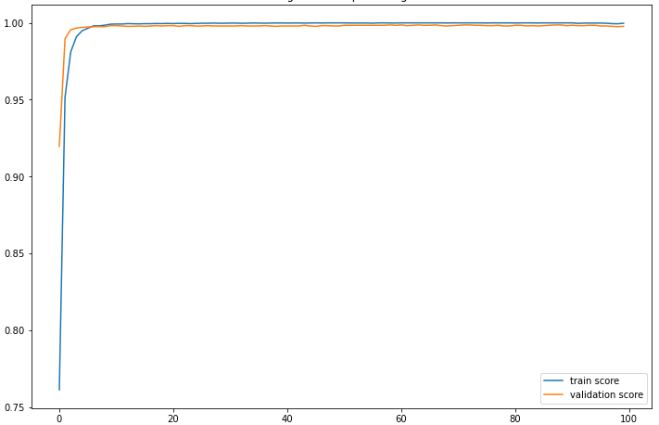 | - Confusion matrix  - performance score  - Feature space: Space [F2] of the variables of the mutations present in the 23 genes most known in antibiotic resistance.  - Learning curve
   |  | Reality
   |  | Negative | Positive
  Prediction | Negative | 5346 | 4
  Prediction | Positive | 6 | 259
  Accuracy | Sensitivity | Specificity | Score f1 | AUC
  0.9773 % | 0.9847 % | 0.9988 % | 0.9810 % | 0.9938 %
   |  | Reality
   |  | Negative | Positive
  Prediction | Negative | 5350 | 0
  Prediction | Positive | 10 | 255
  Accuracy | Sensitivity | Specificity | Score f1 | AUC
  0.9622 % | 1 % | 0.9981 % | 0.9807 % | 0.9887 %
- Confusion matrix  - performance score  - Feature space: Space [F3] of the variables selected according to a variance threshold from [F1].  - Learning curve  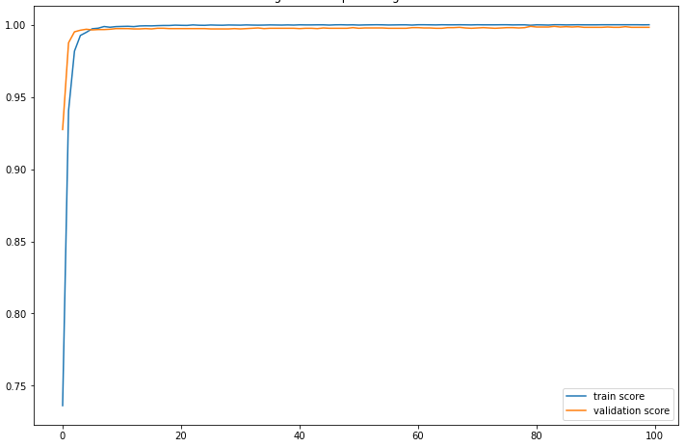 | - Confusion matrix  - performance score  - Feature space: Space [F4] of the "K" best variables selected based on the "X2" test from [F1].  - Learning curve  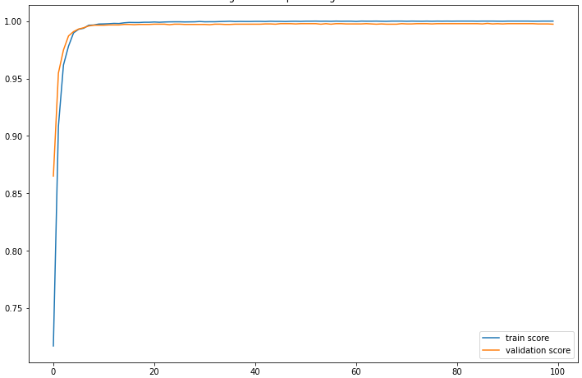
   |  | Reality
   |  | Negative | Positive
  Prediction | Negative | 5349 | 1
  Prediction | Positive | 9 | 256
  Accuracy | Sensitivity | Specificity | Score f1 | AUC
  0.9660 % | 0.9961 % | 0.9983 % | 0.9808 % | 0.9943 %
   |  | Reality
   |  | Negative | Positive
  Prediction | Negative | 5349 | 1
  Prediction | Positive | 10 | 255
  Accuracy | Sensitivity | Specificity | Score f1 | AUC
  0.9622 % | 0.9960 % | 0.9981 % | 0.9788 % | 0.9942 %
- Confusion matrix  - performance score  - Feature space: Space [F8] of the "K" best variables selected based on the "X2" test from [F2].  - Learning curve  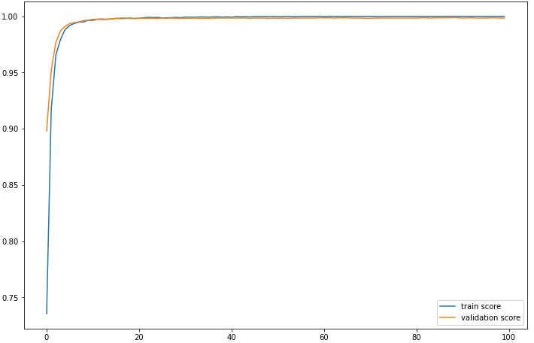 | - Confusion matrix  - performance score  - Feature space: Space [F7] of the selected variables according to a variance threshold from [F2].  - Learning curve  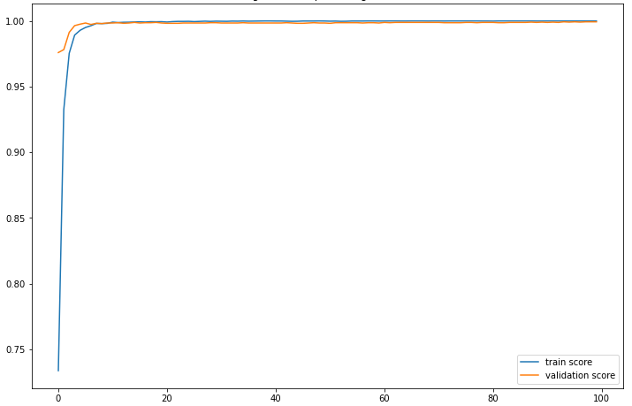
   |  | Reality
   |  | Negative | Positive
  Prediction | Negative | 5349 | 1
  Prediction | Positive | 6 | 259
  Accuracy | Sensitivity | Specificity | Score f1 | AUC
  0.9773 % | 0.9961 % | 0.9988 % | 0.9866 % | 0.9912 %
   |  | Reality
   |  | Negative | Positive
  Prediction | Negative | 5349 | 1
  Prediction | Positive | 7 | 258
  Accuracy | Sensitivity | Specificity | Score f1 | AUC
  0.9735 % | 0.9961 % | 0.9986 % | 0.8153 % | 0.9958 %

Table S31. Result of the DeepLearning algorithm for the prediction of Amikacin according to each feature space.

- Confusion matrix  - performance score  - Feature space: Space [F1] of the variables of all mutations.  - Learning curve  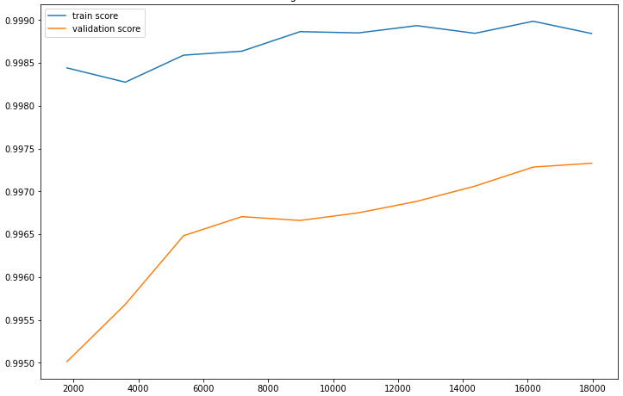 | - Confusion matrix  - performance score  - Feature space: Space [F2] of the variables of the mutations present in the 23 genes most known in antibiotic resistance.  - Learning curve  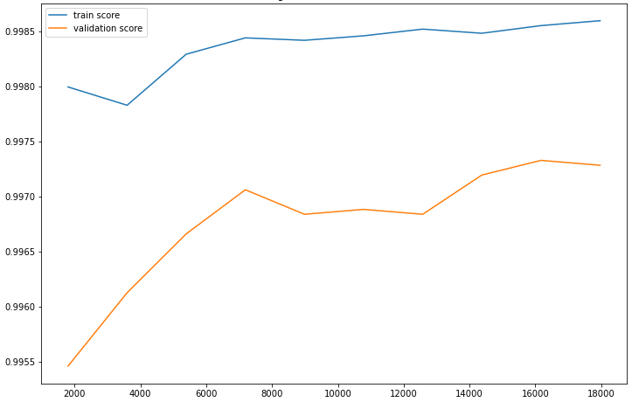
   |  | Reality
   |  | Negative | Positive
  Prediction | Negative | 5334 | 2
  Prediction | Positive | 10 | 269
  Accuracy | Sensitivity | Specificity | Score f1 | AUC
  0.9641 % | 0.9926 % | 0.9981 % | 0.9781 % | 0.9818 %
   |  | Reality
   |  | Negative | Positive
  Prediction | Negative | 5335 | 1
  Prediction | Positive | 9 | 270
  Accuracy | Sensitivity | Specificity | Score f1 | AUC
  0.9677 % | 0.9963 % | 0.9983 % | 0.9818 % | 0.9837 %
- Confusion matrix  - performance score  - Feature space: Space [F3] of the variables selected according to a variance threshold from [F1].  - Learning curve | - Confusion matrix  - performance score  - Feature space: Space [F4] of the "K" best variables selected based on the "X2" test from [F1].  - Learning curve  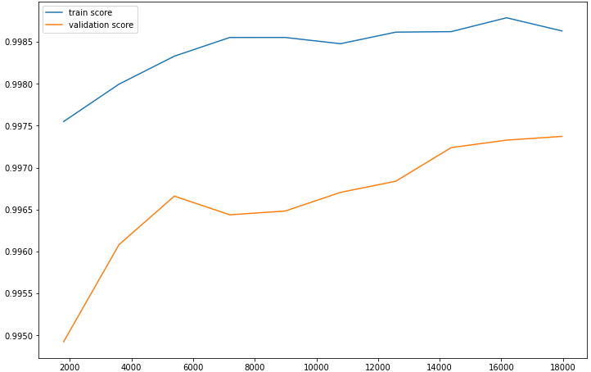
   |  | Reality
   |  | Negative | Positive
  Prediction | Negative | 5334 | 2
  Prediction | Positive | 10 | 269
  Accuracy | Sensitivity | Specificity | Score f1 | AUC
  0.9641 % | 0.9926 % | 0.9981 % | 0.9781 % | 0.9818 %
   |  | Reality
   |  | Negative | Positive
  Prediction | Negative | 5335 | 1
  Prediction | Positive | 11 | 268
  Accuracy | Sensitivity | Specificity | Score f1 | AUC
  0.9605 % | 0.9962 % | 0.9979 % | 0.9781 % | 0.9801 %
- Confusion matrix  - performance score  - Feature space: Space [F5] of the variables selected by the "XGBoost" model from [F1].  - Learning curve  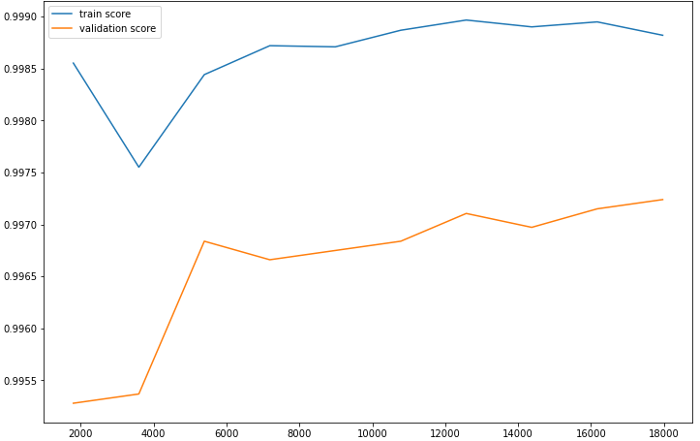 | - Confusion matrix  - performance score  - Feature space: Space [F7] of the selected variables according to a variance threshold from [F2].  - Learning curve
   |  | Reality
   |  | Negative | Positive
  Prediction | Negative | 5334 | 2
  Prediction | Positive | 10 | 269
  Accuracy | Sensitivity | Specificity | Score f1 | AUC
  0.9641 % | 0.9926 % | 0.9981 % | 0.9781 % | 0.9818 %
   |  | Reality
   |  | Negative | Positive
  Prediction | Negative | 5335 | 1
  Prediction | Positive | 9 | 270
  Accuracy | Sensitivity | Specificity | Score f1 | AUC
  0.9677 % | 0.9963 % | 0.9983 % | 0.9818 % | 0.9837 %
- Confusion matrix  - performance score  - Feature space: Space [F8] of the "K" best variables selected based on the "X2" test from [F2].  - Learning curve  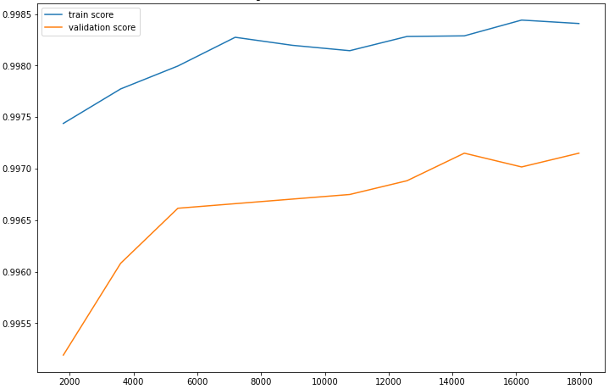 | - Confusion matrix  - performance score  - Feature space: Space [F9] of the variables selected by the "XGBoost" model from [F2].  - Learning curve  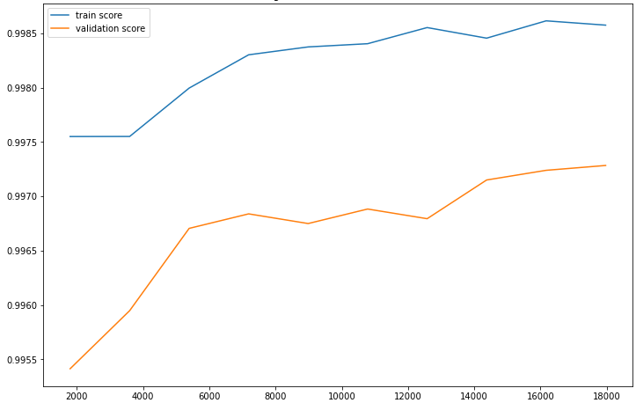
   |  | Reality
   |  | Negative | Positive
  Prediction | Negative | 5335 | 1
  Prediction | Positive | 7 | 272
  Accuracy | Sensitivity | Specificity | Score f1 | AUC
  0.9749 % | 0.9963 % | 0.9986 % | 0.9855 % | 0.9873 %
   |  | Reality
   |  | Negative | Positive
  Prediction | Negative | 5335 | 1
  Prediction | Positive | 9 | 270
  Accuracy | Sensitivity | Specificity | Score f1 | AUC
  0.9677 % | 0.9963 % | 0.9983 % | 0.9818 % | 0.9837 %

Table S32. Result of the XGBoost algorithm for the prediction of Capreomycin according to each feature space.

- Confusion matrix  - performance score  - Feature space: Space [F1] of the variables of all mutations.  - Learning curve  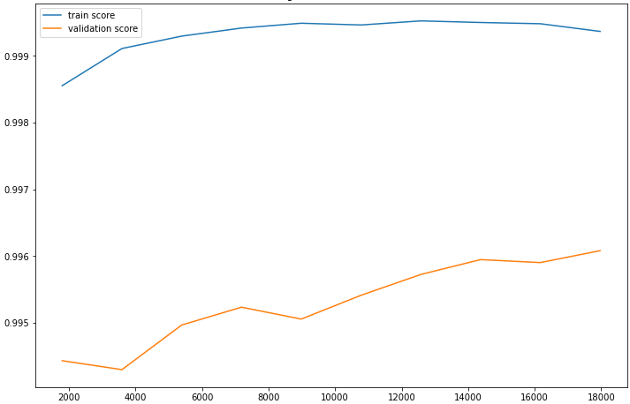 | - Confusion matrix  - performance score  - Feature space: Space [F2] of the variables of the mutations present in the 23 genes most known in antibiotic resistance.  - Learning curve  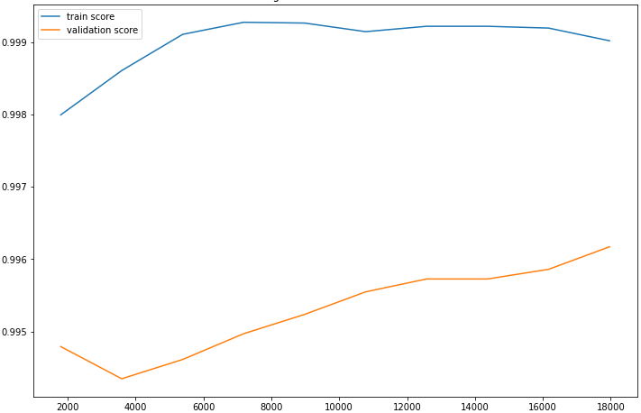
   |  | Reality
   |  | Negative | Positive
  Prediction | Negative | 5334 | 2
  Prediction | Positive | 10 | 269
  Accuracy | Sensitivity | Specificity | Score f1 | AUC
  0.9641 % | 0.9926 % | 0.9981 % | 0.9781 % | 0.9818 %
   |  | Reality
   |  | Negative | Positive
  Prediction | Negative | 5335 | 1
  Prediction | Positive | 8 | 271
  Accuracy | Sensitivity | Specificity | Score f1 | AUC
  0.9713 % | 0.9963 % | 0.9985 % | 0.9836 % | 0.9855 %
- Confusion matrix  - performance score  - Feature space: Space [F3] of the variables selected according to a variance threshold from [F1].  - Learning curve | - Confusion matrix  - performance score  - Feature space: Space [F4] of the "K" best variables selected based on the "X2" test from [F1].  - Learning curve  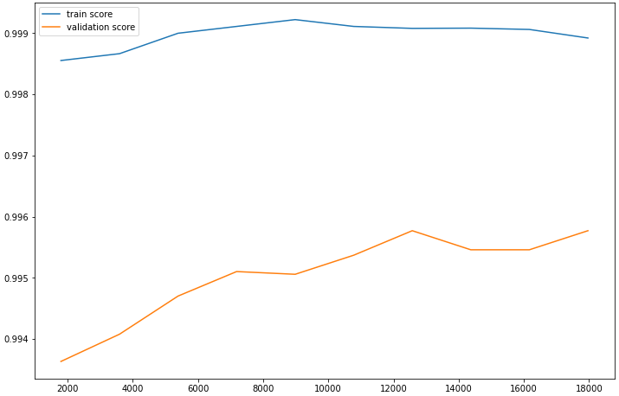
   |  | Reality
   |  | Negative | Positive
  Prediction | Negative | 5334 | 2
  Prediction | Positive | 10 | 269
  Accuracy | Sensitivity | Specificity | Score f1 | AUC
  0.9641 % | 0.9926 % | 0.9981 % | 0.9781 % | 0.9818 %
   |  | Reality
   |  | Negative | Positive
  Prediction | Negative | 5334 | 2
  Prediction | Positive | 9 | 270
  Accuracy | Sensitivity | Specificity | Score f1 | AUC
  0.9677 % | 0.9926 % | 0.9988 % | 0.9983 % | 0.9836 %
- Confusion matrix  - performance score  - Feature space: Space [F5] of the variables selected by the "LightGBM" model from [F1].  - Learning curve  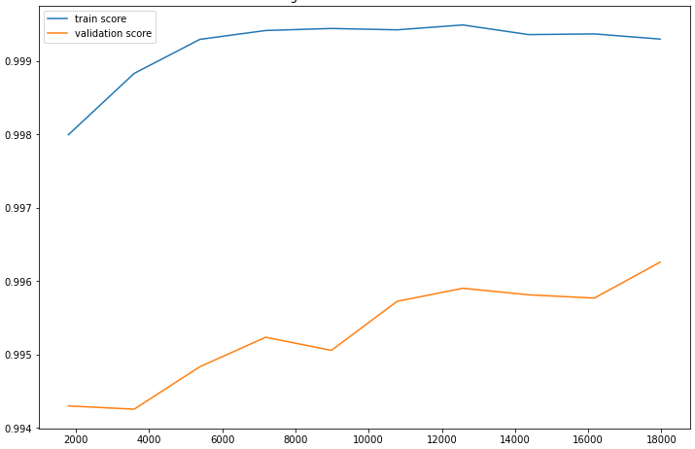 | - Confusion matrix  - performance score  - Feature space: Space [F7] of the selected variables according to a variance threshold from [F2].  - Learning curve
   |  | Reality
   |  | Negative | Positive
  Prediction | Negative | 5333 | 3
  Prediction | Positive | 10 | 269
  Accuracy | Sensitivity | Specificity | Score f1 | AUC
  0.9641 % | 0.9889 % | 0.9981 % | 0.9764 % | 0.9817 %
   |  | Reality
   |  | Negative | Positive
  Prediction | Negative | 5335 | 1
  Prediction | Positive | 8 | 271
  Accuracy | Sensitivity | Specificity | Score f1 | AUC
  0.9713 % | 0.9963 % | 0.9985 % | 0.9836 % | 0.9855 %
- Confusion matrix  - performance score  - Feature space: Space [F8] of the "K" best variables selected based on the "X2" test from [F2].  - Learning curve  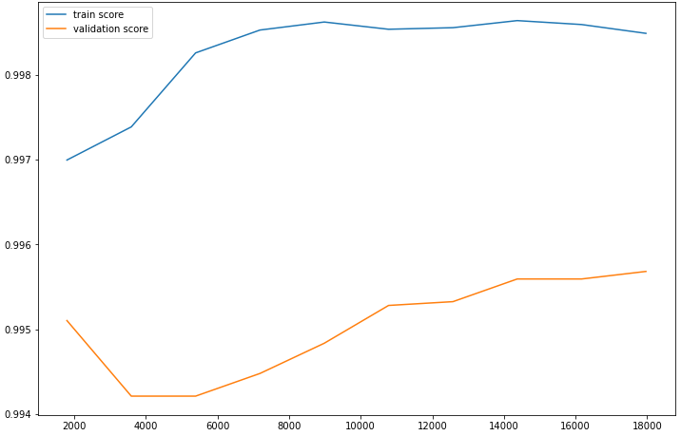 | - Confusion matrix  - performance score  - Feature space: Space [F9] of the variables selected by the "LightGBM" model from [F2].  - Learning curve  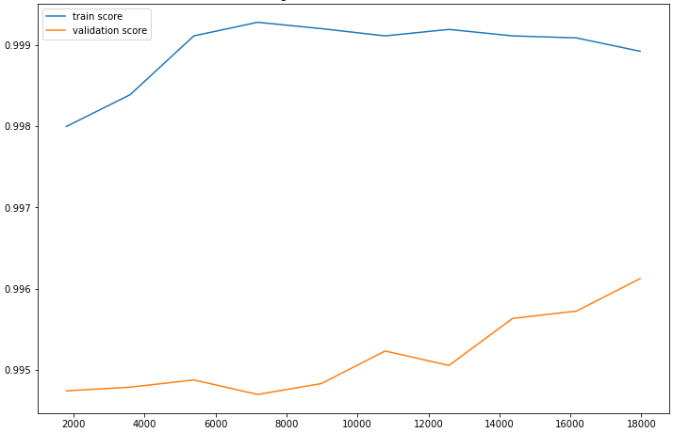
   |  | Reality
   |  | Negative | Positive
  Prediction | Negative | 5334 | 2
  Prediction | Positive | 8 | 271
  Accuracy | Sensitivity | Specificity | Score f1 | AUC
  0.9713 % | 0.9926 % | 0.9985 % | 0.9818 % | 0.9854 %
   |  | Reality
   |  | Negative | Positive
  Prediction | Negative | 5335 | 1
  Prediction | Positive | 8 | 271
  Accuracy | Sensitivity | Specificity | Score f1 | AUC
  0.9713 % | 0.9963 % | 0.9985 % | 0.9836 % | 0.9855 %

Table S33. Result of the LightGBM algorithm for the prediction of Capreomycin according to each feature space.

- Confusion matrix  - performance score  - Feature space: Space [F1] of the variables of all mutations.  - Learning curve  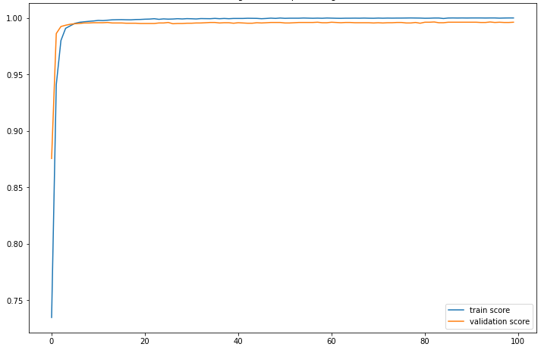 | - Confusion matrix  - performance score  - Feature space: Space [F2] of the variables of the mutations present in the 23 genes most known in antibiotic resistance.  - Learning curve  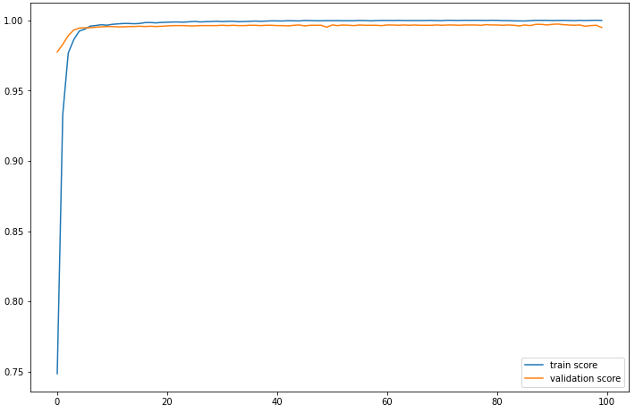
   |  | Reality
   |  | Negative | Positive
  Prediction | Negative | 5332 | 4
  Prediction | Positive | 13 | 266
  Accuracy | Sensitivity | Specificity | Score f1 | AUC
  0.9534 % | 0.9851 % | 0.9975 % | 0.9690 % | 0.9959 %
   |  | Reality
   |  | Negative | Positive
  Prediction | Negative | 5333 | 3
  Prediction | Positive | 12 | 267
  Accuracy | Sensitivity | Specificity | Score f1 | AUC
  0.9569 % | 0.9888 % | 0.9977 % | 0.9807 % | 0.9922 %
- Confusion matrix  - performance score  - Feature space: Space [F3] of the variables selected according to a variance threshold from [F1].  - Learning curve  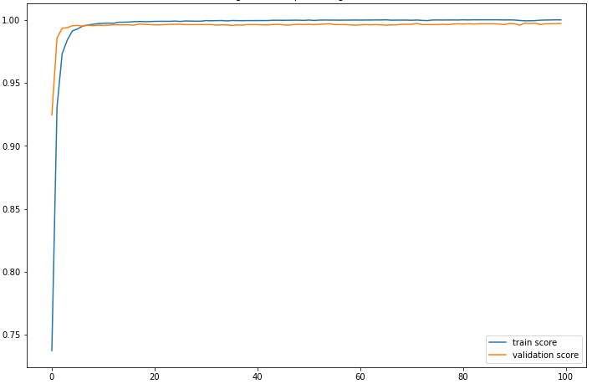 | - Confusion matrix  - performance score  - Feature space: Space [F4] of the "K" best variables selected based on the "X2" test from [F1].  - Learning curve  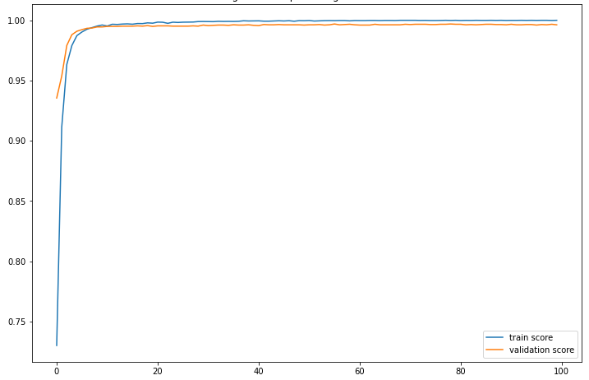
   |  | Reality
   |  | Negative | Positive
  Prediction | Negative | 5331 | 5
  Prediction | Positive | 12 | 267
  Accuracy | Sensitivity | Specificity | Score f1 | AUC
  0.9569 % | 0.9816 % | 0.9977 % | 0.9691 % | 0.9921 %
   |  | Reality
   |  | Negative | Positive
  Prediction | Negative | 5330 | 6
  Prediction | Positive | 13 | 266
  Accuracy | Sensitivity | Specificity | Score f1 | AUC
  0.9534 % | 0.9779 % | 0.9975 % | 0.9655 % | 0.9958 %
- Confusion matrix  - performance score  - Feature space: Space [F8] of the "K" best variables selected based on the "X2" test from [F2].  - Learning curve  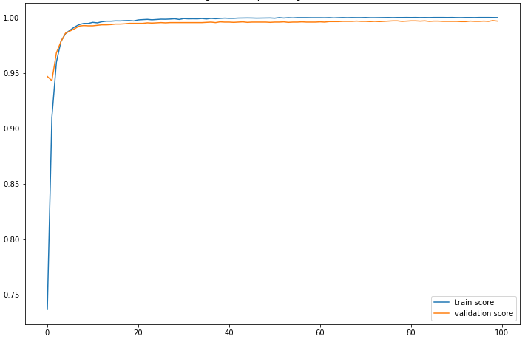 | - Confusion matrix  - performance score  - Feature space: Space [F7] of the selected variables according to a variance threshold from [F2].  - Learning curve  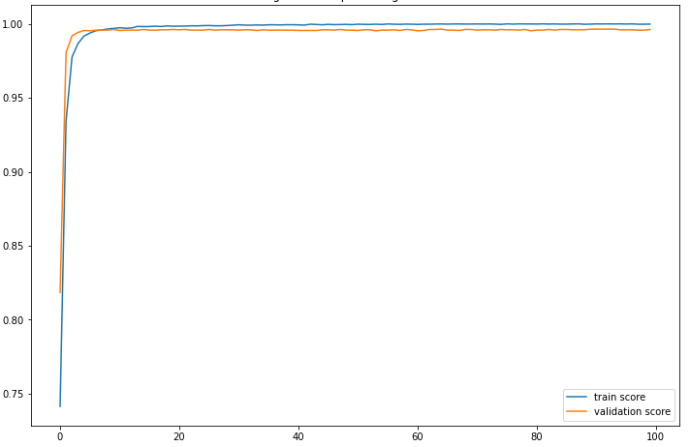
   |  | Reality
   |  | Negative | Positive
  Prediction | Negative | 5330 | 6
  Prediction | Positive | 13 | 266
  Accuracy | Sensitivity | Specificity | Score f1 | AUC
  0.9534 % | 0.9779 % | 0.9975 % | 0.9655 % | 0.9956 %
   |  | Reality
   |  | Negative | Positive
  Prediction | Negative | 5335 | 1
  Prediction | Positive | 14 | 265
  Accuracy | Sensitivity | Specificity | Score f1 | AUC
  0.9498 % | 0.9962 % | 0.9973 % | 0.9724 % | 0.9929 %

Table S34. Result of the DeepLearning algorithm for the prediction of Capreomycin according to each feature space.

- Confusion matrix  - performance score  - Feature space: Space [F1] of the variables of all mutations.  - Learning curve  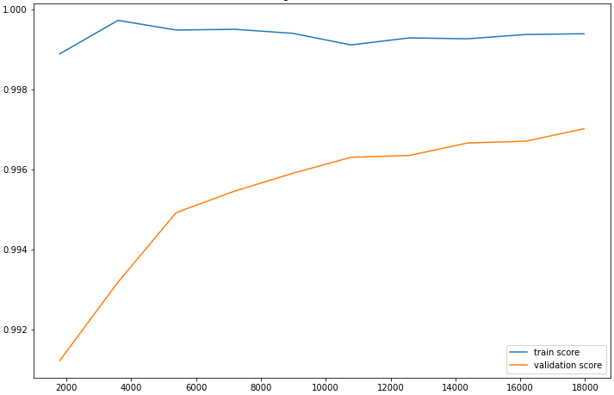 | - Confusion matrix  - performance score  - Feature space: Space [F2] of the variables of the mutations present in the 23 genes most known in antibiotic resistance.  - Learning curve  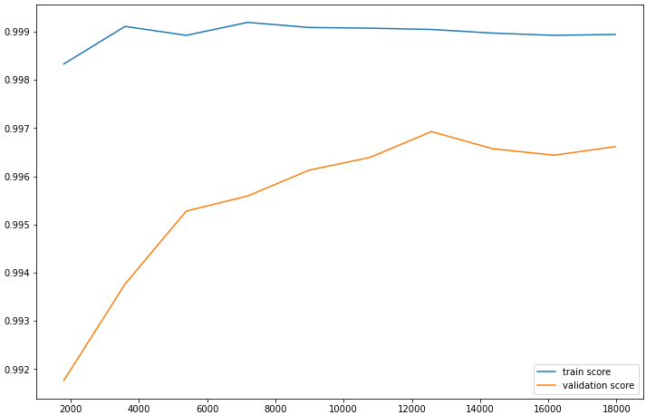
   |  | Reality
   |  | Negative | Positive
  Prediction | Negative | 5176 | 5
  Prediction | Positive | 14 | 420
  Accuracy | Sensitivity | Specificity | Score f1 | AUC
  0.9677 % | 0.9882 % | 0.9973 % | 0.9778 % | 0.9833 %
   |  | Reality
   |  | Negative | Positive
  Prediction | Negative | 5178 | 3
  Prediction | Positive | 12 | 422
  Accuracy | Sensitivity | Specificity | Score f1 | AUC
  0.9723 % | 0.9929 % | 0.9976 % | 0.9825 % | 0.9858 %
- Confusion matrix  - performance score  - Feature space: Space [F3] of the variables selected according to a variance threshold from [F1].  - Learning curve | - Confusion matrix  - performance score  - Feature space: Space [F4] of the "K" best variables selected based on the "X2" test from [F1].  - Learning curve  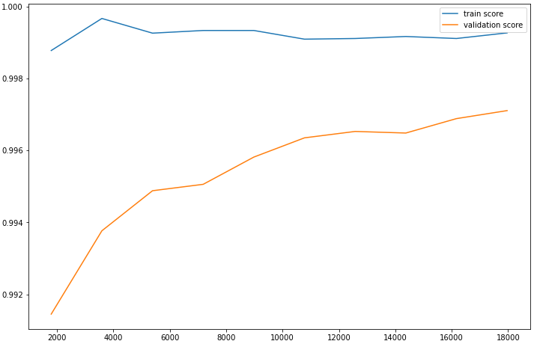
   |  | Reality
   |  | Negative | Positive
  Prediction | Negative | 5176 | 5
  Prediction | Positive | 14 | 420
  Accuracy | Sensitivity | Specificity | Score f1 | AUC
  0.9677 % | 0.9882 % | 0.9973 % | 0.9778 % | 0.9833 %
   |  | Reality
   |  | Negative | Positive
  Prediction | Negative | 5176 | 5
  Prediction | Positive | 13 | 421
  Accuracy | Sensitivity | Specificity | Score f1 | AUC
  0.9700 % | 0.9882 % | 0.9974 % | 0.9790 % | 0.9845 %
- Confusion matrix  - performance score  - Feature space: Space [F5] of the variables selected by the "XGBoost" model from [F1].  - Learning curve  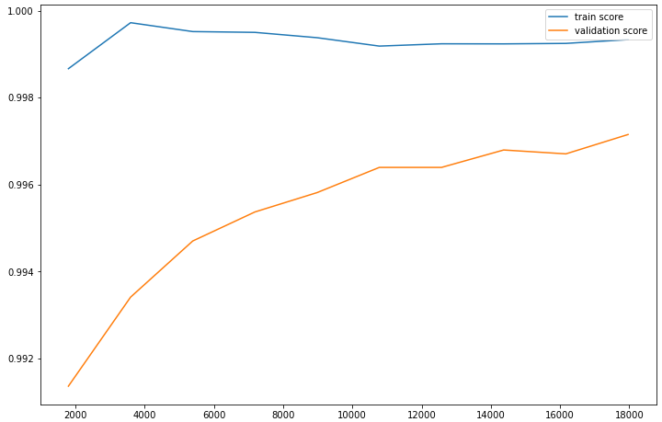 | - Confusion matrix  - performance score  - Feature space: Space [F7] of the selected variables according to a variance threshold from [F2].  - Learning curve
   |  | Reality
   |  | Negative | Positive
  Prediction | Negative | 5175 | 6
  Prediction | Positive | 14 | 420
  Accuracy | Sensitivity | Specificity | Score f1 | AUC
  0.9677 % | 0.9859 % | 0.9973 % | 0.9767 % | 0.9832 %
   |  | Reality
   |  | Negative | Positive
  Prediction | Negative | 5178 | 3
  Prediction | Positive | 12 | 422
  Accuracy | Sensitivity | Specificity | Score f1 | AUC
  0.9723 % | 0.9929 % | 0.9976 % | 0.9825 % | 0.9858 %
- Confusion matrix  - performance score  - Feature space: Space [F8] of the "K" best variables selected based on the "X2" test from [F2].  - Learning curve  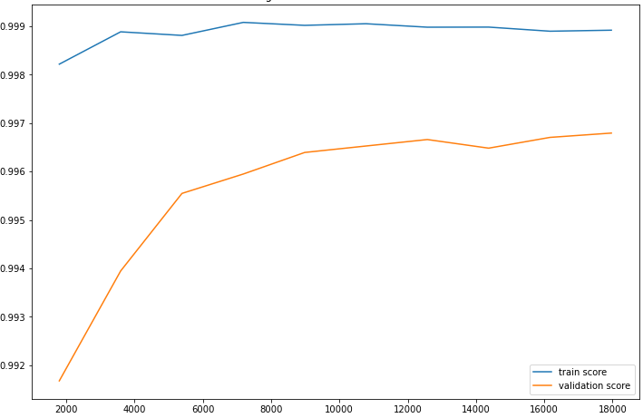 | - Confusion matrix  - performance score  - Feature space: Space [F9] of the variables selected by the "XGBoost" model from [F2].  - Learning curve  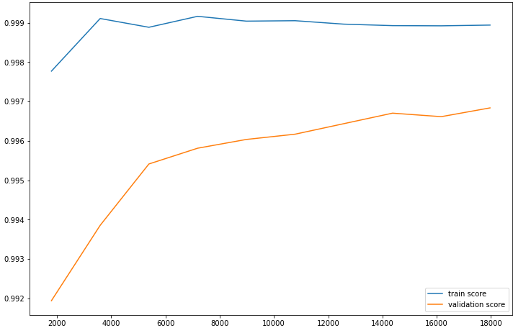
   |  | Reality
   |  | Negative | Positive
  Prediction | Negative | 5178 | 3
  Prediction | Positive | 13 | 421
  Accuracy | Sensitivity | Specificity | Score f1 | AUC
  0.9700 % | 0.9929 % | 0.9974 % | 0.9813 % | 0.9847 %
   |  | Reality
   |  | Negative | Positive
  Prediction | Negative | 5178 | 3
  Prediction | Positive | 13 | 421
  Accuracy | Sensitivity | Specificity | Score f1 | AUC
  0.9700 % | 0.9929 % | 0.9974 % | 0.9813 % | 0.9847 %

Table S35. Result of the XGBoost algorithm for the prediction of Kanamycin according to each feature space.

- Confusion matrix  - performance score  - Feature space: Space [F1] of the variables of all mutations.  - Learning curve  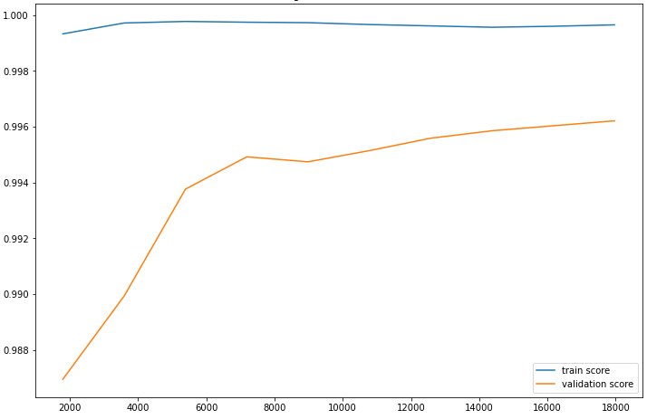 | - Confusion matrix  - performance score  - Feature space: Space [F2] of the variables of the mutations present in the 23 genes most known in antibiotic resistance.  - Learning curve  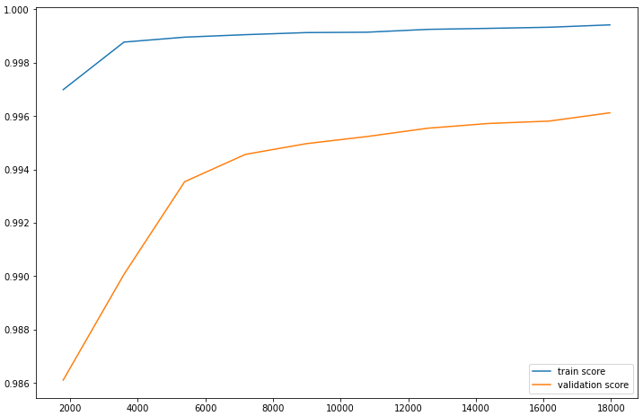
   |  | Reality
   |  | Negative | Positive
  Prediction | Negative | 5176 | 5
  Prediction | Positive | 15 | 419
  Accuracy | Sensitivity | Specificity | Score f1 | AUC
  0.9654 % | 0.9882 % | 0.9971 % | 0.9766 % | 0.9822 %
   |  | Reality
   |  | Negative | Positive
  Prediction | Negative | 5178 | 3
  Prediction | Positive | 15 | 419
  Accuracy | Sensitivity | Specificity | Score f1 | AUC
  0.9654 % | 0.9928 % | 0.9971 % | 0.9789 % | 0.9824 %
- Confusion matrix  - performance score  - Feature space: Space [F3] of the variables selected according to a variance threshold from [F1].  - Learning curve | - Confusion matrix  - performance score  - Feature space: Space [F4] of the "K" best variables selected based on the "X2" test from [F1].  - Learning curve  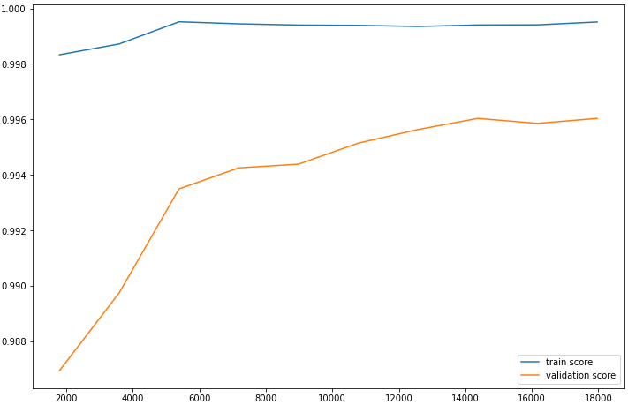
   |  | Reality
   |  | Negative | Positive
  Prediction | Negative | 5176 | 5
  Prediction | Positive | 15 | 419
  Accuracy | Sensitivity | Specificity | Score f1 | AUC
  0.9654 % | 0.9882 % | 0.9971 % | 0.9766 % | 0.9822 %
   |  | Reality
   |  | Negative | Positive
  Prediction | Negative | 5176 | 5
  Prediction | Positive | 14 | 420
  Accuracy | Sensitivity | Specificity | Score f1 | AUC
  0.9677 % | 0.9882 % | 0.9973 % | 0.9778 % | 0.9833 %
- Confusion matrix  - performance score  - Feature space: Space [F5] of the variables selected by the "LightGBM" model from [F1].  - Learning curve  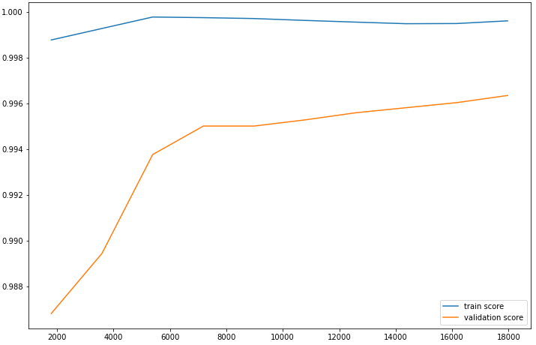 | - Confusion matrix  - performance score  - Feature space: Space [F7] of the selected variables according to a variance threshold from [F2].  - Learning curve
   |  | Reality
   |  | Negative | Positive
  Prediction | Negative | 5178 | 3
  Prediction | Positive | 15 | 419
  Accuracy | Sensitivity | Specificity | Score f1 | AUC
  0.9654 % | 0.9928 % | 0.9971 % | 0.9789 % | 0.9824 %
   |  | Reality
   |  | Negative | Positive
  Prediction | Negative | 5178 | 3
  Prediction | Positive | 15 | 419
  Accuracy | Sensitivity | Specificity | Score f1 | AUC
  0.9654 % | 0.9928 % | 0.9971 % | 0.9789 % | 0.9824 %
- Confusion matrix  - performance score  - Feature space: Space [F8] of the "K" best variables selected based on the "X2" test from [F2].  - Learning curve  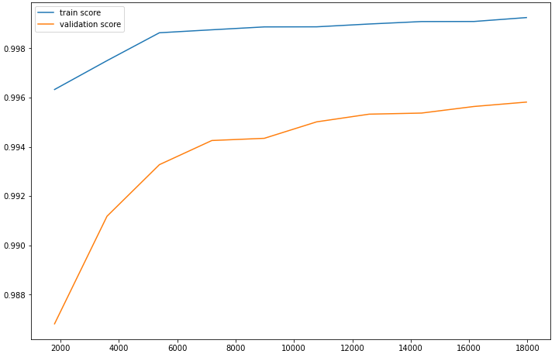 | - Confusion matrix  - performance score  - Feature space: Space [F9] of the variables selected by the "LightGBM" model from [F2].  - Learning curve  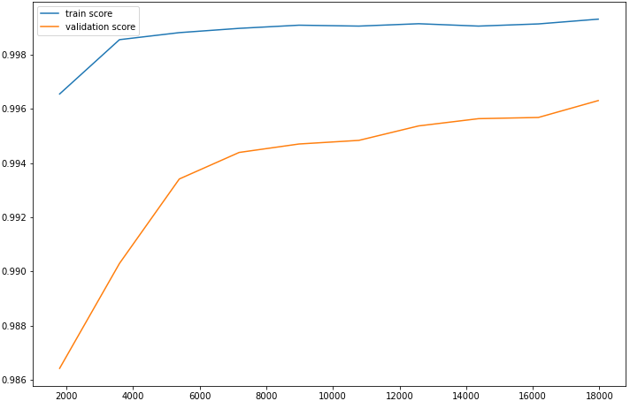
   |  | Reality
   |  | Negative | Positive
  Prediction | Negative | 5175 | 6
  Prediction | Positive | 15 | 419
  Accuracy | Sensitivity | Specificity | Score f1 | AUC
  0.9654 % | 0.9858 % | 0.9985 % | 0.9755 % | 0.9821 %
   |  | Reality
   |  | Negative | Positive
  Prediction | Negative | 5178 | 3
  Prediction | Positive | 15 | 419
  Accuracy | Sensitivity | Specificity | Score f1 | AUC
  0.9654 % | 0.9928 % | 0.9971 % | 0.9789 % | 0.9824 %

Table S36. Result of the LightGBM algorithm for the prediction of Kanamycin according to each feature space.

- Confusion matrix  - performance score  - Feature space: Space [F1] of the variables of all mutations.  - Learning curve  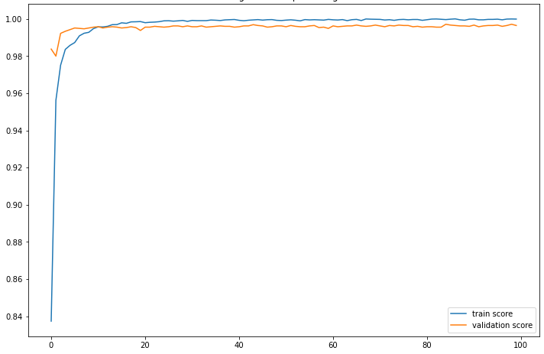 | - Confusion matrix  - performance score  - Feature space: Space [F2] of the variables of the mutations present in the 23 genes most known in antibiotic resistance.  - Learning curve  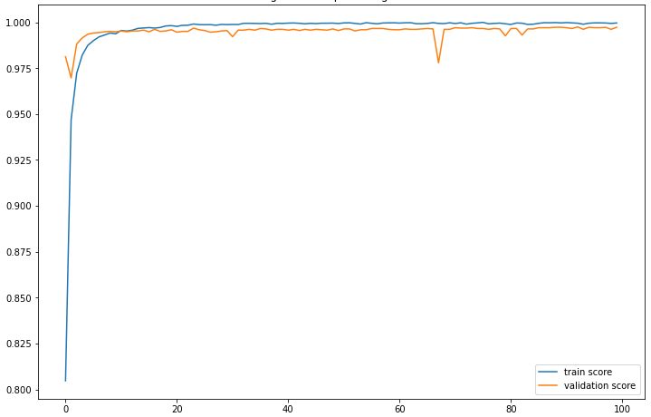
   |  | Reality
   |  | Negative | Positive
  Prediction | Negative | 5173 | 8
  Prediction | Positive | 16 | 418
  Accuracy | Sensitivity | Specificity | Score f1 | AUC
  0.9631 % | 0.9812 % | 0.9969 % | 0.9690 % | 0.9988 %
   |  | Reality
   |  | Negative | Positive
  Prediction | Negative | 5172 | 9
  Prediction | Positive | 12 | 422
  Accuracy | Sensitivity | Specificity | Score f1 | AUC
  0.9723 % | 0.9791 % | 0.9976 % | 0.9757 % | 0.9997 %
- Confusion matrix  - performance score  - Feature space: Space [F3] of the variables selected according to a variance threshold from [F1].  - Learning curve  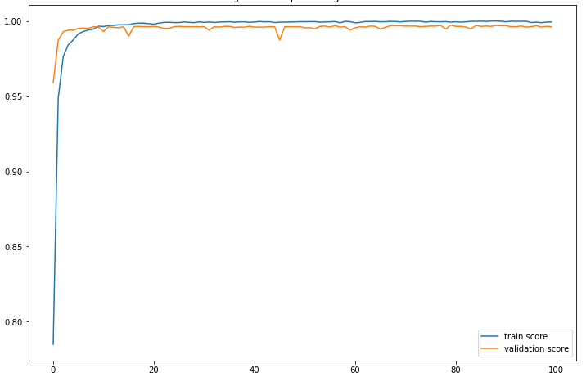 | - Confusion matrix  - performance score  - Feature space: Space [F4] of the "K" best variables selected based on the "X2" test from [F1].  - Learning curve  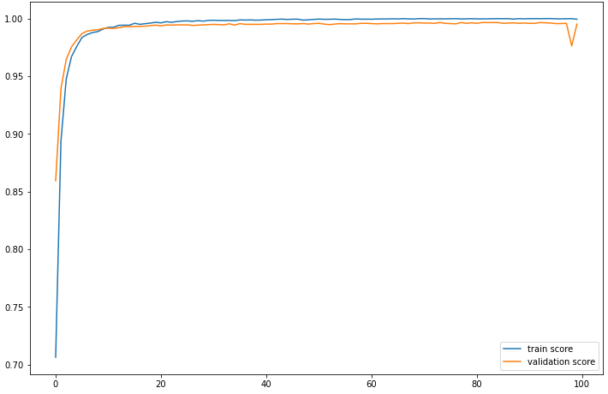
   |  | Reality
   |  | Negative | Positive
  Prediction | Negative | 5177 | 4
  Prediction | Positive | 15 | 419
  Accuracy | Sensitivity | Specificity | Score f1 | AUC
  0.9654 % | 0.9905 % | 0.9971 % | 0.9778 % | 0.9950 %
   |  | Reality
   |  | Negative | Positive
  Prediction | Negative | 5179 | 2
  Prediction | Positive | 25 | 409
  Accuracy | Sensitivity | Specificity | Score f1 | AUC
  0.9423 % | 0.9951 % | 0.9951 % | 0.9655 % | 0.9978 %
- Confusion matrix  - performance score  - Feature space: Space [F8] of the "K" best variables selected based on the "X2" test from [F2].  - Learning curve  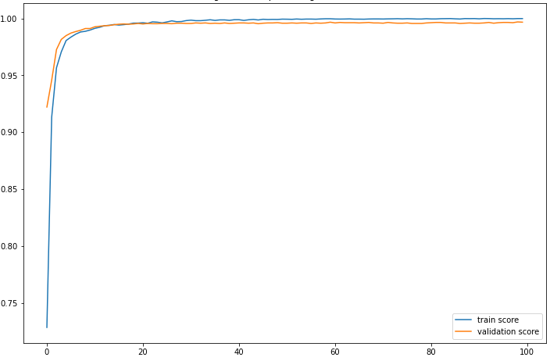 | - Confusion matrix  - performance score  - Feature space: Space [F7] of the selected variables according to a variance threshold from [F2].  - Learning curve  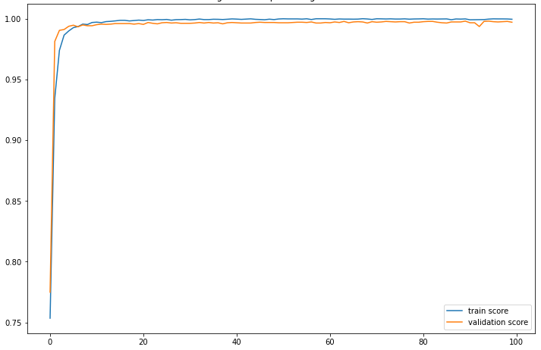
   |  | Reality
   |  | Negative | Positive
  Prediction | Negative | 5172 | 9
  Prediction | Positive | 12 | 422
  Accuracy | Sensitivity | Specificity | Score f1 | AUC
  0.9723 % | 0.9791 % | 0.9976 % | 0.9757 % | 0.9993 %
   |  | Reality
   |  | Negative | Positive
  Prediction | Negative | 5177 | 4
  Prediction | Positive | 17 | 417
  Accuracy | Sensitivity | Specificity | Score f1 | AUC
  0.9608 % | 0.9904 % | 0.9967 % | 0.9754 % | 0.9977 %

Table S37. Result of the DeepLearning algorithm for the prediction of Kanamycin according to each feature space.

