Supplementary Figures
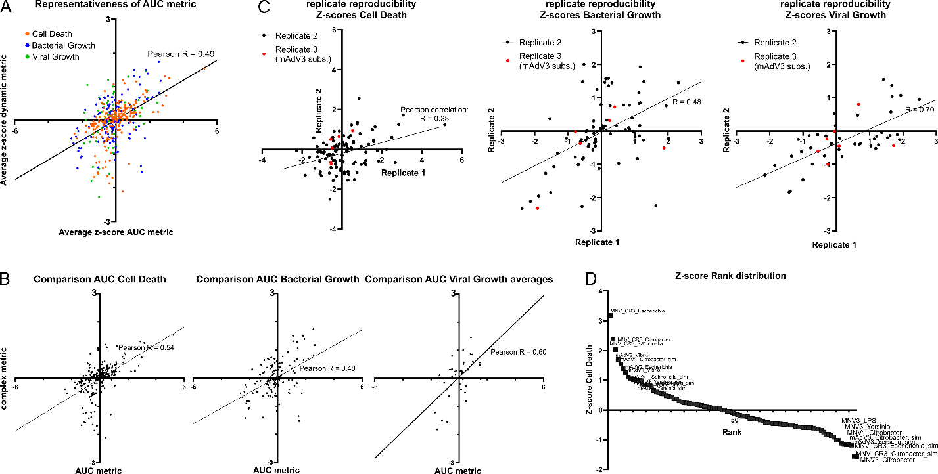
Figure S1: Quality control of the pairwise co-infection screen. A) Scatterplot depicting the correlation between the AUC-metric-based z-score (x-axis) and the average of the dynamic metrics (onset of growth / death, half-point, gradient, maximum growth / death) z-normalized (y-axis). Each dot represents an interaction pair in a specific readout (cell death, bacterial growth or viral growth, as color-coded). Pearson correlation, and a linear approximation are indicated. B) As panel A, but separate for each readout. C) Correlations of the two biological replicates for the z-scores (AUC-based) in each readout, as indicated. Each dot represents an interaction pair. For mAdV3 subsequent infection, a third biological replicate was conducted; the interactions stemming from this are indicated in red. Linear approximation and Pearson correlation are indicated. D) Rank distribution of z-scores (host cell death, AUC-based) for each interaction. Interactions with an absolute z-score larger than 1 are indicated by label.
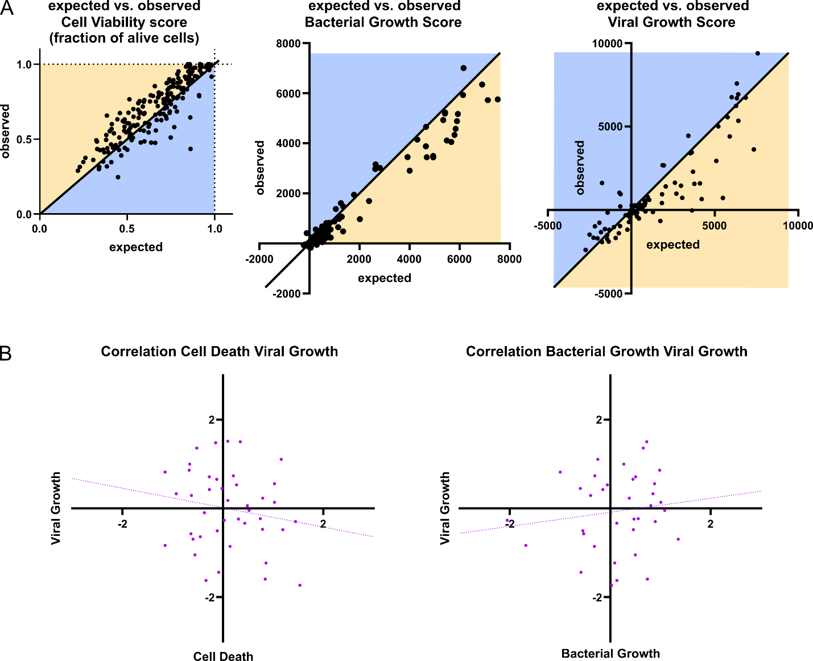
Figure S2: General trends observed in the pairwise screen. A) Scatterplots of expected and observed values (non-z-transformed Bliss scores) for the three assessed readouts as indicated. The line depicts the bisectrix and the area in the graph for synergies (blue) and antagonisms (orange) are indicated. Each dot represents one interaction pair. B) Correlation of z-scores as indicated, Pearson R and linear approximation are indicated. Each point represents a pathogen pair, as in Fig. 2D.
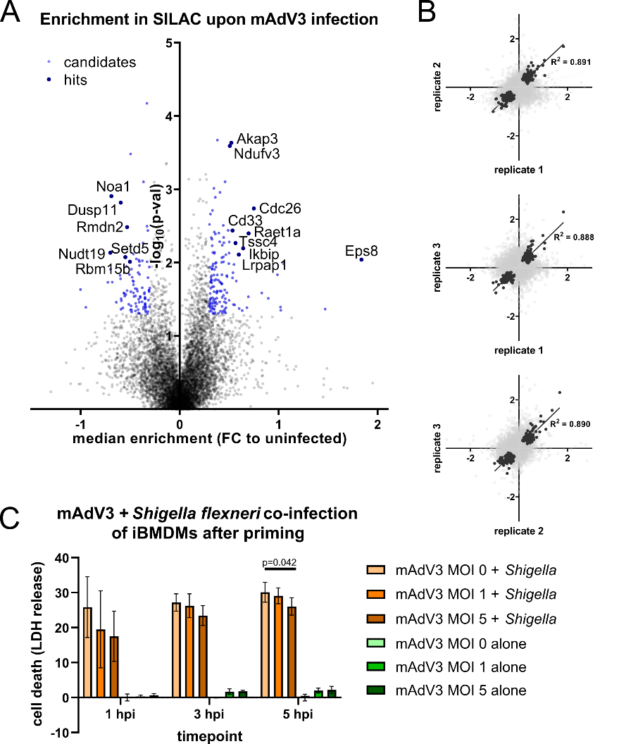
Figure S3: Host proteome alterations upon mAdV3 infection and impact on secondary bacterial infection. A) Volcano plot of SILAC enrichment (x-axis: median logarithmic fold change of three biological replicates, y-axis: negative logarithmic p-value). Hits (absolute log(FC) > 0.5, p-value < 0.01) and candidates (absolute log(FC) > 0.3, p-value < 0.05) are indicated by name. B) Pairwise correlations of the three replicates (log(FC) as indicated. Gray dots: All proteins, black dots: candidates, as defined in panel A. The line and R² value are based on the proteins classified as candidates. C) Cell death (measured by LDH release) assessment of mAdV3-Shigella co-infection over time. MOIs and timepoints are indicated. iBMDMs were primed with IFNγ for at least 6h and infected with the indicated MOI of mAdV3. After overnight infection, cells were infected for the indicated time with Shigella at an MOI of 50. Mean and standard deviation of five replicate wells are given. P-value was calculated using two-sided, unpaired Student’s T-test with Welsh correction.
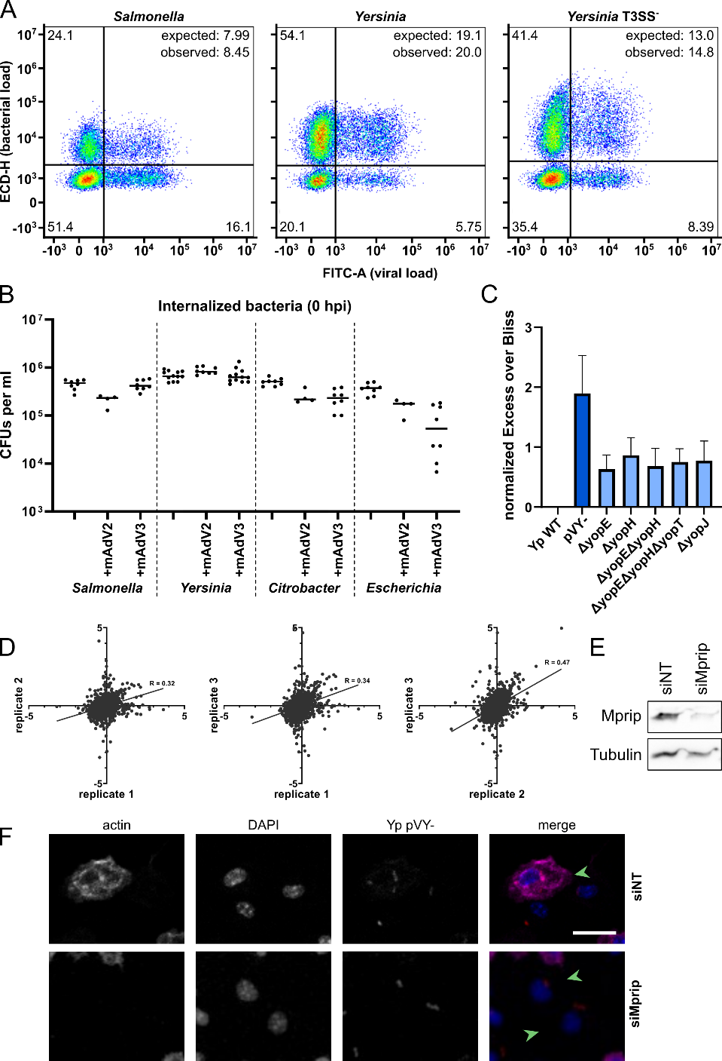
Figure S4: Increased host-cell uptake of Yersinia after mAdV2-infection and involvement of host and bacterial proteins at the interface. A) Representative scatterplots of FITC-signal (viral load) and ECD-signal (bacterial load) for co-infected cell-population. For each quadrant (uninfected, singly infected and doubly infected BMDMs), the fraction of all live cells are indicated. The expected fraction of co-infected cells was calculated by multiplying the fraction of virally and bacterially infected cells. B) CFU counting after invasion (time point 0hpi) for different bacterial pathogens after infection with mAdV2 or mAdV3. Each point represents a quantification across biological triplicates. C) Increase in observed co-infected cells for a panel of Yersinia mutants, normalized to WT Yersinia pseudotuberculosis during infection (MOI 5, time point 0hpi). Mean and standard deviation are indicated, this data is based on biological triplicate. D) Pairwise replicate correlation for the SILAC data displayed in Fig. 5C (logarithmic fold-change). Each dot represents a protein and Pearson R, alongside a linear approximation across all proteins are given. E) Knockdown validation of Mprip by siRNA through Western Blot, 48h after transfection of BMDMs. Tubulin is shown as loading control. F) Representative microscopy images (crop from a field of view acquired with 20x magnification) used for the quantification in Fig. 5F,G. Actin, DAPI, bacterial signal (mCherry) and merge of virally infected cells (green arrows) are shown. Scale bar: 20μm.

