Supplementary Information
Convective Dynamics of Swarming Enzymatic Nanomotors
Shuqin Chen^{1,2}, Xander Peetroons¹, Anna C. Bakenecker¹, Florencia Lezcano¹, Igor S Aranson^{3*}, Samuel Sánchez^{1,4*}
¹Institute for Bioengineering of Catalonia (IBEC), The Barcelona Institute for Science and Technology (BIST), Baldiri i Reixac 10-12, Barcelona 08028, Spain
²Department of Physics, University of Barcelona, Martí i Franquès 1, Barcelona 08028, Spain
³Department of Biomedical Engineering, The Pennsylvania State University, University Park, Pennsylvania 16802, United States
⁴Catalan Institute for Research and Advanced Studies (ICREA), Passeig Lluís Companys 23, Barcelona 08010, Spain
Corresponding authors:
*Igor S Aranson: isa12@psu.edu
*Samuel Sánchez: ssanchez@ibecbarcelona.eu

Supplementary Note 1. Solutal convection equations
We consider the following model: colloidal particles coated by the enzyme (urease) react with the fuel (urea). As a result of the enzymatic reaction, ammonia gas is released. The gas dissolves in the solvent (water), making it effectively lighter. Lighter volumes of solvent raise upward, creating convective plumes. The solvent flow entertains the colloidal particles (particulate) and brings them up. Once fuel is consumed, the reaction slows down, and the particulate sediments to the bottom. We neglect heat produced in the course of the reaction.
Our starting point is two-fluid hydrodynamics. One fluid will be a solvent with the dynamic viscosity $η$, velocity $v$, and pressure $p$, and the solvent density $ρ_{0}$. Other fluid is the particulate with the volume density$ρ$, coarse-grained particulate velocity $u$, pressure $P$. The particulate density $ρ$ is $ρ=ρ_{p}Φ$, where $ρ_{p}$ is the density of a particulate particle, and $Φ$ is the particulate particle filling fraction. The volume filling fraction $Φ$ is related to the particle concentration $n$ as $Φ=V_{0}n$, $V_{0}=4/3πa^{3}$ is the volume of a spherical particle of the radius $a$.
We also consider coupling to the chemical fluid field $c$ that diffuses with the diffusion coefficient $D_{c}$ and is consumed with the rate $γρc$ due to the reaction between particulate and the fuel. The solvent is assumed to be incompressible, i.e., $∇v=0$. The chemical field which is of the form
$$\begin{aligned}∂_{t}c+∇⋅\left(vc\right)=D_{c}∇^{2}c-γρc \#\left( AUTONUM \backslash * Arabic \right)\end{aligned}$$
This reaction-diffusion equation describes the advection of the fuel by the solvent flow $v$, diffusion, and consumption due to chemical reaction with the particulate. The two-fluid hydrodynamics equations assuming that the particulate is dilute can be written in the following general form for the incompressible solvent:
$\begin{aligned}ρ_{0}\left(∂_{t}v+v∇v\right)=η∇^{2}v-∇p+z_{0}ϵρc+κn\left(u-v\right)\#\left( AUTONUM \backslash * Arabic \right)\end{aligned}$
$$\begin{aligned}∇⋅v=0 \#\left( AUTONUM \backslash * Arabic \right)\end{aligned}$$
Here $η$ is the solvent dynamic viscosity, $z_{0}ϵρc$ is the volume buoyancy force due to chemical reaction between particulate, $z_{0}$ is the unit vector in the $z$-direction ($z$-axis is upward). The last term $κn(u-v)$ is due to the friction between particulate and the solvent (or drag force), $κ$ is the friction coefficient. For spherical particles of the radius $a$, $κ=6πηa$. Similar term will appear in the particulate equation:
$$\begin{aligned}ρ\left(∂_{t}u+u∇u\right)=η_{ρ}∇^{2}u-∇P-z_{0}αgρ+κn\left(v-u\right)\#\left( AUTONUM \backslash * Arabic \right)\end{aligned}$$
$\begin{aligned}∂_{t}ρ+∇⋅\left(ρu\right)=0\#\left( AUTONUM \backslash * Arabic \right)\end{aligned}$
Since the particulate is assumed to be compressible, the pressure is to be determined from the equation of state $P=f(ρ)$. In the dilute limit, $P=qρ$, $q$ is some coefficient that depends on temperature, etc. The term $z_{0}gρ$ describes the sedimentation of the particulate, $g$ is the acceleration of gravity. Coefficient $α=(ρ_{p}-ρ_{0})/ρ_{p}$ includes the effect of the Archimedes force. While Eqs. (1)-(5) describe the system, they are cumbersome and hard to solve computationally. Therefore, we consider a simplification. We assume that the motion of particulate is over-damped and neglect the particulate acceleration $ρ(∂_{t}u+u∇u)$ and viscous stress $η_{p}∇^{2}u$. The resulting equation is:
$$\begin{aligned}\begin{matrix}-∇P-z_{0}gαρ+κn\left(v-u\right)=0\end{matrix} \#\left( AUTONUM \backslash * Arabic \right)\end{aligned}$$
Substituting $ρ(v-u)$ from Eq. (6) into the Navier-Stokes equation for the solvent, Eq. (2), we readily obtain
$$\begin{aligned}\begin{matrix}ρ_{0}\left(∂_{t}v+v∇v\right)=η∇^{2}v-∇\tilde{p}-z_{0}ρ\left(gα-ϵc\right)\end{matrix} \#\left( AUTONUM \backslash * Arabic \right)\end{aligned}$$
where $\tilde{p}=p+P$ is the re-normalized pressure. In the following, we drop tildes. Eq. (7) is identical to the Boussinesq model for the buoyancy-driven thermal convection. To exclude $u$, it is useful to rewrite Eq. (6) in terms of the particulate density $ρ$ rather than concentration $n$, $ρ=ρ_{p}V_{0}n$:
$$\begin{aligned}\begin{matrix}-∇P-z_{0}gαρ+κ_{1}ρ\left(v-u\right)=0\end{matrix} \#\left( AUTONUM \backslash * Arabic \right)\end{aligned}$$
where $κ_{1}=κ/(ρ_{p}V_{0})=9η/(2ρ_{p}a^{2})$. If we express the particulate velocity $u$:
$$\begin{aligned}\begin{matrix}u=v-\frac{\frac{∇P}{ρ}+z_{0}αg}{κ_{1}}\end{matrix} \#\left( AUTONUM \backslash * Arabic \right)\end{aligned}$$
and substitute into Eq. (5), we obtain:
$$\begin{aligned}∂_{t}ρ+∇⋅\left(ρv\right)=\frac{1}{κ_{1}}\left(∇^{2}P+αg∂_{z}ρ\right)\#\left( AUTONUM \backslash * Arabic \right)\end{aligned}$$
Since in the dilute limit the pressure is $P=qρ$, we obtain a reaction-diffusion equation:
$$\begin{aligned}∂_{t}ρ+∇⋅\left(ρv\right)=\frac{1}{κ_{1}}\left(q∇^{2}ρ+αg∂_{z}ρ\right)\#\left( AUTONUM \backslash * Arabic \right)\end{aligned}$$
To summarize the equations:
$$\begin{matrix}ρ_{0}(∂_{t}v & + & v∇v)=η∇^{2}v-∇p-z_{0}ρ(gα-ϵc) \\ ∂_{t}c & + & ∇⋅\left(vc\right)=D_{c}∇^{2}c-γρc \\ ∂_{t}ρ & + & ∇⋅\left(ρv\right)=\frac{1}{κ_{1}}\left(q∇^{2}ρ+αg∂_{z}ρ\right) \end{matrix}$$

Supplementary Note 2. Depth-averaged description
To obtain the depth-averaged description, we will use the theoretical approach developed in Ref. [1] to describe experiments in Ref. [2]. We consider a cell where the height $h$ is much smaller than the lateral dimensions $L$. We integrate equation for vertical velocity $v_{z}$ across the depth. It gives for the depth-averaged velocity $V=\int_{0}^{h}{v_{z}}dz/h$ the following equation:
$$∂_{t}V=ν∇_{⊥}^{2}V-ηV+β\left\langle ρ\tilde{c}\right\rangle -p\left(h\right)$$
Here $⟨ρc⟩∼\tilde{ρ},\tilde{c}$ are the depth averaged density and concentration, $η=12ν/h^{2}$. In the following, we drop tildes for briefty, $∇_{⊥}^{2}=∂_{x}^{2}+∂_{y}^{2}$. Here we make the following approximation: the vertical velocity, near the threshold is a symmetric function of $z$ (flow between two parallel plates)
$$v_{z}(z)=\frac{3V}{2h^{3}}(h^{2}-4(z-h/2)^{2})$$
Then, the horizontal velocity can be found from the incompressibility condition $∇⋅v=0$. We assume that the particulate is always at the bottom part of the cells, between $0<z<h/2$. Then, we are interested in only the horizontal velocity in the lower part of the cell, $V_{x},V_{y}$. We assume that the horizontal velocity can be found from a potential $V_{⊥}=∇_{⊥}ϕ$. It gives the equation for the potential $ϕ$:
$$\begin{aligned}∇_{⊥}^{2}ϕ=-\int_{0}^{\frac{h}{2}}{∂_{z}}v\left(z\right)dz=-\frac{3V}{2h}\#\left( AUTONUM \backslash * Arabic \right)\end{aligned}$$
Note that the depth-averaged $\int_{0}^{h}{v}∇vdz=0$ due to the symmetry. However, since we assume that the profiles of $c$ and $ρ$ are not symmetric, then $\int_{0}^{h/2}{v}∇ρdz∼V_{⊥}∇_{⊥}ρ≠0$, as well as the same equation for $c$. Finally, to implement a short-wave instability in the equation, we assume that pressure is given by the condition:
$$p=∫K(r-r^{'})\tilde{α}ρcdr^{'}$$
where $K$ is a kernel that should satisfy certain normalization conditions. It can be written in the Fourier space:
$$\hat{K}(k)=∫\text{exp}(ikr)K(r)dr$$
We assume that $\hat{K}(k)=\text{exp}(-ϵk^{2})$ where parameter $ϵ∼h^{2}$ depended on the chamber height $h$. Combining this together, we obtain for the vertical velocity:
$$\begin{aligned}∂_{t}V=ν∇_{⊥}^{2}V-ηV+β∫K_{1}\left(r-r^{'}\right)ρcdr^{'}-μV^{3} \#\left( AUTONUM \backslash * Arabic \right)\end{aligned}$$
where ${\hat{K}}_{1}(k)=1-\text{exp}(-ϵk^{2})$. Note that ${\hat{K}}_{1}(k=0)=0$: uniform distribution of particles does not produce any vertical flow since it is compensated by the vertical pressure gradient. The term $-μV^{3}$ is introduced to saturate the instability and prevent the blow-up of the solution. Finally, equations for $ρ,c$ take form:
$$\begin{aligned}∂_{t}c+∇_{⊥}\left(V_{⊥}c\right)=D_{c}∇_{⊥}^{2}c-γρc\#\left( AUTONUM \backslash * Arabic \right)\end{aligned}$$
$$\begin{aligned}∂_{t}ρ+∇_{⊥}\left(V_{⊥}ρ\right)=D_{ρ}∇_{⊥}^{2}ρ\#\left( AUTONUM \backslash * Arabic \right)\end{aligned}$$
Solving equations (13), (14), (15) and Eq. (12) generates the dynamics resembling the experiment.

Supplementary Figures
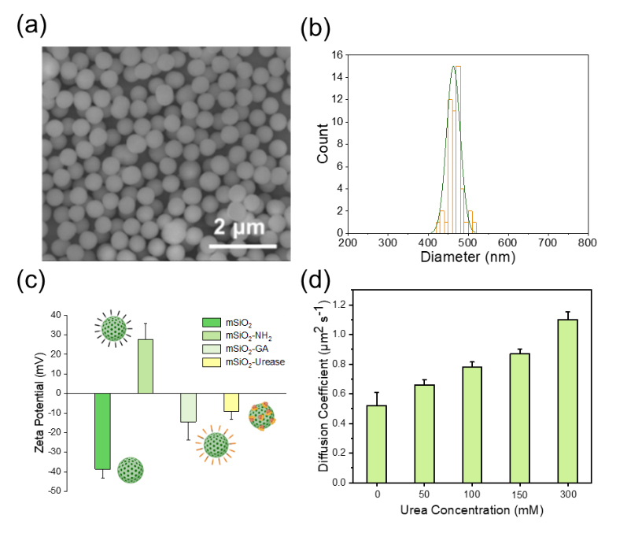
Fig. S1 Synthesis and characterization of UrNMs. (a) SEM image of MSNPs. (b) Statistic particle size distribution of MSNPs. N=50. (c) Zeta potential changes during the process of MSNP surface modification. (d) Diffusion coefficient measurement of UrNMs in elevated concentration of urea solutions by DLS. N=5.
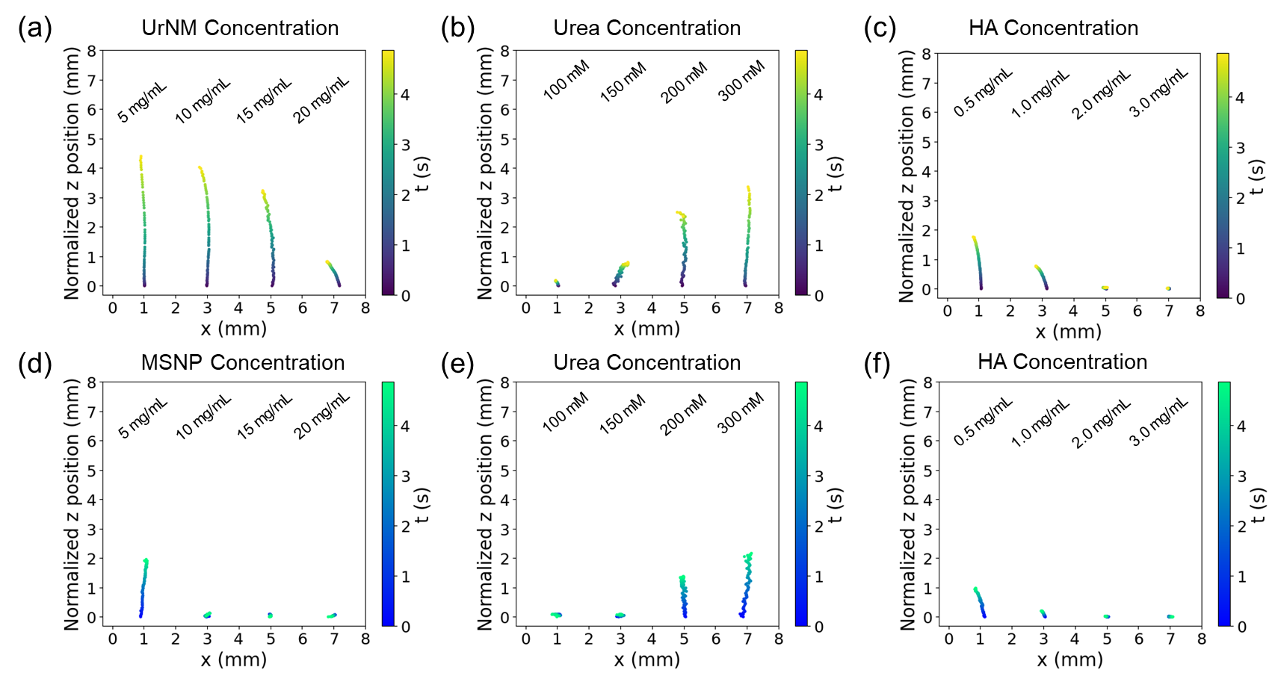
Fig. S2 The center of mass tracking of particulates in y-axis within 5 s. The center of mass tracking of UrNM swarms in y-axis under various conditions: (a) UrNM concentration, (b) urea concentration, and (c) HA concentration. The center of mass tracking of passive MSNP swarms in y-axis under various conditions: (d) MSNP concentration, (e) urea concentration, and (f) HA concentration.
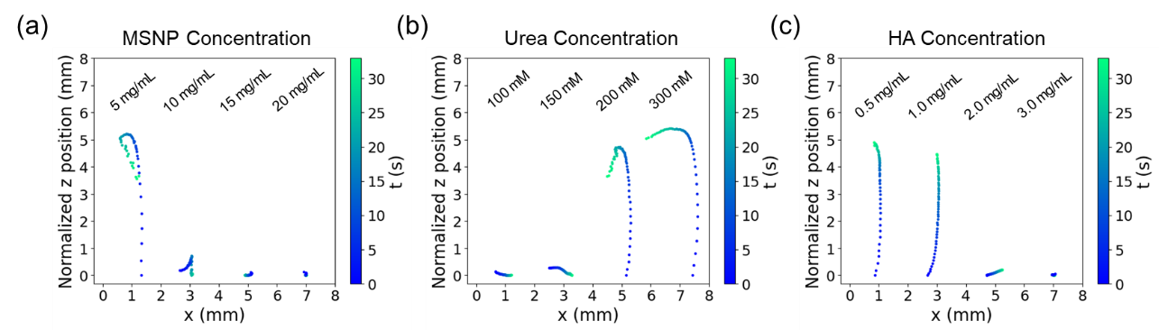
Fig. S3 The center of mass tracking of particulates in y-axis within 32 s. The center of mass tracking of passive MSNP swarms under various conditions: (a) MSNP concentration, (b) urea concentration, and (c) HA concentration.
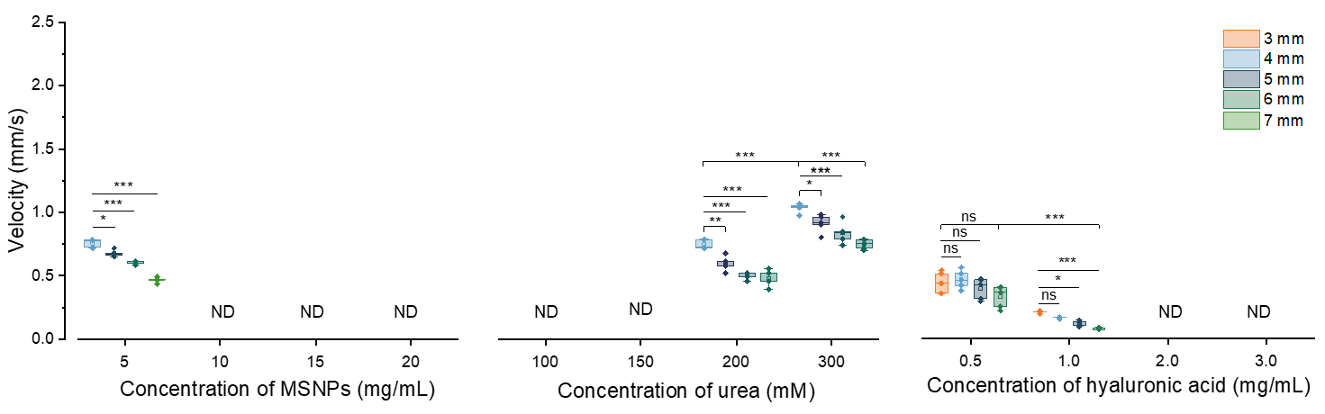
Fig. S4 Velocity analysis of passive MSNPs in varied particle concentration, urea concentration, and fuel with diverse HA concentration. Significant differences were calculated using students’ t-test: ***=P < 0.001; **=P < 0.01; *=P < 0.05; ns = not significant (P > 0.05). N=5. ND means velocity is lower than detectable value.
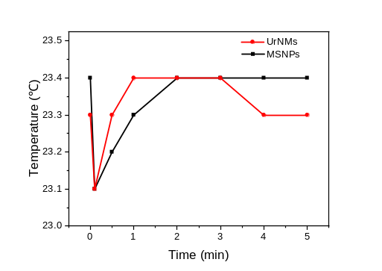
Fig. S5 Temperature variation upon the addition of UrNMs and MSNPs.
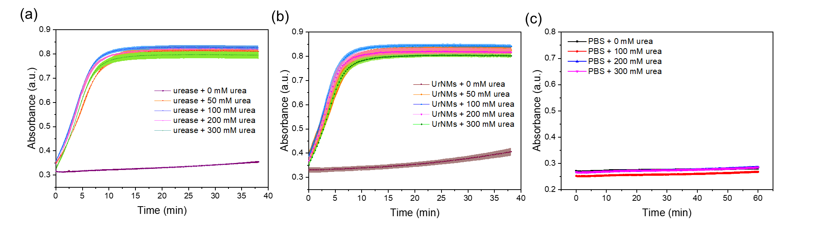
Fig. S6 Enzymatic activity measurement in urea dissolved in PBS buffer. The real-time UV-vis light absorbance of phenol red solutions containing varied concentrations of urea after adding (a) urease, (b) UrNMs, or (c) PBS buffer.
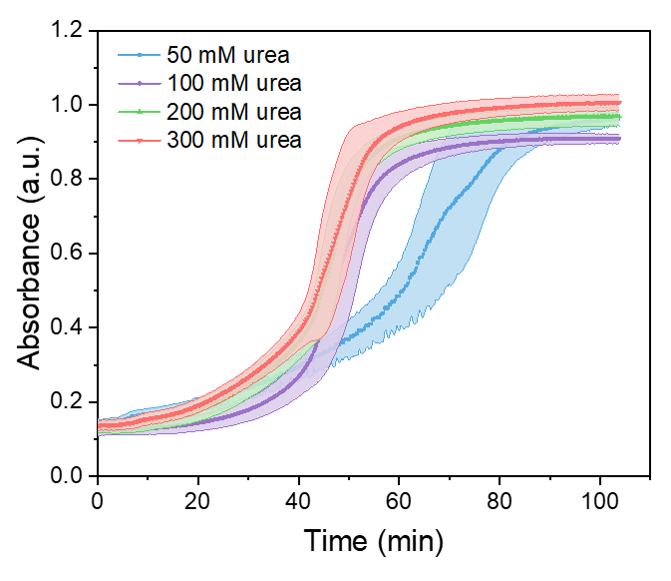
Fig. S7 The real-time UV-vis light absorbance of phenol red solutions containing varied concentrations of urea (in acetate buffer) after adding UrNMs.
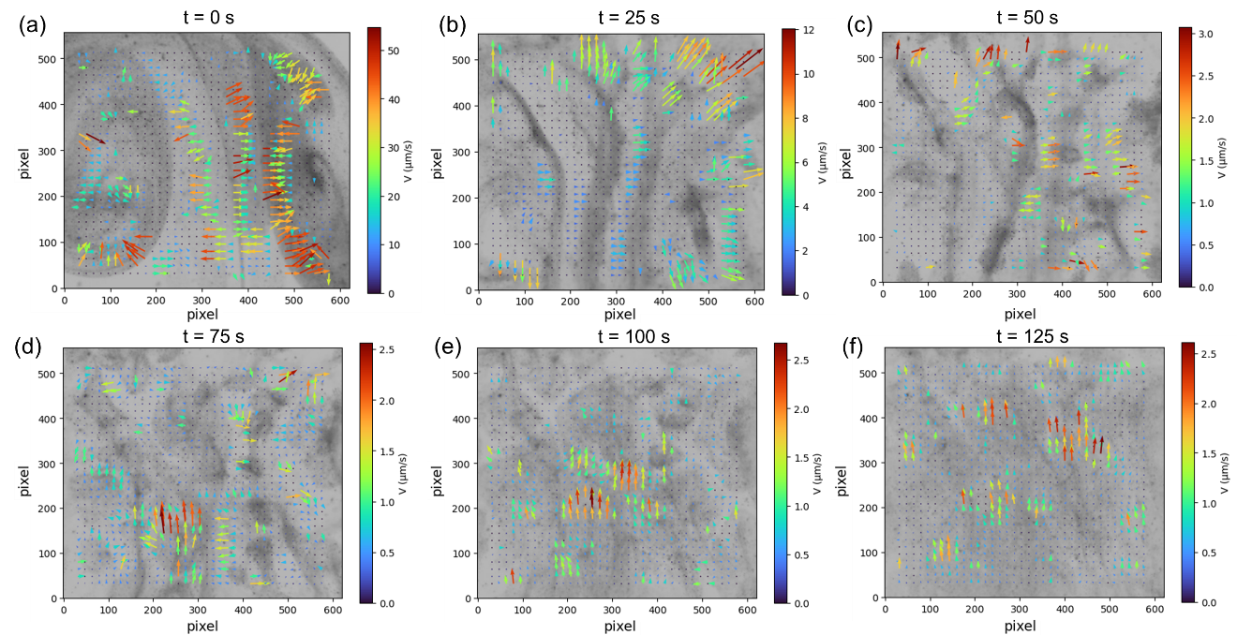
Fig. S8 PIV analysis of UrNMs’ collective motion in a 1.6 mm-high confinement filled with urea. (a)-(f) are results at different time points.
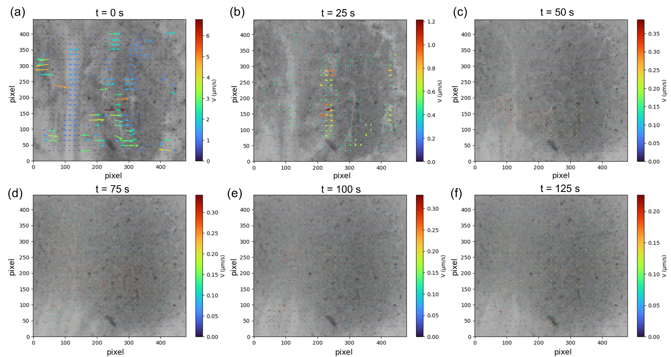
Fig. S9 PIV analysis of UrNMs’ collective motion in a 0.5 mm-high confinement filled with urea. (a)-(f) are results at different time points.
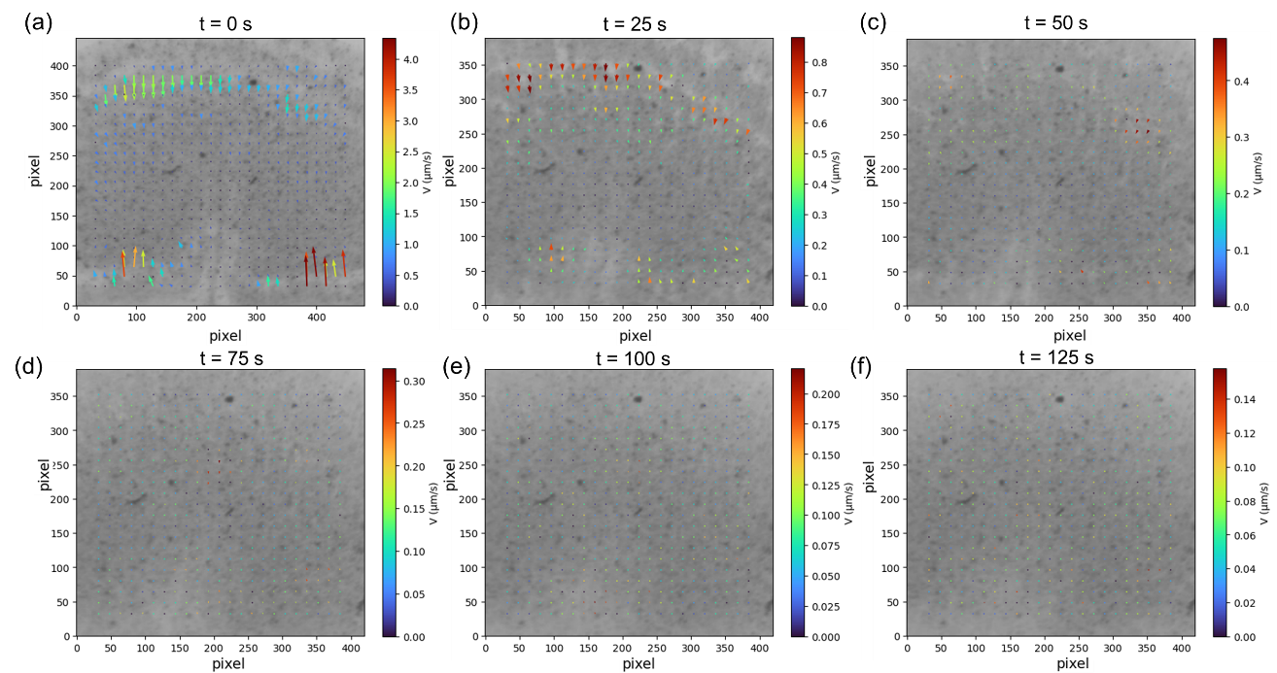
Fig. S10 PIV analysis of UrNMs’ collective motion in a 0.25 mm-high confinement filled with urea. (a)-(f) are results at different time points.
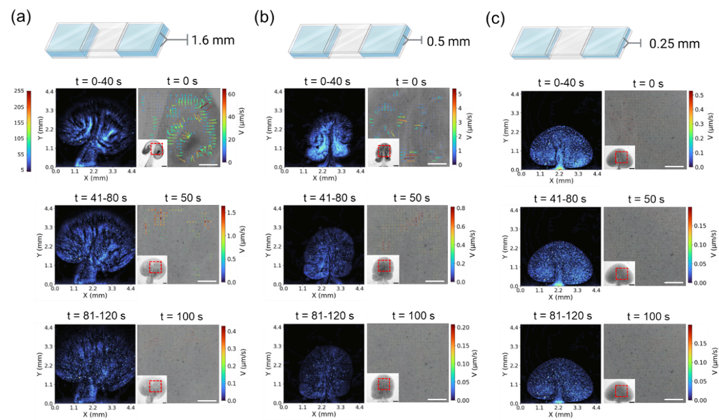
Fig. S11 Swarming behavior shaped by confinement. Intensity maps and particle image velocimetry (PIV) analysis are conducted on the swarming behavior of UrNM in (a) a 1.6 mm-high confinement filled with PBS, (b) a 0.5 mm-high confinement filled with PBS, and (c) a 0.25 mm-high confinement filled with PBS. The average pixel intensity is calculated over 40-second periods from 120-second video recordings (left panels in each figure). The right panels present zoomed-out images that are snapshots of those video recordings at fixed time points, while the zoomed-in views display corresponding PIV measurements. Scale bars in small panel: 1 mm, in enlarged panel: 0.5 mm.
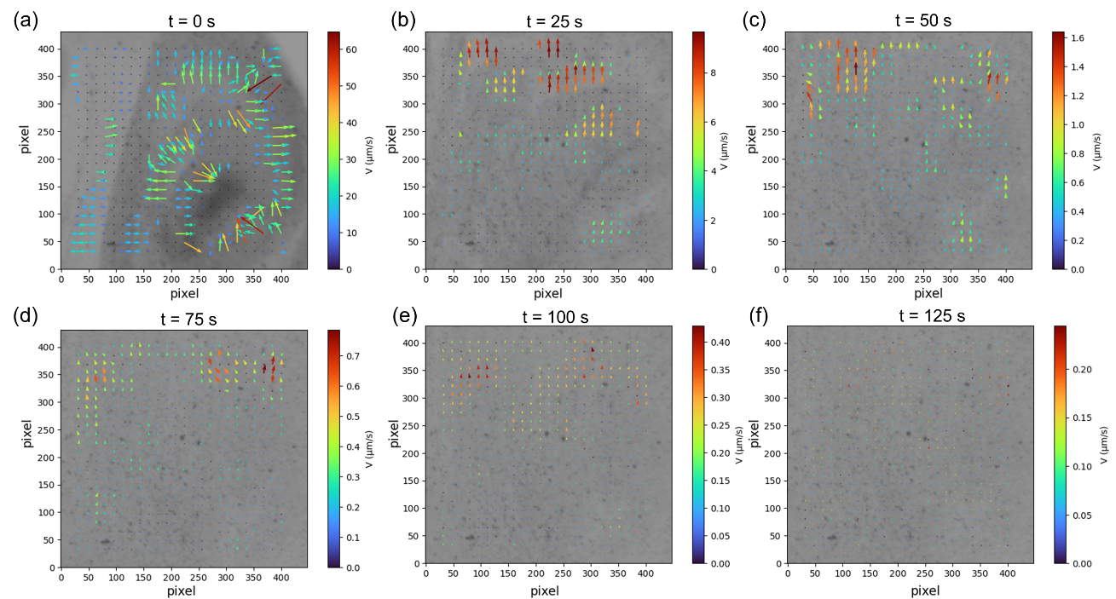
Fig. S12 PIV analysis of UrNMs’ collective motion in a 1.6 mm-high confinement filled with PBS. (a)-(f) are results at different time points.
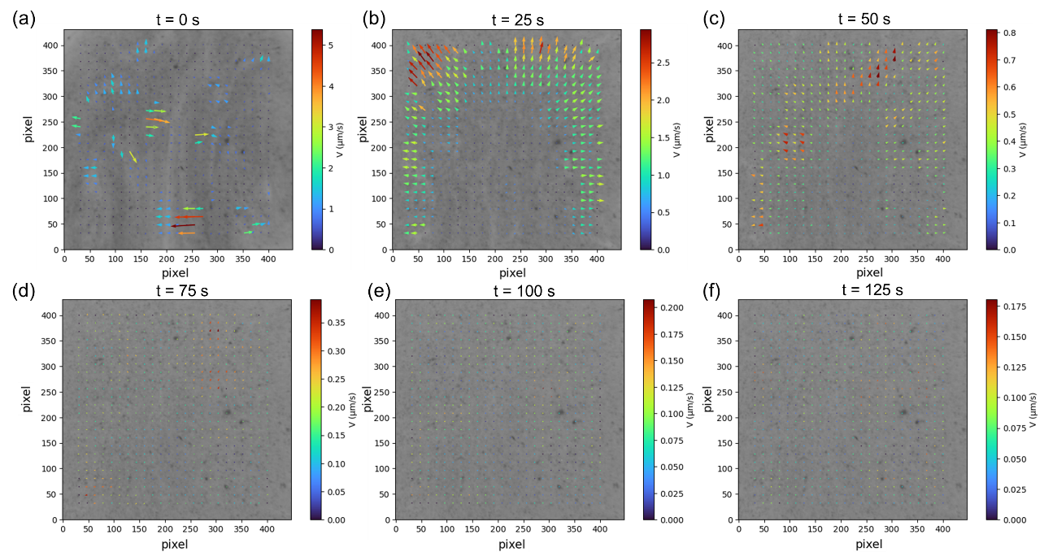
Fig. S13 PIV analysis of UrNMs’ collective motion in a 0.5 mm-high confinement filled with PBS. (a)-(f) are results at different time points.
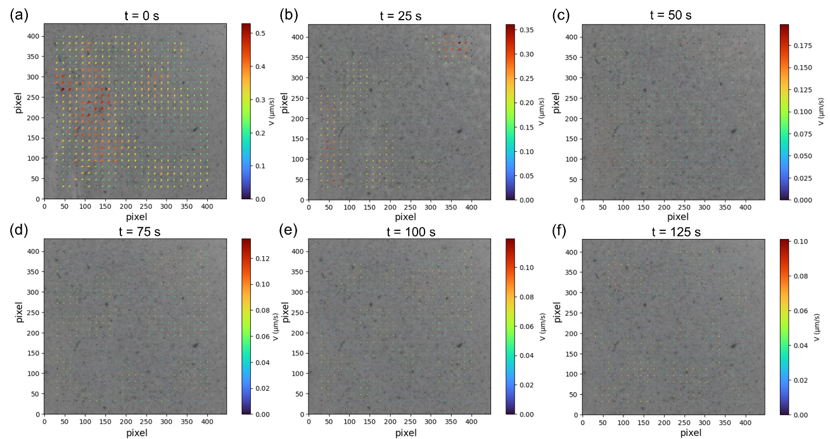
Fig. S14 PIV analysis of UrNMs’ collective motion in a 0.25 mm-high confinement filled with PBS. (a)-(f) are results at different time points.
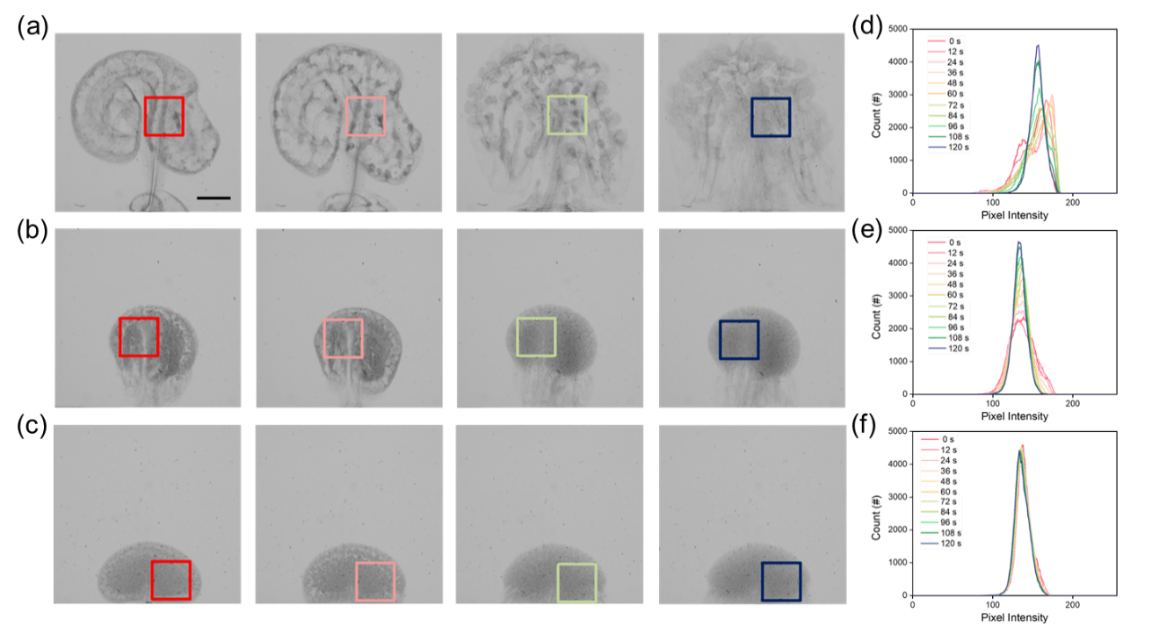
Fig. S15 Histograms of pixel intensity distribution within the selected region of interest. Snapshots of UrNM swarms in vertically confined chamber (filled with fuel) with different heights: (a) 1.6 mm, (b) 0.5 mm, and (c) 0.25 mm, and corresponding pixel intensity distribution histograms (d), (e) and (f) within the region of interest, respectively. Scale bar: 1 mm.
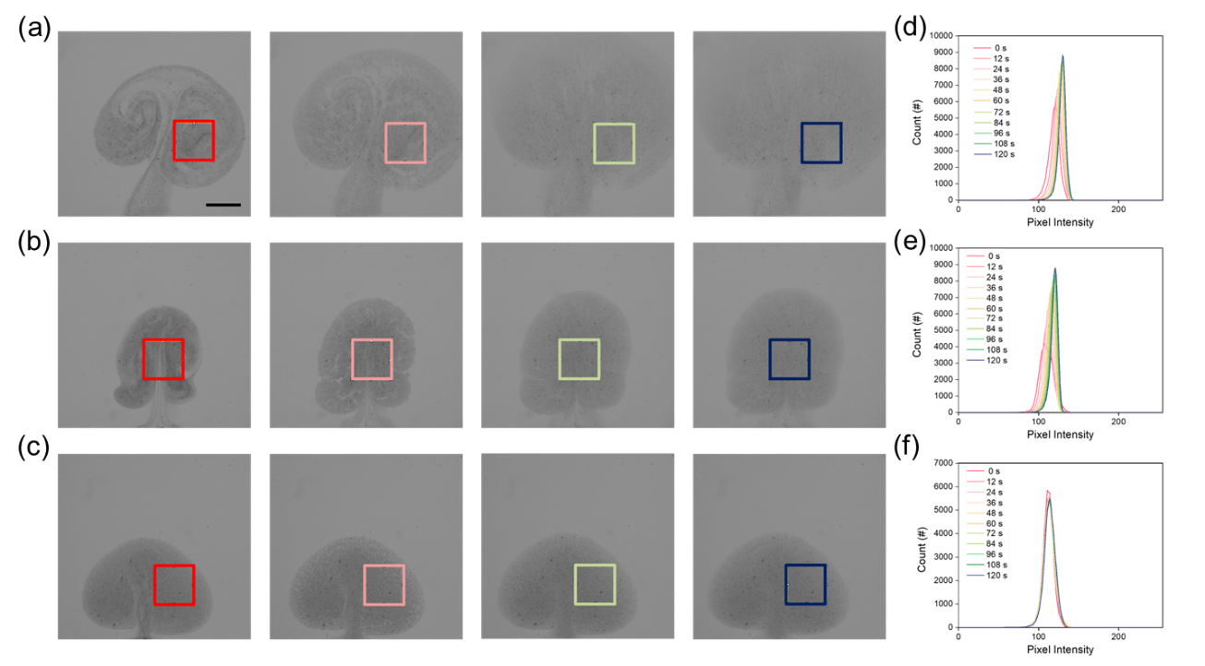
Fig. S16 Histograms of pixel intensity distribution within the selected region of interest. Snapshots of UrNM swarms in PBS solutions that were confined within spaces of different heights: (a) 1.6 mm, (b) 0.5 mm, and (c) 0.25 mm, and corresponding pixel intensity distribution histograms (d), (e) and (f) within the region of interest, respectively. Scale bar: 1 mm.
Table S1. The amount of urease attached on the surface of MSNPs by BCA.
Sample number | Initial enzyme added  (μg/mL) | Supernatant 1  (μg/mL) | Supernatant 2  (μg/mL) | Urease attatched  (μg/mL)
1 | 255.8 | 151.8 | 0 | 104
2 | 263.8 | 151.8 | 0 | 112
3 | 282.8 | 156.8 | 0 | 126

References
- Aranson, I. S. & Sapozhnikov, M. V. Theory of pattern formation of metallic microparticles in poorly conducting liquids. Phys. Rev. Lett. 92, 234301-234304 (2004).
- Sapozhnikov, M. V., Tolmachev, Y. V., Aranson, I. S., & Kwok, W.-K., Dynamic self-assembly and patterns in electrostatically driven granular media. Phys. Rev. Lett. 90, 114301-114304 (2003).

