Supplementary material for
Description and first insights on a large genomic biobank of lung transplantation (Brocard et al.)

Table of contents
Supplementary material and methods: 2
Supplementary Table 1: Characteristics of the donors in GenCOLT and the rest of the COLT cohort 3
Supplementary Table 2: Characteristics of the recipients in GenCOLT and the rest of the COLT cohort 5
Supplementary Table 3: Characteristics of the transplanted patients’ in GenCOLT and the rest of the COLT cohort 7
Supplementary Table 4: Functional characteristics in GenCOLT and the rest of the COLT cohort for chronic obstructive pulmonary disease recipients. 12
Supplementary Table 5: Functional characteristics in GenCOLT and the rest of the COLT cohort for cystic fibrosis recipients 13
Supplementary Table 6: Functional characteristics in GenCOLT and the rest of the COLT cohort in interstitial lung disease recipients 14
Supplementary Table 7: Functional characteristics in GenCOLT and the rest of the COLT cohort in pulmonary hypertension recipients 16
Supplementary Figure 1: SNP enrichment through the SNP imputation process. 18
Supplementary Figure 2: Distribution of HLA alleles in GenCOLT individuals according to typed vs. imputed HLA-A, HLA-B, HLA-C, HLA-DRB1 and HLA-DQB1 gene alleles. 19
Supplementary Figure 3: Genetic ancestry matching between donors and recipients from GenCOLT pairs. 20

Supplementary material and methods:
The clinical records and follow-up data from each participating center are centralized in a secured online database coordinated by the Nantes University Hospital. This database contains a comprehensive set of over 300 variables encompassing various aspects of the lung transplantation process, including demographic information about the recipient, the donor, the transplantation procedure, and subsequent recipient’s follow-up. In the present work, we only present the 67 variables that are mostly used in clinical practice. As per the routine COLT protocol, follow-up visits were conducted at 1-month and 6-month after transplantation, and then every 6 months for a period of up to 5 years for biological sample (blood) collection, and up to 10 years for clinical data. The prospective nature of both the database and the biobank allows the identification of predisposing clinical and biological markers in patients who developed CLAD during follow-up.

Supplementary Table 1: Characteristics of the donors in GenCOLT and the rest of the COLT cohort
 | COLT (N=1413) | GenCOLT (N=392) | p value
Sex |  |  | 0.909 (1)
- Missing | 54 | 4
- Men | 761 (56.0%) | 216 (55.7%)
- Women | 598 (44.0%) | 172 (44.3%)
Age (years) |  |  | 0.807 (2)
- Missing | 51 | 5
- Mean (SD) | 45.16 (15.31) | 45.370 (14.92)
- Range | 9.00 - 73.00 | 18.00 - 71.00
Days in reanimation |  |  | 0.343 (2)
- Missing | 91 | 20
- Mean (SD) | 2.76 (2.84) | 2.60 (2.49)
- Range | 0.00 - 39.00 | 0.00 - 19.00
Cause of death |  |  | 0.926 (1)
- Missing | 72 | 9
- Anoxia | 174 (13.0%) | 51 (13.3%)
- Intoxication | 7 (0.5%) | 1 (0.3%)
- Meningitis | 14 (1.0%) | 4 (1.0%)
- Non-PRA Trauma | 192 (14.3%) | 46 (12.0%)
- Other | 47 (3.5%) | 17 (4.4%)
- PRA Trauma | 181 (13.5%) | 52 (13.6%)
- Tumor | 9 (0.7%) | 2 (0.5%)
- Stroke | 717 (53.5%) | 210 (54.8%)
Blood type |  |  | 0.694 (1)
- Missing | 57 | 5
- A | 546 (40.3%) | 146 (37.7%)
- AB | 27 (2.0%) | 9 (2.3%)
- B | 127 (9.4%) | 33 (8.5%)
- O | 656 (48.4%) | 199 (51.4%)
Tobacco |  |  | 0.918 (1)
- Missing | 108 | 13
- No | 795 (60.9%) | 232 (61.2%)
- Yes | 510 (39.1%) | 147 (38.8%)
Number of packages per year |  |  | 0.099 (2)
- Missing | 1316 | 373
- Mean (SD) | 18.34 (14.15) | 24.32 (15.13)
- Range | 1.00 - 70.00 | 1.00 - 60.00
Type of sampling |  |  | 0.935 (1)
- Missing | 1271 | 366
- Brain death | 137 (96.5%) | 25 (96.2%)
- Maastricht III | 5 (3.5%) | 1 (3.8%)
HIV antibodies |  |  | 0.295 (1)
- Missing | 71 | 10
- Negative | 1337 (99.6%) | 379 (99.2%)
- Positive | 5 (0.4%) | 3 (0.8%)
Toxoplasmosis antibodies |  |  | 0.661 (1)
- Missing | 152 | 30
- Negative | 489 (38.8%) | 145 (40.1%)
- Positive | 772 (61.2%) | 217 (59.9%)
EBV antibodies |  |  | 0.476 (1)
- Missing | 63 | 11
- Negative | 92 (6.8%) | 30 (7.9%)
- Positive | 1258 (93.2%) | 351 (92.1%)
HBC antibodies |  |  | 0.950 (1)
- Missing | 272 | 88
- Negative | 1108 (97.1%) | 295 (97.0%)
- Positive | 33 (2.9%) | 9 (3.0%)
CMV antibodies |  |  | 0.395 (1)
- Missing | 52 | 3
- Negative | 698 (51.3%) | 190 (48.8%)
- Positive | 663 (48.7%) | 199 (51.2%)
P/F ratio |  |  | 0.018 (2)(4)
- Missing | 311 | 83
- Mean (SD) | 358.92 (151.80) | 381.36 (131.86)
- Range | 1.00 - 629.00 | 2.00 - 605.00

- Pearson’s Chi-squared test
- Linear Model ANOVA
- Significant
- Nominally significant

N.B. HIV, human immunodeficiency virus; EBV, Epstein-Barr virus; HBC, Hepatitis B; CMV, Cytomegalovirus; P/F ratio, ratio of arterial oxygen partial pressure (PaO2 in mmHg) to fractional inspired oxygen (FiO2); PRA, public road accident; percentages excludes missing data.

Supplementary Table 2: Characteristics of the recipients in GenCOLT and the rest of the COLT cohort
 | COLT (N=1413) | GenCOLT (N=392) | p value
Sex |  |  | 0.418 (1)
- Men | 746 (52.8%) | 216 (55.1%)
- Women | 667 (47.2%) | 176 (44.9%)
Height (cm) |  |  | 0.236 (2)
- Missing | 45 | 6
- Mean (SD) | 166.78 (9.23) | 167.41 (8.98)
- Range | 130.00 - 190.00 | 146.00 - 190.00
Age (years) |  |  | 0.013 (2)(4)
- Missing | 41 | 1
- Mean (SD) | 45.77 (14.74) | 47.857 (14.177)
- Range | 12.00 - 69.00 | 18.00 - 69.00
Weight (kg) |  |  | 0.121 (2)
- Missing | 49 | 7
- Mean (SD) | 60.34 (15.06) | 61.69 (15.11)
- Range | 24.00 - 117.00 | 36.00 - 110.00
Body mass index (kg/m2) |  |  | 0.240 (2)
- Missing | 53 | 8
- Mean (SD) | 21.54 (4.42) | 21.84 (4.38)
- Range | 13.46 - 40.01 | 13.55 - 34.78
Ischemic cardiopathy |  |  | 0.294 (1)
- Missing | 1086 | 320
- No | 255 (78.0%) | 52 (72.2%)
- Yes | 72 (22.0%) | 20 (27.8%)
High blood pressure |  |  | 0.166 (1)
- Missing | 1001 | 295
- No | 240 (58.3%) | 49 (50.5%)
- Yes | 172 (41.7%) | 48 (49.5%)
Diabetes |  |  | 0.759 (1)
- Missing | 952 | 290
- No | 202 (43.8%) | 43 (42.2%)
- Yes | 259 (56.2%) | 59 (57.8%)
Cardiac insufficiency |  |  | 0.661 (1)
- Missing | 1123 | 336
- No | 269 (92.8%) | 51 (91.1%)
- Yes | 21 (7.2%) | 5 (8.9%)
Gastroesophageal reflux |  |  | 0.614 (1)
- Missing | 1024 | 309
- No | 218 (56.0%) | 44 (53.0%)
- Yes | 171 (44.0%) | 39 (47.0%)
Hepatic damage |  |  | 0.353 (1)
- Missing | 1119 | 333
- No | 253 (86.1%) | 48 (81.4%)
- Yes | 41 (13.9%) | 11 (18.6%)
Dyslipidemia |  |  | 0.015 (1)(4)
- Missing | 1063 | 314
- No | 255 (72.9%) | 46 (59.0%)
- Yes | 95 (27.1%) | 32 (41.0%)
Renal insufficiency |  |  | 0.490 (1)
- Missing | 1133 | 338
- No | 270 (96.4%) | 51 (94.4%)
- Yes | 10 (3.6%) | 3 (5.6%)
Pulmonary embolism |  |  | 0.548 (1)
- Missing | 1083 | 328
- No | 257 (77.9%) | 52 (81.2%)
- Yes | 73 (22.1%) | 12 (18.8%)
Tuberculosis |  |  | 0.174 (1)
- Missing | 597 | 140
- No | 804 (98.5%) | 251 (99.6%)
- Yes | 12 (1.5%) | 1 (0.4%)
Hemoptysis |  |  | 0.582 (1)
- Missing | 1086 | 321
- No | 254 (77.7%) | 53 (74.6%)
- Yes | 73 (22.3%) | 18 (25.4%)
Dialysis |  |  | 0.336 (1)
- Missing | 107 | 19
- No | 1214 (93.0%) | 352 (94.4%)
- Yes | 92 (7.0%) | 21 (5.6%)
Non invasive ventilation |  |  | 0.256 (1)
- Missing | 83 | 24
- No | 762 (57.3%) | 223 (60.6%)
- Yes | 568 (42.7%) | 145 (39.4%)
Oxygenotherapy |  |  | 0.220 (1)
- Missing | 49 | 6
- No | 143 (10.5%) | 49 (12.7%)
- Yes | 1221 (89.5%) | 337 (87.3%)
CMV antibodies |  |  | 0.261 (1)
- Missing | 21 | 2
- Negative | 673 (48.3%) | 176 (45.1%)
- Positive | 719 (51.7%) | 214 (54.9%)
EBV antibodies |  |  | 0.980 (1)
- Missing | 25 | 3
- Negative | 104 (7.5%) | 29 (7.5%)
- Positive | 1284 (92.5%) | 360 (92.5%)
Toxoplasmosis antibodies |  |  | 0.914 (1)
- Missing | 80 | 27
- Negative | 552 (41.4%) | 150 (41.1%)
- Positive | 781 (58.6%) | 215 (58.9%)
HBC antibodies |  |  | 0.666 (1)
- Missing | 35 | 4
- Negative | 1341 (97.3%) | 376 (96.9%)
- Positive | 37 (2.7%) | 12 (3.1%)
Blood type |  |  | 0.487 (1)
- Missing | 195 | 57
- A | 518 (42.5%) | 138 (41.2%)
- AB | 42 (3.4%) | 9 (2.7%)
- B | 136 (11.2%) | 31 (9.3%)
- O | 522 (42.9%) | 157 (46.9%)

- Pearson’s Chi-squared test
- Linear Model ANOVA
- Significant
- Nominally significant

N.B. CMV, Cytomégalovirus ; EBV, Epstein-Barr virus ; percentages excludes missing data.

Supplementary Table 3: Characteristics of the transplanted patients’ in GenCOLT and the rest of the COLT cohort
 | COLT (N=1413) | GenCOLT (N=392) | p value
Phenotype |  |  | 0.954 (1)
- Missing | 215 | 13
- Azithromycin-responsive allograft dysfunction (ARAD) | 29 (2.4%) | 11 (2.9%)
- Bronchiolitis obliterans syndrome (BOS) | 187 (15.6%) | 54 (14.2%)
- Undefined | 32 (2.7%) | 11 (2.9%)
- Mixte | 21 (1.8%) | 8 (2.1%)
- On wait | 26 (2.2%) | 6 (1.6%)
- Other | 262 (21.9%) | 78 (20.6%)
- Restrictive allograft syndrome (RAS) | 35 (2.9%) | 9 (2.4%)
- Stable | 361 (30.1%) | 125 (33.0%)
- Stable with azithromycin | 245 (20.5%) | 77 (20.3%)
Center |  |  | < 0.001 (1)(3)
- Bordeaux | 177 (12.5%) | 46 (11.7%)
- Bruxelles | 21 (1.5%) | 14 (3.6%)
- Grenoble | 58 (4.1%) | 35 (8.9%)
- Le-Plessis-Robinson | 141 (10.0%) | 28 (7.1%)
- Lyon | 106 (7.5%) | 13 (3.3%)
- Marseille | 216 (15.3%) | 81 (20.7%)
- Nantes | 80 (5.7%) | 23 (5.9%)
- Paris-Bichat | 56 (4.0%) | 9 (2.3%)
- Paris-HEGP | 45 (3.2%) | 5 (1.3%)
- Strasbourg | 180 (12.7%) | 89 (22.7%)
- Suresnes | 275 (19.5%) | 25 (6.4%)
- Toulouse | 58 (4.1%) | 24 (6.1%)
Long term corticosteroid therapy |  |  | 0.034 (1)(4)
- Missing | 907 | 283
- No | 105 (20.8%) | 13 (11.9%)
- Yes | 401 (79.2%) | 96 (88.1%)
Immunosuppresive treatment |  |  | 0.045 (1)(4)
- Missing | 1116 | 339
- No | 189 (63.6%) | 26 (49.1%)
- Yes | 108 (36.4%) | 27 (50.9%)
Immunosuppresive treatment type |  |  | 0.831 (1)
- Missing | 1341 | 371
- Azathioprine | 8 (11.1%) | 1 (4.8%)
- Cyclosporine | 4 (5.6%) | 2 (9.5%)
- Mycophenolate mofétil | 6 (8.3%) | 1 (4.8%)
- Other | 50 (69.4%) | 16 (76.2%)
- Tacrolimus | 4 (5.6%) | 1 (4.8%)
Forced expiratory volume in one second at transplant (FEV1) |  |  | 0.835 (2)
- Missing | 65 | 14
- Mean (SD) | 31.77 (19.50) | 31.532 (19.60)
- Range | 3.35 - 122.00 | 10.00 - 110.40
Forced expiratory volume in one second at transplant in liter (FEV1) |  |  | 0.854 (2)
- Missing | 115 | 22
- Mean (SD) | 1.00 (0.68) | 1.0 (0.67)
- Range | 0.16 - 5.00 | 0.22 - 4.53
6 minute walk test |  |  | 0.423 (2)
- Missing | 336 | 80
- Mean (SD) | 327.94 (133.21) | 321.026 (136.90)
- Range | 0.000 - 750.00 | 24.000 - 750.00
Oxygen saturation in the arterial blood at transplant (SaO2) |  |  | 0.368 (2)
- Missing | 1335 | 381
- Mean (SD) | 84.36 (6.71) | 82.36 (7.84)
- Range | 68.000 - 96.00 | 69.00 - 93.00
Time between transplant and rejection in months |  |  | 0.410 (2)
- Missing | 29 | 0
- Mean (SD) | 58.81 (34.37) | 60.40 (31.10)
- Range | 3.00 - 144.00 | 3.00 - 136.00
Time between transplant and death in months |  |  | 0.768 (2)
- Missing | 894 | 241
- Mean (SD) | 41.88 (34.38) | 40.96 (31.79)
- Range | 0.00 - 135.00 | 3.00 - 121.00
Follow up time in months |  |  | 0.530 (2)
- Missing | 63 | 2
- Mean (SD) | 65.80 (35.33) | 67.05 (32.25)
- Range | 3.000 - 162.0 | 3.00 - 152.00
Number of visite |  |  | 0.369 (2)
- Missing | 33 | 1
- Mean (SD) | 10.83 (5.07) | 11.09 (4.70)
- Range | 2.00 - 26.00 | 2.00 - 22.00
Graft type |  |  | 0.684 (1)
- Missing | 49 | 2
- bi-pulmonary | 1154 (84.6%) | 335 (85.9%)
- cardio-pulmonary | 38 (2.8%) | 8 (2.1%)
- mono-pulmonary | 172 (12.6%) | 47 (12.1%)
Lung type |  |  | 0.995 (1)
- Missing | 55 | 8
- bi-pulmonary | 1182 (87.0%) | 335 (87.2%)
- left | 79 (5.8%) | 22 (5.7%)
- right | 97 (7.1%) | 27 (7.0%)
Number of graft |  |  | 0.720 (2)
- Missing | 99 | 27
- Mean (SD) | 1.05 (0.22) | 1.04 (0.21)
- Range | 1.00 - 3.00 | 1.00 - 3.00
Cause of register urgency |  |  | 0.194 (1)
- Missing | 1251 | 350
- extracorporeal circulation | 46 (28.4%) | 11 (26.2%)
- invasive ventilation | 33 (20.4%) | 14 (33.3%)
- invasive ventilation threat | 83 (51.2%) | 17 (40.5%)
Preserving liquid |  |  | < 0.001 (1)(3)
- Missing | 434 | 68
- Celsior | 198 (20.2%) | 20 (6.2%)
- Perfadex | 781 (79.8%) | 304 (93.8%)
Ischemia in minutes |  |  | 0.722 (2)
- Missing | 299 | 75
- Mean (SD) | 372.59 (165.30) | 369.18 (77.54)
- Range | 105.00 - 4320.00 | 155.00 - 800.00
Lung reduction |  |  | 0.030 (1)(4)
- Missing | 239 | 57
- Atypical resections | 36 (3.1%) | 5 (1.5%)
- Lobectomy | 129 (11.0%) | 24 (7.2%)
- No | 1009 (85.9%) | 306 (91.3%)
Surgical revision for hemostasis |  |  | 0.807 (1)
- Missing | 75 | 7
- No | 1179 (88.1%) | 341 (88.6%)
- Yes | 159 (11.9%) | 44 (11.4%)
Primary graft dysfunction |  |  | 0.071 (1)
- Missing | 1180 | 355
- No | 185 (79.4%) | 34 (91.9%)
- Yes | 48 (20.6%) | 3 (8.1%)
Induction treatment |  |  | 0.005 (1)(4)
- Missing | 67 | 13
- No | 401 (29.8%) | 85 (22.4%)
- Yes | 945 (70.2%) | 294 (77.6%)
Thymoglobuline antibodies |  |  | 0.046 (1)(4)
- Missing | 434 | 101
- No | 472 (48.2%) | 121 (41.6%)
- Yes | 507 (51.8%) | 170 (58.4%)
Anti CD3 antibody muronomab |  |  | 0.913 (1)
- Missing | 477 | 117
- No | 933 (99.7%) | 274 (99.6%)
- Yes | 3 (0.3%) | 1 (0.4%)
Anti IL2 antibody daclizumab |  |  | 0.257 (1)
- Missing | 440 | 99
- No | 538 (55.3%) | 173 (59.0%)
- Yes | 435 (44.7%) | 120 (41.0%)
Anti CD52 antibody alemtuzumab |  |  | 0.915 (1)
- Missing | 476 | 116
- No | 934 (99.7%) | 275 (99.6%)
- Yes | 3 (0.3%) | 1 (0.4%)
Duration of post-transplant invasive mechanical ventilation (days) |  |  | 0.489 (2)
- Missing | 158 | 40
- Mean (SD) | 10.87 (30.93) | 9.64 (23.01)
- Range | 0.00 - 500.00 | 0.00 - 275.00
P/F ratio |  |  | 0.789 (2)
- Missing | 1326 | 381
- Mean (SD) | 266.32 (99.49) | 274.82 (92.57)
- Range | 101.00 - 400.00 | 130.00 - 400.00

- Pearson’s Chi-squared test
- Linear Model ANOVA
- Significant
- Nominally significant

N.B. P/F ratio, ratio of arterial oxygen partial pressure (PaO2 in mmHg) to fractional inspired oxygen (FiO2); percentages excludes missing data.

Supplementary Table 4: Functional characteristics in GenCOLT and the rest of the COLT cohort for chronic obstructive pulmonary disease recipients.
 | COLT (N=514) | GenCOLT (N=175) | p value
Phenotype |  |  | 0.886 (1)
- Missing | 86 | 6
- Azithromycin-responsive allograft dysfunction (ARAD) | 8 (1.9%) | 4 (2.4%)
- Bronchiolitis obliterans syndrome (BOS) | 71 (16.6%) | 28 (16.6%)
- On wait | 10 (2.3%) | 2 (1.2%)
- Undefined | 12 (2.8%) | 5 (3.0%)
- Mixte | 6 (1.4%) | 3 (1.8%)
- Other | 101 (23.6%) | 44 (26.0%)
- Restrictive allograft syndrome (RAS) | 13 (3.0%) | 5 (3.0%)
- Stable with azithromycin | 91 (21.3%) | 26 (15.4%)
- Stable | 116 (27.1%) | 52 (30.8%)
Center |  |  | < 0.001 (1)(3)
- Bordeaux | 87 (16.9%) | 21 (12.0%)
- Grenoble | 37 (7.2%) | 25 (14.3%)
- Le-Plessis-Robinson | 35 (6.8%) | 9 (5.1%)
- Lyon | 35 (6.8%) | 4 (2.3%)
- Marseille | 77 (15.0%) | 31 (17.7%)
- Nantes | 16 (3.1%) | 5 (2.9%)
- Paris-Bichat | 30 (5.8%) | 7 (4.0%)
- Paris-HEGP | 5 (1.0%) | 0 (0.0%)
- Strasbourg | 97 (18.9%) | 50 (28.6%)
- Suresnes | 66 (12.8%) | 9 (5.1%)
- Toulouse | 29 (5.6%) | 14 (8.0%)
Forced expiratory volume in one second at transplant in liter (FEV1) |  |  | 0.692 (2)
- Missing | 30 | 10
- Mean (SD) | 0.73 (0.50) | 0.74 (0.50)
- Range | 0.16 - 5.00 | 0.22 - 3.60
Forced expiratory volume in one second at transplant (FEV1) |  |  | 0.288 (2)
- Missing | 17 | 6
- Mean (SD) | 23.88 (12.31) | 25.08 (14.05)
- Range | 3.35 - 102.30 | 11.00 - 102.30
6-minute walk test |  |  | 0.524 (2)
- Missing | 98 | 26
- Mean (SD) | 268.70 (118.43) | 275.99 (122.55)
- Range | 17.00 - 750.00 | 24.00 - 750.00

- Pearson’s Chi-squared test
- Linear Model ANOVA
- Significant

N.B. percentages excludes missing data.

Supplementary Table 5: Functional characteristics in GenCOLT and the rest of the COLT cohort for cystic fibrosis recipients
 | COLT (N=413) | GenCOLT (N=84) | p value
Phenotype |  |  | 0.780 (1)
- Missing | 51 | 2
- Azithromycin-responsive allograft dysfunction (ARAD) | 11 (3.0%) | 5 (6.1%)
- Bronchiolitis obliterans syndrome (BOS) | 43 (11.9%) | 10 (12.2%)
- On wait | 10 (2.8%) | 2 (2.4%)
- Undefined | 2 (0.6%) | 0 (0.0%)
- Mixte | 6 (1.7%) | 2 (2.4%)
- Other | 52 (14.3%) | 8 (9.8%)
- Restrictive allograft syndrome (RAS) | 5 (1.4%) | 1 (1.2%)
- Stable with azithromycin | 91 (25.1%) | 16 (19.5%)
- Stable | 142 (39.2%) | 38 (46.3%)
Center |  |  | < 0.001 (1)(3)
- Bordeaux | 41 (9.9%) | 12 (14.3%)
- Grenoble | 7 (1.7%) | 1 (1.2%)
- Lyon | 42 (10.2%) | 4 (4.8%)
- Marseille | 70 (16.9%) | 21 (25.0%)
- Nantes | 46 (11.1%) | 14 (16.7%)
- Paris-HEGP | 28 (6.8%) | 4 (4.8%)
- Strasbourg | 35 (8.5%) | 18 (21.4%)
- Suresnes | 139 (33.7%) | 10 (11.9%)
- Toulouse | 5 (1.2%) | 0 (0.0%)
Forced expiratory volume in one second at transplant in liter (FEV1) |  |  | 0.771 (2)
- Missing | 21 | 3
- Mean (SD) | 0.86 (0.37) | 0.84 (0.32)
- Range | 0.37 - 3.09 | 0.38 - 2.62
Forced expiratory volume in one second at transplant (FEV1) |  |  | 0.337 (2)
- Missing | 10 | 1
- Mean (SD) | 24.12 (6.99) | 23.32 (6.46)
- Range | 11.20 - 60.66 | 11.200 - 40.00
6-minute walk test |  |  | 0.480 (2)
- Missing | 125 | 32
- Mean (SD) | 419.73 (115.63) | 432.04 (114.89)
- Range | 0.00 - 730.00 | 125.00 - 625.00

- Pearson’s Chi-squared test
- Linear Model ANOVA
- Significant

N.B. percentages excludes missing data.

Supplementary Table 6: Functional characteristics in GenCOLT and the rest of the COLT cohort in interstitial lung disease recipients
 | COLT (N=250) | GenCOLT (N=74) | p value
Phenotype |  |  | 0.945 (1)
- Missing | 33 | 2
- Azithromycin-responsive allograft dysfunction (ARAD) | 6 (2.8%) | 1 (1.4%)
- Bronchiolitis obliterans syndrome (BOS) | 27 (12.4%) | 9 (12.5%)
- On wait | 3 (1.4%) | 1 (1.4%)
- Undefined | 6 (2.8%) | 2 (2.8%)
- Mixte | 6 (2.8%) | 3 (4.2%)
- Other def | 77 (35.5%) | 26 (36.1%)
- Restrictive allograft syndrome (RAS) | 11 (5.1%) | 1 (1.4%)
- Stable with azithromycin | 34 (15.7%) | 11 (15.3%)
- Stable | 47 (21.7%) | 18 (25.0%)
Center |  |  | 0.002 (1)(3)
- Bordeaux | 24 (9.6%) | 4 (5.4%)
- Grenoble | 7 (2.8%) | 6 (8.1%)
- Le-Plessis-Robinson | 21 (8.4%) | 4 (5.4%)
- Lyon | 19 (7.6%) | 3 (4.1%)
- Marseille | 52 (20.8%) | 27 (36.5%)
- Nantes | 8 (3.2%) | 3 (4.1%)
- Paris-Bichat | 24 (9.6%) | 2 (2.7%)
- Paris-HEGP | 7 (2.8%) | 0 (0.0%)
- Strasbourg | 26 (10.4%) | 12 (16.2%)
- Suresnes | 40 (16.0%) | 3 (4.1%)
- Toulouse | 22 (8.8%) | 10 (13.5%)
Forced expiratory volume in one second at transplant in liter (FEV1) |  |  | 0.235 (2)
- Missing | 23 | 5
- Mean (SD) | 1.54 (0.62) | 1.64 (0.70)
- Range | 0.40 - 3.83 | 0.400 - 3.83
Forced expiratory volume in one second at transplant (FEV1) |  |  | 0.569 (2)
- Missing | 12 | 5
- Mean (SD) | 49.90 (18.44) | 51.36 (20.03)
- Range | 4.60 - 112.00 | 10.00 - 105.90
6-minute walk test |  |  | 0.533 (2)
- Missing | 40 | 13
- Mean (SD) | 312.95 (126.53) | 324.74 (141.10)
- Range | 30.00 - 597.00 | 30.00 - 560.00

- Pearson’s Chi-squared test
- Linear Model ANOVA
- Nominally significant

N.B. percentages excludes missing data.

Supplementary Table 7: Functional characteristics in GenCOLT and the rest of the COLT cohort in pulmonary hypertension recipients
 | COLT (N=88) | GenCOLT (N=20) | p value
Phenotype |  |  | 0.875 (1)
- Missing | 16 | 1
- Azithromycin-responsive allograft dysfunction (ARAD) | 1 (1.4%) | 0 (0.0%)
- Bronchiolitis obliterans syndrome (BOS) | 11 (15.3%) | 1 (5.3%)
- On wait | 1 (1.4%) | 0 (0.0%)
- Undefined | 1 (1.4%) | 0 (0.0%)
- Other | 18 (22.2%) | 4 (15.8%)
- Restrictive allograft syndrome (RAS) | 1 (1.4%) | 0 (0.0%)
- Stable with azithromycin | 15 (20.8%) | 5 (26.3%)
- Stable | 24 (33.3%) | 9 (47.4%)
Center |  |  | 0.528 (1)
- Bordeaux | 7 (8.0%) | 3 (15.0%)
- Grenoble | 2 (2.3%) | 1 (5.0%)
- Le-Plessis-Robinson | 55 (62.5%) | 9 (45.0%)
- Lyon | 9 (10.2%) | 1 (5.0%)
- Marseille | 2 (2.3%) | 0 (0.0%)
- Nantes | 3 (3.4%) | 1 (5.0%)
- Paris-HEGP | 1 (1.1%) | 0 (0.0%)
- Strasbourg | 8 (9.1%) | 5 (25.0%)
- Suresnes | 1 (1.1%) | 0 (0.0%)
Forced expiratory volume in one second at transplant in liter (FEV1) |  |  | 0.430 (2)
- Missing | 22 | 2
- Mean (SD) | 2.38 (1.11) | 2.15 (1.00)
- Range | 0.47 - 5.00 | 0.470 - 4.53
Forced expiratory volume in one second at transplant (FEV1) |  |  | 0.726 (2)
- Missing | 17 | 2
- Mean (SD) | 73.47 (25.92) | 70.99 (29.62)
- Range | 4.28 - 122.00 | 14.00 - 110.40
6-minute walk test |  |  | 0.256 (2)
- Missing | 31 | 3
- Mean (SD) | 374.32 (118.60) | 336.35 (124.30)
- Range | 30.00 - 600.00 | 180.00 - 580.00
- Pearson’s Chi-squared test
- Linear Model ANOVA
N.B. P/F ratio, ratio of arterial oxygen partial pressure (PaO2 in mmHg) to fractional inspired oxygen (FiO2); percentages excludes missing data.

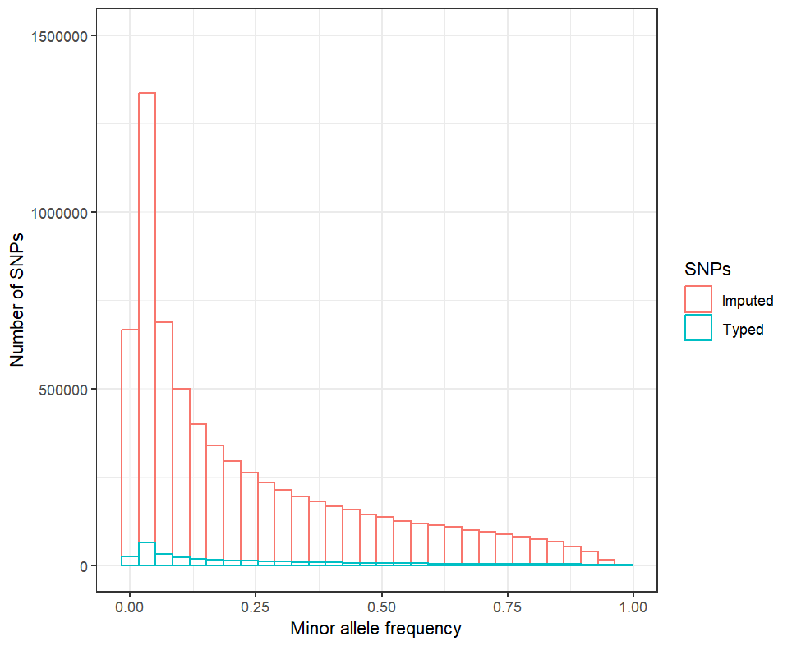

Supplementary Figure 1: SNP enrichment through the SNP imputation process.
Before imputation in blue, we observed a lower number of SNPs (n=400,089). In red after imputation, we significantly increased the number of SNPs (n=7,337,433) available for subsequent association testing, especially those with a minor allele frequency (MAF) >1%.
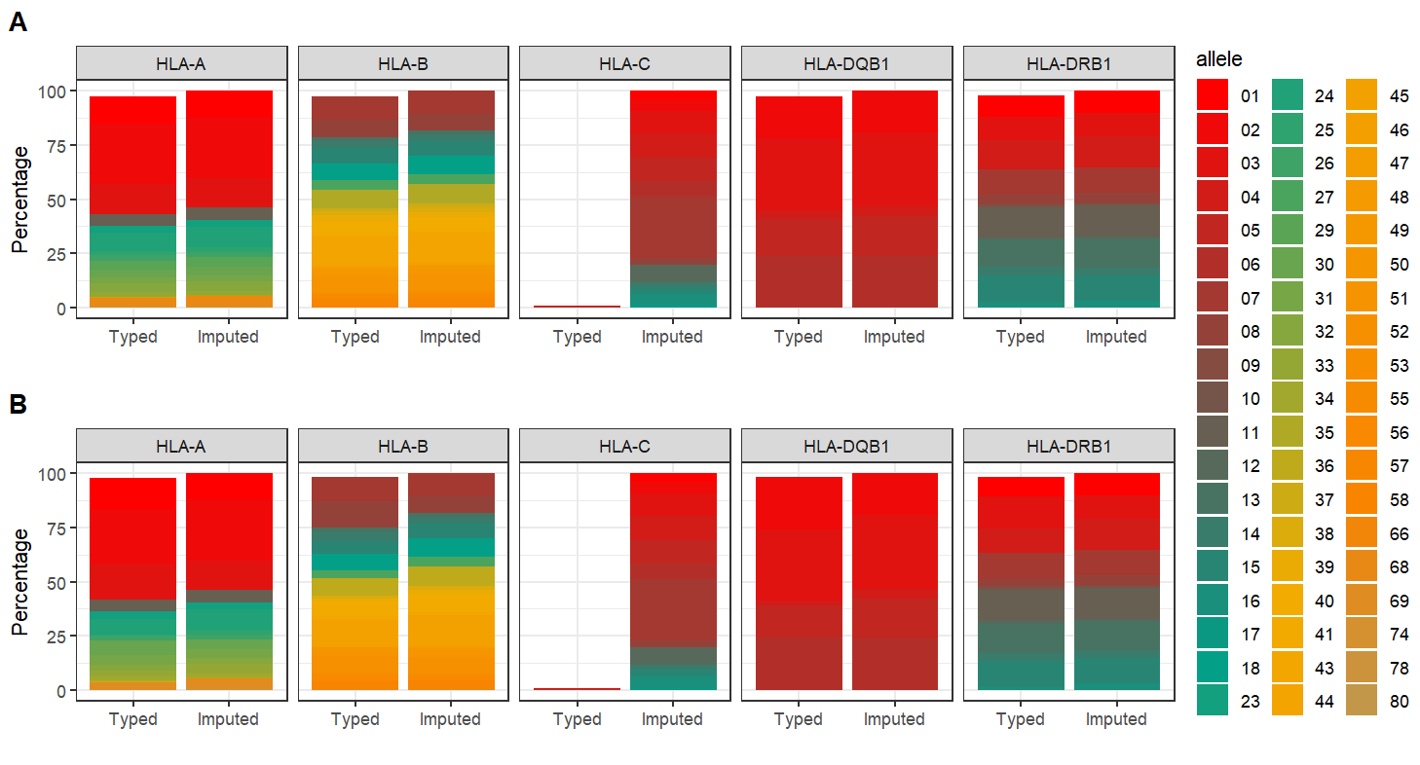

Supplementary Figure 2: Distribution of HLA alleles in GenCOLT individuals according to typed vs. imputed HLA-A, HLA-B, HLA-C, HLA-DRB1 and HLA-DQB1 gene alleles.
We compared the HLA allele (in one-field resolution) distribution before and after imputation with HIBAG in GenCOLT donors (A) and recipients (B).
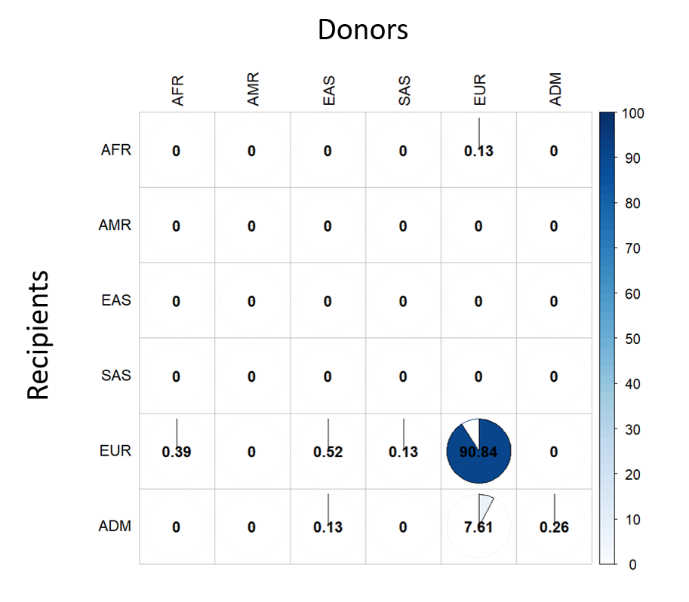

Supplementary Figure 3: Genetic ancestry matching between donors and recipients from GenCOLT pairs.
We evaluated the distribution of genetic ancestry as defined with ADMIXTURE within pairs. Individuals were attributed to an ancestry group when the genetic ancestry proportion was ≥80% in one of the five ancestry reference groups; otherwise, individuals were classified as admixed (ADM).
N.B. AFR, African; AMR, American; EAS, East Asian; EUR, European; SAS, South Asian.

