4-furanylvinylquinoline derivative as a new scaffold for the design of oxidative stress initiator and glucose transporters inhibitor drugs.

Michał Kuczak^{1,2}, Wioleta Cieślik², Robert Musioł², Anna Mrozek-Wilczkiewicz^{1,3*}

¹A. Chelkowski Institute of Physics, University of Silesia in Katowice, 75 Pulku Piechoty 1a, 41-500 Chorzow, Poland
²Institute of Chemistry, University of Silesia in Katowice, Szkolna 9, 40-006 Katowice, Poland
³Biotechnology Centre, Silesian University of Technology, Boleslawa Krzywoustego 8, 44-100 Gliwice, Poland

corresponding author:
*anna.mrozek-wilczkiewicz@us.edu.pl, anna.mrozek-wilczkiewicz@polsl.pl

Keywords: furanylvinylquinolines, cell cycle inhibition, p53 mutation, apoptosis, oxidative stress, GLUT receptor inhibitor, Warburg effect

Table of Contents
- Chemistry 1
- Representative spectra 5
2.1. 1H NMR and 13C NMR spectra 5
2.2. MS spectra 12
- Biological studies 17
  - Cell cycle inhibition 17
  - Apoptosis induction 19
  - qRT-PCR 20
  - Densitometric analysis of protein level 20

Chemistry
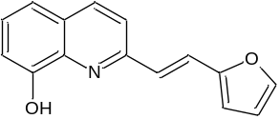2-[(E)-2-(furan-2-yl)vinyl]quinoline-8-ol (1) The compound was obtained by Method B as a beige solid and crystallised from EtOH with a yield of 9%; mp 83-85 ºC; ¹H NMR (500 MHz, DMSO-d₆) δ 9.57 (s, 1H), 8.31 – 8.21 (m, 1H), 8.00 (d, J = 16.0 Hz, 1H), 7.83 – 7.69 (m, 2H), 7.43 – 7.30 (m, 2H), 7.22 (d, J = 16.0 Hz, 1H), 7.12 – 7.02 (m, 1H), 6.78 – 6.58 (m, 2H); ¹³C NMR (126 MHz, DMSO-d₆) δ 153.48, 153.35, 152.92, 144.54, 138.61, 136.95, 128.08, 127.48, 126.19, 122.48, 121.54, 118.01, 112.90, 112.15, 111.67; LR-MS: calculated for C₁₅H₁₁NO₂ [M+H]⁺: 238.08625 m/z, found 238.0 m/z.
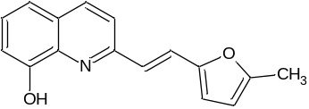2-[(E)-2-(5-methylfuran-2-yl)vinyl]quinolin-8-ol (2) The compound was obtained by Method B as a beige solid and crystallised from EtOH with a yield of 23%; mp 96-98 ºC; ¹H NMR (500 MHz, DMSO-d₆) δ 9.52 (s, 1H), 8.24 (d, J = 8.6 Hz, 1H), 7.93 (d, J = 16.1 Hz, 1H), 7.71 (d, J = 8.6 Hz, 1H), 7.36 (dt, J = 6.0, 2.3 Hz, 1H), 7.33 (dd, J = 8.2, 1.6 Hz, 1H), 7.12 (d, J = 16.1 Hz, 1H), 7.07 (dd, J = 7.2, 1.6 Hz, 1H), 6.60 (d, J = 3.1 Hz, 1H), 6.27 – 6.24 (m, 1H), 2.37 (s, 3H); ¹³C NMR (126 MHz, DMSO-d₆) δ 153.78, 153.27, 151.55, 138.60, 136.85, 127.95, 127.49, 127.29, 124.68, 122.51, 121.49, 117.98, 113.65, 111.57, 109.28, 14.06; LR-MS: calculated for C₁₆H₁₃NO₂ [M+H]⁺: 252.10190 m/z, found 252.0 m/z.
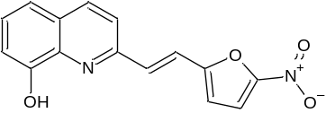2-[(E)-2-(5-nitrofuran-2-yl)vinyl]quinolin-8-ol (3) The compound was obtained by Method B as a yellow solid and crystallised from EtOH with a yield of 48%; mp 189-191 ºC; ¹H NMR (500 MHz, DMSO-d₆) δ 9.77 (s, 1H), 8.34 (d, J = 8.5 Hz, 1H), 8.17 (d, J = 16.0 Hz, 1H), 7.84 (d, J = 8.5 Hz, 1H), 7.81 (d, J = 3.9 Hz, 1H), 7.63 (d, J = 16.0 Hz, 1H), 7.48 – 7.40 (m, 1H), 7.39 (dd, J = 8.2, 1.2 Hz, 1H), 7.14 (d, J = 3.9 Hz, 1H), 7.11 (dd, J = 7.5, 1.3 Hz, 1H); ¹³C NMR (126 MHz, DMSO-d₆) δ 156.00, 153.71, 152.02, 151.79, 138.74, 137.31, 133.27, 128.63, 128.43, 122.18, 120.55, 118.04, 115.96, 114.08, 111.93; LR-MS: calculated for C₁₅H₁₀N₂O₂ [M+H]⁺: 283.07133 m/z, found 283.0 m/z.
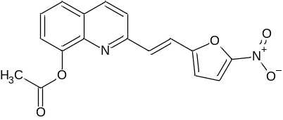2-[(E)-2-(5-nitrofuran-2-yl)vinyl]quinolin-8-yl acetate (4) The compound was obtained by Method A as an orange solid and crystallised from EtOH with a yield of 81%; mp 173-175 ºC; ¹H NMR (500 MHz, Chloroform-d) δ 8.21 (d, J = 8.5 Hz, 1H), 7.73 (dd, J = 8.1, 1.1 Hz, 1H), 7.59 (d, J = 8.5 Hz, 1H), 7.57 – 7.52 (m, 3H), 7.48 (dd, J = 7.5, 1.2 Hz, 1H), 7.42 (t, J = 6.4 Hz, 1H), 6.70 (t, J = 10.0 Hz, 1H), 2.58 (s, 3H); ¹³C NMR (126 MHz, Chloroform-d) δ 169.75, 155.10, 153.50, 151.78, 147.54, 141.14, 136.90, 133.46, 129.06, 126.60, 125.67, 122.03, 121.41, 119.42, 113.83, 112.56, 21.02; LR-MS: calculated for C₁₇H₁₂N₂O₅ [M+H]⁺: 325.08190 m/z, found 325.0 m/z.
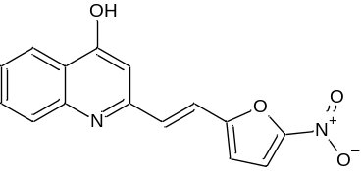2-[(E)-2-(5-nitrofuran-2-yl)vinyl]quinolin-4-ol (5) The compound was obtained by Method B as a yellow solid and crystallised from MeOH with a yield of 55%; mp 306-308 ºC; ¹H NMR (500 MHz, DMSO-d₆) δ 11.69 (s, 1H), 8.06 (dd, J = 8.1, 1.2 Hz, 2H), 7.81 (d, J = 3.9 Hz, 1H), 7.73 – 7.57 (m, 3H), 7.36 – 7.29 (m, 1H), 7.25 (d, J = 16.5 Hz, 1H), 7.15 (d, J = 3.9 Hz, 1H), 6.48 (d, J = 0.9 Hz, 1H); ¹³C NMR (126 MHz, DMSO-d₆) δ 177.93, 154.33, 152.09, 146.27, 141.11, 132.68, 126.92, 126.01, 125.21, 123.89, 121.27, 118.81, 115.66, 115.21, 108.29; LR-MS: calculated for C₁₅H₁₀N₂O₄ [M+H]⁺: 283.07133 m/z, found 283.0 m/z.
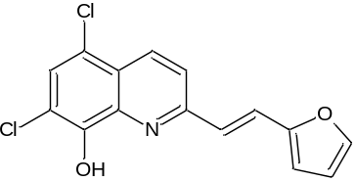5,7-dichloro-2-[2-(furan-2yl)vinyl]-quinolin-8-ol (6) The compound was obtained by Method B as a brown solid and crystallised from EtOH with a yield of 10%; mp 253-255 ºC; ¹H NMR (500 MHz, DMSO-d₆) δ 10.48 (s, 1H), 8.43 (d, J = 8.7 Hz, 1H), 8.18 (d, J = 15.9 Hz, 1H), 7.90 (d, J = 8.7 Hz, 1H), 7.84 (d, J = 1.3 Hz, 1H), 7.73 (s, 1H), 7.26 (d, J = 15.9 Hz, 1H), 6.79 (d, J = 3.3 Hz, 1H), 6.66 (dd, J = 3.3, 1.8 Hz, 1H); ¹³C NMR (126 MHz, DMSO-d₆) δ 155.35, 152.72, 149.10, 145.07, 139.26, 133.79, 127.39, 125.07, 124.28, 124.01, 123.02, 119.59, 115.87, 113.10; LR-MS: calculated for C₁₅H₉Cl₂NO₂ [M+H]⁺: 306.00831 m/z, found 306.0 m/z.
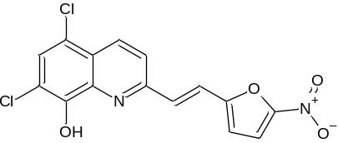5,7-dichloro-2-[2-(5-nitrofuran-2yl)vinyl]-quinolin-8-ol (7) The compound was obtained by Method B as a beige solid and crystallised from EtOH with a yield of 84%; mp 270-271 ºC; ¹H NMR (500 MHz, DMSO-d₆) δ 10.71 (s, 1H), 8.51 (d, J = 8.7 Hz, 1H), 8.33 (d, J = 16.0 Hz, 1H), 7.99 (d, J = 8.8 Hz, 1H), 7.82 (d, J = 3.9 Hz, 1H), 7.80 (s, 1H), 7.65 (d, J = 16.0 Hz, 1H), 7.17 (d, J = 3.9 Hz, 1H); ¹³C NMR (126 MHz, DMSO-d₆) δ 155.57, 153.79, 151.91, 149.37, 139.19, 134.17, 132.05, 128.21, 124.50, 123.50, 122.24, 119.56, 116.06, 115.80, 114.61; LR-MS: calculated for C₁₅H₈Cl₂N₂O₄ [M+H]⁺: 350.99339 m/z, found 351.0 m/z.
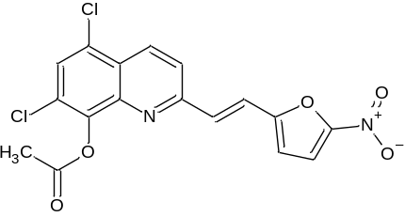5,7-dichloro-2-[2-(5-nitrofuran-2yl)vinyl]-quinolin-8-yl acetate (8) The compound was obtained by Method A as a beige solid and crystallised from EtOH with a yield of 77%; mp 220-222 ºC; ¹H NMR (500 MHz, DMSO-d₆) δ 8.61 (d, J = 8.8 Hz, 1H), 8.13 (d, J = 8.8 Hz, 1H), 8.07 (s, 1H), 7.83 (d, J = 3.9 Hz, 1H), 7.80 (d, J = 16.2 Hz, 1H), 7.58 (d, J = 16.2 Hz, 1H), 7.29 (d, J = 3.9 Hz, 1H), 2.58 (s, 3H); ¹³C NMR (126 MHz, DMSO-d₆) δ 168.74, 156.02, 154.92, 152.09, 143.12, 141.89, 134.52, 132.09, 128.73, 127.46, 127.16, 125.29, 123.46, 122.44, 122.20, 115.75, 20.76; LR-MS: calculated for C₁₇H₁₀Cl₂N₂O₅ [M+H]⁺: 393.00395 m/z, found 393.0 m/z.
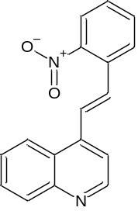4-[(E)-2-(2-nitrophenyl)vinyl]quinoline (9) The compound was obtained by Method A as a beige solid and crystallised from EtOAc with a yield of 32 %; mp 161-163 ºC; ¹H NMR (500 MHz, DMSO-d₆) δ 8.94 (d, J = 4.6 Hz, 1H), 8.52 (d, J = 8.5 Hz, 1H), 8.25 (d, J = 8.5 Hz, 1H), 8.12 (d, J = 16.0 Hz, 1H), 8.07 (d, J = 8.4 Hz, 2H), 7.87 – 7.83 (m, 1H), 7.83 – 7.76 (m, 3H), 7.69 (ddd, J = 8.4, 6.8, 1.4 Hz, 1H), 7.65 (ddd, J = 8.4, 6.8, 1.4 Hz, 1H). ¹³C NMR (126 MHz, DMSO) δ 150.86, 148.71, 148.60, 142.06, 134.16, 131.77, 130.34, 130.04, 129.67, 127.79, 127.30, 126.14, 125.07, 124.65, 117.95. HR-MS: calculated for C₁₇H₁₂N₂O₂ [M+H]⁺: 277.097154 m/z, found 277.09653 m/z.
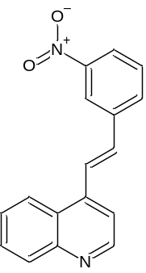4-[(E)-2-(3-nitrophenyl)vinyl]quinoline (10) The compound was obtained by Method A as a beige solid and crystallised from EtOAc with a yield of 33%; mp 111-112 ºC; ¹H NMR (500 MHz, DMSO) δ 8.92 (d, J = 4.6 Hz, 1H), 8.68 (s, 1H), 8.60 (d, J = 8.2 Hz, 1H), 8.34-8.31 (m, 2H), 8.19 (dd, J = 8.2, 1.6 Hz, 1H), 8.06 (d, J = 8.2 Hz, 1H), 7.88 (d, J = 4.6 Hz, 1H), 7.81 (dt, J = 8.2, 2.9 Hz, 1H), 7.78 – 7.71 (m, 2H), 7.71 – 7.65 (m, 1H). ¹³C NMR (126 MHz, DMSO) δ 150.72, 148.89, 148.77, 142.11, 138.81, 134.03, 133.34, 130.69, 130.02, 129.96, 127.15, 126.24, 125.91, 124.81, 123.49, 122.42, 117.50. HR-MS: calculated for C₁₇H₁₂N₂O₂ [M+H]⁺: 277.097154 m/z, found 277.09692 m/z.
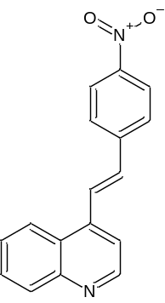4-[(E)-2-(4-nitrophenyl)vinyl]quinoline (11) The compound was obtained by Method A as a yellow solid and crystallised from EtOAc with a yield of 41%; mp 228-229 ºC; ¹H NMR (500 MHz, DMSO-d₆) δ 8.94 (d, J = 8.9 Hz, 1H), 8.58 (dd, J = 9.5, 1.9 Hz, 1H), 8.37 (d, J = 16.2 Hz, 1H), 8.30 (d, J = 8.9 Hz, 2H), 8.13 (d, J = 8.9 Hz, 2H), 8.07 (dd, J = 9.5, 1.9 Hz, 1H), 7.92 (d, J = 4.6 Hz, 1H), 7.82 (ddd, J = 8.2, 6.8, 1.4 Hz, 1H), 7.76 (d, J = 16.2 Hz, 1H), 7.70 (ddd, J = 8.2, 6.8, 1.4 Hz, 1H). ¹³C NMR (126 MHz, DMSO-d₆) δ 150.76, 148.78, 147.42, 143.58, 141.83, 133.33, 130.27, 130.08, 130.02, 128.94, 127.59, 127.30, 126.19, 124.64, 124.46, 124.08, 117.66. HR-MS: calculated for C₁₇H₁₂N₂O₂ [M+H]⁺: 277.097154 m/z, found 277.0979 m/z.
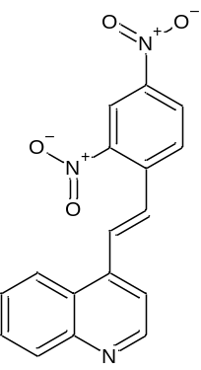4-[(E)-2-(2,4-dinitrophenyl)vinyl]quinoline (12) The compound was obtained by Method A as a yellow solid and crystallised from EtOAc with a yield of 43%; mp 200-201 ºC; ¹H NMR (500 MHz, DMSO-d₆) δ 8.97 (d, J = 4.6 Hz, 1H), 8.81 (d, J = 2.3 Hz, 1H), 8.59 (dd, J = 8.7, 2.3 Hz, 1H), 8.57 – 8.53 (m, 2H), 8.36 (d, J = 16.0 Hz, 1H), 8.09 (dd, J = 8.4, 1.3 Hz, 1H), 7.88 – 7.81 (m, 3H), 7.72 (ddd, J = 8.3, 6.8, 1.4 Hz, 1H). ¹³C NMR (126 MHz, DMSO-d₆) δ 150.93, 148.74, 148.22, 147.17, 141.44, 137.54, 131.48, 131.13, 130.24, 130.08, 128.75, 127.93, 127.52, 126.07, 124.66, 120.78, 118.30. HR-MS: calculated for C₁₇H₁₁N₃O₄ [M+H]⁺: 322.082232 m/z, found 322.08185 m/z.
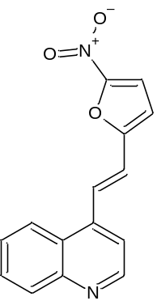4-[(E)-2-(5-nitrofuran-2-yl)vinyl]quinoline (13) The compound was obtained by Method A as a yellow solid and crystallised from EtOH with a yield of 45%; mp 147-148 ºC; ¹H NMR (500 MHz, DMSO-d₆) δ 8.94 (d, J = 4.6 Hz, 1H), 8.45 (dd, J = 8.4, 1.3 Hz, 1H), 8.22 (d, J = 16.2 Hz, 1H), 8.08 (dd, J = 8.4, 1.3 Hz, 1H), 7.93 (d, J = 4.7 Hz, 1H), 7.86 – 7.81 (m, 2H), 7.72 (ddd, J = 8.4, 6.8, 1.3 Hz, 1H), 7.64 (d, J = 16.2 Hz, 1H), 7.35 (d, J = 4.6 Hz, 1H). ¹³C NMR (126 MHz, DMSO-d₆) δ 155.79, 151.82, 150.73, 148.79, 140.54, 130.16, 130.12, 128.05, 127.58, 125.82, 124.15, 121.49, 117.67, 115.91, 114.00. HR-MS: calculated for C₁₅H₁₀N₂O₃ [M+H]⁺: 267.076419 m/z, found 267.0775 m/z.

Representative spectra

¹H NMR and ¹³C NMR spectra

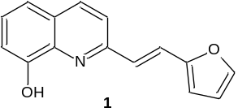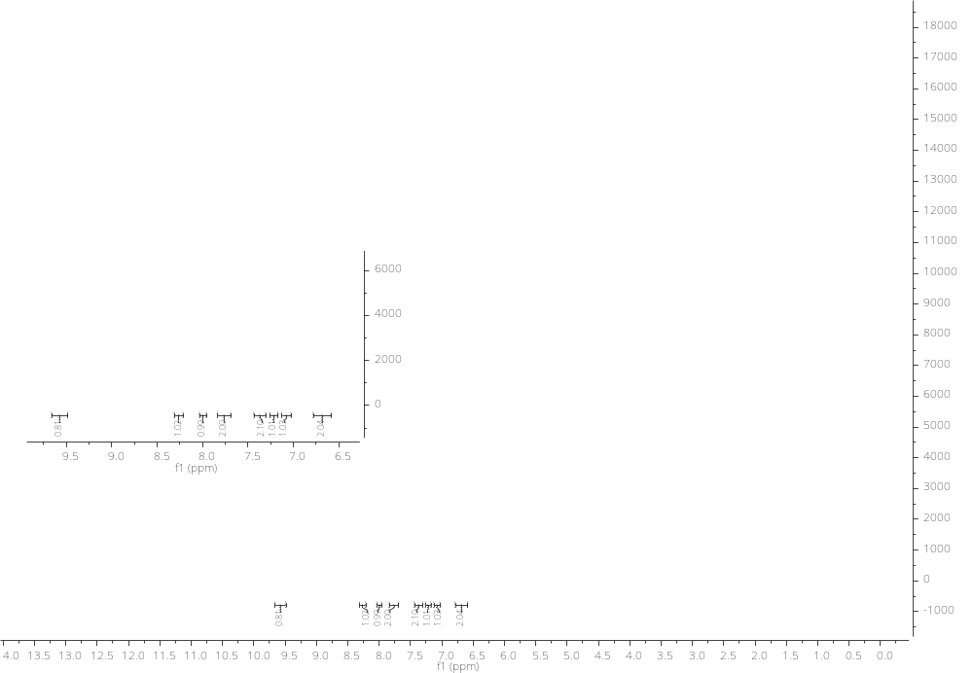
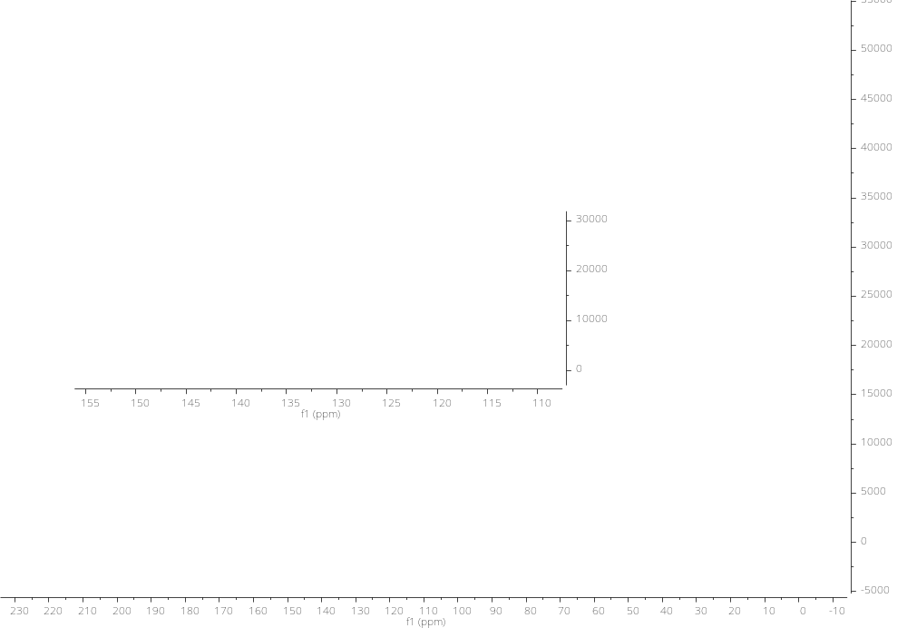

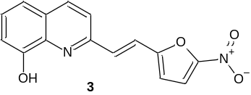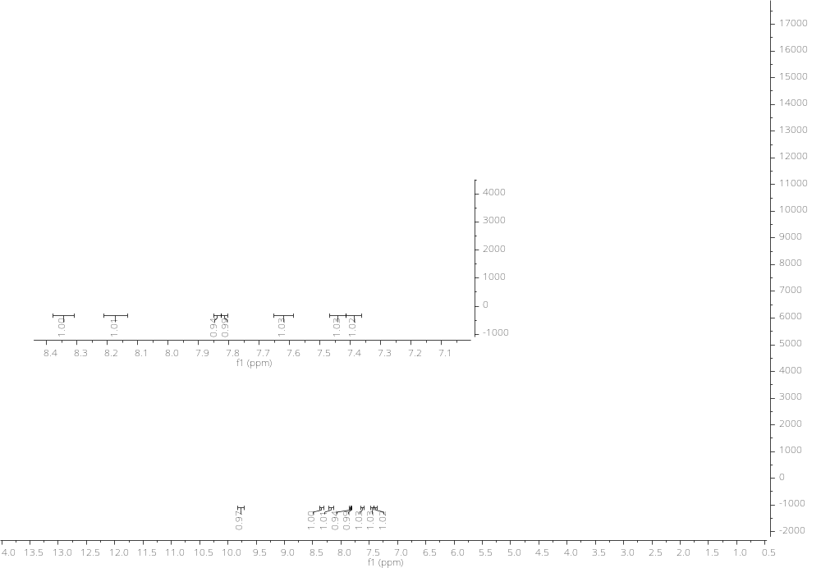
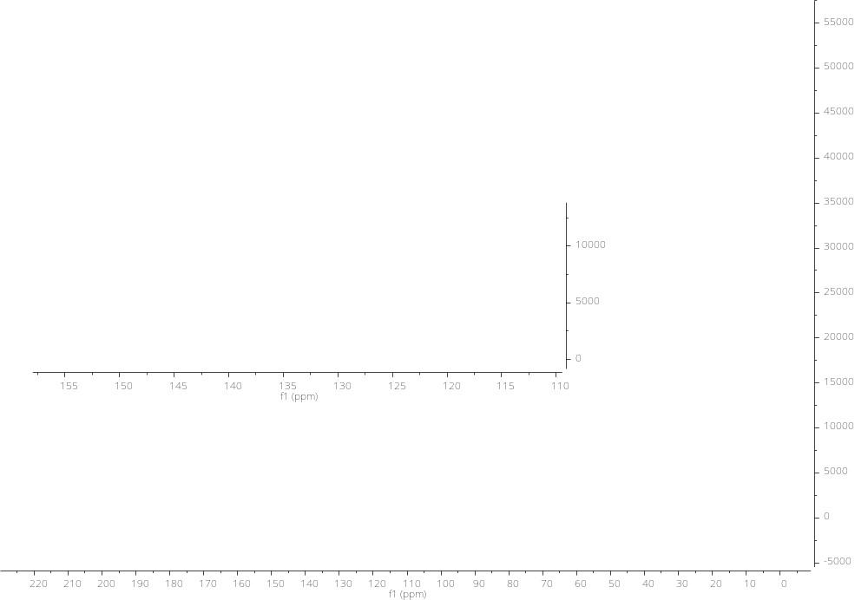
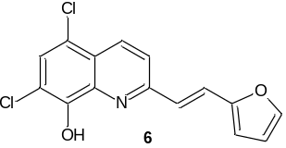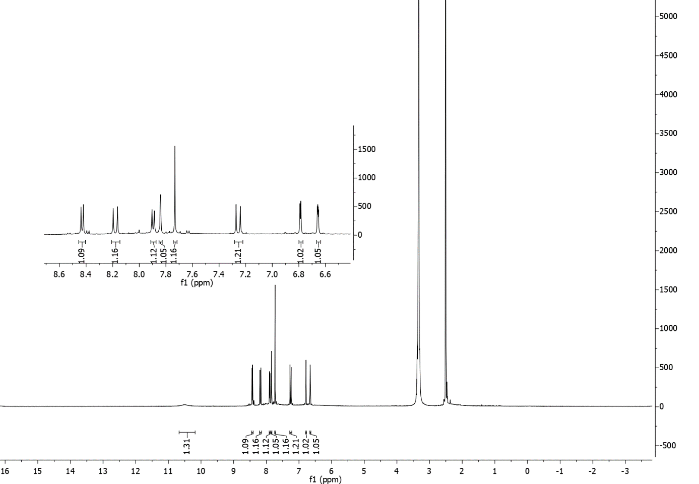
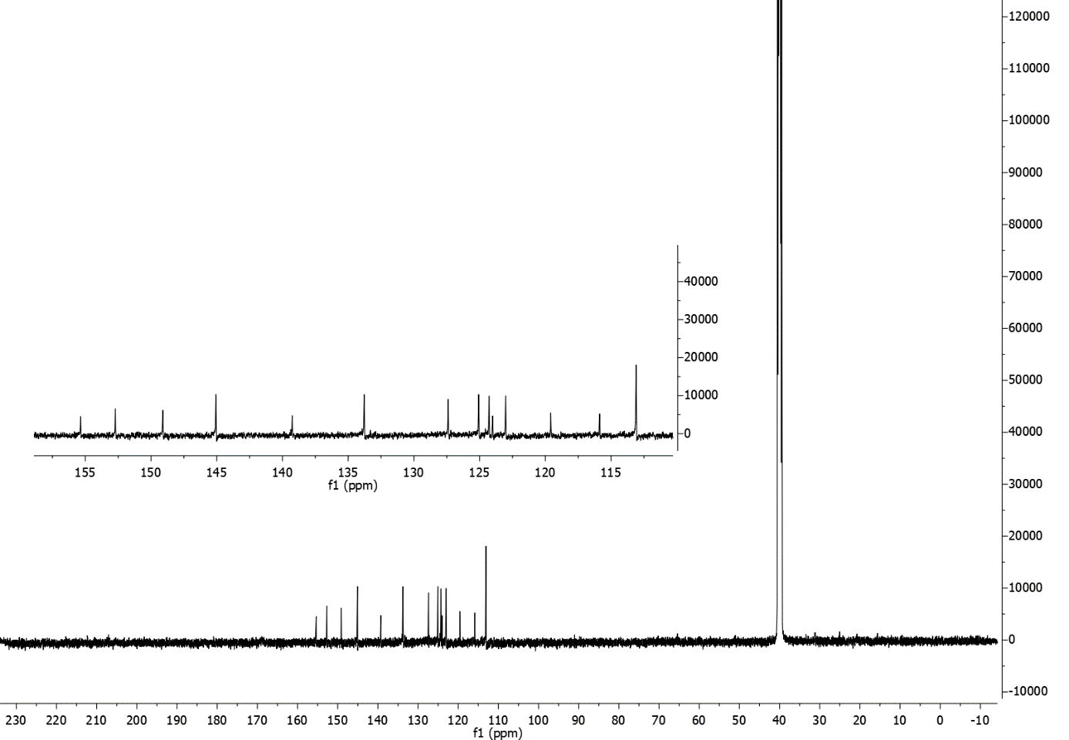

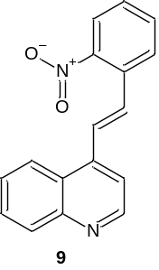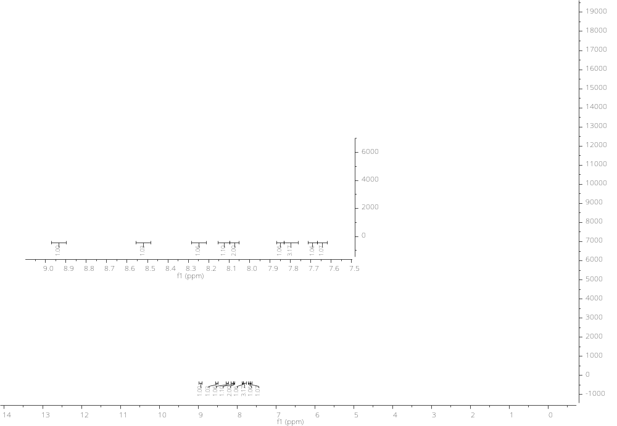
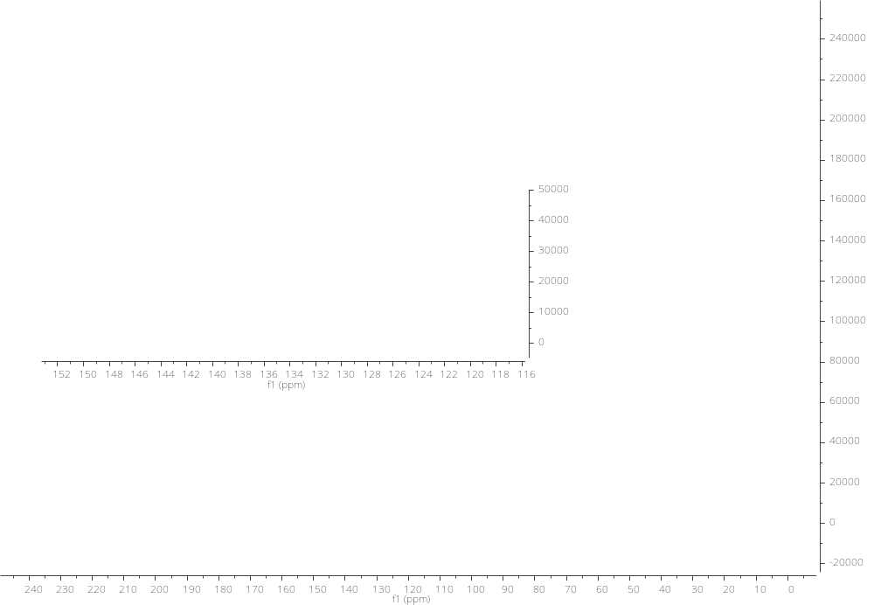
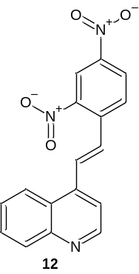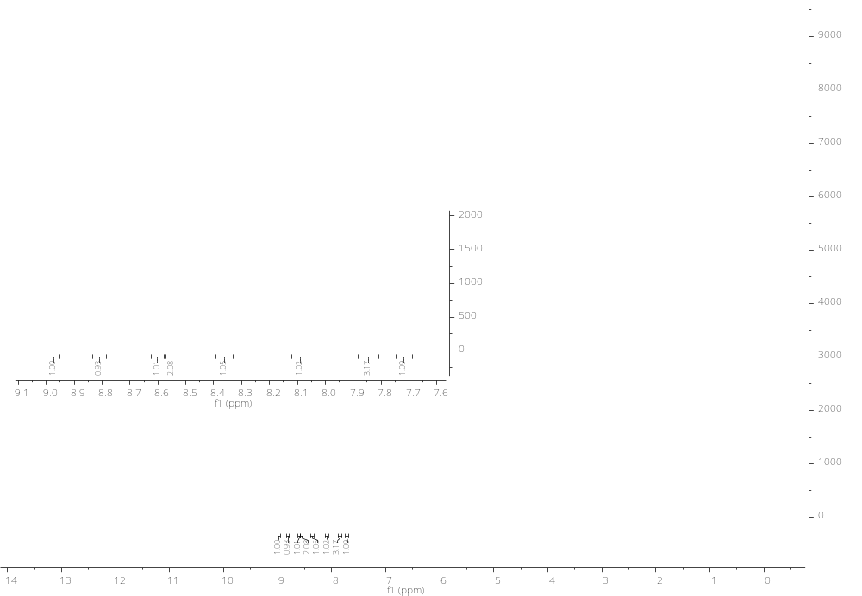
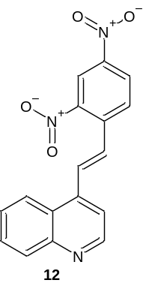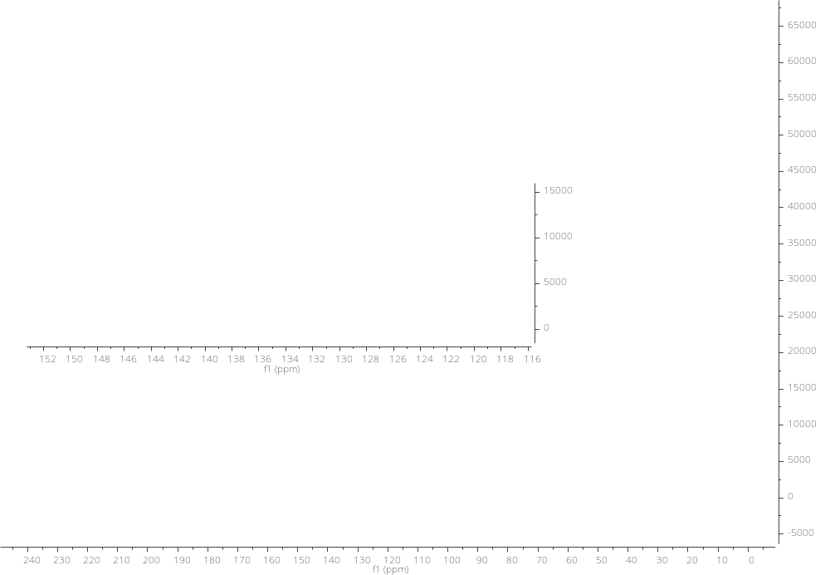
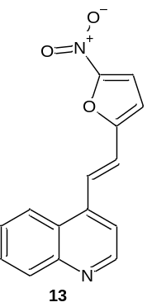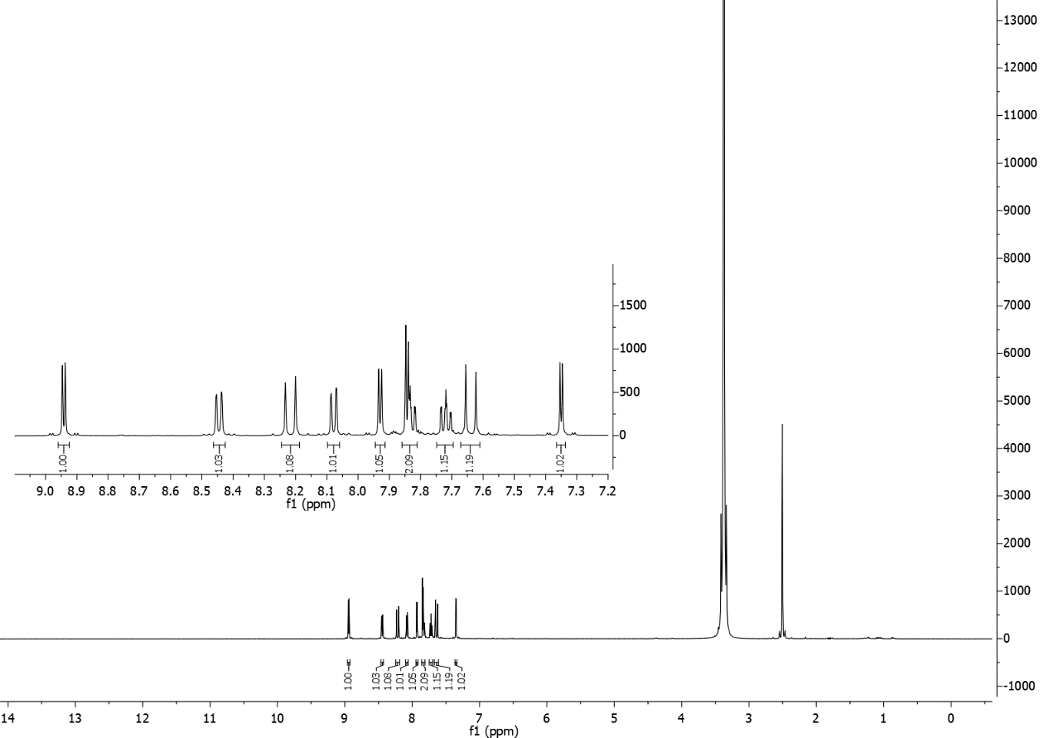
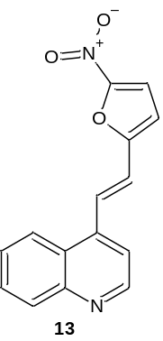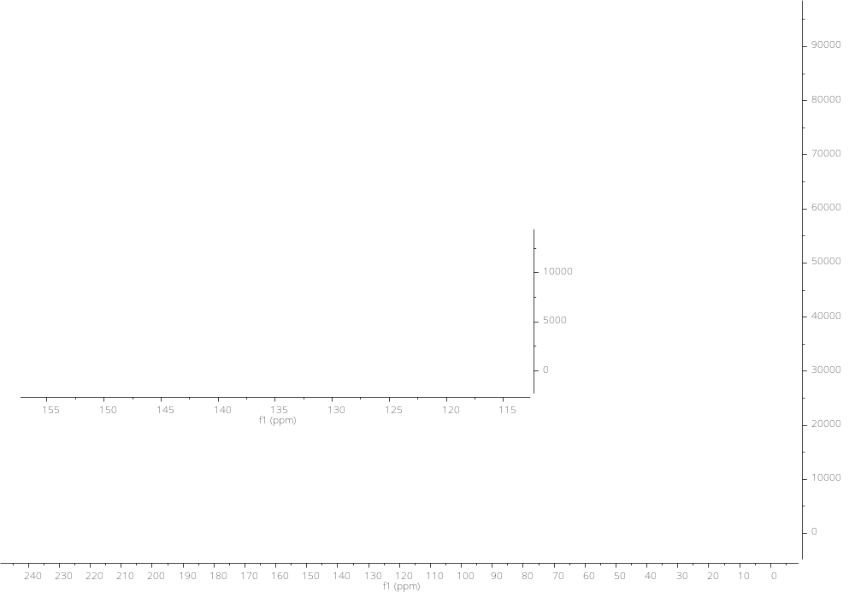

MS spectra
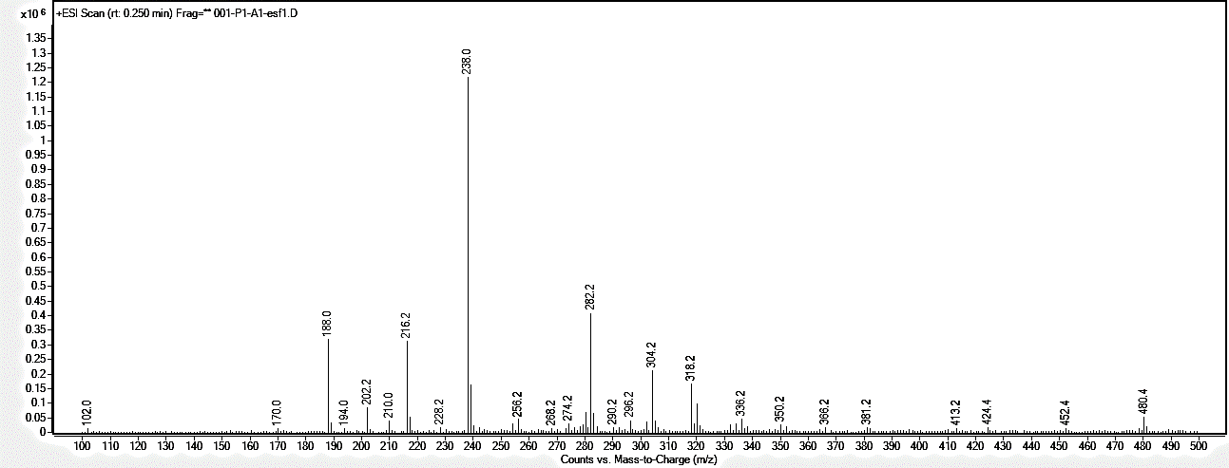

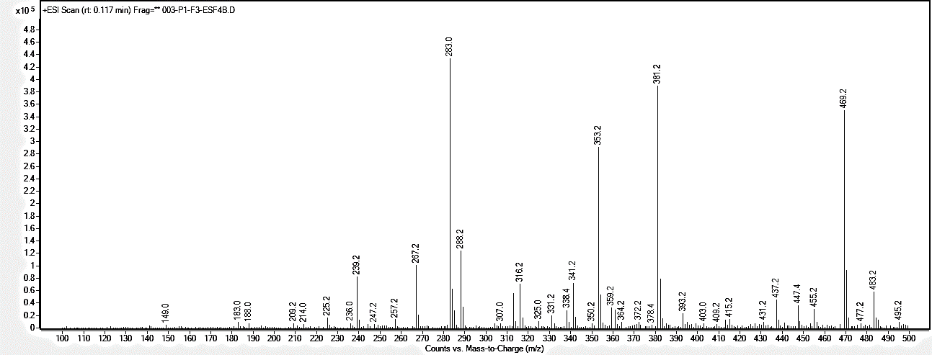
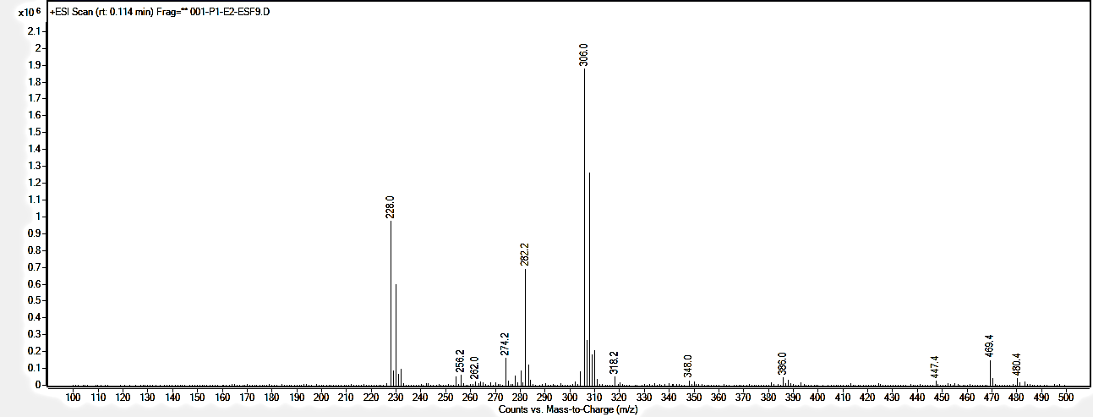
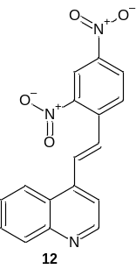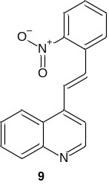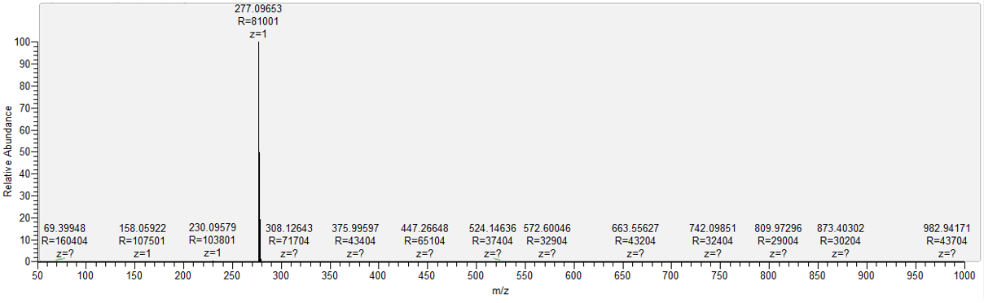
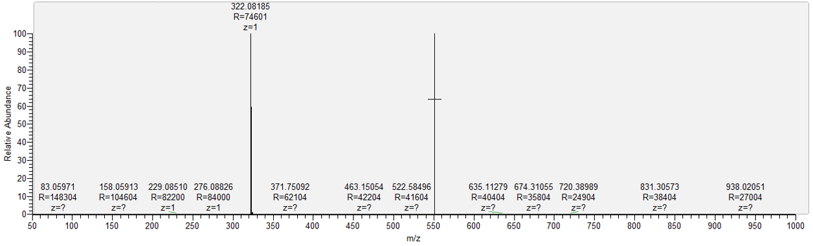
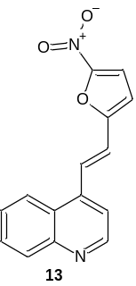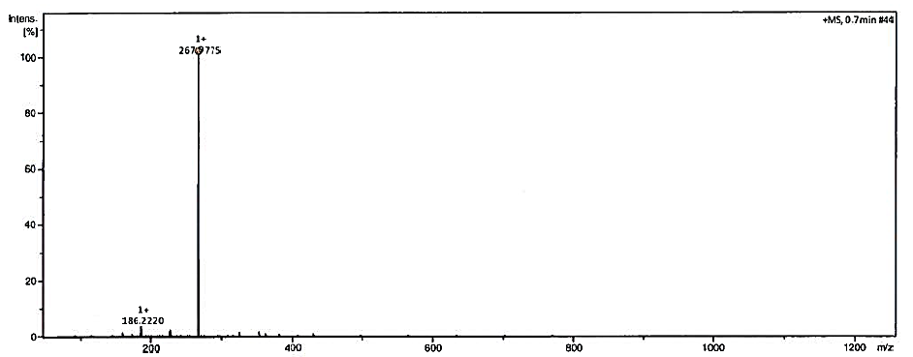

Biological studies

Cell cycle inhibition

Figure S1. The representative histograms from flow cytometry show the distribution of the cells (HCT 116 p53^{+/+}, HCT 116 p53^{-/-}, U-251) in the particular cell cycle phases after 24-h incubation with 13 (concentration 2xIC₅₀).

Figure S2. Absorption spectra of 13 (black, solid line) in decreasing concentration, CT-DNA (red, solid line) and a mixture of 13 with CT-DNA measured after 1.5 h. Absorption λmax 396 nm, Δε M⁻¹ cm⁻¹ 15541,67.

Apoptosis induction
Figure S3. The representative histograms from flow cytometry show the percentage of life, apoptotic (early and late) and dead cells (HCT 116 p53^{+/+}, HCT 116 p53^{-/-}, U-251 after 48-h incubation with 13 (concentration 0.5 µM).

qRT-PCR
Table S1. Sequences of primers used in Real-Time PCR reaction to determine mRNA expression of of selected genes.
Gene | Sequence number in the GenBank database | Starter Forward (5´→3´) | Starter Reverse (5´→3´)
CDK1 | NM_001170407.1 | ATTGAGCGGAGAGCGACG | CCACTTGACCTGTAGTTTTGTGT
TRAIL | NM_003810.4 | AACTCCGTCAGCTCGTTAGA | GTGTTGCTTCTTCCTCTGGTC
DR5 | NM_003842.5 | CCCTGTTCTCTCTCAGGCATC | TCGTTGTGAGCTTCTGTCCA
CASP-8 | NM_001080125.2 | GAGTCATCTCTGTTCTGCTTTAGG | CTGTGAAAACACTTCCCTCCAG
MnSOD | NM_001024465.1 | AAACCTCAGCCCTAACGGTG | CCAGGCTTGATGCACATCTTA
CAT | NM_001752.3 | ACTGTTGCTGGAGAATCGGG | AAGTCTCGCCGCATCTTCAA
GLUT-1 | NM_006516.3 | AGCAACTGTGTGGTCCCTAC | GCTCCTCGGGTGTCTTGTC
GLUT-3 | NM_006931.3 | CGTGGAGAAAACTTGCTGCTG | CTGTGTCCCCATCGCTGTAA
GLUT-4 | NM_001042.3 | CATTCCTTGGTTCATCGTGGC | TAGCCTCCGCAACATACTGG
GADPH | NM_002046 | GAGTCAACGGATTTGGTCGTA | GCCCCACTTGATTTTGGAG

Densitometric analysis of protein level

Figure S4. The charts present the densitometric analysis of results in HCT 116 p53^{+/+} (A), HCT 116 p53^{-/-} (B) and U-251(C) cell lines (as mean ± SD) of several independent experiments. Data were normalized to reference proteins. The statistical analysis was performed using one-way ANOVA with Bonferroni’s post-hoc test: *p<0.05, **p<0.01, ***p<0.001, ****p<0.0001 compared to the untreated cells (control).

