Supplementary Material for “Identifying hotspots of heat waves, droughts, floods, and their co-occurrences”
Marlon Vieira Passos^{a,b,*}, Jung-Ching Kan^{a,b}, Georgia Destouni^{c,b}, Karina Barquetª, Zahra Kalantari^{b,c}
ªStockholm Environment Institute (SEI), SE-104 51, Stockholm, Sweden
^{b}Department of Sustainable Development, Environmental Science and Engineering (SEED), KTH Royal Institute of Technology, SE-100 44, Stockholm, Sweden
^{c}Department of Physical Geography, Stockholm University, SE-106 91, Stockholm, Sweden
*Corresponding Author: marlon.passos@sei.org

Table S1. List of the most intense heat waves in Sweden 1922-2021, based on HWI_{S}.
Month and Year | Total Intensity (°C) | Most Affected County | Duration (days) | Max. Temp. (°C) | Min. Temp. (°C)
July-2018 | 131 | Kalmar | 31 | 32.2 | 19.8
July-1994 | 81 | Östergötland | 19 | 34.1 | 19.7
July-1945 | 71 | Värmland | 13 | 34.9 | 15.3
July-2014 | 70 | Stockholm | 21 | 32.2 | 19.5
July-2003 | 69 | Stockholm | 22 | 31.5 | 20
August-1975 | 66 | Södermanland | 9 | 35.1 | 15
July-1982 | 65 | Värmland | 13 | 33 | 17.3
June-1953 | 65 | Västra Götaland | 13 | 32.7 | 14.3
July-1941 | 61 | Norrbotten | 13 | 33.3 | 15.4
July-1969 | 59 | Västra Götaland | 19 | 30.8 | 16.9

Table S2. List of the most intense droughts in Sweden 1922-2021, based on SPEI12.
Total Intensity | Most Affected County | Duration (months) | Min. Intensity | Start Date | End Date
67.5 | Norrbotten | 35 | -3.2 | October-1945 | September-1948
60 | Stockholm | 39 | -1.9 | April-1971 | July-1974
57.7 | Halland | 35 | -2.3 | February-1932 | January-1935
54.2 | Halland | 39 | -1.8 | October-1936 | January-1940
49.7 | Blekinge | 34 | -2.3 | March-1938 | January-1941
47.5 | Västerbotten | 29 | -2 | January-1946 | July-1948
46.1 | Uppsala | 30 | -2.3 | February-1972 | August-1974
45.7 | Västerbotten | 25 | -2.2 | December-1968 | January-1971
45.2 | Jönköping | 30 | -2.8 | June-1939 | December-1941
44.6 | Jämtland | 21 | -4.3 | February-1948 | November-1949

Table S3. List of the most intense local flood danger periods in Sweden 1922-2021, based on DFI.
Total Intensity | Most Affected County | Duration (days) | Max. Intensity | Start Date | End Date
177.6 | Västernorrland | 105 | 2.8 | 27-10-2000 | 09-02-2001
167.6 | Skåne | 112 | 2.9 | 22-06-2007 | 12-10-2007
166.4 | Västerbotten | 128 | 2.7 | 17-07-1998 | 22-11-1998
162.1 | Kalmar | 129 | 2.5 | 27-09-1960 | 03-02-1961
151.5 | Halland | 129 | 2.5 | 05-11-2006 | 14-03-2007
147.2 | Blekinge | 114 | 3.3 | 01-07-2007 | 23-10-2007
143.2 | Västerbotten | 125 | 3 | 26-08-2001 | 29-12-2001
133.4 | Jämtland | 125 | 2.7 | 09-08-1960 | 12-12-1960
123.5 | Västra Götaland | 139 | 2 | 26-10-2006 | 14-03-2007
121.1 | Uppsala | 89 | 2.4 | 30-10-1981 | 27-01-1982

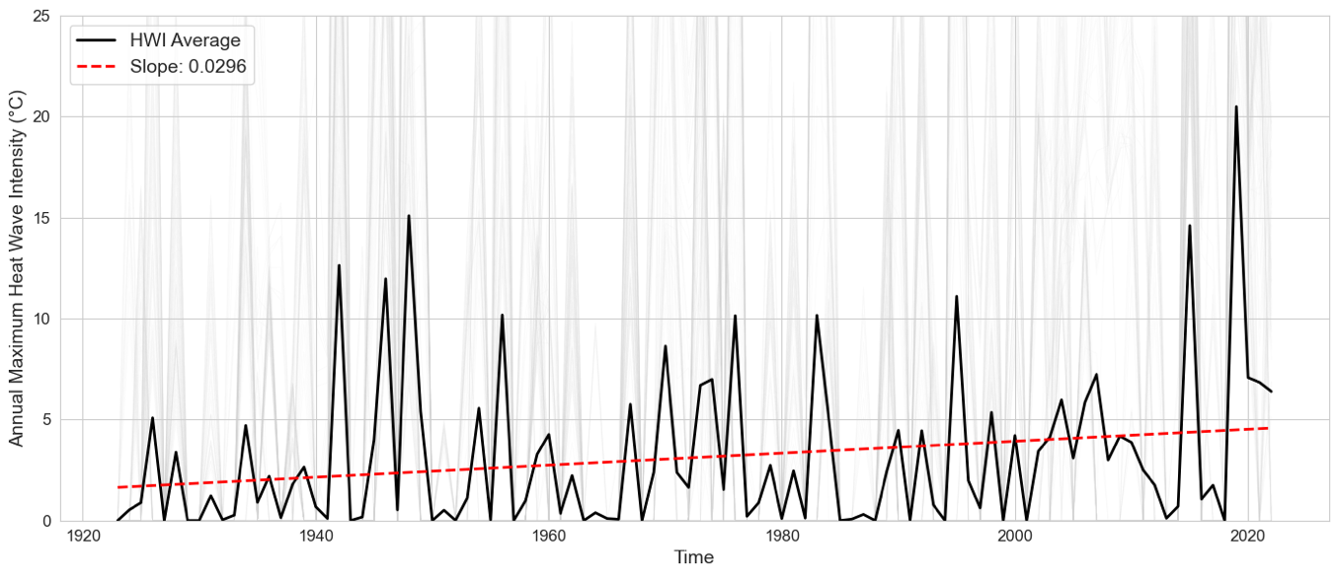
Figure S1. Spatially averaged heat wave trend (SMHI heat wave index, HWI_{S}) in Sweden 1922-2021.
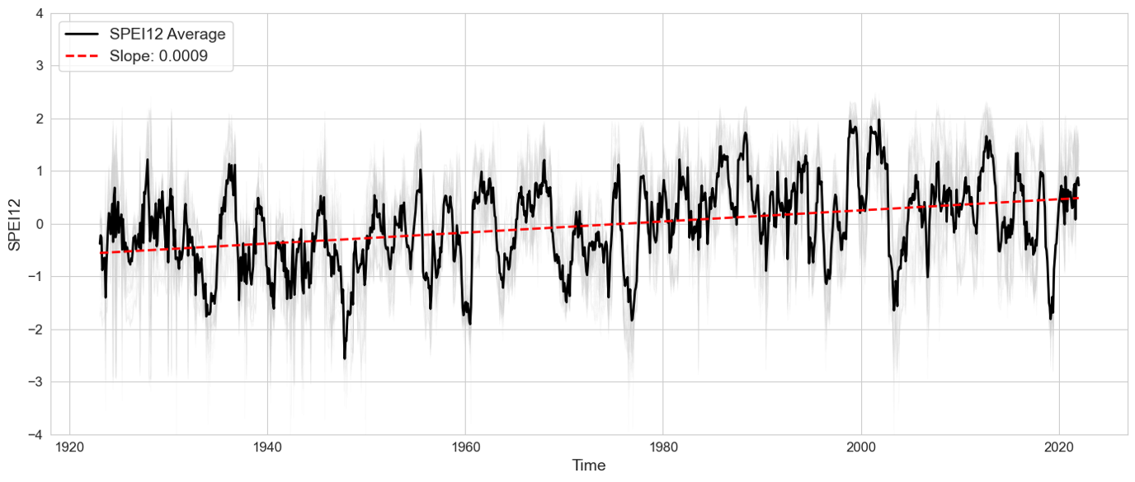
Figure S2. Spatially averaged drought trend (Standardized Precipitation and Evapotranspiration Index, SPEI12) in Sweden 1922-2021.
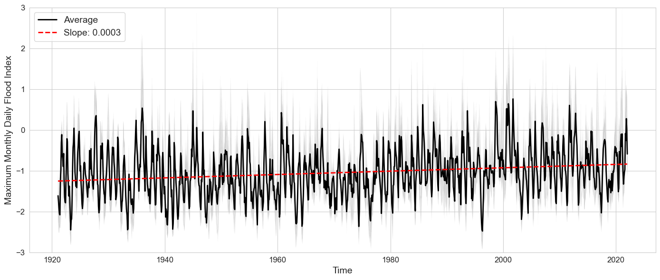
Figure S3. Spatially averaged flood trend (Daily Flood Index, DFI) in Sweden 1922-2021.

Figure S4. Distribution of joint return periods for drought-heatwave-flood hazard pairs, based on the entire study period (1922-2021). No co-occurrences were observed in white areas. Grey areas represent grid cells where the exceedance probability was not statistically significant.

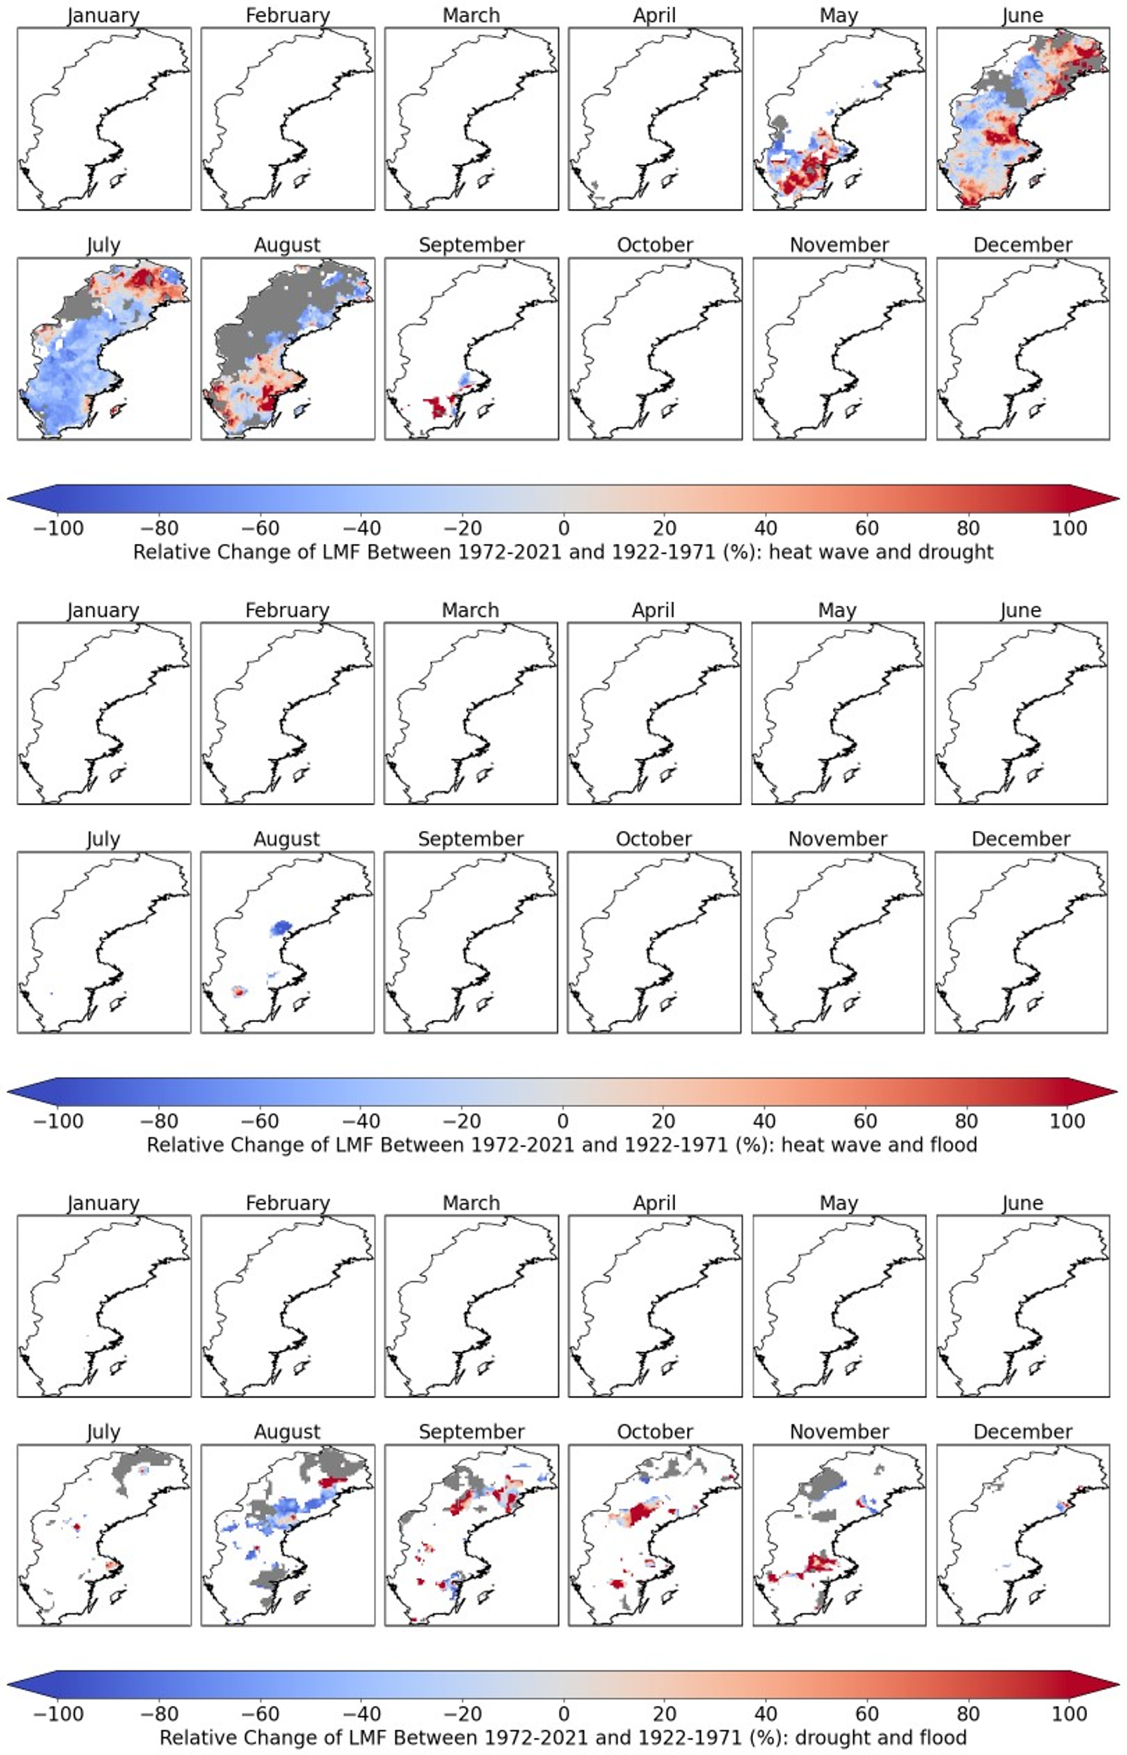
Figure S5. Relative likelihood multiplication factor (LMF) change between the periods 1972-2021 and 1922-1971. No co-occurrences were observed in white areas. Grey areas represent grid cells where the exceedance probability was not statistically significant for either one or both time periods.
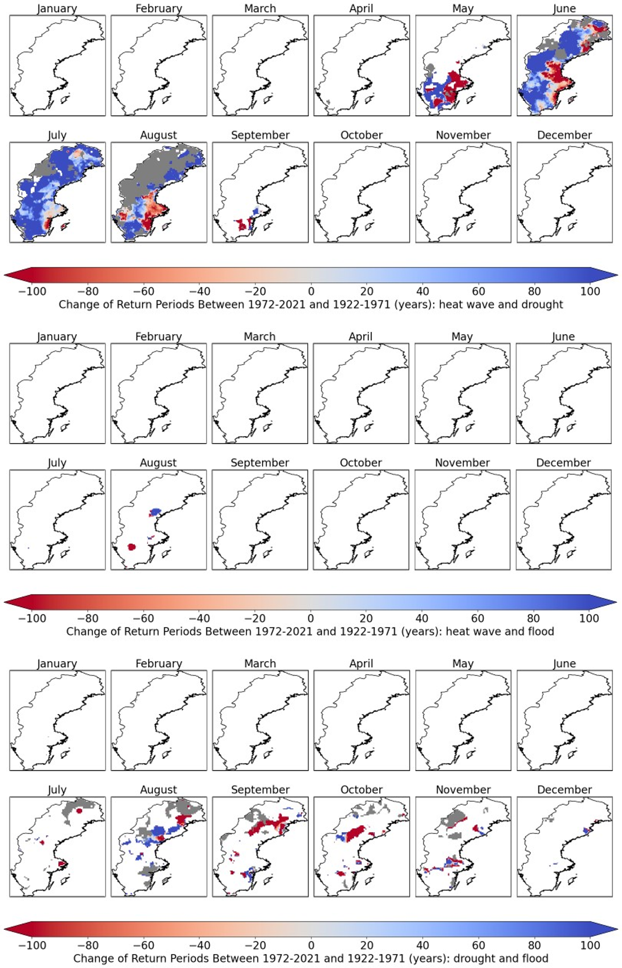
Figure S6. Change in joint return periods between 1972-2021 and 1922-1971. No co-occurrences were observed in white areas. Grey areas represent grid cells where the exceedance probability was not statistically significant for either one or both time periods.

