Extended Data Figures

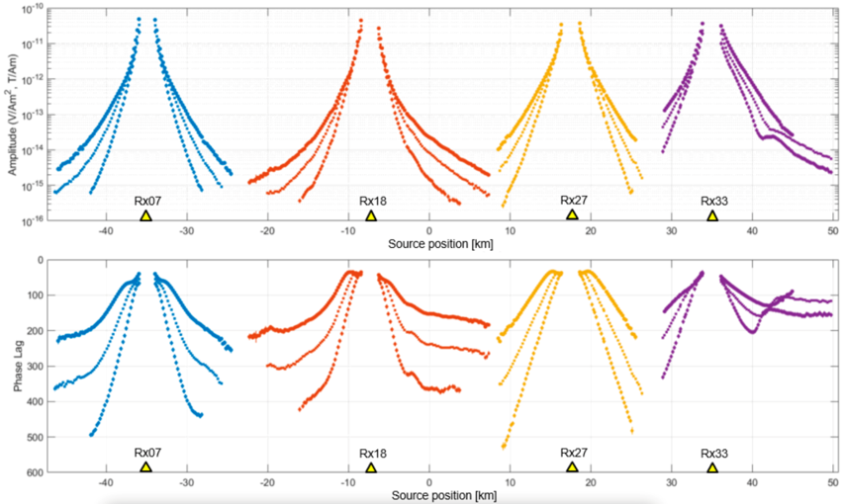

Extended Data Fig. 1a. CSEM data variation. Plot of the controlled source electric field data from receiver Rx07 (blue), Rx18 (red), Rx27 (yellow) and Rx33 (purple) for the three strongest harmonics f=0.25 Hz (dots), f=0.5 Hz (squares) and f=1.0 Hz (prisms). The electric field amplitude (top-panel) and electric field phase (bottom-panel) are plotted for different source positions along the profile.

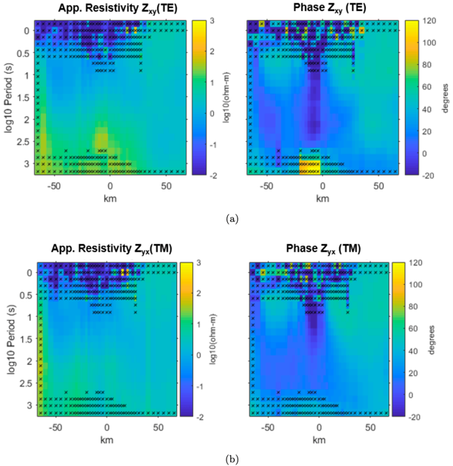
Extended Data Fig. 1b. MT data inclusion and exclusion. Pseudo-section of the processed MT data showing apparent resistivity and phase for the TE mode (a) and apparent resistivity and phase for the TM mode (b). The data in each panel are plotted for all seafloor receivers from west (left) to east (right). Data points marked with black stars have high noise levels and are not used for subsequent analysis and inversion.

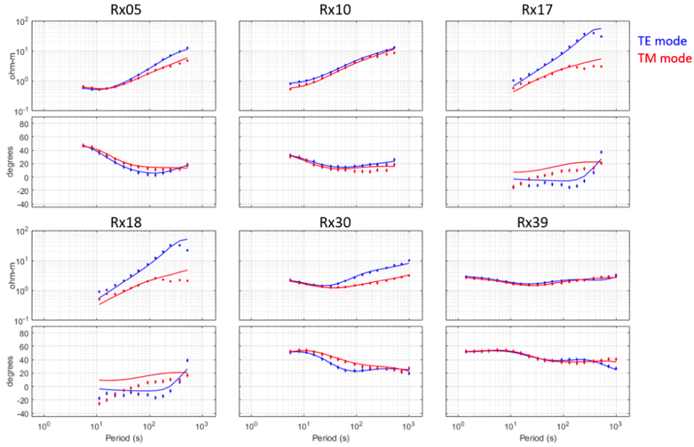

Extended Data Fig. 1c. Selected Data fits. Data fit for the TE-TM mode inversion result for some selected receivers Rx005, Rx010, Rx017, Rx018, Rx030, Rx039 (from top left to bottom right). The data fit is particularly poor for receivers located in the trench (i.e. Rx017 and Rx018).

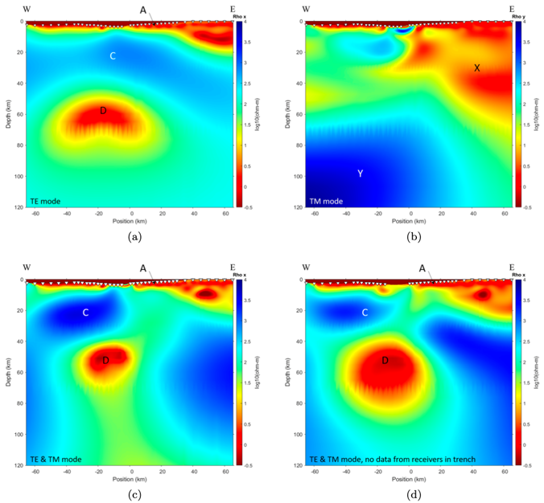
Extended Data Fig. 2. Resistivity models inverted from MT data. The resistivity component perpendicular to the profile (ρ_{x} ) is shown for the TE-mode inversion (a), the resistivity component parallel to the profile (ρ_{y} ) is shown for the TM-mode inversion (b). The joint TM-TE mode inversion results (ρ_{x}) including and excluding data from the receivers in the trench are shown in (c) and (d).

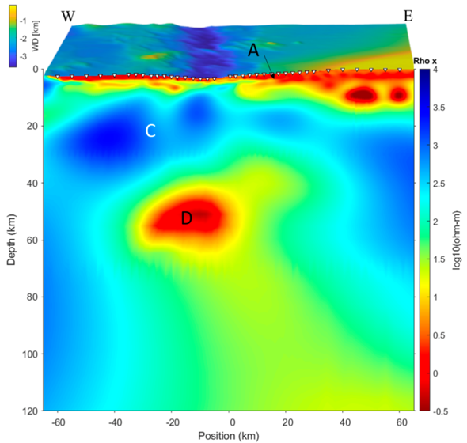

Extended Data Fig. 3. Resistivity model jointly inverted from CSEM and MT data. Display of the resistivity component (ρ_{x}) perpendicular to the profile for the joint CSEM-MT inversion result and the bathymetry north of the profile. The receiver locations are indicated by white triangles. C is the resistive lithosphere, and D is conductive melts.

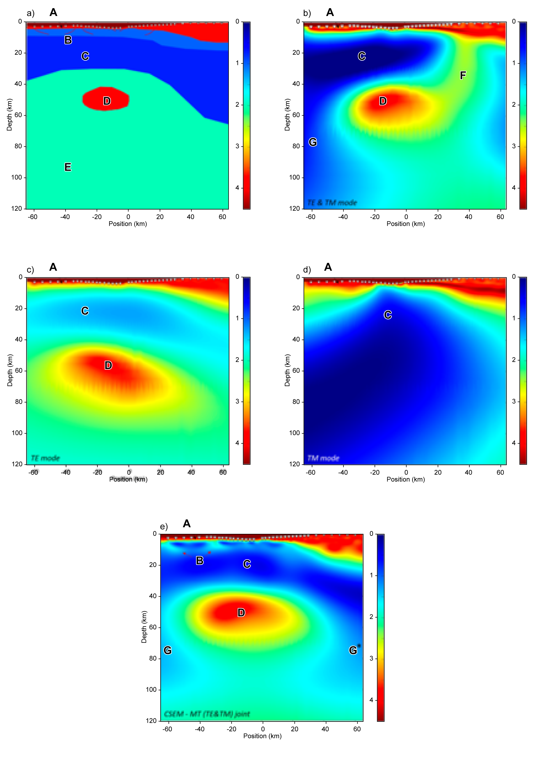

Extended Data Fig. 4. Synthetic resolution and imaging test. Deep synthetic resistivity model (a), corresponding synthetic MT (TE- and TM-mode) inversion result of ρ_{x} (b), the corresponding TE-mode inversion result of ρ_{x} (c), the corresponding TM-mode inversion result of ρ_{y} (d) and the joint CSEM-MT inversion result of ρ_{x} (e).

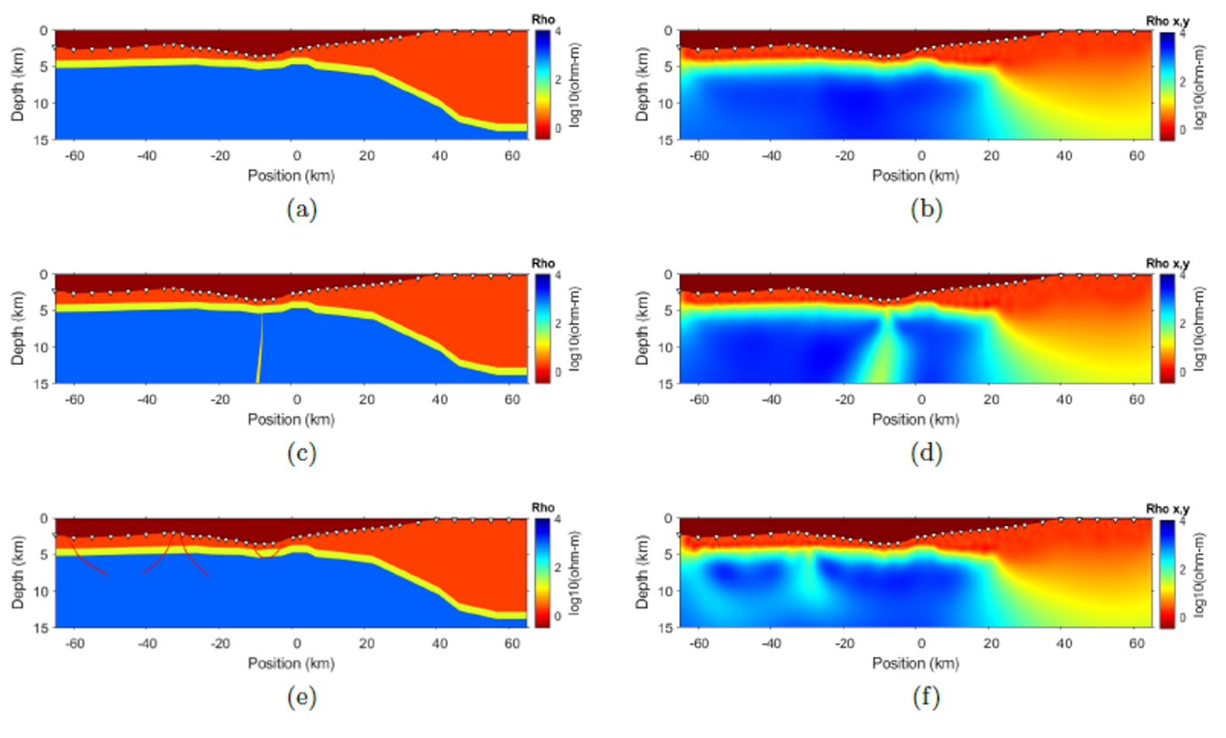
Extended Data Fig. 5. Resistivity model for the synthetic inversion test at ATLAB-2 (Panels a, c, e)) and corresponding inversion results (Panels b, d, f). Small white triangles are receiver positions at the sea floor.

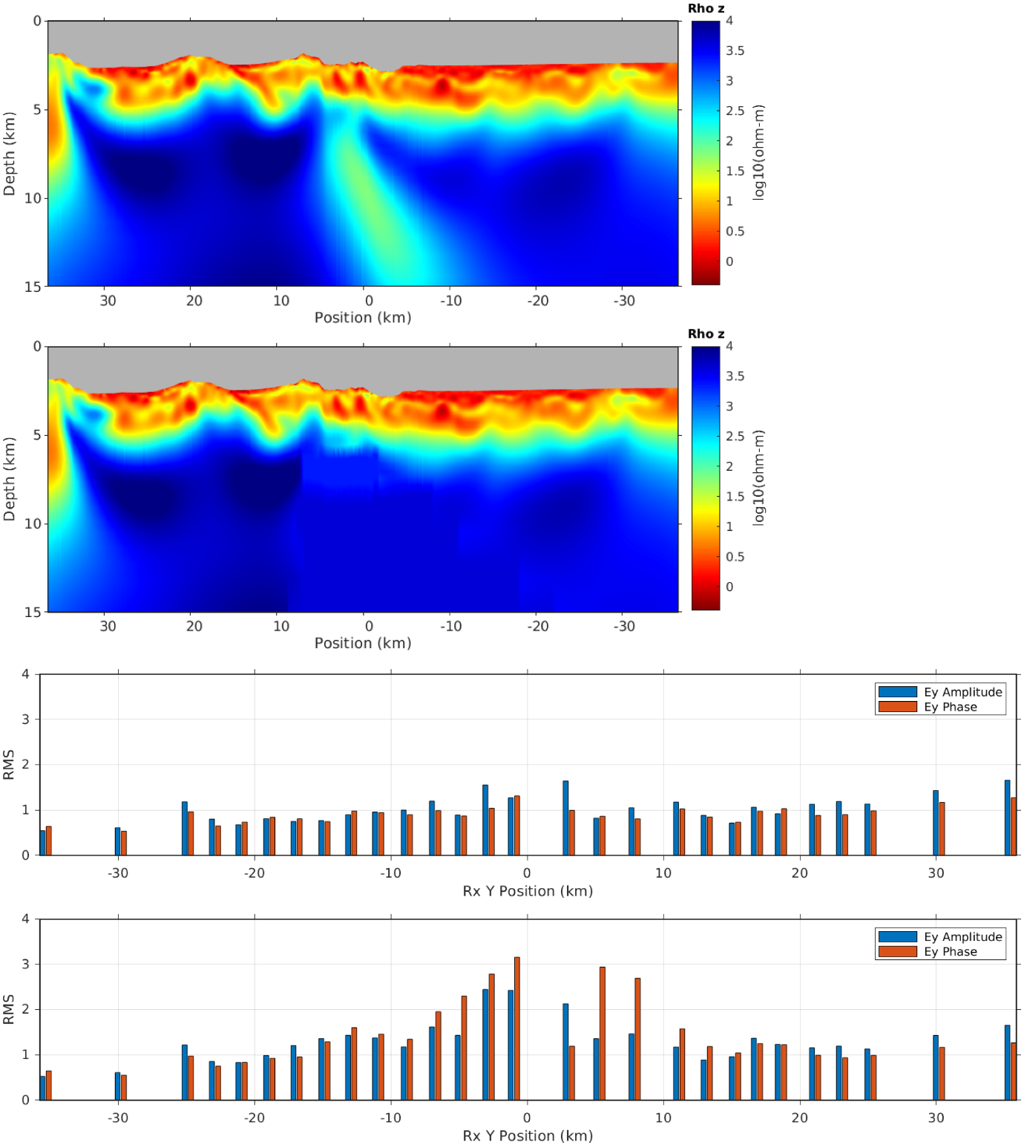

Extended Data Fig. 6. CSEM inversion analysis of the ATLAB-1 dataset. The top panel (a) shows vertical resistivity from CSEM inversion of the electrical field component. To test the significance of the near vertical conductive feeder feature in the central part of the image, we removed it from the image, simulated the forward response and re-calculated data misfit. The second panel (b) shows the inversion image after replacing the vertical feeder with background resistivity values. Corresponding data misfit for the top model (a) is shown in the third panel (with overall RMS of 1.0) and data misfit for the case with vertical feeder removed (b) is shown in the lower diagram (d), where the overall RMS increased to 1.52.

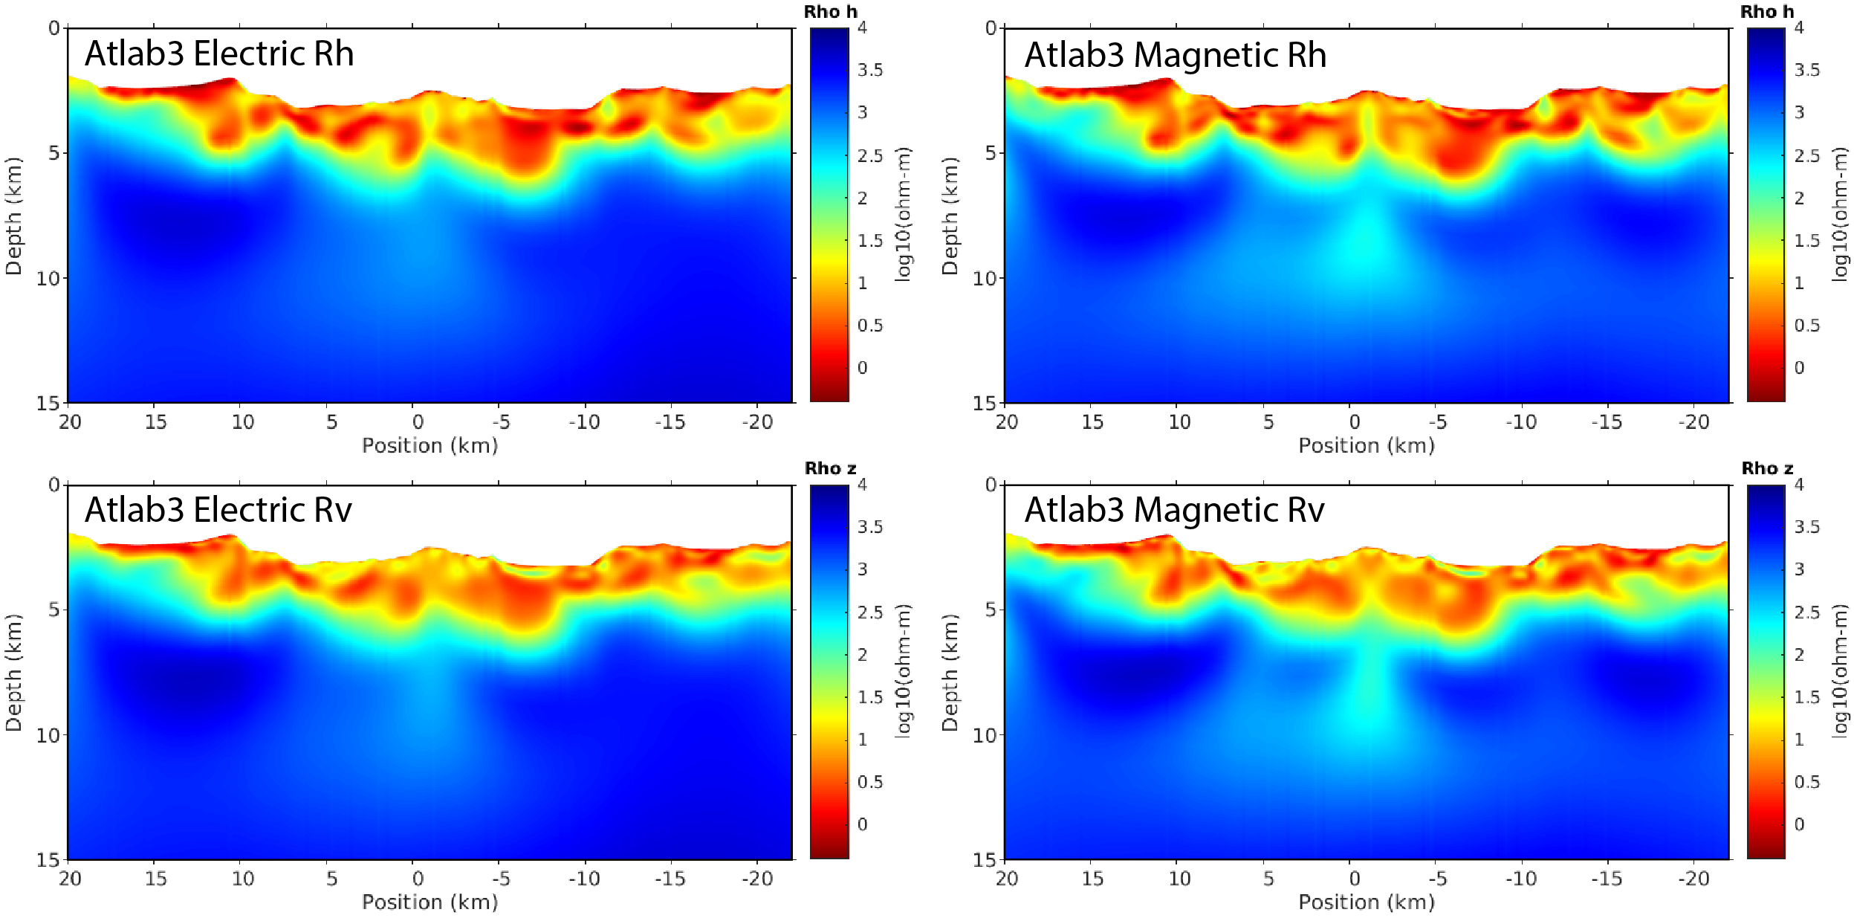

Extended Data Fig. 7. Resistivity images inverted from CSEM data along ATLAB-3. The electric and magnetic CSEM data were inverted separately. Top left is the ρ_{h} component of electric data inversion and bottom left is ρ_{v} component. Top right is the ρ_{h} component of magnetic data inversion and bottom left is ρ_{v} component.

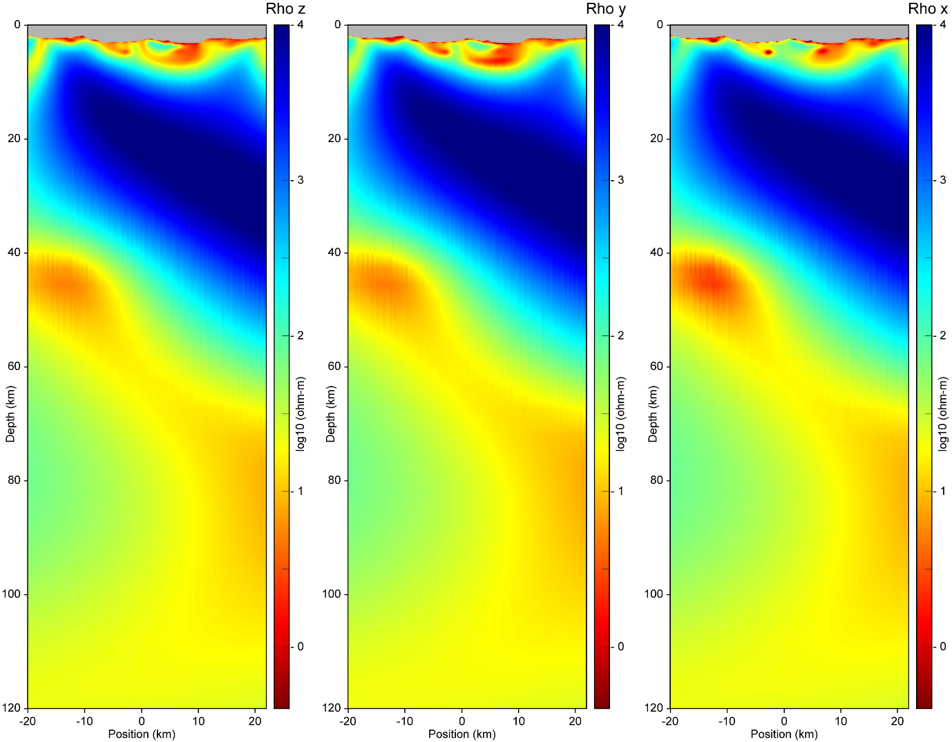 Extended Data Fig. 8a. MT data inversion image along the ATLAB-3 profile. The plots show the three resistivity components of the inverted model: ρ_{z} to the left, ρ_{y} in the middle and ρ_{x} to the right. Both the TE and TM modes of the MT data were included in the inversion.

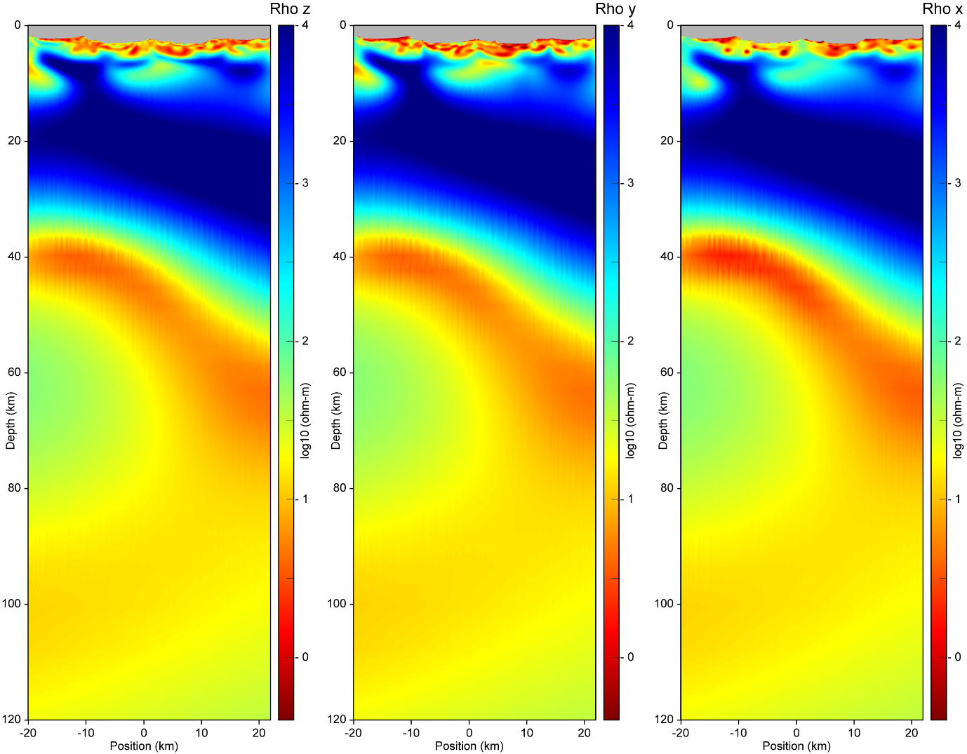 Extended Data Fig. 8b. Joint CSEM and MT data inversion image along the ATLAB-3 profile. The plots show the three resistivity components of the inverted model: ρ_{z} to the left, ρ_{y} in the middle and ρ_{x} to the right. Electric and magnetic CSEM fields and TE and TM mode of the MT data were included in the joint inversion.

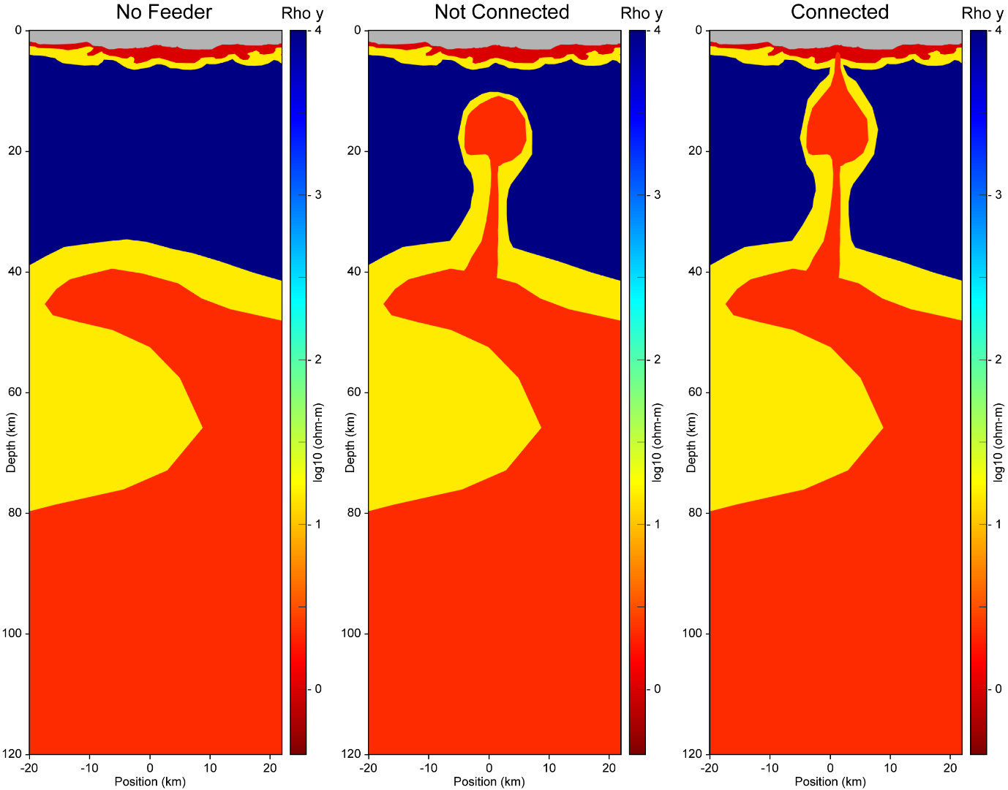

Extended Data Fig. 9a. Conceptual geological scenario models for ATLAB-3. Model without a feeder system (left), model with partly solidified feeder system (middle) and an open feeder system connecting the asthenosphere to the oceanic crust (right).

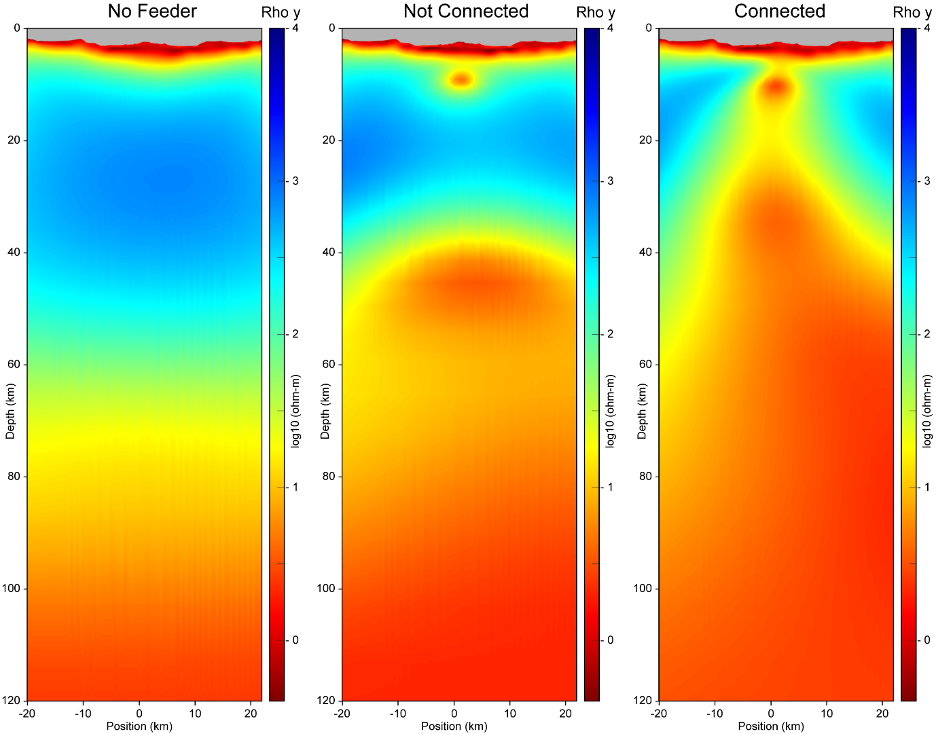

Extended Data Fig. 9b. Synthetic MT inversion images for the three conceptual geological scenario models in ED Fig. 9a. Both the TE and TM mode of the synthetic MT data were included in the inversion.

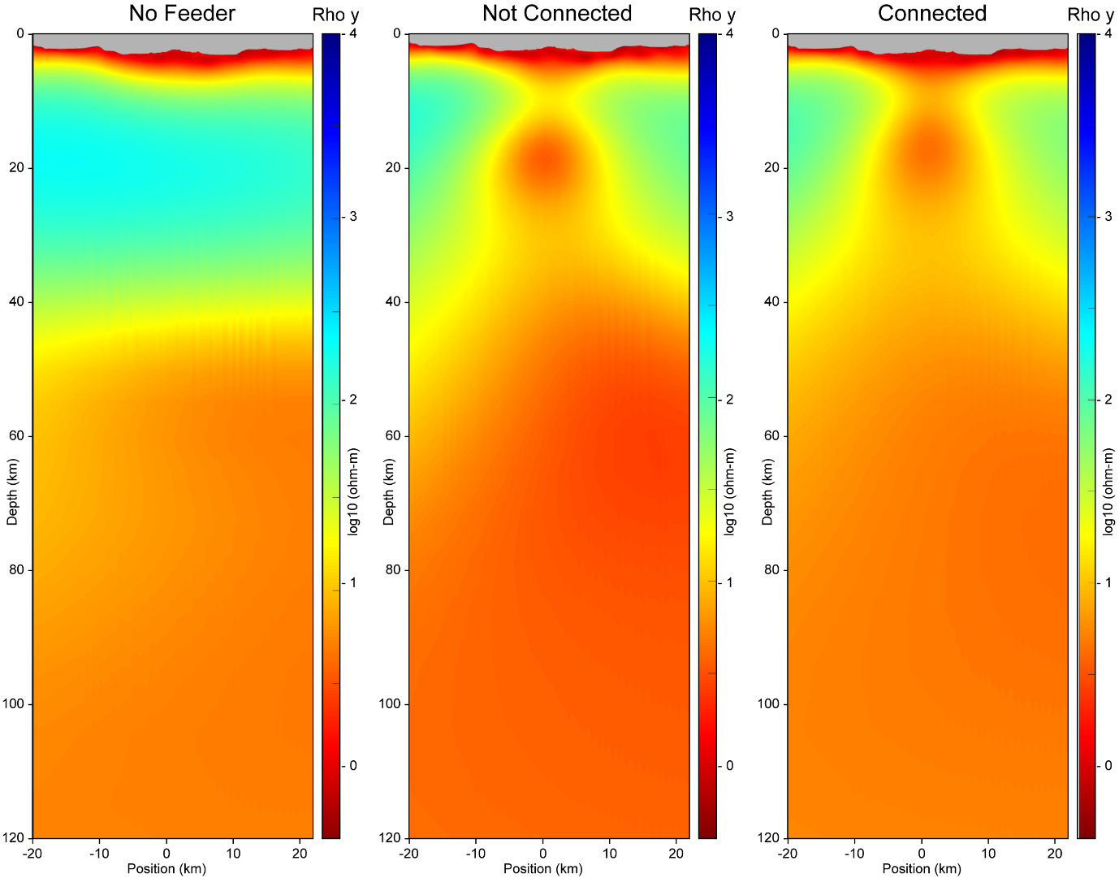

Extended Data Fig. 9c. Synthetic MT inversion images (TE mode) for the three conceptual geological scenario models in ED Fig. 9a.

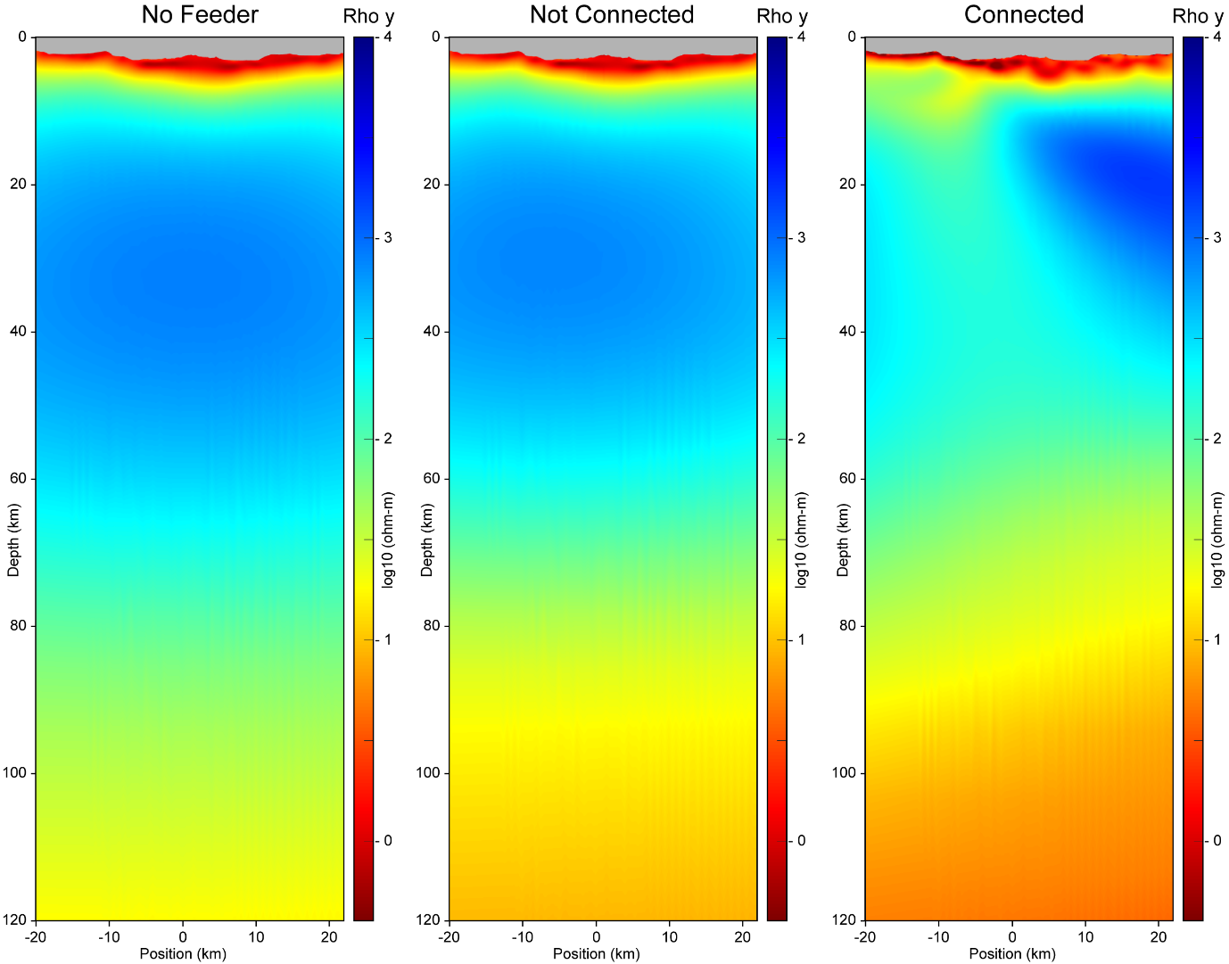

Extended Data Fig. 9d. Synthetic MT inversion images (TM mode) for the three conceptual geological scenario models in ED Fig. 9a.

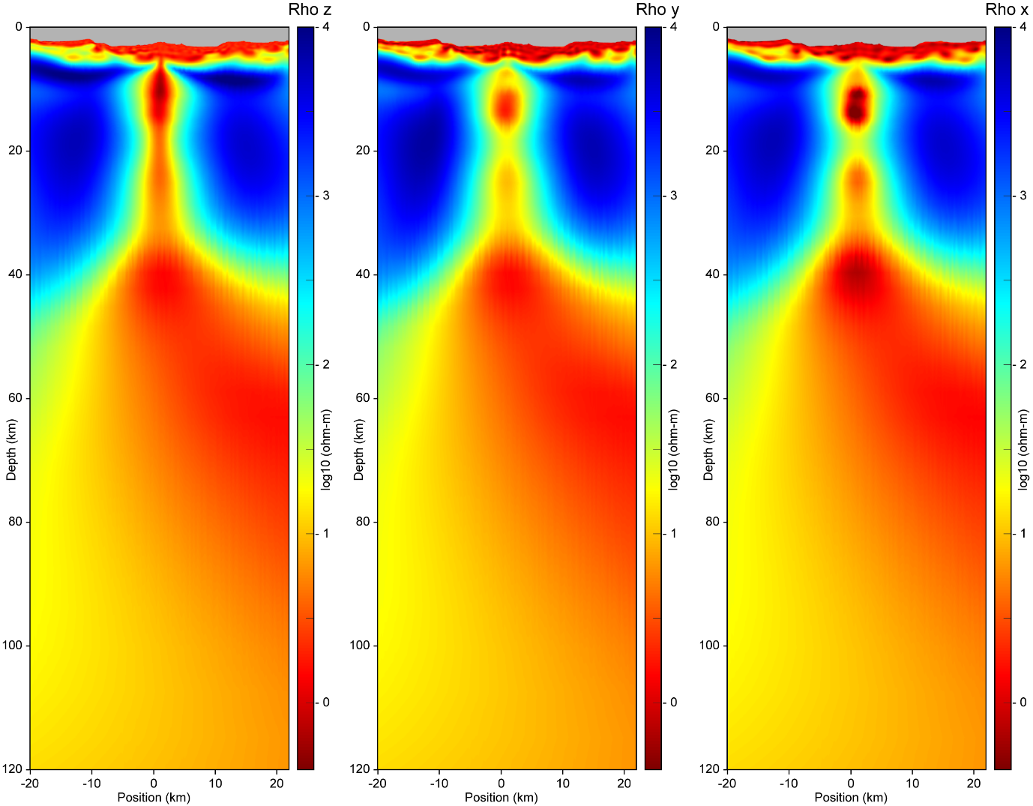

Extended Data Fig. 9e. Synthetic CSEM and MT joint inversion images for the “connected feeder” conceptual geological scenario model of ATLAB-3. The left panel shows ρz, the middle panel ρy and the right panel shows ρx.

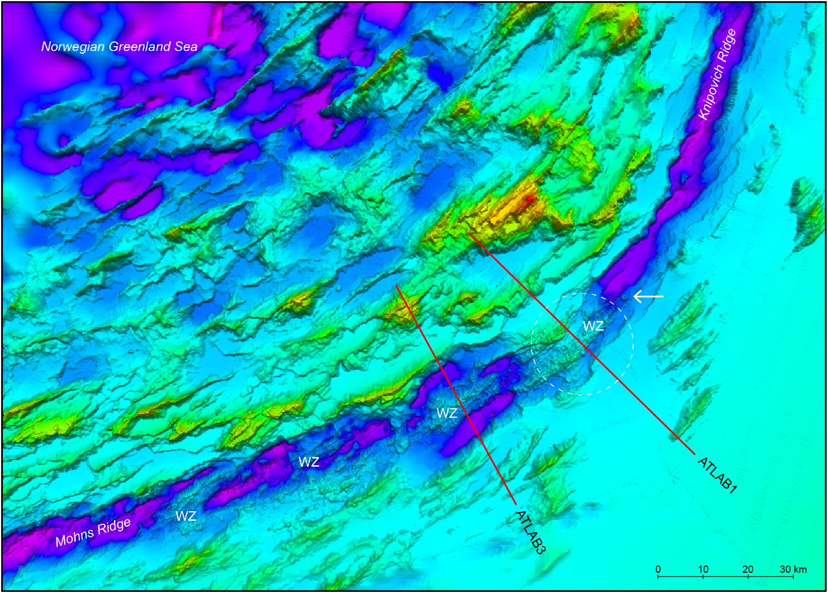

Extended Data Fig. 10a. Bathymetry and location of MT and CSEM surveys (ATLAB-1(5) and ATLAB-2) across the ultraslow-spreading northern Mohns Ridge. Loki’s Castle vent field is located at the crest of the axial volcanic ridge (AVR) at the center of the ATLAB-1 survey line. The interpreted tectonic weak zones (WZ) occur along NE lineaments inside the graben in alternation with quiet areas without volcanism and establish AVRs, volcanoes or venting at the sea floor. The stippled white circle indicates the interpreted approximate extent of the Loki’s Castle melt feeder system at LAB level. See Fig. 4 for reference. Location and scale of area in Figs. 1a,1c,S2. https://kartkatalog.geonorge.no/metadata/kartverket/dybdedata-radata/2fe7b56c-334d-4660-ac50-6fcf973a0f70

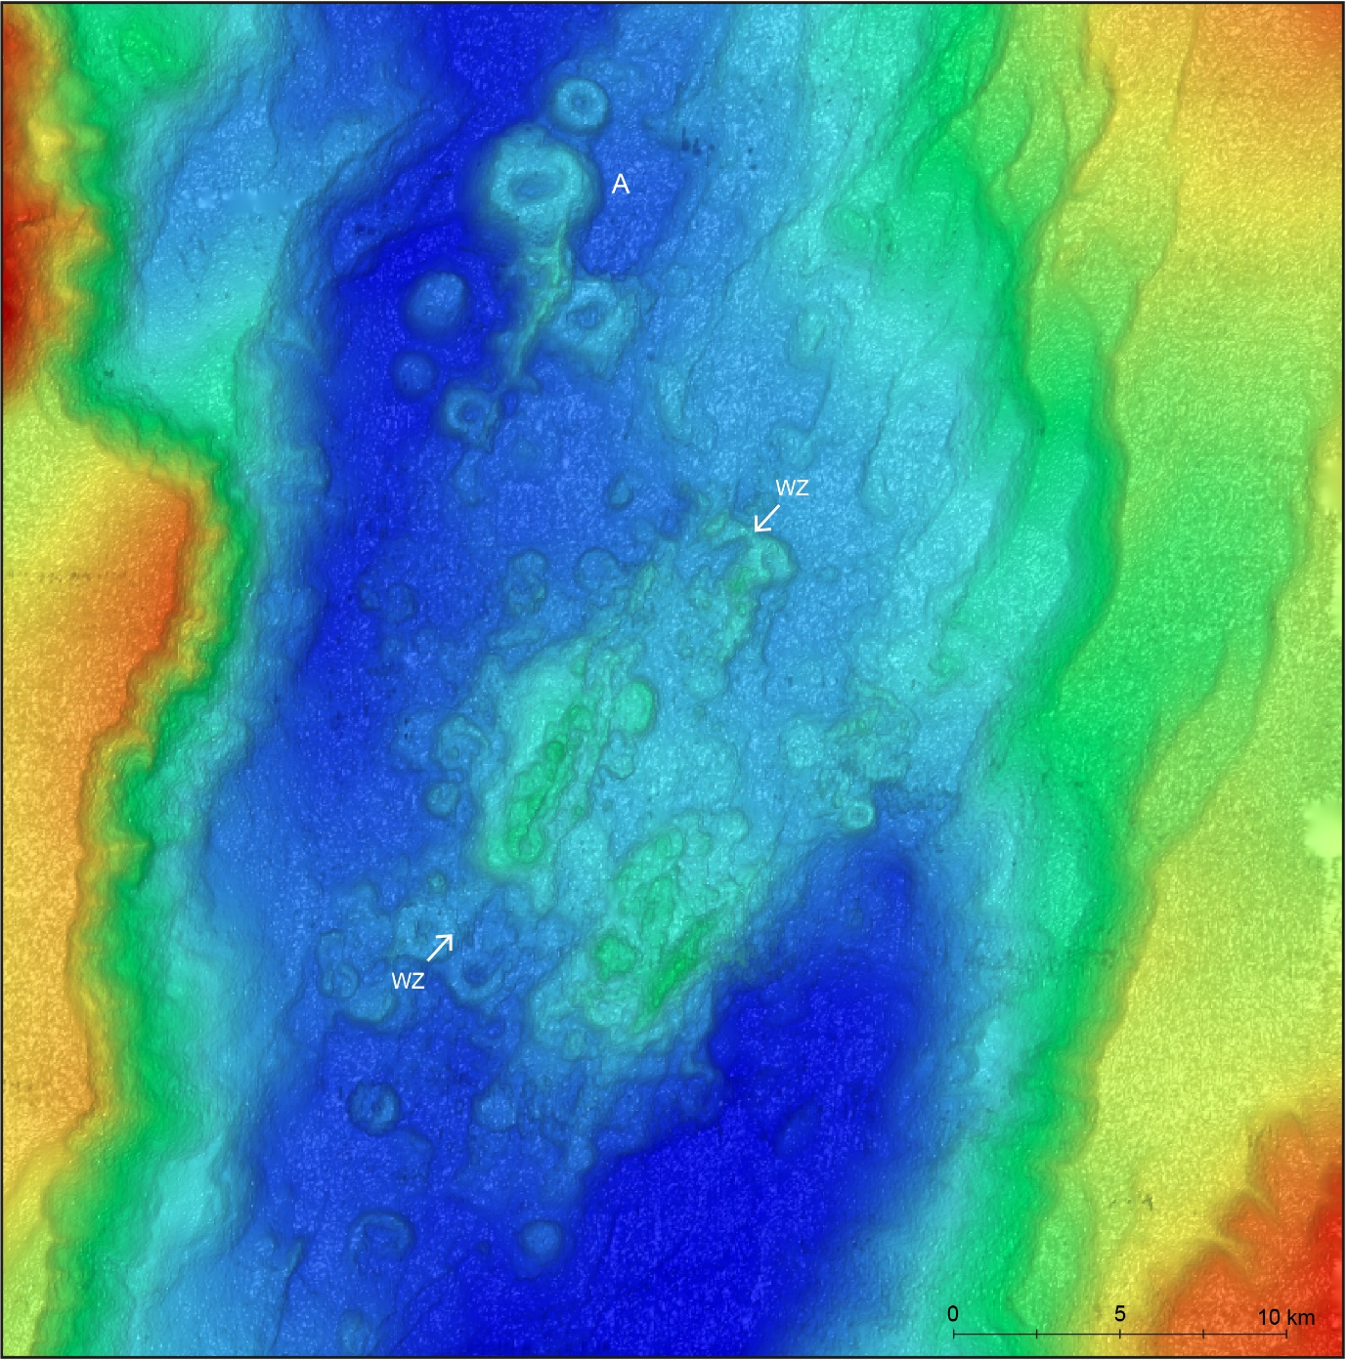

Extended Data Fig. 10b. Bathymetry map of the northern Knipovich Ridge. The interpreted tectonic weak zones (WZ) occur along NE lineaments inside the graben and establish volcanoes and AVRs at the sea floor. In this area individual volcanoes are clearly visible (White color A). Note the short distance to the ATLAB-2 area (see Fig. 1a) without clear indications of recent volcanism at the sea floor. Location of area in Figs. 1a,1b,S1.

