Direct Writing and Printing of Surface and Interface Modified Cellulose for Friction Nanogenerators
Xiaofei Fuª, Xiaofei Wuª, Hailong Liª, Zhengjian Zhang^{*a,b}
ªCollege of Light Industry Science and Engineering, Tianjin University of Science and Technology, Tianjin 300457, China.
^{b}State Key Laboratory of Biobased Fiber Manufacturing Technology, Tianjin University of Science and Technology, Tianjin 300457, China.
Corresponding authors：Zhengjian Zhang, zhangzj@tust.edu.cn

Number of pages: 9
Number of figures: 7

Table of contents
Performance of MC ……………………………………………………………………………S2
Degree of cationization…………………………………………………………………………S3
Characterization of CNF ………………………………………………………………………S4
S1 The TEM images of cellulose nanofibers .…………………………………………………S5
S2 A photo of the friction layer in a multi-layer three-dimensional structure……………S5
S3 SEM image of cationic modified CNF friction layer ……………………………………S6
S4 Rheology test of CNF-SiO₂ ink ……………………………………………………………S7
S5 Related characterization of nano-SiO₂ ……………………………………………………S8
S6. Five samples of friction layers with different mass ratios of dry fibers and SiO₂ ……S9
S7. Photographs capturing the state of the friction layer subsequent to cycle ……………S9

Performance of MC : Sodium carboxymethyl cellulose (CMC) is an aqueous-soluble macromolecule possessing substantial molecular weight, widely employed in the realms of thickening and the regulation of viscosity. Through the amalgamation of CMC with CNF, the viscosity of the printing ink can be adroitly tailored, rendering it exquisitely suited for the realm of printing. Notably, CMC assumes a definitive role in the orchestration of material attributes pertaining to the regulation of frictional electrical properties. As CMC finds integration with CNF, the repulsive forces stemming from electrostatic interactions find themselves shielded over an expanded domain, thereby eliciting a reduction in the inter-fiber repulsion distances. Consequently, the infusion of CMC engenders an augmented proximity between the nanofibers, thereby endowing a prodigious enhancement in the efficiency of electron transfer and bestowing a marked amelioration upon their frictional electrical performance. It is imperative to bear in mind that the influence of viscosity upon the frictional electrical performance is efficacious solely within a defined spectrum. An undue surplus of viscosity may precipitate complications in the realms of ink atomization and adhesion upon the print head, thus culminating in a waning of the frictional electrical performance. Ergo, in the process of formulating printing ink, it becomes indispensable to attain a judicious equilibrium between the viscosity and other performance indicators, ensuring the realization of an optimal frictional electrical performance.

Degree of cationization : The degree of cationization refers to the number or proportion of positively charged ions (cations). As the population of cations increases, so does the overall positive charge within the system. Charge density serves as a metric for quantifying the amount of charge contained per unit volume or area. Consequently, in unaltered conditions, an escalation in the cationization degree may coincide with an augmentation in charge density. To determine the cationization degree of cellulose nanofibrils (CNF), we employed the Müte PCD-05 automatic charge titrator. The titration process involved a maximum titration volume of 2 mL and a minimum volume of 0.2 mL. A 0.3 mL aliquot of the CNF suspension was extracted using a pipette and subsequently diluted with distilled water to achieve a final volume of 10 mL. With the titrator piston secured, the start button was pressed, and a stabilization period of 5 minutes was observed. Once the reading had stabilized, the anionic standard titrant Pes Na (0.001 mol/L) was employed for the titration. The titration process ceased when the reading reached zero, and the titration volume was recorded. By applying equation (1), the specific cationic demand (charge density, mmol/g) was calculated.
Charge Density= $\frac{VC}{m}$ (1)
In the equation, V represents the volume of Pes Na standard solution consumed by the sample in milliliters (mL), C denotes the concentration of the Pes Na standard solution in molar (mol/L), and m signifies the absolute dry mass of the sample in grams (g). The unit of charge density is expressed as mmol/g.
Characterization of CNF : The carboxyl content of the CNF hydrogel is determined through a conductivity titration method, whereby the carboxyl content (expressed in mmol/g) is calculated using formula (2). The specific procedural steps are as follows:
Accurately measure 3g of the absolute dry mass of the hydrogel and immerse it in a 100mL solution of 0.1mol/L HCl, subjecting it to stirring for a duration of 90 minutes. Subsequently, rinse the hydrogel sample with deionized water four times, followed by dispersion in a 450mL solution of 0.001mol/L NaCl in preparation for testing.Next, employing an automated potentiometric titrator under the influence of electromagnetic stirring, perform titration utilizing a 0.01mol/L NaOH standard solution, with the titrator automatically recording the titration curve. Finally, cleanse the sample with deionized water and dry it until a constant weight is achieved. Weigh the sample and employ the titration curve to calculate its carboxyl content.
Carboxyl Content = $\frac{{MV×45}/{1000}}{W}×1$00 (2)
In the calculation, M represents the concentration of the NaOH standard solution (expressed in mol/dm³), V denotes the volume of NaOH consumed at the equivalence point (in mL), and W indicates the weight of the sample (in grams).

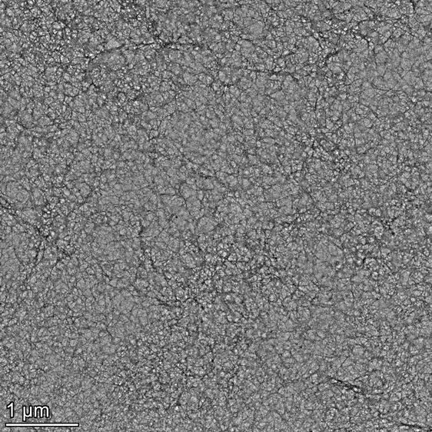
Figure S1. The TEM images of cellulose nanofibers.
The dimensions of the CNF exhibit a scale of approximately 100 nanometers, accompanied by an aspect ratio of 15:1. Evidently discernible is the predominance of individual dispersion within the nanocellulose structure, unveiling a uniform distribution amidst the fibers.

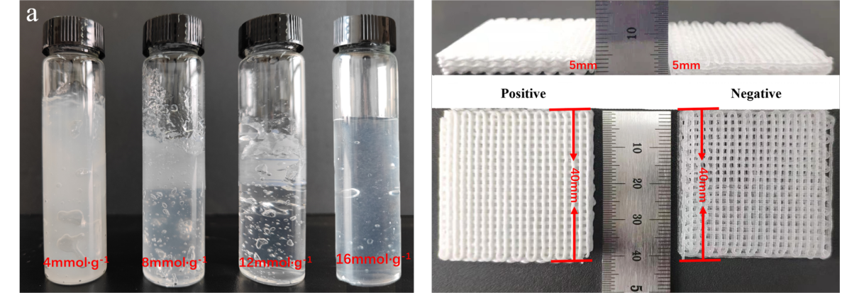
Figure S2. A photo of the friction layer in a multi-layer three-dimensional structure that is directly written and printed without obvious deformation or collapse.

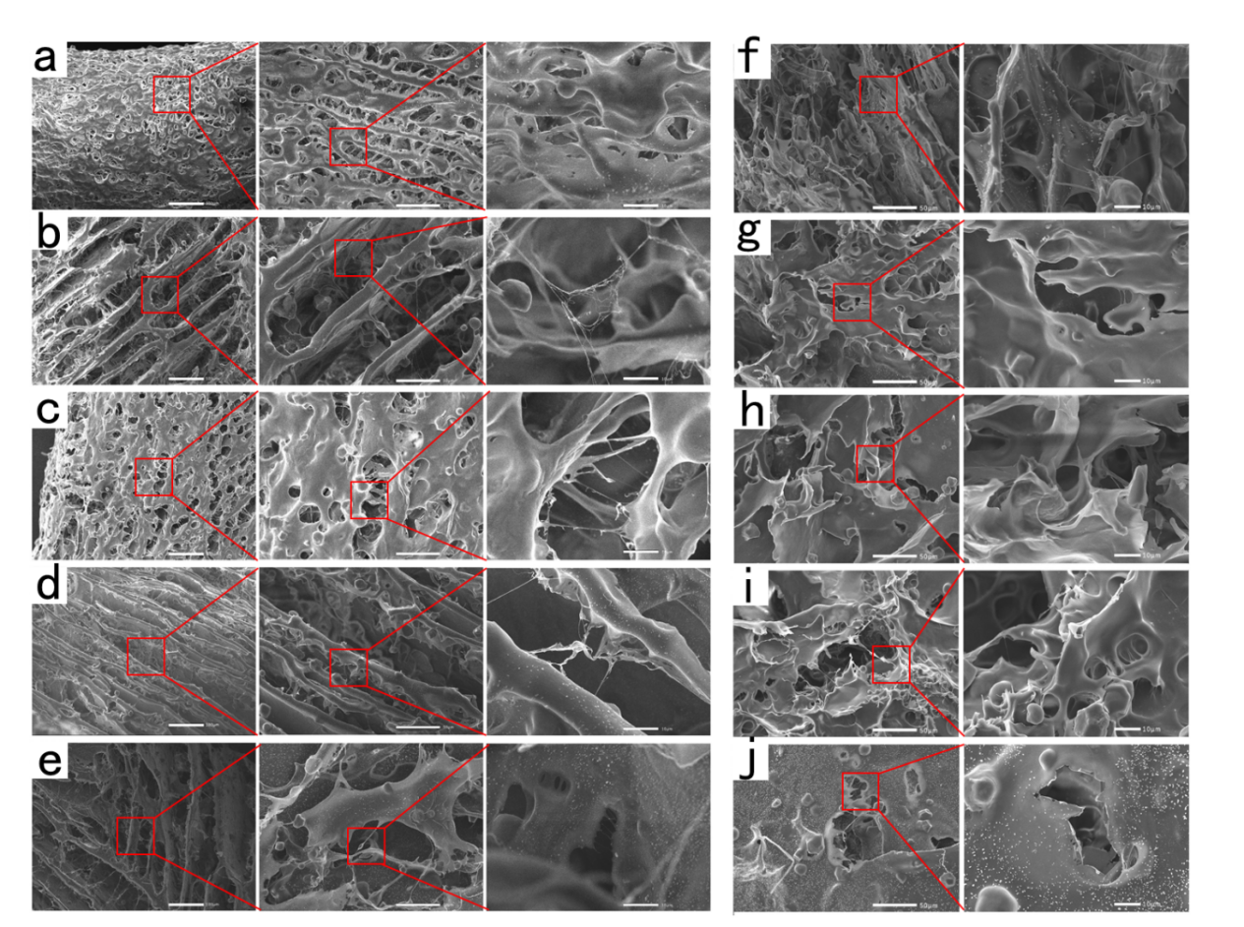
Figure S3. SEM image of cationic modified CNF friction layer.
As shown in Figure S2a-e, the cationic process leads to larger lamellar walls and macropores of freeze-dried Aerogel. In addition, less anisotropy was observed. The successfully modified cationic fiber and the unmodified anionic fiber attracted each other and closely combined, forming a thick lamellar structure on the surface of Aerogel, and the pores on the surface were significantly reduced and uneven. This may be due to the reduction of surface net charge caused by amine functionalization, which reduces the order and dispersion of the suspension, resulting in a decrease in the order and condensation degree of the structure under the action of ice crystals. As shown in Figure S2 7f-j, the sectional view of cationic Aerogel shows that the interior of Aerogel is also extremely irregular, with a large area of irregular sheet structure and relatively large internal cracks.
Figure S4. Rheology test of CNF-SiO₂ ink.
Figure S4a shows that the viscosity of CNF-SiO₂ ink decreases with increasing shear rate and approaches linear deformation, exhibiting a typical behavior of shear thinning. Due to the close linear relationship between the viscosity and shear rate of ink, during the DIW printing process, it is also possible to maintain ink extrusion under a stable pressure, resulting in more uniform printing lines and contributing to the stability and aesthetics of TENG friction layer morphology. Figure S4b shows the relationship between ink modulus and shear strain, showing the dependence of its storage modulus (G′) and loss modulus (G″) on shear stress. The typical feature of both G′ and G″ curves is that they can be divided into two parts: first, they remain basically unchanged, followed by a downward trend. When G′＞ G″, CNF-SiO₂ ink mainly exhibits elastic deformation. Due to the presence of forces between the molecules and molecular chains inside the ink, when subjected to shear action, the elasticity of the ink remains stable and has a good shape when the applied force is insufficient to break the internal force of the ink. When the applied force is large enough to exceed the yield point, G′ and G″ begin to decrease, and at a certain moment, G″＞ G′, at which point the CNF-SiO₂ ink mainly exhibits viscous deformation. The internal structure of the ink is destroyed, and the viscosity of the ink is greater than its elasticity, which helps the ink to extrude smoothly and evenly.

Figure S5. The interval distribution pertaining to the prepared particle sizes of nano-SiO₂.
The figures presented in Figure S5 illustrate the interval distribution pertaining to the prepared particle sizes of nano-SiO₂. Figure S4a portrays the relative composition of diverse particle sizes of nano-SiO₂ in relation to the overall particle size. The abscissa represents each distinct particle size, while the ordinate artfully signifies the corresponding content. A discerning observation from the figure reveals that the particle size distribution of nano-SiO₂ closely approximates a Gaussian distribution, thereby attesting to its commendable uniformity and exemplary utilization performance. The particle size distribution as a whole lies within the range of 300-440 nm, exhibiting a remarkably narrow spread. Precisely half of the particles possess sizes smaller than 360 nm, with the remaining half occupying larger dimensions. This value, 360 nm, serves as the median particle size of the nano-SiO₂ particles.
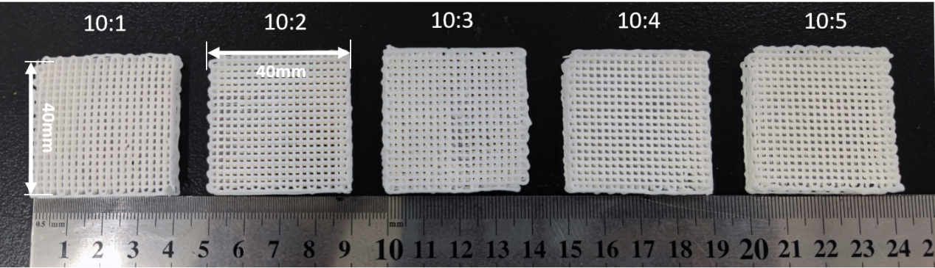
Figure S6. Five samples of friction layers with different mass ratios of dry fibers and SiO₂.
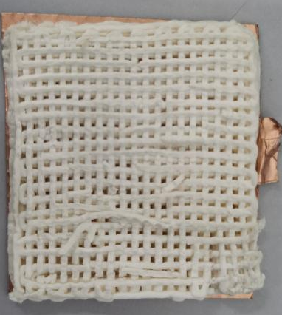
Figure S7. Photographs capturing the state of the friction layer subsequent to 3000 operational cycles.

