Supporting information

Low-temperature catalytic cracking of polyolefin waste using intrinsic properties-controlled zeolite catalyst

Hankyeul Kang¹, Junghwa Yoon¹, Ki Hyuk Kang², Insoo Ro³, Soohwa Jeong⁴, Jong Hun Kang^{1,*}
¹School of Chemical and Biological Engineering and Institute of Chemical Processes, Seoul National University, Seoul 08826, Republic of Korea
²Low-Carbon Petrochemical Research Center, Korea Research Institute of Chemical Technology (KRICT), Daejeon 34114, Republic of Korea
³Department of Chemical and Biomolecular Engineering, Seoul National University of Science and Technology, Seoul 01811, Republic of Korea
⁴Carbon Neutral Technology R&D Department, Korea Institute of Industrial Technology, Cheonan-si 31056, Republic of Korea
* E-mails: jonghunkang@snu.ac.kr

Materials and Synthesis Information

Commercial zeolite information
Commercial zeolites used in this work are as follows: ZSM-5 (NH₄⁺-form, powder, SiO₂:Al₂O₃=23:1 nominal molar ratio, Thermo Scientific), Zeolite Y(1) (H-form, powder, SiO₂:Al₂O₃=30:1 nominal molar ratio, Alfa Aesar). Zeolite Y(2) (CBV712, NH₄⁺-form, powder, SiO₂:Al₂O₃=12:1 nominal molar ratio, Zeolyst), and zeolite beta (NH₄⁺-form, powder, SiO₂:Al₂O₃=25:1 nominal molar ratio, Alfa Aesar). All NH₄⁺-form zeolites were converted to their H-form by calcining at 580 °C for 6 hours.

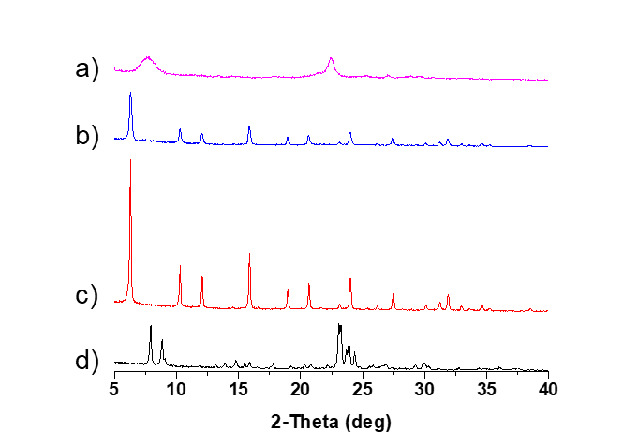
Supplementary Figure 1. Powder X-ray diffraction profiles of commercial zeolites: a) zeolite beta, b) zeolite Y(1), c) zeolite Y(2), d) ZSM-5

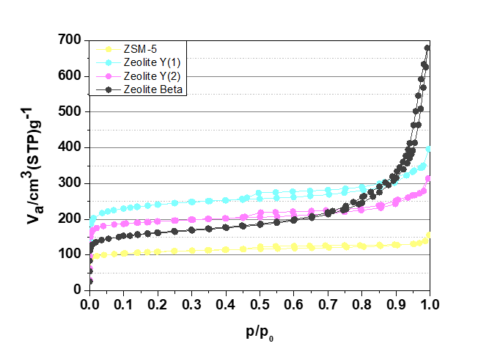
Supplementary Figure 2. 77 K N₂ physisorption profiles of commercial zeolites

Supplementary Table 1. Physical properties of the commercial zeolites.
Sample | Crystal size (nm) | Si/Al† | S_{BET} (m²/g)‡ | V_{mic} (cc/g)‡ | S_{Ext} (m²/g)‡ | V_{meso} (cc/g)‡
ZSM-5 | 100–1000 | 9.8 | 342 | 0.134 | 78 | 0.088
Zeolite Y(1) | 100–1000 | 14.1 | 750 | 0.341 | 87 | 0.316
Zeolite Y(2) | 100–1000 | 6.3 | 601 | 0.265 | 82 | 0.190
Zeolite Beta | 10–100 | 10.2 | 508 | 0.176 | 168 | 0.870
†Characterized by EDS; ‡Characterized based on the N₂ adsorption isotherms obtained at 77 K. Micropore volumes (V_{mic}) were estimated based on the V-t method. Mesoporous volumes (V_{meso}) were estimated based on the BJH method.

Materials for synthesis
All materials for synthesizing the *BEA-type zeolites were used as received without further purification from the specified vendors. The moisture contents of the solid-phase reagents were determined through independent temperature gravimetric analyses (TGA). Aluminum sources used in this work included aluminum isopropoxide (Al(i-C₃H₇)₃, ≥98%, Sigma Aldrich) and sodium aluminate (40.0–44.0% Na₂O, 46.0–53.0% Al₂O₃, DAEJUNG). Silica sources used in this work were fumed silica (Cab-O-Sil®, ACROS) and colloidal silica (LUDOX SM-30, 30% SiO₂ dispersed in H₂O Sigma-Aldrich). Mineralizing agents used in this work were ammonium fluoride (NH₄F, ≥98%, Sigma-Aldrich), sodium hydroxide solution (65.2 wt.% NaOH in H₂O), and sodium hydroxide beads (97%, DAEJUNG). The following organic structure-directing agents (OSDAs) were used as received from the specified vendors: tetraethylammonium hydroxide (TEAOH, 35 wt.% in H₂O, SACHEM).

Zeolite preparation procedures
All *BEA-type zeolites presented in this work were synthesized using conventional hydrothermal methods, which are modifications of previously reported methods in the literature.¹⁻³ Initially, Al sources, TEAOH, mineralizers, and distilled water were mixed to achieve a desired gel composition in 40 mL PTFE liners (PlusKoLab). The mixtures were stirred until they became translucent. Subsequently, Si sources were added, ensuring complete dispersion and homogenization through subsequent stirring. The general gel composition can described as 1.0 SiO₂ : x Al : y TEAOH : z (NH₄F or NaOH) : w H₂O. Additional aging steps could be added at this stage, depending on the sample series. The PTFE liners charged with gels were clad in steel autoclaves and transferred to a convection oven preheated to the desired temperature, which could be rotating or static. The progress of crystallization was monitored by analyzing PXRD patterns of aliquots collected every 3–7 days. Following crystallization, the products were thoroughly rinsed with distilled water and acetone consecutively using a centrifuge and then calcined at 580 °C for 6 hours. The resultant *BEA-type zeolites were converted into their H-forms through ion exchange processes with ammonium nitrate (100 ml 1 M NH₄NO₃ solution per 1 g zeolite, twice at 80°C for 6 hours) followed by subsequent calcination at 580 °C for 6 hours.
The L (large)-series samples were synthesized using fluoride media¹. Desired amounts of aluminum isopropoxide, TEAOH solution, and ammonium fluoride were mixed in a PTFE liner, and fumed silica was gradually added and stirred to ensure homogeneous mixing. The final gel composition can be written as 1 SiO₂ : x Al : 0.45 TEAOH : 0.4 NH₄F : 6.9 H₂O, with x varying between 0.02 and 0.06. Crystallization was carried out in a rotating oven set at 150 °C for 14 days.
The M (medium)- series samples were synthesized using the following procedure.² Desired amounts of sodium aluminate, TEAOH solution, and NaOH solution were mixed in a PTFE liner, and fumed silica was gradually added and stirred to ensure homogeneous mixing. The final gel composition can be written as 1 SiO₂ : x Al : 0.53 TEAOH : 0.13 NaOH : 21.67 H₂O, with x varying between 0.01 and 0.08. Crystallization was carried out in a static oven set at 140 °C for 6–11 days.
The S (small)-series samples were synthesized using the following procedure.³ Desired amounts of aluminum isopropoxide, TEAOH solution, and NaOH beads were mixed in a PTFE liner and colloidal silica was gradually added and stirred to ensure homogeneous mixing. The mixture was stirred for 24 hours at room temperature. The final gel composition can be written as 1 SiO₂ : x Al : 0.36 TEAOH : 0.014 NaOH : 11.8 H₂O, with x varying between 0.006 and 0.05. Crystallization was carried out in a static oven set at 100 °C for 5–22 days.
The detailed gel compositions are presented in Supplementary Table 2.

Supplementary Table 2. Synthesis conditions of the *BEA-type zeolites shown in this work.
Entry | Sample Name |  |  |  |  |  |  | Temp. (°C) | Oven Type | Time (days) | Result
Entry | Sample Name | SiO₂ | Al | TEAOH | NaOH | NH₄F | H₂O
1 | L-BEA-10 | 1.0 | 0.06 | 0.45 | - | 0.4 | 7.0 | 150 | Rotating | 14 | *BEA
2 | L-BEA-15 | 1.0 | 0.034 | 0.45 | - | 0.4 | 7.0 | 150 | Rotating | 14 | *BEA
3 | L-BEA-20 | 1.0 | 0.03 | 0.45 | - | 0.4 | 7.0 | 150 | Rotating | 14 | *BEA
4 | L-BEA-30 | 1.0 | 0.02 | 0.45 | - | 0.4 | 7.0 | 150 | Rotating | 14 | *BEA
5 | M-BEA-10 | 1.0 | 0.08 | 0.53 | 0.13 | - | 21.7 | 140 | Static | 11 | *BEA
6 | M-BEA-20 | 1.0 | 0.01 | 0.53 | 0.13 | - | 21.7 | 140 | Static | 11 | *BEA
7 | S-BEA-10 | 1.0 | 0.05 | 0.36 | 0.014 | - | 11.8 | 100 | Static | 22 | *BEA
8 | S-BEA-20 | 1.0 | 0.02 | 0.36 | 0.014 | - | 11.8 | 100 | Static | 5 | *BEA
9 | S-BEA-30 | 1.0 | 0.01 | 0.36 | 0.014 | - | 11.8 | 100 | Static | 7 | *BEA
10 | S-BEA-50 | 1.0 | 0.006 | 0.36 | 0.014 | - | 11.8 | 100 | Static | 7 | *BEA

Catalytic reaction analysis

Data analysis and quantification
Conversion of LDPE and quantification of the liquid products (C_{5–30}) was calculated from the GC-FID with a calibration curve of C7–C30 saturated alkanes (1000 µg/ml each component in hexane, Sigma Aldrich). The liquid product resulting from the catalytic cracking of LDPE comprised numerous isomers and aromatic compounds. Identifying every peak is challenging, so the signals were categorized into groups based on carbon numbers. The mean retention time of each standard n-alkane served as the reference line for dividing the carbon number groups. Subsequently, the calculation of liquid product hydrocarbons involved integrating the area by groups and utilizing the calibration curve. Conversion of LDPE was calculated using the following equation and quantification of the products was determined from the GC-FID

$$The weight of residue=the weight of liner after reaction-the weight of empty liner-the weight of catalyst$$

$$The weight of liquid products=the weight of liquid reservior after reaction-the weight of empty reservoir$$

$$Conversion \left(\%\right) =\frac{the weight of virgin reactant - the weight of residue}{the weight of virgin reactant}×100$$

$$Liquid selectivity \left(\%\right)= \frac{the weight of liquid products}{the weight of virgin reactant-the weight of residue}×100$$

$$Yield \left(\%\right)= \frac{{the weight of C}_{i}}{the weight of liquid products (C_{5-30})}×100$$

Catalytic cracking process optimization

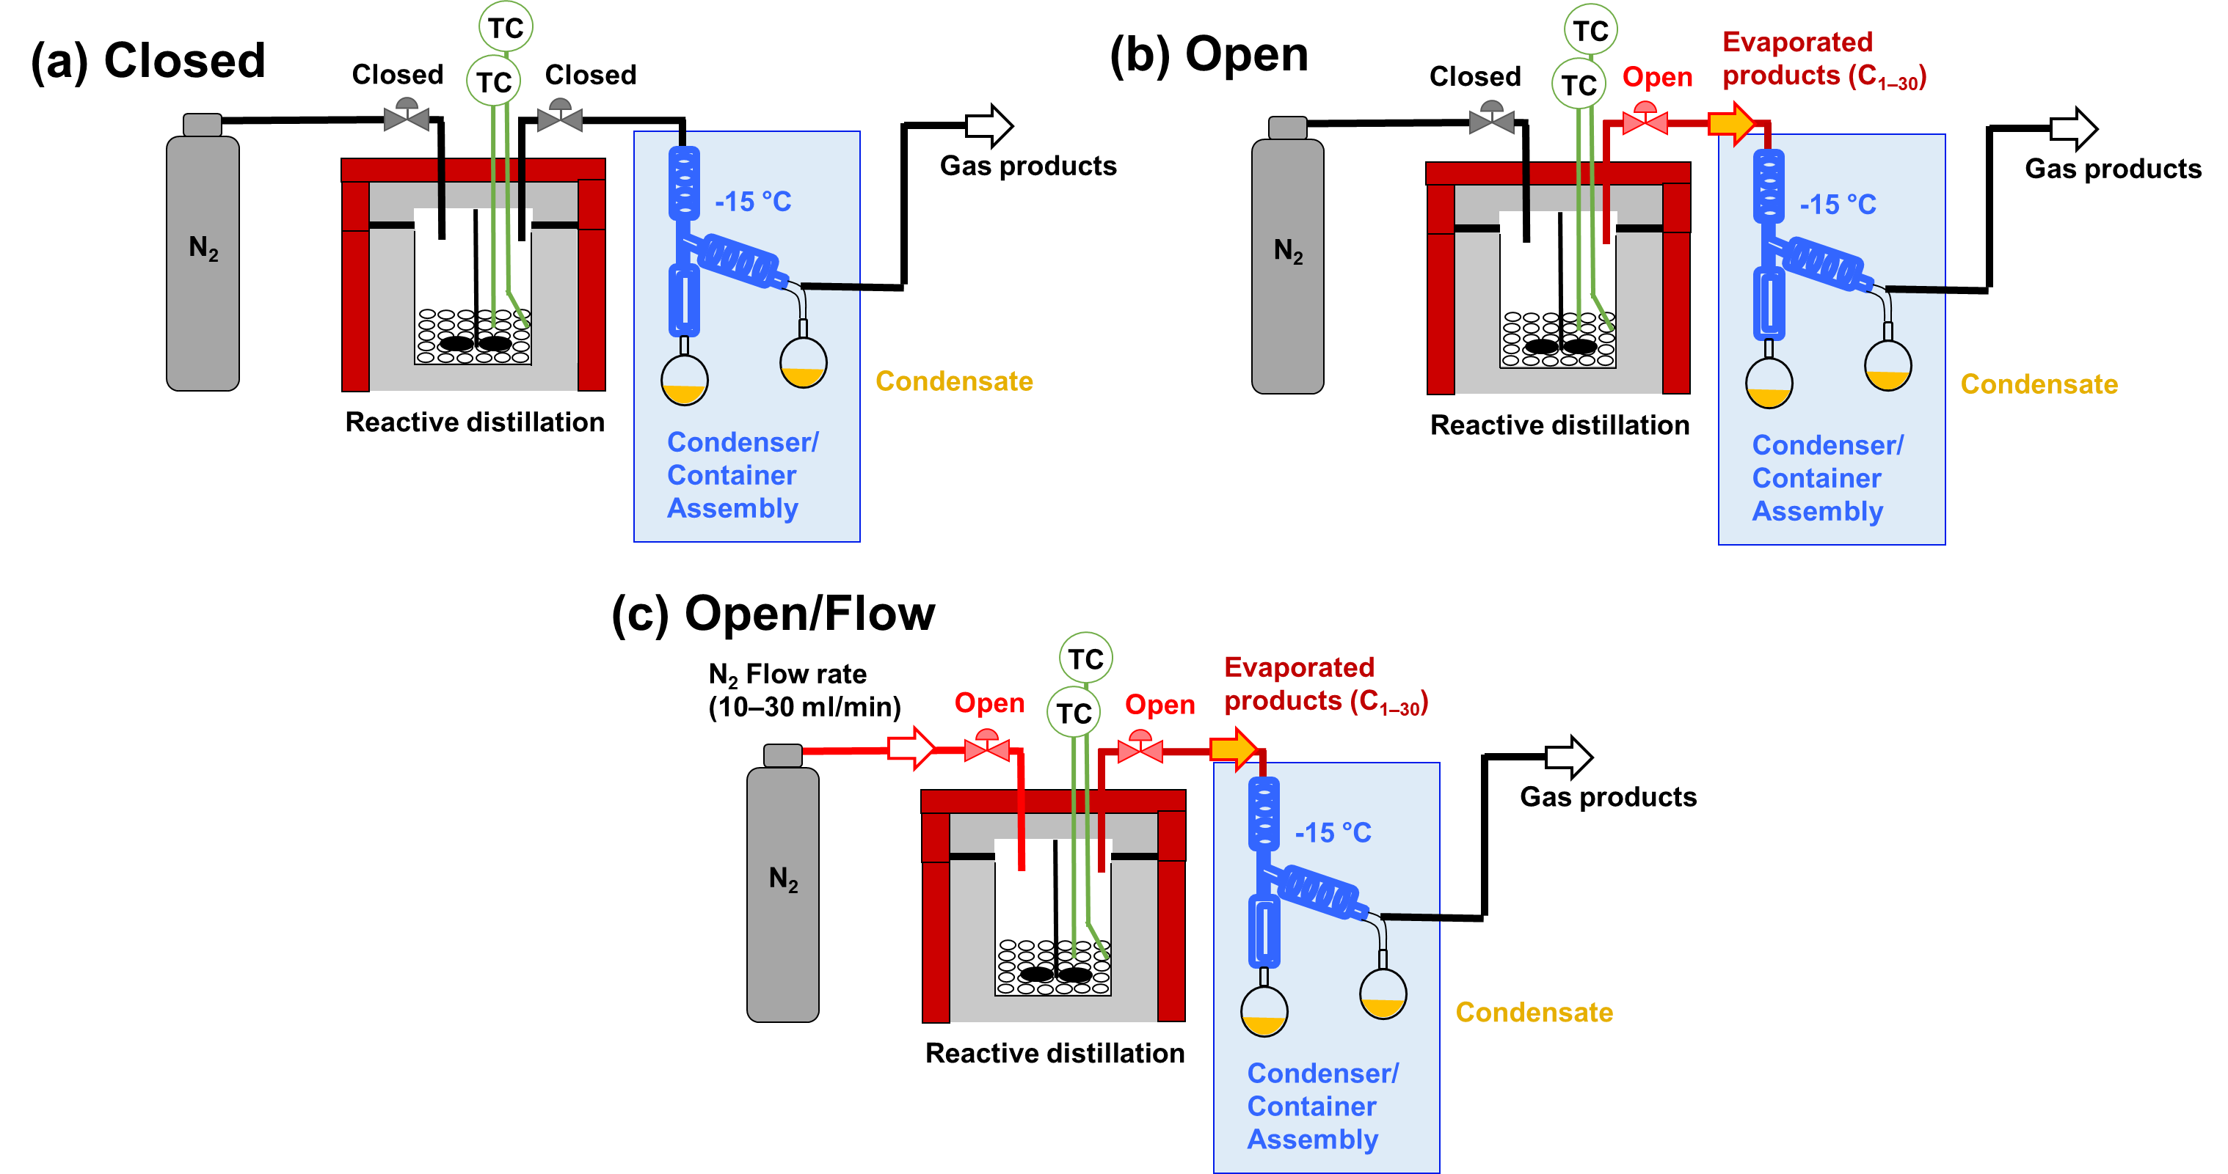

Supplementary Figure 3. Three operation modes of the open-batch reactor system used in this work: (a) closed-batch mode, (b) open-batch/no-flow mode, and (c) open-batch/flow mode.

The semi-batch reactor used in this work was designed to operate in either closed-batch or open-batch mode. The selection can be made by simply switching the 2-way ball valve that regulates the product flow between the reactor and the condenser/container assembly. The effects of batch operation modes were tested using selected zeolite beta (“S-BEA-30” sample (see below), EDS Si/Al ~ 28, particle size ~110 nm) with a PE/zeolite ratio of 10 at 330 °C for 2 hours without inert gas flow.
Supplementary Figure 3 shows the operation modes of the semi-batch reactor used in this work. In the closed batch (Supplementary Figure 1(a)), PE feed and hydrocarbon products are in contact with the zeolite throughout the entire reaction time. In this mode, the conversion and liquid selectivity were 38.3% and 44.9%, respectively (Figure 2(a), main text). These values increased to 45.1% and 65.3% when the reactor operated in the open-batch/no-flow mode (Supplementary Figure 3(b)), respectively. In this open-batch/no-flow operation mode, the volatile components that can evaporate at the reaction temperature (here, 330 °C) can escape the reactor with a shorter contact time, preventing overreaction over zeolite surfaces that forms gas species and solid coke species.
When an inert gas (N₂) flow was introduced from the reactor inlet (Supplementary Figure 3(c)), under the same reaction conditions, the conversion and liquid selectivity improved further; with an N₂ gas flow rate of 10 mL·min⁻¹, the conversion and liquid selectivity increased to 52.2% and 64.2%, respectively. However, the conversion further increased to 58.5% when the N₂ gas flow rate was 30 mL·min⁻¹, but the liquid selectivity decreased to 54.0%. This decrease is presumably due to the loss of evaporated liquid fraction escaping the condenser/container assembly because of the high flow rate of inert carrier gas. The product distribution in the condensate (Figure 2(b), main text) clearly shows that the decrease in contact time (the increase in inert gas flow rate) effectively increases the mean molecular weight of the liquid products, indicating reduced overreaction that forms gas-phase products.
These results imply that liquid product selectivity can be improved and modified based on the proper batch reactor setup, even with the same catalyst and reaction temperature/time.

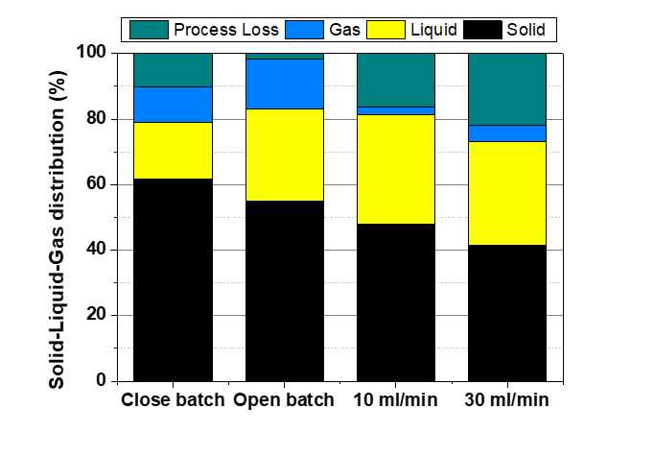
Supplementary Figure 4. Solid-liquid-gas distribution from the 330°C open-batch PE catalytic cracking with S-BEA-30 catalyst with varied reactor configuration.

Some degree of "process loss" (0–20 %) was inevitable in all catalytic runs, attributed to the small-scale and non-steady-state nature of the reaction process. The process loss primarily consisted of gaseous species and minor amounts of liquid volatiles. The solid phase was quantified using a balance. Thus, the reliability of quantified data is ranked as follows: solid > liquid > gas.

Supplementary data for the commercial zeolite experiments

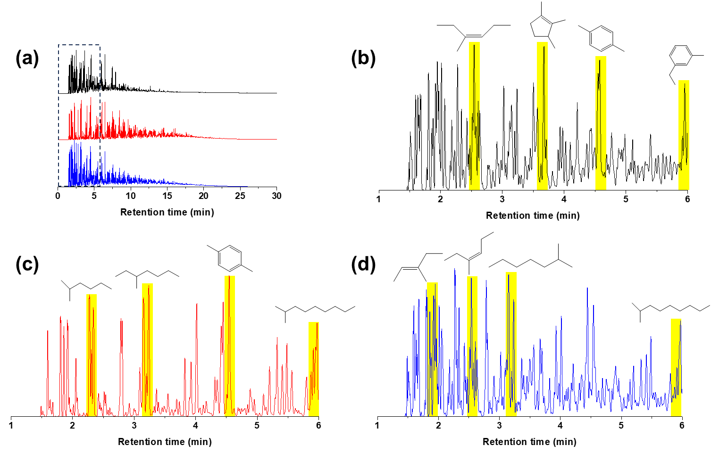
Supplementary Figure 5. Gas chromatography (GC) profiles of the liquid products from 330°C open-batch PE catalytic cracking with commercial zeolites: (a) complete chromatograms (Black: ZSM-5, Red: zeolite Y(1), Blue: zeolite beta); (b-d) magnified GC regions (1–6 min) with the major products identified using mass spectrometry (MS) for ZSM-5, zeolite Y(1), and zeolite beta, respectively.

The complexity of chromatograms suggests extensive isomerization by Brønsted acid sites of zeolites. Zeolites with larger pore openings (12MR, zeolite Y and zeolite beta) produced liquid products with heavier components than those produced over ZSM-5 (10MR), as evidenced by the complete chromatograms shown in Supplementary Figure 5(a). This indicates the influence of micropores in PE catalytic cracking. The largest peaks in the chromatogram of the liquid product from ZSM-5 were primarily aromatics, whereas those from zeolite beta consisted mostly of aliphatic paraffins and olefins.

Supplementary data for the various *BEA-type zeolite experiments

Supplementary Figure 6. Powder X-ray diffraction profiles of synthesized beta zeolites: (a) L-BEA-30, (b) L-BEA-20, (c) L-BEA-15, (d) L-BEA-10, (e) M-BEA-20, (f) M-BEA-10, (g) S-BEA-50, (h) S-BEA-30, (i) S-BEA-20, and (j) S-BEA-10.

The L-series samples exhibited relatively sharp and well-defined diffraction peaks, whereas the M-series and S-series displayed broader diffraction signals, suggesting smaller *BEA crystalline domain sizes.

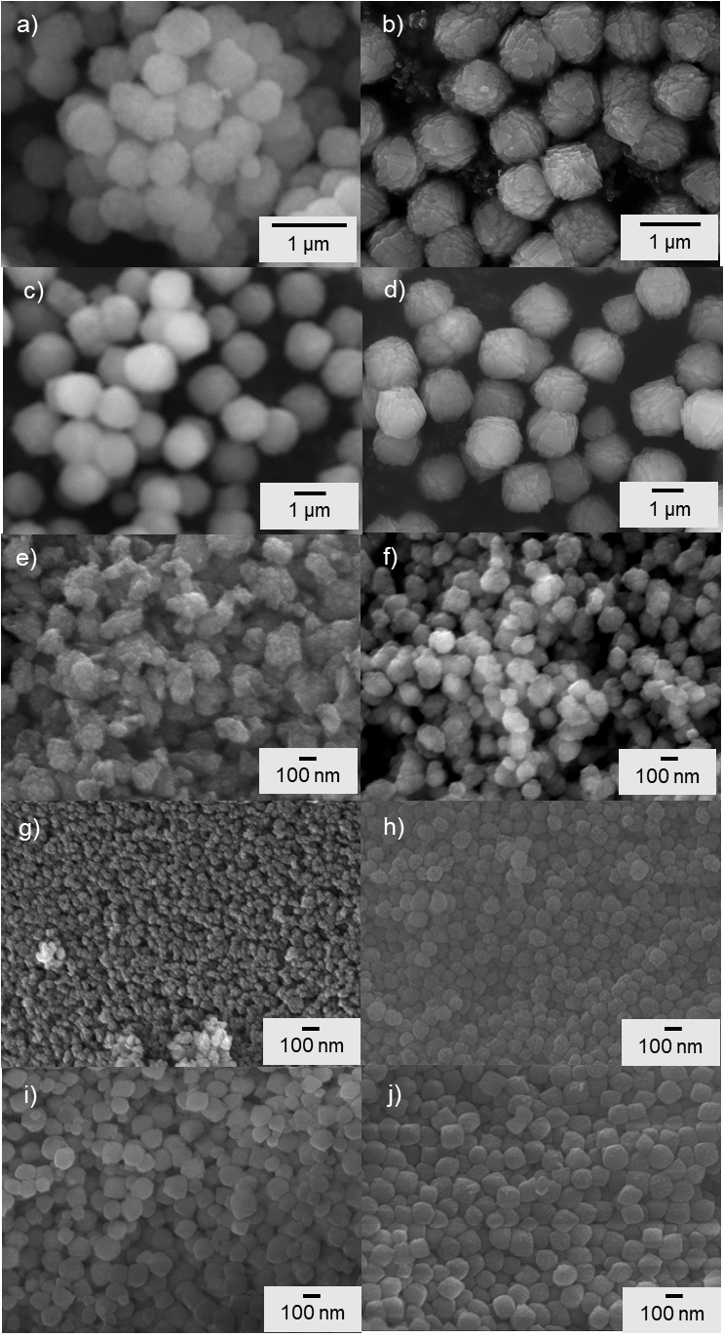
Supplementary Figure 7. Scanning electron microscope images of intrinsic properties-controlled beta zeolites: (a) L-BEA-10, (b) L-BEA-15, (c) L-BEA-20, (d) L-BEA-30, (e) M-BEA-10, (f) M-BEA-20, (g) S-BEA-10, (h) S-BEA-20, (i) S-BEA-30, and (j) S-BEA-50.

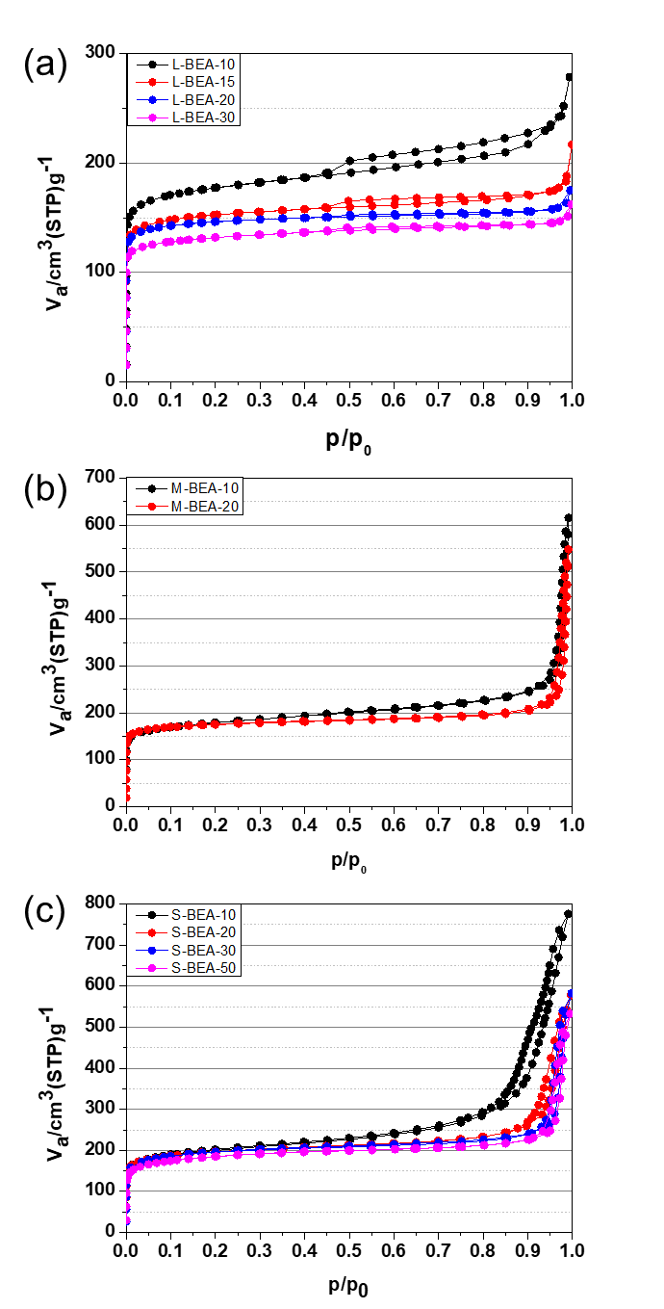
Supplementary Figure 8. 77 K N2 adsorption and desorption isotherms of the prepared *BEA-type zeolite series: (a) L-series, (b) M-series, and (c) S-series.

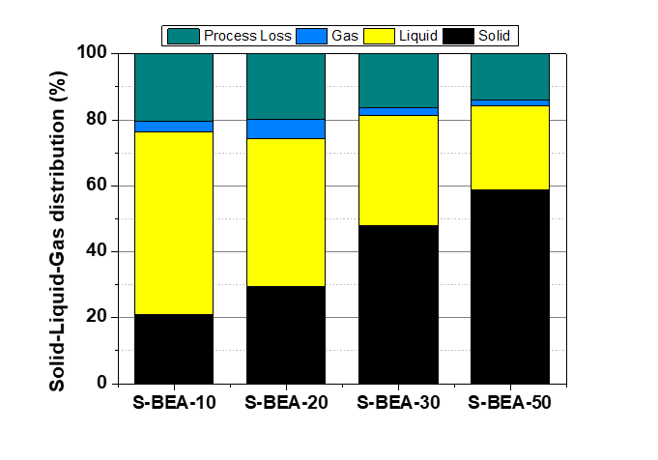
Supplementary Figure 9. Solid-liquid-gas distribution from the 330°C open-batch PE catalytic cracking with the S-series catalyst with varied Si/Al ratio.

The “process loss” mainly consisted of gaseous species and small amounts of liquid volatiles, which was inevitable due to the small-scale, non-steady-state nature of the open batch reactor system, as mentioned above. An increase in the Si/Al ratio led to a larger amount of remaining solid phase, as shown in Supplementary Figure 8. suggesting that less acid sites in the system resulted in a sluggish PE decomposition.

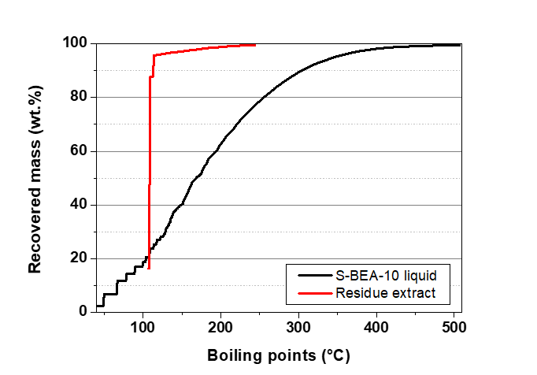
Supplementary Figure 10. SIMDIS profiles of the liquid product obtained from the 330 °C catalytic cracking using S-BEA-10 catalyst and the residue toluene extract.

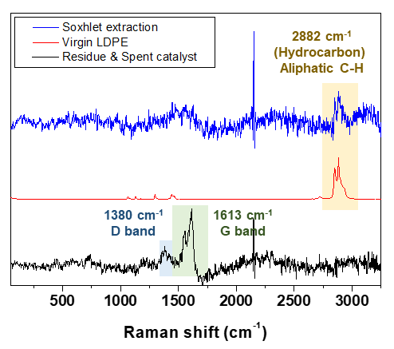
Supplementary Figure 11. Raman spectra of the residue toluene extract, the virgin LDPE, and the post-reaction solid phase recovered from the reaction.

Supplementary Table 3. Selectivity distribution in liquid products.
Sample | C₅–C₁₀  (naphtha) | C₁₀–C₂₀  (middle distillate) | C₂₀–C₃₀  (light vacuum gas oil) | C₃₀–C₄₀  (heavy vacuum gas oil) | C₄₀₊  (residue)
S-BEA-10† | 45.4 | 49.8 | 4.9 | 0 | 0
S-BEA-10‡ | 53.2 | 41.5 | 4.4 | 0.9 | 0
Residue extraction‡ | 98.1(toluene) | 1.9 | 0 | 0 | 0
†Characterized by GC-FID; ‡Characterized based on Simulated distillation (SIMDIS).

To analyze the remaining solid phase composed of spent catalysts and solid hydrocarbons formed after catalytic cracking, Soxhlet extraction was conducted with toluene as the solvent. Analysis of the extract solution by simulated distillation (SIMDIS) revealed it was composed almost entirely of solvent (Supplementary Table 2), indicating the residue contained uncracked LDPE or coke. The Raman spectrum of the post-reaction solid phase (Supplementary Figure 11) indicates that the solid mixture mostly exhibits characteristics of graphitic coke, which may have deposited on the zeolite surface. This is supported by the negligible intensity of the absorption band for aliphatic C-H vibration, suggesting that aliphatic compounds barely survive during the reaction.
Also, the quantification of the liquid product obtained from the cracking experiments using the S-BEA-10 catalyst was cross-verified using GC-FID and SIMDIS. It was confirmed that the majority of the acquired liquid product is indeed within the C₅ to C₃₀ range.

Supplementary data for the catalyst regeneration
Supplementary Figure 12. Characterization of regenerated beta zeolite. a) Powder-XRD profile of regenerated S-BEA-10, b) powder-XRD profile of pristine S-BEA-10, c) N₂ adsorption isotherms of pristine and regenerated S-BEA-10, d) scanning electron microscope image of regenerated S-BEA-10.

Supplementary data for actual post-consumer PE waste decomposition

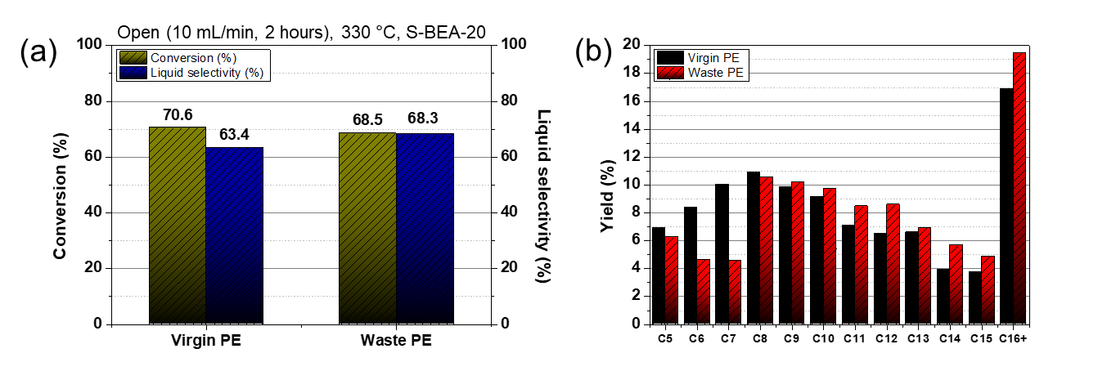
Supplementary Figure 13. The open-batch (10 mL/min, 2 hour) catalytic cracking of actual post-consumer PE using the S-BEA-20 catalyst: the actual post-consumer PE waste catalytic cracking results compared to that of virgin PE: (a) conversion and liquid selectivity and (b) liquid product selectivity distribution.

An actual post-consumer PE waste sample (impurities: Ca 2477.890 ppm, Ti 932.288 ppm, Si 463.216 ppm, Pb 254.981 ppm), collected from a regional waste recycling center in Anseong, Gyeonggi-do, South Korea, was also subjected to a catalytic test using the S-BEA-20 catalyst and compared to the case of the model feed (virgin PE). It achieved a conversion of 69% and a liquid selectivity of 69% under the same conditions. Notably, the product distribution differed, likely due to variations in the molecular weight of the PE.

References

1 Jon, H., Lu, B., Oumi, Y., Itabashi, K. & Sano, T. Synthesis and thermal stability of beta zeolite using ammonium fluoride. Microporous Mesoporous Mater. 89, 88-95 (2006).
2 Xie, B. et al. Organotemplate-Free and Fast Route for Synthesizing Beta Zeolite. Chem. Mater. 20, 4533-4535 (2008).
3 Mintova, S. et al. Variation of the Si/Al ratio in nanosized zeolite Beta crystals. Microporous Mesoporous Mater. 90, 237-245 (2006).

