Supplementary Information

Distinct recognition of mutant huntingtin aggregates by autophagy receptor SQSTM1/p62 or optineurin has differential effects on cell survival

Heejung Kim, Hae Nim Lee, Hoon Ryu, Kyung-Soo Inn, Jihye Seong*

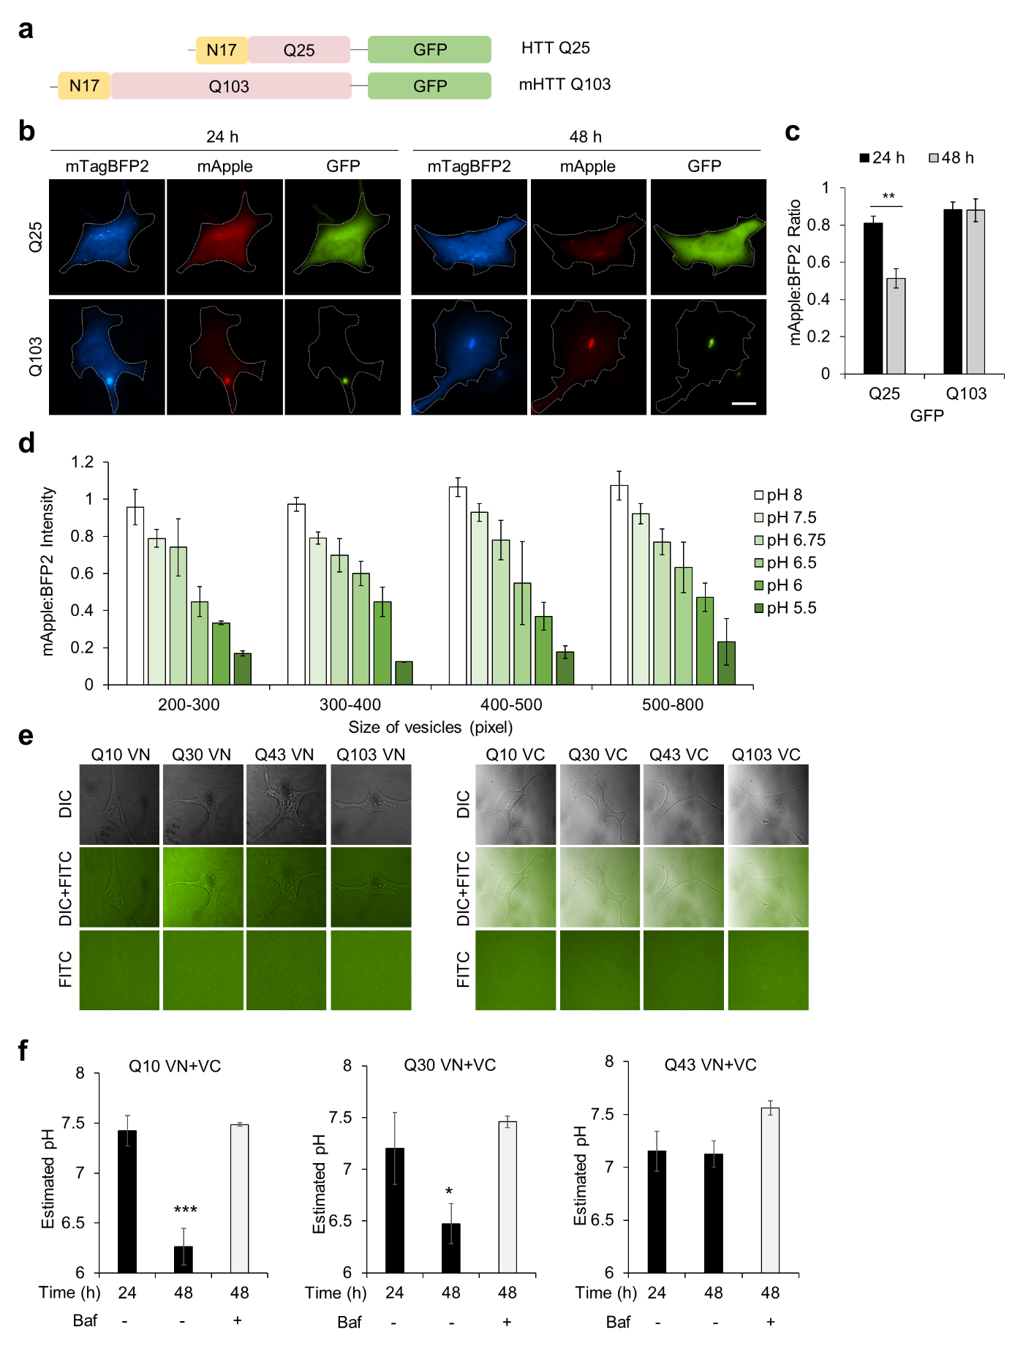Fig S1. Autophagy progression is impaired in HD. a Construct design of HTT-Q25-GFP and mHTT-Q103-GFP. b Representative images of mTagBFP2, mApple, and GFP in the cells expressing RB-LC3 and HTT-polyQ-GFP for indicated times. Scale bar, 20 μm. c The intensity ratios of mApple/BFP2 of RB-LC3 at the autophagic vesicles in the indicated conditions. Data are shown as mean ± s.e.m. Statistical significance: t-test, **p < 0.005, n = 30 cells. d The intensity ratios of mApple/mTagBFP2 in autophagic vesicles containing mHTT aggregates with various sizes were measured under different pH buffers. The cells were pretreated with 50 μM 3-MA for 30 min, then fixed and permeabilized before incubated with different pH buffers. Data are mean ± s.e.m. n = 20 cells. e No fluorescence was observed in the HEK293A cells expressing only VN or VC tagged with polyQ of different lengths. f Quantification of the estimated pH values at autophagic vesicles in the HEK293A cells, treated with bafilomycin A1 (200 nM, 6 h), expressing the BiFC-based HTT-polyQ aggregation sensors with different polyQ lengths, Q10, Q30, or Q43 at indicated times. Data are shown as mean ± s.e.m. Statistical significance: t-test, *p < 0.05, *** p ≤ 0.001, n = 10, 10, 10 cells.

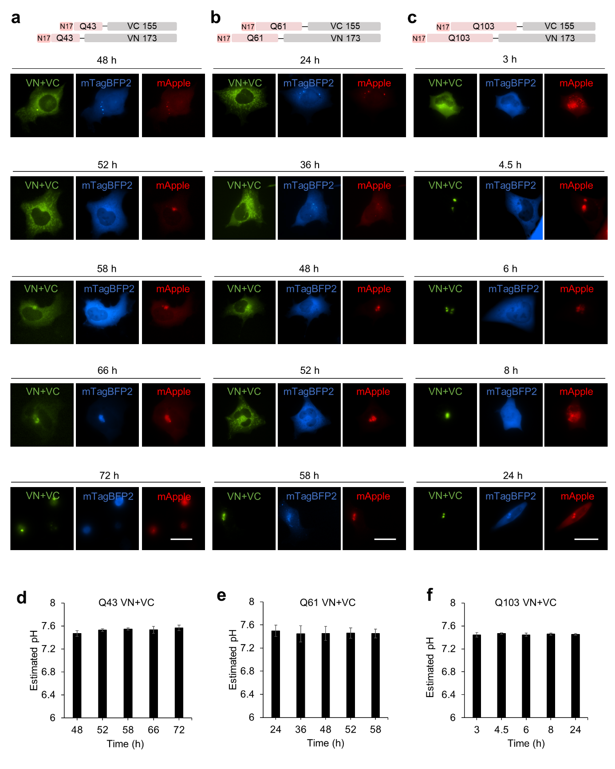Fig S2. Autophagy progression is impaired by mHTT aggregates. a-c Representative images of autophagic vesicles in the HEK293A cells expressing RB-LC3 together with mHTT-polyQ BiFC sensors with different polyQ lengths, Q43 (a), Q61 (b) or Q103 (c), at indicated times. Scale bar: 20 μm. d-f The quantification of estimated pH values at these autophagic vesicles is shown in Supplementary Fig. 2a-c.

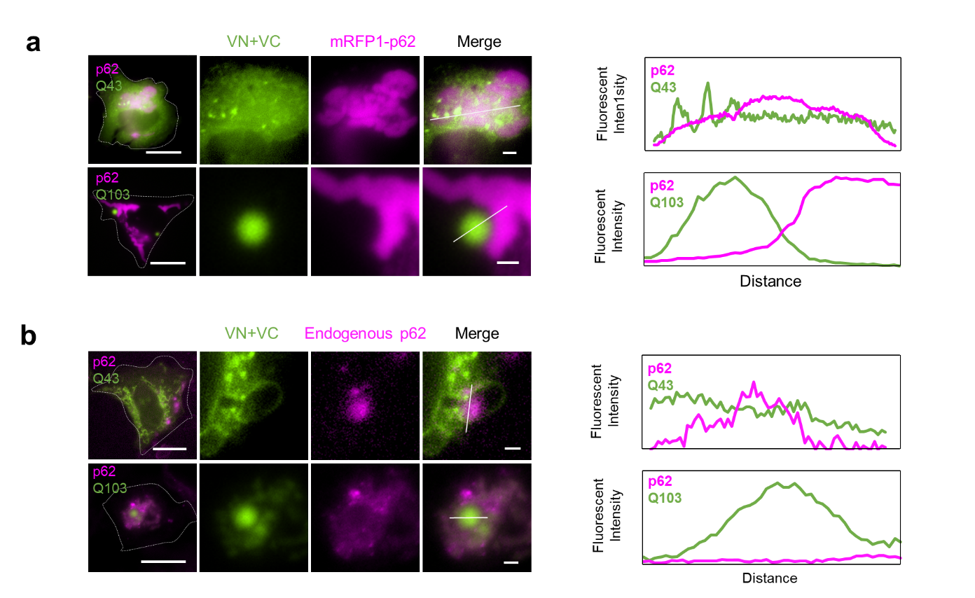Fig S3. Distinct recognition of mHTT aggregates with different polyQ by autophagy receptor SQSTM1/p62. a Representative images of mRFP-p62 and mHTT aggregates of different polyQ lengths, Q43 (upper) or Q103 VN+VC (lower), in STHdhQ7/Q7 cells at 58 h or 6 h post-transfection, respectively. Right images display the boxed areas in the left images at high magnification. Scale bar: 20 μm (left) and 2 μm (right). Line intensity profiles from the merged image show the distribution of SQSTM1/p62 and polyQ aggregates with different polyQ lengths. b Representative images of immunofluorescence staining of endogenous SQSTM1/p62 in HEK293A cells expressing Q43 (upper) or Q103 VN+VC (lower) in at 58 h or 6 h post-transfection, respectively. Right images display the boxed areas in the left images at high magnification. Scale bar: 20 μm (left) and 2 μm (right). Line intensity profiles from the merged image show the distribution of SQSTM1/p62 and mHTT aggregates with different polyQ lengths.

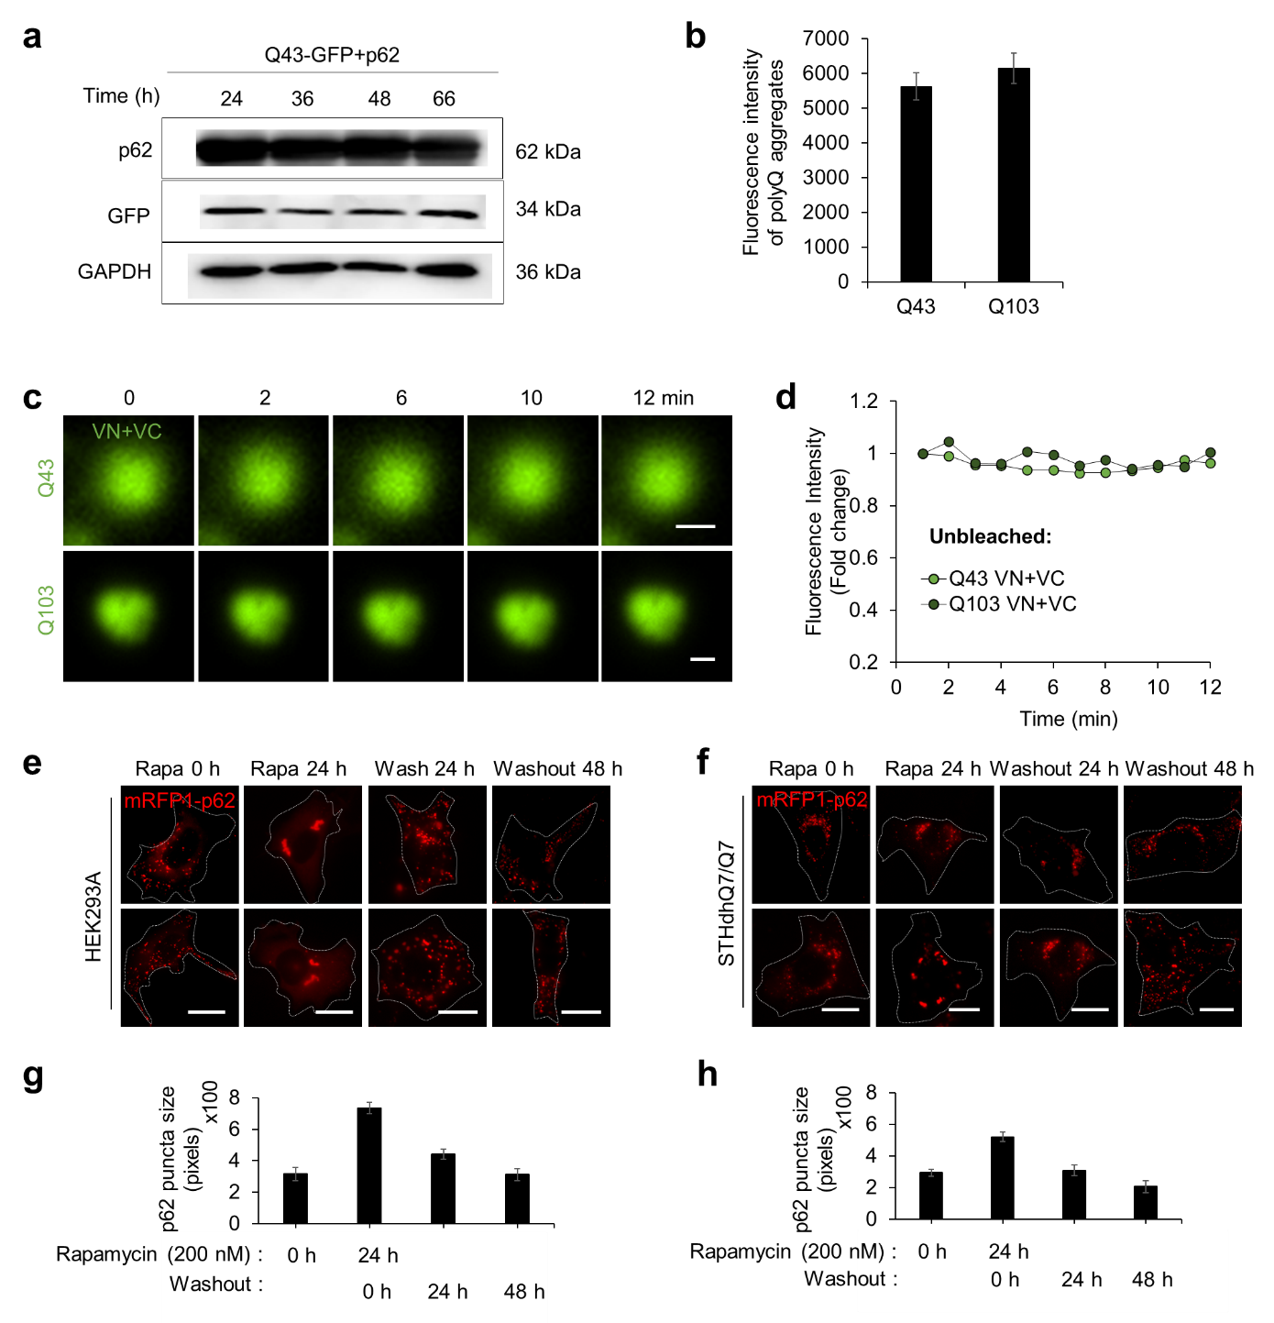Fig S4. Different physical states of Q43 and Q103 aggregates characterized by FRAP assay. a Expression levels of SQSTM1/p62 and Q43-GFP at indicated times were quantified by GFP and SQSTM1/p62 antibodies. Equal loading was verified by GAPDH. b Fluorescent intensity of Q43 and Q103 aggregates in the STHdhQ7/Q7 cells before photobleaching. c, d Representative images (c) and fluorescent intensity (d) of Q43 and Q103 aggregates in the STHdhQ7/Q7 cells without photobleaching. Scale bar: 2 μm. Data are shown as mean ± SD. n = 5. e, f Representative images of mRFP-p62 distributions in HEK293A (e) and STHdhQ7/Q7 cells (f). mRFP1-p62 condensates induced by rapamycin 200 nM for 24 h. After treatment of rapamycin for 24 h, washout of rapamycin was conducted by PBS for 24 and 48 h. Scale bar: 20 μm. g, h Quantification of size of SQSTM1/p62 puncta in each cells expressing mRFP1-p62. Data are shown as mean ± s.e.m. n = over 200 SQSTM1/p62 puncta in 11 cells.

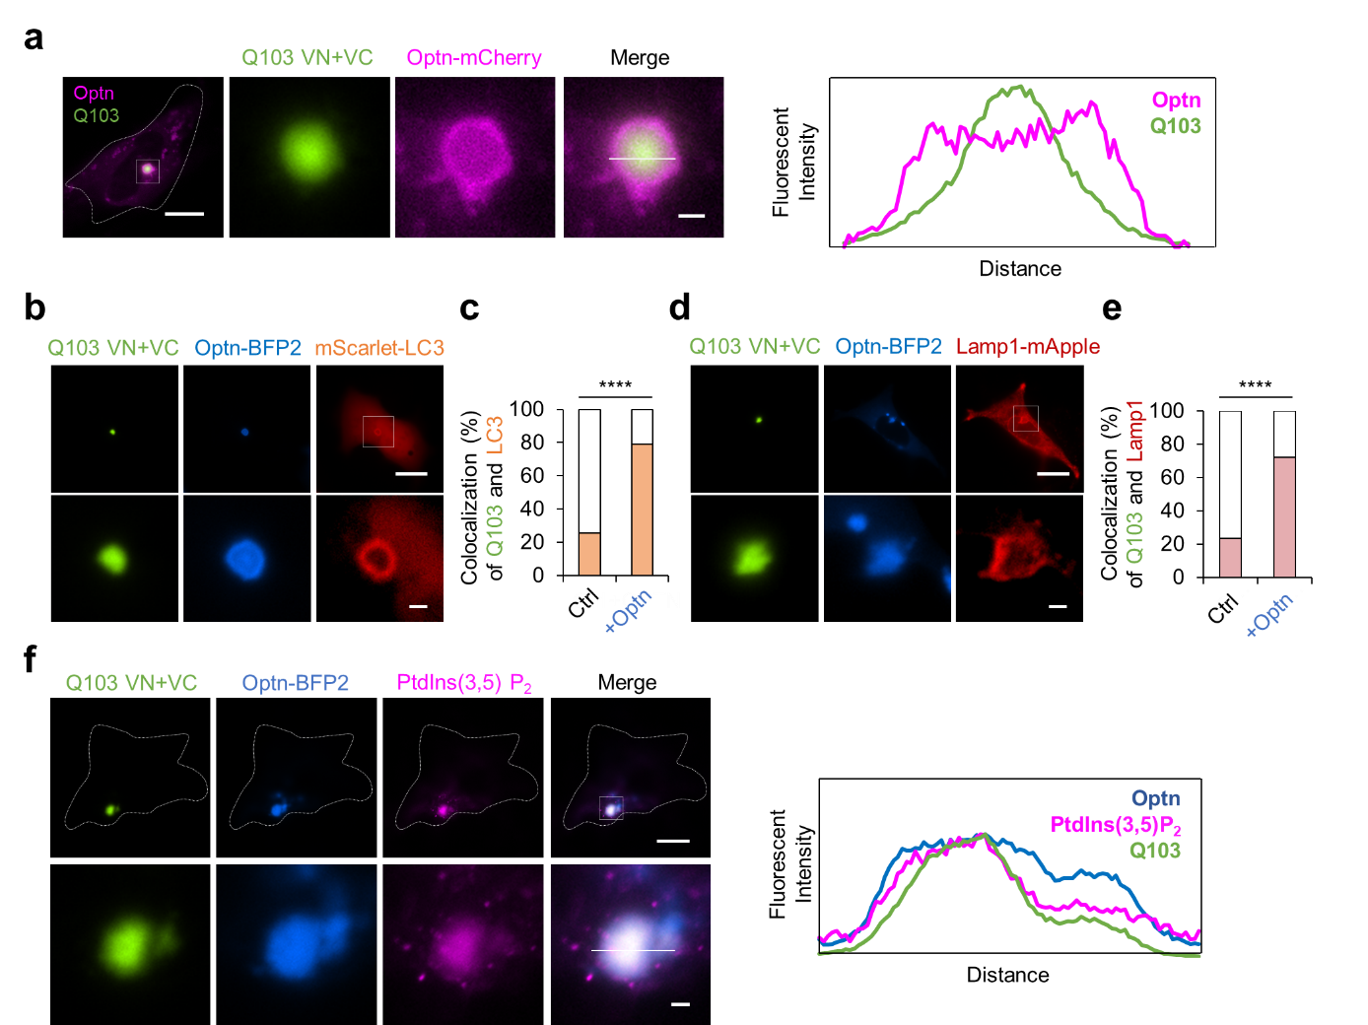Fig S5. Optn preferentially recognizes the mHTT aggregates with longer polyQ lengths. a Representative images of Q103 VN+VC and Optn-mCherry expressed in STHdhQ7/Q7 cells at 72 h post-transfection. Right images display the boxed areas in the left images at high magnification. Scale bar: 20 μm (left) and 2 μm (right). The distribution of Q103 VN+VC and Optn was assessed by line intensity profiles. b, d Representative images of Q103 VN+VC aggregates, Optn-mTagBFP2, and mScarlet-LC3 (b) or Lamp1-mApple (d) at 52 h post-transfection. Lower images display the boxed areas in the upper images at high magnification. Scale bar: 20 μm (upper) and 2 μm (lower). c, e Cell percentages displaying the colocalization of LC3 (c) or Lamp1 (e) with Q103 VN+VC aggregates, without or with Optn overexpression at 52 h post-transfection. Statistical significance: Fisher’s exact test, ****p ≤ 0.0001, n = 43, 43 cells. f Representative images of immunofluorescence staining of PtdIns(3,5)P₂ in HEK293A cells expressing mHTT-polyQ103 and Optn-mTagBFP2 in at 52 h post-transfection. Lower images display the boxed areas in the upper images at high magnification, and line intensity profiles display their distribution. Scale bar: 20 μm (upper) and 2 μm (lower).

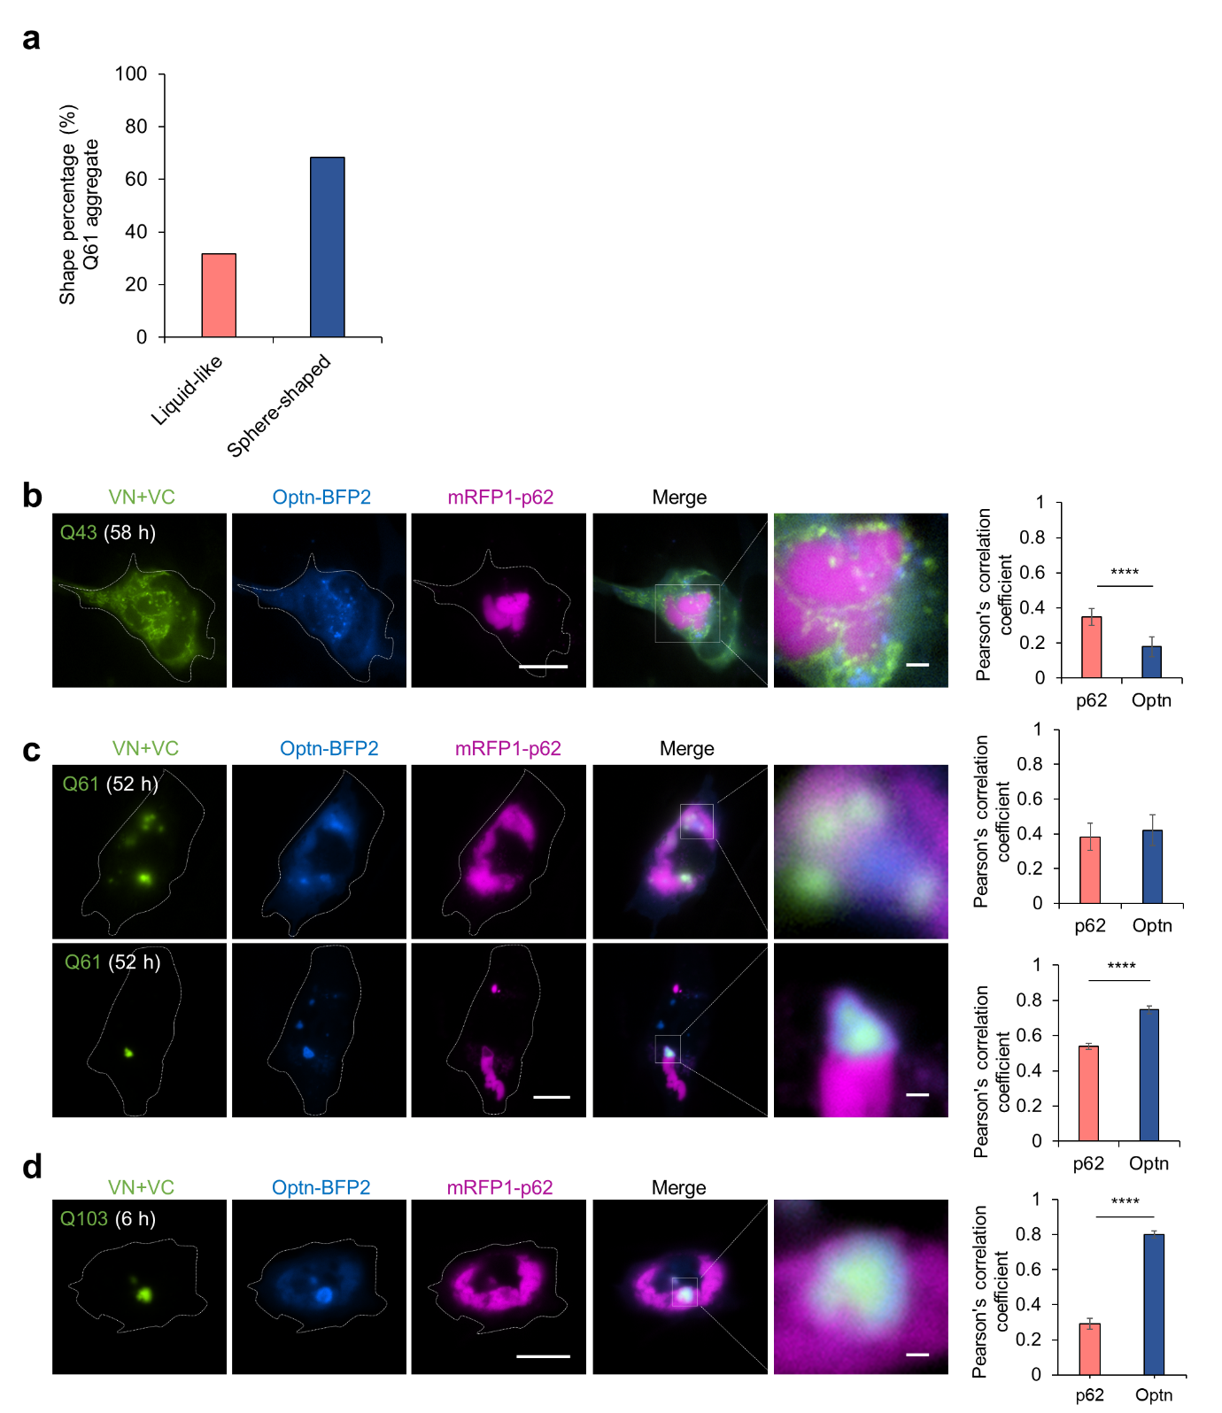Fig S6. mHTT exhibits differential preference toward SQSTM1/p62 and Optn depending on the polyQ lengths. a Cell percentages displaying liquid-like mHTT-polyQ61 condensates or sphere-shaped mHTT-polyQ61 aggregates when both SQSTM1/p62 and Optn were expressed in the HEK293A cells. n = 100 cells. b-d Representative images of mHTT aggregates with different polyQ lengths, Q43 (b), Q61 (c) and Q103 (d), in the STHdhQ7/Q7 cells expressing both SQSTM1/p62 and Optn at the indicated times. The boxed areas in the merge images are displayed at high magnification on the right. Scale bar: 20 μm (left) and 2 μm (right). The graphs on the right show the colocalization of autophagy receptors with mHTT aggregates quantified by Pearson’s correlation coefficient. Data are shown as mean ± s.e.m. Statistical significance: t-test, ****p < 0.0001, n = 20 cells.
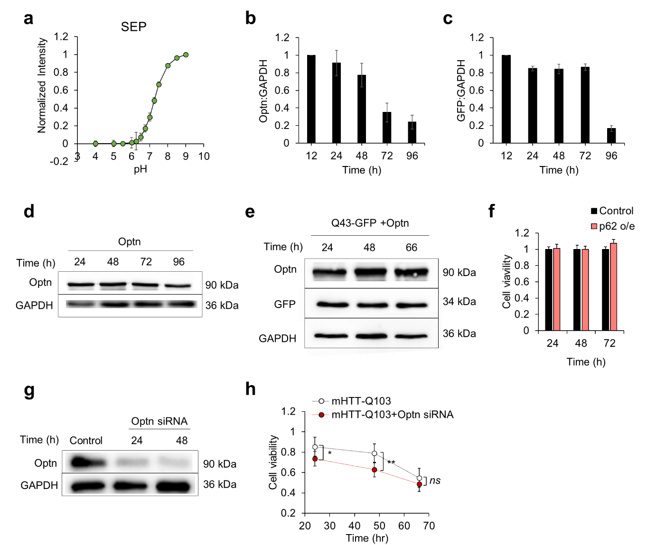Fig S7. Optn can promote cytoprotection by mHTT aggregates with longer polyQ lengths. a The pH titration curve for the fluorescent intensity of purified SEP. The pH-dependent distribution of SEP intensity is shown in the graph. Data are mean ± s.e.m. n = 5. b, c Expression levels of Optn and mHTT-polyQ103-GFP and at indicated times post-transfection in HEK293A cells were quantified by the relative levels of Optn/GAPDH (b) and GFP/GAPDH (c). Data are shown as mean ± s.e.m. n = 3. d Expression levels of Optn at indicated times were quantified by Optn antibodies. Equal loading was verified by GAPDH. e Expression levels of Optn with Q43-GFP at indicated times were quantified by GFP and Optn antibodies. Equal loading was verified by GAPDH. f Cell viability at the indicated time after transfection without or with autophagy receptor, SQSTM1/p62 in HEK293A cells. Data are mean ± SD. n = 5. g Expression levels of Optn without or with the treatment of the Optn siRNA at indicated times. h Cell viability at indicated time after transfection of polyQ103 without (blank) or with the treatment of the Optn siRNA (red). Data are mean ± s.e.m. Statistical significance: t-test, *p < 0.05, **p < 0.005, n = 10.

