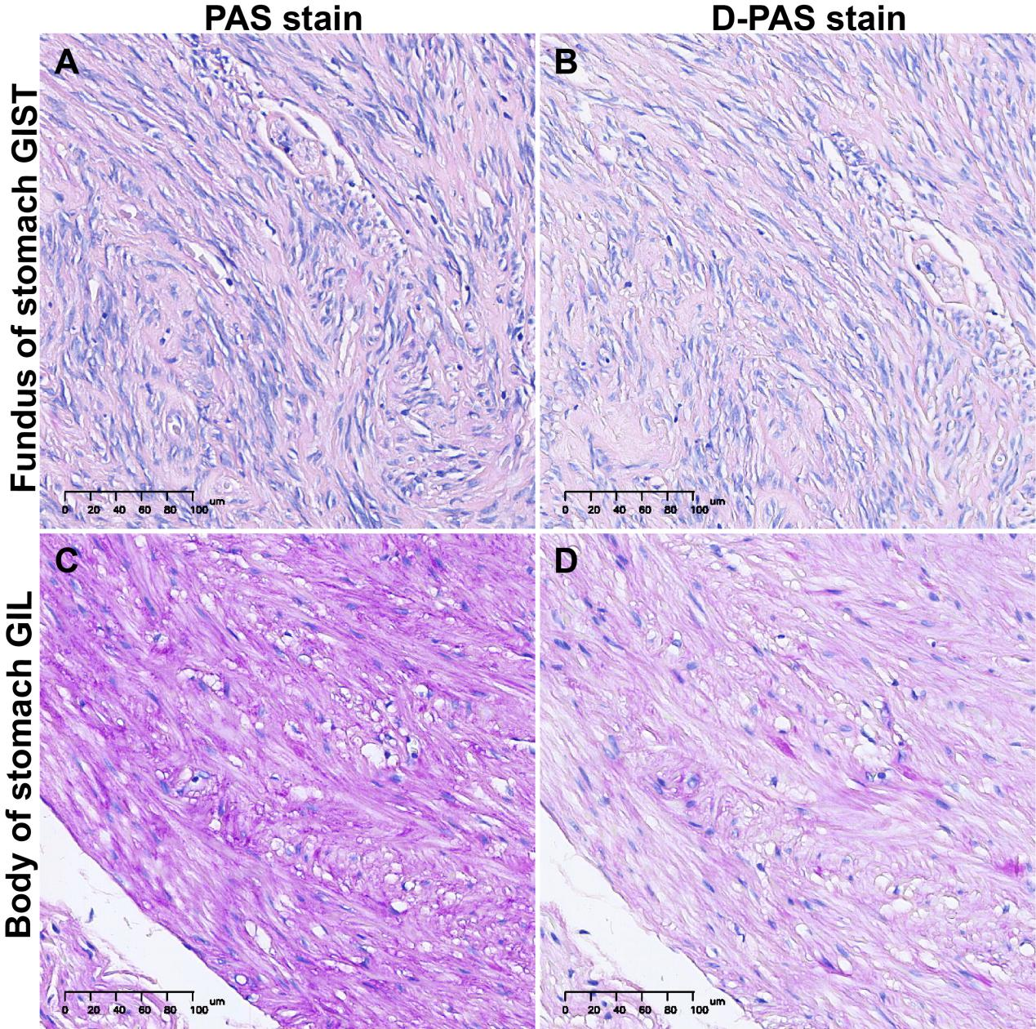
Supplementary material figure 1. PAS and D-PAS stain in GIST and GIL. In fundus of stomach GIST, PAS and D-PAS stain has no significant difference, all showed light purple. But in body of stomach GIL, the staining results changed from rose red to light purple. Magnification: 200 ×.

Supplementary material Table 2: Confirmatory experimental information on cases of GISTs and GILs

 | GISTs (n=7) | leiomyomas (n=3) | Statistical analysis
Gender |  |  | *
Male (n) | 2 | 3
Female (n) | 5 | 0
Age rage, median (years) | 55 - 69, 60 | 53 - 62, 53 | ***
Lesion size range, median (cm) | 0. 4 - 3.5, 0.6 | 0.6 - 0.9, 0.8 | ***
Lesion site of digestive tract |  |  | ***
Esophagus (n) | 0 | 1
Cardia (n) | 0 | 0
Stomach (n) | 7 | 1
Pars descendens duodeni (n) | 0 | 0
Lower digestive tract (n) | 0 | 1
Form of organization |  |  | ns
Spindle cell (n) | 7 | 3
Epithelioid cell(n) | 0 | 0
Lesion location |  |  | ***
Lamina musculi propria | 6 | 2
Muscularis mucosae | 1 | 1

“ns” indicates no significant difference when P > 0.05, “*” indicates P < 0.05, “**” indicates P < 0.01, and “***” indicates P < 0.001 with significant difference.

