Supplementary Information

Galvanic Hydrogenation Reaction in Metal Oxide

JunHwa Kwon^{1,2}†, Soonsung So¹†, Ki-Yeop Cho¹, Seungmin Lee¹, Kiyeon Sim¹, Subin Kim¹, Seunghyun Jo¹, Byeol Kang¹, Youn-Ki Lee¹, Hee-Young Park², Jung Tae Lee³*, Joo-Hyoung Lee¹*, KwangSup Eom^{1,4}*, and Thomas F. Fuller⁴

¹ School of Materials Science and Engineering, Gwangju Institute of Science Technology (GIST), Gwangju 61005, Korea
² Hydrogen and Fuel Cell Research Center, Korea Institute of Science and Technology (KIST), Seoul 02792, Korea
³ Department of Plant and Environmental New Resources, Kyung Hee University, Yongin 17104, Korea
⁴ School of Chemical & Biomolecular Engineering, Georgia Institute of Technology, Atlanta, Georgia 30332, United States
* Authors to whom correspondence should be addressed
†These authors contributed equally to this work.

*Corresponding authors: J. T. Lee (jungtae@khu.ac.kr), J-H Lee (jhyoung@gist.ac.kr ), and K. Eom (keom@gist.ac.kr )

Supplementary Figure 1. (a) Linear sweep voltammetry (LSV) measured of pristine MoO₃ under 1M H₂SO₄ solutions. (b) Cyclic voltammetry (CV) curves of Pt electrode under Mo(Ⅳ) cation solution.
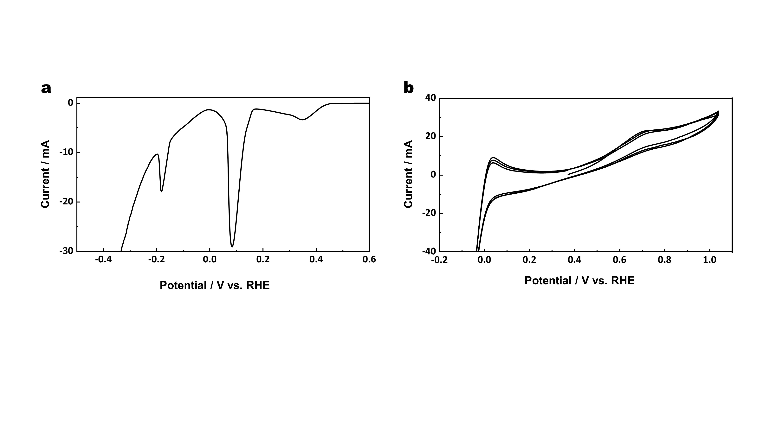

Supplementary Figure 2. Color changes as Mo(Ⅳ) solution is added into the MoO₃ suspension. Both the MoO₃ powder and the cation solution show spontaneous color charge to dark blue under ambient condition. The H-doped MoO₃ was obtained by vacuum filtering after 3 h of stirring under ambient condition.
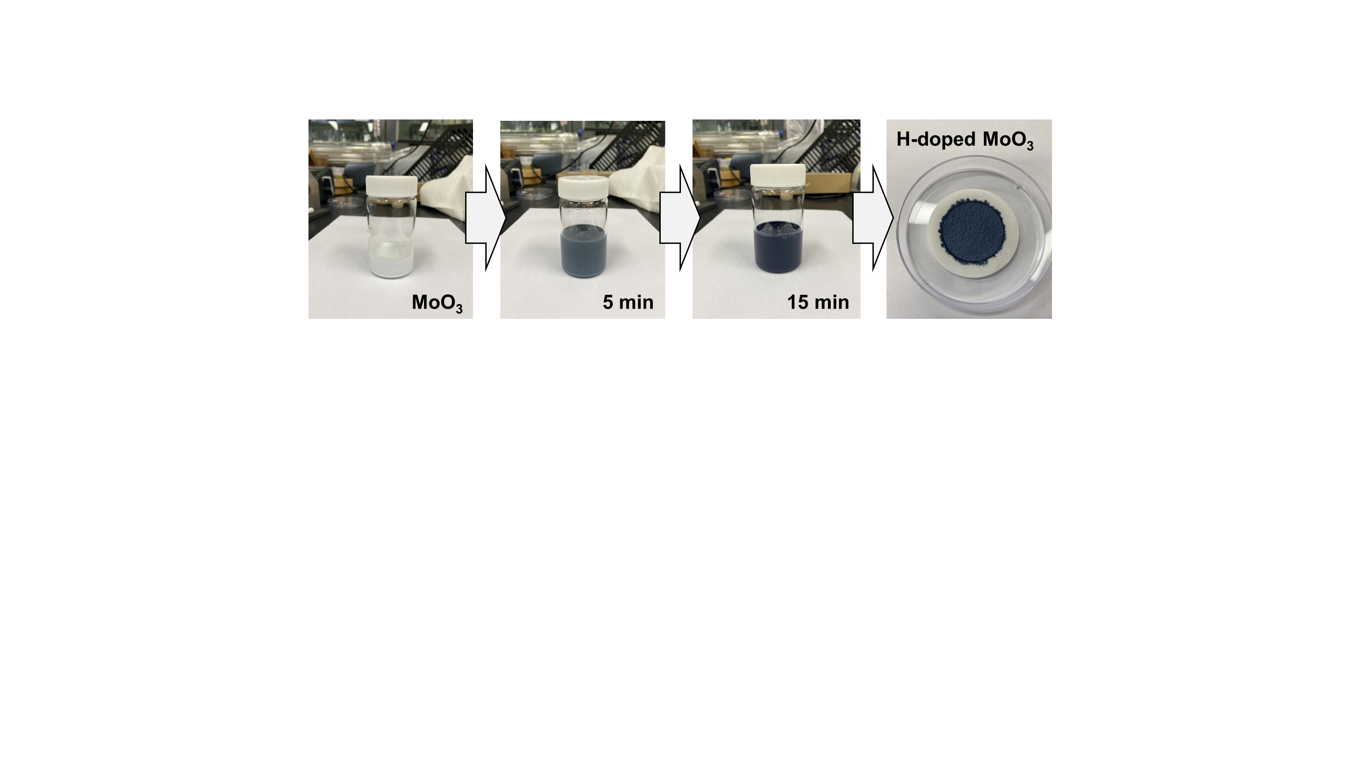
Supplementary Figure 3. X-ray diffraction patterns of pristine MoO₃, and hydrogenated MoO₃ using Mo(Ⅳ), and V(Ⅱ) cation solutions. Mo(Ⅳ) cation solution-treated MoO₃ shows the orthorhombic structure including wider vdW interlayer space, and V(Ⅱ) cation solution-treated MoO₃ shows the monoclinic phases.
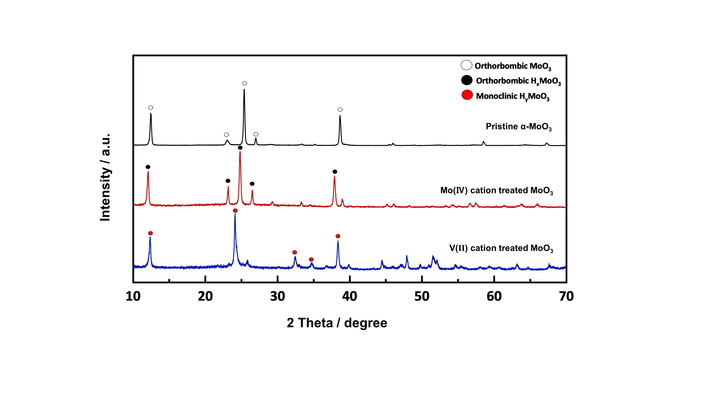

Supplementary Figure 4. (a) Mo 3d and (b) O 1s spectra of X-ray photoelectron spectroscopy (XPS) results of pristine MoO₃, and hydrogenated MoO₃ using Mo(Ⅳ), and V(Ⅱ) solutions.
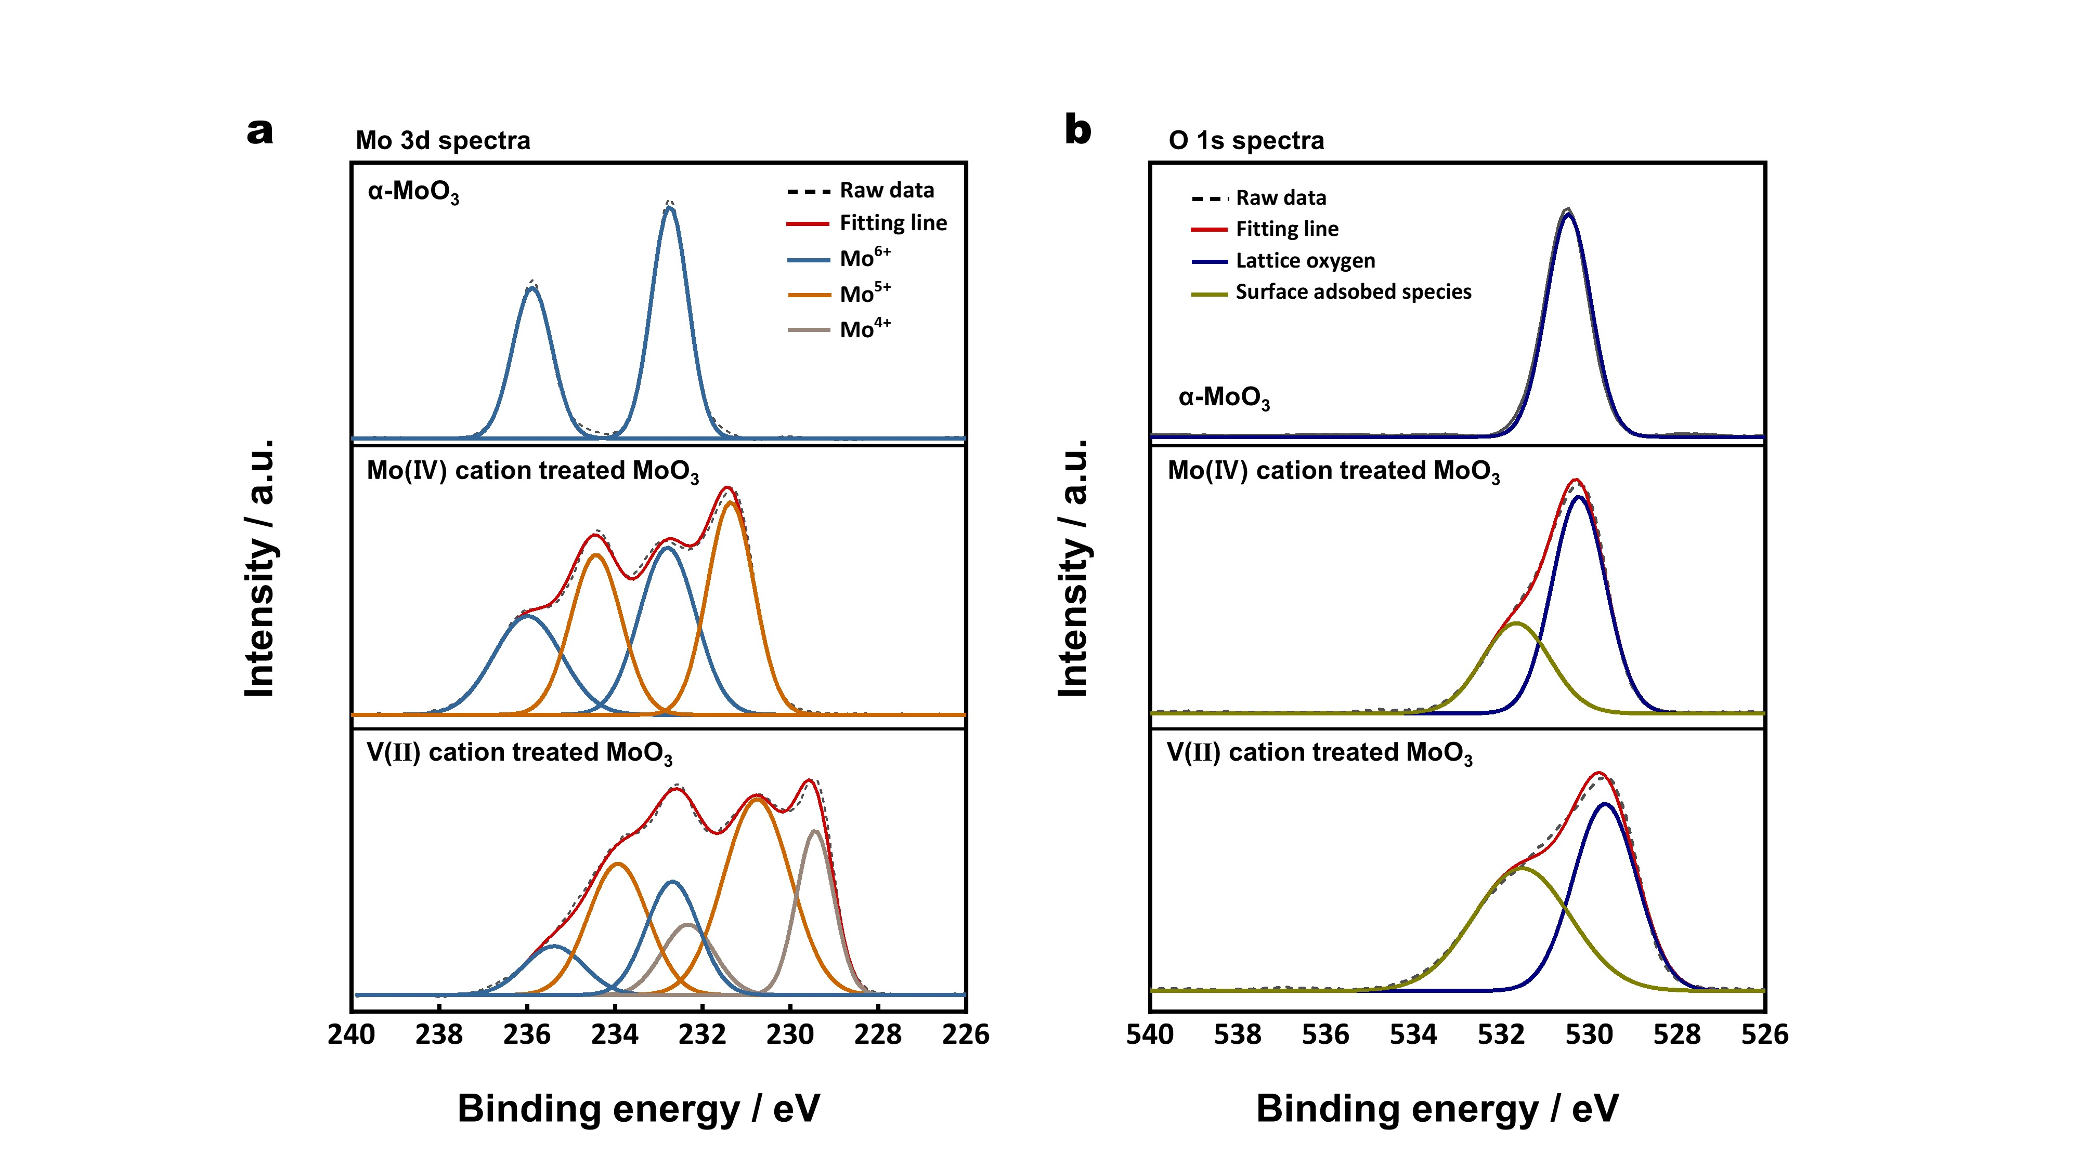

Supplementary Figure 5. X-ray diffraction patterns of pristine monoclinic phase of WO₃, and hydrogenated WO₃ using Mo(Ⅳ), and V(Ⅱ) solutions. Mo(Ⅳ) cation solution-treated MoO₃ shows the identical XRD patters with pristine state, and V(Ⅱ) cation solution-treated WO₃ shows the cubic phase.
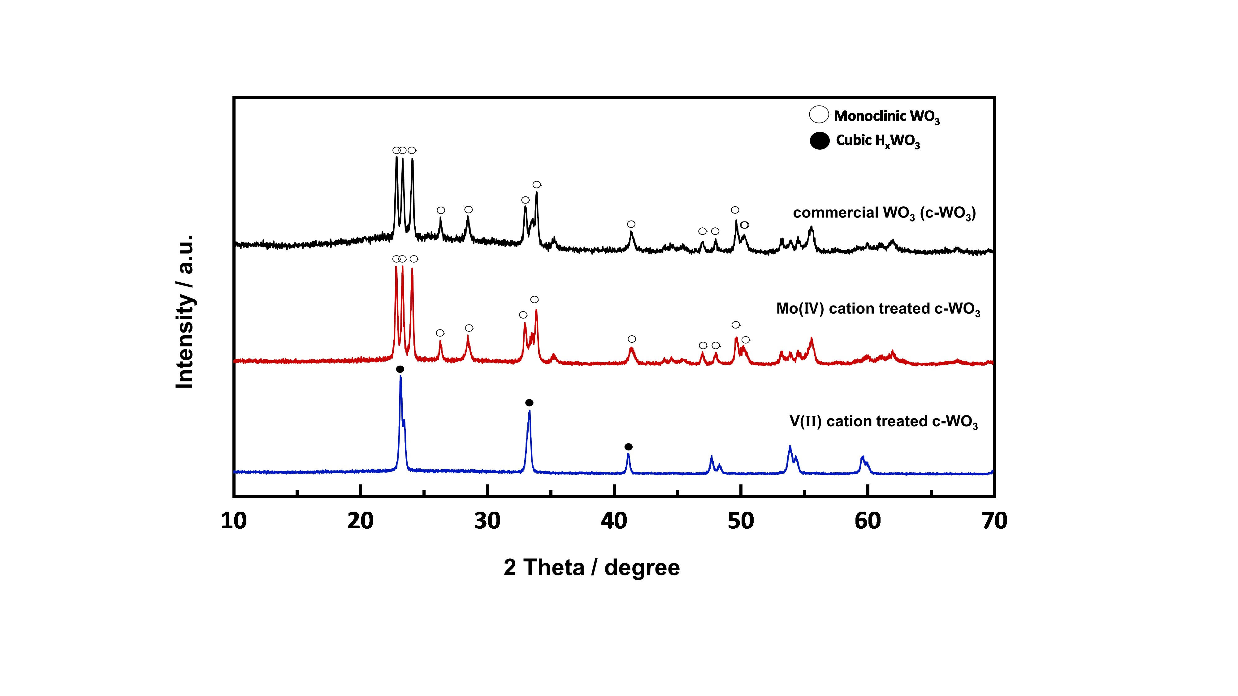

Supplementary Figure 6. (a) W 4f and (b) O1s spectra of X-ray photoelectron spectroscopy (XPS) results of pristine WO₃, and hydrogenated WO₃ using Mo(Ⅳ), and V(Ⅱ) solutions.
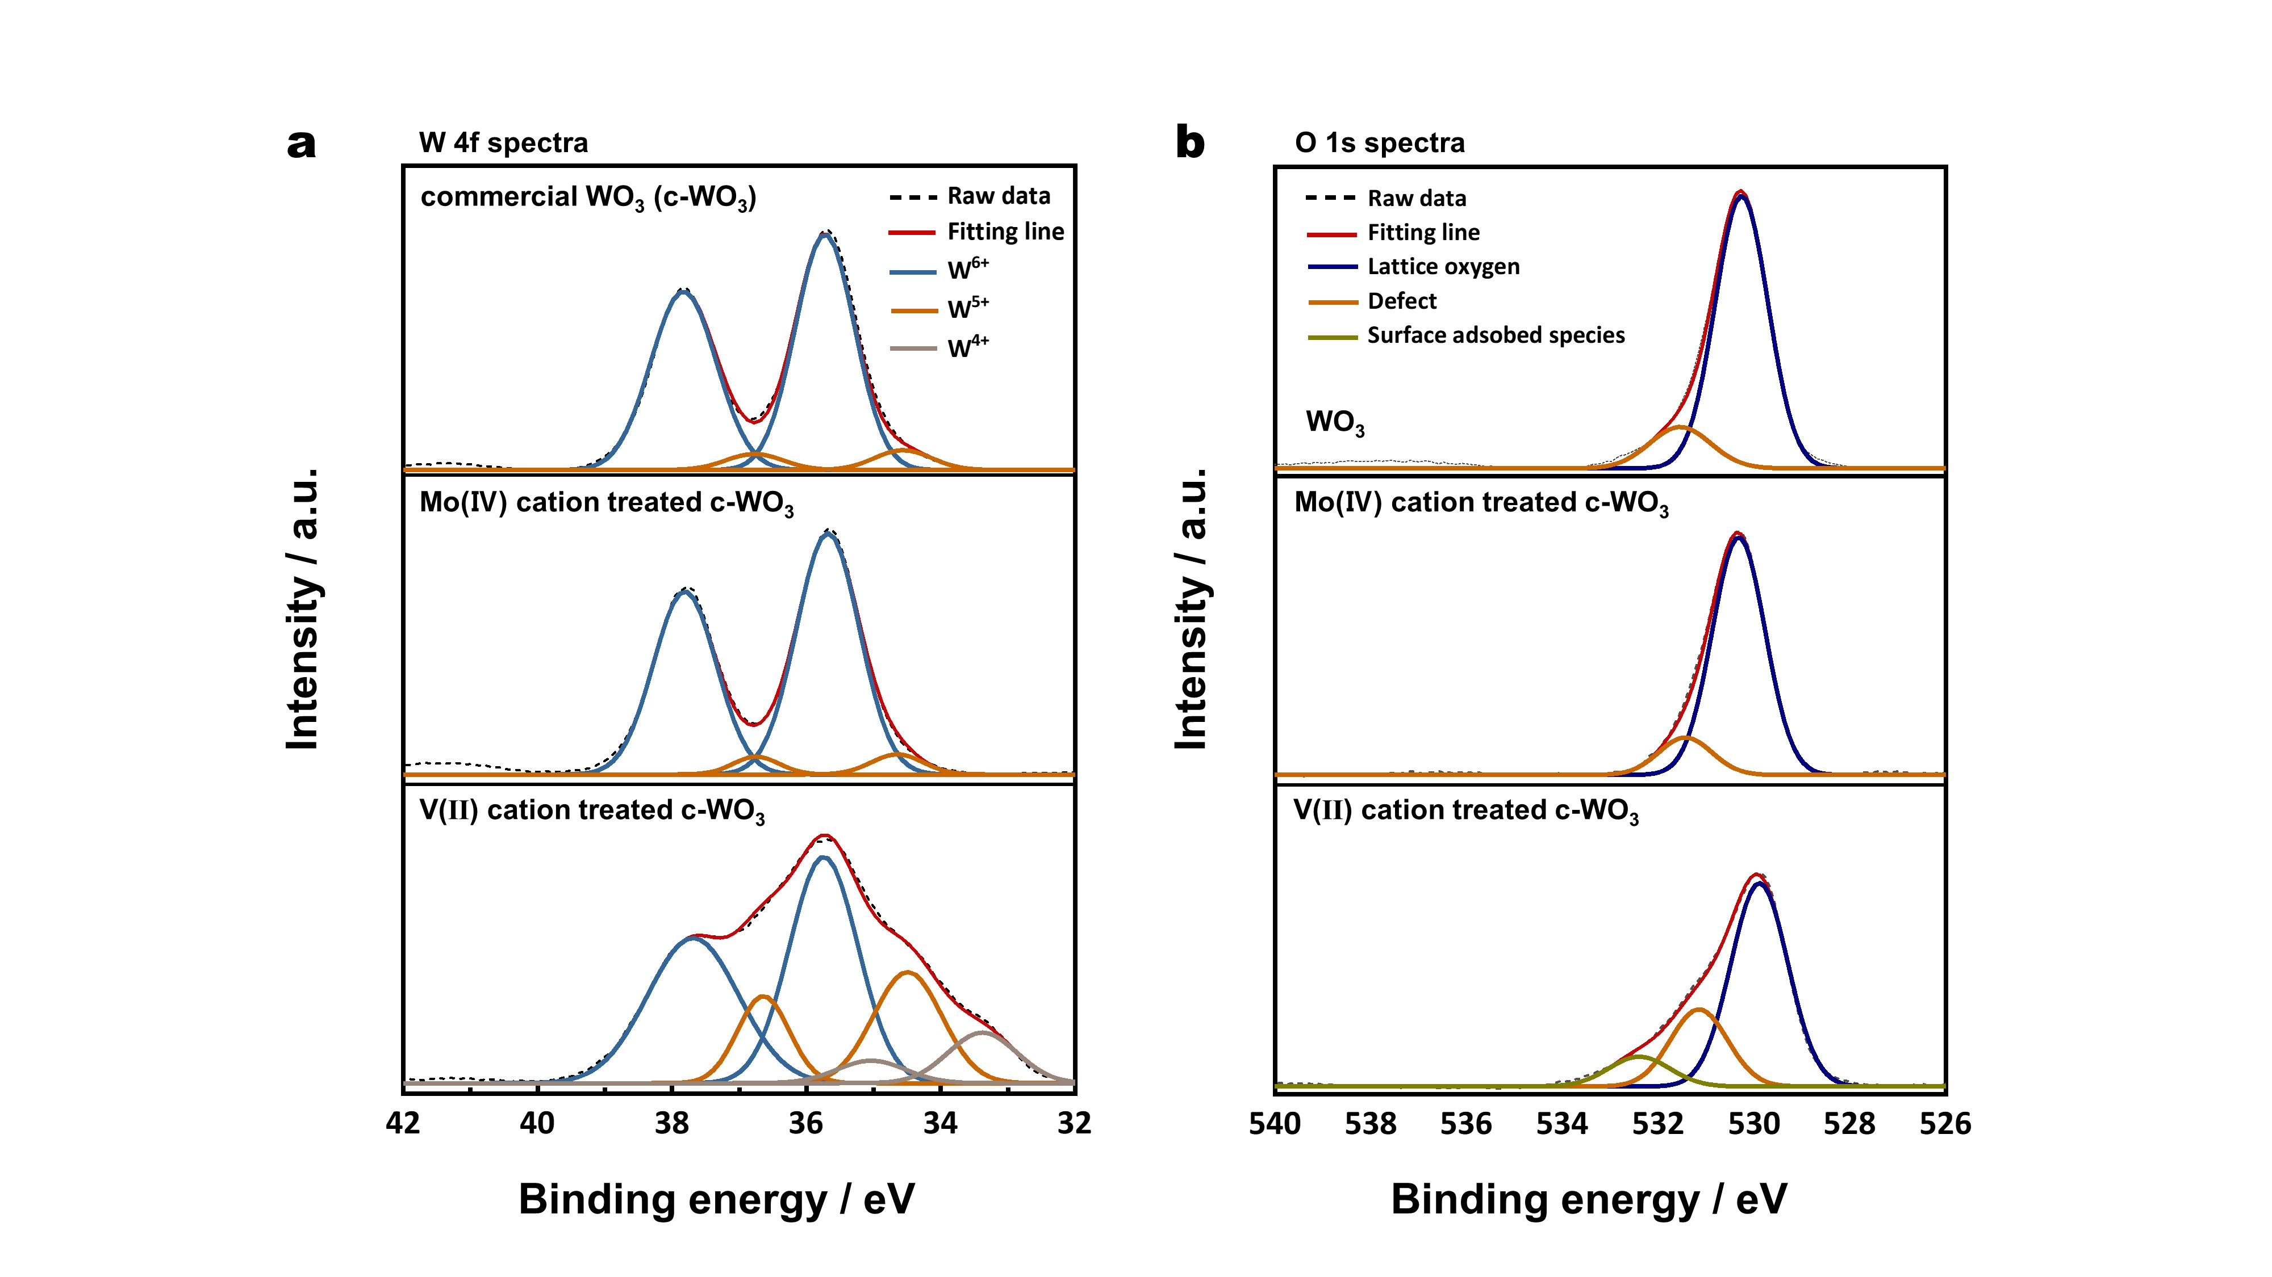

Supplementary Figure 7. Transmission electron microscopy (TEM), scanning electron microscopy (SEM) images and selected area electrode diffraction (SAED) pattern of (a-c) pristine MoO₃ and (d-f) H-MoO₃.
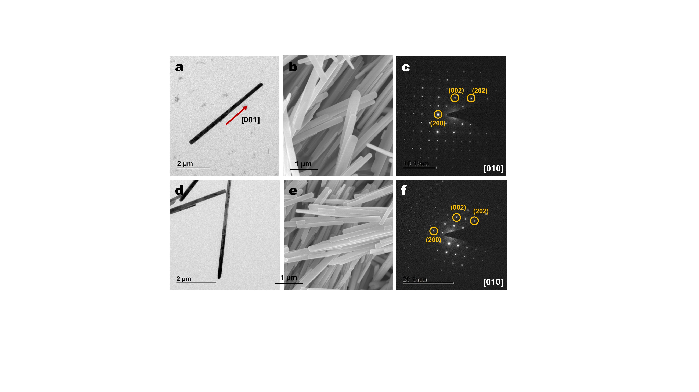

Supplementary Figure 8. (a) Raman analysis of pristine MoO₃ and H-MoO₃. It indicates the raman shift of corner sharing MoO₆ octahedra composed of three different oxygen positions as shown in (c); the terminal oxygen (O_{t}, single coordinated double bond with molybdenum atom), asymmetric oxygen (O_{a}, double coordinated molybdenum atom), symmetric oxygen (O_{s}, triply coordinated bond with a two equal bond with molybdenum and one another bond in adjacent layer)
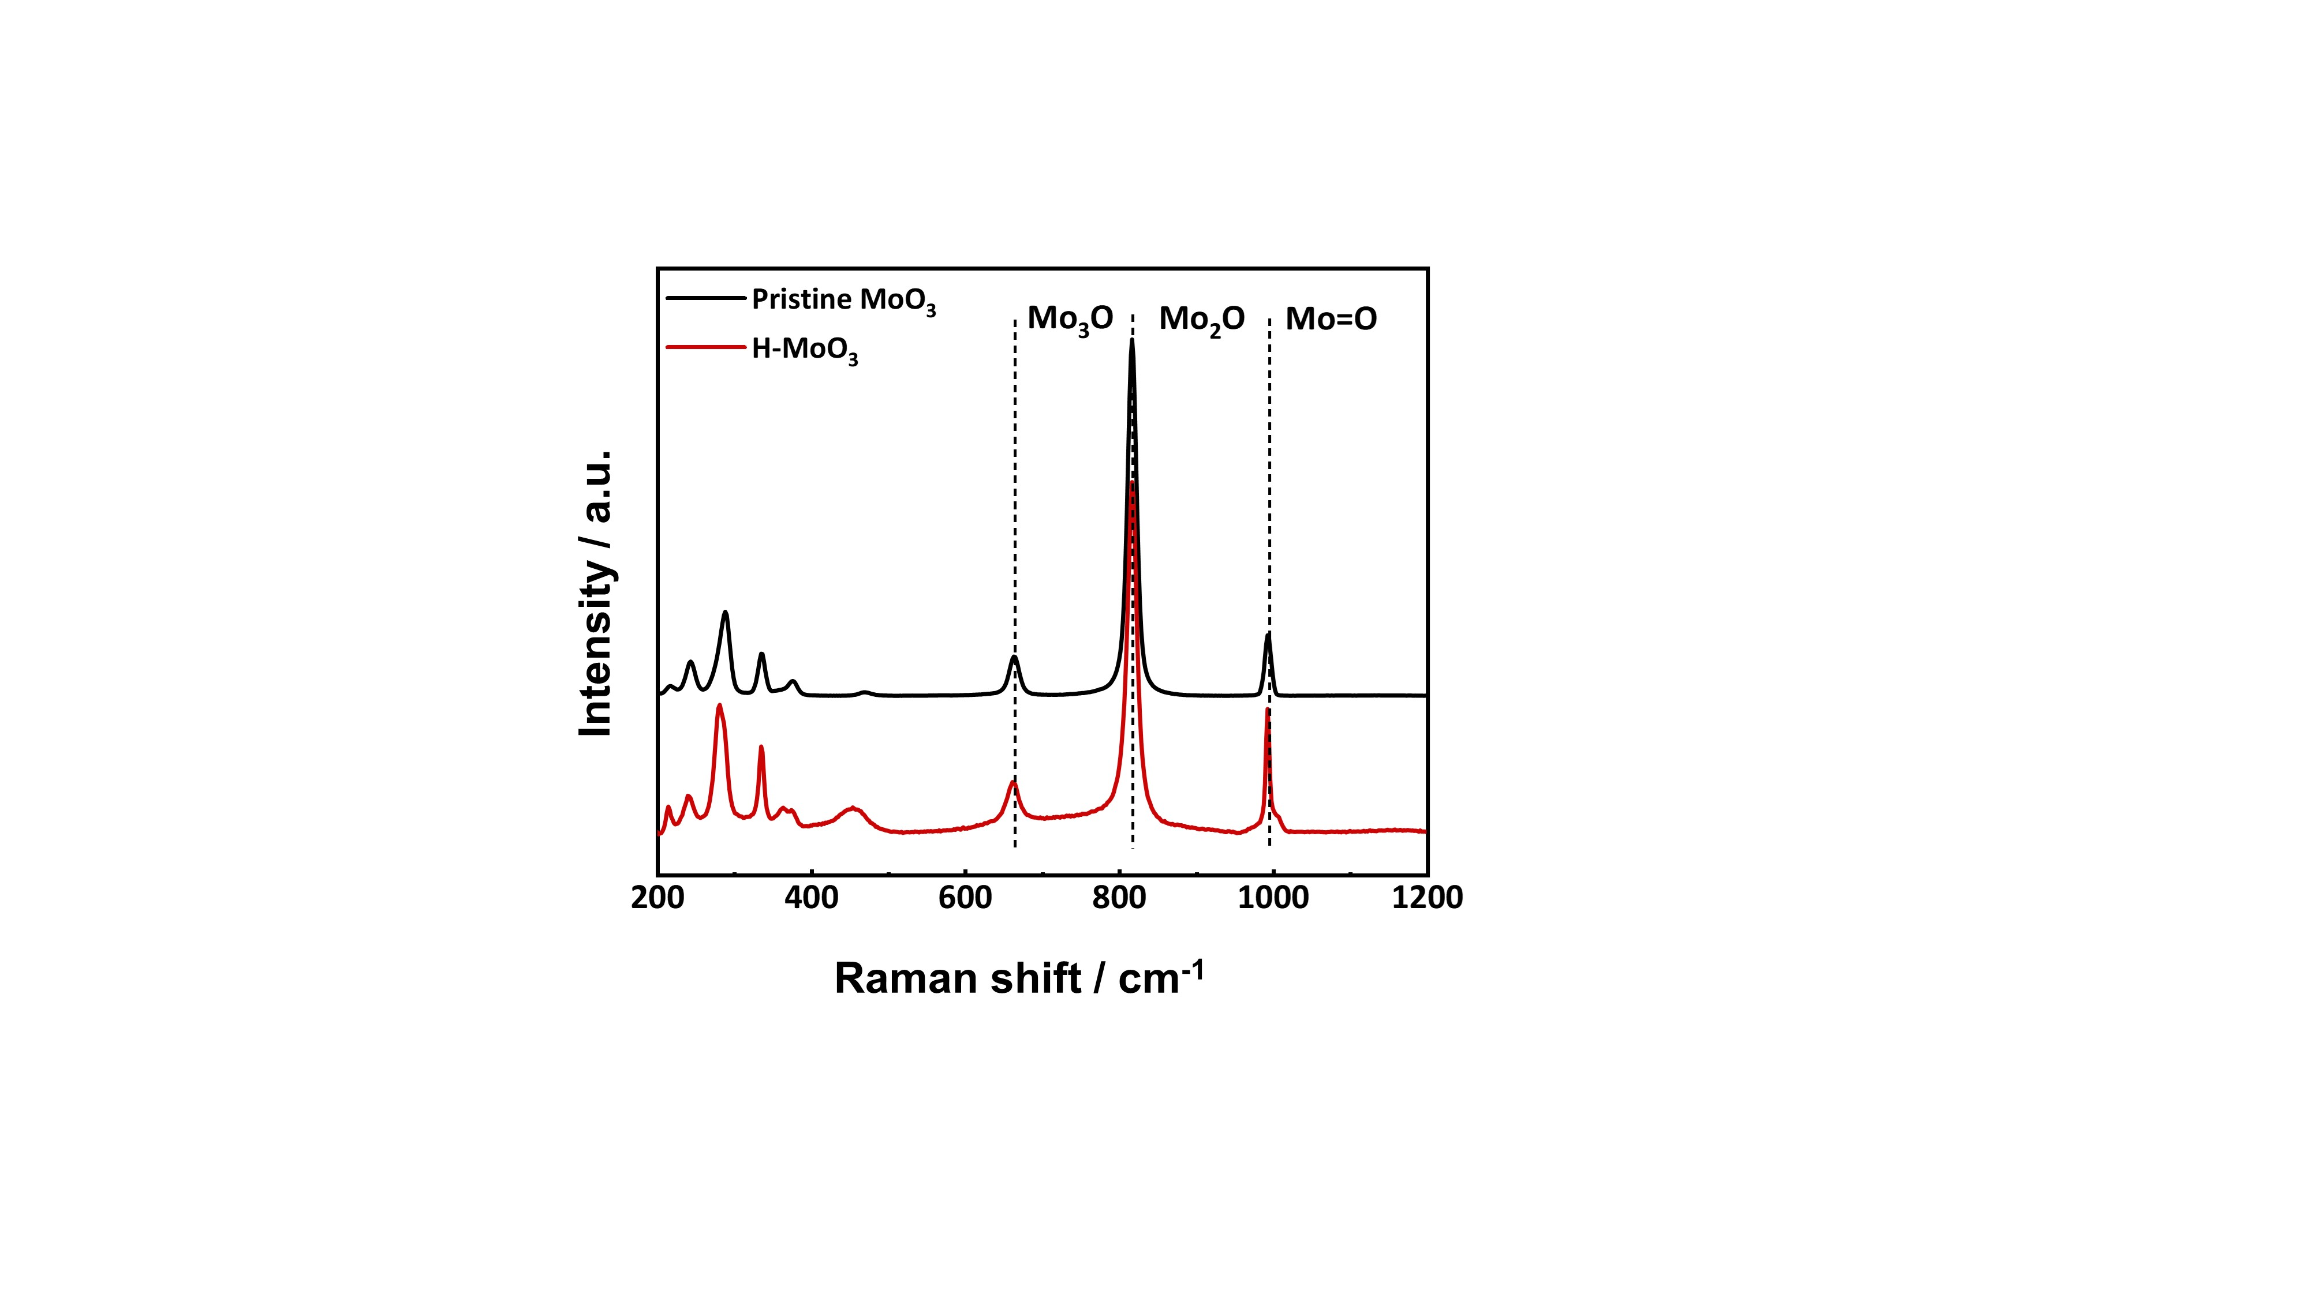

Supplementary Figure 9. Configurations of H-MoO₃ with H=0.5 from DFT calculation.
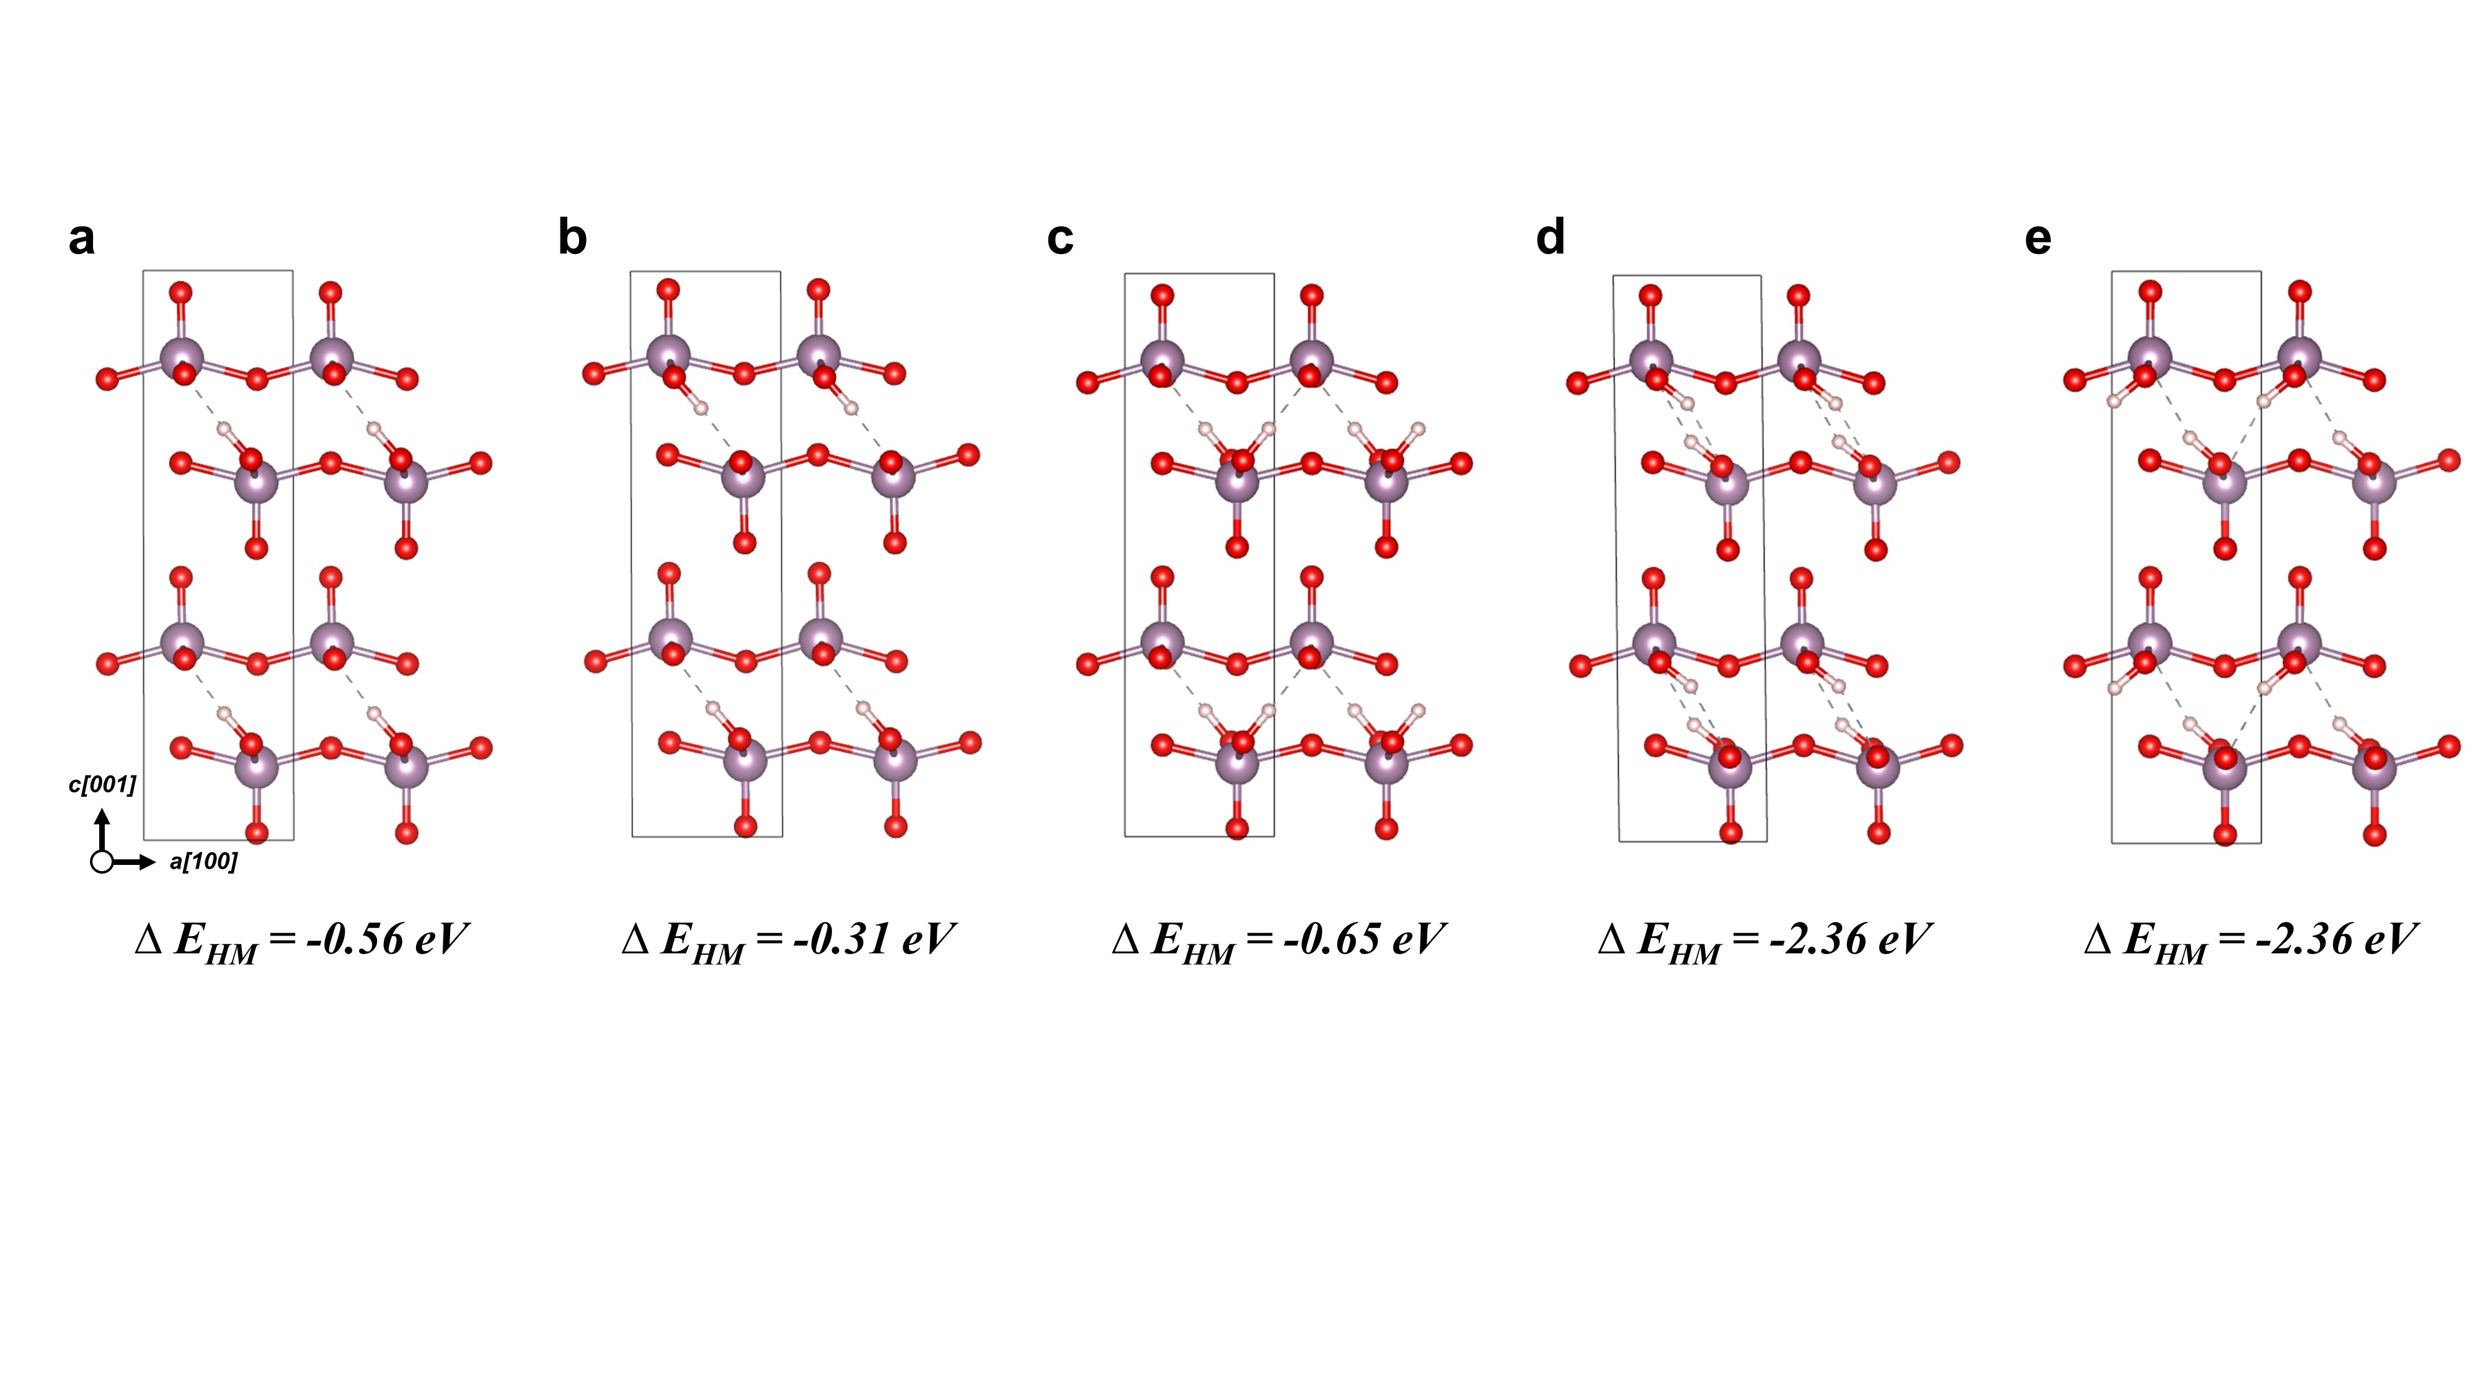
Note: Pristine MoO₃ has three different oxygen sites with O_{a}, O_{s}, and O_{t} to which where hydrogen atoms can bind. According to previous studies^{1,2}, O_{a} sites have highest binding energies and we model the hydrogenated MoO₃ (H-MoO₃) with H-O_{a} bonding. For H-MoO₃, we use twice larger unit cell in [010] direction because the ratio of H atom to Mo atom is set to 0.5. Figure S9 presents all configuration of H-MoO₃ in this study. To choose most favorable configuration, we compared the formation energies of H-MoO₃ (${ΔE}_{HM}$) by the following equations:
${ΔE}_{HM}=E\left[H_{0.5}MoO_{3}\right]-\left(E\left[MoO_{3}\right]+0.25E\left[H_{2}\right]\right)$ (1)
where the $E\left[H_{0.5}MoO_{3}\right]$, $E\left[MoO_{3}\right]$, and $E\left[H_{2}\right]$ are the total energy of H_{0.5}MoO₃, MoO₃ scaled same as to H_{0.5}MoO₃ and hydrogen molecule scaled with 0.25 for stoichiometry, respectively. We adopt the configuration in Fig. S9(e) for this study.

Supplementary Figure 10. Cyclic voltammetry (CV) curves for the first three cycles are measured between 1.5 and 3.5 V vs. Li/Li⁺ at 0.1 mV s⁻¹ of scan rate for (a) MoO₃ and (b) H-MoO₃.
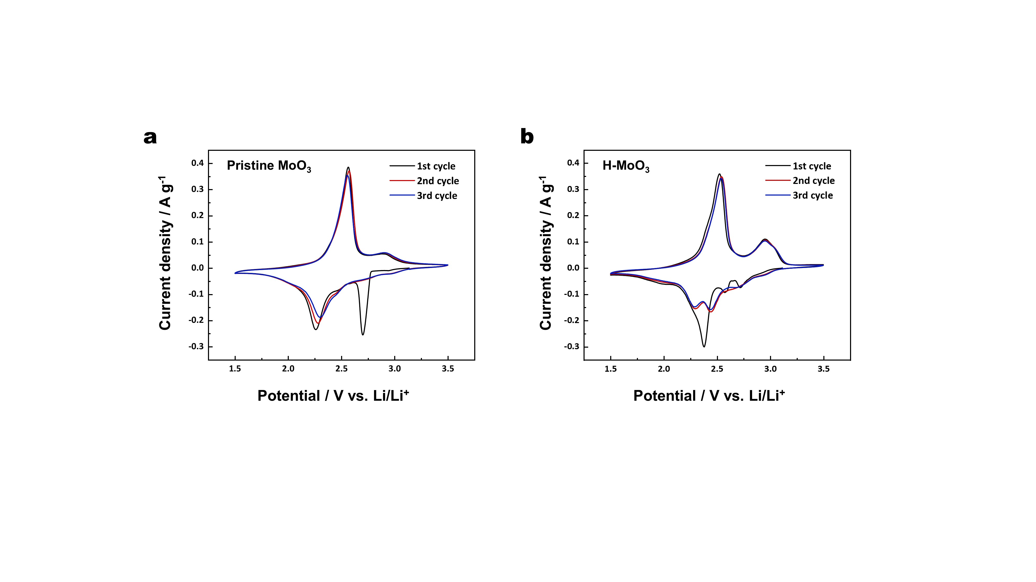

Supplementary Figure 11. Ex-situ XRD results of pristine MoO₃ and H-MoO₃ after fully lithiation (1.5 V vs. Li/Li⁺) and delithiation (3.5 V vs. Li/Li⁺).
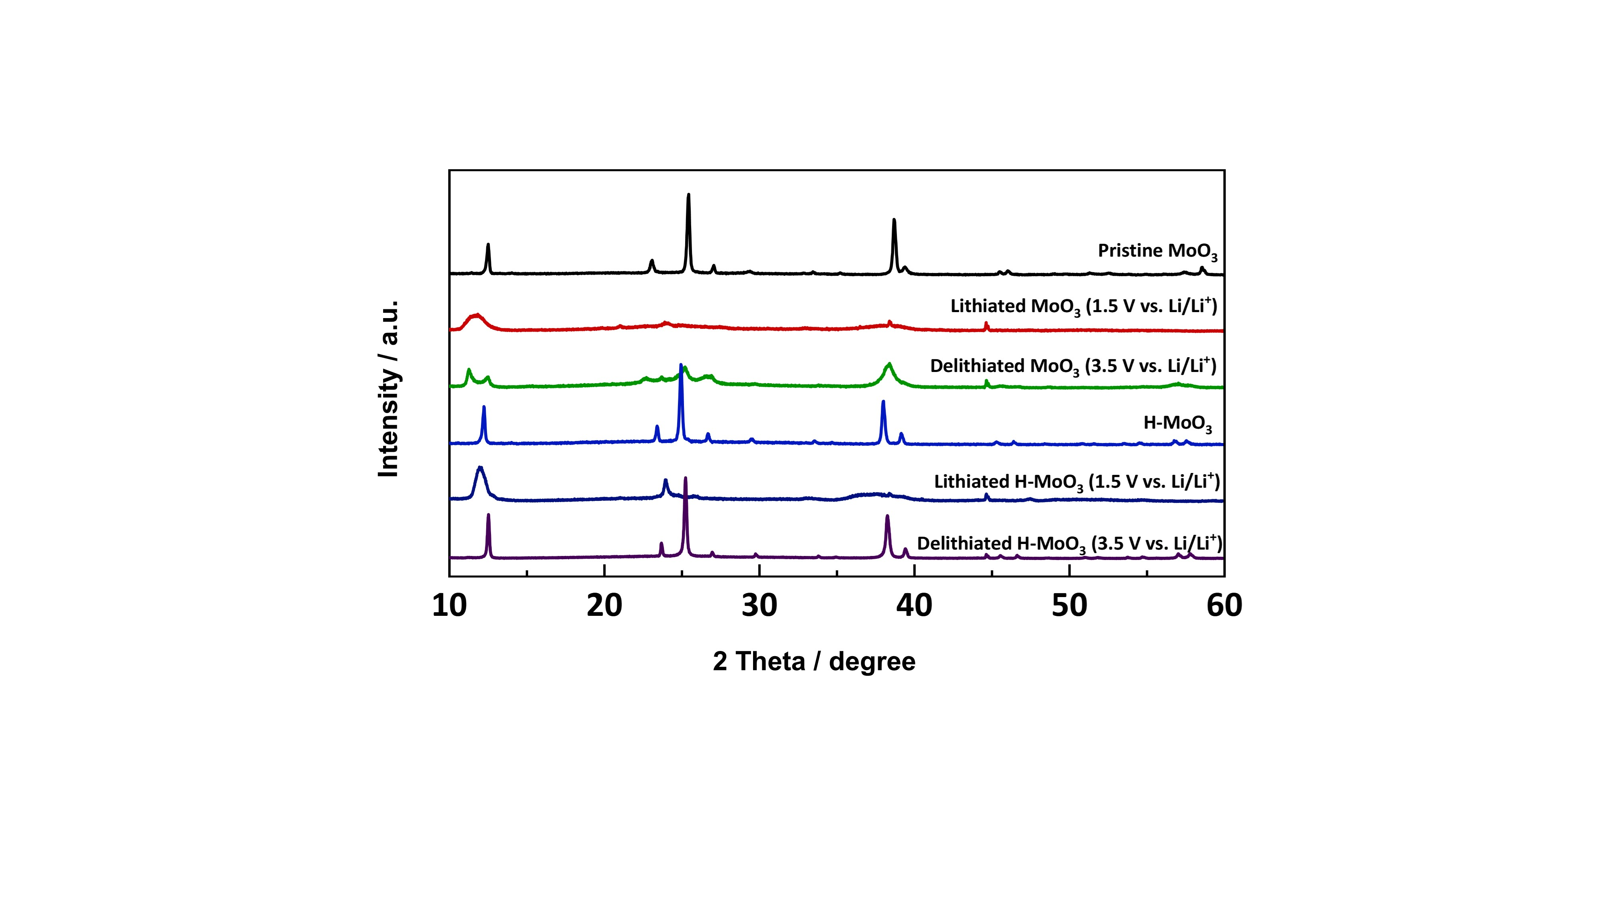

Supplementary Figure 12. Voltammetric charge/discharge plateau of (a) pristine MoO₃ and (b) H-MoO₃ measured at various scan rates of 0.1, 0.2, 0.4, 0.6, 0.8, 1.0 mV s⁻¹. The log (ʋ) versus log (i) plots for major (c) cathodic and (d) anodic peak of pristine MoO₃ and H-MoO₃: the pseudo-capacitive current density could be represented as i=aʋ^{b}, where ʋ is the specific scan rate and a b-value indicates the diffusion limited (b=0.5) and capacitive characteristics (0.5<b<1.0).
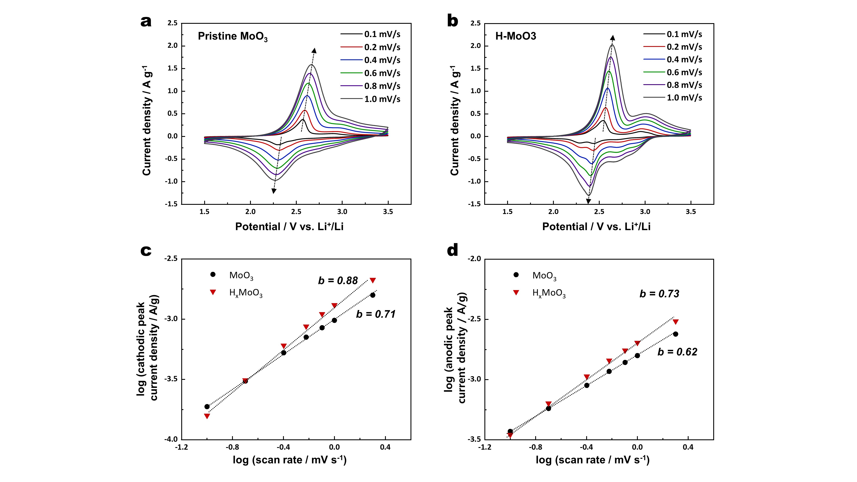
Note: The capacitive current density could be represented as i = C x dV⁄dt = C ʋ; thus, in theory, the capacitive output current increases linearly as the applied sweep rate increases. For diffusion limited cases, peak current follows the Randles-Sevcik equation, represented as i = 2.69 *10⁵ x n^{3/2}A D^{1/2} C ʋ^{1/2}, where n is number of electrode for redox reaction, A is electrode area, D is diffusion coefficient, and C is concentration; thus, diffusion-controlled output current is proportional to ʋ^{1/2}. Therefore, for the capacitor-like fast redox reaction, pseudo-capacitive output current could be represented as i =aʋ^{b}, where b-value is the indicators of ion diffusion characteristics. A b-value rounded to nearest 0.5 implies the diffusion limited cases (Randles-Sevcik eq). Meanwhile. as b-value is closed by 1.0, it represents the capacitor-like electrode behaviors. A b-value could be measured by the slope in log (ʋ) versus log (i) plot.

Supplementary Figure 13. The characteristics of the total electronic density of states (DOS) for pristine MoO₃ and H-MoO₃ obtained from DFT calculation. The density of states calculation shows the advent of donor level energy state after the hydrogenation. The Fermi-level consequently shifts up, resulting in enhanced electronic properties of H-doped MoO₃.
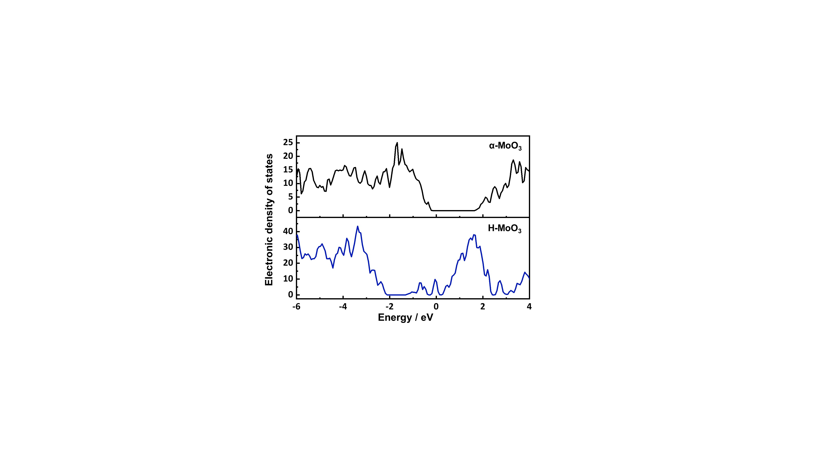

Supplementary Figure 14. Configurations of pristine MoO₃ containing one Li atom at (a) inter-layer and (b) intra-layer site.
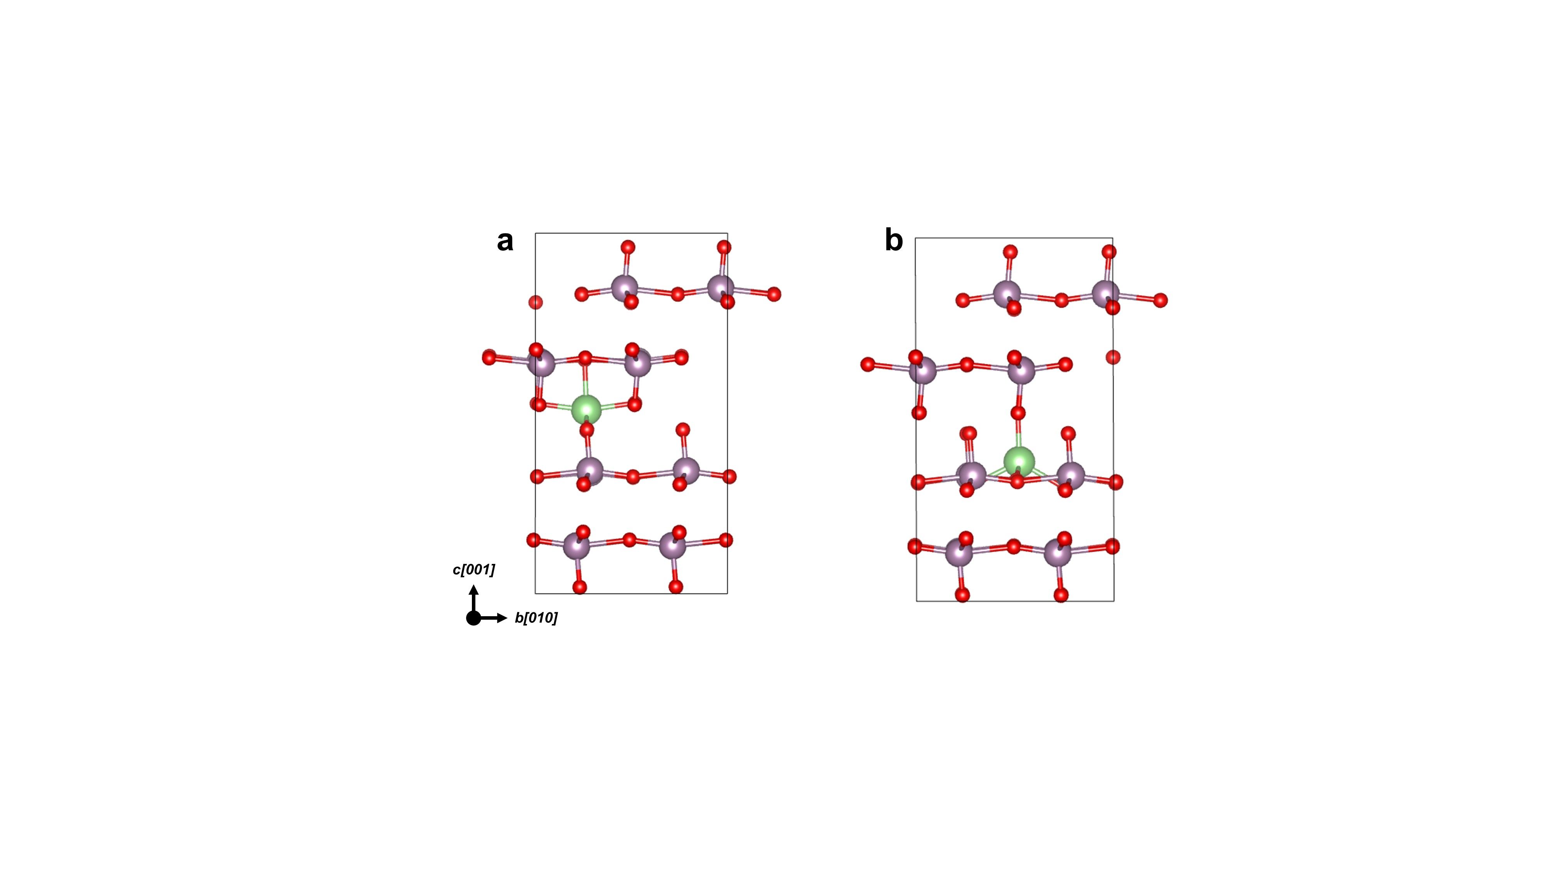
Note: Through the formation energies calculation of lithiated pristine MoO₃, it is confirmed that Li ion could be located into the inter-layer site, surrounded by terminal oxygen, and intra-layer site, adjacent to symmetric and asymmetric oxygen, respectively. After establishing the accomodatable sites for Li-ion, the energy barrier along the predicted Li diffusion pathways through the bulk MoO₃ lattice are calculated by the NEB approaches as shown in Fig. S17 and Table S3, 4.

Supplementary Figure 15. Configurations of H-MoO₃ containing one Li atom at (a) inter-layer*, (b) inter-layer, (c) intra-layer and (d) intra-layer* sites. * Mark represents the lithiation sites derived by proton interferences inducing lattice disorder.
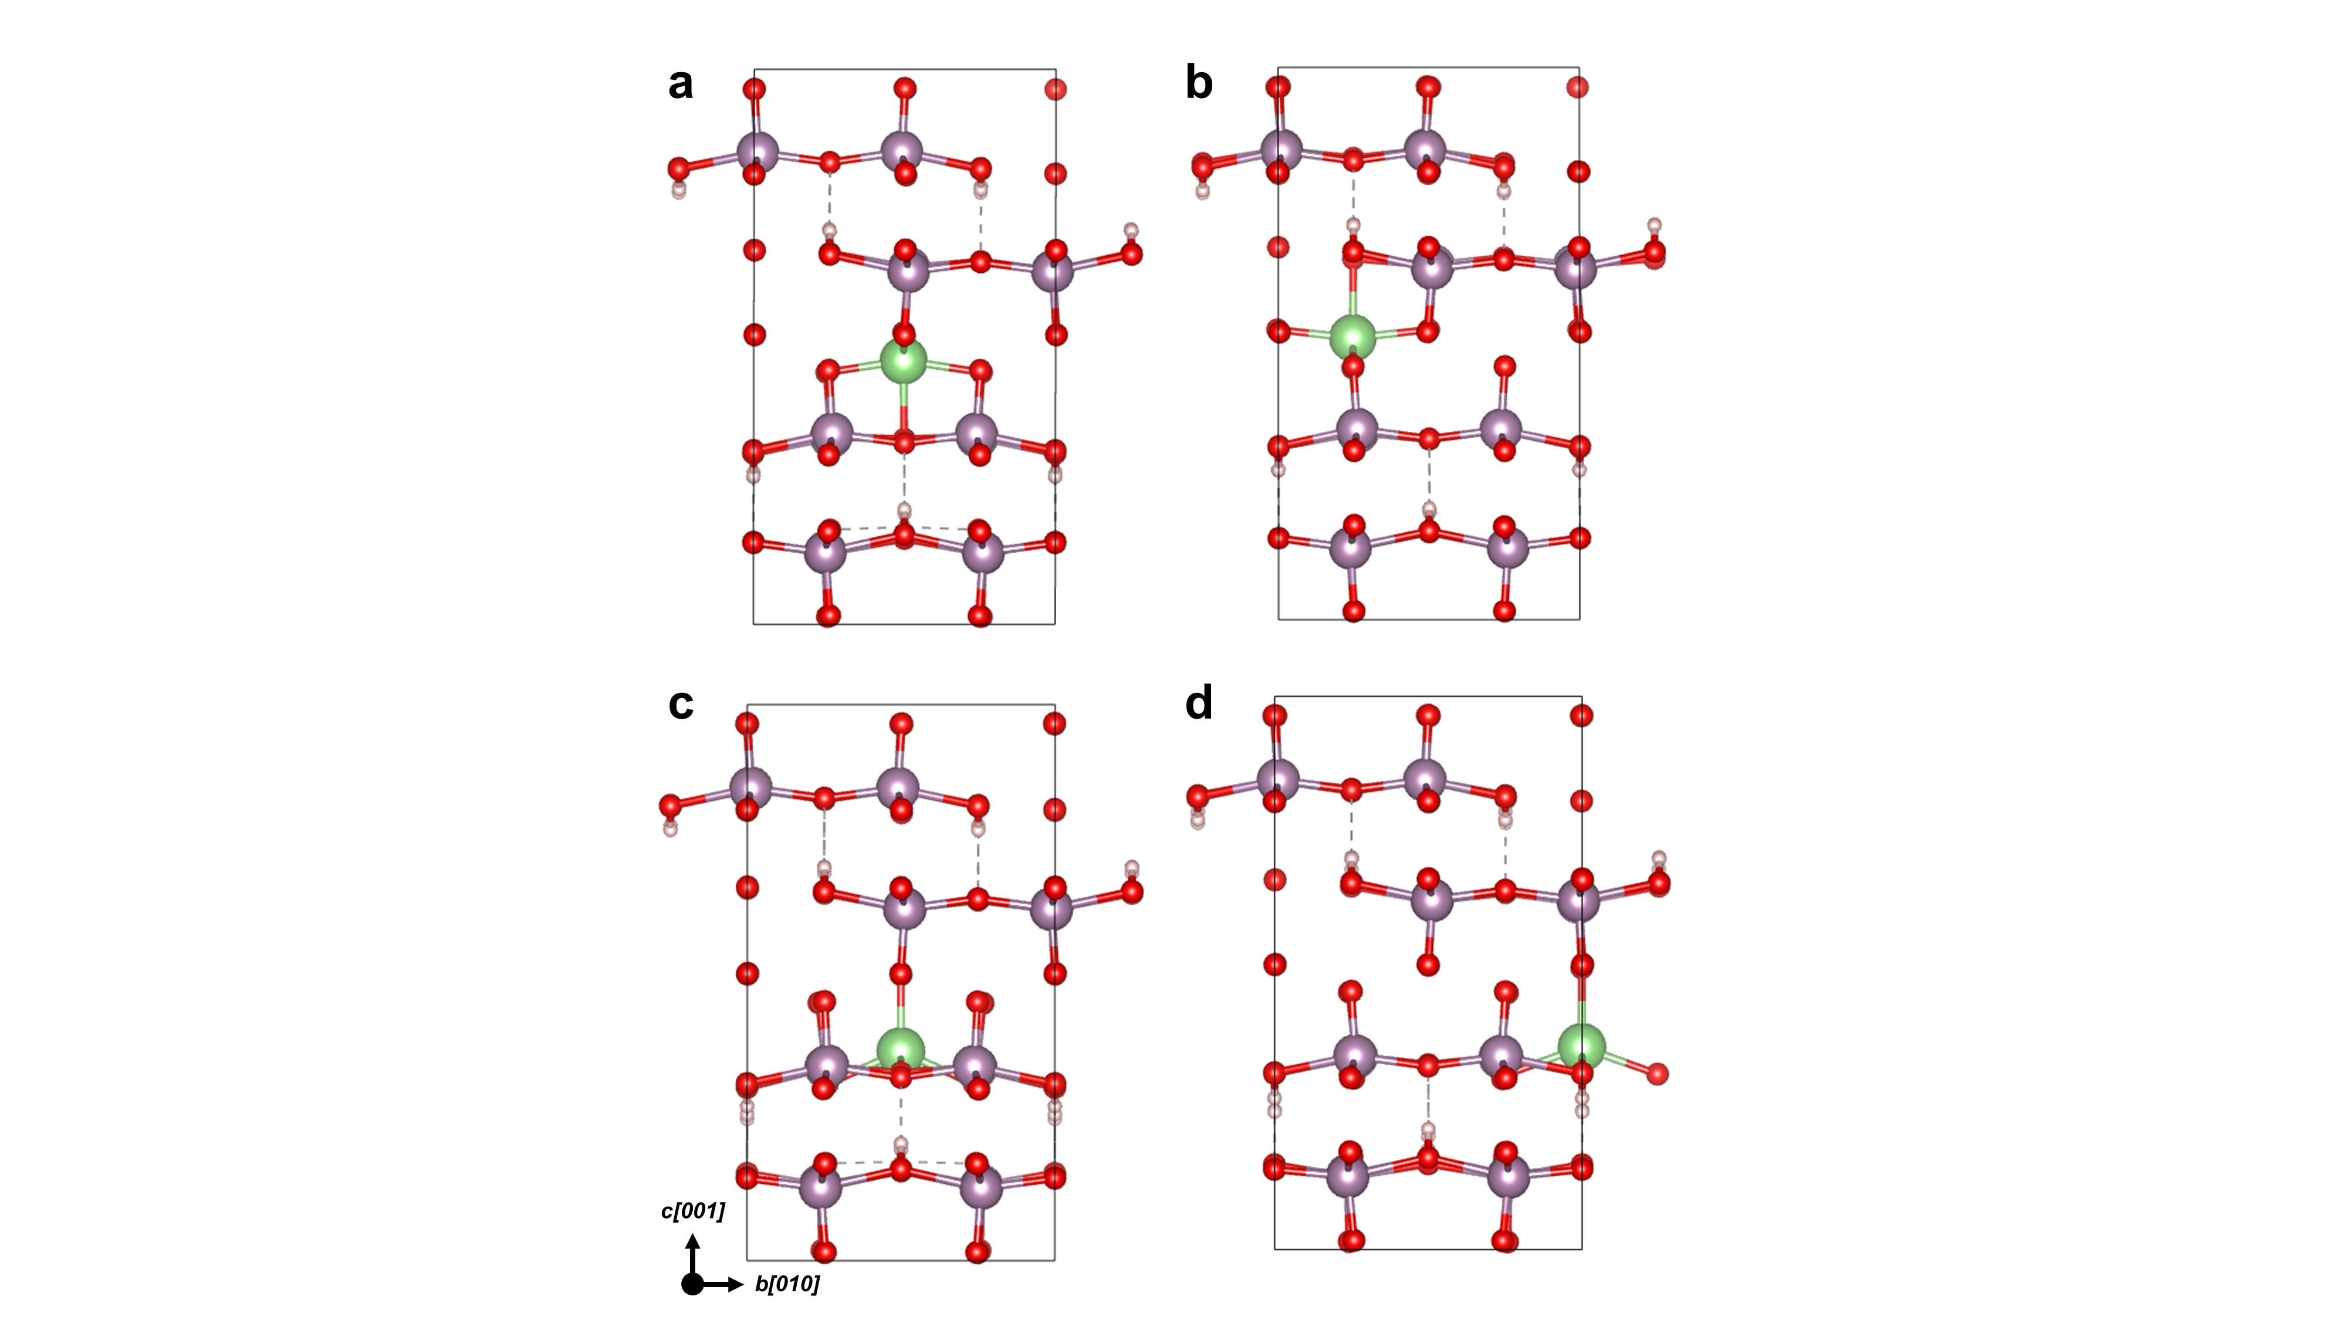
Note: In comparison to the pristine MoO₃, formation energy of both inter- and intra-layer splits into the two different states, respectively, resulting in totally four cases having distinctive formation energy state of lithiated H-MoO₃ due to the asymmetric lattice. After establishing the accomodatable sites, the energy barrier along the predicted Li diffusion pathways through the bulk H-MoO₃ lattice are calculated by the NEB approaches as shown in Fig. S18 and Table S3, 4.

Supplementary Figure 16. Angle-resolved x-ray photoelectron spectroscopy (ARXPS) of H-MoO₃ measured at varied photoelectron tilt angles from zero to 70º.
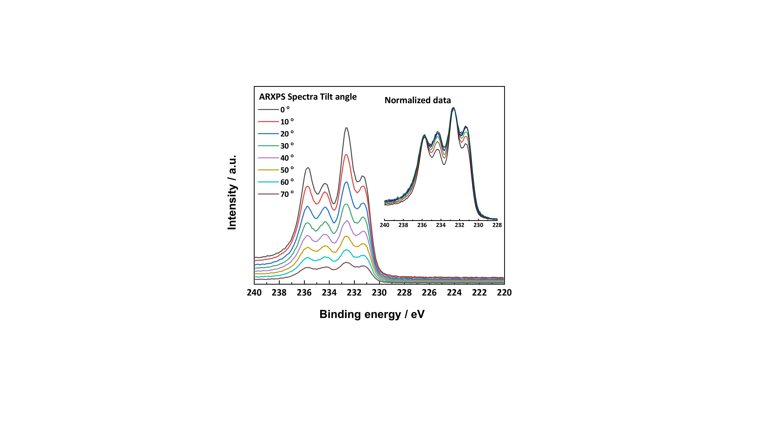

Supplementary Figure 17. Calculated energy barriers and pathways for Li diffusion in pristine MoO₃.
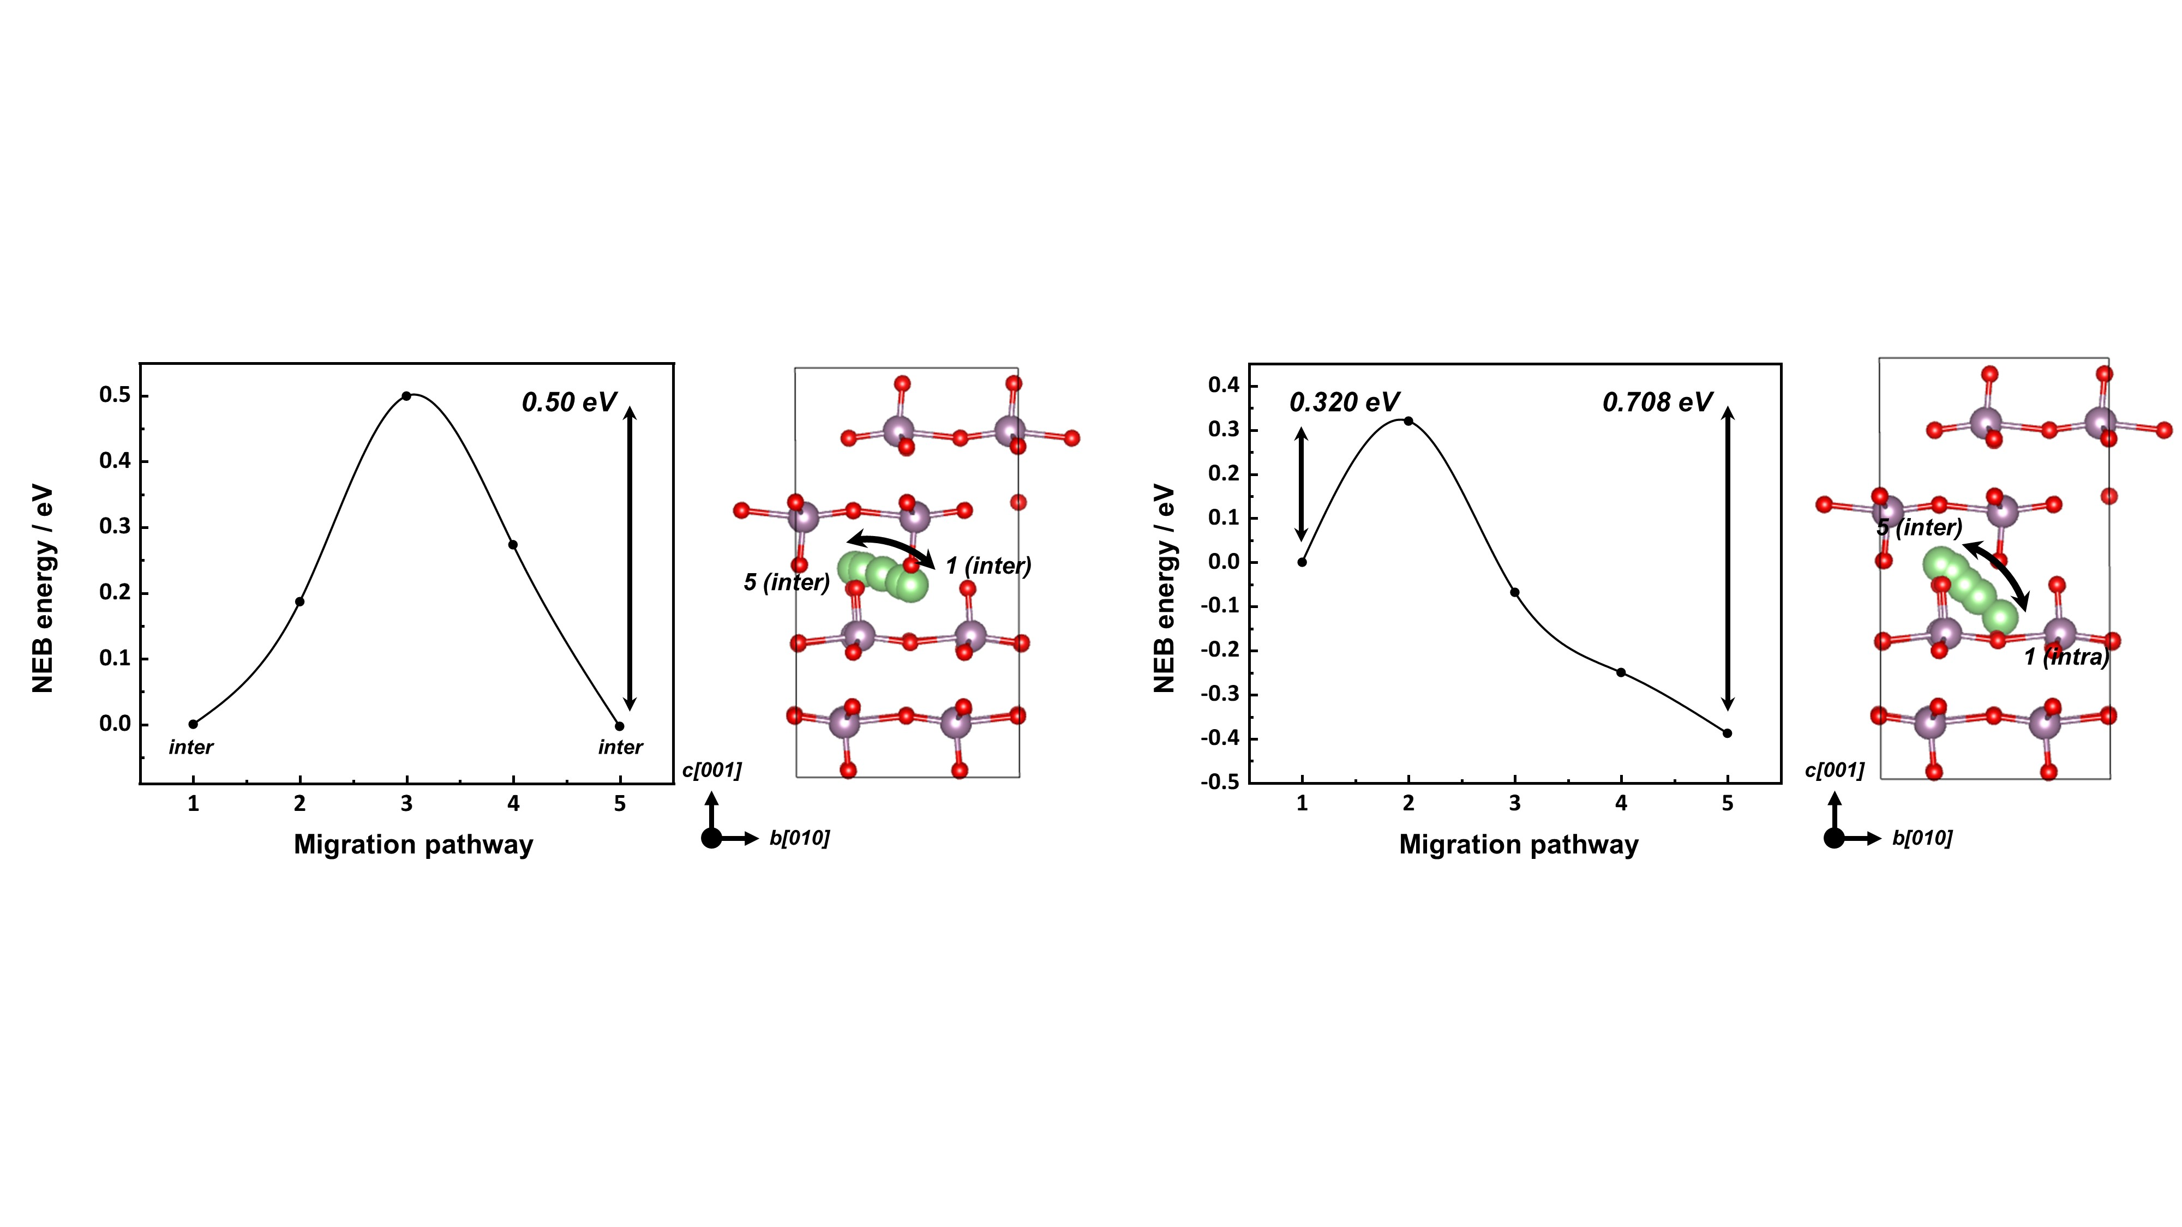
Note: The NEB results show the two probable Li ion diffusion pathways. A point of initial and final sites of diffusion pathways are originally set up by Li-ion accomodatable sites which were established by formation energy calculation of lithiated MoO₃. Considering the irreversibility of intercalated Li-ion on intra-layer site, it is expected that Li ion would diffuse into the bulk MoO₃ along the adjacent inter-layer sites during lithiation process as depicted in Fig. 4d. Therefore, it is expected that the inter-layer pathway exhibiting an energy barrier of 0.5 eV would be bottleneck energy barrier for Li-ion diffusion through into the bulk MoO₃.

Supplementary Figure 18. Calculated energy barriers and pathways for Li diffusion in H-MoO₃.
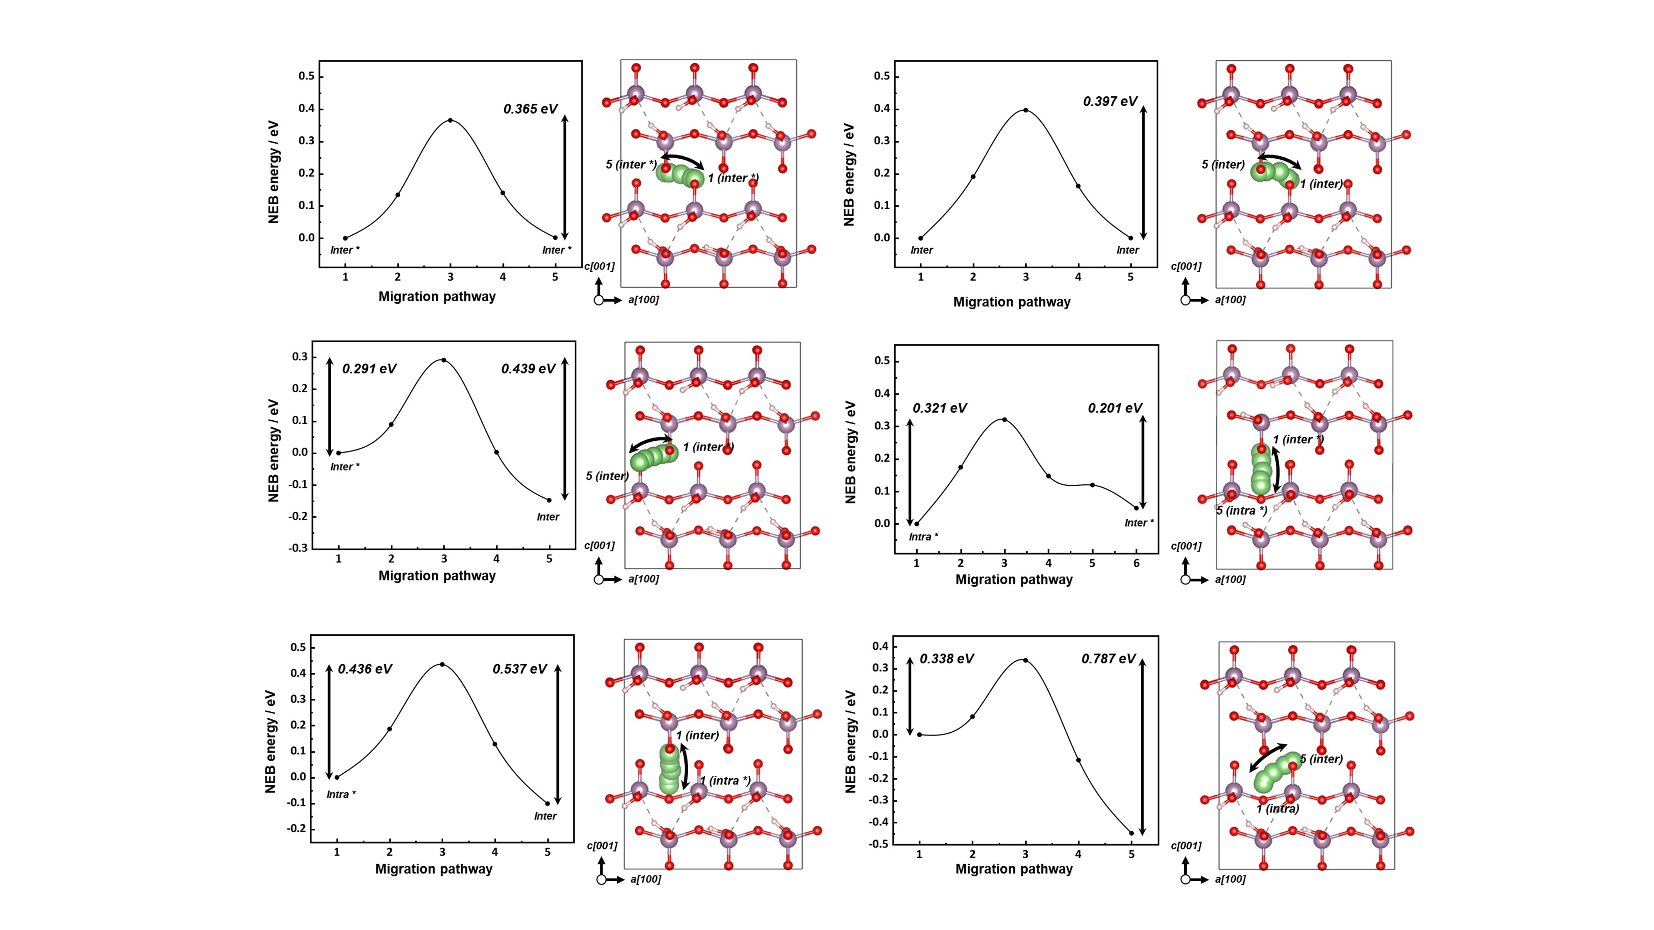
Note: Due to the lattice disorder and formation energy division, there are more diverse Li ion diffusion pathways in case of H-MoO₃. Initial and final sites were established by four different Li-ion accomodatable sites of lithiated H-MoO₃ as represented at Fig. S15. It is confirmed that the energy barrier along the most stable sites (inter-layer) exhibits the energy barrier of 0.397 eV as shown in Fig. 4d, which value is lower than that of pristine MoO₃. It implies that energy barrier of rate determining steps for Li ion diffusion through the bulk regions decreased after proton adoption.

Supplementary Table S1. Optimized structural parameters of pristine MoO₃ from DFT calculation with PBE, optB88b, optB86b, D2 and D3 methods for vdW interaction compared with previous experimental results.
Methods | a (Å) | b (Å) | c (Å) | $Δ$d (Å) | Band gap  (eV) | vdW gap (Å) | $Δ$H_{f} (eV)
PBE | 3.693 | 3.888 | 13.286 | 0.425 | 2.004 | 0.458 | 7.811
optB88b | 3.710 | 3.915 | 13.950 | 0.429 | 1.919 | 0.725 | 8.779
optB86b | 3.700 | 3.908 | 13.935 | 0.430 | 1.946 | 0.741 | 8.448
D2 | 3.688 | 3.915 | 13.904 | 0.452 | 2.049 | 0.708 | 7.916
D3 | 3.682 | 3.938 | 14.188 | 0.477 | 2.084 | 0.764 | 8.022
Exp³⁻⁶. | 3.697 | 3.963 | 13.860 | 0.52 | 2.2 | 0.80 | 7.76
Note: Table S1 displays the structural parameters of pristine MoO₃ after the optimization. As the bulk pristine MoO₃ is stabilized by van der Waals (vdW) interactions between interlayers, we adopt and compare the various vdW corrections including optB88b, optB86b, D2, and D3 corrections. Here, the a, b, and c are the lattice parameters in [100], [010], and [001] directions, respectively. The $Δd$, vdW gap, and $ΔH_{f}$ are the bond length difference between the Mo and two neighboring O_{a}, the perpendicular distance between two adjacent MoO₃ interlayers, and the formation energy of bulk pristine MoO₃, respectively. The $ΔH_{f}$can be defined as
${ΔH}_{f}=-(E\left[MoO_{3}\right]-E\left[Mo\right]-3/2E\left[O_{2}\right])$ (2)
where the $E\left[MoO_{3}\right]$, $E\left[Mo\right]$, and $E\left[O_{2}\right]$ are the total energy of bulk pristine MoO₃, per atom energy of solid Mo metal, and per atom energy of oxygen molecule, respectively. Among the parameters, we regard the $Δd$, band gap, and vdW gap as pivotal parameters to study the energetics of Li diffusion in MoO₃ structures and thus choose the GGA with D3 vdW correction for overall DFT calculation.
Supplementary Table S2. Formation energies of Li-containing pristine MoO₃ and H_{0.5}MoO₃ at inter- and intra-layer sites.
 | Li-MoO₃ |  | Li-H_{0.5}MoO₃
Site | intra | Inter | Intra | Intra * | Inter * | Inter
ΔH_{f} (eV) | -1.648 | -2.026 | -1.246 | -1.593 | -1.548 | -1.696

Supplementary Table S3. NEB energies for Li diffusion through inter-layer to inter-layer in MoO₃ and H_{0.5}MoO₃.
position | Inter to inter  (pristine MoO₃) (eV) | Inter * to inter *  (H-MoO₃) (eV) | Inter to inter  (H-MoO₃) (eV) | Inter to inter *  (H-MoO₃) (eV)
1 | 0.0000 | 0.0000 | 0.0000 | 0.0000
2 | 0.1866 | 0.1345 | 0.1908 | 0.0895
3 | 0.4997 | 0.3654 | 0.3968 | 0.2909
4 | 0.2733 | 0.1407 | 0.1618 | 0.0027
5 | -0.0032 | 0.0018 | 0.0005 | -0.1477

Supplementary Table S4. NEB energies for Li diffusion through intra-layer to inter-layer in MoO₃ and H_{0.5}MoO₃
position | Intra to inter  (pristine MoO₃) (eV) | Intra * to inter *  (H-MoO₃) (eV) | Intra * to inter  (H-MoO₃) (eV) | Intra to inter *  (H-MoO₃) (eV) | Intra to inter  (H-MoO₃) (eV)
1 | 0.0000 | 0.0000 | 0.0000 | 0.0000 | 0.0000
2 | 0.3202 | 0.1743 | 0.1871 | 0.0673 | 0.0819
3 | -0.0683 | 0.3207 | 0.4363 | 0.3495 | 0.3382
4 | -0.2502 | 0.1473 | 0.1287 | -0.0922 | -0.1157
5 | -0.3881 | 0.1196 | -0.1011 | -0.3008 | -0.4485
6 |  | 0.0484

References
1 Wu, Y. et al. Chemical switching of low-loss phonon polaritons in alpha-MoO(3) by hydrogen intercalation. Nat Commun 11, 2646 (2020). https://doi.org:10.1038/s41467-020-16459-3
2 Sha, X., Chen, L., Cooper, A. C., Pez, G. P. & Cheng, H. Hydrogen absorption and diffusion in bulk α-MoO3. The Journal of Physical Chemistry C 113, 11399-11407 (2009).
3 Molina-Mendoza, A. J. et al. Centimeter-Scale Synthesis of Ultrathin Layered MoO3 by van der Waals Epitaxy. Chemistry of Materials 28, 4042-4051 (2016). https://doi.org:10.1021/acs.chemmater.6b01505
4 Deb, S. K. & Chopoorian, J. A. Optical Properties and Color-Center Formation in Thin Films of Molybdenum Trioxide. Journal of Applied Physics 37, 4818-4825 (1966). https://doi.org:10.1063/1.1708145
5 Liu, H. et al. Huge Absorption Edge Blue shifts of Layered α-MoO3 Crystals upon Thickness Reduction Approaching 2D Nanosheets. The Journal of Physical Chemistry C 122, 12122-12130 (2018). https://doi.org:10.1021/acs.jpcc.8b03340
6 Khalate, S. A., Kate, R. S., Pathan, H. M. & Deokate, R. J. Structural and electrochemical properties of spray deposited molybdenum trioxide (α-MoO3) thin films. Journal of Solid State Electrochemistry 21, 2737-2746 (2017). https://doi.org:10.1007/s10008-017-3540-4

