Electronic Supplementary Information (ESI)

Construction of artificial metalloenzymes
by protein refolding

Guangnan Ou ^{a, b,}*, Biyan He^{c}

ª Department of Biological Engineering, Jimei University, Xiamen 361021, Fujian, China.
^{b} Fujian Provincial Key Laboratory of Food Microbiology and Enzyme Engineering, Xiamen 361021, Fujian, China.
^{c} Department of Environmental Engineering, Jimei University, Xiamen 361021, Fujian, China.

Ⅰ. General 2
Ⅱ. UV-vis absorption spectroscopy measurements 2
Ⅲ. Circular dichroism spectroscopy measurements 2
Ⅳ. Peroxidase activity assay 3
Fig. S1 DichroWeb fitting for BSA with a NRMSD value of 0.018. 3
Fig. S2 DichroWeb fitting for Hem+BSA with a NRMSD value of 0.018. 4
Fig. S3 DichroWeb fitting for rnBSA with a NRMSD value of 0.021. 4
Fig. S4 DichroWeb fitting for Hem-BSA with a NRMSD value of 0.018. 5
Fig. S5 The initial rate of oxidation of guaiacol catalyzed by Hem+BSA. 6
Fig. S6 The initial rate of oxidation of guaiacol catalyzed by Hem-BSA. 6
Fig. S7 Lineweaver–Burk plots of the double reciprocal of the Michaelis-Menten equation of Hemin 6
References 7

Ⅰ. General
Horseradish peroxidase, hemin, and guaiacol were purchased from Sigma-Aldrich. BSA was purchased from China National Pharmaceutical Group Co., Ltd. (Sinopharm). All other chemicals and reagents were of analytical grade.

Ⅱ. UV-vis absorption spectroscopy measurements
The UV-vis absorption spectra were obtained using an UNICO 2800 UV-vis spectrophotometer equipped with a thermostated cell holder.

Ⅲ. Circular dichroism spectroscopy measurements
Circular Dichroism (CD) measurements were carried out on an Applied Photophysics (UK) (Model: CIRASCAN) spectropolarimeter equipped with a Peltier temperature controller. All the CD measurements were performed at 25℃ with an accuracy of ± 0.1℃. Spectra were collected with a scan speed of 200 nm min⁻¹ and with a spectral bandwidth of 1 nm. Each spectrum was the average of two scans. Secondary structure (Far-UV CD) was measured over the wavelength range of 190-250 nm using a 0.1 cm path length cuvette. Phosphate buﬀer solutions were subtracted from all the measurements. The results were expressed as mean residue ellipticity (MRE) in deg cm² dmol⁻¹ which is deﬁned as
$$MRE=\frac{θ_{obs}\left(mdeg\right)M}{nlC}$$
where θ_{obs} is the CD in millidegrees, M is molecular weight of the protein in g/dmol, n is the number of amino acid residues (583 in the case of BSA), l is the path length (0.1 cm) of the cuvette, and C is the concentration of the protein in g/L.
The quantitative determination of helix, sheet, and other secondary structure contents of proteins based on their CD spectra was calculated on analysis website, DichroWeb (located at: http://dichroweb.cryst.bbk.ac.uk) using CONTINLL as the algorithm with ridge regression methods and dataset 7.[1]
The “goodness-of-fit” parameter is the Normalised Root Mean Squared Deviation (NRMSD), which provides a means of evaluating the difference between the experimental and calculated spectra. It is defined as:
$$NRSD=\sqrt{\frac{\sum_{λ}{{(θ_{exp}-θ_{calc})}^{2}}}{\sum_{λ}{{(θ_{calc})}^{2}}}}$$
where θ_{exp} and θ_{calc} are the experimental and back-calculated ellipticities, respectively, at each data point in the spectrum, with lower values indicating a closer match between experimental and reference data. NRMSD values for analyses using CONTINLL would be a very good fit if the NRMSD values are less than 0.03.[2]

Ⅳ. Peroxidase activity assay
Peroxidase activity was measured by following the H₂O₂-dependent oxidation of guaiacol at 470 nm. Guaiacol stock solutions (1.0 mmol/L) were prepared by dissolving guaiacol in 0.1 mol/L buffer. H₂O₂ stock solutions (150 mmol/L) were prepared daily by appropriate dilution of 30% H₂O₂ in distilled water. The assay was performed by mixing 500 μL guaiacol stock solutions with 15 μL of catalyst solution (final concentration 1.0 μmol/L). In the case of temperature dependence experiments, the mixture was then incubated at the designated temperature for 10 min. The reaction was started by adding 15 μL of 150 mmol/L H₂O₂. The initial velocity (v₀) of the oxidation of guaiacol was determined from linear plotting of the absorbance versus time, using an extinction coefficient of 2.66×10⁴ (mol/L)⁻¹/cm for guaiacol-derived oxidation product.
All assays were carried out at room temperature except the temperature dependence experiments using a UV-Vis spectrophotometer (Unico, UV2800) which cell was connected to a thermostat.

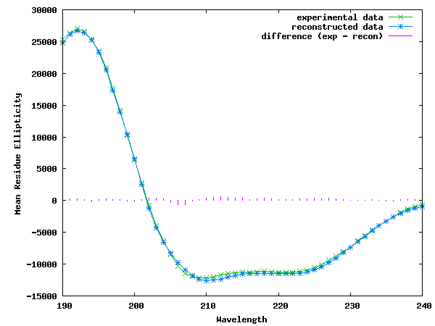

Fig. S1 DichroWeb fitting for BSA with a NRMSD value of 0.018.

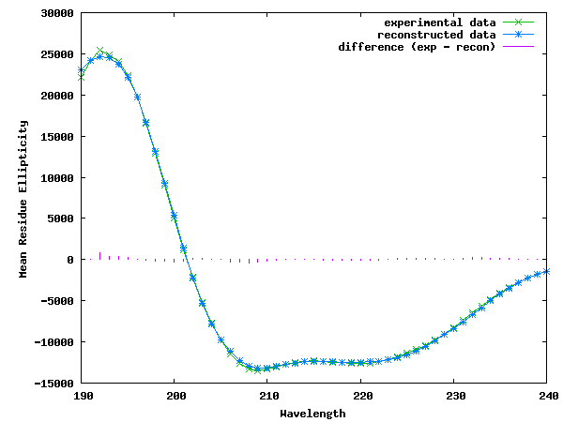

Fig. S2 DichroWeb fitting for Hem+BSA with a NRMSD value of 0.018.

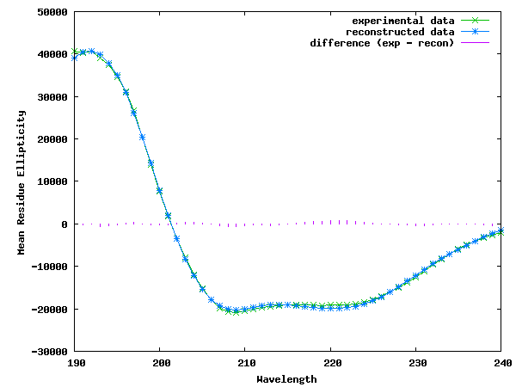

Fig. S3 DichroWeb fitting for rnBSA with a NRMSD value of 0.021.

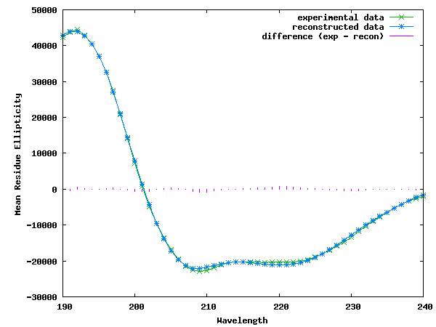

Fig. S4 DichroWeb fitting for Hem-BSA with a NRMSD value of 0.018.

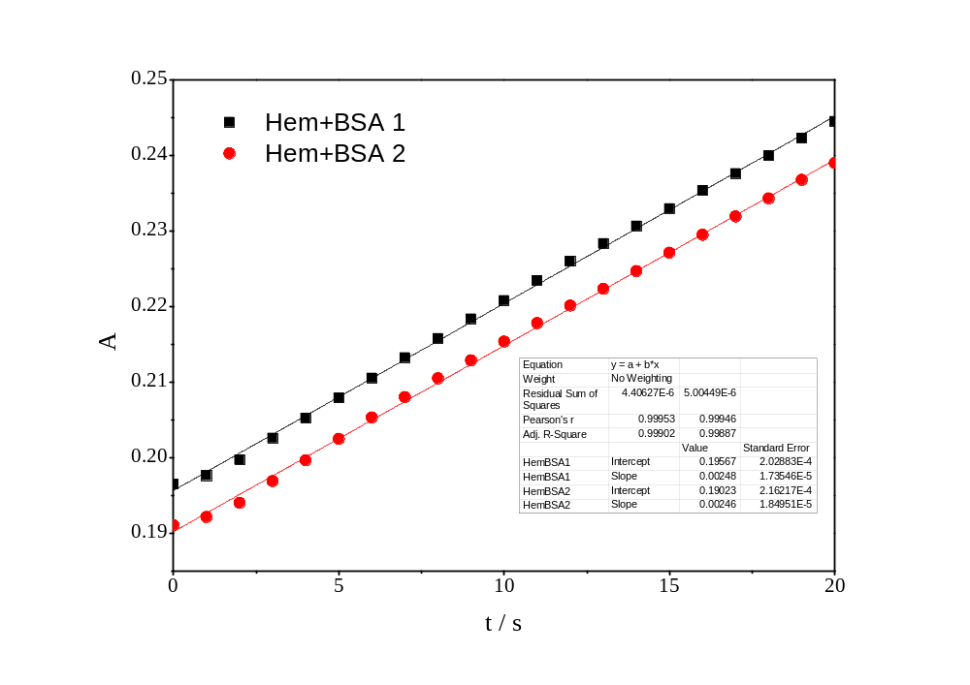

Fig. S5 The initial rate of oxidation of guaiacol catalyzed by Hem+BSA.
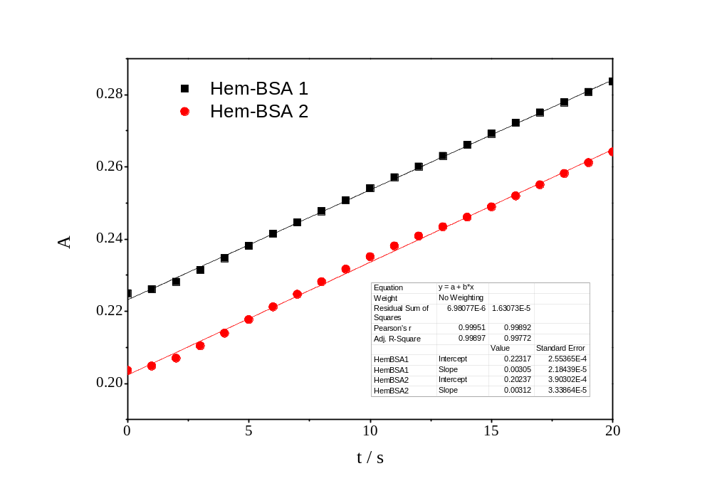

Fig. S6 The initial rate of oxidation of guaiacol catalyzed by Hem-BSA.
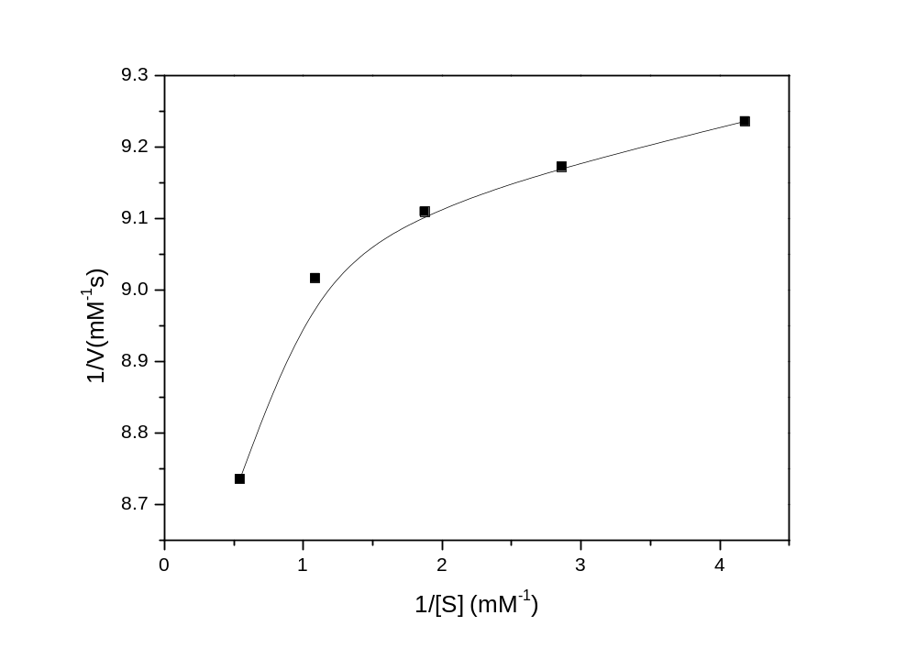

Fig. S7 Lineweaver–Burk plots of the double reciprocal of the Michaelis-Menten equation of Hemin

References
- N. Sreerama, R.W. Woody, Anal. Biochem., 2000, 287, 252-260.
- A. J. Miles, S. G. Ramalli, B. A. Wallace, Protein Sci., 2022, 31, 37-46.

