Graphical Abstract

Construction of artificial metalloenzymes by protein refolding
Guangnan Ou *, Biyan He
Jimei University 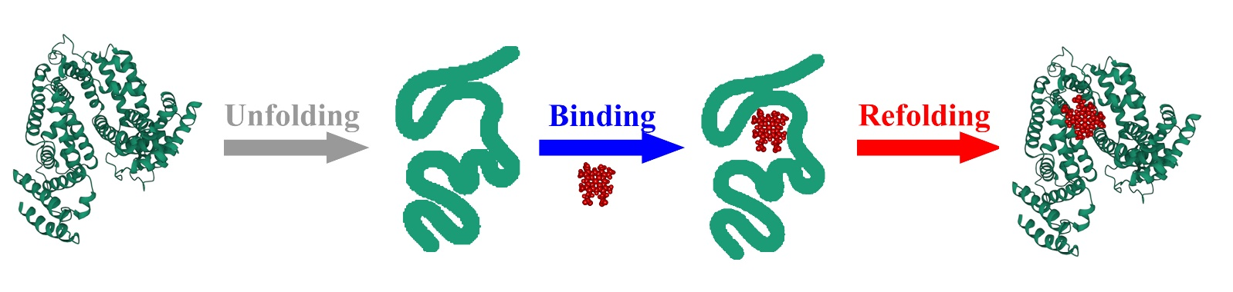
Hemins were packed into the inside of bovine serum albumin by protein refolding. The as-prepared artificial hemeprotein exhibited peroxidase-like activities with an optical pH at pH 7.0 and an optical temperature at 65°C. The artificial hemeprotein has much more affinity to the guaiacol than HRP, and has lower guaiacol oxidation efficiency than HRP.

