Supplementary Information
Array-based specific classification of bacterial species via the redox state transition of riboflavin
Xizhe Li#, Pengxin Xue#, Bingyu Li, Ruirui Liu, Tao Fu, Jie Gao*, Lianbing Zhang*, and Yayan Wu*

Table of Contents

1. Bacterial information
2. UV-Vis spectra for 14 bacteria and bacterial mixtures discrimination.
3. Discrimination of G- and G+ bacteria (OD₆₀₀=0.1)
4. Discrimination of bacterial mixtures (OD₆₀₀=0.1)
5. Table of colorimetric and fluorometric response pattern for PCA and LDA

1. Bacterial information
Table S1. Details of bacteria used in this study.
No | Name of pathogens | abbr | Gram straining | Strain
1 | Escherichia coli | E. coli | negative | CMCC(B)44102
2 | Shigella flexneri | S. flexneri | negative
3 | Enterobacter sakazakii | E. sakazakii | negative
4 | Pseudomonas aeruginosa | P. aeruginosa | negative
5 | Salmonella paratyphi | S. paratyphi | negative
6 | Escherichia coli BL21 | E. coli BL21 | negative | BL21
7 | Staphylococcus aureus | S. aureus | positive
8 | Enterococcus faecalis | E. faecalis | positive
9 | Staphylococcus epidermidis | S. epidermidis | positive
10 | Bacillus aceticus | B. aceticus | positive
11 | Bacillus subtilis | B. subtilis | positive
12 | Listeria monocytogenes | L. monocytogenes | positive
13 | Streptococcus pneumoniae | S. pneumoniae | positive
14 | Hemolytic streptococcus | H. streptococcus | positive

2. UV-Vis spectra for 14 bacteria and bacterial mixtures discrimination.
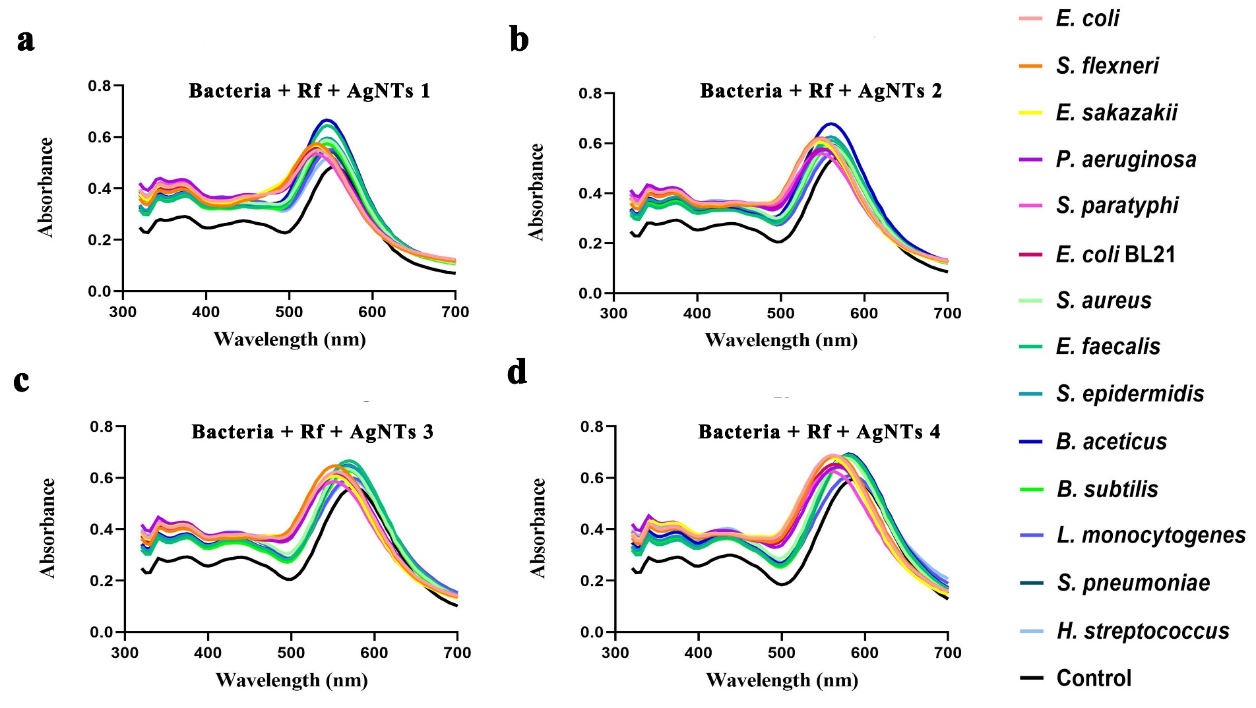
Figure S1. UV-Vis spectra of sensor arrays with 14 bacteria (OD₆₀₀=0.1).
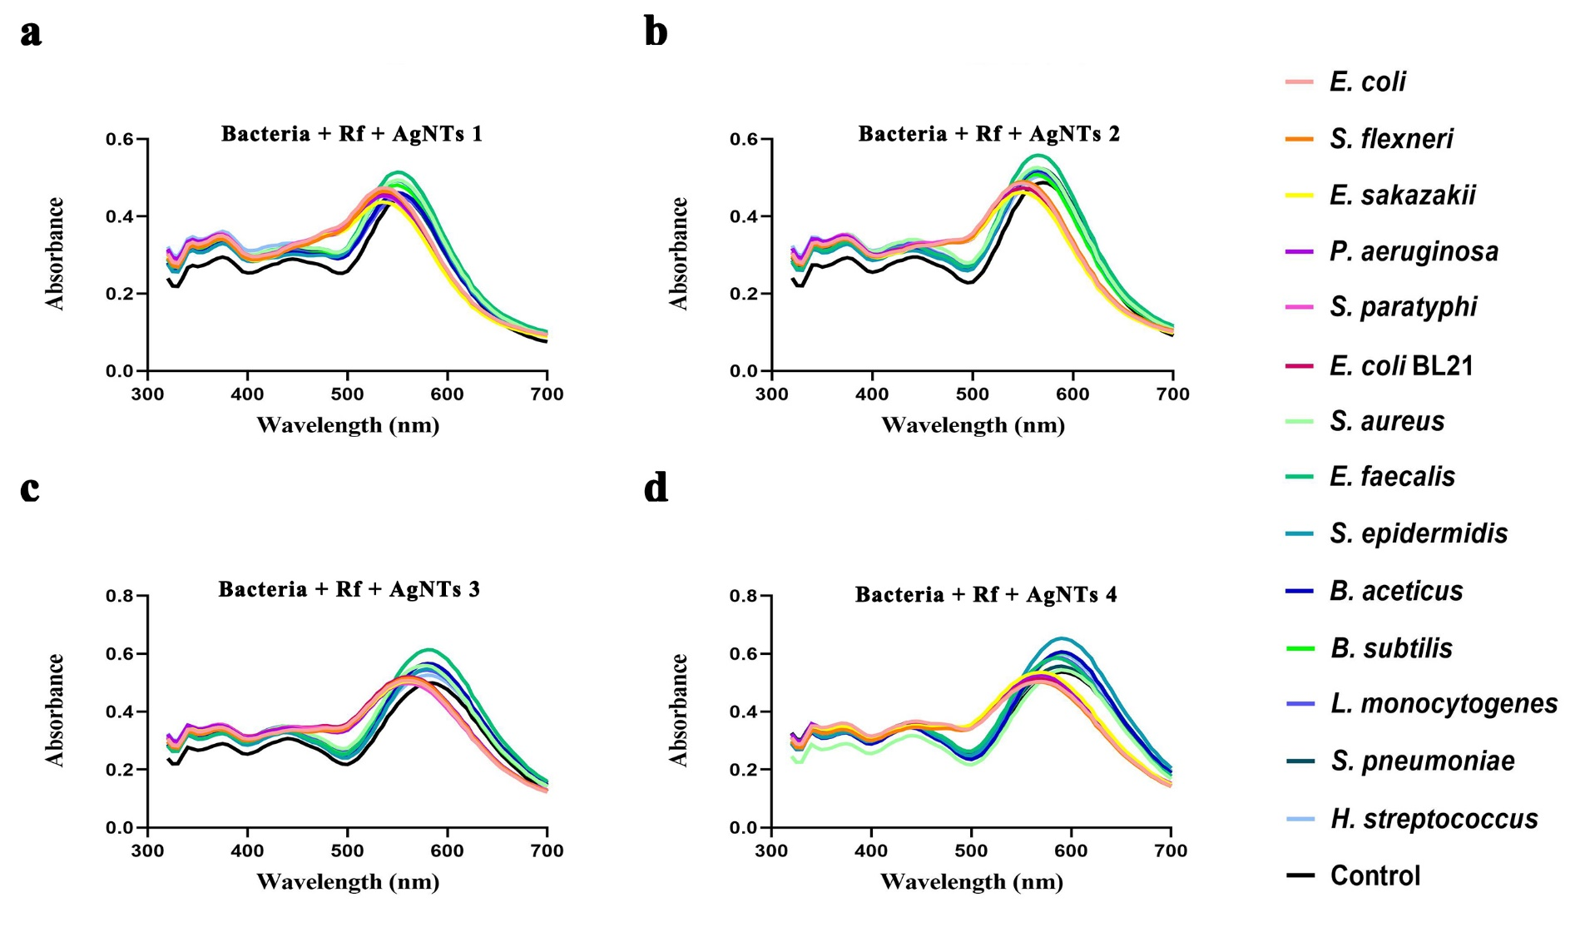
Figure S2. UV-Vis spectra of sensor arrays with 14 bacteria (OD₆₀₀=0.05).
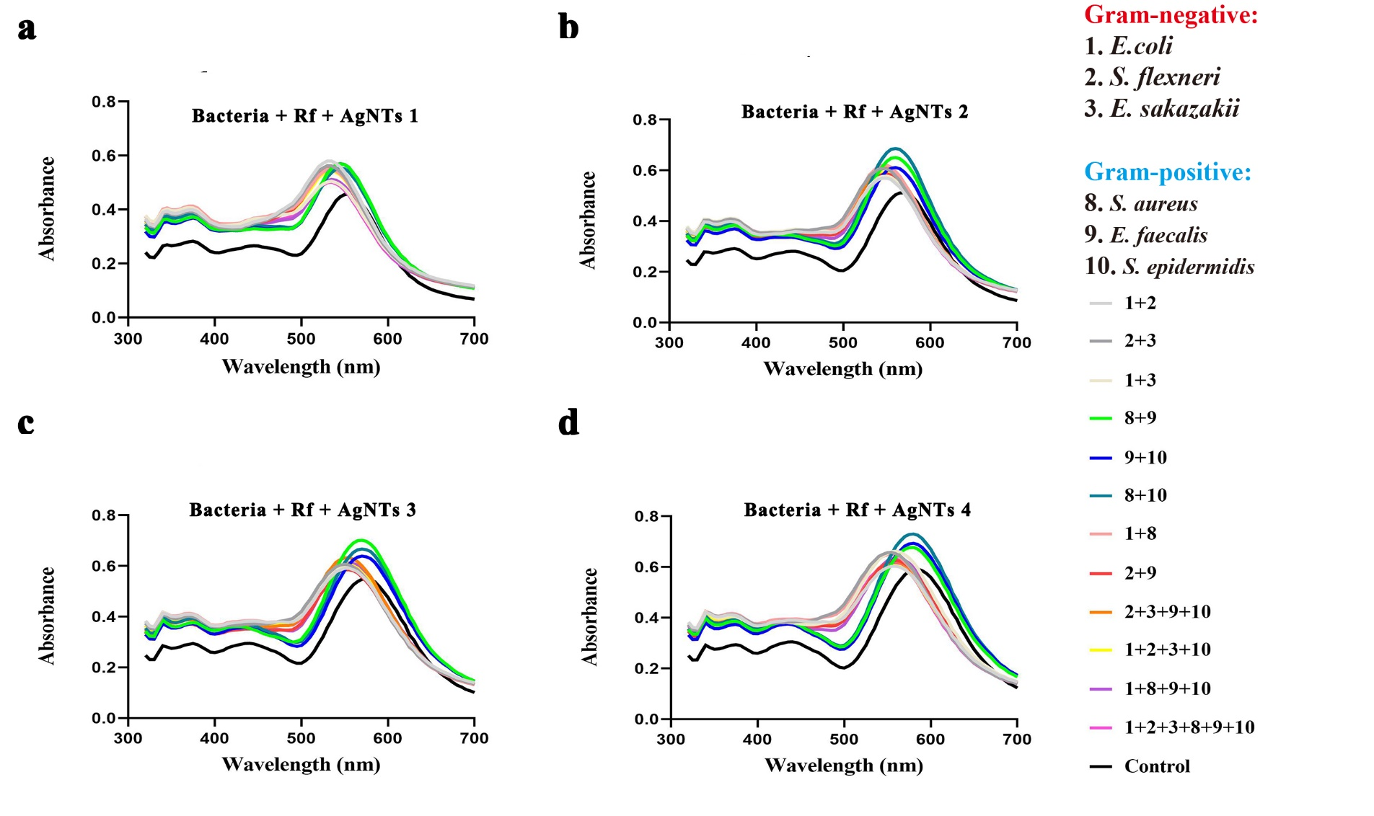
Figure S3. UV-Vis spectra of sensor arrays with 12 bacterial mixtures (OD₆₀₀=0.1).
3. Discrimination of G- and G+ bacteria (OD₆₀₀=0.1).
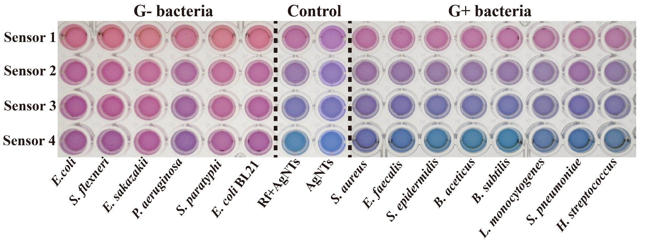
Figure S4. Representative photograph of the sensor array response against 14 bacteria including 6 G- and 8 G+ bacteria (OD₆₀₀=0.1). 100 μL bacteria was incubated with 10 μL Rf (0.5 mM) and then 90 μL AgNTs was added.
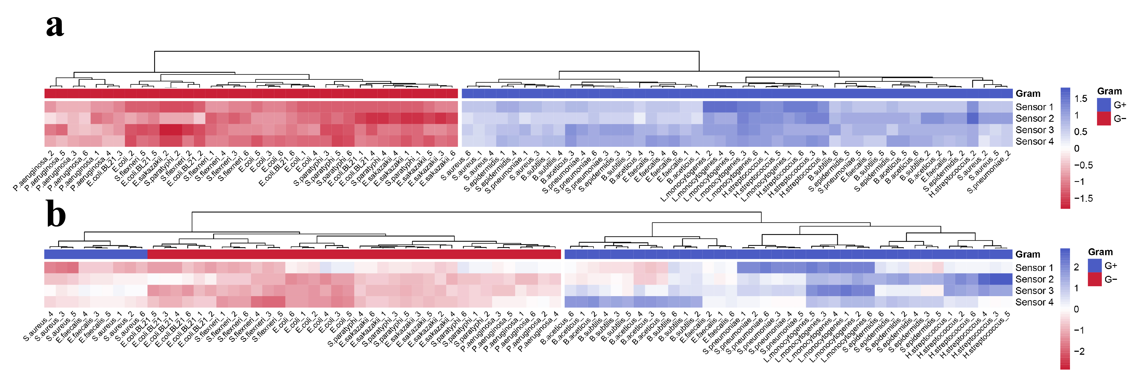
Figure S5. Response patterns displayed by heat map and HCA results for (a) colorimetric mode and (b) fluorometric mode.
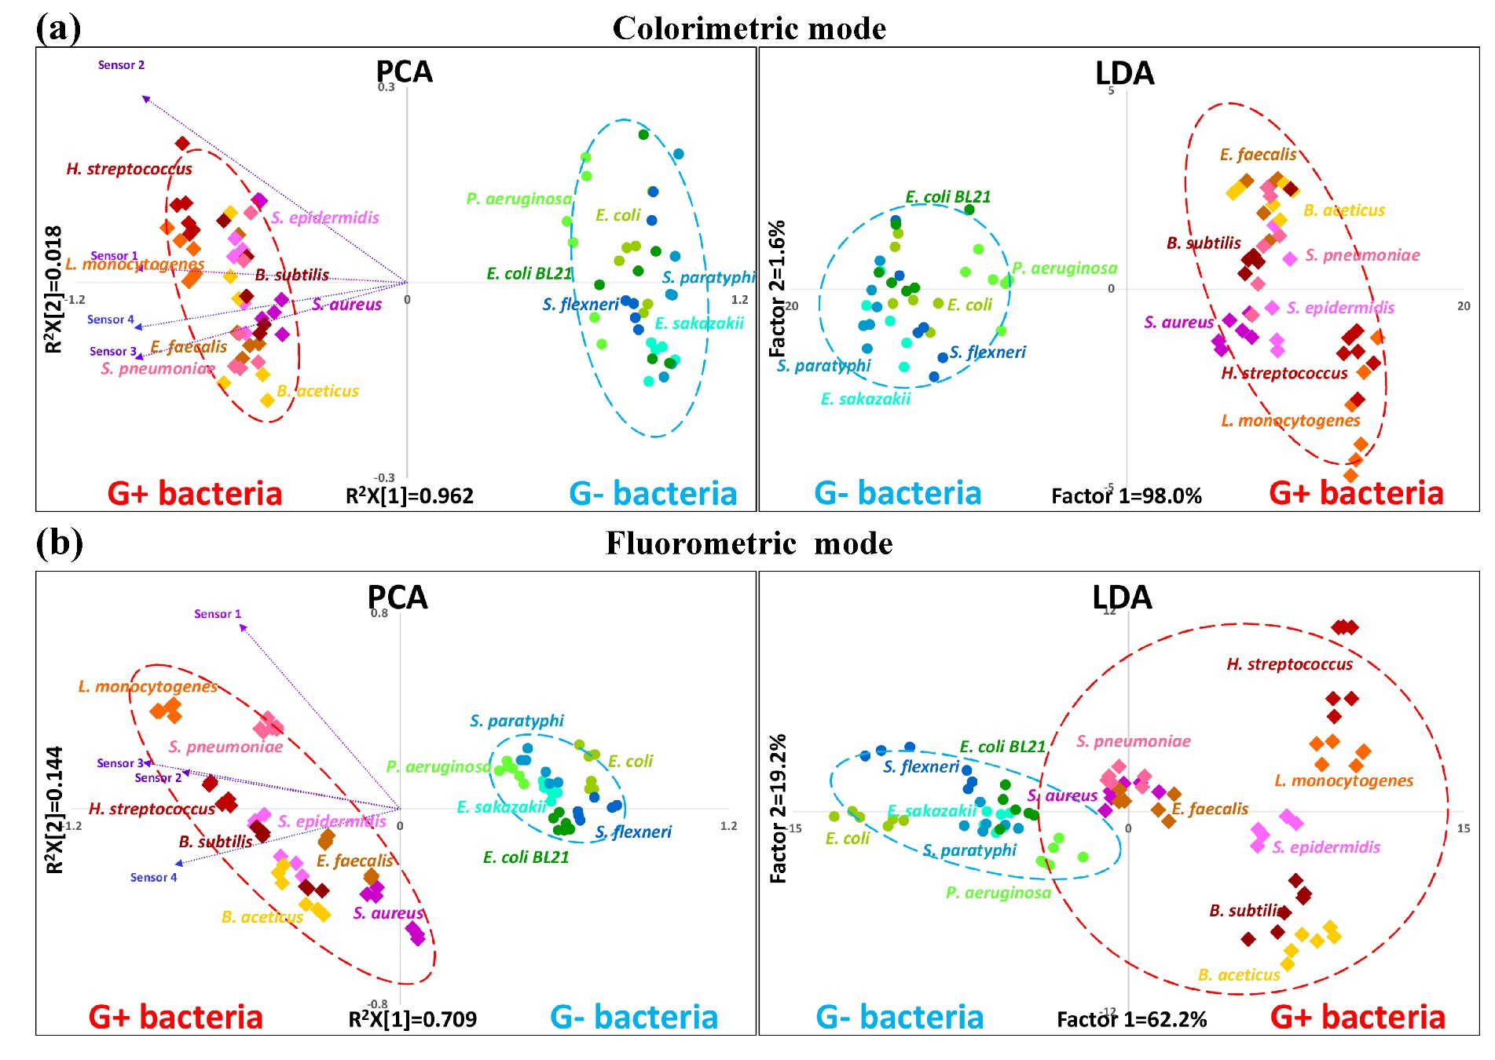
Figure S6. PCA and LDA results of bacterial samples (OD₆₀₀=0.1) for colorimetric mode (a) and fluorometric mode (b), respectively.
4. Discrimination of bacterial mixtures.
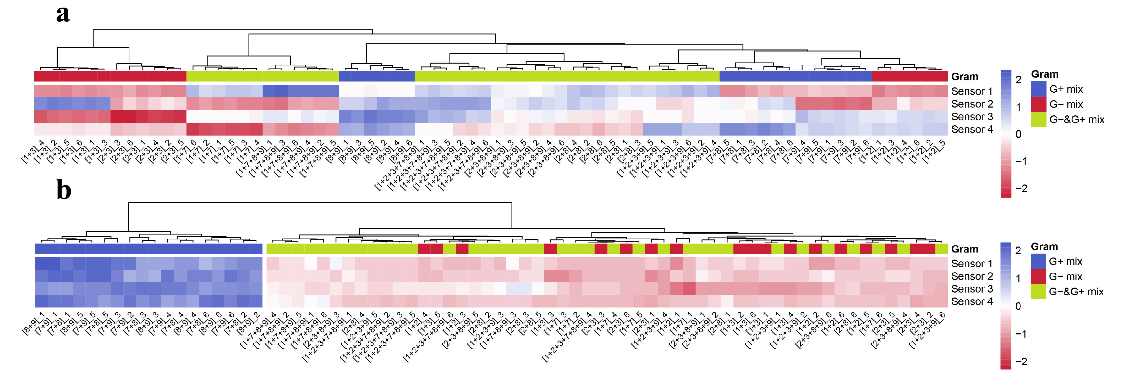
Figure S7. Response patterns displayed by heat map and HCA results for (a) colorimetric mode and (b) fluorometric mode.
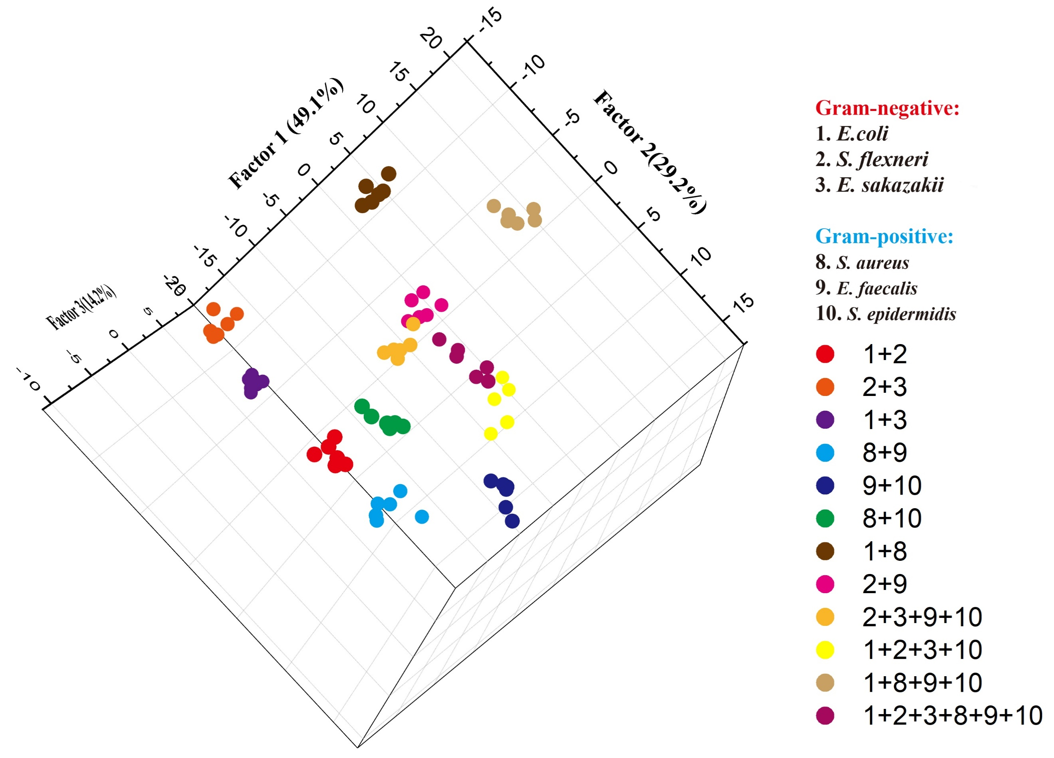
Figure S8. 3D canonical score plot of bacterial mixtures obtained from fluorescence response patterns.
5. UV-Vis and Fluorescence Response Pattern for PCA and LDA.
Table S2. Training matrix of UV-Vis response pattern obtained from sensor array of Rf and AgNTs against 14 bacteria (OD₆₀₀=0.1). LDA results showed the first two canonical scores and bacterial verification. PCA results displayed the transformed coordinate for PCA score plot.
 | UV-Vis Response Patterns |  |  |  | LDA results |  |  | PCA results
Bacteria | Sensor 1 | Sensor 2 | Sensor 3 | Sensor 4 | Factor 1 | Factor 2 | Verification | M1.t[1] | M1.t[2]
E. coli | -21 | -18 | -19 | -27 | -13.75 | 1.06 | E. coli | 0.87 | -0.03
E. coli | -21 | -15 | -22 | -29 | -13.88 | -0.36 | E. coli | 0.88 | 0.14
E. coli | -19 | -16 | -18 | -26 | -11.18 | -0.35 | E. coli | 0.76 | 0.03
E. coli | -21 | -18 | -18 | -27 | -13.57 | 1.41 | E. coli | 0.85 | -0.05
E. coli | -20 | -16 | -19 | -28 | -12.68 | -0.28 | E. coli | 0.82 | 0.06
E. coli | -19 | -16 | -19 | -27 | -11.67 | -1.09 | E. coli | 0.79 | 0.05
S. flexneri | -18 | -19 | -21 | -24 | -11.43 | -2.21 | S. flexneri | 0.82 | -0.05
S. flexneri | -22 | -15 | -24 | -25 | -13.72 | 1.73 | E. coli BL21 | 0.89 | 0.14
S. flexneri | -19 | -19 | -19 | -26 | -12.38 | -1.09 | S. flexneri | 0.83 | -0.07
S. flexneri | -18 | -18 | -20 | -24 | -10.91 | -1.73 | S. flexneri | 0.79 | -0.03
S. flexneri | -21 | -16 | -23 | -26 | -13.49 | 0.34 | E. coli BL21 | 0.88 | 0.10
S. flexneri | -19 | -18 | -19 | -26 | -12.04 | -0.96 | S. flexneri | 0.82 | -0.03
E. sakazakii | -21 | -21 | -21 | -28 | -15.44 | -0.41 | S. paratyphi | 0.97 | -0.12
E. sakazakii | -22 | -15 | -26 | -30 | -15.62 | -0.92 | S. paratyphi | 0.98 | 0.20
E. sakazakii | -19 | -21 | -19 | -26 | -13.07 | -1.36 | E. sakazakii | 0.87 | -0.15
E. sakazakii | -21 | -20 | -20 | -27 | -14.61 | 0.46 | E. sakazakii | 0.92 | -0.10
E. sakazakii | -20 | -20 | -19 | -28 | -14.04 | -0.80 | E. sakazakii | 0.90 | -0.10
E. sakazakii | -19 | -20 | -20 | -27 | -13.21 | -1.96 | E. sakazakii | 0.88 | -0.09
P. aeruginosa | -18 | -18 | -16 | -22 | -9.57 | 0.44 | P. aeruginosa | 0.70 | -0.09
P. aeruginosa | -18 | -12 | -20 | -21 | -7.94 | 0.24 | P. aeruginosa | 0.64 | 0.19
P. aeruginosa | -17 | -14 | -16 | -21 | -7.20 | 0.15 | P. aeruginosa | 0.60 | 0.06
P. aeruginosa | -18 | -17 | -17 | -20 | -8.80 | 1.01 | P. aeruginosa | 0.68 | -0.05
P. aeruginosa | -17 | -13 | -21 | -20 | -7.46 | -1.05 | P. aeruginosa | 0.65 | 0.16
P. aeruginosa | -17 | -13 | -15 | -22 | -6.98 | 0.23 | P. aeruginosa | 0.58 | 0.09
S. paratyphi | -21 | -21 | -21 | -27 | -15.14 | -0.02 | S. paratyphi | 0.95 | -0.12
S. paratyphi | -22 | -15 | -26 | -30 | -15.62 | -0.92 | S. paratyphi | 0.98 | 0.20
S. paratyphi | -21 | -19 | -23 | -27 | -14.82 | -0.45 | S. paratyphi | 0.95 | -0.02
S. paratyphi | -21 | -21 | -20 | -26 | -14.65 | 0.72 | E. sakazakii | 0.93 | -0.14
S. paratyphi | -21 | -18 | -23 | -30 | -15.40 | -1.49 | S. paratyphi | 0.97 | 0.04
S. paratyphi | -21 | -19 | -22 | -29 | -15.25 | -0.89 | S. paratyphi | 0.96 | -0.02
E. coli BL21 | -21 | -20 | -20 | -24 | -13.69 | 1.64 | E. coli BL21 | 0.88 | -0.12
E. coli BL21 | -21 | -13 | -23 | -28 | -13.08 | -0.05 | E. coli BL21 | 0.85 | 0.23
E. coli BL21 | -19 | -16 | -18 | -20 | -9.34 | 2.01 | P. aeruginosa | 0.69 | 0.00
E. coli BL21 | -21 | -21 | -22 | -25 | -14.70 | 0.42 | S. paratyphi | 0.95 | -0.12
E. coli BL21 | -21 | -17 | -22 | -27 | -13.95 | 0.16 | E. coli BL21 | 0.90 | 0.05
E. coli BL21 | -20 | -17 | -20 | -26 | -12.58 | 0.03 | E. coli BL21 | 0.83 | 0.02
S. aureus | -9 | -7 | -8 | -10 | 5.62 | -1.53 | S. aureus | -0.45 | -0.03
S. aureus | -9 | -3 | -7 | -11 | 6.86 | -1.05 | S. aureus | -0.53 | 0.13
S. aureus | -8 | -7 | -7 | -7 | 7.42 | -1.21 | S. aureus | -0.52 | -0.05
S. aureus | -9 | -7 | -7 | -9 | 6.11 | -0.79 | S. aureus | -0.48 | -0.05
S. aureus | -9 | -3 | -8 | -9 | 7.29 | -0.61 | S. aureus | -0.54 | 0.13
S. aureus | -9 | -8 | -7 | -10 | 5.46 | -1.31 | S. aureus | -0.45 | -0.08
E. faecalis | -10 | -7 | -6 | -4 | 7.12 | 2.73 | E. faecalis | -0.54 | -0.09
E. faecalis | -9 | -3 | -5 | -7 | 8.45 | 1.21 | B. subtilis | -0.61 | 0.07
E. faecalis | -9 | -6 | -5 | -2 | 8.96 | 2.79 | E. faecalis | -0.61 | -0.08
E. faecalis | -9 | -7 | -6 | -3 | 8.13 | 1.92 | E. faecalis | -0.57 | -0.10
E. faecalis | -9 | -4 | -5 | -8 | 7.80 | 0.69 | B. subtilis | -0.58 | 0.04
E. faecalis | -9 | -7 | -5 | -2 | 8.62 | 2.65 | E. faecalis | -0.60 | -0.12
S. epidermidis | -7 | -7 | -6 | -5 | 8.92 | -1.29 | S. epidermidis | -0.58 | -0.08
S. epidermidis | -9 | -3 | -5 | -6 | 8.76 | 1.61 | B. subtilis | -0.62 | 0.07
S. epidermidis | -9 | -7 | -3 | -4 | 8.37 | 2.56 | B. aceticus | -0.60 | -0.13
S. epidermidis | -7 | -6 | -6 | -6 | 8.95 | -1.55 | S. epidermidis | -0.59 | -0.03
S. epidermidis | -8 | -4 | -6 | -7 | 8.63 | -0.47 | S. epidermidis | -0.59 | 0.05
S. epidermidis | -8 | -4 | -7 | -3 | 9.67 | 0.76 | S. epidermidis | -0.63 | 0.04
B. aceticus | -10 | -8 | -5 | -5 | 6.66 | 2.55 | B. aceticus | -0.52 | -0.14
B. aceticus | -9 | -2 | -5 | -6 | 9.10 | 1.74 | B. subtilis | -0.64 | 0.11
B. aceticus | -8 | -7 | -2 | -2 | 9.86 | 2.48 | B. aceticus | -0.66 | -0.15
B. aceticus | -10 | -9 | -5 | -5 | 6.32 | 2.42 | E. faecalis | -0.50 | -0.18
B. aceticus | -9 | -4 | -5 | -3 | 9.34 | 2.66 | B. aceticus | -0.64 | 0.01
B. aceticus | -9 | -5 | -5 | -4 | 8.69 | 2.13 | E. faecalis | -0.61 | -0.02
B. subtilis | -9 | -7 | -6 | -6 | 7.21 | 0.74 | S. pneumoniae | -0.53 | -0.08
B. subtilis | -9 | -2 | -5 | -4 | 9.71 | 2.53 | B. aceticus | -0.66 | 0.09
B. subtilis | -9 | -7 | -3 | -4 | 8.37 | 2.56 | B. aceticus | -0.60 | -0.13
B. subtilis | -9 | -7 | -7 | -6 | 7.03 | 0.39 | S. epidermidis | -0.52 | -0.06
B. subtilis | -9 | -4 | -5 | -8 | 7.80 | 0.69 | B. subtilis | -0.58 | 0.04
B. subtilis | -9 | -5 | -3 | -9 | 7.51 | 0.85 | B. subtilis | -0.58 | -0.02
L. monocytogenes | -4 | -3 | -4 | -3 | 13.36 | -2.92 | L. monocytogenes | -0.77 | 0.05
L. monocytogenes | -3 | 9 | -3 | -5 | 13.28 | -4.70 | L. monocytogenes | -0.76 | 0.01
L. monocytogenes | -4 | -1 | -1 | -2 | 14.89 | -1.23 | H. streptococcus | -0.87 | 0.08
L. monocytogenes | -3 | -4 | -3 | -4 | 13.59 | -4.31 | L. monocytogenes | -0.78 | 0.01
L. monocytogenes | -3 | -4 | -3 | -3 | 13.90 | -3.91 | L. monocytogenes | -0.79 | 0.00
L. monocytogenes | -4 | -2 | -2 | -3 | 14.06 | -2.09 | H. streptococcus | -0.82 | 0.06
S. pneumoniae | -8 | -8 | -5 | -7 | 7.44 | -0.65 | S. aureus | -0.54 | -0.12
S. pneumoniae | -9 | -3 | -7 | -8 | 7.78 | 0.13 | B. subtilis | -0.56 | 0.11
S. pneumoniae | -9 | -7 | -3 | -4 | 8.37 | 2.56 | B. aceticus | -0.60 | -0.13
S. pneumoniae | -8 | -7 | -3 | -4 | 9.07 | 1.35 | S. pneumoniae | -0.62 | -0.13
S. pneumoniae | -9 | -4 | -5 | -7 | 8.11 | 1.08 | B. subtilis | -0.59 | 0.03
S. pneumoniae | -9 | -6 | -4 | -4 | 8.53 | 2.34 | B. aceticus | -0.61 | -0.08
H. streptococcus | -5 | -2 | -3 | -3 | 13.18 | -1.23 | H. streptococcus | -0.78 | 0.07
H. streptococcus | -5 | 1 | -4 | -4 | 13.72 | -1.57 | H. streptococcus | -0.81 | 0.21
H. streptococcus | -4 | -1 | -4 | -1 | 14.66 | -1.87 | H. streptococcus | -0.83 | 0.12
H. streptococcus | -5 | -1 | -4 | -2 | 13.65 | -1.05 | H. streptococcus | -0.80 | 0.12
H. streptococcus | -5 | -2 | -3 | -4 | 12.87 | -1.62 | H. streptococcus | -0.77 | 0.08
H. streptococcus | -4 | -2 | -4 | -3 | 13.70 | -2.78 | L. monocytogenes | -0.79 | 0.09
Table S3. Training matrix of fluorescence response pattern obtained from sensor array of Rf and AgNTs against 14 bacteria (OD₆₀₀=0.1). LDA results showed the first two canonical scores and bacterial verification. PCA results displayed the transformed coordinate for PCA score plot.
 | Fluorescence Response Patterns |  |  |  | LDA results |  |  | PCA results
Bacteria | Sensor 1 | Sensor 2 | Sensor 3 | Sensor 4 | Factor 1 | Factor 2 | Verification | M1.t[1] | M1.t[2]
E. coli | -9.39 | -11.94 | -10.55 | -17.40 | -10.07 | -0.52 | E. coli | 0.69 | 0.08
E. coli | -9.45 | -11.56 | -11.16 | -17.80 | -10.56 | -0.45 | E. coli | 0.71 | 0.08
E. coli | -6.00 | -11.84 | -12.07 | -19.25 | -13.18 | -0.28 | E. coli | 0.71 | 0.22
E. coli | -5.06 | -12.84 | -10.23 | -18.25 | -12.04 | -0.33 | E. coli | 0.65 | 0.26
E. coli | -6.33 | -11.63 | -11.36 | -18.93 | -12.37 | 0.04 | E. coli | 0.69 | 0.22
E. coli | -8.46 | -12.69 | -10.68 | -17.53 | -10.77 | -0.87 | E. coli | 0.70 | 0.11
S. flexneri | -12.89 | -8.68 | -8.88 | -17.86 | -7.24 | 2.47 | S. flexneri | 0.65 | -0.01
S. flexneri | -13.51 | -8.10 | -9.69 | -17.33 | -7.00 | 1.80 | S. flexneri | 0.66 | -0.04
S. flexneri | -12.72 | -10.10 | -10.52 | -21.44 | -11.07 | 3.67 | S. flexneri | 0.77 | 0.01
S. flexneri | -11.84 | -10.44 | -8.76 | -20.50 | -9.79 | 3.87 | S. flexneri | 0.71 | 0.05
S. flexneri | -12.34 | -10.16 | -11.24 | -21.68 | -11.80 | 3.34 | S. flexneri | 0.79 | 0.02
S. flexneri | -12.85 | -8.20 | -9.91 | -17.06 | -7.19 | 1.35 | S. flexneri | 0.65 | -0.02
E. sakazakii | -9.43 | -8.55 | -8.82 | -13.82 | -5.57 | -0.92 | E. sakazakii | 0.53 | 0.09
E. sakazakii | -11.09 | -8.08 | -8.78 | -14.45 | -5.30 | -0.07 | E. sakazakii | 0.55 | 0.03
E. sakazakii | -9.91 | -9.70 | -9.03 | -14.67 | -6.48 | -0.78 | E. sakazakii | 0.57 | 0.07
E. sakazakii | -10.17 | -10.60 | -7.47 | -14.57 | -5.71 | -0.17 | E. sakazakii | 0.55 | 0.07
E. sakazakii | -9.63 | -9.00 | -8.64 | -15.05 | -6.35 | 0.02 | E. sakazakii | 0.55 | 0.09
E. sakazakii | -8.65 | -8.54 | -9.15 | -13.72 | -5.93 | -1.26 | S. paratyphi | 0.52 | 0.12
P. aeruginosa | -6.46 | -9.56 | -6.23 | -10.93 | -3.37 | -2.15 | P. aeruginosa | 0.39 | 0.20
P. aeruginosa | -7.34 | -7.75 | -6.79 | -9.71 | -2.04 | -2.71 | P. aeruginosa | 0.36 | 0.16
P. aeruginosa | -8.42 | -8.25 | -8.62 | -10.94 | -3.78 | -3.03 | P. aeruginosa | 0.45 | 0.10
P. aeruginosa | -7.28 | -8.48 | -6.48 | -11.25 | -3.12 | -1.57 | P. aeruginosa | 0.39 | 0.17
P. aeruginosa | -7.66 | -7.93 | -8.60 | -10.97 | -3.91 | -2.94 | P. aeruginosa | 0.44 | 0.14
P. aeruginosa | -6.79 | -9.48 | -7.30 | -10.40 | -3.53 | -3.20 | P. aeruginosa | 0.41 | 0.17
S. paratyphi | -6.76 | -9.03 | -7.18 | -12.87 | -4.94 | -1.00 | S. paratyphi | 0.44 | 0.20
S. paratyphi | -6.81 | -8.67 | -7.77 | -13.44 | -5.52 | -0.78 | S. paratyphi | 0.46 | 0.20
S. paratyphi | -9.08 | -8.79 | -9.15 | -14.48 | -6.38 | -0.72 | E. sakazakii | 0.54 | 0.10
S. paratyphi | -8.37 | -9.32 | -7.90 | -15.44 | -6.64 | 0.59 | S. paratyphi | 0.53 | 0.15
S. paratyphi | -8.84 | -9.60 | -9.55 | -15.09 | -7.36 | -0.84 | S. paratyphi | 0.58 | 0.11
S. paratyphi | -5.45 | -9.35 | -8.10 | -13.71 | -6.53 | -1.16 | S. paratyphi | 0.47 | 0.25
E. coli BL21 | -12.79 | -7.01 | -9.21 | -14.10 | -4.47 | -0.08 | E. coli BL21 | 0.56 | -0.04
E. coli BL21 | -13.98 | -5.97 | -10.06 | -14.03 | -4.23 | -0.20 | E. coli BL21 | 0.58 | -0.09
E. coli BL21 | -14.14 | -5.53 | -10.92 | -15.68 | -5.62 | 0.73 | E. coli BL21 | 0.62 | -0.08
E. coli BL21 | -13.90 | -5.39 | -10.19 | -16.15 | -5.52 | 1.61 | E. coli BL21 | 0.60 | -0.06
E. coli BL21 | -14.11 | -4.32 | -11.56 | -14.84 | -5.06 | 0.11 | E. coli BL21 | 0.60 | -0.09
E. coli BL21 | -11.84 | -5.91 | -11.39 | -14.22 | -5.77 | -1.05 | E. coli BL21 | 0.58 | -0.01
S. aureus | -12.86 | -6.14 | -3.68 | -10.72 | 1.36 | 1.19 | S. aureus | -0.12 | -0.35
S. aureus | -13.18 | -5.77 | -4.32 | -11.74 | 0.53 | 1.74 | S. aureus | -0.09 | -0.35
S. aureus | -16.15 | -8.93 | -6.08 | -12.30 | -1.05 | 0.06 | S. aureus | 0.06 | -0.51
S. aureus | -15.98 | -9.11 | -4.87 | -12.89 | -0.82 | 1.22 | S. aureus | 0.04 | -0.49
S. aureus | -16.91 | -8.30 | -5.88 | -12.72 | -0.77 | 0.82 | S. aureus | 0.06 | -0.53
S. aureus | -12.31 | -5.92 | -4.66 | -12.11 | -0.23 | 1.68 | S. aureus | -0.08 | -0.32
E. faecalis | -6.75 | -6.15 | -2.52 | -9.03 | 1.32 | 0.11 | E. faecalis | -0.26 | -0.11
E. faecalis | -7.93 | -3.97 | -2.83 | -9.29 | 2.04 | 1.05 | E. faecalis | -0.27 | -0.14
E. faecalis | -11.03 | -6.65 | -4.56 | -11.18 | -0.18 | 0.63 | E. faecalis | -0.11 | -0.28
E. faecalis | -10.92 | -6.96 | -4.04 | -11.78 | -0.40 | 1.32 | E. faecalis | -0.10 | -0.27
E. faecalis | -10.82 | -6.44 | -4.85 | -11.31 | -0.44 | 0.61 | E. faecalis | -0.10 | -0.27
E. faecalis | -7.06 | -4.97 | -3.36 | -8.27 | 1.79 | -0.57 | E. faecalis | -0.27 | -0.13
S. epidermidis | -6.07 | 3.94 | -3.21 | -3.74 | 7.50 | -0.70 | S. epidermidis | -0.53 | -0.07
S. epidermidis | -5.75 | 4.40 | -3.42 | -4.24 | 7.10 | -0.29 | S. epidermidis | -0.53 | -0.05
S. epidermidis | -9.16 | 2.17 | -5.70 | -4.64 | 5.76 | -2.04 | S. epidermidis | -0.38 | -0.22
S. epidermidis | -9.16 | 2.49 | -3.45 | -4.87 | 7.06 | -0.27 | S. epidermidis | -0.44 | -0.19
S. epidermidis | -10.63 | 2.52 | -5.69 | -5.13 | 6.00 | -1.39 | S. epidermidis | -0.36 | -0.27
S. epidermidis | -4.78 | 2.45 | -3.71 | -4.54 | 5.80 | -1.07 | S. epidermidis | -0.50 | -0.02
B. aceticus | -8.20 | -6.58 | -1.05 | 1.00 | 9.02 | -6.92 | B. aceticus | -0.44 | -0.26
B. aceticus | -9.04 | -5.65 | -2.08 | 1.38 | 9.20 | -7.47 | B. aceticus | -0.43 | -0.30
B. aceticus | -11.36 | -8.64 | -4.16 | 0.54 | 7.11 | -9.12 | B. aceticus | -0.28 | -0.43
B. aceticus | -10.91 | -8.57 | -1.89 | 0.64 | 8.43 | -7.73 | B. aceticus | -0.34 | -0.39
B. aceticus | -11.16 | -7.37 | -4.09 | 0.17 | 7.28 | -8.31 | B. aceticus | -0.30 | -0.41
B. aceticus | -7.23 | -6.15 | -2.40 | 0.53 | 7.75 | -7.34 | B. aceticus | -0.42 | -0.23
B. subtilis | -5.31 | -2.96 | -1.97 | -0.53 | 7.81 | -5.15 | B. subtilis | -0.50 | -0.11
B. subtilis | -5.35 | -2.00 | -2.07 | -1.46 | 7.48 | -4.11 | B. subtilis | -0.50 | -0.10
B. subtilis | -9.55 | -5.08 | -4.62 | -0.72 | 6.66 | -7.20 | B. subtilis | -0.34 | -0.32
B. subtilis | -9.78 | -5.77 | -3.19 | -1.31 | 6.97 | -6.05 | B. subtilis | -0.34 | -0.32
B. subtilis | -9.54 | -6.11 | -5.49 | -1.41 | 5.35 | -7.62 | B. subtilis | -0.28 | -0.33
B. subtilis | -4.49 | -3.55 | -1.13 | -0.52 | 7.87 | -4.91 | B. subtilis | -0.52 | -0.07
L. monocytogenes | 3.47 | 1.74 | 6.92 | -2.90 | 10.52 | 3.63 | L. monocytogenes | -0.88 | 0.40
L. monocytogenes | 3.37 | 3.60 | 5.73 | -2.86 | 10.48 | 3.54 | L. monocytogenes | -0.89 | 0.40
L. monocytogenes | 2.75 | 2.05 | 5.70 | -4.41 | 9.12 | 4.20 | L. monocytogenes | -0.82 | 0.38
L. monocytogenes | 4.06 | 0.92 | 6.03 | -4.63 | 8.41 | 4.05 | L. monocytogenes | -0.83 | 0.43
L. monocytogenes | 4.26 | 2.10 | 4.73 | -3.59 | 8.64 | 2.81 | L. monocytogenes | -0.84 | 0.42
L. monocytogenes | 3.71 | 2.60 | 5.56 | -2.51 | 10.18 | 2.74 | L. monocytogenes | -0.88 | 0.40
S. pneumoniae | 2.74 | -2.26 | -1.31 | -8.83 | 0.62 | 1.48 | S. pneumoniae | -0.50 | 0.32
S. pneumoniae | 2.80 | -1.66 | -1.09 | -9.18 | 0.71 | 2.12 | S. pneumoniae | -0.51 | 0.33
S. pneumoniae | 3.23 | -4.21 | -1.13 | -10.19 | -0.96 | 1.88 | S. pneumoniae | -0.45 | 0.34
S. pneumoniae | 2.78 | -3.25 | -0.77 | -10.42 | -0.44 | 2.70 | S. pneumoniae | -0.47 | 0.33
S. pneumoniae | 2.89 | -3.57 | -1.36 | -10.34 | -0.88 | 2.12 | S. pneumoniae | -0.45 | 0.33
S. pneumoniae | 4.10 | -3.00 | -1.49 | -9.83 | -0.80 | 1.75 | S. pneumoniae | -0.48 | 0.37
H. streptococcus | -6.25 | 4.08 | 3.50 | -7.54 | 9.15 | 6.75 | H. streptococcus | -0.63 | 0.04
H. streptococcus | -6.84 | 6.03 | 2.93 | -7.02 | 9.97 | 6.76 | H. streptococcus | -0.65 | 0.02
H. streptococcus | -6.31 | 11.06 | 2.79 | -10.12 | 9.38 | 11.02 | H. streptococcus | -0.69 | 0.11
H. streptococcus | -6.57 | 9.23 | 4.27 | -9.77 | 9.96 | 11.02 | H. streptococcus | -0.70 | 0.10
H. streptococcus | -6.55 | 10.95 | 3.00 | -10.01 | 9.62 | 11.05 | H. streptococcus | -0.69 | 0.10
H. streptococcus | -6.54 | 4.90 | 2.21 | -6.83 | 9.20 | 5.68 | H. streptococcus | -0.62 | 0.01
Table S4. Training matrix of UV-Vis response pattern obtained from sensor array of Rf and AgNTs against 14 bacteria (OD₆₀₀=0.05). LDA results showed the first two canonical scores and bacterial verification. PCA results displayed the transformed coordinate for PCA score plot.
 | UV-Vis Response Patterns |  |  |  | LDA results |  |  | PCA results
Bacteria | Sensor 1 | Sensor 2 | Sensor 3 | Sensor 4 | Factor 1 | Factor 2 | Verification | M1.t[1] | M1.t[2]
E. coli | -19 | -21 | -26 | -17 | -13.15 | 0.07 | P. aeruginosa | 0.85 | -0.03
E. coli | -20 | -22 | -28 | -19 | -15.60 | 0.41 | P. aeruginosa | 0.94 | -0.05
E. coli | -19 | -20 | -27 | -18 | -13.88 | 1.43 | P. aeruginosa | 0.86 | 0.00
E. coli | -18 | -23 | -28 | -17 | -14.27 | -0.53 | S. flexneri | 0.88 | 0.00
E. coli | -18 | -21 | -27 | -18 | -13.73 | 0.55 | P. aeruginosa | 0.85 | 0.02
E. coli | -17 | -20 | -29 | -16 | -13.39 | 2.41 | E. sakazakii | 0.81 | 0.10
S. flexneri | -18 | -23 | -25 | -19 | -13.50 | -2.20 | S. flexneri | 0.88 | -0.06
S. flexneri | -17 | -21 | -26 | -18 | -12.83 | -0.07 | E. sakazakii | 0.82 | 0.03
S. flexneri | -19 | -22 | -29 | -16 | -14.54 | 0.91 | E. coli | 0.88 | 0.01
S. flexneri | -17 | -23 | -27 | -19 | -14.20 | -1.16 | E. coli BL21 | 0.88 | 0.01
S. flexneri | -18 | -22 | -27 | -15 | -12.70 | -0.25 | E. sakazakii | 0.82 | 0.00
S. flexneri | -16 | -24 | -28 | -18 | -14.16 | -1.49 | E. coli BL21 | 0.87 | 0.04
E. sakazakii | -16 | -21 | -27 | -19 | -13.41 | 0.40 | S. paratyphi | 0.83 | 0.08
E. sakazakii | -17 | -20 | -28 | -15 | -12.45 | 1.87 | E. coli | 0.78 | 0.09
E. sakazakii | -18 | -23 | -28 | -19 | -15.09 | -0.55 | E. coli BL21 | 0.92 | 0.00
E. sakazakii | -18 | -22 | -29 | -17 | -14.59 | 0.84 | E. coli | 0.88 | 0.04
E. sakazakii | -17 | -20 | -28 | -18 | -13.68 | 1.85 | E. sakazakii | 0.83 | 0.08
E. sakazakii | -19 | -21 | -26 | -16 | -12.74 | 0.08 | E. coli | 0.83 | -0.03
P. aeruginosa | -18 | -20 | -27 | -17 | -13.10 | 1.37 | E. coli | 0.82 | 0.04
P. aeruginosa | -18 | -21 | -28 | -18 | -14.25 | 1.10 | E. coli | 0.87 | 0.03
P. aeruginosa | -18 | -22 | -27 | -20 | -14.76 | -0.28 | E. coli BL21 | 0.90 | -0.01
P. aeruginosa | -19 | -23 | -29 | -16 | -14.75 | 0.09 | S. paratyphi | 0.90 | -0.01
P. aeruginosa | -19 | -21 | -26 | -19 | -13.97 | 0.06 | P. aeruginosa | 0.88 | -0.04
P. aeruginosa | -20 | -22 | -27 | -19 | -15.07 | -0.14 | P. aeruginosa | 0.93 | -0.07
S. paratyphi | -17 | -21 | -28 | -18 | -13.89 | 1.03 | E. sakazakii | 0.84 | 0.06
S. paratyphi | -17 | -20 | -28 | -19 | -14.09 | 1.84 | E. sakazakii | 0.84 | 0.08
S. paratyphi | -19 | -24 | -29 | -19 | -16.19 | -0.74 | E. coli BL21 | 0.97 | -0.04
S. paratyphi | -20 | -24 | -30 | -18 | -16.67 | -0.12 | E. coli BL21 | 0.98 | -0.05
S. paratyphi | -17 | -23 | -25 | -17 | -12.32 | -2.25 | S. flexneri | 0.82 | -0.03
S. paratyphi | -18 | -21 | -25 | -17 | -12.26 | -0.55 | S. flexneri | 0.81 | -0.02
E. coli BL21 | -19 | -22 | -28 | -19 | -15.24 | 0.34 | P. aeruginosa | 0.92 | -0.02
E. coli BL21 | -18 | -23 | -29 | -20 | -16.03 | 0.00 | E. coli BL21 | 0.94 | 0.01
E. coli BL21 | -20 | -25 | -28 | -19 | -16.24 | -2.05 | E. coli BL21 | 0.99 | -0.10
E. coli BL21 | -16 | -23 | -27 | -20 | -14.24 | -1.24 | S. flexneri | 0.88 | 0.04
E. coli BL21 | -17 | -23 | -28 | -18 | -14.32 | -0.61 | S. flexneri | 0.88 | 0.03
E. coli BL21 | -18 | -23 | -29 | -18 | -15.21 | 0.01 | E. coli BL21 | 0.91 | 0.02
S. aureus | -5 | -9 | -10 | -5 | 7.87 | 0.20 | S. aureus | -0.58 | 0.08
S. aureus | -5 | -10 | -10 | -6 | 7.24 | -0.63 | S. aureus | -0.54 | 0.06
S. aureus | -6 | -10 | -9 | -4 | 8.23 | -1.10 | S. aureus | -0.57 | 0.01
S. aureus | -7 | -9 | -9 | -4 | 8.08 | -0.21 | S. aureus | -0.56 | 0.00
S. aureus | -6 | -10 | -7 | -2 | 10.11 | -2.18 | S. pneumoniae | -0.62 | -0.02
S. aureus | -6 | -10 | -8 | -4 | 8.76 | -1.65 | S. aureus | -0.58 | 0.00
E. faecalis | -5 | -5 | -5 | 0 | 13.41 | 0.75 | L. monocytogenes | -0.79 | 0.07
E. faecalis | -6 | -6 | -5 | -1 | 12.43 | -0.01 | E. faecalis | -0.73 | 0.02
E. faecalis | -7 | -8 | -6 | -3 | 10.29 | -1.04 | S. epidermidis | -0.63 | -0.03
E. faecalis | -9 | -6 | -5 | -3 | 10.52 | 0.18 | E. faecalis | -0.63 | -0.08
E. faecalis | -7 | -6 | -5 | -1 | 12.06 | 0.06 | E. faecalis | -0.71 | -0.01
E. faecalis | -8 | -7 | -6 | -1 | 10.96 | -0.14 | E. faecalis | -0.66 | -0.04
S. epidermidis | -7 | -7 | -5 | 0 | 12.26 | -0.75 | E. faecalis | -0.71 | -0.03
S. epidermidis | -6 | -8 | -6 | 0 | 11.89 | -1.09 | E. faecalis | -0.70 | 0.00
S. epidermidis | -7 | -10 | -5 | -1 | 11.22 | -3.21 | S. epidermidis | -0.64 | -0.09
S. epidermidis | -8 | -9 | -5 | -1 | 11.07 | -2.33 | S. epidermidis | -0.64 | -0.10
S. epidermidis | -8 | -9 | -4 | -3 | 10.78 | -2.89 | S. epidermidis | -0.62 | -0.12
S. epidermidis | -10 | -8 | -3 | -3 | 10.79 | -2.49 | B. aceticus | -0.60 | -0.18
B. aceticus | -10 | -9 | -3 | -5 | 9.76 | -3.32 | B. aceticus | -0.55 | -0.20
B. aceticus | -9 | -9 | -4 | -4 | 10.00 | -2.83 | B. aceticus | -0.58 | -0.15
B. aceticus | -12 | -10 | -4 | -5 | 8.29 | -3.45 | B. aceticus | -0.48 | -0.27
B. aceticus | -11 | -11 | -5 | -4 | 8.33 | -3.78 | B. aceticus | -0.49 | -0.23
B. aceticus | -11 | -8 | -2 | -6 | 9.73 | -2.99 | B. aceticus | -0.54 | -0.24
B. aceticus | -10 | -9 | -2 | -4 | 10.70 | -3.86 | B. aceticus | -0.58 | -0.22
B. subtilis | -5 | -3 | -5 | -5 | 11.78 | 2.35 | B. subtilis | -0.74 | 0.10
B. subtilis | -4 | -3 | -5 | -6 | 11.73 | 2.28 | B. subtilis | -0.74 | 0.13
B. subtilis | -6 | -2 | -8 | -2 | 11.27 | 4.91 | H. streptococcus | -0.74 | 0.15
B. subtilis | -7 | -4 | -6 | -1 | 11.96 | 2.25 | L. monocytogenes | -0.73 | 0.04
B. subtilis | -5 | -6 | -9 | -2 | 10.26 | 2.12 | L. monocytogenes | -0.69 | 0.12
B. subtilis | -6 | -5 | -8 | -2 | 10.64 | 2.46 | L. monocytogenes | -0.69 | 0.09
L. monocytogenes | -5 | -5 | -8 | 0 | 11.82 | 2.40 | L. monocytogenes | -0.75 | 0.12
L. monocytogenes | -6 | -5 | -7 | -1 | 11.58 | 1.91 | L. monocytogenes | -0.72 | 0.07
L. monocytogenes | -7 | -6 | -9 | -1 | 9.95 | 2.26 | L. monocytogenes | -0.66 | 0.06
L. monocytogenes | -6 | -7 | -10 | -2 | 9.16 | 1.92 | L. monocytogenes | -0.64 | 0.09
L. monocytogenes | -6 | -5 | -8 | 0 | 11.46 | 2.47 | L. monocytogenes | -0.73 | 0.09
L. monocytogenes | -8 | -6 | -4 | -1 | 12.23 | -0.42 | E. faecalis | -0.70 | -0.06
S. pneumoniae | -5 | -10 | -5 | -5 | 10.30 | -3.37 | S. pneumoniae | -0.62 | -0.03
S. pneumoniae | -5 | -9 | -6 | -5 | 9.98 | -2.00 | S. pneumoniae | -0.63 | 0.01
S. pneumoniae | -5 | -10 | -6 | -3 | 10.59 | -2.81 | S. pneumoniae | -0.64 | -0.01
S. pneumoniae | -6 | -9 | -4 | -1 | 12.32 | -3.01 | S. epidermidis | -0.69 | -0.05
S. pneumoniae | -7 | -9 | -5 | -4 | 10.20 | -2.41 | S. pneumoniae | -0.61 | -0.07
S. pneumoniae | -8 | -8 | -3 | -4 | 11.11 | -2.63 | S. epidermidis | -0.63 | -0.12
H. streptococcus | -5 | -3 | -8 | 0 | 12.25 | 4.04 | H. streptococcus | -0.78 | 0.16
H. streptococcus | -6 | -4 | -7 | -1 | 11.79 | 2.73 | L. monocytogenes | -0.74 | 0.09
H. streptococcus | -5 | -1 | -10 | -2 | 10.79 | 6.76 | H. streptococcus | -0.76 | 0.23
H. streptococcus | -7 | -4 | -9 | -1 | 10.37 | 3.90 | H. streptococcus | -0.69 | 0.10
H. streptococcus | -6 | -2 | -9 | -1 | 11.16 | 5.47 | H. streptococcus | -0.75 | 0.17
H. streptococcus | -7 | -4 | -7 | -2 | 11.02 | 2.79 | B. subtilis | -0.70 | 0.06
Table S5. Training matrix of fluorescence response pattern obtained from sensor array of Rf and AgNTs against 14 bacteria (OD₆₀₀=0.05). LDA results showed the first two canonical scores and bacterial verification. PCA results displayed the transformed coordinate for PCA score plot.
 | Fluorescence Response Patterns |  |  |  | LDA results |  |  | PCA results
Bacteria | Sensor 1 | Sensor 2 | Sensor 3 | Sensor 4 | Factor 1 | Factor 2 | Verification | M1.t[1] | M1.t[2]
E. coli | -0.94 | -2.08 | -7.23 | -14.52 | -5.75 | -7.40 | E. coli | 0.77 | -0.04
E. coli | -0.31 | -1.95 | -7.35 | -14.11 | -5.79 | -6.98 | E. coli | 0.75 | 0.02
E. coli | -1.23 | -1.53 | -7.24 | -14.52 | -5.60 | -7.26 | E. coli | 0.76 | -0.07
E. coli | -1.99 | -4.99 | -6.69 | -11.81 | -6.27 | -5.43 | E. coli | 0.81 | -0.15
E. coli | -2.54 | -4.90 | -5.96 | -10.67 | -5.69 | -4.80 | E. coli | 0.79 | -0.22
E. coli | -1.59 | -4.75 | -5.37 | -11.78 | -5.16 | -6.53 | E. coli | 0.77 | -0.12
S. flexneri | -0.18 | -8.87 | -8.20 | -6.90 | -8.63 | -0.18 | P. aeruginosa | 0.80 | 0.01
S. flexneri | -0.97 | -8.67 | -7.51 | -7.88 | -8.05 | -1.57 | S. flexneri | 0.82 | -0.07
S. flexneri | -0.45 | -9.44 | -6.90 | -8.59 | -7.81 | -2.99 | S. flexneri | 0.83 | -0.02
S. flexneri | -0.35 | -7.08 | -5.71 | -5.82 | -6.13 | -0.87 | S. flexneri | 0.70 | -0.03
S. flexneri | -0.10 | -6.96 | -5.23 | -6.11 | -5.70 | -1.58 | S. flexneri | 0.68 | -0.01
S. flexneri | 0.79 | -6.96 | -4.37 | -6.13 | -5.01 | -2.47 | S. flexneri | 0.65 | 0.07
E. sakazakii | 4.32 | -10.63 | -15.23 | -7.69 | -14.59 | 3.89 | E. sakazakii | 0.87 | 0.49
E. sakazakii | 4.93 | -10.16 | -14.69 | -6.82 | -14.00 | 4.27 | E. sakazakii | 0.82 | 0.54
E. sakazakii | 5.26 | -10.55 | -14.78 | -5.99 | -14.19 | 5.06 | E. sakazakii | 0.81 | 0.56
E. sakazakii | 2.03 | -7.27 | -13.81 | -6.67 | -12.47 | 4.62 | E. sakazakii | 0.80 | 0.25
E. sakazakii | 2.22 | -7.05 | -13.59 | -5.59 | -12.22 | 5.52 | E. sakazakii | 0.76 | 0.26
E. sakazakii | 2.65 | -6.29 | -12.67 | -5.28 | -11.25 | 5.11 | E. sakazakii | 0.71 | 0.29
P. aeruginosa | 3.44 | -6.56 | -10.65 | -6.82 | -9.74 | 1.71 | P. aeruginosa | 0.70 | 0.36
P. aeruginosa | 3.28 | -6.31 | -10.13 | -7.12 | -9.26 | 1.04 | P. aeruginosa | 0.69 | 0.34
P. aeruginosa | 3.20 | -6.86 | -9.74 | -7.31 | -9.13 | 0.45 | P. aeruginosa | 0.70 | 0.34
P. aeruginosa | 0.47 | -6.46 | -8.70 | -6.65 | -8.25 | 0.76 | P. aeruginosa | 0.73 | 0.07
P. aeruginosa | 1.01 | -5.61 | -8.27 | -6.22 | -7.63 | 0.87 | P. aeruginosa | 0.68 | 0.11
P. aeruginosa | 1.22 | -5.09 | -7.76 | -6.00 | -7.06 | 0.71 | P. aeruginosa | 0.65 | 0.12
S. paratyphi | -1.52 | -2.43 | -8.53 | -7.71 | -6.89 | 0.52 | S. paratyphi | 0.69 | -0.13
S. paratyphi | -0.87 | -1.13 | -7.59 | -7.95 | -5.72 | -0.41 | S. paratyphi | 0.63 | -0.07
S. paratyphi | -1.50 | -1.34 | -8.27 | -8.18 | -6.34 | 0.00 | S. paratyphi | 0.67 | -0.13
S. paratyphi | -2.41 | -5.91 | -5.26 | -6.50 | -5.45 | -1.40 | S. paratyphi | 0.72 | -0.23
S. paratyphi | -1.97 | -5.55 | -4.86 | -7.13 | -5.02 | -2.37 | S. paratyphi | 0.70 | -0.19
S. paratyphi | -2.10 | -5.22 | -4.88 | -6.84 | -4.93 | -2.00 | S. paratyphi | 0.69 | -0.20
E. coli BL21 | -2.50 | -4.40 | -12.52 | -9.98 | -10.67 | 1.44 | E. coli BL21 | 0.87 | -0.17
E. coli BL21 | -2.10 | -4.43 | -11.76 | -10.29 | -10.06 | 0.43 | E. coli BL21 | 0.86 | -0.14
E. coli BL21 | -2.20 | -4.10 | -11.65 | -10.91 | -9.88 | -0.22 | E. coli BL21 | 0.86 | -0.15
E. coli BL21 | -2.85 | -6.76 | -9.83 | -10.64 | -9.31 | -1.77 | E. coli BL21 | 0.91 | -0.22
E. coli BL21 | -3.41 | -5.97 | -9.30 | -9.60 | -8.66 | -0.96 | E. coli BL21 | 0.87 | -0.28
E. coli BL21 | -2.85 | -6.21 | -9.13 | -10.25 | -8.59 | -1.89 | E. coli BL21 | 0.87 | -0.22
S. aureus | 9.62 | 2.20 | 4.58 | 2.41 | 5.12 | -1.46 | S. aureus | -0.66 | 0.65
S. aureus | 9.61 | 2.75 | 5.01 | 2.27 | 5.64 | -1.87 | S. aureus | -0.68 | 0.65
S. aureus | 9.85 | 2.78 | 5.13 | 2.59 | 5.74 | -1.68 | S. aureus | -0.70 | 0.67
S. aureus | 3.94 | 0.71 | 4.79 | 2.77 | 4.68 | -0.57 | S. aureus | -0.50 | 0.11
S. aureus | 4.20 | 1.83 | 5.96 | 3.54 | 5.96 | -0.64 | S. aureus | -0.57 | 0.12
S. aureus | 4.41 | 1.41 | 6.11 | 2.92 | 5.94 | -1.47 | S. aureus | -0.56 | 0.15
E. faecalis | 7.14 | 4.13 | 7.18 | -1.82 | 7.70 | -7.14 | E. faecalis | -0.62 | 0.42
E. faecalis | 6.04 | 3.58 | 7.40 | -2.43 | 7.67 | -7.84 | E. faecalis | -0.57 | 0.32
E. faecalis | 5.22 | 4.62 | 6.79 | -2.54 | 7.50 | -7.13 | E. faecalis | -0.57 | 0.24
E. faecalis | 5.76 | 3.05 | 6.31 | -2.10 | 6.64 | -6.63 | E. faecalis | -0.54 | 0.30
E. faecalis | 5.50 | 2.08 | 5.65 | -2.61 | 5.81 | -6.70 | E. faecalis | -0.49 | 0.28
E. faecalis | 5.28 | 2.43 | 4.97 | -1.84 | 5.39 | -5.26 | E. faecalis | -0.49 | 0.26
S. epidermidis | 0.23 | -1.77 | 5.55 | -0.54 | 4.39 | -4.26 | S. epidermidis | -0.30 | -0.22
S. epidermidis | 0.19 | -2.26 | 5.35 | 1.28 | 4.08 | -2.35 | S. epidermidis | -0.32 | -0.23
S. epidermidis | -0.08 | -1.95 | 5.17 | 0.69 | 4.03 | -2.70 | S. epidermidis | -0.31 | -0.25
S. epidermidis | 1.42 | 0.33 | 7.98 | 3.36 | 7.00 | -2.27 | S. epidermidis | -0.50 | -0.15
S. epidermidis | 2.60 | 0.44 | 8.20 | 4.78 | 7.23 | -1.21 | B. subtilis | -0.56 | -0.05
S. epidermidis | 1.65 | 1.16 | 7.30 | 4.25 | 6.73 | -0.72 | B. subtilis | -0.53 | -0.13
B. aceticus | -2.71 | -0.18 | 1.91 | 2.62 | 1.98 | 2.67 | B. aceticus | -0.27 | -0.50
B. aceticus | -2.45 | 0.00 | 0.99 | 4.04 | 1.32 | 4.84 | B. aceticus | -0.29 | -0.47
B. aceticus | -2.30 | -0.10 | 1.94 | 3.43 | 2.04 | 3.40 | B. aceticus | -0.30 | -0.46
B. aceticus | 0.94 | 2.38 | 4.08 | 7.60 | 4.58 | 5.62 | B. aceticus | -0.55 | -0.20
B. aceticus | 1.21 | 1.92 | 4.08 | 8.51 | 4.44 | 6.42 | B. aceticus | -0.56 | -0.18
B. aceticus | 0.82 | 2.66 | 3.62 | 8.85 | 4.31 | 7.32 | B. aceticus | -0.57 | -0.22
B. subtilis | -2.10 | -1.87 | 8.56 | 4.02 | 6.66 | -1.85 | B. subtilis | -0.38 | -0.49
B. subtilis | -2.44 | -2.13 | 7.90 | 5.03 | 6.06 | -0.27 | B. subtilis | -0.37 | -0.52
B. subtilis | -2.81 | -1.28 | 8.82 | 4.51 | 7.04 | -1.37 | B. subtilis | -0.39 | -0.56
B. subtilis | 1.51 | 0.06 | 6.58 | 3.08 | 5.81 | -1.44 | S. epidermidis | -0.46 | -0.13
B. subtilis | 2.40 | 1.25 | 6.98 | 3.41 | 6.52 | -1.40 | S. epidermidis | -0.53 | -0.05
B. subtilis | 2.84 | 0.56 | 6.33 | 3.55 | 5.81 | -0.90 | S. epidermidis | -0.51 | -0.01
L. monocytogenes | 2.71 | 6.21 | 5.34 | 5.50 | 6.82 | 2.78 | L. monocytogenes | -0.67 | -0.04
L. monocytogenes | 4.01 | 5.26 | 6.42 | 5.66 | 7.40 | 1.67 | L. monocytogenes | -0.70 | 0.08
L. monocytogenes | 4.43 | 4.93 | 5.90 | 5.01 | 6.90 | 1.34 | L. monocytogenes | -0.68 | 0.13
L. monocytogenes | 4.03 | 3.22 | 8.15 | 8.26 | 8.11 | 2.50 | L. monocytogenes | -0.73 | 0.06
L. monocytogenes | 4.28 | 3.11 | 9.02 | 9.98 | 8.76 | 3.43 | L. monocytogenes | -0.78 | 0.07
L. monocytogenes | 4.59 | 3.21 | 9.30 | 8.64 | 9.02 | 1.82 | H. streptococcus | -0.77 | 0.10
S. pneumoniae | 1.58 | 8.75 | 3.07 | 5.08 | 5.83 | 4.84 | S. pneumoniae | -0.66 | -0.13
S. pneumoniae | 2.51 | 9.09 | 3.61 | 6.10 | 6.38 | 5.30 | S. pneumoniae | -0.72 | -0.05
S. pneumoniae | 0.71 | 10.26 | 3.15 | 7.01 | 6.35 | 7.08 | S. pneumoniae | -0.71 | -0.23
S. pneumoniae | 0.40 | 3.67 | 5.21 | 8.62 | 5.87 | 5.99 | S. pneumoniae | -0.61 | -0.27
S. pneumoniae | 1.71 | 3.76 | 4.20 | 8.82 | 5.13 | 6.83 | S. pneumoniae | -0.63 | -0.14
S. pneumoniae | 1.09 | 4.33 | 5.11 | 8.96 | 6.01 | 6.40 | S. pneumoniae | -0.64 | -0.21
H. streptococcus | 5.06 | 7.42 | 7.09 | 5.83 | 8.63 | 1.44 | H. streptococcus | -0.79 | 0.17
H. streptococcus | 5.48 | 8.03 | 6.43 | 5.69 | 8.32 | 1.87 | H. streptococcus | -0.80 | 0.21
H. streptococcus | 5.81 | 6.65 | 7.98 | 5.93 | 9.10 | 0.55 | H. streptococcus | -0.81 | 0.24
H. streptococcus | 1.74 | 2.55 | 7.43 | 8.15 | 7.28 | 3.27 | L. monocytogenes | -0.64 | -0.15
H. streptococcus | 2.85 | 2.92 | 8.96 | 8.64 | 8.62 | 2.36 | L. monocytogenes | -0.71 | -0.06
H. streptococcus | 2.55 | 2.34 | 9.08 | 8.52 | 8.53 | 2.09 | L. monocytogenes | -0.69 | -0.09
Table S6. Training matrix of UV-Vis response pattern obtained from sensor array of Rf and AgNTs against 12 bacterial mixtures (OD₆₀₀=0.1). LDA results showed the first two canonical scores and bacterial verification. PCA results displayed the transformed coordinate for PCA score plot.
 | UV-Vis Response Patterns |  |  |  | LDA results |  |  | PCA results
Bacteria | Sensor 1 | Sensor 2 | Sensor 3 | Sensor 4 | Factor 1 | Factor 2 | Verification | M1.t[1] | M1.t[2]
1+2 | -21 | -20 | -26 | -28 | -7.55 | 0.62 | 1+2 | 0.42 | 0.47
1+2 | -20 | -19 | -23 | -28 | -6.07 | 1.36 | 1+2 | 0.34 | 0.46
1+2 | -19 | -20 | -17 | -28 | -4.69 | 1.18 | 2+9 | 0.26 | 0.46
1+2 | -19 | -21 | -18 | -27 | -5.03 | 0.04 | 2+9 | 0.28 | 0.46
1+2 | -18 | -20 | -21 | -28 | -5.82 | -0.04 | 1+2+3+10 | 0.29 | 0.46
1+2 | -19 | -20 | -20 | -28 | -5.59 | 0.65 | 1+2 | 0.30 | 0.46
2+3 | -18 | -23 | -21 | -31 | -8.69 | -1.46 | 1+8 | 0.38 | 0.47
2+3 | -18 | -21 | -21 | -30 | -7.23 | -0.26 | 2+3 | 0.33 | 0.46
2+3 | -19 | -21 | -20 | -29 | -6.55 | 0.18 | 2+3 | 0.33 | 0.46
2+3 | -18 | -20 | -20 | -31 | -6.89 | 0.88 | 2+3 | 0.30 | 0.46
2+3 | -19 | -19 | -21 | -29 | -5.85 | 1.44 | 1+2 | 0.30 | 0.46
2+3 | -19 | -21 | -21 | -29 | -6.85 | 0.00 | 1+8 | 0.34 | 0.46
1+3 | -17 | -20 | -24 | -27 | -6.20 | -1.33 | 1+3 | 0.30 | 0.46
1+3 | -17 | -21 | -23 | -28 | -6.85 | -1.62 | 1+3 | 0.31 | 0.46
1+3 | -18 | -23 | -18 | -29 | -6.87 | -1.42 | 1+3 | 0.32 | 0.46
1+3 | -18 | -20 | -24 | -29 | -7.18 | -0.32 | 1+8 | 0.34 | 0.47
1+3 | -18 | -21 | -18 | -27 | -4.96 | -0.47 | 2+9 | 0.26 | 0.46
1+3 | -18 | -21 | -23 | -28 | -6.92 | -1.11 | 1+3 | 0.33 | 0.47
8+9 | -7 | -7 | -6 | -3 | 17.40 | 0.18 | 8+10 | -0.94 | 0.01
8+9 | -8 | -9 | -4 | -2 | 17.39 | -0.65 | 9+10 | -0.92 | 0.01
8+9 | -10 | -11 | -2 | -6 | 15.02 | 0.28 | 8+9 | -0.82 | 0.01
8+9 | -9 | -10 | -3 | -7 | 14.84 | 0.56 | 8+9 | -0.84 | 0.01
8+9 | -6 | -7 | -4 | -8 | 15.79 | 1.25 | 8+10 | -0.94 | 0.01
8+9 | -11 | -9 | -6 | -3 | 16.11 | 0.78 | 8+9 | -0.82 | 0.02
9+10 | -5 | -8 | -5 | -1 | 18.26 | -1.89 | 9+10 | -1.00 | 0.01
9+10 | -8 | -10 | -5 | -3 | 16.13 | -1.30 | 9+10 | -0.88 | 0.01
9+10 | -10 | -12 | -2 | -4 | 15.44 | -0.94 | 9+10 | -0.82 | 0.01
9+10 | -9 | -9 | -4 | -9 | 14.12 | 1.60 | 8+9 | -0.83 | 0.02
9+10 | -6 | -8 | -4 | -4 | 17.12 | -0.46 | 9+10 | -0.96 | 0.01
9+10 | -10 | -10 | -5 | -2 | 16.45 | -0.52 | 9+10 | -0.84 | 0.01
8+10 | -5 | -7 | -6 | -3 | 17.55 | -0.85 | 8+10 | -0.99 | 0.01
8+10 | -7 | -12 | -3 | -3 | 15.81 | -2.90 | 9+10 | -0.88 | 0.01
8+10 | -7 | -9 | -2 | -6 | 16.24 | 0.18 | 8+10 | -0.93 | 0.01
8+10 | -10 | -8 | -3 | -9 | 14.85 | 3.01 | 8+9 | -0.84 | 0.01
8+10 | -6 | -7 | -4 | -5 | 17.16 | 0.51 | 8+10 | -0.97 | 0.01
8+10 | -9 | -8 | -5 | -4 | 16.60 | 0.90 | 8+9 | -0.89 | 0.01
1+8 | -19 | -21 | -28 | -28 | -8.51 | -1.48 | 1+8 | 0.45 | -0.22
1+8 | -19 | -22 | -21 | -29 | -7.35 | -0.72 | 1+8 | 0.39 | -0.23
1+8 | -19 | -23 | -20 | -28 | -7.09 | -1.51 | 1+8 | 0.39 | -0.23
1+8 | -19 | -21 | -20 | -29 | -6.55 | 0.18 | 2+3 | 0.36 | -0.23
1+8 | -19 | -21 | -21 | -30 | -7.31 | 0.25 | 2+3 | 0.38 | -0.23
1+8 | -18 | -20 | -21 | -28 | -5.82 | -0.04 | 1+2+3+10 | 0.32 | -0.23
2+9 | -18 | -20 | -23 | -23 | -4.14 | -1.63 | 2+3+9+10 | 0.30 | -0.23
2+9 | -18 | -20 | -17 | -27 | -4.16 | 0.43 | 2+9 | 0.26 | -0.24
2+9 | -18 | -19 | -14 | -27 | -2.76 | 1.68 | 2+9 | 0.20 | -0.25
2+9 | -18 | -19 | -18 | -28 | -4.42 | 1.22 | 2+9 | 0.26 | -0.24
2+9 | -17 | -19 | -16 | -29 | -4.20 | 1.31 | 2+9 | 0.22 | -0.24
2+9 | -19 | -20 | -19 | -28 | -5.29 | 0.83 | 1+2+3+8+9+10 | 0.31 | -0.24
2+3+9+10 | -17 | -18 | -23 | -28 | -5.36 | 0.54 | 2+3+9+10 | 0.28 | -0.23
2+3+9+10 | -18 | -19 | -23 | -26 | -5.01 | -0.16 | 2+3+9+10 | 0.31 | -0.23
2+3+9+10 | -15 | -20 | -18 | -26 | -3.79 | -1.54 | 2+9 | 0.20 | -0.24
2+3+9+10 | -19 | -19 | -21 | -27 | -4.94 | 0.95 | 2+3+9+10 | 0.31 | -0.24
2+3+9+10 | -19 | -20 | -18 | -27 | -4.53 | 0.76 | 2+9 | 0.29 | -0.24
2+3+9+10 | -20 | -18 | -22 | -26 | -4.36 | 1.76 | 2+3+9+10 | 0.32 | -0.24
1+2+3+10 | -17 | -20 | -24 | -27 | -6.20 | -1.33 | 1+3 | 0.33 | -0.23
1+2+3+10 | -18 | -20 | -23 | -28 | -6.43 | -0.39 | 1+2+3+10 | 0.34 | -0.23
1+2+3+10 | -19 | -20 | -16 | -27 | -3.93 | 1.11 | 2+9 | 0.27 | -0.24
1+2+3+10 | -19 | -22 | -23 | -29 | -7.95 | -1.07 | 1+8 | 0.41 | -0.23
1+2+3+10 | -18 | -20 | -19 | -28 | -5.22 | 0.32 | 1+2+3+8+9+10 | 0.29 | -0.24
1+2+3+10 | -18 | -21 | -22 | -30 | -7.54 | -0.44 | 2+3 | 0.37 | -0.23
1+8+9+10 | -16 | -19 | -19 | -21 | -1.38 | -1.72 | 1+8+9+10 | 0.16 | -0.25
1+8+9+10 | -17 | -19 | -18 | -23 | -2.06 | -0.53 | 1+8+9+10 | 0.19 | -0.24
1+8+9+10 | -16 | -20 | -14 | -27 | -3.11 | -0.07 | 2+9 | 0.18 | -0.25
1+8+9+10 | -18 | -19 | -17 | -22 | -1.38 | -0.09 | 1+8+9+10 | 0.19 | -0.25
1+8+9+10 | -17 | -19 | -18 | -24 | -2.52 | -0.28 | 1+8+9+10 | 0.20 | -0.24
1+8+9+10 | -18 | -19 | -19 | -20 | -1.07 | -0.94 | 1+8+9+10 | 0.20 | -0.24
1+2+3+8+9+10 | -17 | -18 | -19 | -28 | -4.15 | 1.25 | 2+3+9+10 | 0.23 | -0.24
1+2+3+8+9+10 | -18 | -20 | -19 | -29 | -5.68 | 0.57 | 1+2+3+8+9+10 | 0.30 | -0.24
1+2+3+8+9+10 | -18 | -20 | -18 | -28 | -4.92 | 0.50 | 1+2+3+8+9+10 | 0.28 | -0.24
1+2+3+8+9+10 | -19 | -21 | -20 | -29 | -6.55 | 0.18 | 2+3 | 0.36 | -0.23
1+2+3+8+9+10 | -18 | -20 | -18 | -29 | -5.37 | 0.74 | 1+2+3+8+9+10 | 0.29 | -0.24
1+2+3+8+9+10 | -19 | -20 | -18 | -29 | -5.45 | 1.25 | 1+2+3+8+9+10 | 0.31 | -0.24
Table S7. Training matrix of fluorescence response pattern obtained from sensor array of Rf and AgNTs against 12 bacterial mixtures (OD₆₀₀=0.1). LDA results showed the first two canonical scores and bacterial verification. PCA results displayed the transformed coordinate for PCA score plot.
 | Fluorescence Response Patterns |  |  |  | LDA results |  |  | PCA results
Bacteria | Sensor 1 | Sensor 2 | Sensor 3 | Sensor 4 | Factor 1 | Factor 2 | Verification | M1.t[1] | M1.t[2]
1+2 | -13.43 | -18.36 | -9.07 | -3.77 | -4.50 | 0.17 | 1+2 | 0.55 | -0.26
1+2 | -12.52 | -17.02 | -8.1 | -3.1 | -3.83 | 2.19 | 1+2 | 0.53 | -0.20
1+2 | -12.11 | -18.45 | -9.19 | -4.3 | -3.08 | 0.29 | 1+2 | 0.49 | -0.27
1+2 | -12.6 | -16.08 | -8.18 | -3.93 | -4.20 | 1.49 | 1+2 | 0.53 | -0.22
1+2 | -12.96 | -17.17 | -8.19 | -3.23 | -4.15 | 1.74 | 1+2 | 0.55 | -0.21
1+2 | -12.69 | -17.24 | -8.4 | -4.54 | -3.34 | 0.45 | 1+2 | 0.51 | -0.24
2+3 | -12.67 | -17.95 | -17.98 | -10.43 | -11.48 | -11.12 | 2+3 | 0.49 | -0.79
2+3 | -12.83 | -16.5 | -17.63 | -11.44 | -11.65 | -11.68 | 2+3 | 0.49 | -0.80
2+3 | -12 | -19.19 | -18.93 | -11.64 | -10.46 | -12.78 | 2+3 | 0.44 | -0.85
2+3 | -11.93 | -17.07 | -17.45 | -11.42 | -10.21 | -11.20 | 2+3 | 0.45 | -0.78
2+3 | -12.82 | -16.94 | -18.17 | -10.6 | -12.51 | -11.26 | 2+3 | 0.50 | -0.81
2+3 | -11 | -17.01 | -18.68 | -11.49 | -10.94 | -11.45 | 2+3 | 0.43 | -0.83
1+3 | -12.3 | -9.21 | -15.65 | -9.16 | -15.38 | -6.39 | 1+3 | 0.57 | -0.66
1+3 | -12.6 | -8.74 | -15.87 | -9.08 | -16.32 | -6.50 | 1+3 | 0.59 | -0.67
1+3 | -11.9 | -9.45 | -15.84 | -9.08 | -15.13 | -6.25 | 1+3 | 0.56 | -0.66
1+3 | -12.32 | -9.39 | -16.81 | -9.2 | -16.71 | -7.15 | 1+3 | 0.58 | -0.71
1+3 | -12.76 | -8.97 | -15.78 | -8.71 | -16.40 | -6.22 | 1+3 | 0.60 | -0.66
1+3 | -12.14 | -9.41 | -16.1 | -9.78 | -15.28 | -7.22 | 1+3 | 0.56 | -0.69
8+9 | -12.28 | -16.04 | -10.15 | 2.61 | -10.32 | 7.00 | 8+9 | 0.62 | 0.51
8+9 | -10.24 | -13.6 | -9.25 | 3.23 | -9.52 | 9.79 | 8+9 | 0.58 | 0.57
8+9 | -11.73 | -15.67 | -10.72 | 2.15 | -10.55 | 6.59 | 8+9 | 0.60 | 0.47
8+9 | -11.13 | -13.89 | -10.33 | 2 | -10.75 | 7.38 | 8+9 | 0.60 | 0.49
8+9 | -12.33 | -15.07 | -10.17 | 2.86 | -11.26 | 7.42 | 8+9 | 0.64 | 0.51
8+9 | -10.32 | -13.15 | -9.76 | 0.83 | -9.14 | 7.17 | 8+9 | 0.55 | 0.50
9+10 | -6.73 | -13.11 | -3.79 | -0.13 | 2.19 | 11.68 | 9+10 | 0.35 | 0.79
9+10 | -7.03 | -10.43 | -3.93 | 1 | -0.89 | 13.13 | 9+10 | 0.41 | 0.80
9+10 | -7.16 | -13.33 | -4.4 | -0.6 | 1.47 | 10.58 | 9+10 | 0.36 | 0.75
9+10 | -6.58 | -11.25 | -3.95 | -0.15 | 0.77 | 12.06 | 9+10 | 0.37 | 0.78
9+10 | -7.54 | -12.04 | -3.11 | 1.83 | 0.39 | 13.81 | 9+10 | 0.42 | 0.85
9+10 | -6.55 | -11.09 | -3.98 | -0.62 | 0.92 | 11.63 | 9+10 | 0.36 | 0.77
8+10 | -9.96 | -20.86 | -8.17 | -3.41 | 1.38 | 2.42 | 8+10 | 0.36 | 0.50
8+10 | -10.35 | -20.77 | -8.41 | -4.58 | 1.35 | 0.91 | 8+10 | 0.36 | 0.46
8+10 | -9.65 | -21.08 | -8.03 | -3.65 | 2.13 | 2.37 | 8+10 | 0.35 | 0.51
8+10 | -10.31 | -20.93 | -6.6 | -4.7 | 3.87 | 1.84 | 8+10 | 0.34 | 0.54
8+10 | -9.42 | -20.83 | -7.86 | -3.35 | 2.19 | 2.95 | 8+10 | 0.34 | 0.52
8+10 | -10.38 | -21.15 | -9.02 | -5.09 | 1.14 | -0.04 | 8+10 | 0.35 | 0.43
1+8 | -3.88 | -19.78 | -10.24 | -18.45 | 12.31 | -10.12 | 1+8 | -0.62 | -0.19
1+8 | -4.4 | -19.26 | -10.07 | -18.63 | 11.79 | -10.36 | 1+8 | -0.61 | -0.19
1+8 | -3.23 | -20.26 | -9.96 | -18.88 | 13.87 | -10.11 | 1+8 | -0.66 | -0.18
1+8 | -3.67 | -20.22 | -10.58 | -19.37 | 12.95 | -11.20 | 1+8 | -0.65 | -0.23
1+8 | -3.27 | -19.63 | -10.46 | -18.81 | 12.68 | -10.23 | 1+8 | -0.65 | -0.21
1+8 | -2.37 | -19.94 | -10.17 | -19.99 | 14.79 | -10.80 | 1+8 | -0.71 | -0.21
2+9 | -4.71 | -15.31 | -11.18 | -10.23 | 2.22 | -2.00 | 2+9 | -0.39 | -0.09
2+9 | -2.33 | -13.6 | -11.2 | -11 | 3.53 | -1.09 | 2+9 | -0.47 | -0.08
2+9 | -3.78 | -15.39 | -11.67 | -11.45 | 3.22 | -2.99 | 2+9 | -0.44 | -0.12
2+9 | -3.3 | -12.44 | -11.01 | -11.04 | 2.07 | -1.31 | 2+9 | -0.43 | -0.08
2+9 | -4.01 | -14.17 | -10.81 | -10.72 | 2.77 | -1.63 | 2+9 | -0.42 | -0.07
2+9 | -2.71 | -13.3 | -11.6 | -12.36 | 3.27 | -2.82 | 2+9 | -0.47 | -0.13
2+3+9+10 | -5.98 | -14.97 | -11.01 | -8.5 | 0.03 | -0.81 | 2+3+9+10 | -0.31 | -0.06
2+3+9+10 | -6.91 | -12.84 | -9.77 | -9.92 | 0.04 | -1.54 | 2+3+9+10 | -0.30 | -0.04
2+3+9+10 | -6.36 | -14.62 | -10.5 | -9.05 | 0.40 | -1.19 | 2+3+9+10 | -0.31 | -0.05
2+3+9+10 | -5.66 | -13.6 | -9.3 | -9.8 | 2.24 | -0.63 | 2+3+9+10 | -0.35 | 0.00
2+3+9+10 | -6.34 | -14.07 | -10.66 | -8.33 | -0.61 | -0.45 | 2+3+9+10 | -0.29 | -0.04
2+3+9+10 | -4.86 | -13.76 | -9.54 | -11.08 | 3.53 | -1.63 | 2+3+9+10 | -0.40 | -0.03
1+2+3+10 | -3.34 | -17.12 | -9.97 | 0.13 | 0.19 | 9.32 | 1+2+3+10 | -0.28 | 0.18
1+2+3+10 | -3.05 | -15.44 | -10.11 | -2.33 | 0.47 | 7.32 | 1+2+3+10 | -0.32 | 0.13
1+2+3+10 | -3.31 | -16.98 | -10.13 | 0.21 | -0.15 | 9.36 | 1+2+3+10 | -0.28 | 0.18
1+2+3+10 | -1.93 | -15.41 | -10.29 | -2.49 | 1.33 | 7.68 | 1+2+3+10 | -0.36 | 0.13
1+2+3+10 | -4.3 | -15.43 | -10.11 | 0.23 | -2.16 | 9.18 | 1+2+3+10 | -0.23 | 0.17
1+2+3+10 | -1.67 | -16.54 | -11.38 | -2.77 | 1.18 | 6.67 | 1+2+3+10 | -0.37 | 0.08
1+8+9+10 | 3.24 | -20.51 | -9.18 | -13.78 | 17.81 | -1.13 | 1+8+9+10 | -0.80 | 0.01
1+8+9+10 | 2.21 | -19.02 | -9.64 | -14.64 | 15.72 | -2.48 | 1+8+9+10 | -0.76 | -0.04
1+8+9+10 | 3.45 | -20.69 | -9.18 | -14.57 | 18.60 | -1.82 | 1+8+9+10 | -0.83 | -0.01
1+8+9+10 | 2.27 | -18.78 | -9.13 | -15.36 | 16.67 | -2.80 | 1+8+9+10 | -0.78 | -0.03
1+8+9+10 | 2.48 | -19.2 | -9.29 | -14.32 | 16.34 | -1.85 | 1+8+9+10 | -0.77 | -0.02
1+8+9+10 | 2.21 | -19 | -10.3 | -15.83 | 15.57 | -4.04 | 1+8+9+10 | -0.78 | -0.09
1+2+3+8+9+10 | -3.89 | -11.1 | -5.31 | -7.71 | 5.82 | 5.29 | 1+2+3+8+9+10 | -0.38 | 0.24
1+2+3+8+9+10 | -4.27 | -10.51 | -6.44 | -9.94 | 4.94 | 2.35 | 1+2+3+8+9+10 | -0.39 | 0.14
1+2+3+8+9+10 | -3.09 | -10.87 | -6.58 | -8.09 | 4.98 | 4.67 | 1+2+3+8+9+10 | -0.40 | 0.18
1+2+3+8+9+10 | -4.12 | -10.46 | -7.97 | -10.88 | 3.64 | 0.61 | 1+2+3+8+9+10 | -0.40 | 0.05
1+2+3+8+9+10 | -3.93 | -10.28 | -6.27 | -8.03 | 4.16 | 4.58 | 1+2+3+8+9+10 | -0.37 | 0.19
1+2+3+8+9+10 | -3.65 | -10.8 | -7.68 | -9.63 | 3.94 | 2.20 | 1+2+3+8+9+10 | -0.40 | 0.09
Table S8. Training matrix of UV-Vis response pattern obtained from sensor array of Rf and AgNTs against 7 bacteria concentrations (OD₆₀₀=0.5-0.005) of E. coli (1-6) and S. aureus (7-12). LDA results showed the first two canonical scores and bacterial verification.
 |  | UV-Vis Response Patterns |  |  |  | Results LDA
Group | OD₆₀₀ | AgNTs1 | AgNTs2 | AgNTs3 | AgNTs4 | Factor 1 | Factor 2 | Factor 3 | Factor 4 | Verification
1 | 0.5 | -27 | -23 | -17 | -40 | -14.15 | 5.98 | -5.22 | -2.51 | 1
1 | 0.5 | -26 | -17 | -16 | -39 | -12.34 | 5.68 | -4.70 | 0.77 | 1
1 | 0.5 | -24 | -15 | -16 | -41 | -13.32 | 7.23 | -3.25 | 1.36 | 1
1 | 0.5 | -25 | -19 | -17 | -41 | -14.20 | 6.69 | -3.71 | -0.67 | 1
1 | 0.5 | -26 | -18 | -17 | -39 | -12.77 | 5.07 | -4.36 | 0.27 | 1
1 | 0.5 | -27 | -16 | -16 | -41 | -14.12 | 6.06 | -4.92 | 1.68 | 1
2 | 0.25 | -22 | -18 | -25 | -47 | -21.09 | 4.59 | 1.97 | -0.05 | 2
2 | 0.25 | -22 | -17 | -26 | -42 | -17.38 | 1.14 | 1.95 | 0.73 | 2
2 | 0.25 | -20 | -16 | -27 | -44 | -18.79 | 2.08 | 3.72 | 0.83 | 2
2 | 0.25 | -21 | -17 | -24 | -45 | -18.82 | 4.65 | 1.95 | 0.15 | 2
2 | 0.25 | -23 | -18 | -28 | -46 | -21.62 | 1.30 | 2.60 | 0.65 | 2
2 | 0.25 | -19 | -18 | -26 | -43 | -17.52 | 3.15 | 3.55 | -0.84 | 2
3 | 0.1 | -22 | -18 | -26 | -35 | -11.85 | -2.19 | 1.11 | 0.16 | 3
3 | 0.1 | -19 | -17 | -27 | -36 | -12.21 | -1.30 | 3.31 | -0.05 | 3
3 | 0.1 | -18 | -17 | -29 | -36 | -12.69 | -2.42 | 4.68 | -0.11 | 3
3 | 0.1 | -20 | -17 | -27 | -37 | -13.26 | -1.25 | 2.89 | 0.26 | 3
3 | 0.1 | -21 | -18 | -25 | -36 | -12.04 | -0.46 | 1.33 | -0.29 | 3
3 | 0.1 | -22 | -16 | -25 | -36 | -12.15 | -1.25 | 0.97 | 1.26 | 3
4 | 0.05 | -21 | -21 | -24 | -26 | -3.88 | -4.15 | -0.42 | -2.19 | 4
4 | 0.05 | -20 | -18 | -25 | -27 | -4.60 | -4.50 | 0.90 | -0.54 | 4
4 | 0.05 | -18 | -16 | -24 | -26 | -2.81 | -3.67 | 1.60 | -0.05 | 4
4 | 0.05 | -22 | -20 | -24 | -26 | -4.05 | -4.77 | -0.86 | -1.26 | 4
4 | 0.05 | -23 | -24 | -25 | -25 | -4.13 | -5.81 | -1.42 | -3.28 | 4
4 | 0.05 | -21 | -23 | -23 | -24 | -2.05 | -4.02 | -1.23 | -3.54 | 4
5 | 0.025 | -21 | -12 | -20 | -17 | 5.38 | -7.07 | -2.27 | 2.93 | 5
5 | 0.025 | -19 | -15 | -22 | -16 | 5.74 | -7.72 | -0.75 | 0.70 | 5
5 | 0.025 | -18 | -14 | -21 | -17 | 5.61 | -6.16 | -0.44 | 0.87 | 5
5 | 0.025 | -20 | -12 | -21 | -15 | 6.86 | -8.40 | -1.54 | 2.75 | 5
5 | 0.025 | -21 | -14 | -23 | -16 | 4.96 | -9.57 | -1.29 | 2.07 | 5
5 | 0.025 | -20 | -13 | -22 | -16 | 5.63 | -8.51 | -1.10 | 2.25 | 5
6 | 0.01 | -10 | -11 | -12 | -7 | 19.01 | -1.06 | -0.81 | -0.84 | 6
6 | 0.01 | -12 | -13 | -13 | -9 | 16.43 | -1.39 | -1.41 | -1.33 | 6
6 | 0.01 | -13 | -14 | -15 | -8 | 16.19 | -3.73 | -1.29 | -1.38 | 6
6 | 0.01 | -11 | -12 | -14 | -8 | 17.18 | -2.40 | -0.48 | -0.90 | 6
6 | 0.01 | -11 | -12 | -14 | -9 | 16.37 | -1.90 | -0.37 | -0.91 | 6
6 | 0.01 | -10 | -13 | -15 | -8 | 16.99 | -2.56 | 0.38 | -1.71 | 6
7 | 0.5 | -9 | -10 | -6 | -13 | 7.49 | 3.58 | -1.55 | -2.05 | 7
7 | 0.5 | -8 | -9 | -6 | -12 | 8.46 | 3.03 | -0.94 | -1.77 | 7
7 | 0.5 | -11 | -9 | -6 | -11 | 8.01 | 1.69 | -2.93 | -0.18 | 7
7 | 0.5 | -9 | -10 | -6 | -12 | 8.02 | 2.90 | -1.71 | -2.00 | 7
7 | 0.5 | -7 | -8 | -6 | -9 | 10.48 | 1.13 | -0.64 | -1.41 | 8
7 | 0.5 | -9 | -10 | -5 | -9 | 10.16 | 1.77 | -2.61 | -2.00 | 8
8 | 0.25 | -7 | -8 | -6 | -7 | 11.54 | -0.22 | -0.96 | -1.32 | 8
8 | 0.25 | -8 | -8 | -5 | -8 | 11.24 | 1.14 | -1.84 | -0.98 | 8
8 | 0.25 | -10 | -7 | -6 | -9 | 9.62 | 0.37 | -2.32 | 0.89 | 8
8 | 0.25 | -7 | -8 | -6 | -9 | 10.48 | 1.13 | -0.64 | -1.41 | 8
8 | 0.25 | -7 | -7 | -6 | -10 | 10.06 | 1.72 | -0.33 | -0.70 | 8
8 | 0.25 | -7 | -7 | -6 | -10 | 10.06 | 1.72 | -0.33 | -0.70 | 8
9 | 0.1 | -6 | -4 | -6 | -9 | 11.24 | 0.99 | 0.60 | 1.08 | 9
9 | 0.1 | -5 | -5 | -6 | -8 | 11.99 | 0.63 | 0.90 | -0.15 | 9
9 | 0.1 | -6 | -5 | -6 | -7 | 12.20 | -0.27 | 0.13 | 0.41 | 9
9 | 0.1 | -6 | -5 | -6 | -9 | 11.13 | 1.08 | 0.44 | 0.33 | 9
9 | 0.1 | -5 | -5 | -7 | -12 | 9.32 | 2.43 | 1.95 | -0.19 | 9
9 | 0.1 | -6 | -4 | -6 | -11 | 10.18 | 2.35 | 0.91 | 0.99 | 9
10 | 0.05 | -2 | -3 | -3 | -6 | 15.89 | 2.49 | 1.46 | -0.49 | 11
10 | 0.05 | -3 | -3 | -4 | -7 | 14.48 | 2.03 | 1.43 | 0.11 | 10
10 | 0.05 | -5 | -3 | -4 | -7 | 13.83 | 1.59 | 0.20 | 1.14 | 10
10 | 0.05 | -4 | -3 | -5 | -8 | 13.08 | 1.58 | 1.40 | 0.71 | 10
10 | 0.05 | -4 | -3 | -6 | -9 | 12.00 | 1.35 | 1.98 | 0.80 | 9
10 | 0.05 | -3 | -2 | -4 | -7 | 14.59 | 1.94 | 1.59 | 0.86 | 10
11 | 0.025 | -2 | -1 | -3 | -5 | 16.64 | 1.63 | 1.61 | 1.05 | 11
11 | 0.025 | -3 | -2 | -3 | -5 | 16.20 | 1.49 | 0.85 | 0.82 | 11
11 | 0.025 | -3 | -3 | -2 | -3 | 17.70 | 1.14 | -0.05 | 0.03 | 11
11 | 0.025 | -2 | -3 | -3 | -4 | 16.95 | 1.13 | 1.14 | -0.40 | 11
11 | 0.025 | -4 | -2 | -3 | -5 | 15.88 | 1.27 | 0.23 | 1.34 | 11
11 | 0.025 | -3 | -3 | -2 | -5 | 16.64 | 2.49 | 0.26 | -0.06 | 11
12 | 0.01 | 1 | 0 | -2 | -4 | 18.80 | 2.44 | 3.02 | 0.17 | 12
12 | 0.01 | -1 | 0 | -1 | -3 | 19.23 | 2.22 | 1.22 | 1.12 | 12
12 | 0.01 | -1 | 1 | 0 | -2 | 20.41 | 2.36 | 0.79 | 1.79 | 12
12 | 0.01 | 0 | 1 | -1 | -4 | 19.13 | 3.03 | 2.15 | 1.31 | 12
12 | 0.01 | -2 | -2 | 0 | -3 | 19.23 | 3.08 | -0.13 | 0.01 | 12
12 | 0.01 | -1 | -1 | 0 | -4 | 19.13 | 3.90 | 0.79 | 0.20 | 12

Table S9. Training matrix of fluorescence response pattern obtained from sensor array of Rf and AgNTs against 7 bacteria concentrations (OD₆₀₀=0.5-0.005) of E. coli (1-6) and S. aureus (7-12). LDA results showed the first two canonical scores and bacterial verification.

 |  | Fluorescence Response Patterns |  |  |  | Results LDA
Group | OD₆₀₀ | AgNTs1 | AgNTs2 | AgNTs3 | AgNTs4 | Factor 1 | Factor 2 | Factor 3 | Factor 4 | Verification
1 | 0.5 | -9.03 | -9.14 | -7.71 | -12.14 | -2.90 | -0.81 | 4.57 | -1.81 | 1
1 | 0.5 | -4.57 | -4.94 | -2.55 | -9.29 | -2.95 | -1.94 | 7.19 | 0.70 | 1
1 | 0.5 | -9.33 | -8.71 | -6.54 | -11.01 | -1.57 | -0.61 | 5.68 | -1.69 | 1
1 | 0.5 | -3.87 | -4.38 | -2.81 | -8.76 | -2.94 | -1.65 | 6.25 | 0.90 | 1
1 | 0.5 | -9.23 | -9.50 | -6.09 | -10.94 | -1.83 | -0.17 | 6.97 | -1.62 | 1
1 | 0.5 | -4.43 | -5.01 | -2.37 | -9.24 | -3.04 | -1.88 | 7.48 | 0.77 | 1
2 | 0.25 | 3.09 | -11.53 | -14.12 | -17.28 | -18.27 | 1.19 | -2.50 | 0.83 | 2
2 | 0.25 | 3.19 | -7.42 | -10.82 | -14.89 | -15.06 | -0.59 | -1.88 | 1.63 | 2
2 | 0.25 | 3.48 | -11.75 | -13.83 | -16.84 | -18.29 | 1.67 | -1.99 | 0.98 | 2
2 | 0.25 | 3.56 | -7.36 | -10.01 | -14.98 | -15.40 | -0.87 | -0.87 | 1.89 | 2
2 | 0.25 | 4.04 | -11.35 | -13.61 | -16.93 | -18.72 | 1.40 | -2.08 | 1.22 | 2
2 | 0.25 | 3.56 | -7.15 | -10.93 | -14.54 | -15.00 | -0.37 | -2.34 | 1.74 | 2
3 | 0.1 | -0.29 | -7.70 | -11.09 | -9.78 | -8.05 | 3.04 | -2.23 | 0.45 | 3
3 | 0.1 | -0.47 | -3.14 | -8.41 | -7.72 | -4.74 | 0.85 | -2.78 | 1.08 | 3
3 | 0.1 | -0.10 | -6.79 | -10.78 | -9.45 | -7.65 | 2.65 | -2.64 | 0.61 | 3
3 | 0.1 | -0.96 | -3.34 | -7.09 | -7.71 | -4.34 | 0.47 | -0.79 | 1.14 | 4
3 | 0.1 | -0.44 | -6.26 | -10.86 | -9.33 | -7.10 | 2.36 | -3.20 | 0.51 | 3
3 | 0.1 | -0.44 | -2.41 | -7.76 | -7.28 | -4.17 | 0.52 | -2.61 | 1.24 | 3
4 | 0.05 | -6.45 | -10.18 | -11.35 | -13.30 | -6.46 | 0.62 | 0.47 | -1.67 | 4
4 | 0.05 | -3.19 | -8.25 | -9.50 | -10.16 | -6.03 | 1.98 | 0.69 | -0.23 | 4
4 | 0.05 | -7.22 | -9.86 | -11.20 | -13.15 | -5.57 | 0.33 | 0.45 | -1.87 | 4
4 | 0.05 | -3.29 | -6.88 | -8.88 | -10.35 | -5.65 | 0.72 | 0.35 | -0.08 | 4
4 | 0.05 | -6.89 | -10.48 | -10.90 | -12.62 | -5.61 | 1.12 | 1.30 | -1.75 | 4
4 | 0.05 | -3.29 | -7.36 | -9.39 | -9.47 | -5.10 | 1.90 | 0.00 | -0.20 | 4
5 | 0.025 | -6.44 | -13.01 | -11.55 | -10.07 | -4.71 | 5.10 | 2.35 | -1.87 | 5
5 | 0.025 | -3.61 | -8.84 | -9.62 | -10.69 | -6.28 | 1.89 | 1.13 | -0.41 | 4
5 | 0.025 | -6.58 | -12.68 | -11.45 | -9.22 | -3.80 | 5.51 | 2.12 | -1.88 | 5
5 | 0.025 | -3.30 | -8.93 | -9.41 | -10.91 | -6.75 | 1.78 | 1.50 | -0.28 | 4
5 | 0.025 | -6.35 | -12.87 | -10.91 | -9.25 | -4.06 | 5.49 | 3.00 | -1.73 | 5
5 | 0.025 | -2.97 | -7.87 | -8.64 | -10.30 | -6.18 | 1.40 | 1.52 | 0.01 | 4
6 | 0.01 | -11.94 | -11.39 | -7.31 | -10.35 | 0.33 | 1.34 | 7.15 | -2.80 | 6
6 | 0.01 | -6.61 | -6.27 | -5.94 | -5.44 | 1.42 | 2.64 | 3.57 | -0.62 | 6
6 | 0.01 | -11.23 | -11.14 | -6.51 | -9.23 | 0.74 | 1.98 | 7.84 | -2.43 | 6
6 | 0.01 | -7.09 | -5.14 | -5.71 | -4.20 | 3.19 | 2.72 | 2.81 | -0.68 | 6
6 | 0.01 | -11.80 | -11.21 | -6.83 | -8.52 | 1.77 | 2.56 | 7.45 | -2.67 | 6
6 | 0.01 | -5.77 | -5.65 | -5.85 | -4.34 | 1.79 | 3.26 | 2.97 | -0.31 | 6
7 | 0.5 | -6.06 | 0.94 | -7.96 | -10.05 | -0.63 | -4.98 | -5.06 | -0.38 | 7
7 | 0.5 | -1.97 | 4.06 | -5.35 | -7.98 | -1.39 | -5.32 | -4.81 | 1.52 | 7
7 | 0.5 | -6.04 | 0.59 | -7.97 | -9.54 | -0.35 | -4.34 | -4.82 | -0.39 | 7
7 | 0.5 | -1.67 | 3.04 | -5.46 | -7.02 | -1.19 | -3.79 | -4.19 | 1.54 | 7
7 | 0.5 | -5.88 | 1.55 | -7.96 | -8.92 | 0.32 | -4.44 | -5.73 | -0.29 | 7
7 | 0.5 | -3.19 | 3.47 | -6.03 | -7.60 | -0.25 | -4.68 | -5.16 | 0.99 | 7
8 | 0.25 | -13.98 | 6.01 | -5.13 | -10.35 | 7.48 | -11.08 | -4.98 | -2.13 | 8
8 | 0.25 | -9.35 | 7.11 | -3.82 | -7.73 | 6.05 | -9.14 | -4.83 | -0.39 | 8
8 | 0.25 | -12.98 | 6.07 | -4.66 | -10.02 | 6.93 | -10.79 | -4.52 | -1.73 | 8
8 | 0.25 | -9.30 | 7.36 | -2.85 | -7.42 | 6.36 | -9.34 | -3.77 | -0.19 | 8
8 | 0.25 | -13.66 | 5.43 | -4.95 | -9.63 | 7.62 | -10.11 | -4.33 | -2.03 | 8
8 | 0.25 | -8.19 | 8.25 | -3.04 | -7.77 | 5.40 | -9.91 | -4.87 | 0.18 | 8
9 | 0.1 | -10.77 | -4.81 | -8.81 | -9.77 | 1.80 | -1.75 | -0.80 | -2.33 | 9
9 | 0.1 | -7.91 | -2.06 | -6.86 | -6.22 | 3.15 | -0.71 | -1.16 | -0.95 | 9
9 | 0.1 | -11.25 | -4.57 | -9.48 | -8.81 | 3.03 | -1.03 | -1.96 | -2.58 | 9
9 | 0.1 | -7.09 | -1.56 | -6.23 | -5.93 | 2.87 | -0.82 | -0.86 | -0.56 | 9
9 | 0.1 | -9.57 | -4.20 | -9.66 | -8.84 | 1.71 | -0.88 | -2.67 | -2.06 | 9
9 | 0.1 | -6.37 | -0.74 | -6.18 | -6.19 | 2.29 | -1.43 | -1.54 | -0.28 | 9
10 | 0.05 | -4.36 | 0.03 | -7.06 | -1.35 | 4.74 | 2.64 | -4.05 | 0.22 | 10
10 | 0.05 | -1.19 | 3.79 | -3.39 | 0.24 | 4.60 | 0.98 | -2.82 | 2.05 | 10
10 | 0.05 | -4.28 | 0.78 | -6.13 | -1.43 | 4.86 | 1.81 | -3.45 | 0.45 | 10
10 | 0.05 | -0.46 | 4.65 | -3.36 | 1.72 | 5.44 | 1.75 | -3.74 | 2.33 | 10
10 | 0.05 | -4.61 | 0.06 | -6.43 | -1.18 | 5.11 | 2.51 | -3.22 | 0.25 | 10
10 | 0.05 | -0.95 | 4.34 | -3.79 | 2.06 | 6.03 | 2.26 | -4.04 | 2.08 | 10
11 | 0.025 | -7.66 | 4.02 | 3.57 | -3.43 | 7.36 | -5.64 | 7.29 | 1.22 | 11
11 | 0.025 | -3.22 | 6.02 | 7.63 | 2.60 | 9.21 | -2.46 | 10.04 | 3.40 | 11
11 | 0.025 | -7.92 | 3.67 | 4.78 | -2.37 | 8.36 | -5.00 | 9.14 | 1.32 | 11
11 | 0.025 | -2.85 | 7.11 | 7.22 | 1.68 | 8.47 | -3.70 | 8.59 | 3.51 | 11
11 | 0.025 | -8.19 | 3.35 | 3.65 | -2.42 | 8.42 | -4.54 | 7.92 | 1.02 | 11
11 | 0.025 | -3.03 | 6.43 | 6.42 | 2.08 | 8.73 | -2.72 | 8.09 | 3.28 | 11
12 | 0.01 | -7.16 | -1.22 | -8.25 | 6.66 | 13.21 | 9.64 | -5.13 | -0.97 | 12
12 | 0.01 | -2.21 | 1.20 | -5.36 | 9.82 | 12.39 | 10.73 | -4.07 | 1.21 | 12
12 | 0.01 | -7.38 | -1.14 | -7.78 | 6.17 | 13.03 | 9.00 | -4.49 | -0.95 | 12
12 | 0.01 | -1.96 | 1.37 | -3.74 | 10.41 | 12.76 | 10.64 | -2.12 | 1.57 | 12
12 | 0.01 | -6.30 | -0.87 | -6.90 | 6.10 | 12.16 | 8.72 | -3.63 | -0.45 | 12
12 | 0.01 | -2.27 | 1.69 | -4.33 | 10.19 | 12.92 | 10.37 | -3.15 | 1.39 | 12

