Array-based specific classification of bacterial species via the redox state transition of riboflavin
(For Table of Content Only)
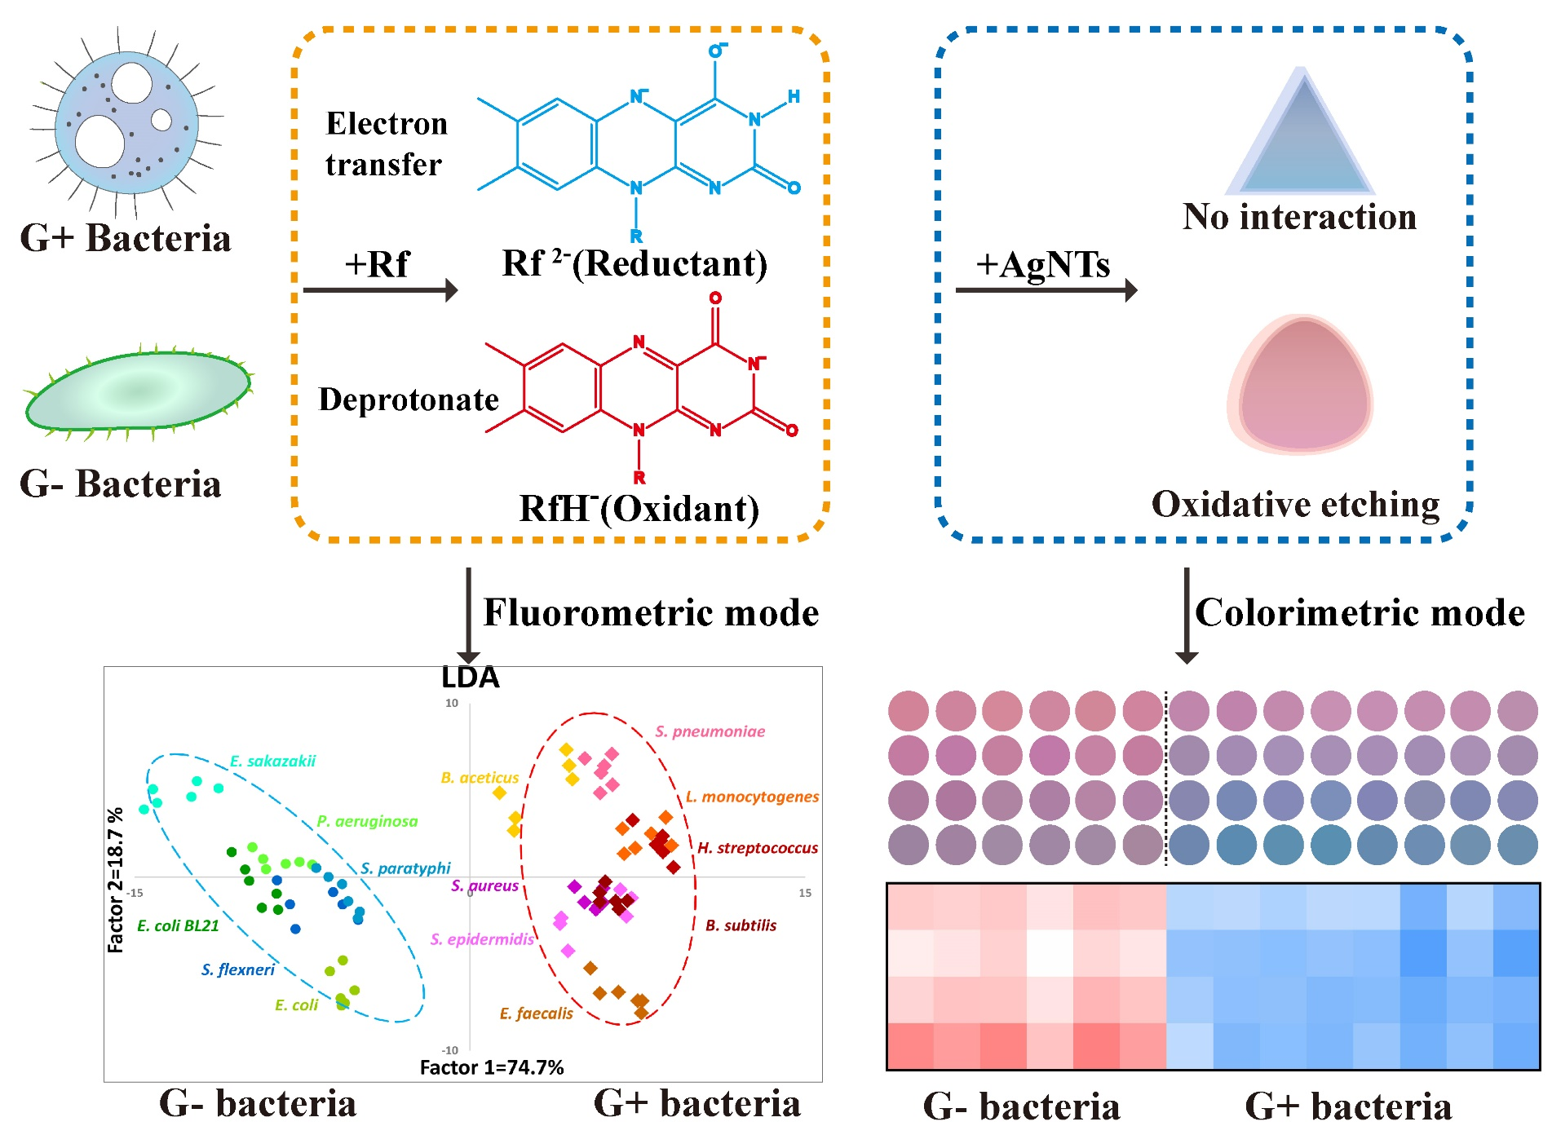
Schematic diagram of the dual-mode sensor array based on the redox state transition of Rf in the presence of G- or G+ bacteria. Due to the PCET reaction, Rf was converted to an oxidized or reduced state, leading to the exact opposite color change after reacting with AgNTs. The color change of AgNTs would be the colorimetric mode for the classification of G- or G+ bacteria species while the fluorescence variation of Rf would be the fluorometric mode for individual bacterial discrimination.

