Supplementary Information
Aluminum-doped carbon dots for the simultaneous selective detection of five tetracycline antibiotics

Chaojie Yu, Qinxing Sun, Zongzhen Wang, Mengxue Sun, Xiang Xu,* Weina Li*

College of Chemistry and Pharmaceutical Sciences, Qingdao Agricultural University, Qingdao, 266109, China.
* Correspondence to: Qingdao Agricultural University, 700 Changcheng Road, Qingdao 266109, China.

*Corresponding author
E-mail: wnli@qau.edu.cn (W. N. Li), rainerxu@163.com (X. Xu)

Table of Contents
Fig. S1. The relationship between the fluorescence intensity of Al-CDs and (a) MC, (b) TC, (c) OTC, (d) DOC and (e) CTC at a concentration of 0-500 μM.........................…………………………………………..………...…...…S-3
Fig. S2. Detection of (a) MC, (b) TC and (c) DOC seawater samples by Al-CDs....………………………………………………………….………...………S-3
Table S1. Fluorescence lifetime of Al-CDs and Al-CDs+TC……….………..…… S-3
Table S2. Determination of MC, TC, DOC in seawater samples using Al-CDs through fluorescence intensity.…………………………………………....……….. S-3

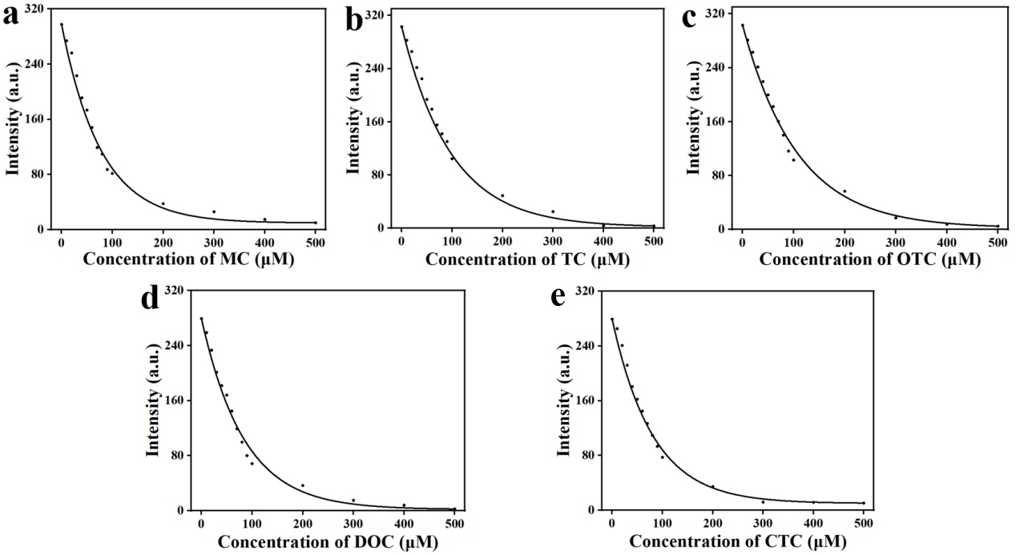
Fig. S1. The relationship between the fluorescence intensity of Al-CDs and (a) MC, (b) TC, (c) OTC, (d) DOC and (e) CTC at a concentration of 0-500 μM.
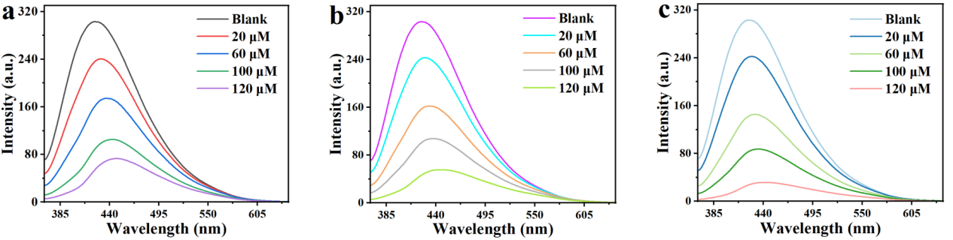
Fig. S2. Detection of (a) MC, (b) TC and (c) DOC seawater samples by Al-CDs.
Table S1. Fluorescence lifetime of Al-CDs and Al-CDs+TC.
Sample | τ₁ (ns) | A₁% | τ₂ (ns) | A₂% | τ_{ave} (ns)
Al-CDs | 2.004 | 46.2 | 8.112 | 53.8 | 5.29
Al-CDs+TC | 1.567 | 39.7 | 7.310 | 60.3 | 5.03

Table S2. Determination of MC, TC, DOC in seawater samples using Al-CDs through fluorescence intensity.
Unit | Added (μM) | Fluorescence spectra
Unit | Added (μM) | Detected (μM) | Recovery (%) | RSD (%)
MC | 20 | 22.51 | 112.55 | 2.43
MC | 60 | 56.66 | 94.43 | 2.65
MC | 100 | 92.83 | 92.83 | 2.12
MC | 120 | 113.89 | 94.95 | 2.87
TC | 20 | 24.41 | 122.05 | 3.02
TC | 60 | 69.11 | 115.18 | 3.46
TC | 100 | 97.41 | 97.41 | 2.98
TC | 120 | 123.49 | 102.91 | 2.31
DOC | 20 | 18.93 | 94.65 | 2.87
DOC | 60 | 59.89 | 99.82 | 1.98
DOC | 100 | 92.74 | 92.74 | 2.45
DOC | 120 | 112.63 | 93.86 | 3.36

