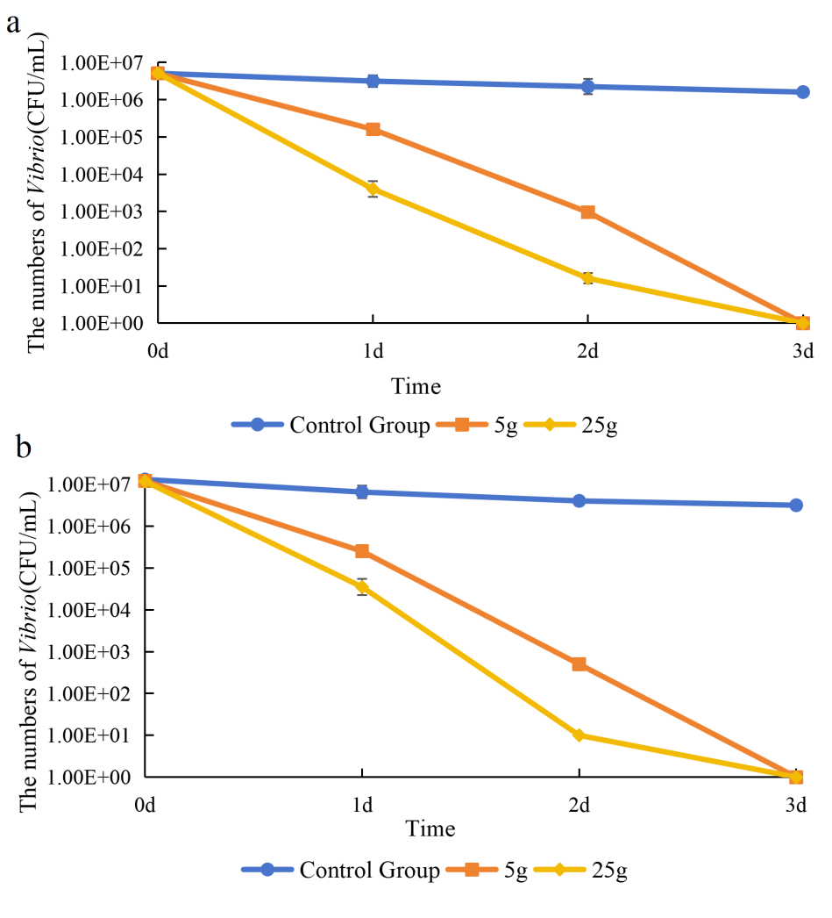
Fig. S1 Effect of different biomass of seaweeds on the inhibition of Vibrio anguillarum. a, Gracilariopsis lemaneiformis; b, Ulva pertusa.

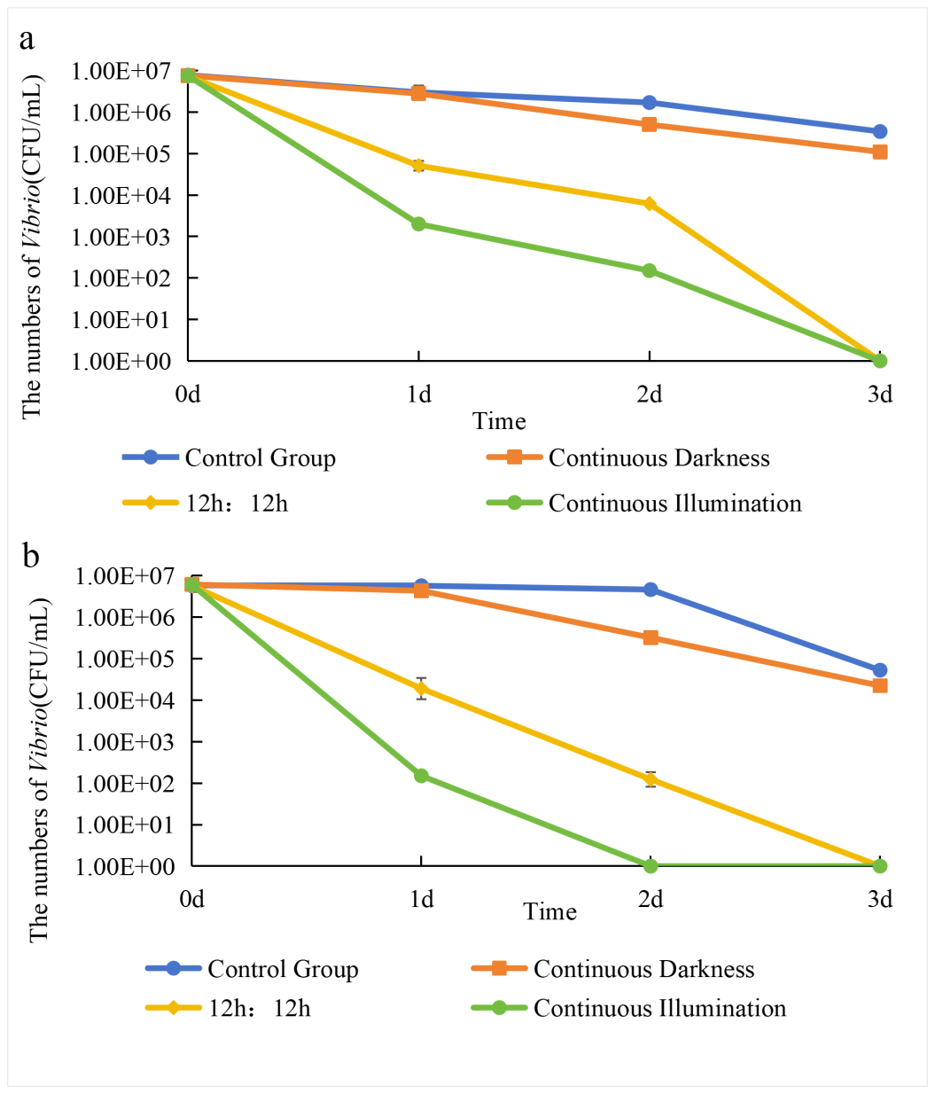
Fig. S2 Effect of light dark cycle difference on the inhibition of Vibrio anguillarum. a, Gracilariopsis lemaneiformis; b, Ulva pertusa.
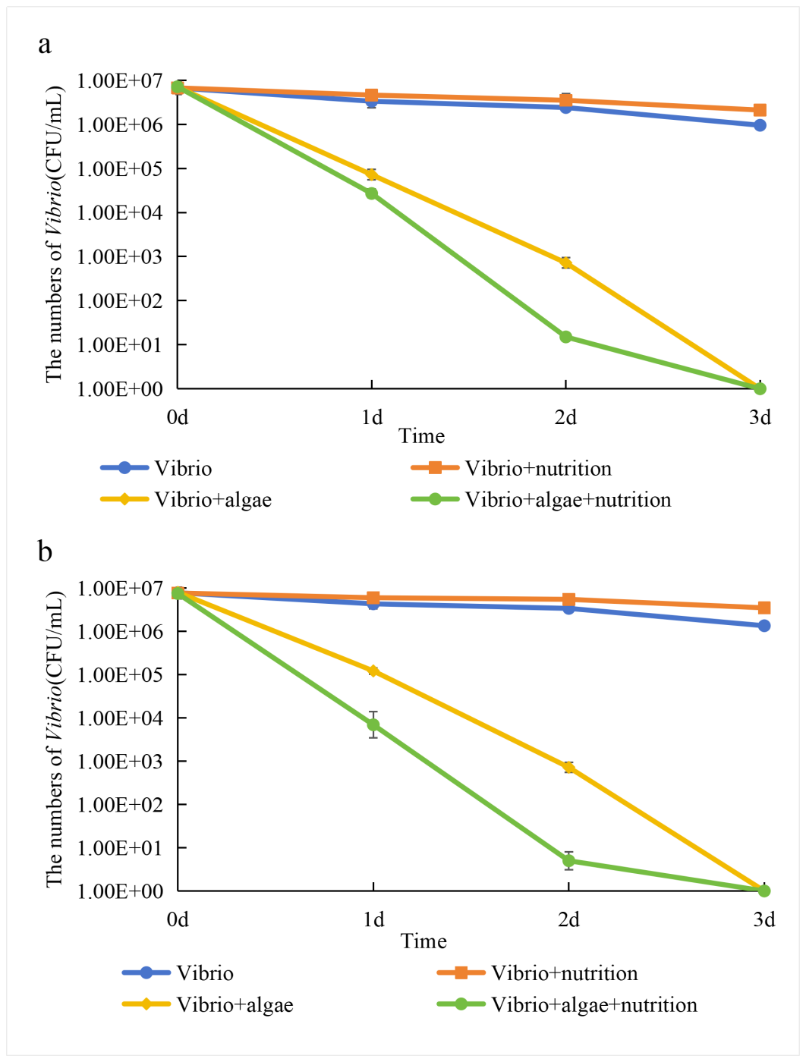
Fig. S3 Effect of adding nutrients on the inhibition of seaweeds against V. anguillarum. a, G. lemaneiformis; b, U. pertusa.
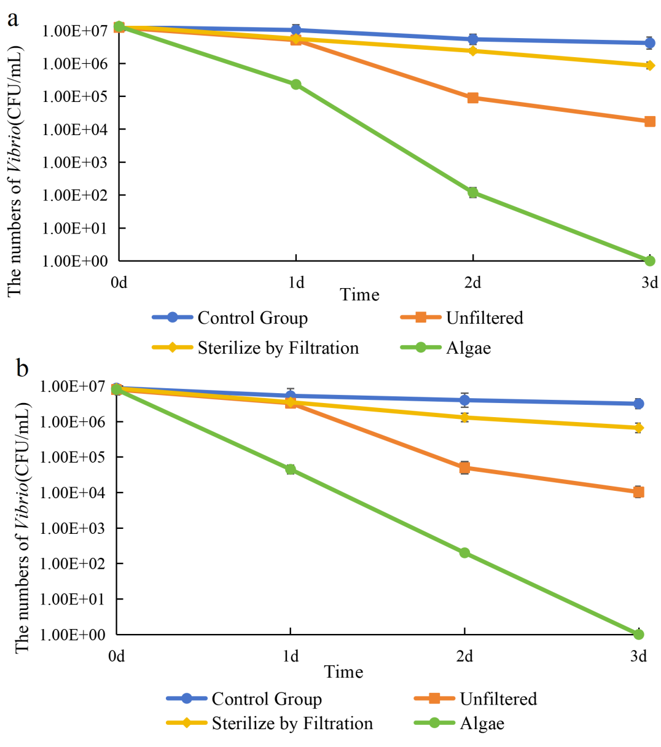
Fig. S4 Inhibition of seaweeds to Vibrio growth and the removal of seaweeds. a, G. lemaneiformis; b, U. pertusa.
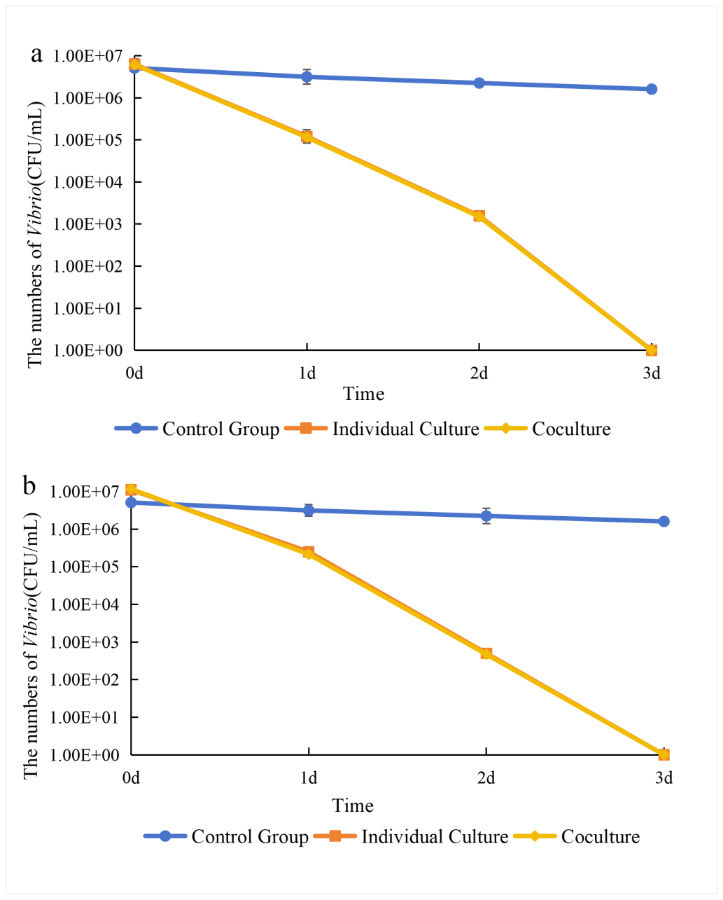
Fig. S5 Seaweed inhibition to V. anguillarum in the co-culture and mono-culture systems. a, G. lemaneiformis; b, U. pertusa.

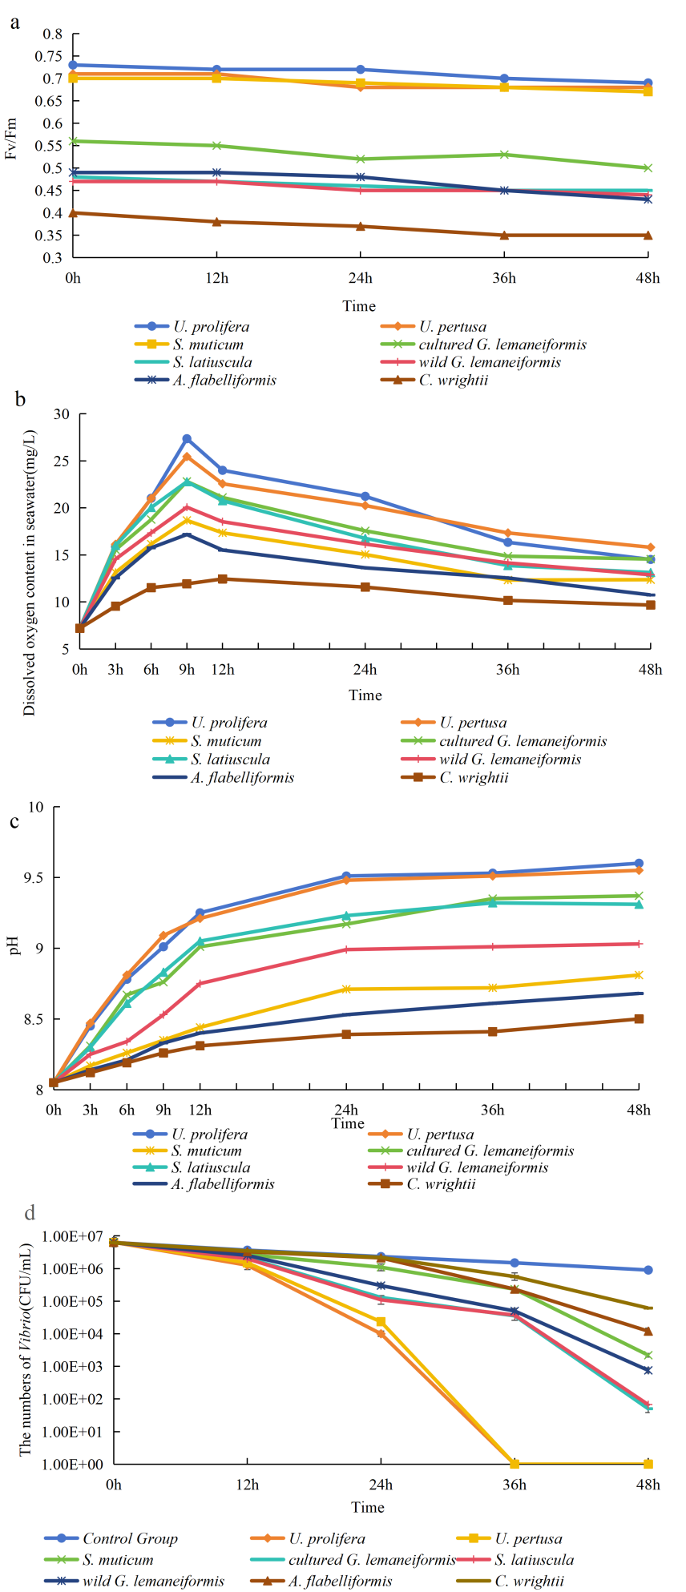
Fig.S6 The Fv/Fm, dissolved oxygen value, pH value detected and seaweeds inhibiting effects on V. alginolyticus 21-1.

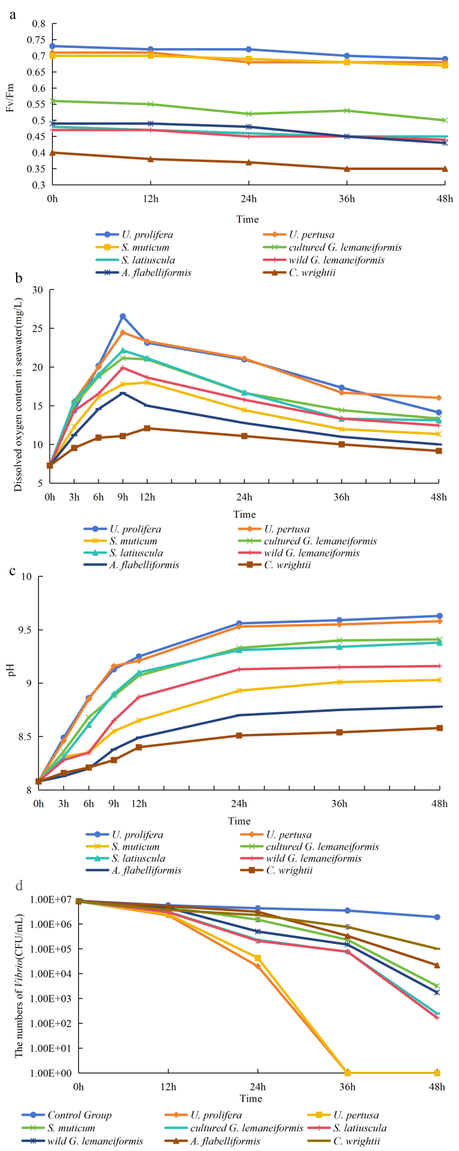
Fig.S7 The detected Fv/Fm, dissolved oxygen value, pH value and seaweeds inhibition effects on V. furnissii.
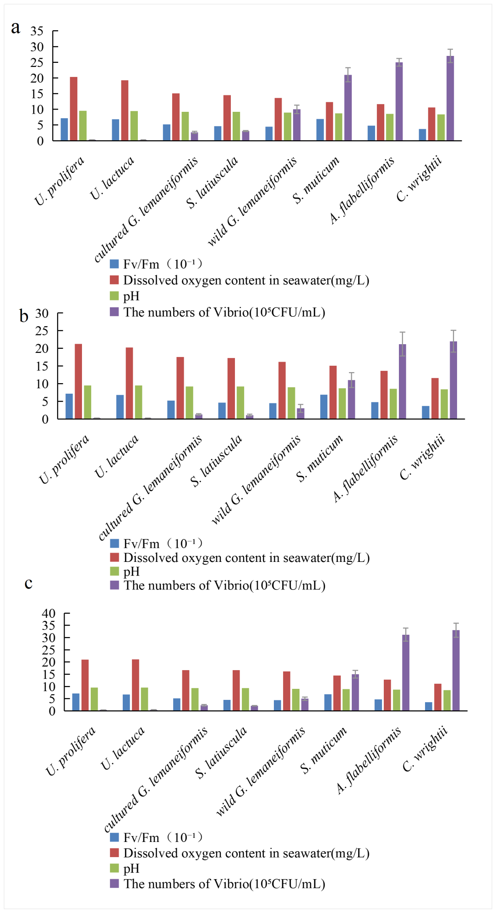
Fig. S8 The detected Fv/Fm of seaweeds, dissolved oxygen content, pH and Vibrio number in 24 hrs. a, V. anguillarum 65; b, V. alginolyticus 21-1; c, V. furnissii.

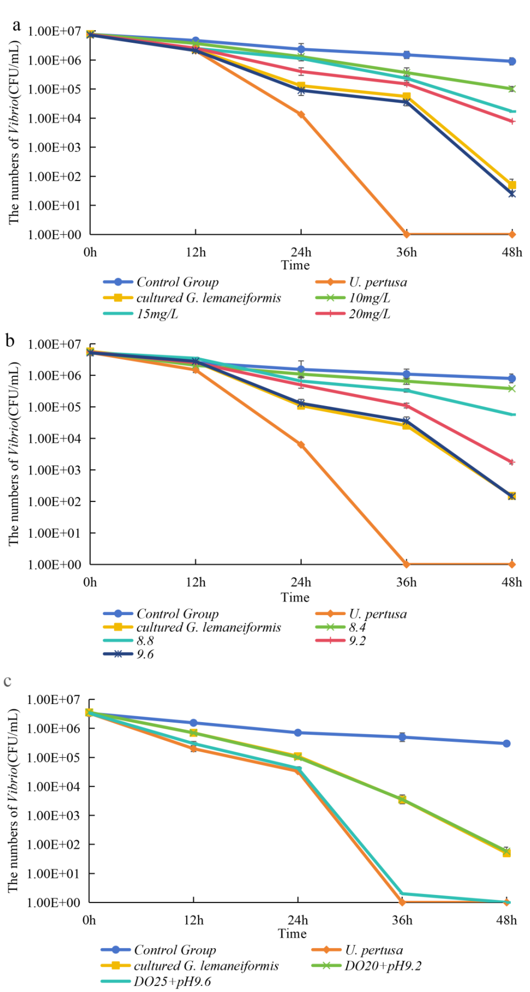
Fig. S9 Inhibitions on V. alginolyticus 21-1, the detected dissolved oxygen and pH values. a, different DO; b, different pH; c, different DO+ different pH.

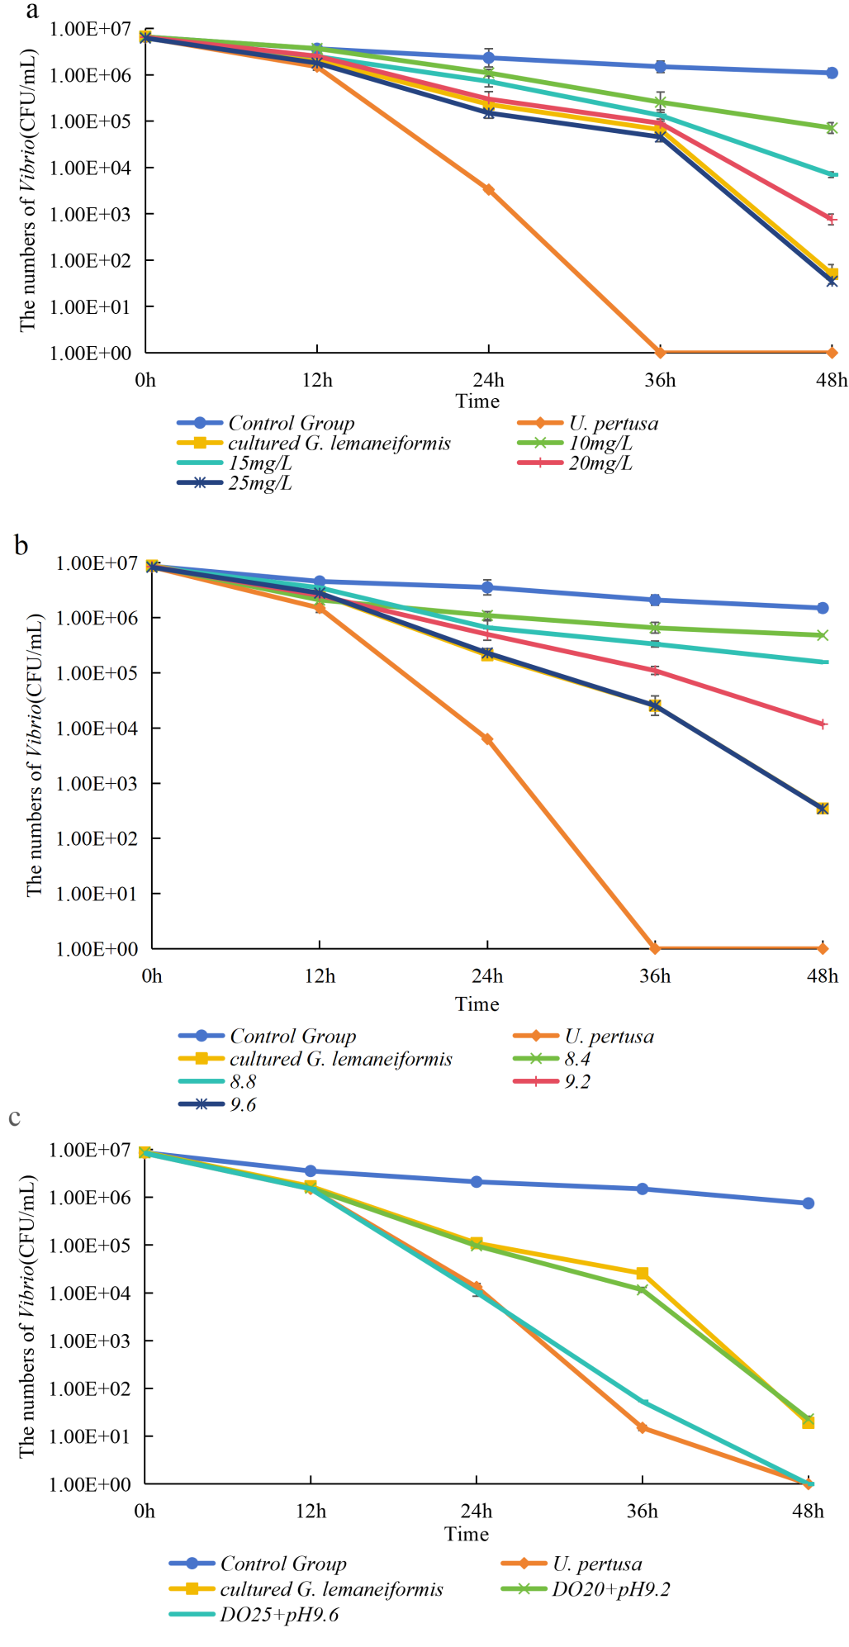
Fig. S10 Inhibition effects on V. furnissii and the detected dissolve oxygen and pH values. a, different DO; b, different pH; c, different DO+ different pH.

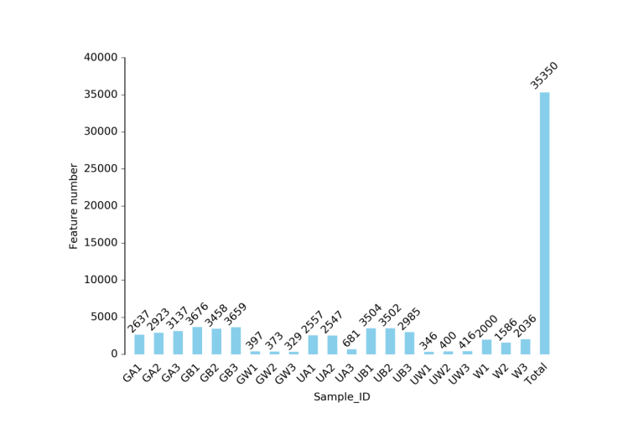
Fig. S11 Distribution diagram of ASV number of each sample
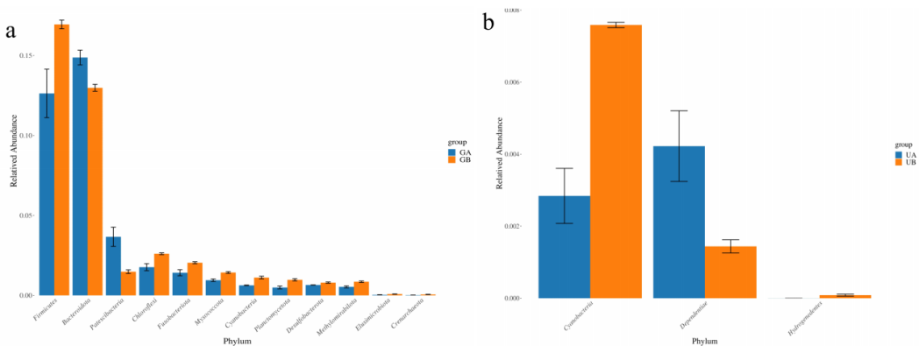
Fig. S12 Variance analysis to the epiphytic microorganisms on seaweeds before and after three days of culture. a, G. lemaneiformis; b, U.pertusa.

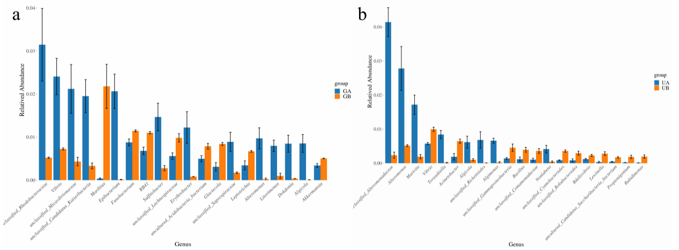
Fig. S13 Variances of epiphytic microorganisms on the seaweeds before and after three days in culture. a, G. lemaneiformis; b, U. pertusa.

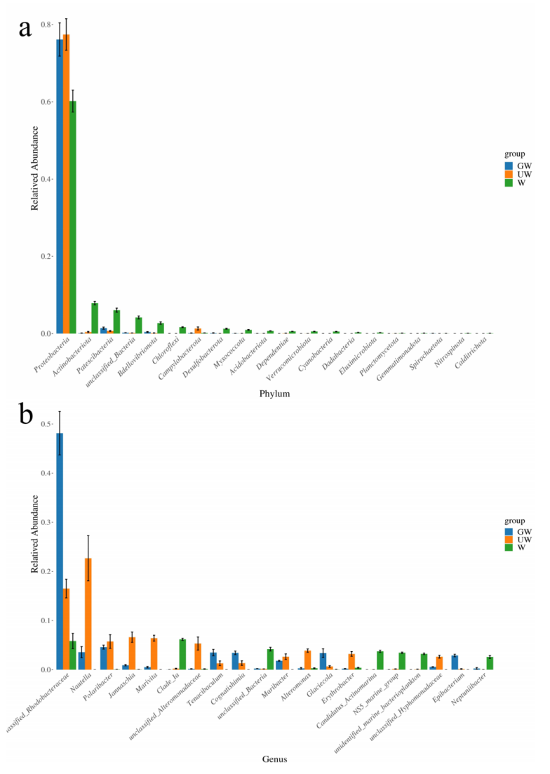
Fig. S14 Microorganism variances in the co-culture seawater. The abscissa is the top 20 species with significant difference and maximum relative abundance. a, the level of phylum; b, the level of genus.

Table S1 Statistics of sample sequencing data processing results
Sample | Raw Reads | Clean Reads | Denoised Reads | Merged Reads | Non-chimeric Reads
GA1 | 80510 | 80355 | 76560 | 61736 | 55294
GA2 | 80203 | 80075 | 76072 | 63016 | 56883
GA3 | 80169 | 80024 | 78050 | 60250 | 52497
GB1 | 80150 | 80000 | 78119 | 64381 | 57412
GB2 | 80065 | 79921 | 77235 | 61634 | 53869
GB3 | 79790 | 79670 | 77223 | 62028 | 54758
GW1 | 80168 | 80043 | 51890 | 45946 | 43117
GW2 | 79908 | 79783 | 49978 | 43650 | 41541
GW3 | 79738 | 79587 | 47125 | 39871 | 38641
UA1 | 79595 | 79437 | 72036 | 57773 | 51580
UA2 | 79640 | 79492 | 71839 | 58137 | 51772
UA3 | 80079 | 79935 | 57675 | 51195 | 48800
UB1 | 80200 | 80064 | 78287 | 62662 | 55321
UB2 | 79912 | 79771 | 78307 | 63876 | 56442
UB3 | 79842 | 79694 | 76478 | 62647 | 56042
UW1 | 80107 | 79979 | 43508 | 36679 | 35291
UW2 | 79698 | 79566 | 50380 | 43588 | 41444
UW3 | 80137 | 80017 | 50548 | 43792 | 41515
W1 | 80020 | 79886 | 65977 | 61385 | 57987
W2 | 79714 | 79580 | 62073 | 56319 | 53024
W3 | 79934 | 79789 | 66820 | 62374 | 58926

