Extended Data

Figure ED1. (a) Raw LOVECLIM and (b) raw HadCM3 precipitation anomalies for northern Australia. Grey shading indicates Heinrich events, Marine Isotope Stage boundaries also shown.
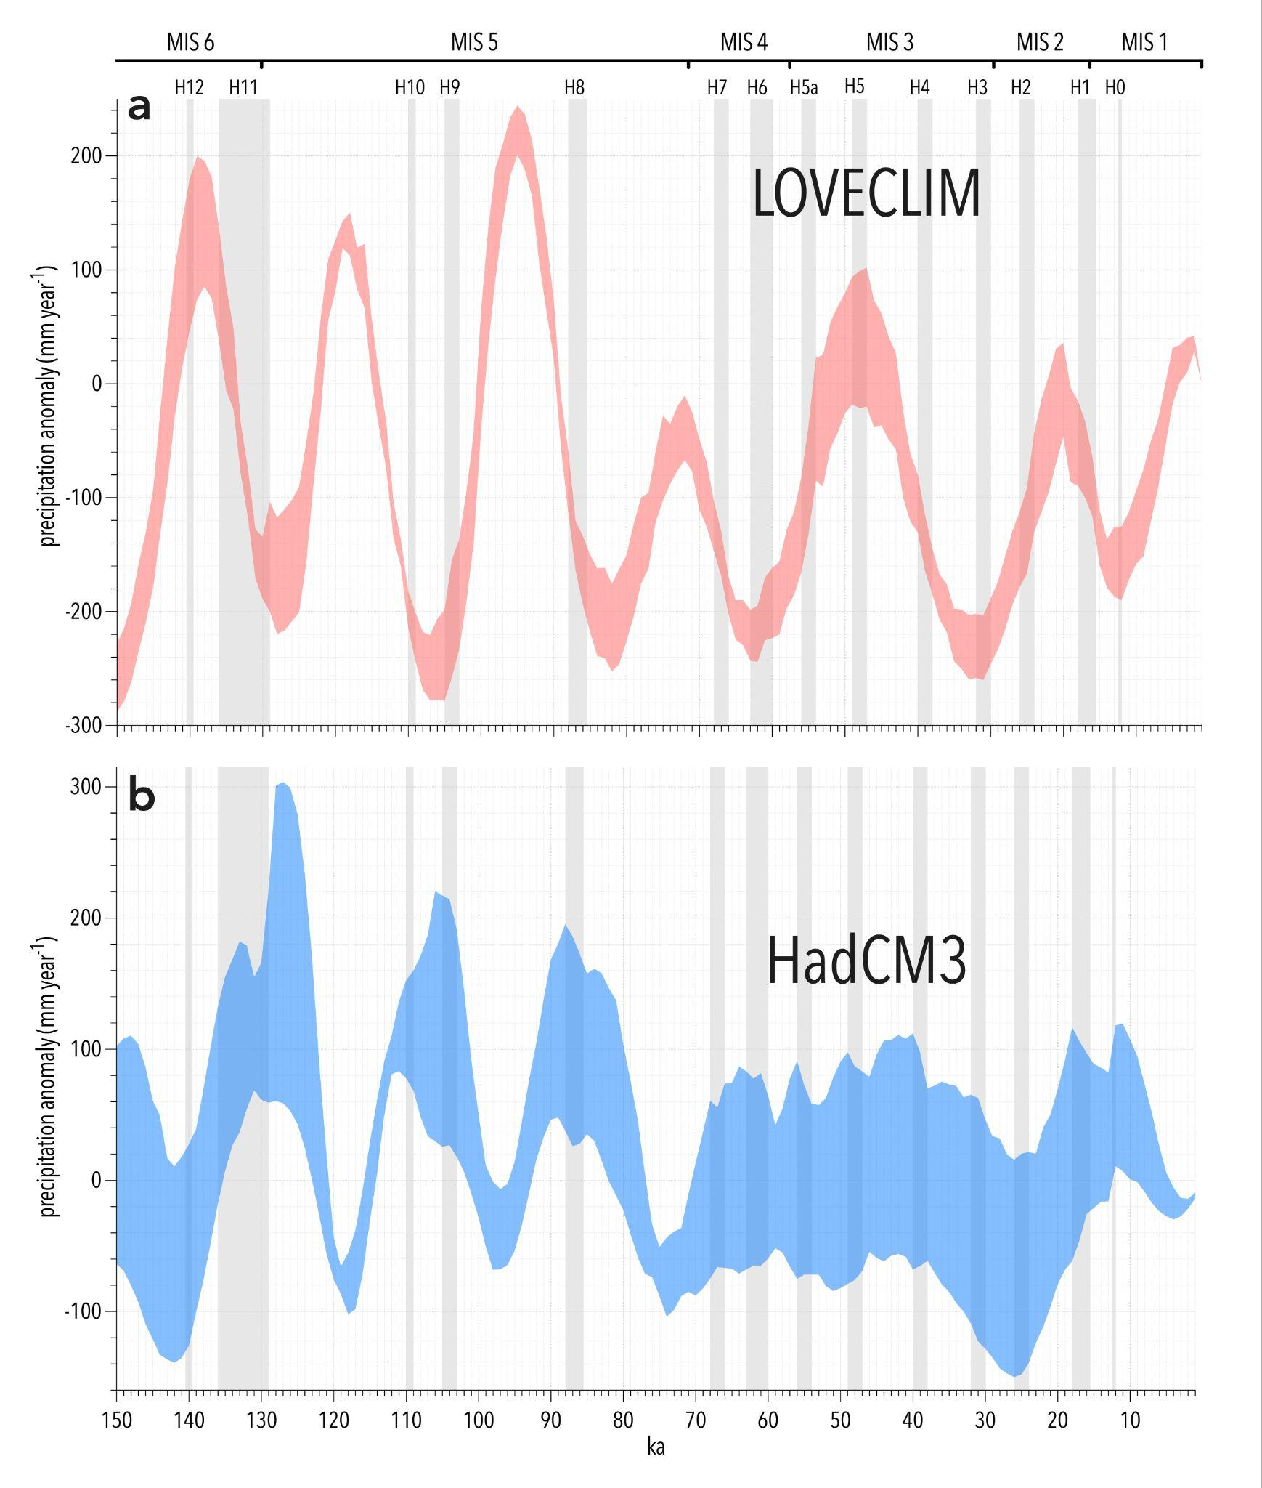

Figure ED2. (a) Raw composite speleothem oxygen isotope record for the east Asian summer monsoon²¹ and (b) the modified Dole effect (ΔDE*) record⁵², in original units. Grey shading indicates Heinrich events, Marine Isotope Stage boundaries also shown.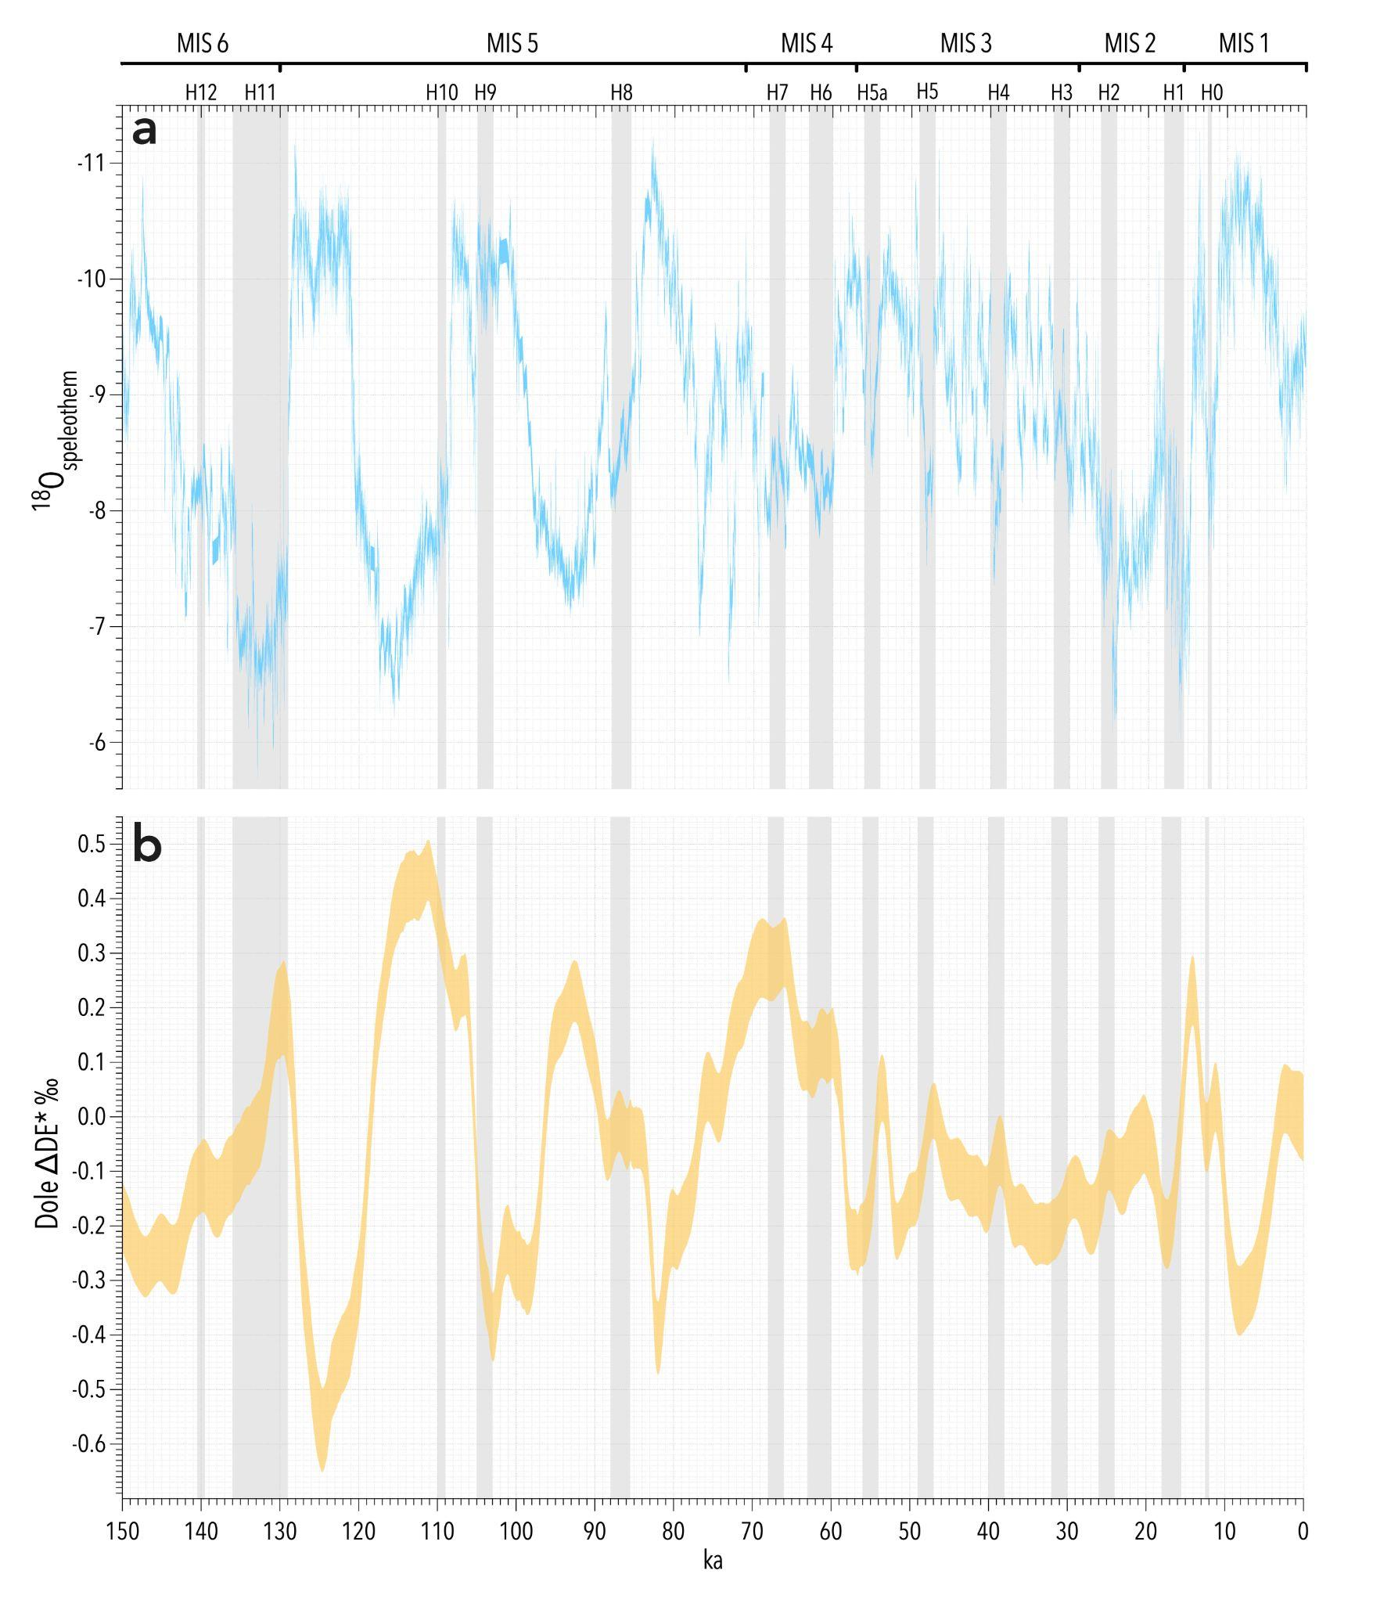

Figure ED3. (a) Raw %tree pollen of total dryland pollen and (b) raw δ²H_{pam} time series from Girraween lagoon, in original units. In both cases coloured shading is analytical error at ± 1σ. Grey shading indicates Heinrich events; Marine Isotope Stage boundaries also shown.
